**PHARMACEUTICAL MARKETING CHANNEL**

**By: Sunil Kumar Verma**

**B.PHARM: 4TH Year**

**Email: sunilverma03434@gmail.com**

**Guide Name: Mr Pramod Mishra**

**Email: pramoddmishra000@gmail.com**

**Assistant Professor (SCPM College of Pharmacy)**

**Co Guide Name: Dr. TARKESHWAR PRASAD SHUKLA**

**Email: tk007.shukla@gmail.com**

**Principal (SCPM College of Pharmacy)**

**ABSTRACT**

Marketing is a marketing strategy that promotes a product or service to a customer. Marketing is meant to increase client satisfaction and commercial success. This paper aims to give the conclusions after reviewing the body of exploration on pharmaceutical marketing. To gain an understanding of the foundations of pharmaceutical marketing, this paper presents the information acquired from a review of the literature.. We give the conclusions after reviewing the body of exploration on the pharmaceutical industry. The foundations of pharmaceutical marketing are outlined. The strategies employed to engage healthcare Professionals are often distinct from those Used for patients, and vice versa. In addition, the strategies employed for healthcare professionals are often different from those used for patients. Pharmaceutical marketing plays a crucial role in establishing trust between healthcare professionals, patients, and pharmaceutical companies. This study aims to comprehend the fundamental principles and concepts of pharmaceutical marketing, reviewing the existing literature to provide insights into the marketing mix, consumer behaviour, and green marketing in the pharmaceutical industry. The research explores the marketing blend, including product, price, place, promotion, people, process, physical evidence, packaging, partnership, and policy, and their impact on the industry. Additionally, the study examines consumer behaviour, including factors influencing purchase decisions, and the role of green marketing in promoting environmentally friendly products.

The abstract also highlights the importance of marketing research, pharmaceutical marketing strategies, and tactics employed by pharmaceutical companies, including affiliate marketing, targeted marketing, customer interaction plans, digital advertising, and more.

**Keywords. pharmaceutical industry," "prescription drugs," "generic medications," "drug development," "healthcare solutions," and "medication safety,"**

**INTRODUCTION :**

“ Trust is erected through marketing; the pharmaceutical assiduity may bear further trust- structure than any other assiduity. ”

- Anonymised

The thing of marketing is to satisfy the demands of both individualities and groups while turning a profit. Delivering a product to a particular client for their collective advantage is known as marketing. In pharmaceutical marketing, the consumer is a croaker Or group of croakers Who advise end consumers to buy pharmaceutical products. Marketing is meant to increase client satisfaction and commercial success.

Pharmaceutical Marketing Channels

Pharmaceutical marketing channels: Designing channel, channel members selecting the appropriate channel, conflict in channels, physical distribution management: Strategic importance, tasks in physical distribution management.

**Pharmaceutical marketing channels**

• Pharmaceutical marketing channels are the different ways in which pharmaceutical companies promote and sell their products to healthcare providers, patients, and other stakeholders.

• Here are some of the most common pharmaceutical marketing channels.

**1. Sales Representatives:**

• Pharmaceutical sales representatives (also known as "drug reps") are typically employed by pharmaceutical companies to promote their products directly to healthcare providers.

• They meet with physicians, pharmacists, and other healthcare professionals to provide information about new drugs, provide samples, and answer questions.

**2. Direct-to-Consumer (DTC) Advertising:**

• DTC advertising refers to the promotion of pharmaceutical products directly to patients through television, print media, and online advertising.

• This type of advertising has become increasingly common in recent years, with pharmaceutical companies spending billions of dollars on DTC advertising campaigns.

The focus of marketing enterprise is on how guests use products, services, and conditioning. It comprises a number of suggestions for consumer .

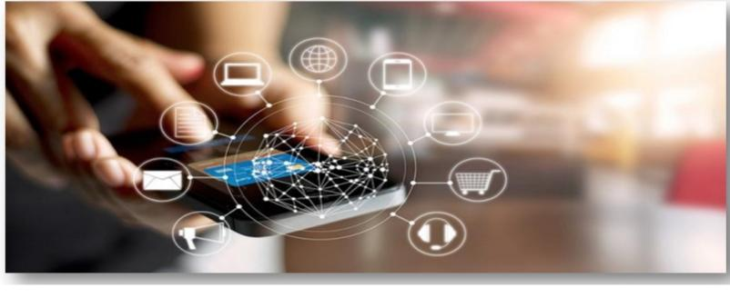**3. Digital Marketing:**

Digital marketing has become an important channel for pharmaceutical companies to reach healthcare providers and patients.

This includes email marketing, social media advertising, search engine marketing, and mobile app advertising.

**4. Medical Conferences:**

• Pharmaceutical companies often sponsor medical conferences and events, where they can show case their products and provide information to healthcare providers.

**5. Direct Mail:**

• Pharmaceutical companies may also use direct mail campaigns to target healthcare providers and patients.

• This may include sending samples of new drugs, informational brochures, or other marketing materials.

**6. Retail Pharmacies:**

• Pharmaceutical companies may also promote their products through retail pharmacies.

• This may include in-store displays, coupon programs, or other promotions.

• It's worth noting that there are regulations and guidelines in place to govern pharmaceutical marketing practices, particularly with regards to the promotion of prescription drugs.

**Designing Channel**

Designing a channel involves determining the best way to deliver products or services to customers through a variety of distribution channel.

• The goal is to create a channel strategy that maximizes sales and profits while providing the best customer experience possible. Here are some steps to consider when designing a channel.

**1. Identify your target market:**

• Before you can design a channel strategy, you need to understand who your customers are and what their needs and preferences are.

• This will help you determine which channels are most effective in reaching them.

**2. Determine your channel options:**

• Once you know who your target market is, you can start exploring different channel options.

• These may include direct sales, wholesalers, distributors, retailers, e-commerce platforms, and more.

**3. Evaluate channel partners:**

• If you are considering working with channel partners, you need to evaluate their capabilities and determine whether they are a good fit for your business.

• This may include looking at their experience, reputation, and customer base.

**4. Develop a channel strategy:**

• Once you have evaluated your options, it's time to develop a channel strategy.

• This involves deciding which channels to use, how to allocate resources to each channel, and how to coordinate efforts across channels.

**5. Implement the strategy:**

• After you have developed a channel strategy, it's time to put it into action.

• This may involve training channel partners, creating marketing materials, and developing processes for tracking sales and customer feedback.

**6. Monitor and adjust.**

• Finally, it's important to regularly monitor your channel strategy and make adjustments as needed.

• This may involve changing your product mix, adjusting pricing or incentives, or shifting resources to different channels based on performance.

**Channel Members**

**•** Channel members are the organizations or individuals involved in the distribution of products from the manufacturer to the end user.

• There are several types of channel members, including:

**1. Manufacturers:**

• Manufacturers are the producers of the products and are responsible for creating the product and making it available to the market

**2. Wholesalers:**

• Wholesalers buy products from the manufacturers in bulk and sell them to retailers or other businesses.

• They often act as intermediaries between manufacturers and retailers.

**3. Retailers:**

• Retailers are the final link in the distribution chain and sell products directly to the end user.

• They can operate through physical stores or online platform

**4. Distributors:**

• Distributors are organizations that purchase products from manufacturers and sell them to other businesses or retailers.

• They often specialize in specific industries or product categories

**5. Agents:**

• Agents act as intermediaries between manufacturers and buyers and are typically paid a commission for their services.

• They do not take possession of the products but facilitate the transaction.

**6. Brokers:**

• Brokers bring buyers and sellers together but do not take possession of the products.

• They earn a commission for successfully completing the transaction.

• Channel members play a critical role in the distribution of products and are essential in making the products available to the end user.

• It is important to carefully select and manage channel members to ensure effective distribution and optimal sale.

**Selecting the appropriate Channel**

• Selecting the appropriate channel involves choosing the most effective and efficient way todistribute products to the target market.

• Here are some factors to consider when selecting a channel:

**1. Customer preferences:**

• Consider the needs and preferences of the target market, including their buying habits, preferred channels, and accessibility to the channels.

**2. Product characteristics:**

• Assess the type of product being sold, its complexity, perishability, and other characteristics to determine the most suitable distribution channel.

**3. Competition:**

• Analyse the competition and determine the distribution channels they are using, as well as the effectiveness of those channels.

**4. Cost:**

• Evaluate the costs associated with each channel option, including transportation costs, inventory holding costs, and marketing costs.

**5. Channel partners:**

• Consider the capabilities of potential channel partners, including their expertise, resources, and geographic reach.

**6. Company objectives:**

• Determine the overall company objectives and ensure that the selected distribution channel aligns with those objectives.

**7. Legal and regulatory requirements:**

• Consider any legal or regulatory requirements that may impact the selection of a distribution channel, such as licensing or certification requirements.

**Conflict in**

**Channels**

**•** Channel conflict occurs when there is disagreement or tension among channel members, which can result in a breakdown in communication and cooperation, and ultimately, impact the sales and profitability of the company.

• Here are some common types of channel conflict:

**1. Vertical conflict:**

• This type of conflict occurs between different levels of the distribution channel, such as between manufacturers and retailers, or between wholesalers and distributors.

**2. Horizontal conflict:**

• This type of conflict occurs between channel members at the same level, such as between competing retailers.

**3. Multichannel conflict:**

• This type of conflict occurs when a company uses multiple channels to reach the same target market, which can lead to competition and disagreements among the channels.

**4. Territorial conflict:**

• This type of conflict occurs when channel members disagree on the geographic boundaries of their sales territories.

**5. Pricing conflict:**

• This type of conflict occurs when channel members disagree on the pricing of the products.

**To manage channel conflict, companies can take the following steps**

**1. Communication:**

• Encourage open communication among channel members and establish clear lines of communication to ensure that everyone is on the same page.

**2. Negotiation:**

• Work with channel members to resolve conflicts through negotiation and compromise.

**3. Collaboration:**

• Foster collaboration among channel members and encourage them to work together to achieve common goals.

**4. Consistency:**

• Ensure that pricing, promotion, and other marketing efforts are consistent across all channels to minimize conflicts.

**5. Mediation:**

• Seek mediation from a neutral third party, such as a mediator or arbitrator, to resolve conflicts that cannot be resolved through negotiation.

**Physical Distribution**

**Management**

Physical distribution management, also known as logistics management, involves the planning, implementation, and control of the movement and storage of goods from the point of origin to the point of consumption.

• Effective physical distribution management is critical for ensuring customer satisfaction, reducing costs, and improving overall efficiency.

• Here are some key elements of physical distribution management.

**1. Transportation:**

• This involves selecting the most appropriate mode of transportation (e.g., truck, train, ship, plane) and managing the transportation process to ensure timely delivery.

**2. Warehousing:**

• This involves managing inventory, selecting appropriate storage facilities, and ensuring that goods are stored and handled appropriately to prevent damage.

**3. Order processing**:

• This involves managing the order fulfillment process, from receiving orders to preparing and shipping the products.

**4. Inventory management:**

• This involves managing inventory levels to ensure that products are available when customers need them, while minimizing excess inventory and associated costs.

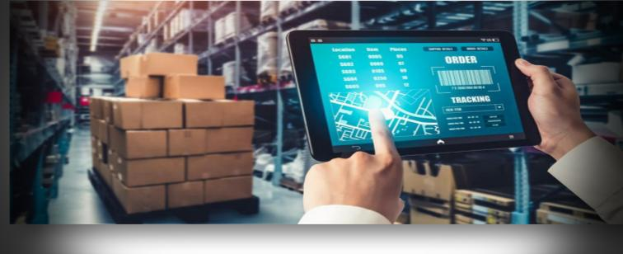

**5. Packaging and labelling:**

• This involves designing appropriate packaging and labelling that protects the product during transportation and storage, and they communicates important information to customers.

**6. Reverse logistics:**

• This involves managing the process of returning products from the customer to the manufacturer or retailer, including managing the transportation and disposal of returned products.

**Strategic**

**Importance**

• Physical distribution management is of strategic importance to companies for several reasons:

La1**. Customer satisfaction:**

• Effective physical distribution management can ensure that products are delivered to customers on time, in good condition, and with minimal hassle. This can lead to higher levels of customer satisfaction and loyalty.

**2. Competitive advantage:**

• Companies that have efficient and effective physical distribution systems can gain a competitive advantage by delivering products faster and more reliably than their competitors.

**3. Cost reduction:**

• By managing transportation, warehousing and inventory levels more effectively, companies can reduce costs associated with physical distribution, such as transportation, storage, and handling costs.

**4. Improved efficiency:**

• Effective physical distribution management can improve overall supply chain efficiency, allowing companies to operate more smoothly and respond more quickly to changes in demand.

**5. Increased sales:**

• By ensuring that products are available when and where customers need them, companies can increase sales and revenue.

**6. Improved forecasting and planning:**

• Effective physical distribution management can provide companies with better visibility into inventory levels, transportation schedules, and other factors that impact supply chain performance, allowing them to make better forecasting and planning decisions.

**Tasks in Physical Distribution Management**

**•** The tasks involved in physical distribution management typically include:

**1. Transportation planning and management:**

• This includes selecting the most appropriate mode of transportation (e.g. air, rail, road, sea) for the products, negotiating rates with transportation providers, and managing the transportation process to ensure timely and cost-effective delivery.

**2. Warehousing and inventory management:**

• This includes managing inventory levels, selecting appropriate storage facilities, managing warehouse operations such as receiving, picking, packing and shipping, and ensuring that goods are stored and handled appropriately to prevent damage.

**3. Order processing and fulfillment:**

• This includes managing the process of receiving orders, preparing and shipping products, and managing the associated paperwork, such as packing lists and bills.

**4. Packaging and labelling:**

• This includes designing appropriate packaging and labelling that protects the product during transportation and storage, and communicates important information to customers.

**5. Reverse logistics:**

• This includes managing the process of returning products from the customer to the manufacturer or retailer, including managing the transportation and disposal of returned product.

**6. Customer service and communication:**

• This includes providing customers with timely and accurate information on order status, delivery times, and any other issues related to the physical distribution process.

**7. Data analysis and optimization:**

• This includes analyzing performance metrics such as transportation costs, inventory levels, and order fulfillment times, and using that data to identify areas for improvement and optimize the physical distribution process.

**CONCLUSION:**

Pharmaceutical marketing plays a vital role in promoting healthcare products and services to healthcare professionals, patients, and other stakeholders. Understanding the foundation of pharmaceutical marketing, including the marketing mix, regulatory environment, and ethical considerations, is crucial for developing effective marketing strategies.