IoT-Based Automatic Plant Watering System

# Sahil Ghanwat1, Rohit Lavand2, Madhav Kanchewad3

*1Sahil Ghanwat E&TC & Trinity Academy of Engineering 2Rohit Lavand E&TC & Trinity Academy of Engineering 3Madhav Kanchewad E&TC & Trinity Academy of Engineering*

# ABSTRACT

Watering plants is one of the most labor-intensive and time-consuming tasks in daily gardening. The physical effort involved in watering only adds to the challenge of maintaining a garden. To simplify this task and promote a more efficient lifestyle, humans have created the "Automatic Plant Watering System." This system helps water plants automatically, ensuring the soil remains adequately moist while conserving water. It operates without the need for human intervention, thanks to the AtMega328 microcontroller. By automating the process, this system not only minimizes labor but also helps conserve water, reducing the chances of overwatering. The goal behind this design is to ease the workload of gardeners and replace manual watering methods. This automated system ensures optimal plant care and makes gardening more efficient. Moreover, integrating solar panels into large administrative buildings can further enhance energy conservation. [1]

Keywords—Watering System, NodeMCU ESP8266, I2C Module, Relay Module, Soil Moisture Sensor,

# I.INTRODUCTION

Plants play a vital role in human life by helping maintain ecological balance and providing essential resources. Therefore, conserving plant life is a significant responsibility. One major challenge is ensuring plants receive the right amount of water— both under-watering and over-watering can be harmful. Inconsistent watering can lead to decreased soil fertility and water waste, while excess watering can damage the soil.

To address these issues, an automated plant watering system is needed. This system can automatically irrigate plants based on real-time sensor data or be manually controlled through a mobile app that allows users to turn the water motor ON or OFF. The proposed solution is a cost-effective and sustainable system that uses sensors to measure environmental factors such as humidity, temperature, and soil moisture, along with a soil fertility sensor to monitor nutrient levels.

Watering plants efficiently is a crucial aspect of garden and plant care. This automated system aids in water management and decision-making, while a GSM module provides network connectivity for remote monitoring and control.[2]

# WORKING

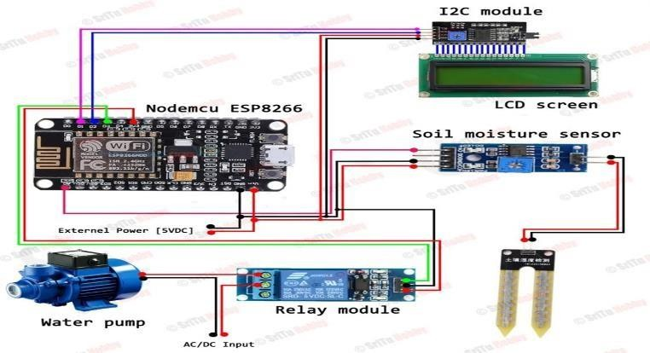

Figure : Circuit diagram of automatic plant watering system

Soil moisture sensor:

A soil moisture sensor is designed to precisely measure the moisture content in the soil. When the detected moisture level is above the set threshold, the output is 0V. If the moisture level falls below the threshold, the output becomes 5V. The digital pin checks the current moisture level to determine if it

crosses the threshold. This threshold voltage can be adjusted using a potentiometer. [3]

Relay Module:

A relay module is an electrically operated switch that allows control of high-voltage devices using low- voltage signals. While many relays use a solenoid mechanism to operate mechanically, other types may function based on different principles. Relays have been widely used in various applications, ranging from early computers to telephone systems, and are capable of performing logical control operations.[4]

Water Pump:

Water is utilized in this system for the specific task of artificial irrigation through pumping, which is controlled electronically by a microcontroller. The pump can be activated (turned on) by sending a trigger signal and deactivated (turned off) as required. This artificial irrigation process is referred to as a Water Pumping Station. There are various types of pumps available for such purposes, and in this project, a small electric pump is used, which is connected to an H-bridge motor driver for efficient control.

# HARDWARE REQUIRED

* 1. NodeMCU ESP8266
  2. I2C Module
  3. Relay Module
  4. Soil Moisture Sensor
  5. Water Pump
  6. LCD Screen

1. NodeMCU ESP8266:

The NodeMCU is an open-source development board powered by the ESP8266 microcontroller, which includes built-in Wi-Fi functionality. It's widely used in Internet of Things (IoT) applications due to its compact size, affordability, and ease of use. Programmed using the Arduino IDE, the NodeMCU features multiple GPIO pins that can be connected to various components like sensors and relays. Its energy efficiency and wireless connectivity make it perfect for smart home applications, automation, and remote-controlled systems.

1. I2C Module:

The I2C (Inter-Integrated Circuit) module is a communication protocol that allows multiple devices, such as sensors and displays, to be connected to a microcontroller using just two wires: the Serial Clock Line (SCL) and the Serial Data Line (SDA). This protocol enables easy communication between devices, even when there are limited pins available on the microcontroller. I2C is commonly used in embedded systems for connecting sensors, displays, EEPROMs, and real-time clocks.

1. Soil Moisture Sensor:

A soil moisture sensor is used to determine the water content present in the soil. Typically, a soil moisture probe contains multiple sensors to gather accurate readings. There are several commonly used technologies for soil moisture measurement, including:

* + Frequency domain sensors, such as capacitive sensors
  + Neutron moisture meters, which utilize the moderating effect of water on neutrons
  + Soil resistivity-based methods

In this project, we will utilize soil moisture sensors that can be directly inserted into the soil to monitor its moisture levels.

1. Water Pump:

A water pump is used to move water from a reservoir or water source to the plants. Controlled by the system (usually via a relay or transistor), the pump is activated when the soil moisture sensor detects low moisture levels. When the soil’s moisture falls below a predefined threshold, the pump is switched on to irrigate the plants. Once the soil moisture reaches the optimal level, the pump automatically shuts off. This automated watering process saves time, reduces water waste, and ensures efficient plant care.

1. LCD Screen:

An LCD (Liquid Crystal Display) screen is commonly used to display information in electronic devices. It works by manipulating liquid crystals to control the passage of light, usually illuminated by a backlight. LCDs are lightweight, energy-efficient, and used in various devices like clocks, calculators, and TVs. In embedded systems, they are often used to display real-time sensor readings, status updates, or control information, providing clear and readable output for users.

# CONCLUSION

The “Automatic Plant Watering System” has been successfully developed and tested. It was created by integrating the essential features of each hardware component, all of which were carefully selected and strategically placed to ensure optimal performance. The system operates automatically, with moisture sensors continuously monitoring the soil moisture levels of individual plants. When a sensor detects that the moisture level is below the set threshold, it signals the microcontroller, which then activates the water pump to irrigate the corresponding plant. Once the required moisture level is achieved, the system automatically stops the pump. Extensive testing confirms that the system operates reliably and as intended.[5]

# ACKNOWLEDGMENTS

We are grateful to Prof. C. H. Jain, our mentor and advisor, for his unwavering support throughout the project's completion. Without her unwavering support, we could not have finished the job on schedule and with high quality.

# REFERENCES

1. B. Ramya, S. Swathi, V. Sai, K. Pallavi, and K. S. Naik, “Automatic Plant Watering System,” 2022.
2. K. Shah, S. Pawar, G. Prajapati, S. Upadhyay, and

G. Hegde, *PROPOSED AUTOMATED PLANT WATERING SYSTEM USING IOT*. [Online].

Available: [https://ssrn.com/abstract=3360353](https://ssrn.com/abstract%3D3360353)

1. A. Reghukumar and V. Vijayakumar, “Smart Plant Watering System with Cloud Analysis and Plant Health Prediction.,” in *Procedia Computer Science*, Elsevier B.V., 2019, pp. 126–135. doi: 10.1016/j.procs.2020.01.088.
2. S. Sudarshan Gowda, D. R. Students, and J. H. Kumar B Asst Professor, “Automated Plant

Watering System.” [Online]. Available:

[www.ijert.org](http://www.ijert.org/)

1. P. Singh Bains, R. Kumar Jindal, and H. K. Channi, “Modeling and Designing of Automatic Plant Watering System Using Arduino,” *Accepted*, vol. 7, no. 3, pp. 676–680, 2017, [Online]. Available: [www.ijsrst.com](http://www.ijsrst.com/)