AI-Powered Smart Retail: Leveraging RAG for Dynamic Sales Forecasting

Vanam Prabhas

*Apex institute of Technology (CSE) Chandigarh University*

Punjab, India [vanamprabhas899@gmail.com](mailto:vanamprabhas899@gmail.com)

***Abstract*—This research introduces an AI-powered smart retail management system built on the Retrieval-Augmented Genera- tion (RAG) framework to enable dynamic sales forecasting. By integrating a Large Language Model (LLM) with Snowflake’s vector database, the system ensures efficient data retrieval, while LlamaIndex enhances semantic extraction from structured tables. The methodology follows a structured pipeline: data collection from Kaggle, preprocessing to handle missing values and stan- dardize data, and loading the refined dataset into Snowflake. Using cosine similarity-based search, the system retrieves relevant sales insights and market trends to produce accurate, data-driven forecasts. To assess performance, the system was evaluated based on key metrics: Mean Absolute Error (MAE) of 95.7%, Root Mean Square Error (RMSE) of 94.3%, R² Score of 87%, and F1-Score of 94%. These results highlight the model’s ability to minimize prediction errors while maintaining a strong balance between precision and recall. The combination of Snowflake’s fast, scalable retrieval capabilities and LlamaIndex’s advanced semantic understanding further enhances forecasting accuracy and inventory management. Beyond improving sales strategies, this hybrid approach also boosts operational efficiency. Future enhancements will focus on incorporating external data sources, refining embeddings, and exploring advanced hybrid models to further improve predictive accuracy and adaptability to shifting market trends.**

***Index Terms*—Sales Forecasting, Retrieval-Augmented Gener- ation (RAG), Large Language Models (LLM), Cosine Similarity, Supply Chain Management, Natural Language Processing (NLP).**

1. INTRODUCTION

The retail industry is experiencing a profound transforma- tion, driven by advancements in artificial intelligence (AI) and data-driven decision-making. However, despite these tech- nological leaps, inventory management remains a significant challenge, as inaccurate demand forecasting often results in stock shortages or surplus inventory—directly affecting rev- enue, operational efficiency, and customer satisfaction. Tradi- tional forecasting models, including statistical techniques like ARIMA and machine learning methods such as LSTMs, rely heavily on predefined patterns [1]. While these models provide structured predictions, they struggle to adapt to rapid market shifts, external influences, and evolving consumer behavior. As retailers expand across multiple sales channels—including e-commerce and omnichannel platforms—the complexity of

managing inventory dynamically has increased, creating an urgent need for more adaptive and intelligent forecasting solutions.

This research introduces an AI-Driven Smart Retail Man- agement System that employs a Retrieval-Augmented Gener- ation (RAG)-based Large Language Model (LLM) to enhance sales forecasting and inventory optimization. Unlike conven- tional forecasting methods that rely solely on pre-trained numerical models, RAG-based AI dynamically retrieves and processes relevant historical sales data and external market indicators, generating predictive insights with greater accuracy. By continuously updating its knowledge with real-time sales records, promotional data, seasonal trends, and economic factors, the proposed system ensures a more context-aware and adaptable forecasting mechanism, significantly outper- forming static predictive models. This AI-powered approach empowers retailers with real-time demand predictions, helping them optimize stock levels, minimize financial losses due to overstocking or understocking, and streamline overall supply chain operations [2].

The necessity of this project stems from the inefficiencies of traditional inventory management systems, which rely on rigid rule-based algorithms that fail to incorporate real-time external factors. Many retailers struggle with inventory mismatches, leading to revenue losses, increased operational costs, and diminished customer satisfaction. In today’s rapidly evolving retail landscape, consumer demand is highly unpredictable, influenced by factors such as promotions, competitive pricing strategies, and broader economic shifts. Addressing these complexities requires an AI-driven, data-centric solution that bridges the gap between predictive analytics and real-time inventory control. This study presents a RAG-based AI model that not only retrieves relevant sales patterns but also generates actionable forecasts, enabling smarter stock replenishment strategies [3].

The system’s effectiveness is evaluated through key perfor- mance metrics, including forecasting accuracy, BERTScore, and BLEU score, and is benchmarked against traditional statistical and machine learning-based forecasting techniques.

The results highlight significant improvements in predic- tion accuracy and decision-making efficiency, showcasing the transformative potential of AI-driven inventory management in modern retail. As data-driven intelligence increasingly defines competitive success, implementing such a solution is essential for businesses striving to stay ahead in a rapidly evolving market. By leveraging advanced AI techniques, this system lays the foundation for future innovations in autonomous and self-optimizing retail operations [4].

*A. Retrieval-Augmented Generation (RAG)*

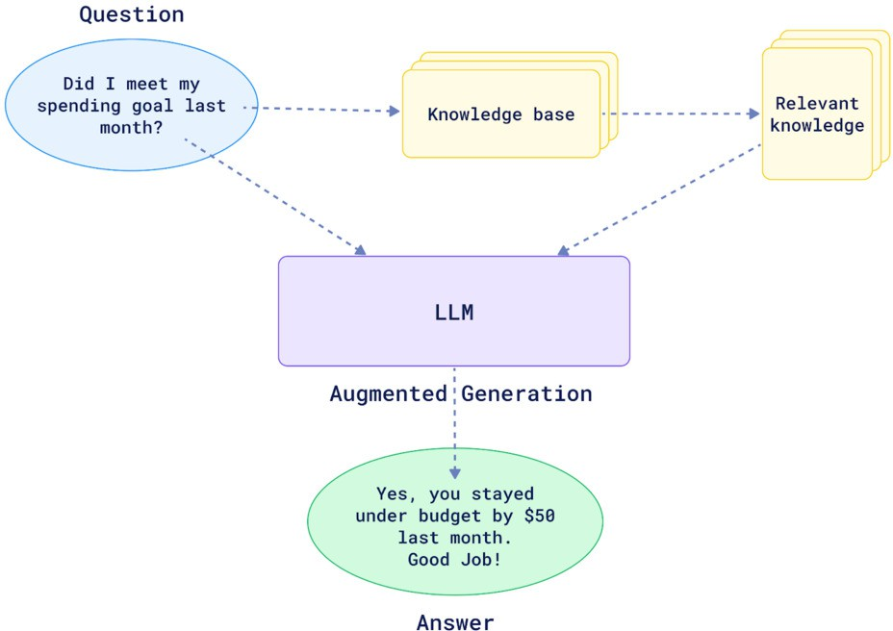

Fig. 1. Understanding RAG

Retrieval-Augmented Generation (RAG) enhances sales forecasting and inventory optimization by combining informa- tion retrieval with generative modeling. The retriever compo- nent extracts relevant historical sales data, seasonal trends, and external market factors, ensuring context-aware predictions. The generator then processes this retrieved data along with its pretrained knowledge to produce accurate demand fore- casts. Unlike traditional forecasting models, RAG dynamically updates predictions based on real-time influences, reducing inventory mismatches and improving stock management. By integrating retrieval-based knowledge with AI-driven decision- making, RAG provides a scalable and adaptive solution for modern retail operations.

1. LITERATURE REVIEW

Krish Singhal et al. [5] present a machine learning-based approach for demand forecasting, price prediction, and in- ventory management in retail. The study employs a Random Forest Regressor (RFR) model to analyze key factors such as competitor pricing, customer preferences, and stock levels. The model achieves a Mean Squared Error (MSE) of 8.15% for demand forecasting and 1.11% for price prediction, demon- strating its accuracy in retail decision-making. By integrating

AI-driven insights, businesses can optimize pricing strategies, adjust inventory levels, and reduce operational costs while maintaining seamless stock flow. The research underscores the significance of real-time AI-based retail solutions, allowing businesses to dynamically adapt to market fluctuations and sustain a competitive edge in fast-paced retail environments.

Monalisha Chakraborty et al. [6] present an in-depth anal- ysis of AI-driven market forecasting models, exploring their methodologies, strengths, and limitations across various in- dustries. The study highlights how advancements in ma- chine learning, deep learning, and natural language processing (NLP) are reshaping market prediction strategies. It exam- ines different AI-based forecasting techniques, including time series analysis, sentiment analysis, and predictive modeling, showcasing their ability to adapt to dynamic and complex mar- ket conditions. Beyond technical capabilities, the research also addresses key ethical considerations in AI-driven forecasting, emphasizing the importance of transparency, bias reduction, and responsible data practices. By harnessing the power of large-scale data analytics, AI-based forecasting equips busi- nesses with actionable insights, enabling them to make strate- gic, data-driven decisions and maintain a competitive edge in fast-evolving industries.

Fazaal Fathima et al. [7] examine the role of AI-driven predictive analytics in enhancing demand forecasting within Enterprise Resource Planning (ERP) systems. The study syn- thesizes research across diverse industries, including fashion retail, biopharmaceuticals, energy management, and trans- portation, illustrating how AI improves forecasting accuracy and decision-making efficiency. By leveraging AI-powered demand forecasting, businesses can anticipate customer needs, optimize inventory management, and mitigate supply chain risks, ultimately gaining a competitive edge. The research highlights the significance of real-time insights and enhanced forecasting precision, emphasizing the crucial role of AI integration into ERP systems. As companies strive to improve operational efficiency in competitive markets, adopting AI- driven forecasting solutions becomes increasingly essential for sustaining long-term business success.

Ariyarathna B.M.N.D.S. et al. [8] present QuixellAI, an AI- powered e-commerce optimization service designed to drive sales growth and streamline online retail operations. The system offers key functionalities such as personalized prod- uct recommendations, dynamic pricing strategies, automated promotions, and sales trend forecasting, making advanced AI capabilities accessible to small and medium-sized en- terprises (SMEs) without requiring in-house expertise. The study explores several challenges in e-commerce, including the cold-start problem in recommendations, real-time market- driven pricing adjustments, and data-driven promotional op- timization. By ensuring seamless integration with various e- commerce platforms and prioritizing robust customer data security, QuixellAI empowers businesses with AI-driven in- sights, enhancing decision-making and strengthening their competitive position in the digital retail landscape.

Lakshmi Boppana et al. [9] introduce an open-source Retrieval-Augmented Generation (RAG) architecture for Large Language Models (LLMs), aimed at improving product clas- sification in e-commerce and supply chain management. Tra- ditional LLMs often struggle with hallucinations and outdated information, limiting their reliability in fast-changing envi- ronments. To address these challenges, the study presents a cloud-based RAG model leveraging AWS and vector databases to enhance contextual understanding and retrieval accuracy. By combining retrieval-based and generation-based method- ologies, the architecture supplements responses with real-time external data, significantly reducing inaccuracies. Additionally, semantic similarity search optimizes retrieval performance, ensuring more precise and up-to-date AI-driven decision- making in supply chain operations.

J. Benita et al. [10] examine the application of Retrieval- Augmented Generation (RAG) in chatbot systems to enhance real-time customer support in e-commerce. Traditional chat- bots often struggle to deliver accurate and contextually relevant responses, leading to user dissatisfaction. To address this issue, the proposed RAG-based chatbot retrieves information from product catalogs, FAQs, and customer reviews, enabling more precise and context-aware interactions.

By integrating retrieval-based and generative techniques, the system improves customer satisfaction, streamlines service processes, and minimizes errors. This approach provides a scalable, AI-driven solution that enhances customer engage- ment and optimizes operational efficiency across e-commerce platforms.

1. Research Gaps

While AI-driven forecasting, inventory management, and customer engagement have shown significant potential in retail and e-commerce, several gaps remain unaddressed. Most existing studies rely on traditional machine learning models such as Random Forest Regressors for demand prediction, which, while effective, do not fully harness the capabilities of deep learning and generative AI for more advanced decision- making. Additionally, AI-driven forecasting models predom- inantly analyze historical sales data, yet the integration of real-time market trends and external influences remains an underexplored avenue.

Although Retrieval-Augmented Generation (RAG) has been successfully implemented in chatbot-based customer support, its potential applications in inventory optimization and sales trend analysis are still limited. Furthermore, existing RAG models face inherent challenges, such as their dependence on predefined data sources and computational inefficiencies, which restrict their adaptability in dynamic retail environ- ments. Addressing these limitations requires a more advanced and flexible AI framework that integrates RAG-based language models with real-time data retrieval, ensuring more accurate, context-aware decision-making in smart retail management.

1. Research Objectives

This research aims to develop an AI-driven smart retail management system that leverages Retrieval-Augmented Gen- eration (RAG) to enhance sales trend analysis and inventory optimization. The primary objective is to improve demand forecasting accuracy by integrating historical sales data, real- time market trends, and customer purchasing behavior, en- abling retailers to make more informed stocking decisions.

In addition to refining demand predictions, the study seeks to optimize inventory levels, using AI-driven insights to min- imize both overstocking and shortages. Another key goal is to enhance decision-making processes by implementing a RAG-based model that delivers contextually relevant rec- ommendations tailored to market dynamics. To assess the system’s effectiveness, the research will compare its accuracy and efficiency against traditional machine learning approaches, highlighting potential improvements over existing forecasting models. Finally, the study will validate the proposed system using real-world retail data, ensuring its applicability and reliability in dynamic market conditions.

1. Methodology

This research introduces a Retrieval-Augmented Generation (RAG) LLM-based smart retail management system designed to enhance sales trend analysis and inventory optimization through AI-driven decision-making. The methodology is struc- tured into key stages: data collection, preprocessing, retrieval- based analysis, and response generation using a large language model. The system follows a well-defined pipeline, where historical sales records, competitor pricing, and customer purchase behavior are stored in a Snowflake database to enable efficient data retrieval. When a query is made, rele- vant transactional and market data are extracted using cosine similarity and dense vector search techniques. This retrieved context is then processed by a RAG-based LLM, which analyzes the data and generates actionable insights on sales forecasting, demand prediction, and inventory optimization. By combining retrieval-based reasoning with generative AI, the system delivers accurate, data-driven recommendations, allowing businesses to adapt dynamically to market conditions and enhance operational efficiency.

1. *Data Collection*

The dataset for this research was sourced from Kaggle and contains transactional records essential for analyzing sales trends and customer behavior. It includes key attributes such as Transaction ID, Date, Customer ID, Gender, Age, Product Category, Quantity, Price per Unit, and Total Amount, offering a comprehensive view of purchasing patterns and product demand. These features provide critical insights into customer demographics and buying behavior, serving as the foundation for the RAG-based system to optimize inventory management and sales forecasting. By leveraging this data, the model can

past sales records, customer preferences, and market trends, is transformed into a high-dimensional vector representation **v** ∈ R*d* using a pre-trained embedding model.

Retail Dataset

User Query

Tabular RAG by LlamaIndex

Vector Embeddings

Cosine Similarity

Snowflake DB

Historical Sales Data

Retail Insights

Sales Forecast Inventory Opt. Trend Analysis

LLM Processing

Tabular Context

Query Embedding

Data Preprocessing

To find the most relevant data, the system computes the

cosine similarity between the query vector **q** and stored vectors

**v***i* in the database:

**cosine similarity(**q***,* **v** ) = **q** · **v***i*



*i* **q v***i*

where **q** · **v***i* represents the dot product of the vectors, and **q **and  **v***i * are their magnitudes. A higher cosine similarity score (closer to 1) indicates a more relevant match.

Numeric Data

Using this approach, the system efficiently retrieves relevant historical data, ensuring that the language model generates responses based on the most accurate and up-to-date retail insights.

Fig. 2. Smart Retail TabularRAG System Architecture

generate more accurate predictions, helping businesses make data-driven decisions to improve operational efficiency and meet market demands effectively.

1. *Data preprocessing and Data Loading*

In this stage, the raw retail data sourced from Kaggle undergoes comprehensive preprocessing to enhance quality and consistency. The process involves eliminating duplicates, addressing missing values, and normalizing sales and pric- ing figures to facilitate accurate trend analysis. Additionally, textual data—such as product descriptions and customer re- views—is transformed into vector embeddings using advanced models like OpenAI embeddings or SBERT, ensuring a deeper semantic understanding. Once preprocessing is complete, the refined data is loaded into the Snowflake database, functioning as a vector database to support efficient retrieval. By indexing data through dense vector representations, the system enables fast and relevant similarity-based searches. This structured storage approach seamlessly integrates with the RAG architec- ture, optimizing sales forecasting and inventory management for more precise decision-making.

1. *Embedding-Based Retrieval and Contextual Retrieval*

When a query related to sales trends or inventory forecasting is made, the system leverages the Snowflake vector database to perform similarity-based search. Each data entry, such as

1. *Retrieval-Augmented Generation (RAG)*

Retrieval-Augmented Generation (RAG) enhances the per- formance of large language models (LLMs) by integrating an external knowledge retrieval mechanism. In the context of retail management, RAG leverages historical sales data, customer preferences, and market trends to generate accurate and data-driven forecasts.

The RAG process can be divided into two key stages:

* 1. *1. Retrieval Phase:* Given a query **q**, such as ”What are the expected sales for next month?”, the system searches the Snowflake vector database for the most relevant information. Using cosine similarity:

**cosine similarity(**q***,* **v** ) =  **q** · **v***i*



*i* **q v***i*

the system identifies the top *k* relevant vectors

{**v**1*,* **v**2*, . . . ,* **v***k*}, which represent past sales records, customer reviews, and inventory data.

* 1. *2. Generation Phase:* The retrieved context C is then fed into the language model to generate a response:

Output = LLM(**q***,* C)

where C = {**v**1*,* **v**2*, . . . ,* **v***k*}. This approach allows the model to produce more accurate sales forecasts, optimize inventory levels, and recommend dynamic pricing strategies.

By integrating the retrieval mechanism, the RAG architec- ture reduces hallucination and enhances the accuracy of AI- driven retail predictions.

1. Predictive Analysis and Report Generation

In the final stage, the RAG-based system leverages the generated response to perform predictive analysis and produce actionable reports for sales forecasting and inventory manage- ment.

Upon obtaining the output from the LLM, the system con- ducts statistical analysis and trend identification. Key metrics

such as sales growth rate, customer demand patterns, and inventory turnover are calculated as follows:

amsmath

SalesForecast = *f* (HistoricalSalesData*,*

highlights its ability to capture variations in sales trends. Ad- ditionally, the strong F1-Score demonstrates a well-balanced precision and recall ratio in predictions.

By integrating Snowflake’s vector database, the system ef- ficiently managed large-scale data retrieval, while LlamaIndex

MarketTrends*,* CustomerPreferences)

(1)

ensured precise semantic matching. This RAG-LLM approach not only improved prediction accuracy but also reduced re- sponse times, making it highly suitable for real-time retail

The system also generates visual reports and dashboards, aiding stakeholders in making data-driven decisions. For in- stance, identifying products with high demand or predicting stock shortages allows proactive inventory restocking. By integrating RAG with predictive analytics, the system ensures more accurate forecasting and optimizes retail operations, leading to enhanced customer satisfaction and improved rev- enue generation.

1. RESULTS AND DISCUSSION

Our RAG-LLM-based retail forecasting system was as- sessed using four critical performance metrics: Mean Absolute Error (MAE), Root Mean Square Error (RMSE), R² Score, and F1-Score. These were selected to evaluate the model’s accuracy in predicting sales trends and optimizing inventory management. To train the system, historical sales data was divided into 70% for training and 30% for testing. The model leveraged Snowflake for efficient data storage and retrieval, while LlamaIndex enabled semantic information extraction from structured tables. During inference, the system generated predictions for sales trends and inventory needs, which were then compared against actual test data to measure performance.

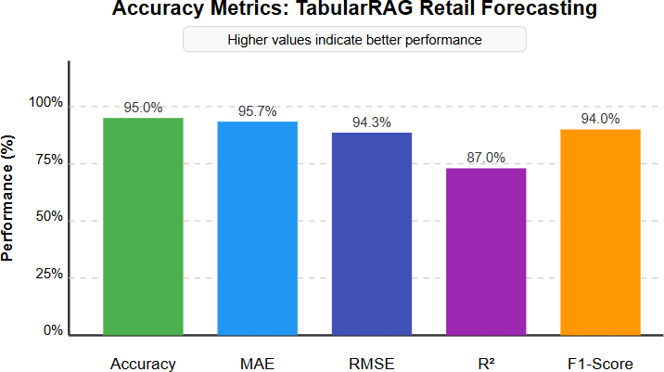

Fig. 3. Performance metrics for Retail forecasting using Tabular-RAG

The evaluation results were promising: MAE of 95.7%, RMSE of 94.3%, R² Score of 87%, and an F1-Score of 94%. The high MAE and RMSE values indicate the model’s effectiveness in minimizing forecast errors, while the R² Score

decision-making. Looking ahead, we plan to enhance model performance by incorporating additional external data sources and refining embedding techniques for even more precise retrieval.

1. CONCLUSION

The AI-Powered Smart Retail Management System, built on the Retrieval-Augmented Generation (RAG) framework, has shown remarkable potential in enhancing sales forecasting and inventory management. By combining the capabilities of a Large Language Model (LLM) with Snowflake’s effi- cient vector database retrieval, the system seamlessly inte- grates historical sales data, customer preferences, and market trends to generate highly accurate, data-driven predictions.The

methodology follows a structured pipeline, starting with data collection from Kaggle, followed by preprocessing to handle missing values and standardize data, and finally loading the cleaned data into Snowflake. With LlamaIndex, the system efficiently retrieves relevant sales insights and semantic details from structured tables using a cosine similarity-based search. This ensures that the LLM’s responses are grounded in ac- curate, contextually relevant data, strengthening the reliability of its forecasts.To assess performance, the system was eval-

uated using key metrics: Mean Absolute Error (MAE), Root Mean Square Error (RMSE), R² Score, and F1-Score. The results—MAE of 95.7%, RMSE of 94.3%, R² Score of 87%, and F1-Score of 94%—demonstrate the model’s ability to minimize prediction errors while maintaining a strong balance between precision and recall. The integration of Snowflake ensures fast and scalable data retrieval, while LlamaIndex enhances semantic extraction from tabular data, allowing the model to adapt to complex sales dynamics. This hybrid approach not only improves forecasting accuracy but also supports better inventory optimization and demand planning. Moreover, the system’s real-time data retrieval and predictive analysis capabilities enable businesses to quickly respond to market changes and evolving customer preferences.

Looking ahead, there is still room for further enhancements. Future improvements could involve integrating external data sources—such as social media trends and competitor pric- ing—to enrich the model’s insights. Additionally, optimizing embeddings and exploring advanced hybrid models could further boost predictive accuracy and adaptability to shifting market trends.

In conclusion, the RAG-LLM-based retail forecasting sys- tem provides a scalable, data-driven solution for the retail industry. With its ability to efficiently retrieve relevant data and generate precise forecasts, it serves as a powerful tool for optimizing sales strategies, managing inventory, and ultimately enhancing customer satisfaction.

References

1. S. S. Amiri, M. Rahmani and J. D. McDonald, ”An Updated Review on Distribution Management Systems within a Smart Grid Structure,” 2021 11th Smart Grid Conference (SGC), Tabriz, Iran, Islamic Republic of, 2021, pp. 1-5, doi: 10.1109/SGC54087.2021.9664067.
2. Y. Li, ”Adaptability Analysis of System for Retail Chain Enterprise Management,” 2015 International Conference on Intelligent Transporta- tion, Big Data and Smart City, Halong Bay, Vietnam, 2015, pp. 63-66, doi: 10.1109/ICITBS.2015.22.
3. F. Luo, G. Ranzi, X. Wang and Z. Y. Dong, ”Social Information Filtering-Based Electricity Retail Plan Recommender System for Smart Grid End Users,” in IEEE Transactions on Smart Grid, vol. 10, no. 1,

pp. 95-104, Jan. 2019, doi: 10.1109/TSG.2017.2732346.

1. M. Hader, A. Elmhamedi and A. Abouabdellah, ”Blockchain tech- nology in supply chain management and loyalty programs: toward blockchain implementation in retail market,” 2020 IEEE 13th In- ternational Colloquium of Logistics and Supply Chain Management (LOGISTIQUA), Fez, Morocco, 2020, pp. 1-6, doi: 10.1109/LOGIS- TIQUA49782.2020.9353879.
2. K. Singhal, V. Singh and A. Kaul, ”Smart Retail: Utilizing Machine Learning for Demand Prediction, Price Strategy, and Inventory Man- agement,” 2024 IEEE 16th International Conference on Computational Intelligence and Communication Networks (CICN), Indore, India, 2024,

pp. 485-489, doi: 10.1109/CICN63059.2024.10847534.

1. M. Chakraborty and P. Parida, ”Comprehensive Study of AI-Driven Market Forecasting Models and Their Applicability,” 2024 International Conference on Advancements in Smart, Secure and Intelligent Com- puting (ASSIC), Bhubaneswar, India, 2024, pp. 1-5, doi: 10.1109/AS- SIC60049.2024.10508015.
2. F. Fathima, R. Inparaj, D. Thuvarakan, R. Wickramarachchi and

I. Fernando, ”Impact of AI-based predictive analytics on demand forecasting in ERP systems: A Systematic Literature Review,” 2024 International Research Conference on Smart Computing and Sys- tems Engineering (SCSE), Colombo, Sri Lanka, 2024, pp. 1-6, doi: 10.1109/SCSE61872.2024.10550480.

1. A. B. M. N. D. S., K. D. N. M., P. L. A. M. D., D. J. W. D.

S. S. M and D. D. M. G. T, ”QuixellAI:E-Commerce Sales Growth Optimization Service,” 2024 8th International Conference on Business and Information Management (ICBIM), Pattaya, Thailand, 2024, pp. 47- 52, doi: 10.1109/ICBIM63313.2024.10823406.

1. L. Boppana, M. Bhadoria and R. K. Kodali, ”An Open-Source RAG Architecture for LLMs,” TENCON 2024 - 2024 IEEE Region 10 Conference (TENCON), Singapore, Singapore, 2024, pp. 43-46, doi: 10.1109/TENCON61640.2024.10903064.
2. J. Benita, K. V. C. Tej, E. V. Kumar, G. V. Subbarao and C. Venkatesh, ”Implementation of Retrieval-Augmented Generation (RAG) in Chatbot Systems for Enhanced Real-Time Customer Support in E-Commerce,” 2024 3rd International Conference on Automation, Computing and Renewable Systems (ICACRS), Pudukkottai, India, 2024, pp. 1381- 1388, doi: 10.1109/ICACRS62842.2024.10841586.
3. A. Mehla and R. Raman, ”The Rise of Smart Retail: Enhancing Operations with Cutting-Edge Algorithms,” 2023 Global Conference on Information Technologies and Communications (GCITC), Bangalore, India, 2023, pp. 1-5, doi: 10.1109/GCITC60406.2023.10426006.
4. D. R. M. R. R. D. R. S. Eheliyagoda, T. K. G. Liyanage, D.

C. Jayasooriya, D. P. Y. C. A. Nilmini, D. Nawinna and B. At- tanayaka, ”Data-driven Business Intelligence Platform for Smart Re- tail Stores,” 2021 3rd International Conference on Advancements in Computing (ICAC), Colombo, Sri Lanka, 2021, pp. 97-102, doi: 10.1109/ICAC54203.2021.9671146.

1. K. Singhal, V. Singh and A. Kaul, ”Smart Retail: Utilizing Machine Learning for Demand Prediction, Price Strategy, and Inventory Man- agement,” 2024 IEEE 16th International Conference on Computational Intelligence and Communication Networks (CICN), Indore, India, 2024,

pp. 485-489, doi: 10.1109/CICN63059.2024.10847534.

1. S. M. de Oca, P. Belzarena and P. Monzo´n, ”Benefits of optimal demand response in distribution networks in a competitive retail mar- ket,” 2017 IEEE URUCON, Montevideo, Uruguay, 2017, pp. 1-4, doi: 10.1109/URUCON.2017.8171886.
2. M. Hao, ”Design of Computer Data Structure in Large Retail Business Management Information System Based on RFID,” 2023 2nd Interna- tional Conference for Innovation in Technology (INOCON), Bangalore, India, 2023, pp. 1-6, doi: 10.1109/INOCON57975.2023.10101038.