**A REVIEW OF DEEP LEARNING TECHNIQUES FOR DETECTING LEUKEMIA USING CLASSIFICATION AND SEGMENTATION BASED ON THE BLOOD SMEAR IMAGES**

Shankaran Umapathy K **1,** Dr. J Vijayakumar **2,** Hemalatha A**3,** Mervin Paul Raj**4**

1Student, Department of Electronics and Instrumentation, Bharathiar University, Coimbatore,Tamil Nadu, India

2Associate Professor & Head, Department of Electronics and Instrumentation, Bharathiar University, Coimbatore, Tamil Nadu, India

3,4Reasearch Scholar, Department of Electronics and Instrumentation, Bharathiar University, Coimbatore, Tamil Nadu, India

**ABSTRACT**

Early diagnosis of Leukemia remains critical for an effective treatment because Leukemia is a severe blood cancer. Manually examining Leukemia requires more external effort; sometimes, human mistakes cause errors. Detecting Leukemia using automated techniques is becoming important research in the medical industry because of (DL) deep learning advancement, particularly in CNNs (Convolutional neural networks). The review analyses the historical development of (DL) deep learning methods used to detect Leukemia over time. This research presents different segmentation approaches combined with pre-trained networks such as VGG16 along with Res-Net and inception and evaluation of the performances. This paper details the difficulties of Artificial intelligence-driven Leukemia diagnosis, the proposed research study paths, and possible upgrades.

**Keywords:** Keywords: Leukemia detection, deep Learning, Segmentation, CNN, Deep Learning, VGG16, Res-Net.

**INTRODUCTION**

The human body contains multiple WBC (White Blood Cells) variations. Leukemia is a malignant tumour where the white cells increase and destroy other cells [1]. Generally, cells grow and multiply to create a new batch of cells as the body requires them. When cells age, they die to occupy the place of the aged cell. Due to certain conditions, this cycle will not work properly in cancer. New cells are born when the body does not require them, and old cells do not die [2].

The normal WBCs (White Blood Cells) are interrupted with these abnormal WBCs. This situation is called a disease known as the Leukemia. They can be classified into two categories.

**Acute Leukemia**: Abnormal WBCs do not perform like normal cells, and these cells increase rapidly in number.

**Chronic Leukemia**: Unlike acute Leukemia, these cells increase gradually in numbers [3].

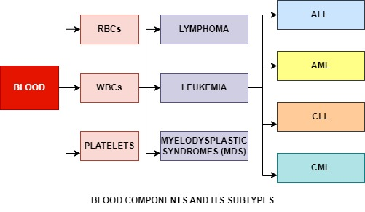Further, Leukemia is categorised into four types. ALL, AML, CLL, CML. ALL (Acute Lymphocytic Leukemia) is seen in children between 2-10 years old. It is

Figure 1. Blood components

most common and has also been observed in some adults. AML (Acute Myeloid Leukemia) are common in children under age one, uncommon between twelve and twenty and observed in the adult age group of 40 years. CLL (Chronic Lymphocytic Leukemia) often happens to older patients, and it is exceptionally unusual in patients below the age group of 40. CML (Chronic Myeloid Leukemia) have the chance to occur in all age groups but is ordinary for adults aged more than 45 years. The American Cancer Society has highlighted a fact that in 2016, it is estimated that about 5.9 Lakh individuals died because of Leukemia in the US (United States) [4]. Out of all types, AML is the most common type. It occurs when the bone marrow starts to make blast cells that have not been completely matured. The main thing that differentiates AML from other forms of Leukemia is that AML has eight different subtypes, which is based on the cell from which Leukemia is developed.

|  |  |
| --- | --- |
| M0 | Myeloblastic on special analysis |
| M1 | Myeloblastic without maturation |
| M2 | Myeloblastic with maturation |
| M3 | Promyelocytic |
| M4 | Myelomonocytic |
| M5 | Monocytic |
| M6 | ErythroLeukemia |
| M7 | Megakaryocytic |

|  |  |  |
| --- | --- | --- |
| **Blood cells** | **Count** | **Purpose** |
| Platelets | 1.5L to 4.5L per microliter | Helps in blood clotting |
| RBCs | 4.5L per microliter | The main function is to supply oxygen from the lungs to the rest of the body. |
| WBCs | 4500 to 11000 per microliter | It plays a defensive role in fighting against infections. |

1. Table 1. Various types of AML

These are the subtypes of the Acute Myeloid Leukemia [5].

Table 2. Normal blood counts and their functions

**LITERATURE REVIEW**

The articles from the publications were examined, and this approach explores a systematic approach to how the field has improved. Each article published was systematically examined to understand the contributions, methods, and findings. This method ensures a thorough analysis of the existing literature. This allows the researchers to identify the seminal works and key advancements in the research progress.

Dharani T et al. [20] presented an image processing for diagnosing Leukemia. They used it for the classification of its subtypes Acute lymphoblastic Leukemia (ALL), Acute myeloid Leukemia (AML), Chronic lymphoblastic Leukemia (CLL), Chronic Myeloid Leukemia (CML). Using a Support vector machine, blood images were analysed for abnormal images. The proposed method includes image pre-processing, segmentation and feature extraction based on the size and shape of the cell. [44] employed for leukocyte identification and classification with gathered microscopic images. The proposed method isolates the full leukocyte before the segmentation. Features such as colour, shape, and texture are extracted for the classification. The mentioned system achieved 93% accuracy with the help of a Support Vector Machine (SVM). [6] Fuzzy-based segmentation is used to detect the white blood cells. Hausdorff was used further, and the contour signature feature was used to classify the leukocyte as normal or leukemic using the support vector machine. The proposed research paper achieved 93% accuracy by providing a low-cost, more efficient solution for medical diagnostics. [10] The image analysis method is used to detect Leukemia subtype ALL (Acute lymphoblastic Leukemia) using blood smear images. The fuzzy method is used to isolate the White blood cells. The support vector machine achieved 95% accuracy by enhancing the automated screening. [18] proposed an automated Leukemia detection system using microscopic blood images. Image pre-processing, segmentation, and feature extraction differentiate between the abnormal White blood cells. Support vector machines and artificial neural networks are used to classify, and the classification is achieved with better accuracy. [22] involves segmentation, feature extraction and classification of WBC from the blood smear images. For classifying the subtypes, SVM (Support vector machine) and DFT (Discrete Fourier transform) are used, and the proposed system achieved more than 90% accuracy. [39] An SVM (Support Vector Machine) is trained with 250 dataset images containing blood smear images that differ from all types of Leukemia (ALL, AML, CLL, CML) with 97.69% accuracy.

Amjad Rehman et al. [30] present a deep Learning-based approach for classifying the Acute lymphoblastic Leukemia (ALL) with all its subtypes. Using Hue, Saturation, and Value (HUE) colour segmentation, bone marrow images are processed, and a Convolutional Neural Network (CNN) is trained for classification. The proposed method achieved 97.78% accuracy. [35] the machine learning method is used for detecting Acute Lymphoblastic Leukemia using image processing techniques. Features are extracted using open-CV, and classification is done using CNN (Convolutional Neural Network), FNN (Feedforward Neural Network), SVM (Support Vector Machine) and KNN (K-Nearest Neighbor). The system achieved 98.33% using the convolutional Neural Network.

Saif S.Al-Jabari et al.[18] proposed an automatic segmentation model for Acute lymphoblastic Leukemia (ALL) using the local pixel method and artificial neural network (ANN). A machine learning-based statistical feature is used to enhance the accuracy of the segmentation. This method outperformed traditional methods and achieved over 97% accuracy under different lighting conditions. [21] Middle filtering and hough transform techniques are applied to analyse blood morphological operations. For improved accuracy, support vector machines and neural networks are used.

N.H.M.Daud et al. [24] explored a segmentation method for detecting the nucleus in chronic blood images. For nucleus segmentation, Lab colour thresholding, Sobel edge detection and watershed transform techniques were used. The mentioned technique isolates the damaged Leukemia cells more efficiently by slightly improving the accuracy. [31] semantic segmentation is used to analyse the blood cells in the peripheral smear images. The proposed method uses the Segnet architecture based on the VGG-16 for WBC and RBC for segmentation. The proposed model achieves 94.93% accuracy for white blood cells and 91.11% for RBC segmentation. [33] A segmentation approach for CLL (Chronic Lymphocytic Leukemia) using a watershed algorithm and optimal thresholding. Over-segmentation errors are minimised by 1% of local minima. Nucleus segmentation accuracy is 99.92%, and cell segmentation achieved 99.85% accuracy. [34] presents a robust image processing technique for detecting ALL (Acute lymphoblastic Leukemia). MATLAB is used for blood cell segmentation, followed by an extraction feature. K-Nearest Neighbors, Support vector Machine and Artificial Neural Network are compared for the minimum classification accuracy. [36] explores the identification of Leukemia based on the blood cells of humans using image processing techniques. RGB-HSV is used for the segmentation of cells' median filtering. Feature extraction method is used to detect the ALL and AML. For AML, the system achieved 100% accuracy, and for ALL, it achieved 80% accuracy. [39] image processing technique based on the WBC nucleus segmentation in malignant and normal cells involves RGB to LAB colour space conversion and watershed transformation algorithm. The proposed method achieved 88.57% accuracy. [8] Zack algorithm was used to remove the background, and watershed segmentation was used to separate the clustered lymphoblasts. The mentioned system achieved about 90% accuracy in counting and detecting the lymphoblasts from blood smear images, enhancing the early diagnosis. [41] Different types of WBC (White Blood Cells) image segmentation in microscopic images, such as edge detection, K-Means Clustering, and based segmentation, are analysed. K-means and Edge detection provide the best WBC (White Blood Cell) segmentation results. [46] explains the segmentation and counting method of the leukocytes by using the HSV (Hue Saturation Value) colour models and blob analysis. The method achieves 98.88% accuracy with an average of 0.07 seconds processing time, enhancing the counting and diagnosis efficiency.

Farah H.A. Jabar et al. [9] explore a K-Means clustering method by combining a mean shift algorithm for segmenting the Acute Leukemia images. The proposed system achieves better segmentation accuracy by reducing the noise in the background. The result shows an enhanced performance, making it suitable for automatic leukemic detection. [12] compares two important techniques: K-means clustering and HSI color-based segmentation. Both models classified blood cells into background regions and damaged cells. Out of the two methods, the K-means clustering method showed a better result by saving the important details and reducing the noise of the blood smear images. [14] this paper explores a MATLAB-based Leukemia detection that can differentiate RBC and Young WBC. The proposed system employs image pre-processing methods like Histogram Equalisation and feature extraction using morphological operations. K-means clustering is used for the segmentation area. [16] K-means clustering and watershed transform are applied for the segmentation, and feature extraction is handled using histogram equalisation and morphological operations. The mentioned method classifies the acute or chronic based on the un-grown WBC count, achieving 97.8% accuracy. [19] explored the detection using image processing with the K-means clustering method. Using MATLAB software, this method segments white blood cells and extracts the statistical and geometrical features. The proposed method achieved 90% accuracy, reducing manual errors while increasing accuracy. [25] presents an automated ALL detection using the digital image processing technique, and K-means, feature extraction and Hausdorff dimension are used for segmentation and extraction. For classification, a BPNN (Back propagation neural network) is used with achieving 99.74% accuracy. [29] A computer-aided approach for detecting Acute Lymphoblastic Leukemia (ALL), which uses the blood smear images and for the noise removal image pre-processing methods such as HIS conversion and Gaussian bilateral is used. It is followed by shape-based feature extraction. [43] Colour conversion, histogram equalisation, and median filtering for pre-processing methods are involved. The K-means clustering method and Support Vector Machine are used to identify and classify White Blood Cells into normal and abnormal categories.

Pradeep Kumar Das et al. [42] present an automated system for detecting and classifying acute lymphoblastic Leukemia (ALL). K-Means clustering is used to segment Leukemia using GLCM and GLRLM feature extraction. The mentioned method achieved 96% accuracy. [13] employs the K-Means method for segmenting the blood images, and it uses feature extraction methods like GLCM (Gray-level Co-Occurrence) and GLDM (Gray-level Difference Method). An SVM is used as a classifier to determine whether the cell is cancerous and to identify the Leukemia type. The proposed paper enhances early detection with better accuracy by reducing manual errors. [26] presented an automated system for detecting cancers in the white blood cells, which includes AML, ALL and myeloma, using image processing. The proposed method uses a Gaussian distribution, Otsu’s method, and K-means clustering for segmentation with the help of feature extraction using GLCM. The CNN (Convolutional Neural Network) achieved 97.3% accuracy

Ashikur Rahman et al. [32] propose an automatic system for detecting Leukemia, classifying ALL (Acute Lymphoblastic Leukemia) from blood smear images. Morphological, texture, colour feature extraction and image processing techniques are applied. An ensemble classifier (EOC) is used in malignancy classification, achieving 93.6% accuracy.

Adnan Khashman et al. [7] proposed an automated segmentation method to detect the Leukemia using the morphological analysis. This method enhances the image, enabling a feature extraction to classify the Leukemia, achieving 98.33% accuracy. This method reduces the cost of the diagnosis with reduced time.

Minali D.Joshni et al. [11] Otsu’s method and K-Nearest Neighbors techniques were used to segment the blood smear images and differentiate the damaged cells from the healthy normal cells. The proposed system achieved about 93% accuracy, and this method was tested on 108 images from a public dataset.

Shubhangi Khobragade et al. [15] this paper explores image processing for detecting Leukemia using Microscopic White blood cell images. The LabVIEW and MATLAB software apply image enhancement, segmentation and feature extraction. Mean and SD (Standard Deviation) distinguish between the leukemic and normal cells. This method achieved over 91% accuracy. Vasundhara Acharya et al. [17] this paper explores a computer-aided system for detecting the ALL (Acute lymphoblastic Leukemia) category using the data mining algorithm and image segmentation algorithm. The WBCs are segmented into the nucleus and cytoplasm using a Novel algorithm. By comparing the Random forest and K-nearest neighbour algorithm, the method achieved 98.6%.

Umamaheswari D et al. [23] proposed an image processing combined with a machine learning approach for acute lymphoblastic Leukemia (ALL) detection. Otsu’s method and morphological operators are used for segmentation, and GLCM (Gray-level co-occurrence matrix) is used to extract text features. The KNN used in the proposed method achieved 95.96% accuracy in classifying normal and damaged cells. [28] Otsu’s global thresholding is used for segmentation, and minimum filtering highlights the nucleus. The feature extraction method uses geometric parameters such as area, perimeter, eccentricity and circularity.

Mohammed AL-Momin et al. [27] presented a MATLAB-based approach for diagnosing blood abnormalities, including Leukemia and cell disorders. Image processing techniques such as grayscale conversion, binary transformation, and circular hough transform are used to classify and segment cells.

Laura Boldu et al. [40] present machine learning for diagnosing acute Leukemia using blood smear images. Mathematic morphology and feature extraction techniques classify different cell types of colour clustering. Using linear

discriminant analysis, the system achieved 85.8% accuracy, and cell classification achieved 94% accuracy for smear blood images.

Subrajeet Mohapatra et al. [45] present a neural network-based segmentation approach for acute Leukemia detection. Functional Link Artificial Neural Network (FLANN) is used for pixel classification to segment lymphocytes into the nucleus, cytoplasm and background. Compared with the existing methods, the proposed method shows better and improved segment accuracy.

Zhencun Jiang et al. [47] present a method for diagnosing ALL using a hybrid model which integrates the CNN with a vision Transformer (ViT). The proposed CNN-ViT algorithm attains an Accuracy of 98.5%, which surpasses traditional CNN and diverse deep-learning models

3

|  |  |
| --- | --- |
| Analysation of various methods based on the review paper | Average Accuracy |
| K-Means Clustering | ~95.20% |
| SVM | ~95.60% |
| CNN | ~98.70% |
| Watershed transform | ~97.30% |
| Ensemble Learning | ~96.80% |
| Fuzzy segmentation | ~94% |
| Artificial Neural Network | ~97% |

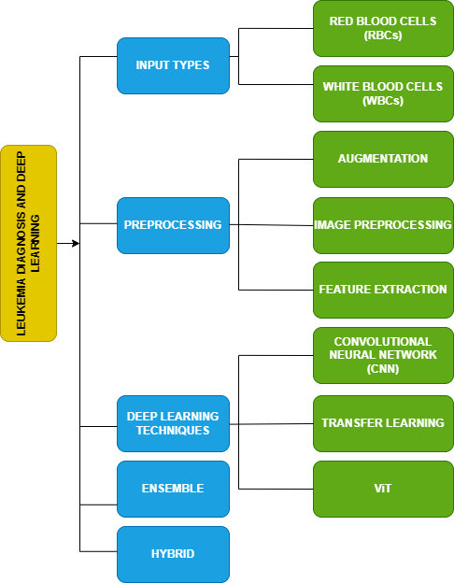Table 3. Average accuracy of various methods

Figure 2. Hierarchy structure for the diagnosis of Leukemia based on the review paper

**DEEP LEARNING ARCHITECTURE**

Deep Learning structure contains multiple layers of artificial neurons that identify a data's intricate patterns.

Popular types of Deep Leukemia

* Convolutional Neural Network (CNN) – used for images
* Recurrent Neural Networks (RNN) – used for handling sequential data

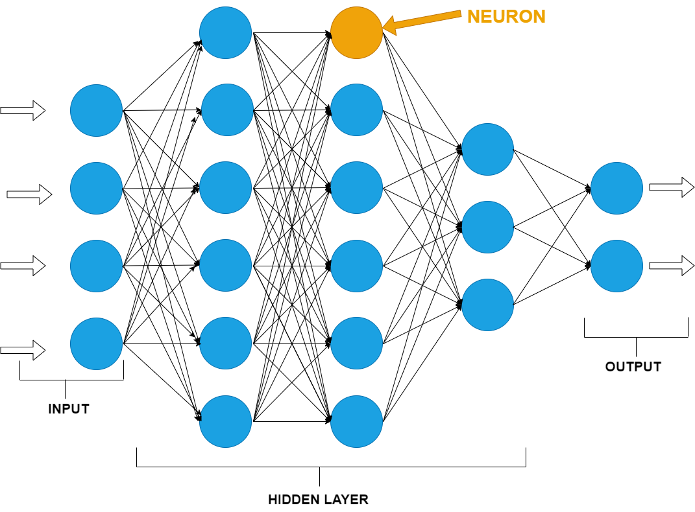

Figure 3. Architecture of Deep learning

**Inclusion and Exclusion criteria**

|  |  |
| --- | --- |
| INCLUSION CRITERIA | EXCLUSION CRITERIA |
| Studies on different methods for detecting Leukemia using classification and segmentation with the help of Deep learning | Studies that are not related to the research key terms. |
| Comprehensive articles which have clear evidence | Incomplete or Insufficient detailed articles |
| Articles that are published only in the English language | Articles that are being published other than in English |
| Articles that include keywords “Deep learning”, “Transfer learning”, “CNN”, “Neural Networks”, “Segmentation”, “Blood smear”, “Leukemia ” “Acute lymphoblastic Leukemia ” are included. | Articles that include keywords such as “DNA” And “RNA” are excluded. |

Table 4. Inclusion and exclusion criteria

**CHALLENGES IN THE LEUKEMIA DETECTION USING DEEP LEARNING**

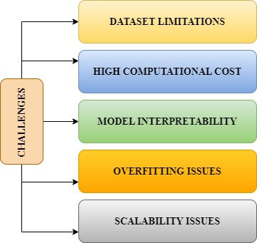Deep Learning for analysing related images faces challenges such as dataset limitations, high computational cost compared to other methods, lack of clarity, scalability and overfitting issues. To overcome these issues, solutions include augmenting the data, using GANs and compression of the model, more clear artificial intelligence and federated learning methods. Enhancement of the architectures and increasing the dataset's quality could enhance the model's accuracy with ease of access and deployment in real-world medical diagnosis.

Figure 4. Challenges in leukemia detection

**FUTURE DIRECTIONS**

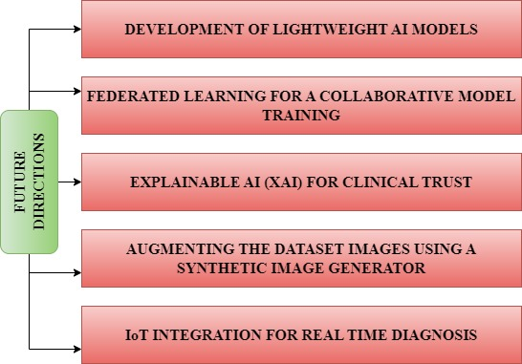Lightweight Artificial intelligence models such as Mobile-Net and Pruned Convolutional Neural Networks (CNN) enable Leukemia detection using low-resource devices. Federating learning allows to secure the model training by isolating the patient’s data. XAI techniques such as Grad-CAM and SHAP are used to improve clinical trust. Synthetic image generators bypass data scarcity, especially in AI-based Leukemia detection. IoT integration facilitates real-time diagnosis, which enables faster diagnosis, particularly in remote areas.

Figure 5. Future directions

.

**CONCLUSION**

Over the years, the deep learning-based detection method has significantly enhanced from Traditional CNN model architecture to an advanced Hybrid model with explained artificial intelligence techniques. The enhancements improved automated Leukemia diagnoses' accuracy, efficiency, and reliability. However, several challenges remain in terms of the quality of the datasets, lack of clarity, and high computational cost. The dependency on large labelled datasets continues to be a barrier while collecting the data, and annotating requires extensive manual effort and expert validation. The deep learning method uses black boxes to reduce the problems, especially in untraceable conditions. Federated learning and attention mechanisms are used to overcome those limitations. The attention mechanism helps focus on the critical features in blood smear images. The federated learning method enables collaboration model training across hospitals and medical research institutions to maintain patient data privately. Another key area for future research is augmenting synthetic data, which involves GANs (Generative Adversarial Networks) to create an artificial image similar to the original datasets. This method helps address data scarcity issues and enhances the robustness of artificial intelligence models. Future researchers should focus on making deep learning models scalable and interpretable with more accuracy when deploying in real-world applications.

**REFERENCES**

1. P, H., Modi, H., Pandya, M., & Potdar, M. (2015). Leukemia Detection using Digital Image Processing Techniques. International Journal of Applied Information Systems, 10(1), 43–51. https://doi.org/10.5120/ijais2015451461
2. Raje, C., & Rangole, J. (2014). Detection of Leukemia in microscopic images using image processing. International Conference on Communication and Signal Processing, 255–259. https://doi.org/10.1109/iccsp.2014.6949840
3. Tathagata Hazra, Mrinal Kumar, Dr. Sanjaya Shankar Tripathy, Automatic Leukemia Detection Using Image Processing Technique - International Journal of Latest Technology in Engineering, Management & Applied Science (IJLTEMAS) Volume VI, Issue IV, April 2017 | ISSN 2278-2540 www.ijltemas.in Page 42
4. Raphael, R. T., & Joy, K. R. (2019). Segmentation and Classification Techniques of Leukemia Using Image Processing: an Overview. International Conference on Intelligent Sustainable Systems (ICISS 2019) IEEE Xplore Part Number: CFP19M19-ART; ISBN: 978-1-5386-7799-5, 378–384. <https://doi.org/10.1109/iss1.2019.8907988>
5. Bagasjvara, R., Candradewi, I., Hartati, S., & Harjoko, A. (2016). Automated detection and classification techniques of Acute Leukemia using image processing: A review. 2016 2nd International Conference on Science and Technology-Computer (ICST), Yogyakarta, Indonesia, 35–43. https://doi.org/10.1109/icstc.2016.7877344
6. Mohapatra, S., Samanta, S. S., Patra, D., & Satpathi, S. (2011). Fuzzy Based Blood Image Segmentation for Automated Leukemia Detection. 2011 IEEE, 1–5. <https://doi.org/10.1109/icdecom.2011.5738491>
7. KHASHMAN, A., AL-ZGOUL, E., Intelligent Systems Research Group (ISRG), & Department of Electrical & Electronic Engineering, Near East University. (1790). Image segmentation of blood cells in leukemia patients. In RECENT ADVANCES in COMPUTER ENGINEERING and APPLICATIONS (p. 104) [Journal-article]. http://isrg.neu.edu.tr
8. Shankar, V., Deshpande, M. M., Chaitra, N., & Aditi, S. (2016). Automatic detection of acute lymphoblasitc leukemia using image processing. 2016 IEEE International Conference on Advances in Computer Applications (ICACA), Coimbatore, 186–189. https://doi.org/10.1109/icaca.2016.7887948
9. Jabar, F. H., Ismail, W., Salam, R. A., & Hassan, R. (2013b). Image segmentation using an adaptive clustering technique for the detection of acute leukemia blood cells images. International Conference on Advanced Computer Science Applications and Technologies, 373–378. <https://doi.org/10.1109/acsat.2013.80>
10. Mohapatra, S., Patra, D., & Satpathi, S. (2010). Image analysis of blood microscopic images for acute leukemia detection. 2010 International Conference on Industrial Electronics, Control and Robotics, 215–219. <https://doi.org/10.1109/iecr.2010.5720171>
11. M. D. Joshi, A. H. Karode, and S. R. Suralkar, "White Blood Cells Segmentation and Classification to Detect Acute Leukemia," International Journal of Emerging Trends & Technology in Computer Science (IJETTCS), vol. 2, no. 3, pp. 147–151, May–June 2013.
12. Fatma, M., & Sharma, J. (2014). Leukemia Image Segmentation using K-Means Clustering and HSI Color Image Segmentation. In Amity University, International Journal of Computer Applications (pp. 6–7) [Journal-article].
13. Rejintal, A., & N, A. (2016). Image processing based leukemia cancer cell detection. In IEEE, IEEE International Conference on Recent Trends in Electronics Information Communication Technology (pp. 471–472) [Conference-proceeding].
14. Christo Ananth, P. Thenmozhi, Stalin Jacob, Dr. A. Anitha. Leukemia Blood Cancer Detection Using MATLAB. (n.d.). In Turkish Journal of Physiotherapy and Rehabilitation (Vol. 32, Issue 3, pp. 10257–10258) [Journal-article].
15. Khobragade, S., Mor, D. D., & Dr. C.Y.Patil. (2015). Detection of leukemia in microscopic white blood cell images. In 2015 International Conference on Information Processing (ICIP) (p. 435). IEEE. https://ieeexplore.ieee.org/document/7397395
16. Kazi, M., 25, Maurya, V., 39, Shaikh, F., 55, & Upadhyay, D., 66. (2018). Synopsis Report on Leukemia Detection using Image Processing (By Prof. Junaid Mandviwala, Department of Electronics and Telecommunication Engineering, Rizvi College of Engineering, & University of Mumbai).
17. Vasundhara Acharya, Preetham Kumar. Detection of Acute Lymphoblastic Leukemia Using Image Segmentation and Data Mining Algorithms. (2019). In Medical & Biological Engineering & Computing [Journal-article]. <https://doi.org/10.1007/s11517-019-01984-1>
18. Al-Jaboriy, S. S., Sjarif, N. N. A., Chuprat, S., & Abduallah, W. M. (2019). Acute lymphoblastic leukemia segmentation using local pixel information. Pattern Recognition Letters, 125, 85–90. https://doi.org/10.1016/j.patrec.2019.03.024
19. P, R., & P, S. D. (2021). Detection of Blood Cancer-Leukemia using K-means Algorithm. 2022 6th International Conference on Intelligent Computing and Control Systems (ICICCS), 838–842. <https://doi.org/10.1109/iciccs51141.2021.9432244>
20. Dharani, T., & Hariprasath, S. (2018). Diagnosis of leukemia and its types using digital image processing techniques. In 2018 3rd International Conference on Communication and Electronics Systems (ICCES) (pp. 275–279). IEEE. <https://doi.org/10.1109/CESYS.2018.8723906>
21. Sharma, Naveen & Gosh, Divia & Saini, Arun. (2024). Leukemia Detection and Staging Using Image Processing and Artificial Intelligence: A MATLAB-Based Simulation Approach.
22. Shaikh, M. B. N., & Deshpande, S. (2017). Computer aided leukemia detection using digital image processing techniques. 2017 2nd IEEE International Conference on Recent Trends in Electronics, Information & Communication Technology (RTEICT), 344–348. https://doi.org/10.1109/rteict.2017.8256613
23. Umamaheswari, D., & Geetha, S. (2018). Segmentation and Classification of Acute Lymphoblastic Leukemia Cells Tooled with Digital Image Processing and ML Techniques. 2017 2nd IEEE International Conference on Recent Trends in Electronics Information & Communication Technology (RTEICT), May 19-20, 2017, India, 1336–1341. https://doi.org/10.1109/iccons.2018.8662950
24. Daud, N. H. M., Raof, R. a. A., Osman, M. K., & Harun, N. H. (2021). Segmentation technique for nucleus detection in blood images for chronic Leukemia. Journal of Physics Conference Series, 1755(1), 012053. https://doi.org/10.1088/1742-6596/1755/1/012053
25. Ahmed, A. S., Morsy, M., & Abo-Elsoud, M. E. A. (2016). Microscopic Digital Image Segmentation And feature Extraction of Acute Leukemia. International Journal of Science and Engineering Applications, 5(5), 228–233. https://doi.org/10.7753/ijsea0505.1001
26. Agrawal, R., Satapathy, S., Bagla, G., & Rajakumar, K. (2019). Detection of White Blood Cell Cancer using Image Processing. 2019 International Conference on Vision Towards Emerging Trends in Communication and Networking (ViTECoN), 1–6. https://doi.org/10.1109/vitecon.2019.8899602
27. Al-Momin, M., & Almomin, A. (2021). A MATLAB model for diagnosing sickle cells and other blood abnormalities using image processing. International Journal of Power Electronics and Drive Systems/International Journal of Electrical and Computer Engineering, 11(6), 5060. https://doi.org/10.11591/ijece.v11i6.pp5060-5065
28. Begum, A. J., & Razak, T. A. (2017). Diagnosing Leukemia from Microscopic Images Using Image Analysis and Processing Techniques. 2017 World Congress on Computing and Communication Technologies (WCCCT), 227–230. https://doi.org/10.1109/wccct.2016.63
29. Kandhari, R., Bhan, A., Bhatnagar, P., & Goyal, A. (2021). Computer based diagnosis of Leukemia in blood smear images. 2021 Third International Conference on Intelligent Communication Technologies and Virtual Mobile Networks (ICICV). https://doi.org/10.1109/icicv50876.2021.9388546
30. Rehman, A., Abbas, N., Saba, T., Rahman, S. I. U., Mehmood, Z., & Kolivand, H. (2018). Classification of acute lymphoblastic leukemia using deep learning. Microscopy Research and Technique, 81(11), 1310–1317. https://doi.org/10.1002/jemt.23139
31. Tran, T., Kwon, O., Kwon, K., Lee, S., & Kang, K. (2018). Blood Cell Images Segmentation using Deep Learning Semantic Segmentation. 2018 IEEE International Conference on Electronics and Communication Engineering (ICECE), 13–16. https://doi.org/10.1109/icecome.2018.8644754
32. Rahman, A., & Hasan, M. M. (2018). Automatic Detection of White Blood Cells from Microscopic Images for Malignancy Classification of Acute Lymphoblastic Leukemia. International Conference on Innovation in Engineering and Technology (ICIET) 27-29  December, 2018, 1–6. https://doi.org/10.1109/ciet.2018.8660914
33. Mohammed, E. A., Mohamed, M. M. A., Naugler, C., & Far, B. H. (2013). Chronic lymphocytic leukemia cell segmentation from microscopic blood images using watershed algorithm and optimal thresholding. May 2013  Canadian Conference on Electrical and Computer Engineering. https://doi.org/10.1109/ccece.2013.6567770
34. Bhattacharjee, R., & Saini, L. M. (2015). Robust technique for the detection of Acute Lymphoblastic Leukemia. 2015 IEEE Power, Communication and Information Technology Conference (PCITC). https://doi.org/10.1109/pcitc.2015.7438079
35. Rajpurohit, S., Patil, S., Choudhary, N., Gavasane, S., & Kosamkar, P. (2018). Identification of Acute Lymphoblastic Leukemia in Microscopic Blood Image Using Image Processing and Machine Learning Algorithms. 2018 International Conference on Advances in Computing, Communications and Informatics (ICACCI), 2359–2363. https://doi.org/10.1109/icacci.2018.8554576
36. Sigit, R., Bachtiar, M. M., & Fikri, M. I. (2018). Identification Of Leukemia Diseases Based On Microscopic Human Blood Cells Using Image Processing. 2018 International Conference on Applied Engineering (ICAE), 1–5. https://doi.org/10.1109/incae.2018.8579387
37. Khomairoh, N., Sigit, R., Harsono, T., Hernaningsih, Y., & Anwar, A. (2020). Segmentation system of Acute myeloid leukemia (AML) subtypes on microscopic blood smear image. 2022 International Electronics Symposium (IES), 565–570. https://doi.org/10.1109/ies50839.2020.9231651
38. Ahasan, R., Ratul, A. U., & Bakibillah, A. S. M. (2016). White blood cells nucleus segmentation from microscopic images of strained peripheral blood film during leukemia and normal condition. 2016 5th International Conference on Informatics, Electronics and Vision (ICIEV), 361–366. <https://doi.org/10.1109/iciev.2016.7760026>
39. Dese, K., Raj, H., Ayana, G., Yemane, T., Adissu, W., Krishnamoorthy, J., & Kwa, T. (2021). Accurate Machine-Learning-Based classification of Leukemia from Blood Smear Images. Clinical Lymphoma Myeloma & Leukemia, 21(11), e903–e914. https://doi.org/10.1016/j.clml.2021.06.025
40. Boldú, L., Merino, A., Alférez, S., Molina, A., Acevedo, A., & Rodellar, J. (2019). Automatic recognition of different types of acute Leukemia in peripheral blood by image analysis. Journal of Clinical Pathology, 72(11), 755–761. https://doi.org/10.1136/jclinpath-2019-205949
41. Kumar, P. R., Sarkar, A., Mohanty, S. N., & Kumar, P. P. (2020). Segmentation of White Blood Cells using Image Segmentation Algorithms. 2020 5th International Conference on Computing, Communication and Security (ICCCS), 1–4. https://doi.org/10.1109/icccs49678.2020.9277312
42. Das, P. K., Jadoun, P., & Meher, S. (2020). Detection and Classification of Acute Lymphocytic Leukemia. 2020 IEEE-HYDCON, 1–5. https://doi.org/10.1109/hydcon48903.2020.9242745
43. Deshmukh, P., Jadhav, C. R., & Rani, N. U. (2017). Automatic white blood cell segmentation for detecting leukemia. In Lecture notes in networks and systems (pp. 385–392). https://doi.org/10.1007/978-981-10-3932-4_40
44. Putzu, L., Caocci, G., & Di Ruberto, C. (2014). Leucocyte classification for Leukemia detection using image processing techniques. Artificial Intelligence in Medicine, 62(3), 179–191. https://doi.org/10.1016/j.artmed.2014.09.002
45. Mohapatra, S., Patra, D., Kumar, S., & Satpathy, S. (2012). Lymphocyte image segmentation using functional link neural architecture for acute leukemia detection. Biomedical Engineering Letters, 2(2), 100–110. https://doi.org/10.1007/s13534-012-0056-9
46. Quinones, V. V., Macawile, M. J., Ballado, A., Cruz, J. D., & Caya, M. V. (2018). Leukocyte segmentation and counting based on microscopic blood images using HSV saturation component with blob analysis. 2018 3rd International Conference on Control and Robotics Engineering (ICCRE), 254–258. https://doi.org/10.1109/iccre.2018.8376475
47. Haruna, Y., Qin, S., Chukkol, A. H. A., Yusuf, A. A., Bello, I., & Lawan, A. (2025). Exploring the synergies of hybrid convolutional neural network and Vision Transformer architectures for computer vision: A survey. Engineering Applications of Artificial Intelligence, 144, 110057. https://doi.org/10.1016/j.engappai.2025.110057