**DEEP LEARNING FOR VIRAL SKIN DISEASE DETECTION: A SYSTEMATIC REVIEW OF AUTOMATED STRATEGIES IN ARTIFICAL INTELLIGENCE**

**Archana j1, VijayaKumar J2,Mervin paulraj3,Hemalatha4**

1 Student, Department of Electronics and Instrumentation, Bharathiar University, Coimbatore-641046,

Tamil Nadu, India

2 Head of the Department, Associate Professor, Department of Electronics and Instrumentation, Bharathiar University, Coimbatore-641046,

Tamil Nadu, India

**ABSTRACT**

As the largest organ in the human body, the skin is a protective barrier against all external threats in humans as well as in animals. Pox diseases are a type of viral infection that spreads throughout the body. Skin infections that come under the pox category remain a global health concern. The major pox diseases are monkeypox, chickenpox, cowpox, and smallpox. The most dangerous among them is smallpox, which is the deadliest in history. To cure these infections, traditional methods are used by evaluating through visualization; this leads to inaccurate results and creates confusion between poxes. Although the polymerase chain method is a laboratory test for the identification of pox diseases, it has better predictions and high accuracy. After COVID-19, artificial intelligence grew. Here, the machine learning techniques recognized and identified diseases accurately without any medical support. By the way, machine learning in artificial intelligence has a variety of methods to identify pox diseases, and these methods are reviewed. This review paper concentrates on the machine learning methods that can be used for the identification and classification of pox diseases.

**Keywords:** Pox diseases, Artificial Intelligence, Machine Learning, Deep Learning, CNN

1. **INTRODUCTION**

The largest organ in the body, the skin serves as a barrier to keep the body in balance, protect against infections, and prevent injuries [1]. The skin is susceptible to a range of conditions including infections, allergies and inflammatory disorders which can interfere with its normal function and result in symptoms like rashes, lesions, and scarring [2]. Skin diseases such as pox diseases are linked because both involve viral infections that cause skin rashes and lesions needing specific treatment and diagnosis. Both humans and animals can contract pox diseases [3] which are a class of viral infections caused by different kinds of poxviruses and under the Orthopox virus family [4]. In humans well known pox diseases include smallpox, chickenpox, monkeypox, Cowpox and molluscum contagiosum [5].

**1.1 POX DISEASES AND ARTIFICAL INTELLIGENCE**

Pox diseases are infections caused by the virus called Poxviridae, which affects humans and animals. The major classes of poxes are smallpox, cowpox, monkeypox, and chickenpox [3]. Identification of these viral diseases is a long procedure. Recently, artificial intelligence has played a serious role in the biomedical field, which leads to the easy identification of pox diseases. Through different machine learning techniques, pox diseases can be detected, classified, and monitored through the dataset containing medical information. There are many techniques in machine learning.

**1.2 SMALLPOX**

The Orthopoxvirus family member is the variola virus which cause smallpox. Its most serious and high feared infection which having high death rates and serious health issues [6][7].

The smallpox major symptoms are high fever, weakness, and a type of unique rash that develops in different stages as normal flat spots as macules, then as raised bumps as papules, fluid-filled blisters as vesicles, pus-filled lesions as pustules, and finally scabs. Smallpox spreads through the air when the infected patient coughs or sneezes and can spread through close contact with the infected patient. The virus only spreads when the area is contaminated, potentially infecting others who keep in close contact with the patient [8].

In history, the origin of smallpox was found in Egypt and in Indian texts suggesting its presence in early 1500 BCE [9]. In Europe, 400,000 people were killed yearly in the 18th century, affecting many regions [10]. In 1796, Edward Jenner developed the vaccine for smallpox, which was a breakthrough in its prevention [10][11]. In 1967 the World Health Organization (WHO) conducted an eradication program [8]. In the 1980s in all parts of the world smallpox is eradicated [12]. The success of the vaccine has also raised a concern about the possibility of using the virus as a bioweapon [13]. In 1796 Edward Jenner discovered the cowpox vaccine, which changed how smallpox was eradicated. This led to the global vaccination efforts and the elimination of smallpox in 1980 [14].

|  |  |  |  |  |
| --- | --- | --- | --- | --- |
|  |  |  |  |  |

*figure 1: smallpox*

**1.1.2 COWPOX**

Cowpox is a member of the Orthopoxvirus family; it is more closely similar to other viruses in the variola virus. The vaccinia virus is used in the smallpox vaccine [6]. Cowpox infection can be spread from animals to humans The major cause of cowpox is cowpox virus (CPXV). It majorly affects the rodents, which are natural reservoirs. It can also affect domestic animals like cats, cattle, and sometimes humans [15]. In humans, cowpox appears visually as pustular lesions mainly on the hands and face. The major symptoms are fever and swollen lymph nodes [13]. Cowpox infections are mild; then the boy doesn't compare to smallpox, and it will go its own way. The cowpox plays a main role in the development of smallpox vaccines. Cowpox was a major thing in Jenner's discovery of vaccination. Edward found that those who had cowpox were immune to smallpox. He tested and discovered the vaccine by testing on a boy by spreading cowpox, and he didn't get the smallpox [14]. The PCR is the diagnostic tool that is used to identify the poxes. The methods to identify poxes using CRISPR-based diagnostics, next-generation sequencing (NGS), and antigen tests are becoming increasingly important in virology due to their speed, accuracy, and ability to detect various pathogens. PCR is still one of the most commonly used methods for detecting viral infections due to its reliability [16].

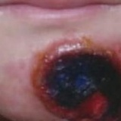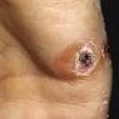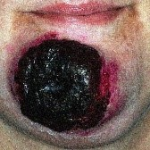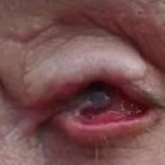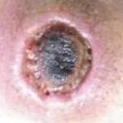 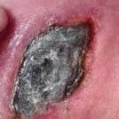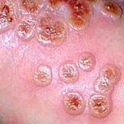

*figure 2: cowpox*

**1.1.3 MONKEYPOX**

Monkeypox, caused by the monkeypox virus (MPXV), belongs to the poxviridae family [17]. Monkeypox was first identified in laboratory monkeys in 1958, and in 1970 it was confirmed in humans in the Democratic Republic of Congo [18]. The major symptoms of monkeypox are fever, headache, swollen lymph nodes, and rashes. The pox has different stages, starting as flat spots and raised bumps, then blisters and pus-filled lesions, before forming scabs and healing [19]. Monkeypox human infections usually occur through direct contact with infected animals. Human-to-human transmission can spread through respiratory droplets, skin lesions, or any contaminated objects, but it is less efficient than smallpox [20]. In 2003, an outbreak occurred in the US linked to imported animals. Human-to-human transmission was observed but remained less efficient than smallpox [21].

In 2017, a large outbreak occurred in Nigeria and cases spread to neighbouring countries like the US with a minimum of 200 cases [21]. By mid-2002 over 79,655 cases were reported with a minimum number of deaths [22]. In 2023 and into 2024 ongoing outbreaks have continued to cause concern with efforts focused on reducing transmission. As of 2024, the global situation of monkeypox (Mpox) remains concerning [23]. By 18 August 2024, twelve countries reported 3,562 confirmed pox cases, including 26 deaths. Most cases were in the Democratic Republic of the Congo (3,235), Burundi (153), and the Central African Republic (45). In the first seven months of 2024, there were over 14,000 cases and 511 deaths far exceeding the total cases in 2023. This sharp increase shows the need for better detection tools [25].

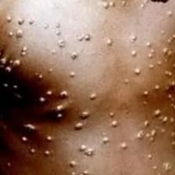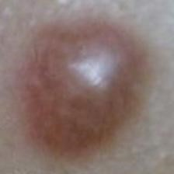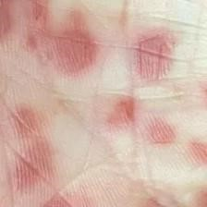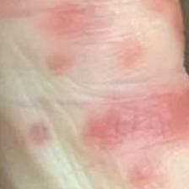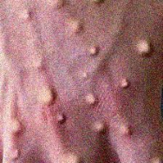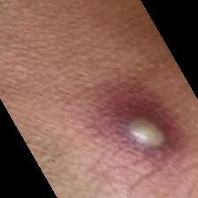

*figure 3: monkeypox*

**1.1.4 CHICKENPOX**

Chickenpox also known as varicella is a highly contagious viral infection caused by the varicella-zoster virus (VZV) a member of the herpesvirus family [26]. The disease is characterized by an itchy red rash that starts as small bumps then progresses to fluid-filled blisters which eventually scab over [27]. Chickenpox is most common in children but can also affect adults who have not previously been infected or vaccinated [28]. The virus spreads easily through respiratory droplets or direct contact with the fluid from the blisters. Symptoms can include fever fatigue and a general feeling of being unwell [29]. Chickenpox is usually mild it can cause complications especially in adults’ pregnant women and those with weakened immune systems [30]. Vaccination is the most effective way to prevent chickenpox. Chickenpox has been around for centuries and was common especially in children before a vaccine was created [31]. The virus that causes chickenpox was discovered in the late 1800s. In 1995 a vaccine for chickenpox was introduced which helped reduce the number of cases and deaths. Before the vaccine about 100 to 150 people died each year in the U.S. from chickenpox. Today with the vaccine chickenpox is much less common and not as deadly.

|  |  |  |  |  |  |  |
| --- | --- | --- | --- | --- | --- | --- |
|  |  |  |  |  |  |  |

*figure 4: chickenpox*

**1.2 ARTIFICIAL INTELLIGENCE**

Artificial intelligence is developing machines through the algorithms that are capable of doing work like humans do. The primary tasks will involve solving complex problems, interacting with various languages, and comprehending pixel patterns. The major goal is to develop a machine that automatically thinks, learns, and rectifies errors according to the new situations. The AI is used to decrease the human power by applying automation in machinery in all fields [32]. In pox disease detection, AI plays a huge role. By using the advanced algorithms and machine learning techniques, AI can handle a large amount of data accurately and identify the patterns that may be hard for humans to recognize. By the way, this improves the accuracy and efficiency of pox detection, resulting in majorly better results in healthcare settings [33]. The methods used in machine learning are continuously evolving, allowing for more sophisticated analyses and predictions. Techniques such as deep learning and neural networks are increasingly being integrated into pox detection systems, enabling them to adapt and learn from new data, thus further enhancing their performance over time [34]. As a result, healthcare professionals can focus on more critical aspects of patient care, employing their expertise where it is most needed. Furthermore, the integration of AI in pox detection can facilitate faster responses to outbreaks, enabling swift public health interventions to prevent further spread [35].

1. **MACHINE LEARNING TECHNIQUES IN POX DETECTION**

Machine Learning is a subset of AI that is concentrated on to develop the ability of machine to learn from the given data [32]. The past ai tools where partially operated manually by adding the rules and logics programmed ml algorithms which allows the machine to automatically learn from the data and improve gradually without any repetitive actions for each task. Machine Learning is designed to recognises the patterns, predictions and making decisions on processing data. Machine Learning is converting industries by making data driven decisions fast and accurate [36]. Machine Learning is majorly used in many fields such medical field for diagnosis of diseases, fraud detection and personalized recommendations. Deep learning is subset of AI, based on artificial neural networks developed for too fast processing as human brain. Deep Learning is capable of learning from unstructured data like audio, video, image and text and automatically extracting complex features from they data [37].

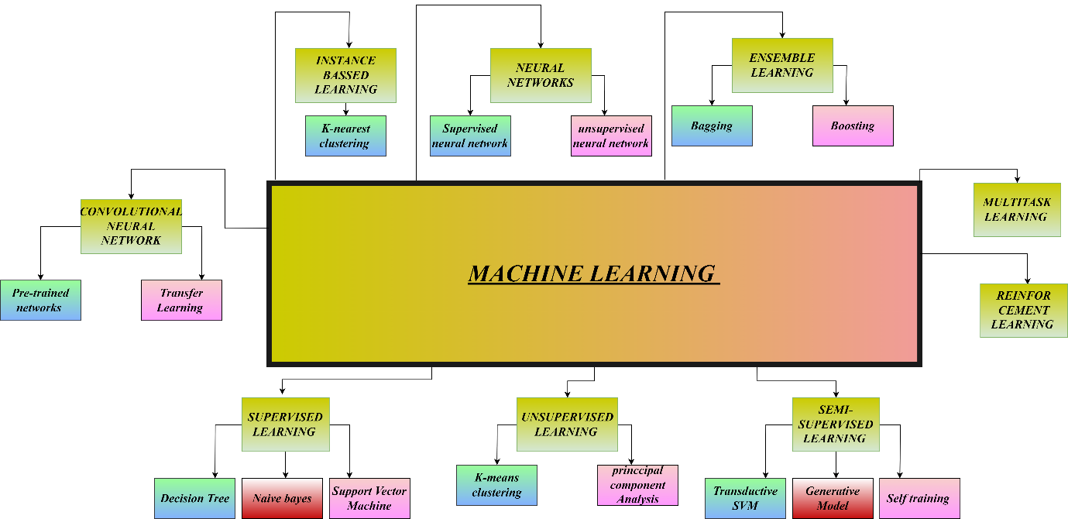  
f*igure 5: Types of machine learning*

**2.1 SUPERVISED LEARNING**

Supervised learning is a machine learning type that majorly involves tasks that will produce functions that address the inputs to the correct outputs, focusing on classification tasks where the learner approximates a function to map vectors into already defined classes on input-output examples [38]. The process of learning has two parts, which are named "train and test." The training does the process of training the model, which learns the features from the data provided for training by using the algorithm to build a model. The process of testing the model executes predicted outcomes, which are for the production of data. The final result is the classification of the data, denoting the model’s prediction [39]. There are three major techniques used in supervised learning: a decision tree, naïve Bayes, and a support vector machine.

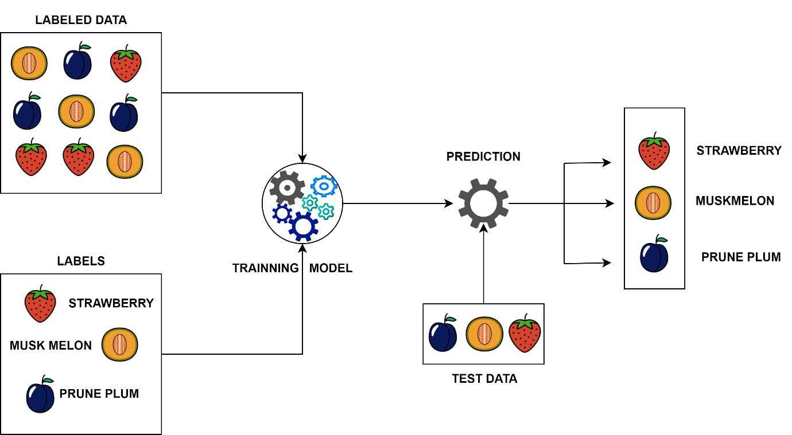

*Figure 6: supervised learning*

**2.1.1 DECISION TREE**

A decision tree is a supervised learning technique used for classification and regression problems; it is the easiest and most visual model that solves issues. The flowchart of the decision tree is with nodes and branches where connected; the nodes represent the questions, and the branches represent the most possible answers. The flow of the algorithm of the decision tree will end in the last node, where it provides the final solution/decision of the classification or regression. This method is popular because it is understandable by visualizing, handles noisy, unnecessary data well, and performs competitively in many situations. This makes them useful in fields like data analysis, machine learning, and big data [40].

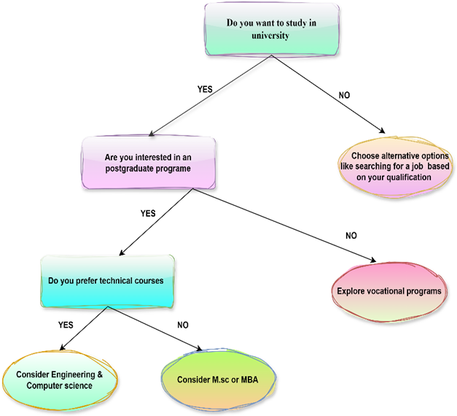  
*figure 7: decision tree*

**2.1.2 NAIVE BAYES**

Naive Bayes is a type of supervised machine learning algorithm, focuses on the classification of data it is all based on the baya’s theorem. It derives that features of independent, this can simplify calculations and that can make the method efficient. the naive bayes algorithm is trained with the labelled data, this can evaluate the probabilities of the various classes, enabling that to predict the class of the new inputs. simple by nature, used well in machine learning applications, its majorly in the high dimension data, making it a reliable choice for a variety of problems [41].

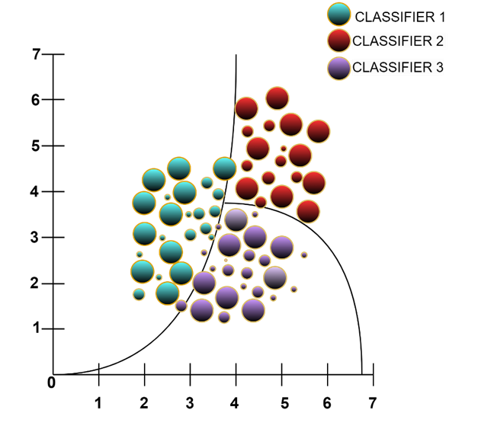

*figure 8: naive bayes*

**2.1.3 SUPPORT VECTOR MACHINE**

Support Vector Machine is a supervised machine learning technique majorly employed for the classification and regression tasks. It aims to define an optimal plane those can be the best which separates data points into different classes. SVM is popular because of its effectiveness and high dimensional spaces and has proven highly successful in different prediction tasks [42].

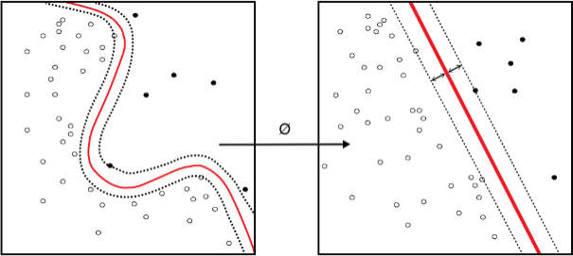

*figure 9: support vector machine*

**2.2 UNSUPERVISED LEARNING**

Unsupervised learning is a type of machine learning that analyzes and organizes unlabeled data without any human power. The objective is to recognize hidden patterns or natural groupings within the data. The major key techniques are clustering, detection, association, and autoencoders. It is not like supervised learning; it removes the need for labeled datasets and provides greater flexibility and automation. Unsupervised learning is effective in fields such as computer vision, speech recognition, autonomous vehicles, and natural language processing. Common algorithms include k-means clustering and principal component analysis [43].

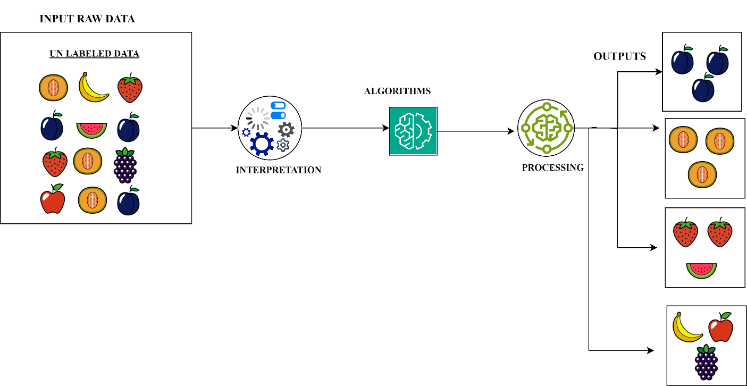  
*figure 10: unsupervised learning*

**2.2.1 K-MEANS CLUSTERING**

K-means clustering is a popular unsupervised technique in machine learning that splits data into kk clusters or groups. The primary goal is to ensure that those data points inside a particular cluster are as similar as possible while the clusters are as different as possible. This algorithm assigns each data point to its respective close cluster center and subsequently updates that cluster center based on the average of the assigned points. Once all the iterations are over, the algorithm stops when the cluster centers stop changing due to convergence. K-means is the method commonly used for data clustering, pattern recognition, and image segmentation [44].

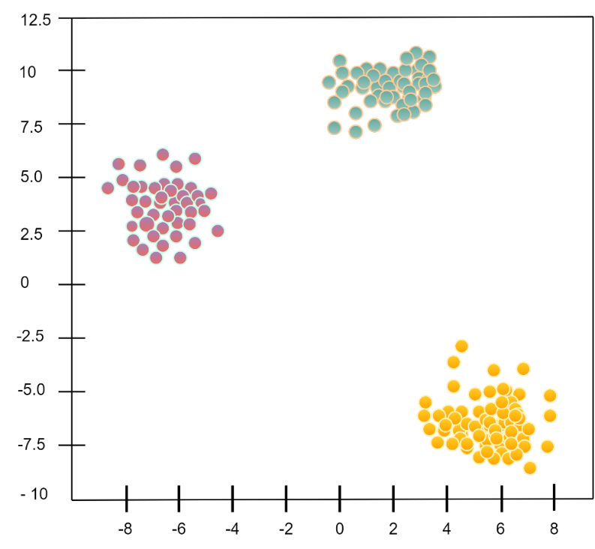  
*figure 11: k-means clustering*

**2.2.1 PRINCIPAL COMPONENT ANALYSIS**

Principal component analysis is an unsupervised mechanism used in the machine learning domain to diminish dimensional space in its raw data form. It helps convert high-dimensional datasets into a low-dimensional representation while retaining the essential variance information. PCA simplifies data, eases visualization, and improves the efficiency of other algorithms, all while retaining the crucial information by determining the principal components [45].

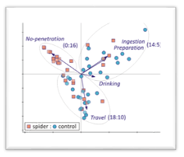

*figure 12: principal component analysis*

**2.3 SEMI SUPERVISED LEARNING**

Semi-supervised learning usually refers to a machine-learning technique whereby a larger amount of unlabeled training data is combined with a smaller quantity of labeled training data. The method comprehensively combines the best of supervised and unsupervised learning in that it takes into account the guidance offered by labeled data and also uncovers patterns and structures in the unlabeled data. It is particularly useful in situations where cost factors into, say, labeling data is burdensome or costly, thereby allowing for improved performance of the model with minimal labeled data [46].

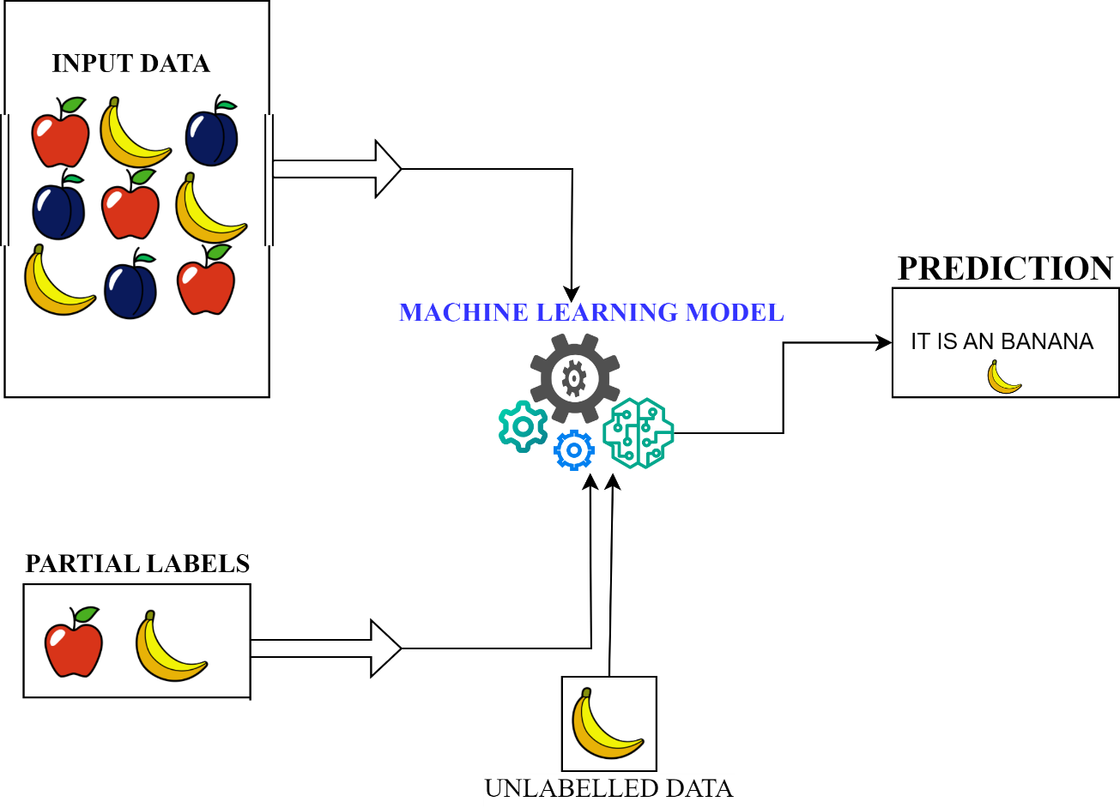  
*figure 13: semi supervised learning*

**2.3.1 TRANSDUCTIVE SVM**

The Transductive Support Vector Machines are a semi-supervised learning approach that employs both the labeled training data and some unlabelled test data-TSVM under its use during training. It takes full advantage of the structure of the dataset to improve the decision boundary, thus reducing misclassifications. The recommendation is that TSVM is applied when the test dataset size is significantly larger than that of the training dataset, thereby extending predictive capabilities [47].

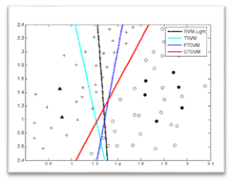

*figure 14: Transductive svm*

**2.3.2 GENERATIVE MODEL**

Generative models are statistical models that optimize the geography of the joint probability distribution of the input data and output labels, whereby such models can generate new data points that are similar to those of training data and can be employed in data augmentation tasks and semi-supervised learning tasks. They incorporate supervised data by enhancing learning when there is a dearth of labeled data by adding synthetic samples [48].

**2.3.3 SELF TRAINNING**

In self-training, a model is trained initially on a small labeled dataset and subsequently used to predict unlabeled data. The predictions with high confidence level are finally included in the labeled set and retraining is done on the new dataset. This iterative approach employs unlabeled data in order to obtain better performance from the model [49].

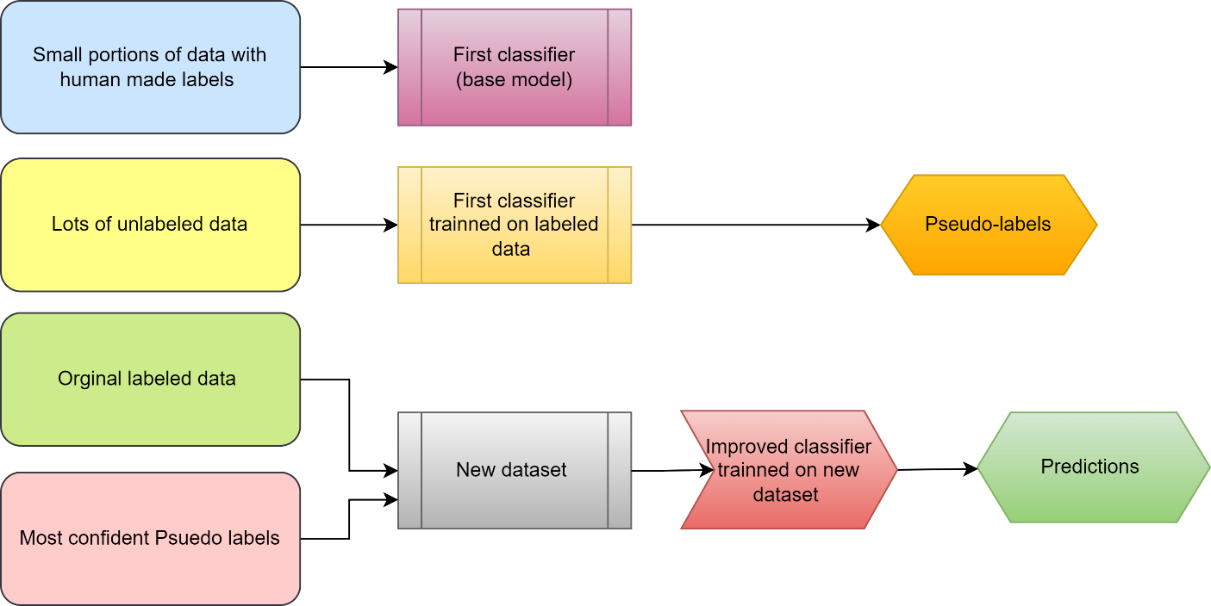

*figure 15: self- training*

**2.4 REINFORCEMENT LEARNING**

Reinforcement learning is a method of machine learning in which a machine interacts with an environment to learn ideal behavior. It does so through a process of taking action and receiving rewards or penalties in such a way as to maximize cumulative rewards over time. In contrast to supervised learning, reinforcement learning does not depend on labeled training data but rather on trial-and-error exploration to see what effects its actions will entail. Such information allows the agent to iteratively refine its course of action in response to other observed or guessed consequences, thereby improving performance in the future. This approach is well suited to issues where an explicit definition of a solution is unavailable; one must find the latter through interaction with the environment [50].

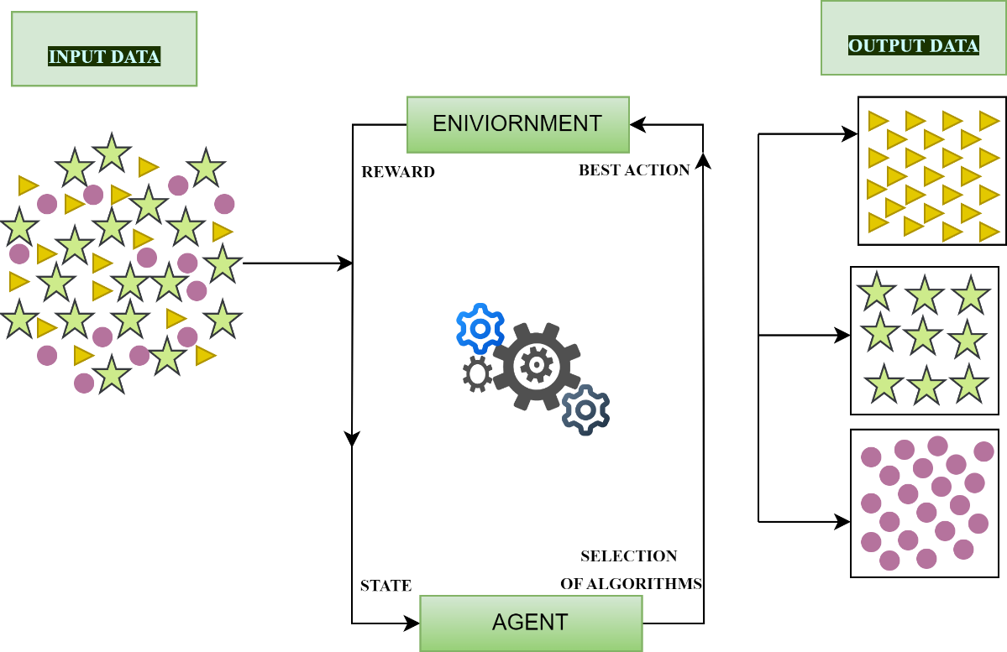

*figure 16: reinforcement learning*

**2.5 MULTI TASK LEARNING**

Multi-task learning (MTL) provides an application in machine learning with the objective of enhancing the performances of several related tasks while jointly learning the various tasks alongside each other. The basic intuition behind MTL assumes that jointly learning related tasks can yield better results than learning them separately. Multi-task learning can be thought of in supervised, unsupervised, semi-supervised, active, reinforcement, online, or multi-view learning setups. Using the relationships among tasks, MTL addresses some of the issues, such as sparsity in the data, and enhances overall learning performance across various tasks, making the resultant models much more efficient and effective [51].

**2.6 ENSEMBLE LEARNING**

Ensemble learning involves the training of multiple models by grouping predictions from each one and dispatching the performance of a single model. The fundamental idea is the utilization of the individual strengths of any number of fundamental models and integrating their predictions to get better results. Different basis learners, like decision trees, neural networks, or support vector machines, are trained using ensemble methods. The output of these base learners is then combined using methods like weighted averaging, majority voting, or stacking. By lowering bias and variance, these methods improve the model's accuracy and strength. Ensemble learning has been widely used in medical diagnosis, fraud detection, and sentiment analysis, beating single-model approaches in almost every situation. Many machine-learning researchers and practitioners now choose this approach due to its success and adaptability. The three main categories of ensemble learning are stacking, bagging, and boosting [52].

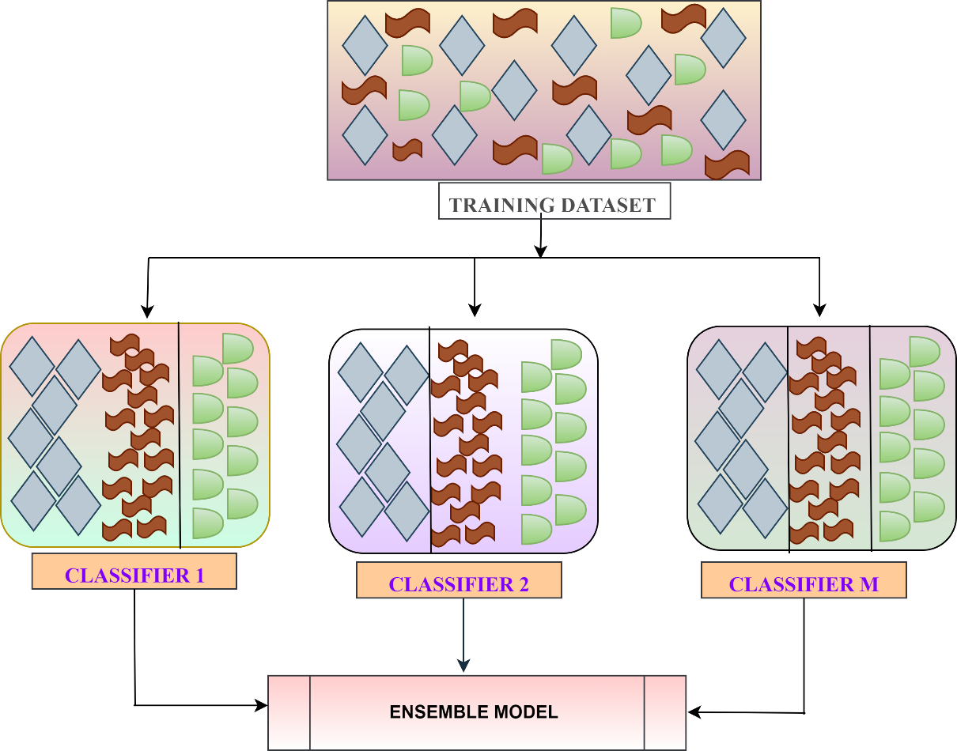

*figure 17: ensemble learning*

**2.6.1 BOOSTING**

Boosting is an ensemble learning technique that effectively merges several weak learners to form a combined strong learner. Boosting works by adding models sequentially and adding new models to the ensemble to improve previous ones specifically targeting that model's errors. The iterative procedure thereby refines the accuracy and stability of the ensemble model. In ensemble classification, boosting is among the famous methods that have been shown to outperform other methods in terms of accuracy, precision, and computational efficiency [53].

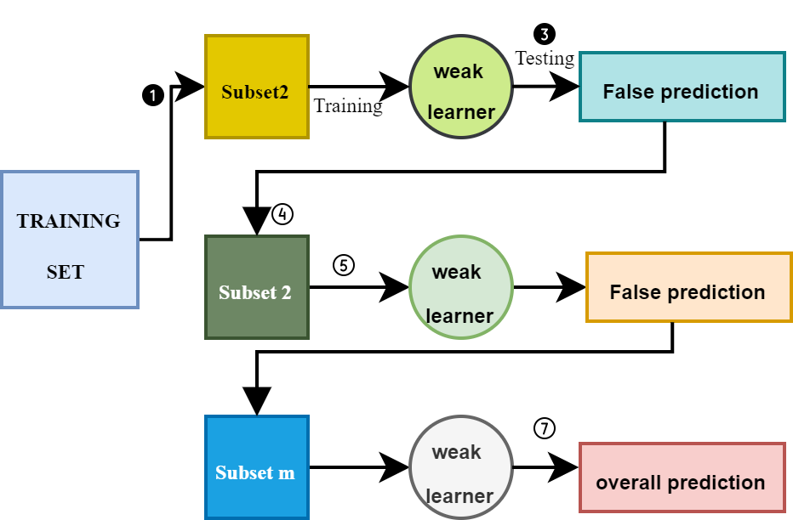

*figure 18: boosting*

**2.6.2 BAGGING**

Bagging is an ensemble machine learning technique for building multiple models from the same dataset and pooling their predictions to obtain improved overall predictive accuracy. Random samples are made from the training data, and individual models are trained on each sample, concentrating their outputs to make a final prediction. This way, variance in the model is reduced, thus providing better generalization capacity and more reliable and robust performance [54].

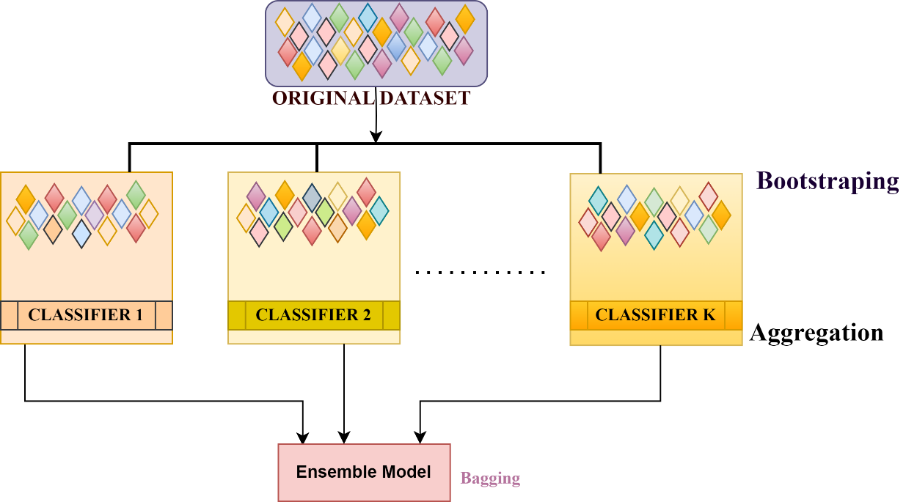

*figure 19: bagging*

**2.7 NEURAL NETWORKS**

Artificial neural networks are machine-learning systems that follow the architecture and function of the human brain, which consists of interconnected nodes called neurons. Typically, neurons are composed of three layers: an input layer, which attaches input features; middle or hidden layers, which extract features; and an output layer, which makes predictions or identifies output classes. Due to the ability of neural networks to learn non-linear complex relationships in data, those models can provide excellent predictions for tasks such as image recognition, natural language processing, or speech recognition. This is because, during the training process with big data, they can learn to extract and generalize important features and general relationships on their own. Neural networks are robust for many applications. This is mainly due to their capability of learning from data without requiring explicit programmatic instructions. The training process alters the connections between neurons such that the prediction errors are minimized. This enables the network to find relationships in the data from which even a person may find it challenging to extrapolate. Neural networks exhibit good generalization to new and unseen data and thus are less sensitive to noise and missing inputs in real-world cases. These features make neural networks a successful and powerful approach in machine learning and artificial intelligence because of their flexibility and ability to learn [55].

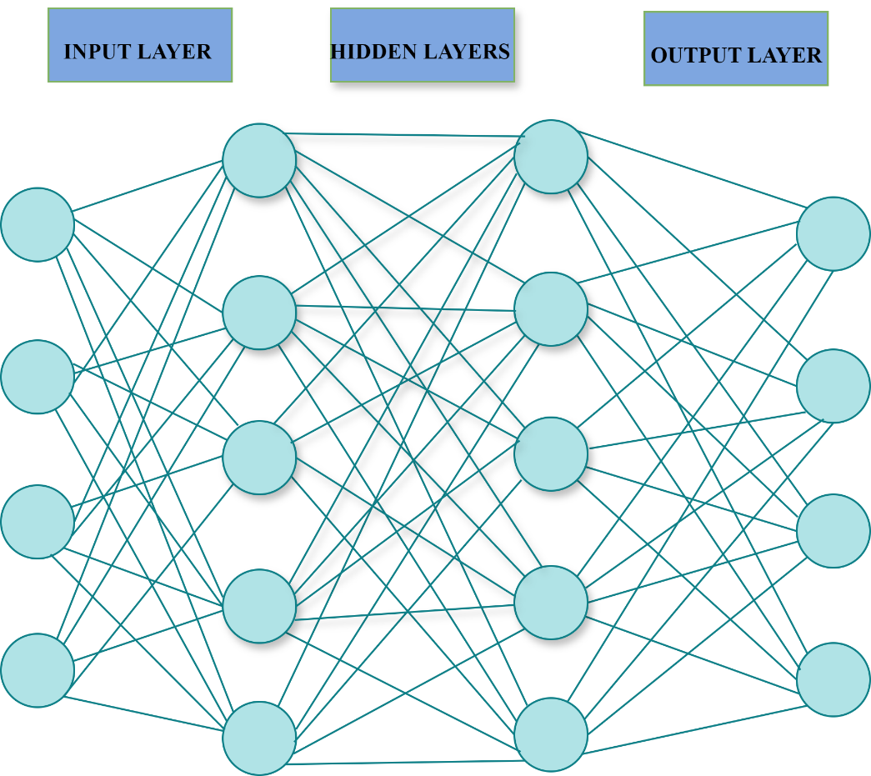

*figure 20: neural network*

**2.7.1 SUPERVISED NEURAL NETWORK**

Supervised neural networks are a group of machine learning models that learn from labeled data, that is, with suitable input-output pairs. The network learns such a mapping by optimizing its internal parameters to map the input to the output, typically in an iterative way using gradient descent. These networks have done quite well in areas such as classification, regression, and sequence prediction, achieving state-of-the-art performance in commercial applications. The phenomenal success for their cause has also been worked upon for elaborating recent years' well-being on the size of labeled datasets that enable the network in learning complex patterns and interrelations within data [56].

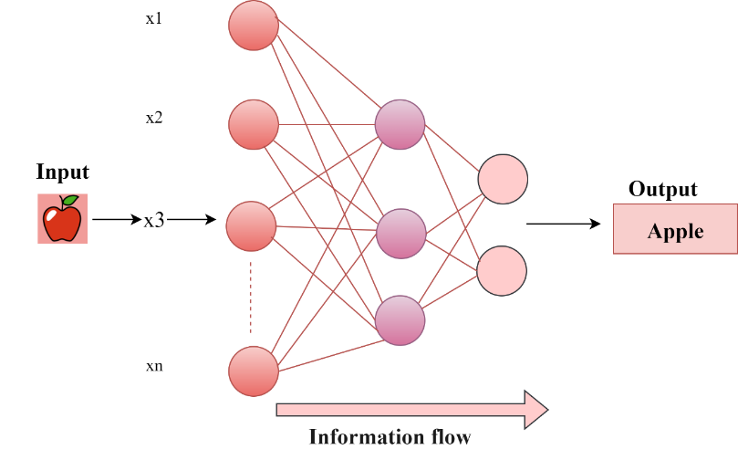

*figure 21: supervised learning*

**2.7.2 UNSUPERVISED NEURAL NETWORK**

Unsupervised learning is a machine learning approach in which a model learns to characterize input patterns in a manner reflecting the inherent structure of the entire dataset itself. Hidden structures are unveiled in unlabeled data by inferring a function. In other words, nowhere in the training process is any output label used. Unsupervised learning algorithms can be defined as those techniques and methods of training wherein the algorithms learn from unlabeled data with no guidance on discerning data classes. Inputs are large datasets and features associated with each observation? Even though the outputs are not specified, the model learns to identify patterns and relationships within a dataset by itself [57].

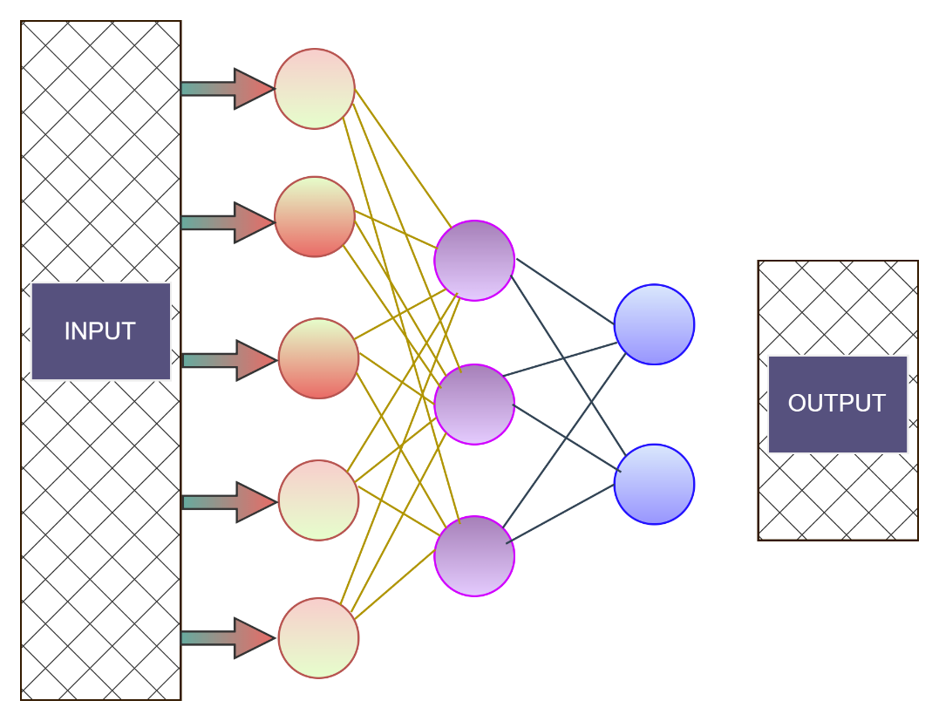

*figure 22: unsupervised neural network*

**2.8 INSTANCES BASED LEARNING**

Instance-based learning (IBL) is a subset of machine learning where the model is represented directly by the training instances, without any form of abstraction or generalization. Classification in IBL is commonly achieved by finding the nearest neighbour(s) among the training set and using their class label(s) to derive the prediction for the new point of interest. Primarily, it is in deciding the training instances whose knowledge to store that lie as a bottleneck, as keeping all instances will end in excessive memory usage, thus becoming rather sluggish during the classification phase. Sometimes, there may be shortcomings in terms of scalability and less coverage of the entire supervised space from such an instance-based framework. However, some schemes, like mining non-linear hypersurfaces and similarity-based pattern classification, are good in terms of memory consumption and speed [58].

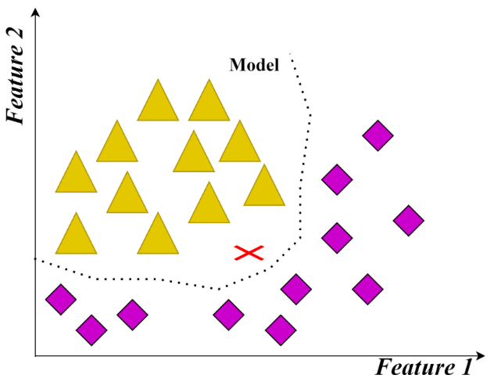

*figure 23: Instances based learning*

**2.8.1 K NEAREST LEARNING**

The k-nearest neighbour (KNN) algorithm is among supervised machine learning algorithms that serve predominantly in classification tasks and finds extensive applications in disease prediction. KNN classifies unlabeled data on the basis of labels and features of the training data. The algorithm classifies the data points based on the closeness of the testing query to the k nearest data points in the training set to the query. After determining these neighbours, KNN further considers the final classification based on majority voting from among the neighbours in the training set. The algorithm is thus simple but efficient for pattern recognition and classification tasks [59].

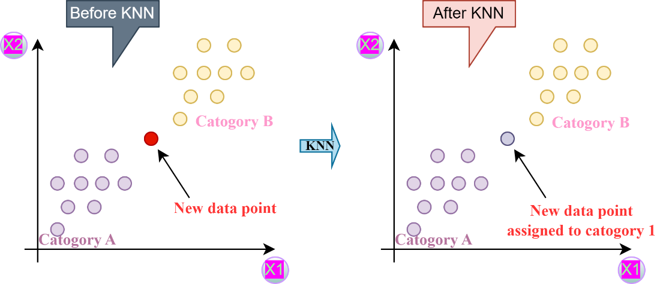

*figure 24: k nearest learning*

**2.9 CONVOLUTIONAL NEURAL NETWORK**

Convolutional Neural Networks (CNNs) in particular are the best for image and video recognition tasks by capturing spatial hierarchies [60]. CNNs pass images through layers: convolution layers for feature detection, pooling layers to shrink the image size, and fully connected layers for classification [61].

**2.9.1 PRETRAINED NETWORKS**

Transfer learning is another popular practice in deep learning, which uses the pre-trained model and adapts it for a new but related task [62] to reduce the extensive training process while improving performance as it helps especially when there is very little data available for the new task. Various well-known architectures include AlexNet, VGG, ResNet, and GoogLenet, which are known to work well for image classification tasks[63] [64]. AlexNet includes a series of convolutional and fully connected layers [65], while VGG, with the count of 16, proves to be good in classification and localization. ResNet takes care of the vanishing gradient by incorporating shortcut connections, while GoogLenet introduces the inception modules to achieve better feature detection [66]. All these models along with the other efficient alternatives like SqueezeNet and InceptionResNet promote the creation of many images processing tasks which continues to improve performance and efficiency of use in real-world applications.

**2.9.2 TRANSFER LEARNING**

Transfer Learning is a technique used in deep learning that can utilizes the knowledge gained from solving one to specify the other/similar problems, similar to human learning. This approach allows for the use of pre trained networking models, which can reduce the amount of data. Several Convolution Neural Network (CNN) architectures have been proposed to enhance system performance while maintaining a consistent learning structure. The most specific pretrained networks are AlexNet, VGG16, VGG19, Resnet, Dense net, Mobile net and Efficient net are commonly used for the image classification, providing, significant improvements in accuracy and efficiency [67].

**CONCLUSION**

Pox illnesses, like smallpox and monkeypox, have historically generated widespread fear and suffering due to their severity. If not detected in a period of time these diseases, which present with symptoms including painful skin lesions and a high temperature, can cause major problems or even death. Although early detection can stop the spread of these diseases and save lives, it is even more important given the possibility of outbreaks. Machine learning (ML) methods have become effective tools for improving the detection of pox diseases in recent years. In particular, Convolutional Neural Networks (CNNs) have shown efficiency in the analysis of medical images, detecting patterns like rashes and skin lesions that are significant indicators of pox infections. These models provide a quicker and more accurate method of diagnosis by analyzing huge amounts of data and rapidly identifying features that the human eye might neglect. By simultaneously identifying several connected diseases, methods such as multi-task learning (MTL) could improve diagnosis accuracy. These models are further strengthened by ensemble techniques like boosting and bagging, which combine the output of several algorithms to reduce errors. These models are especially helpful in environments with limited resources because transfer learning enables them to function effectively even with very little information.By integrating machine learning into the detection process, we can make diagnosing pox illnesses more efficient and accessible, ultimately enhancing patient care and helping manage outbreaks more efficiently. These technologies present a promising future for quicker, more precise healthcare responses as they develop further.

1. **REFERENCES**
2. Mohd Zaid NA, Sekar M, Bonam SR, et al. Promising Natural Products in New Drug Design, Development, and Therapy for Skin Disorders: An Overview of Scientific Evidence and Understanding Their Mechanism of Action. *Drug Des Devel Ther*. 2022; 16:23-66. Published 2022 Jan 6. doi:10.2147/DDDT.S326332
3. Sarkar, Swarnabha & Mishra, Ritu. (2024). Mpox and related poxviruses: A literature review of evolution, pathophysiology, and clinical manifestations. Asian Pacific Journal of Tropical Biomedicine. 14. 319-330. DOI: 10.4103/apjtb.apjtb_193_24
4. Jayswal S, Kakadiya J. A narrative review of pox: smallpox vs monkeypox. *Egypt J Intern Med*. 2022;34(1):90. doi:10.1186/s43162-022-00174-0
5. Islam, Towhidul & Hussain, Mohammad & Chowdhury, Forhad & Islam, B. (2022). A Web-scraped Skin Image Database of Monkeypox, Chickenpox, Smallpox, Cowpox, and Measles. 10.1101/2022.08.01.502199.
6. Shchelkunova, Galina & Shchelkunov, Sergei. (2022). Smallpox, Monkeypox and Other Human Orthopoxvirus Infections. Viruses. 15. 103. 10.3390/v15010103.
7. Mohanty, Biswajit & Costantino, Valentina & Narain, Jai & Chughtai, Abrar & Das, Arpita & Macintyre, Chandini. (2020). Modelling the impact of a smallpox attack in India and influence of disease control measures. BMJ Open. 10. e038480. 10.1136/bmjopen-2020-038480.
8. Riedel S. Smallpox and biological warfare: a disease revisited. Proc (Bayl Univ Med Cent). 2005 Jan;18(1):13-20. doi: 10.1080/08998280.2005.11928026. PMID: 16200143; PMCID: PMC1200695.
9. Y. Li, D.S. Carroll, S.N. Gardner, M.C. Walsh, E.A. Vitalis, I.K. Damon, On the origin of smallpox: Correlating variola phylogenics with historical smallpox records, Proc. Natl. Acad. Sci. U.S.A.
10. 104 (40) 15787-15792,<https://doi.org/10.1073/pnas.0609268104>Barquet N, Domingo P. Smallpox: the triumph over the most terrible of the ministers of death. Ann Intern Med. 1997 Oct 15;127(8 Pt 1):635-42. doi: 10.7326/0003-4819-127-8_part_1-199710150-00010. Erratum in: Ann Intern Med 1998 May 1;128(9):787. PMID: 9341063.
11. Mary Vaishali, P., & Boopathy, N. (2024). Edward Jenner: The Pioneer of Vaccination and His Enduring Legacy in Modern Medicine. *Cureus*, *16*(9), e68805. <https://doi.org/10.7759/cureus.68805>
12. Jayswal, S., Kakadiya, J. A narrative review of pox: smallpox vs monkeypox. *Egypt J Intern Med* **34**, 90 (2022). <https://doi.org/10.1186/s43162-022-00174-0>
13. 13.MacNeill AL. Comparative Pathology of Zoonotic Orthopoxviruses. Pathogens. 2022 Aug 9;11(8):892. doi: 10.3390/pathogens11080892. PMID: 36015017; PMCID: PMC9412692.
14. Hajj Hussein I, Chams N, Chams S, El Sayegh S, Badran R, Raad M, Gerges-Geagea A, Leone A, Jurjus A. Vaccines Through Centuries: Major Cornerstones of Global Health. Front Public Health. 2015 Nov 26; 3:269. doi: 10.3389/fpubh.2015.00269. PMID: 26636066; PMCID: PMC4659912.
15. Mahendra Pal, Rajkumar Singh, Bhupendra C Parmar, Kirubel Paulos Gutama, Adugna Girma Lema. Human cowpox: A viral zoonosis that poses emerging health threat. J Adv Microbiol Res 2022;3(1):22-26.
16. Altindiş M, Kahraman Kilbaş EP. Managing Viral Emerging Infectious Diseases via Current and Future Molecular Diagnostics. Diagnostics (Basel). 2023 Apr 15;13(8):1421. doi: 10.3390/diagnostics13081421. PMID: 37189522; PMCID: PMC10137430.
17. Altindis M, Puca E, Shapo L. Diagnosis of monkeypox virus - An overview. Travel Med Infect Dis. 2022 Nov-Dec; 50:102459. doi: 10.1016/j.tmaid.2022.102459. Epub 2022 Sep 13. PMID: 36109000; PMCID: PMC9534096.
18. Muñoz-Saavedra L, Escobar-Linero E, Civit-Masot J, Luna-Perejón F, Civit A, Domínguez-Morales M. A Robust Ensemble of Convolutional Neural Networks for the Detection of Monkeypox Disease from Skin Images. *Sensors*. 2023; 23(16):7134. <https://doi.org/10.3390/s23167134>
19. Çeli̇k, Muhammed & Inik, Özkan. (2023). Detection of Monkeypox Among Different Pox Diseases with Different Pre-Trained Deep Learning Models. Journal of the Institute of Science and Technology. 13. 10-21. 10.21597/jist.1206453.
20. Khan, Saddam & Iqbal, Rashid & Naz, Saeeda. (2023). A Recent Survey of the Advancements in Deep Learning Techniques for Monkeypox Disease Detection. 10.48550/arXiv.2311.10754.
21. Patel M, Surti M, Adnan M. Artificial intelligence (AI) in Monkeypox infection prevention. J Biomol Struct Dyn. 2023 Oct-Nov;41(17):8629-8633. doi: 10.1080/07391102.2022.2134214. Epub 2022 Oct 11. PMID: 36218112; PMCID: PMC9627635.
22. Thakur M, Das P, Sobti RC, Kaur T. Human monkeypox: epidemiology, transmission, pathogenesis, immunology, diagnosis and therapeutics. Mol Cell Biochem. 2023 Sep;478(9):2097-2110. doi: 10.1007/s11010-022-04657-0. Epub 2023 Jan 10. PMID: 36626099; PMCID: PMC9838351.
23. Cabanillas B, Murdaca G, Guemari A, Torres MJ, Azkur AK, Aksoy E, Vitte J, Fernández-Santamaria R, Karavelia A, Castagnoli R, Valdelvira R, Orsi A, Ogliastro M, Massaro E, Yücel EÖ, Novak N, Agache I, Akdis M, Akdis CA. Monkeypox 2024 outbreak: Fifty essential questions and answers. Allergy. 2024 Dec;79(12):3285-3309. doi: 10.1111/all.16374. Epub 2024 Nov 4. PMID: 39495103.
24. Henderson, Donald A. (‎1971)‎. Smallpox / by Donald A. Henderson. <https://iris.who.int/handle/10665/67486>
25. Sah, Ranjit & Apostolopoulos, Vasso & Mehta, Rachana & Rohilla, Ranjana & Sah, Sanjit & Mohanty, Aroop & Mehta, Vini & Feehan, Jack & Luna, Camila & Novales, Francisco & Al-Tawfiq, Jaffar & Cascio, Antonio & Samayoa-Bran, Ana & Bonilla-Aldana, D. & Rodriguez-Morales, Alfonso. (2024). Mpox Strikes Once More in 2024: Declared Again as a Public Health Emergency of International Concern. Travel Medicine and Infectious Disease. 61. 102753. 10.1016/j.tmaid.2024.102753.
26. Oyola, J., Arroyo, V., Ruedin, A., Acevedo, D. (2012). Detection of Chickenpox Vesicles in Digital Images of Skin Lesions. In: Alvarez, L., Mejail, M., Gomez, L., Jacobo, J. (eds) Progress in Pattern Recognition, Image Analysis, Computer Vision, and Applications. CIARP 2012. Lecture Notes in Computer Science, vol 7441. Springer, Berlin, Heidelberg. <https://doi.org/10.1007/978-3-642-33275-3_72>
27. Bianchi, Leonardo & Simonetti, Stefano & Hansel, Katharina & Baldelli, Franco & Schiaroli, Elisabetta & Luca, Stingeni. (2018). Gangrenous Chickenpox with Atypical Clinical and Histopathological Findings. Dermatopathology. 5. 38-40. 10.1159/000486668.
28. Gershon AA, Breuer J, Cohen JI, Cohrs RJ, Gershon MD, Gilden D, Grose C, Hambleton S, Kennedy PG, Oxman MN, Seward JF, Yamanishi K. Varicella zoster virus infection. Nat Rev Dis Primers. 2015 Jul 2; 1:15016. doi: 10.1038/nrdp.2015.16. PMID: 27188665; PMCID: PMC5381807.
29. Okeniyi, O. & Adeoye, O. & Ojo, Da & Adewoye, K. (2018). Modeling of Infectious Disease Through the Contact, Treatment and Recovery 0f Chicken Pox Patients (A Case Study of Offa Local Government Area of Kwara State). International Journal of Engineering and Applied Sciences (IJEAS). 5. 10.31873/IJEAS.5.10.01.
30. A. Konopka, “A Comprehensive Review of TORCH Syndrome: Characterization and Prevention Strategies”, *Qual Sport*, vol. 21, p. 53987, Aug. 2024.
31. Cenoz MG, Martínez-Artola V, Guevara M, Ezpeleta C, Barricarte A, Castilla J. Effectiveness of one and two doses of varicella vaccine in preventing laboratory-confirmed cases in children in Navarre, Spain. Hum Vaccin Immunother. 2013 May;9(5):1172-6. doi: 10.4161/hv.23451. Epub 2013 Jan 16. PMID: 23324571; PMCID: PMC3899156.
32. Sukhpal Singh Gill, Muhammed Golec, Jianmin Hu, Minxian Xu, Junhui Du, Huaming Wu, Guneet Kaur Walia, Subramaniam Subramanian Murugesan, Babar Ali, Mohit Kumar, Kejiang Ye, Prabal Verma, Surendra Kumar, Felix Cuadrado, and Steve Uhlig. 2024. Edge AI: A Taxonomy, Systematic Review and Future Directions. Cluster Computing 28, 1 (Feb 2025). <https://doi.org/10.1007/s10586-024-04686-y>
33. Asif, S., Zhao, M., Li, Y., Tang, F., Ur Rehman Khan, S., & Zhu, Y. (2024). AI-based approaches for the diagnosis of Mpox: challenges and future prospects. *Archives of Computational Methods in Engineering*, *31*(6), 3585-3617
34. Thieme, A. H., Zheng, Y., Machiraju, G., Sadee, C., Mittermaier, M., Gertler, M., ... & Gevaert, O. (2023). A deep-learning algorithm to classify skin lesions from mpox virus infection. *Nature medicine*, *29*(3), 738-747.
35. Chadaga, K., Prabhu, S., Sampathila, N., Nireshwalya, S., Katta, S. S., Tan, R. S., & Acharya, U. R. (2023). Application of artificial intelligence techniques for monkeypox: a systematic review. *Diagnostics*, *13*(5), 824
36. Xie, Na & Zhang, Wentao. (2024). Empowering big data analytics through machine learning: Applications, challenges, and future directions. Applied and Computational Engineering. 93. 76-82. 10.54254/2755-2721/93/20240917.
37. Rane, Nitin & Mallick, Suraj & Kaya, Ömer & Rane, Jayesh. (2024). Role of machine learning and deep learning in advancing generative artificial intelligence such as ChatGPT. 10.70593/978-81-981271-4-3_5.
38. V. Gupta, V. K. Mishra, P. Singhal and A. Kumar, "An Overview of Supervised Machine Learning Algorithm," 2022 11th International Conference on System Modeling & Advancement in Research Trends (SMART), Moradabad, India, 2022, pp. 87-92, doi: 10.1109/SMART55829.2022.10047618
39. Stafford, Imogen & Kellermann, M. & Mossotto, Enrico & Beattie, Dr & MacArthur, Ben & Ennis, Stewart. (2020). A systematic review of the applications of artificial intelligence and machine learning in autoimmune diseases. npj Digital Medicine. 3. 30. 10.1038/s41746-020-0229-3.
40. Jena, Monalisa & Dehuri, Satchidananda. (2020). DecisionTree for Classiﬁcation and Regression: A State-of-the Art Review. Informatica. 44. 10.31449/inf. v44i4.3023.
41. Wettig, Hannes, Peter D. Grünwald, Teemu Roos, Petri Myllymäki and Henry Tirri. “On Supervised Learning of Bayesian Network Parameters.” (2002).
42. Tolan, Ghada & Abou-El-Enien, Tarek & Khorshid, Motaz. (2015). A Comparison among Support Vector Machine and other Machine Learning Classification Algorithms. IPASJ International Journal of Computer Science (IIJCS). Volume 3. 25-35.
43. Samreen, Naeem., Aqib, Ali., Sania, Anam., Muhammad, Munawar, Ahmed. "An Unsupervised Machine Learning Algorithms: Comprehensive Review." International Journal of Computing and Digital Systems, 13 (2023).:911-921. doi: 10.12785/ijcds/130172
44. K. P. Sinaga and M. -S. Yang, "Unsupervised K-Means Clustering Algorithm," in IEEE Access, vol. 8, pp. 80716-80727, 2020, doi: 10.1109/ACCESS.2020.2988796.
45. Xiong, Shifeng. (2024). A unified framework of principal component analysis and factor analysis. 10.48550/arXiv.2405.20137.
46. Nguyen, Khoi Duc Minh, Yen Lam Hoang Nguyen and Bao Le. “Semi-Supervising Learning, Transfer Learning, and Knowledge Distillation with SimCLR.” *ArXiv* abs/2108.00587 (2021): n. pag.
47. Almalki, Bander, Aman Sawhney and Li Liao. “Transmembrane Protein Inter-Helical Residue Contacts Prediction Using Transductive Support Vector Machines.” *EPiC Series in Computing*: n. pag. <https://doi.org/10.29007/3ztg>
48. Yamaguchi, Shin'ya. "Generative Semi-Supervised Learning with Meta-Optimized Synthetic Samples." *arXiv*, 28 Sept. 2023, arxiv.org/pdf/2309.16143.
49. C. Rosenberg, M. Hebert and H. Schneiderman, "Semi-Supervised Self-Training of Object Detection Models," 2005 Seventh IEEE Workshops on Applications of Computer Vision (WACV/MOTION'05) - Volume 1, Breckenridge, CO, USA, 2005, pp. 29-36, doi: 10.1109/ACVMOT.2005.107.
50. Kaelbling, Leslie P., Michael L. Littman, and Andrew W. Moore. "Reinforcement Learning: A Survey." *Journal of Artificial Intelligence Research*, vol. 4, 1996, pp. 237–285.
51. Zhang, Yu & Yang, Qiang. (2018). An overview of multi-task learning. National Science Review. 5. 30-43. 10.1093/nsr/nwx105.
52. I. D. Mienye and Y. Sun, "A Survey of Ensemble Learning: Concepts, Algorithms, Applications, and Prospects," in IEEE Access, vol. 10, pp. 99129-99149, 2022, doi: 10.1109/ACCESS.2022.3207287.
53. Okey OD, Maidin SS, Adasme P, Lopes Rosa R, Saadi M, Carrillo Melgarejo D, Zegarra Rodríguez D. BoostedEnML: Efficient Technique for Detecting Cyberattacks in IoT Systems Using Boosted Ensemble Machine Learning. Sensors. 2022; 22(19):7409. <https://doi.org/10.3390/s22197409>
54. Ngo, Giang, Rodney Beard, and Rohitash Chandra. "Evolutionary Bagging for Ensemble Learning." *Neurocomputing*, vol. 512, 2022, pp. 292–301.
55. Eliwa EHI, El Koshiry AM, Abd El-Hafeez T, Farghaly HM. Utilizing convolutional neural networks to classify monkeypox skin lesions. Sci Rep. 2023 Sep 3;13(1):14495. doi: 10.1038/s41598-023-41545-z. PMID: 37661211; PMCID: PMC10475460.
56. Zhang, Yuting, Kibok Lee, and Honglak Lee. "Augmenting Supervised Neural Networks with Unsupervised Objectives for Large-scale Image Classification." *Proceedings of the 33rd International Conference on Machine Learning (ICML 2016) *, 2016, pp. 612–620.
57. H. U. Dike, Y. Zhou, K. K. Deveerasetty and Q. Wu, "Unsupervised Learning Based on Artificial Neural Network: A Review," 2018 IEEE International Conference on Cyborg and Bionic Systems (CBS), Shenzhen, China, 2018, pp. 322-327, doi: 10.1109/CBS.2018.8612259.
58. Wilson, D. R., and T. R. Martinez. "Reduction Techniques for Instance-Based Learning Algorithms." *Machine Learning*, vol. 38, no. 3, 2000, pp. 257–286.
59. Uddin, Shahadat, et al. "Comparative Performance Analysis of K-Nearest Neighbour (KNN) Algorithm and Its Different Variants for Disease Prediction." *Scientific Reports*, vol. 12, no. 6256, 2022, pp. 1–13. <https://doi.org/10.1038/s41598-022-10358-x>.
60. A Survey of Convolutional Neural Networks: Analysis, Applications, and Prospects Li, Z., Yang, W., Peng, S., & Liu, F. (2022). A survey of convolutional neural networks: Analysis, applications, and prospects. *IEEE Transactions on Neural Networks and Learning Systems*, 33(12), 6999-7019.
61. Liu, Y. (2018). Feature Extraction and Image Recognition with Convolutional Neural Networks. *Journal of Physics: Conference Series*, 1087, 062032.
62. Iman, M., Arabnia, H. R., & Rasheed, K. (2023). A Review of Deep Transfer Learning and Recent Advancements. *Technologies*, 11(2), 40.
63. Marmanis, Dimitrios, et al. "Deep Learning Earth Observation Classification Using ImageNet Pretrained Networks." *IEEE Geoscience and Remote Sensing Letters*, vol. 13, no. 1, Jan. 2016, pp. 105-109.
64. Khandelwal, S., & Raman, B. (2020). Comparison of Convolutional Neural Network Architectures for Classification of Tomato Plant Diseases. Applied Sciences, 10(4), 1245
65. Brain Tumor Detection using Transfer Learning with AlexNet and CNN Kapadnis, S. A. (2020). Brain Tumor Detection using Transfer Learning with AlexNet and CNN. *National College of Ireland*.
66. Analysis of Residual Block in the Resnet for Image Classification Jin, X. (2023). Analysis of Residual Block in the ResNet for Image Classification. *Proceedings of the 2023 International Conference on Artificial Intelligence and Data Engineering*, 128004. SchizoGoogLeNet: The GoogLeNet-Based Deep Feature Extraction Design for Automatic Detection of Schizophrenia
67. Siuly, S., Li, Y., Wen, P., & Alcin, O. F. (2022). SchizoGoogLeNet: The GoogLeNet-Based Deep Feature Extraction Design for Automatic Detection of Schizophrenia. *Computational Intelligence and Neuroscience*, 2022, 1992596. <https://doi.org/10.1155/2022/1992596>
68. Altun, Murat, et al. "Monkeypox Detection Using CNN with Transfer Learning." *Sensors*, vol. 23, no. 4, 2023, p. 1783. <https://doi.org/10.3390/s23041783>.