Maid Hiring Management System

**Divyani Bhande, Krushnali Mahajan, Utkarsha Jaiswal, Prof. Jagruti Mahajan**

Department of Computer Science and Engineering, Thakur Shiv Kumar Singh Memorial Engineering College Burhanpur(MP)

**ABSTRACT**

The Online Maid Hiring System is a web-based platform designed to streamline and simplify the process of finding and hiring domestic help. This system connects households with verified and skilled maids for services such as cleaning, cooking, babysitting, and elderly care. It provides users with detailed maid profiles, including experience, availability, location, and user ratings, ensuring transparency and trust. Employers can search, filter, and book maids based on specific requirements, while maids can manage their schedules and job offers. The system also features secure registration, real-time notifications, and a feedback mechanism. By digitizing the maid hiring process, the platform promotes efficiency, reliability, and convenience for both employers and workers.

### **INTRODUCTION**

In today’s fast-paced world, managing household chores alongside professional and personal responsibilities has become increasingly challenging. The demand for reliable domestic help is on the rise, especially in urban areas where families often require assistance with tasks such as cleaning, cooking, childcare, and elder care. Traditionally, hiring maids has been an informal process, relying heavily on word-of-mouth referrals, manual vetting, and inconsistent service quality. This approach often leads to trust issues, lack of transparency, and inefficiency. The **Online Maid Hiring System** is designed to address these challenges by providing a digital platform where users can easily search for, evaluate, and hire domestic help based on their specific needs. The system acts as a bridge between employers (households) and job seekers (maids), offering a structured and secure environment for both parties. It enables users to access maid profiles that include essential information such as skills, work experience, availability, expected salary, and user ratings. This not only simplifies the decision-making process but also enhances safety and reliability. From the maid’s perspective, the platform provides a legitimate channel to find job opportunities, manage work schedules, and build a reputation through ratings and reviews. It also helps eliminate middlemen and exploitation by ensuring fair and direct communication with potential employers.

###### **OBJECTIVE OF PROJECT**

There are some basic objectives of the maid hiring System.

* To develop a user-friendly platform for hiring maids and domestic workers online.
* To provide a **centralized database** of verified maids with detailed profiles including skills, experience, and availability.
* To enable **easy search and filtering** of maids based on services, location, timing, and ratings.
* To facilitate **secure user registration and login** for admins, customers, and maids.
* To allow customers to **book and schedule services** based on their convenience.
* To offer **real-time notifications and updates** regarding bookings and availability.
* To ensure **feedback and rating mechanisms** for quality assurance and accountability.

**SCOPE**

* **Geographical Reach**: Can be expanded to urban and semi-urban areas, potentially scaling nationally or internationally.
* **Platform Access**: Available as a web-based platform and mobile app for easy access across devices.
* **Variety of Services**: Covers a wide range of domestic services including cleaning, cooking, childcare, elderly care, and more.
* **Target Audience**: Households, maid agencies, and independent maids across diverse demographics.
* **Scalability**: Designed to handle increasing users, maids, and service demands with minimal adjustments.

**LIMITATIONS**

* **Dependence on User Data**: Accuracy and reliability depend on the information provided by users and maids.
* **Geographical Constraints**: Initially limited to specific regions or cities, requiring expansion for broader reach.
* **Internet Access**: Requires internet connectivity for both employers and maids to access the platform.
* **Service Availability**: Limited to services offered by registered maids, which may not cover all household needs.
* **Background Check Limitations**: May not be able to conduct thorough background checks in every region due to legal or logistical constraints.
* **Booking Reliability**: Potential scheduling conflicts or cancellations if maids are unavailable due to personal issues.
* **Payment Systems**: Requires integration with secure and widely accepted payment methods, which may have regional limitations.
* **Maid Retention**: Difficulty in retaining maids on the platform due to job mobility or inconsistent demand.

**APPLICATIONS**

* 🏠 **Households**: Find and hire trusted maids for various services.
* 📱 **Users**: Book and manage maid services via mobile or web.
* 🧹 **Maid Agencies**: Register and manage worker profiles, track bookings.
* 👩‍🔧 **Independent Maids**: Showcase skills, find jobs, and manage schedules.
* 🧾 **Admin**: Oversee user management, profile verification, and platform activity.
* 🌐 **Smart City Solutions**: Integrate into smart city services for easy domestic help access.
* 🛡️ **Background Verification**: Collaborate for safety checks and maid validation.
* 📊 **Data Insights**: Analyze user trends, feedback, and service demand.

**RESULT**

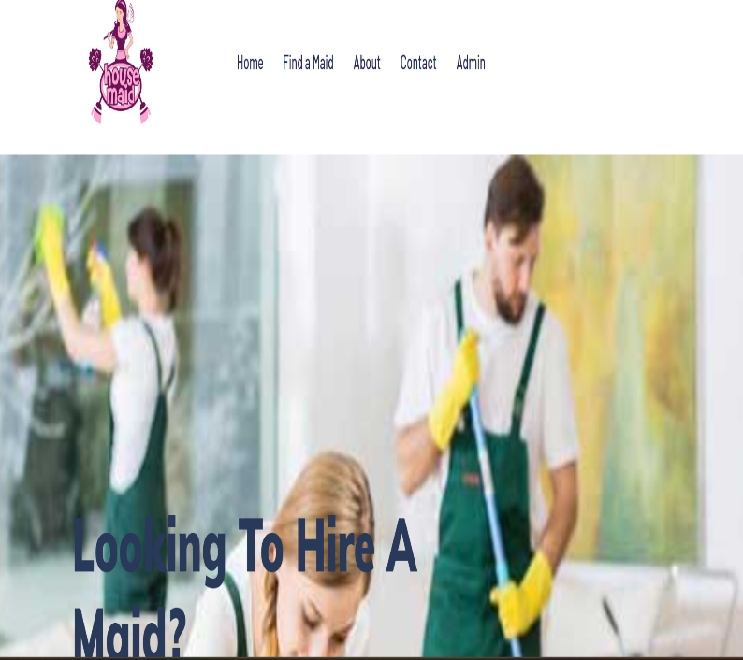 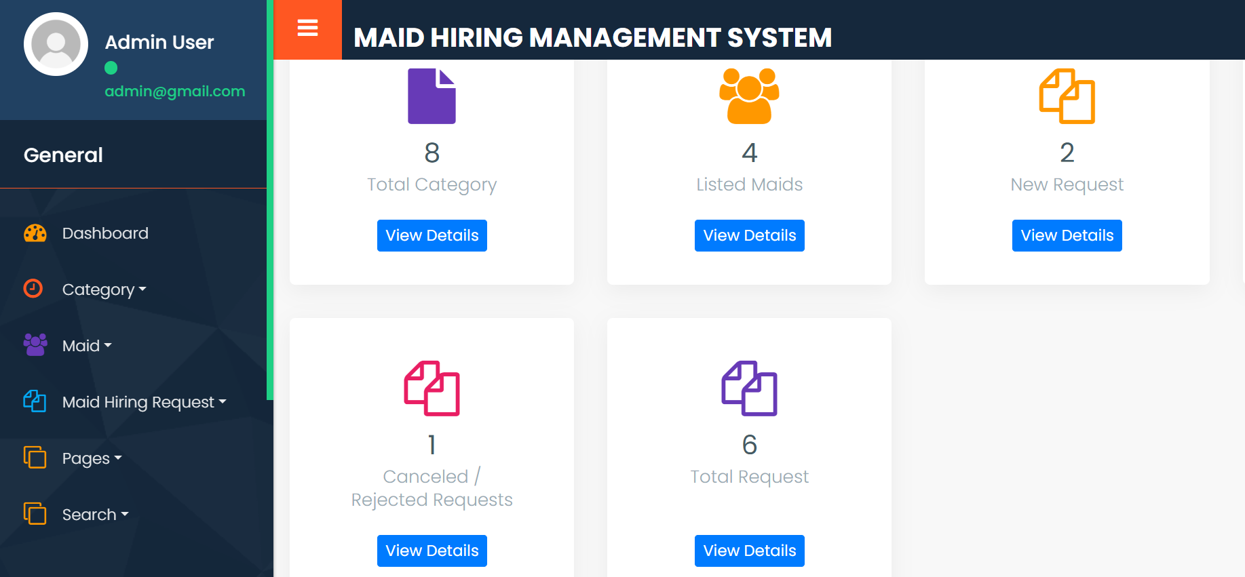

**Fig 1.1** Dashboard Page of Maid Hiring System

**DESCRIPTION**

The **Online Maid Hiring System** is a web-based platform designed to simplify and digitize the process of hiring domestic help. It acts as a bridge between households looking for reliable maids and domestic workers seeking job opportunities. The system allows users to register, browse maid profiles, filter based on specific services, availability, and location, and book appointments with ease. Maids can register themselves, showcase their skills, update their availability, and accept or reject bookings. An admin panel is provided for managing users, verifying maid details, monitoring activity, and ensuring platform security. The system includes features like secure login, real-time notifications, ratings and reviews, and payment integration to ensure transparency, trust, and convenience. This platform not only helps users find domestic help quickly and efficiently but also empowers maids by giving them visibility and equal access to job opportunities.

**CONCLUSION**

* **Streamlines the Hiring Process**: The system replaces the traditional, time-consuming method of finding domestic help with a quick, user-friendly digital solution.
* **Improves Accessibility**: Users can easily access a pool of verified maids based on their specific needs, such as cleaning, cooking, babysitting, or elderly care.
* **Empowers Domestic Workers**: Maids can independently register, showcase their skills, manage availability, and connect with potential clients—leading to better job opportunities and income stability.
* **Advanced Search & Filtering**: The platform provides smart filters based on location, service type, ratings, and availability, making it easier for users to find suitable maids.
* **Efficient Booking & Scheduling**: Both users and maids can manage appointments through a smooth booking system, reducing scheduling conflicts and confusion.

**FUTURE SCOPE**

* **Expansion to More Cities/Countries**
* **Launch of Dedicated Mobile Apps**
* **AI-Based Maid Recommendations**
* **Multilingual Support for Wider Reach**
* **Integration with Government ID Verification**
* **Advanced Analytics for Admin & Users**
* **Real-Time Tracking of Maid Services**
* **AI Chatbot for 24/7 User Support**
* **Integration with Smart Home Devices** (e.g., for entry access or cleaning schedules
* **Corporate Tie-Ups** for providing maids to offices or co-working spaces
* **DIY Support & Emergency Services** integration (e.g., plumber, electrician)
* **Skill Certification & Training Courses** for maids via the platform

**REFERENCES**

* **Websites & Articles**
* UrbanClap (now **Urban Company**) – <https://www.urbancompany.com>
* Housejoy – <https://www.housejoy.in>
* Helpr – <https://www.helpr.in>
* "Online Domestic Help Services in India" – Economic Times Article
* "Impact of Technology on Household Services" – ResearchGate publication
* **Research Papers & Journal**
* Sharma, R. (2020). "Digital Platforms for Home Services: A Case Study on UrbanClap", IJERT.
* Singh, A., & Mehra, P. (2021). "Role of Web Applications in On-demand Service Sector", IJIRCCE.
* Nair, V. (2022). "User Experience in Online Maid Booking Platforms", International Journal of Computer Applications.
* **Books & Academic Resources**

Laudon, K. C., & Laudon, J. P. (2021). Management Information Systems (Global Edition).

Sommerville, I. (2016). Software Engineering (10th Edition).

* **Development Tools & Docs**

MySQL Documentation – <https://dev.mysql.com/doc>

PHP/JavaScript/Python official docs (based on your tech stack)

Bootstrap & HTML5 – <https://getbootstrap.com>

W3Schools Tutorials – <https://www.w3schools.com>