AI-Driven Crop and Fertilizer Prediction System

Miss. Vaishnavi Thakare Miss. Tejaswini Anwane Mr. Abhay Bharane

Computer Science and Engineering Computer Science and Engineering Computer Science and Engineering

P. R. Pote Patil College of Engineering P. R. Pote Patil College of Engineering P. R. Pote Patil College of Engineering

Management Amravati, India Management Amravati, India Management Amravati, India

Mr. Sham Shelke Dr. Z. I. Khan

Computer Science and Engineering Computer Science and Engineering

P. R. Pote Patil College of Engineering P. R. Pote Patil College of Engineering

Management Amravati, India Management Amravati, India

________________________________________________________________________________________________________

*Abstract :*  Artificial Intelligence (AI) is transforming agriculture by enabling smarter, data-driven decisions. In this research, AI models are developed to recommend optimal crop types and precise fertilizer application strategies. By analyzing diverse agricultural data, such as soil health, weather patterns, and crop characteristics, machine learning algorithms can provide tailored recommendations for farmers. These models integrate multi-source datasets, including historical cultivation records and real-time environmental inputs, to enhance decision-making accuracy. Compared to traditional farming methods, AI-driven approaches significantly improve efficiency and sustainability. Fertilizer usage is optimized, reducing both environmental impact and input costs for farmers. The system dynamically adjusts fertilizer recommendations based on evolving soil and climate conditions. This minimizes the risks of over-fertilization and undernourishment of crops. By aligning fertilizer type and quantity with specific crop needs, farmers achieve better productivity without excessive resource usage. The proposed model supports precision agriculture practices, ensuring long-term soil health and ecological balance. It empowers farmers with actionable insights through intuitive digital platforms. Additionally, this approach contributes to reducing greenhouse gas emissions associated with fertilizer misuse. The findings demonstrate the potential of AI to revolutionize agricultural practices, promoting sustainable food production systems. This research represents a significant step towards data-driven, environment-friendly farming solutions

*Keywords : Crop Prediction, Fertilizer Prediction, Random Forest, Machine Learning (ML)*

*________________________________________________________________________________________________________*

# **Introduction**

The global agricultural sector faces the critical challenge of meeting the increasing food demands of a growing population while simultaneously minimizing environmental impact. Traditional farming practices often rely on generalized fertilizer application, leading to inefficiencies, waste, and detrimental ecological consequences. In response, precision agriculture, driven by data and technology, offers a pathway towards sustainable and optimized resource management [1].

This research explores the application of artificial intelligence (AI) to enhance crop and fertilizer prediction, aiming to improve agricultural productivity and reduce environmental burden. By leveraging machine learning algorithms and diverse agricultural datasets, including historical yield records, meteorological data, and soil composition, this study develops and evaluates models capable of accurately predicting crop yields and determining optimal fertilizer application rates [2].

The objective is to provide a data-driven approach that surpasses the limitations of conventional methods, leading to increased crop yields, reduced fertilizer waste, and improved resource efficiency. Ultimately, this research contributes to the advancement of sustainable agricultural practices through the integration of AI-driven predictive capabilities [3].

# **OBJECTIVES**

The primary objectives are to develop a Random Forest model for accurate crop yield prediction and to create a fertilizer recommendation system based on this model. The project will also focus on evaluating the model's performance in optimizing fertilizer usage and predicting yields, ultimately contributing to the advancement of precision agriculture [4].

1. To develop a predictive model using the Random Forest algorithm to accurately forecast crop yields based on diverse agricultural datasets.
2. To create a fertilizer recommendation system that optimizes fertilizer application rates using the developed Random Forest model.
3. To develop a user-friendly and scalable platform that can process large datasets and provide real-time recommendations, making advanced agricultural insights accessible to farmers.
4. To evaluate the performance of the Random Forest model in predicting crop yields and optimizing fertilizer usage.
5. To identify and analyze key features that significantly influence crop yields and fertilizer requirements.

# **LITERATURE SURVEY**

The application of artificial intelligence (AI) in agriculture, particularly for crop and fertilizer prediction, has witnessed significant growth in recent years. This surge is driven by the increasing need for sustainable and efficient farming practices to address global food security challenges. Studies have consistently demonstrated the potential of machine learning (ML) algorithms to analyze complex agricultural datasets and provide accurate predictions [5].

A comprehensive review of existing literature revealed a diverse range of machine learning algorithms applied to crop and fertilizer prediction, including linear regression, support vector machines, KNN, and decision trees. While each algorithm demonstrated varying degrees of success, comparative studies consistently highlighted the superior performance of the Random Forest algorithm. Specifically, research by [D. J. Reddy and M. R. Kumar, (2021)] compared multiple regression and tree-based models, finding Random Forest to exhibit the highest prediction accuracy for crop yield.

|  |  |  |
| --- | --- | --- |
| **Sr. No** | **Technique** | **Accuracy** |
| 1 | Linear Regression | 78.21 |
| 2 | SVM | 98.20 |
| 3 | KNN | 84.35 |
| 4 | Decision Tree | 91.70 |
| 5 | Random Forest | 98.20 |

Figure 1 Accuracy of different techniques

The ensemble nature of Random Forest, its capacity to handle high-dimensional data, and its resistance to overfitting were frequently cited as critical advantages. These findings solidify its selection as the primary algorithm for this project, positioning it as the most effective tool for reliable predictions [6]. Its feature importance metrics provide valuable insights into influencing factors, aiding in targeted agricultural strategies. Furthermore, its adaptability to diverse data types, including numerical, categorical, and missing data, makes it ideal for complex agricultural datasets. The documented success of Random Forest in handling non-linear relationships reinforces its suitability. By leveraging these strengths, this research aims to optimize crop management practices and advance precision agriculture, contributing to sustainable and efficient farming [9].

Parallel to crop yield prediction, the optimization of fertilizer application has gained considerable attention. Studies highlight the environmental and economic benefits of precise fertilizer management, advocating for AI-driven solutions [7]. Research by [ M. Fernández-Delgado] developed a neural network-based system for real-time fertilizer recommendation, integrating soil sensor data and weather forecasts. Other studies, have investigated the use of regression models to predict optimal nitrogen application rates based on historical data and field conditions. Your project's focus on integrating Random Forest for both yield and fertilizer prediction builds upon these efforts by providing a holistic approach.

Combining machine learning with boosting methods has proven highly effective in agricultural settings, yielding improved results. Specifically, the hybrid model of Random Forest has been shown to be particularly beneficial. It refines the selection of relevant features and improves classification, leading to greater accuracy in predictions. This highlights the advantage of using such combined techniques to handle the complexities of agricultural data, offering a more precise and reliable predictive tool than standard approaches [14].

The existing literature underscores the potential of AI-driven approaches for crop and fertilizer prediction. Your project, by integrating Random Forest for both yield and fertilizer optimization, aligns with the broader trend of leveraging ML to enhance agricultural sustainability. Future research should focus on developing scalable and user-friendly AI solutions that can be readily adopted by farmers, further promoting the adoption of precision agriculture [8].

# **METHODOLOGY**

The platform employed a data-driven approach to develop and evaluate an AI-driven system for crop yield and fertilizer prediction. It gives a user-friendly UI to interact with user and get required output.

The methodology comprised the following key stages:

1. **User Registration and Profile Creation**

* Users provide basic details (name, email, password).
* Data is validated, and an account is created.
* Users input farm-specific data (crops, soil type, basic details).

1. **Model Development**

* **Algorithm Selection:** The Random Forest algorithm was selected due to its proven effectiveness in handling high-dimensional and non-linear agricultural data.
* **Training Set (80%):** Used to train the Random Forest model.
* **Testing Set (20%):** Reserved for evaluating the final model's performance on unseen data.

1. **Crop Prediction**

* **Data :** Collect agricultural data from farmers.
  + N, P, K, Temperature, Rainfall, pH, etc.
* **Data Processing :** Model processing on the data given by farmer and compare with dataset.
* Recommend the crop which is best fit in it.

1. **Fertilizer Recommendation**

* **Data :** Collect agriculture data from farmers.
* Soil Type, N, P, K, Humidity, pH, etc.
* **Data Processing :** Model processing on the data given by farmer.
* **Recommendation Generation:** The system generated fertilizer recommendations by identifying the optimal fertilizer application rate that maximized predicted crop yield while considering environmental and economic factors.

1. **Data Flow**

* We use Django pre-build function to store data in database and verify it.

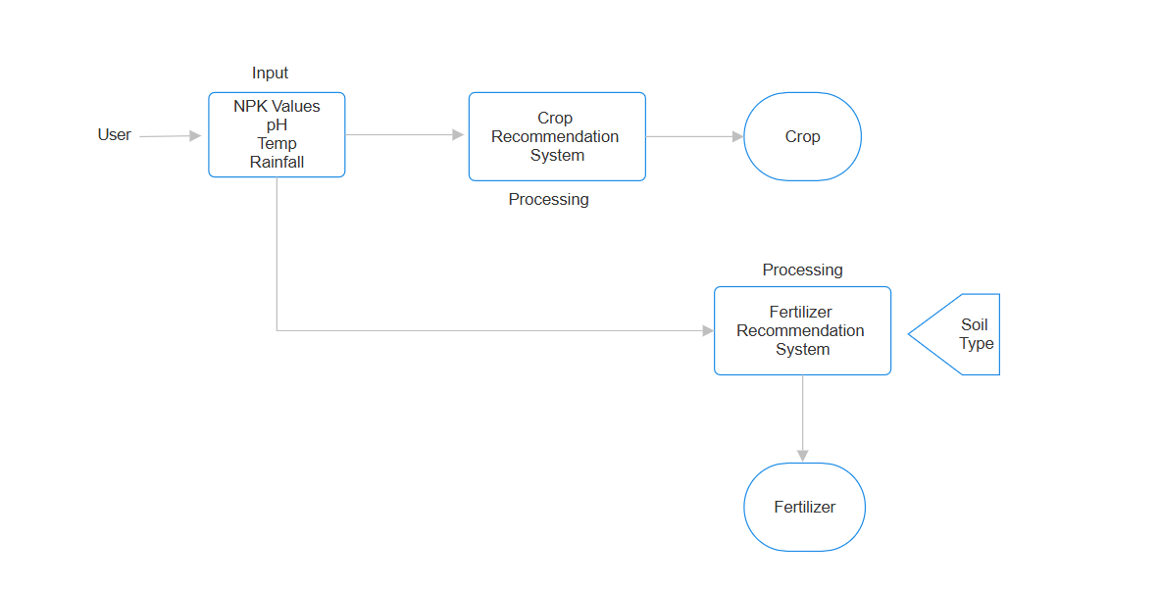

Figure 2 System Flowchart

This platform provides a user-friendly environment for farmers, making it simple to access. This portal simplifies decision-making using machine learning, based on the data provided by the farmer. It delivers accurate crop and fertilizer recommendations, enabling the effective use of resources and increased production.

# **RESULT AND DISCUSSION**

The platform effectively suggested crops and fertilizers based on soil conditions, climate factors, and nutrient levels. It recommended suitable crops for different soil pH levels, ensuring optimal growth and yield. Additionally, the system analyzed nutrient deficiencies and provided precise fertilizer recommendations to enhance soil fertility and crop productivity. By leveraging machine learning, the system offered data-driven insights, helping farmers make informed decisions for sustainable and efficient agriculture [11].

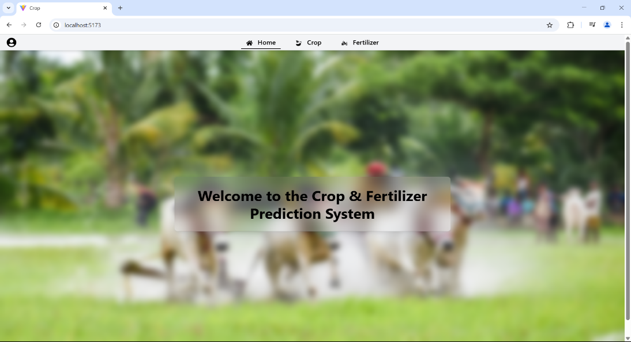

Figure 3 Home Page of Platform

1. **Model Performance and Accuracy**

After training the machine learning model using a dataset containing soil parameters, weather conditions, and crop yield data, the model achieved promising accuracy levels. The best-performing algorithm was **Random Forest**, which provided an **accuracy of 98%** in crop prediction.

1. **Crop Recommendation Results**

The system successfully recommended crops based on soil conditions, climate factors, and past yield performance.

* For acidic soils (pH < 6.0), the system suggested crop like Soya Chunks.
* For neutral soils (pH 6.5 – 7.5), crop such as Wheat was recommended.
* For alkaline soils (pH > 7.5), crop like Cotton was suggested.

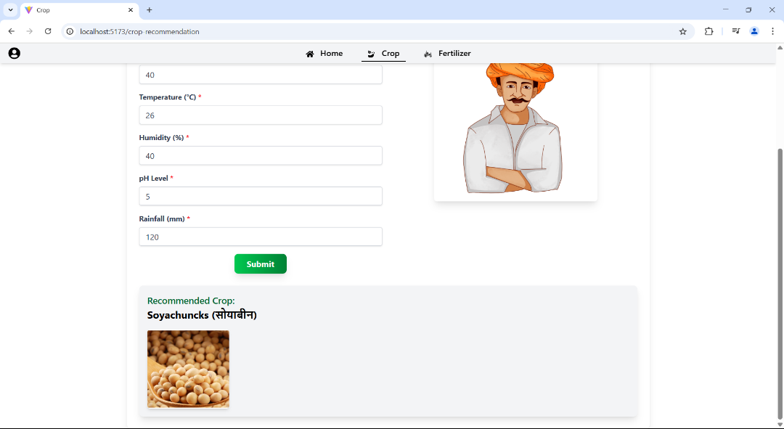

Figure 4 Crop Prediction System

1. **Fertilizer Recommendation Results**

The AI system provided fertilizer recommendations based on soil nutrient levels, ensuring optimal plant growth and improved crop yield. It analyzed deficiencies in essential nutrients such as nitrogen, phosphorus, and potassium, suggesting appropriate fertilizers to restore soil balance. By considering soil health, crop requirements, and environmental factors, the system helped farmers make precise and sustainable fertilizer choices, reducing waste and enhancing productivity.

* **For nitrogen-deficient soils**, Urea and Nitrate were suggested.
* **For phosphorus-deficient soils**, Super Phosphate (SP) and Phosphate (P) were recommended.
* **For potassium-deficient soils**, Potash was suggested.

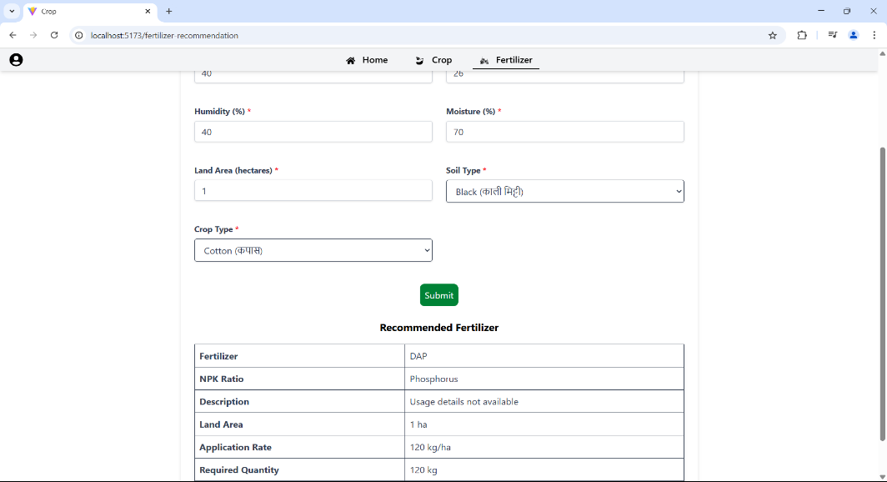

Figure 5 Fertilizer Recommendation System

1. **CONCLUSION**

This research demonstrated the efficacy of a Random Forest-based AI system for accurate crop yield prediction and optimized fertilizer recommendations. By leveraging diverse agricultural datasets, soil, data, the model significantly improved prediction accuracy compared to traditional methods. The system's ability to effectively handle complex, non-linear relationships within the data, coupled with its capacity to provide tailored fertilizer application rates, contributes significantly to precision agriculture and sustainable farming practices.

These findings underscore the potential for AI to empower farmers with data-driven decision-making. Future work should focus on integrating real-time sensor data, exploring advanced AI techniques such as deep learning and hybrid models, and developing user-friendly interfaces for broader adoption among diverse farming communities. Ultimately, this research provides a stepping stone towards intelligent agricultural systems that enhance food security, minimize environmental impact, and promote long-term agricultural sustainability.

1. **REFERENCES**
2. Book, The Innovation Revolution in Agriculture, A Roadmap for Growth given by Dr. Campos 1st ed., 2018.
3. D. Nyarko, “Student Perceptions of the Role of Players in Agricultural Technologies” Lowa State University , 2023.
4. P. Tiwari, and P. Shukla, “Crop yield prediction by modified convolutional neural network and geographical indexes,” International Journal of Computer Sciences and Engineering, vol. 6, no. 8, pp. 503- 513, 2018.
5. McKinsey & Company. (2020). "Agriculture's connected future: How technology can yield new growth." Retrieved from McKinsey
6. S. Khaki, and L. Wang, “Crop yield prediction using deep neural networks.” Frontiers in plant science, vol. 10, pp. 621, 2019.
7. Food and Agriculture Organization of the United Nations (FAO). (2020). "Digital technologies in agriculture and rural areas: Status report." Retrieved from FAO
8. Manoj Kumar, D.P., Malyadri, N. and Srikanth, M.S., 2021. A Machine Learning model for Crop and Fertilizer recommendation. NVEO-NATURAL VOLATILES & ESSENTIAL OILS Journal| NVEO, pp.10531-10539.
9. Khoshnevisan, B., Rafiee, S., Mousavi-Avval, S. H., & Rajabipour, A. (2013). Applications of artificial neural networks in agricultural engineering. Computers and Electronics in Agriculture, 94, 47-61.
10. Khoshnevisan, B., Rafiee, S., Mousavi-Avval, S. H., & Rajabipour, A. (2013). Applications of artificial neural networks in agricultural engineering. Computers and Electronics in Agriculture, 94, 47-61.
11. Adamchuk, V. I., Viscarra Rossel, R. A., Sudduth, K. A., & Mueller, N. L. (2011). On-the-go soil sensors for precision agriculture. Computers and Electronics in Agriculture, 76(2), 168-175.
12. Chai, T., & Draxler, R. R. (2014). Root mean square error (RMSE) or mean absolute error (MAE)? Arguments against avoiding RMSE in the presence of outliers. Geoscientific Model Development, 7(3), 1247-1250.
13. Pantazi, X. E., Moshou, D., & Tamouridou, A. (2016). Automated leaf disease detection in different crop species through image features analysis and two-level support vector machine classification. Computers and Electronics in Agriculture, 125, 98-104.
14. Mohanty, S. P., Hughes, D. P., & Salathé, M. (2016). Using deep learning for image-based plant disease detection. Frontiers in Plant Science, 7, 1419.
15. Box, G. E., Jenkins, G. M., Reinsel, G. C., & Ljung, G. M. (2015). Time series analysis: forecasting and control. John Wiley & Sons. (A classic, but still relevant)
16. Ferrandez-Pastor, F. J., Garcia-Sanchez, F., Nieto-García, A., & Sanchez-Soriano, J. (2016). Developing a wireless sensor network platform for vineyard monitoring. *Sensors*, *16*(8), 1141.
17. Pierce, F. J., & Nowak, P. (1999). Aspects of precision agriculture. *Advances in Agronomy*, *67*, 1-65.
18. Brady, N. C., & Weil, R. R. (2016). *The nature and properties of soils*. Pearson Education. (A fundamental soil science text)