**DESIGN AND CONSTRUCTION OF A REMOTE-CONTROLLED SOLAR POWER-DRIVEN ELECTRIC VEHICLE**

**BY**

**1ADAMU DAHIRU & 2IBRAHIM G.W**

1Department of Computer Engineering 2Department of Mechanical Engineering

1&2 The Federal Polytechnic Ilaro, Ogun State Nigeria

**Abstract**

This study delineates the formulation, advancement, and empirical assessment of a remote-operated, solar-powered electric vehicle, specifically designed to foster sustainable and renewable energy paradigms within the realm of transportation. The initiative amalgamates solar energy collection, proficient energy storage mechanisms, electric propulsion systems, and wireless remote-control technologies into an integrated vehicle model. A chassis of minimal weight was meticulously engineered to maximize energy efficiency, while the photovoltaic array was judiciously dimensioned to fulfill the operational requirements of both the electric motor and the control system. The remote-control apparatus facilitates precise navigational capabilities, thereby augmenting the vehicle’s applicability across diverse operational contexts. Evaluations of performance under varying environmental conditions evidenced effective harnessing of solar energy, acceptable vehicle velocity, and dependable control responsiveness. The outcomes indicate that compact solar electric vehicles can function as credible prototypes for the prospective advancement of environmentally sustainable transportation technologies. Further recommendations for system refinement and prospective enhancements are also elucidated.

**Keywords:** Electric mobility, Remote control system, Renewable energy, Solar-powered vehicle Sustainable transportation

1. **INTRODUCTION**

The accelerated depletion of fossil fuel reserves, coupled with escalating apprehensions regarding environmental degradation, has intensified the global quest for sustainable and renewable energy alternatives(Rohini K S et al., 2022). The transportation sector constitutes a significant source of greenhouse gas emissions, representing approximately 24% of global CO₂ emissions (Khamisani’ & A., 2018). Conventional internal combustion engine vehicles exhibit a pronounced reliance on non-renewable petroleum-based fuels, resulting in environmental pollution, economic susceptibility, and prolonged energy insecurity. Therefore, there exists an imperative necessity to develop clean and renewable energy-driven transportation systems that mitigate carbon footprints and foster environmental sustainability.

Solar energy, characterized as an abundant and inexhaustible resource, has emerged as a viable solution for the propulsion of vehicles. Solar-powered transportation systems harness solar radiation via photovoltaic (PV) technology to convert solar energy directly into electricity, which can subsequently be utilized to drive electric motors (Sambo & Garba, 2023). In comparison to conventional fuels, solar energy presents numerous advantages, including the absence of operational emissions, diminished dependence on finite resources, and the potential for decentralized energy generation. The integration of solar power into vehicular systems not only curtails greenhouse gas emissions but also augments energy autonomy and reduces long-term operational expenditures.

Notwithstanding substantial technological progress, various constraints continue to hinder the extensive adoption of electric and hybrid vehicles. Issues such as limited driving range, protracted battery charging durations, dependence on grid electricity (which may itself originate from non-renewable sources), and the elevated initial cost of ownership obstruct the mass commercialization of these innovative technologies (Akshay S1, Dhananjaya V2, Galvin Ignatius Menezes3, 2019). Furthermore, remote-controlled electric vehicles, typically employed for specialized or research applications, have seldom been investigated in conjunction with direct solar power systems. A notable research gap persists in the design of compact, efficient, solar-driven remote-controlled vehicles capable of showcasing the feasibility of renewable-powered transport prototypes.

The principal aim of this project is to conceptualize and construct a small-scale, remote-controlled electric vehicle that is directly powered by solar energy. The project seeks to optimize energy harvesting, storage, and utilization while ensuring dependable remote operability. Specifically, the research aspires to explore the integration of photovoltaic panels, energy storage systems, electric drive motors, and wireless control systems into a cohesive functional unit.

The ambit of this research is confined to the development of a prototype capable of functioning under moderate sunlight conditions, with remote control functionalities for maneuverability. The investigation encompasses system design, component selection, vehicle fabrication, circuit integration, and performance evaluation under real-world conditions. While the current project prioritizes small-scale applications, the design principles and findings are intended to contribute to the advancement of larger-scale developments in solar-driven transportation technologies.

1. **Overview of Existing Solar-Powered and Electric Vehicle Technologies**

The domain of solar-powered and electric vehicle (EV) technologies has experienced remarkable progress in recent decades. Solar vehicles predominantly employ photovoltaic (PV) panels for the direct conversion of solar radiation into electrical energy, which can either power the vehicle instantaneously or replenish onboard batteries for subsequent utilization (Aldandan et al., 2024). Contemporary electric vehicles, exemplified by manufacturers such as Tesla and Nissan, predominantly depend on battery energy storage systems, typically derived from lithium-ion technology, which are charged through the electrical grid. While the commercial application of solar-powered vehicles remains restricted, specialized initiatives such as the World Solar Challenge have effectively demonstrated the viability of solar mobility over extended distances (Manivannan & Kaleeswaran, 2017).

The proliferation of battery electric vehicles (BEVs) has been significantly influenced by advancements in battery energy density, cost reductions, and enhancements in electric motor efficiencies (Husnain, 2022). Nonetheless, fully solar-powered vehicles face constraints imposed by factors such as limited surface area available for PV panels, variability in solar irradiance, and restrictions associated with energy storage.

* 1. **Related Works on Remote-Controlled Vehicles**

Historically, remote-controlled (RC) vehicles have been powered by internal combustion engines or rechargeable batteries, primarily serving hobbyist, military, and research purposes. Recent innovations have facilitated the development of RC vehicles endowed with capabilities for autonomous navigation, obstacle avoidance, and wireless telemetry, utilizing technologies such as radio frequency (RF) communication, Bluetooth, and Wi-Fi modules (Ambavane et al., 2021). Certain experimental initiatives have amalgamated solar panels with RC vehicles to prolong operational durations by augmenting battery power (Kavishwar et al., 2024).

Despite the existence of several prototypes that incorporate solar energy into RC vehicles, they frequently encounter limitations stemming from low power generation rates, which result in diminished speeds or constrained maneuverability. The majority of these systems utilize solar energy as a supplementary source rather than as the primary energy source.

* 1. **Comparison of Previous Designs**

Earlier designs of solar-powered RC vehicles have attained varying levels of success predicated on distinct methodologies. For instance, (Heeraman et al., 2024) developed a rudimentary solar-assisted RC car that employed solar energy to sustain battery charge during operation. Although this design showcased extended operational time, it was hindered by low speed and inadequate power generation in low-light environments.

In contrast, (Dwivedi et al., 2018) introduced an autonomous RC vehicle capable of basic decision-making; however, this vehicle was entirely reliant on battery power, exhibiting no integration of renewable energy sources. This limitation curtailed operational sustainability and highlighted the necessity for energy autonomy within remote-controlled systems.

The strengths of these prior designs encompass successful implementation of wireless control and basic integration of renewable energy systems. However, significant limitations persist, including:

Insufficient energy harvesting to sustain continuous operation. Reliance on bulky or inefficient energy storage systems. Restricted scalability to practical or real-world applications.

* 1. **Identification of Research Gap**

While existing literature has investigated various aspects of solar energy integration within RC vehicles and advancements in wireless control technologies, a pronounced research gap persists regarding the design of a compact, efficient remote-controlled vehicle predominantly powered by solar energy. There remains a dearth of integrated systems that concurrently optimize solar energy harvesting and energy storage under realistic environmental conditions. Furthermore, the balance between functional mobility, power management, and weight reduction required for realistic solar-powered RC applications is not addressed by the majority of existing designs.   
By creating a prototype of a remote-controlled electric vehicle that runs mostly on solar power and is backed by effective energy storage, lightweight design, and reliable wireless control capabilities, this project seeks to close these gaps.

**3. Methodology**

**3.1. System Design**

Four main functional parts make up the proposed remote-controlled solar-powered electric vehicle system: the battery storage unit, the electric motor drive system, the remote-control unit, the solar panel, and the chassis structure. The combined objectives of remote mobility and energy sustainability are met by these elements. Figure 1.0 displays the system's block diagram.

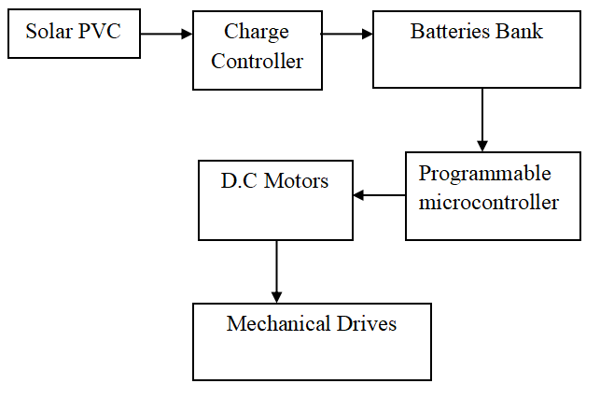

Figure 1 System Block Diagram

The integration of these subsystems ensures that the vehicle can effectively harness solar energy for propulsion while being remotely operated over a reasonable distance. The methodology focuses on maximizing energy efficiency, optimizing system weight, and ensuring reliable remote-control operation.

**3.1.2 Component Selection**

The selection of components for the solar-powered remote-controlled electric vehicle is crucial to achieving optimal performance, energy efficiency, and reliability. Below is a summarized table of the key components chosen for this project.

**Table 1: Component selection and standard**

| **Component** | **Specification** |
| --- | --- |
| **Solar Panel** | 15-20 Watts, 18-20% efficiency, Monocrystalline |
| **Motor** | DC Motor, 1-3 Nm torque, 12-24V, 50-100W |
| **Battery** | Li-ion, 12V, 2000-3000 mAh |
| **Remote Control** | RF (2.4 GHz) Transmitter/Receiver |
| **Frame Material** | Aluminum alloy, carbon fiber (optional), ABS plastic |

**3.2 Design Considerations**

The frame will be designed to hold all components securely, including the solar panel, battery, motor, and remote-control system. Special attention was given to the weight distribution to ensure the vehicle's stability and handling. The frame also allowed easy access to electrical components for maintenance or upgrades.

## **Power Requirement Calculation**

The mechanical power (P) needed by the DC motor is given by:  
P = F × v  
where: - F is the force required to move the vehicle (N) - v is the velocity of the vehicle (m/s)  
Assuming:  
- Mass of vehicle (m) = 5 kg  
- Rolling resistance coefficient (Crr) ≈ 0.015  
- Gravitational acceleration (g) = 9.81 m/s²  
- Target velocity (v) = 1.57 m/s (approx. 5.65 km/h)  
Force required (F) = m × g × Crr = 5 × 9.81 × 0.015 = 0.73575 N  
Thus, Power (P) = 0.73575 × 1.57 ≈ 1.15 W

**Battery Capacity Calculation**

Assuming desired operation time (t) = 2 hours:  
Energy required (E) = Power × Time = 1.15 W × 2 hr = 2.3 Wh  
Considering battery voltage (V) = 12V,  
Battery capacity (C) = (Energy × 1000) / Voltage = (2.3 × 1000) / 12 ≈ 191.67 mAh  
Choosing a standard battery size: 2200 mAh Li-ion battery for sufficient margin.

**Solar Panel Sizing**

Assuming solar panel operates at peak sunlight for 4 hours/day.  
Required panel output = Battery Energy / Available sunlight hours = 2.3 Wh / 4 hr ≈ 0.575 W  
Selecting a solar panel of 10W rating provides ample charging capacity.

## **Motor Selection**

The motor must deliver at least 1.15 W of mechanical power. Considering system efficiency around 70%,  
Electrical power required = 1.15 W / 0.7 ≈ 1.64 W  
At 12V system voltage:  
Motor current = Power / Voltage = 1.64 / 12 ≈ 0.137 A

## **3.3 Assembly Procedures**

**Chassis Construction**

The materials employed in the fabrication of the chassis comprised a lightweight aluminum alloy for the principal framework and ABS plastic for the exterior panels. The aluminum framework was meticulously cut in accordance with design specifications and subsequently assembled utilizing screws, thereby ensuring a construction that is both lightweight and robust, capable of sustaining all vehicle components. The wheels were affixed to the chassis with precise alignment to facilitate seamless mobility. ABS plastic was utilized in the design of the body panels, incorporating designated spaces for the installation of the solar panel, battery, and various electronic components.

**Mounting the Solar Panel**

The solar panel was affixed to the upper surface of the vehicle body to optimize exposure to solar radiation. Brackets and adhesive mounts were employed to securely fasten the panel to the framework, thereby ensuring that it remained unobstructed by other vehicle components.

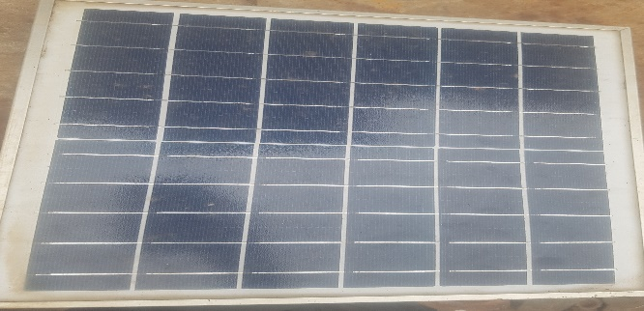

Figure 2 Solar panel

**Installing the Motor and Motor Driver**

The DC motor was securely positioned in proximity to the wheel axle to enhance the efficiency of torque transfer. The motor was interconnected with a motor driver circuit that is responsible for modulating the voltage and current in accordance with signals received from the remote control.

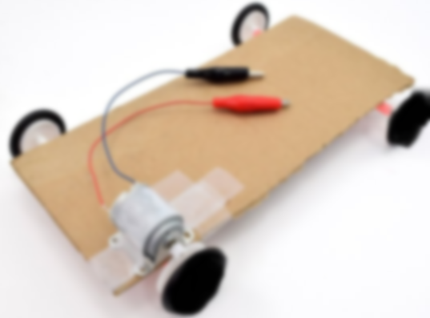

Figure 3: Motor installation

**Battery and Wiring Setup**

A Li-ion battery was installed within a safeguarded compartment on the chassis to mitigate the risk of external damage. It was interconnected with both the motor driver circuit and the solar panel, facilitating the battery's capability to power the motor while simultaneously receiving recharges from solar energy. All wiring was systematically arranged to prevent potential short circuits or power loss.

**Installing the Remote-Control Receiver**

An RF receiver module was strategically mounted on the chassis in a location that optimizes signal reception. The receiver was directly wired to the motor driver circuit. It decoded the signals from the remote control and converted them into motion commands for the motor, thereby enabling the remote operation of the vehicle.



Figure 4 System chassis

**4.0 Results Analysis**

This section delineates the analysis of the data accrued from the various tests conducted on the solar-powered remote-controlled electric vehicle. The test results are encapsulated in tables and graphs, succeeded by a discourse on the efficiency, performance, and system responsiveness of the vehicle under varying conditions.4.1 Summary of Test Results

**Table 2: Speed Test Results**

| **Test Condition** | **Measured Speed (km/h)** | **Notes** |
| --- | --- | --- |
| Full Sunlight | 5.65 km/h | Optimal performance |
| Shaded Condition | 3.4 km/h | Reduced speed due to less sunlight |
| 5 kg Load (Full Sun) | 5.2 km/h | Slight speed reduction due to added weight |
| 10 kg Load (Full Sun) | 4.3 km/h | Noticeable slowdown under heavy load |

**Table 3: Battery Charge/Discharge Rates**

| **Condition** | **Battery Voltage (V)** | **Time to Full Charge (hrs)** | **Discharge Rate (V/min)** | **Notes** |
| --- | --- | --- | --- | --- |
| Full Sunlight Charging | 18.5 V (fully charged) | 3 hours | 0.25 V/min | Battery charges efficiently under direct sunlight |
| Shaded Charging | 17.8 V (fully charged) | 5 hours | 0.3 V/min | Slower charging due to low solar intensity |
| Full Charge, Full Sun (Discharge Test) | 18.5 V (start) | - | 0.5 V/min | Moderate discharge rate under normal operation |
| Full Charge, Shade (Discharge Test) | 18.0 V (start) | - | 0.65 V/min | Faster discharge under low sunlight conditions |

**Table 4: Solar Panel Efficiency**

| **Condition** | **Solar Panel Power Output (W)** | **Incident Solar Power (W/m²)** | **Solar Efficiency (%)** |
| --- | --- | --- | --- |
| Full Sunlight | 12 W | 900 W/m² | 13.3% |
| Partial Shade | 6 W | 500 W/m² | 12.0% |
| Overcast Conditions | 3 W | 300 W/m² | 10.0% |

# **4.2 Discussion on Efficiency, Performance, and System Responsiveness**

**Efficiency**

The efficiency of the solar panels within the system was assessed to be approximately 13.3% under optimal solar irradiance conditions (specifically, 900 W/m²). This figure is consistent with the anticipated performance metrics for diminutive solar panel systems, which generally exhibit reduced efficiencies in comparison to their larger commercial counterparts. In environments characterized by shading, the efficiency diminished to approximately 12.0%, with a further reduction to 10.0% occurring under overcast atmospheric conditions. This decline in efficiency correlates with the reduction in solar irradiance, which directly influences the battery charging rate of the vehicle. The duration required for charging extended from approximately 3 hours in conditions of full sunlight to 5 hours in shaded environments.

**Performance**

The velocity of the vehicle was observed to fluctuate in accordance with the availability of solar power and the weight being transported.

**System Responsiveness**

The radio frequency-based remote-control system provided a dependable communication range of approximately 80 meters. This range is deemed sufficient for standard operational tasks, although the presence of obstacles and electromagnetic interference may potentially hinder operational efficacy. The responsiveness of the control system was deemed satisfactory, exhibiting immediate execution of motion commands with no notable input delay under typical operational scenarios.

**Battery Discharge**

In conditions of diminished light, the rates of battery discharge were observed to be elevated, indicating an increased dependence on stored energy when solar input is inadequate. This phenomenon highlights the necessity of sustaining robust solar energy input to prolong operational endurance.

**5.0 Conclusion**

From the comprehensive analysis of the test outcomes, it can be inferred that the solar-powered remote-controlled electric vehicle exhibits commendable performance under optimal sunlight conditions, achieving a maximum speed of 5.65 km/h alongside efficient battery functionality. Nonetheless, the efficiency and performance of the system deteriorate in lower light conditions, and the vehicle's load capacity imposes constraints on its overall speed. The insights derived from the battery charge/discharge rates and solar efficiency assessments provide invaluable perspectives on areas necessitating enhancement, particularly in optimizing the energy output from the solar panel and augmenting the battery's capacity to accommodate increased loads or extended operational durations.

**Implications for Future Improvements**

To augment the vehicle's performance, prospective designs could integrate solar panels with higher efficiencies, attaining rates of 18% or greater, thereby enhancing energy capture capabilities. An increase in battery capacity would facilitate the accommodation of heavier loads and extend operational durations, even in suboptimal lighting conditions. Upgrading the direct current motor could result in higher velocities and enhanced torque, particularly when functioning with larger payloads, thereby improving the overall robustness and capability of the system.

**REFERENCES**

Akshay S1, Dhananjaya V2, Galvin Ignatius Menezes3, P. A. K. P. R. (2019). Design & Fabrication of Remote Controlled Solar Lawn Mower. *International Research Journal of Engineering and Technology*, *6*(4), 89–93.

Aldandan, A., Dallol, L., Aldhefeeri, M., Alsalili, O., Esmaeili, S., Badreddine, F., & Hussain, G. (2024). Design and Implementation of a One-Seater Solar Car. *Journal of Sustainable Development of Energy, Water and Environment Systems*, *12*(1), 1–14. https://doi.org/10.13044/J.SDEWES.D12.0487

Ambavane, S. S., Bhoir, S. R., Pimpare, S. S., & Kulkarni, P. A. (2021). Designing of Solar Charging Stations for Electric Vehicle. *International Research Journal of Engineering and Technology*, 1247–1251. www.irjet.net

Dwivedi, A., Doltade, A., Lahane, S., & Bhagat, A. (2018). *Design and Development of Solar Powered Weeding Machine*. *8*(08), 608–615.

Heeraman, J., Kalyani, R., & Amala, B. (2024). Towards a Sustainable Future: Design and Fabrication of a Solar-Powered Electric Vehicle. *IOP Conference Series: Earth and Environmental Science*, *1285*(1). https://doi.org/10.1088/1755-1315/1285/1/012035

Husnain. (2022). Design and Analysis of a Micro Solar Electric Vehicle for Application in Pakistan. *IEEE Conference on Technologies for Sustainability (SusTech)*, *July*.

Kavishwar, S., Dhunde, A., Fande, A., Chamlate, S., Thakre, V., Indurkar, R., Zade, H., Petkar, A., Yadav, S., Sahani, R., Boratkar, A., Shingade, S., Dhapke, M., Manwatkar, P., & Murar, A. (2024). Design and Fabrication of Solar Based Electric Vehicle. *International Journal of Innovative Science and Research Technology (IJISRT)*, *9*(7), 1361–1364. https://doi.org/10.38124/ijisrt/ijisrt24jul1124

Khamisani’, & A., A. (2018). *Design Methodology of Off-Grid PV Solar Powered System ( A Case Study of Solar Powered Bus Shelter ) Author : Ayaz A . Khamisani Advisors : Dr . Peter Ping Liu , Dr . Jerry Cloward , Dr . Rendong Bai Table of content*. 20.

Manivannan, S., & Kaleeswaran, E. (2017). Solar powered electric vehicle. *2016 1st International Conference on Sustainable Green Buildings and Communities, SGBC 2016*. https://doi.org/10.1109/SGBC.2016.7936074

Rohini K S, Nikhatha H, Manoj S, Shashank M C, & Yathish Babu. (2022). *Solar And Wind Powered Electric Bus*. *10*(5), 14–17. www.jetir.org

Sambo, A., & Garba, U. (2023). Sustainable development of electric vehicles in Nigeria: Charging stations, research and development, and the way forward in a situation of electricity inadequacy. *Proceedings of the Nigerian Academy of Science*, *16*(1s), 28–45. https://doi.org/10.57046/jcnj4641