Analyzing the Impact of Virtual Gymnasium Environments on User Engagement and Fitness Motivation

**Ashraf Muslim Teli, Mubashshir Husain, Abdul Mohsin, Prof. Swapnil Gupta**

Department of Computer Science & Technology, Thakur Shivkumar Singh Memorial Engineering College, Burhanpur (MP)

**ABSTRACT**

The fitness industry is experiencing significant growth and transformation, characterized by an evolving definition of the gym environment. This research examines the future landscape of fitness, highlighting the integration of diverse health professionals such as exercise physiologists, physiotherapists, occupational therapists, and dieticians within fitness facilities. It posits that gyms will transition from traditional spaces focused solely on physical exercise to comprehensive wellness centres where individual exercise routines are assessed, treated, and restored through a holistic approach. By analysing current trends and innovations, this paper aims to provide insights into the emerging dynamics of the fitness sector and the implications for consumers and service providers alike.

**INTRODUCTION**

This project is designed to facilitate a gyms and fitness centre to automate it its operations of keeping records and store them in form of a large and user-friendly database further facilitating easy access to the personnel. A gymnasium, also known as a gym, is a covered location for athletics. The word is derived from the ancient Greek term "gymnasium". They are commonly found in athletic and fitness centres, and as activity and learning spaces in educational institutions. As one of the important facilities to improve the quality of the city, the gymnasium construction planning cannot be ignored. A strong start to any fitness-related content can help keep readers engaged and encourage them to explore more. It also helps to include relevant fitness keywords and themes to improve discoverability and reach the right audience. Additionally, the tone and message should align with the overall fitness brand or personal voice to maintain a consistent and trustworthy presence. A gym enthusiast, or "gym rat," is someone dedicated to regular training and physical development. In many ways, they can be seen as health entrepreneurs—investing time, energy, and sometimes money to transform their bodies and improve their lifestyles. Gym goes beyond lifting weights—it involves learning, discipline, self-care, and a constant drive to become better, both physically and mentally.

**DIETARY REQUIREMENTS**

A perfect diet is one that is healthy and provides adequate amount of water, carbohydrates, proteins, fats, dietary Fiber, vitamin and minerals. Having a balanced and proper diet is very important for the persons indulged in exercises to get desired results in terms of physical fitness. According to World Health Organization [WHO] a person needs to get at least 60– 75% of total energy from carbohydrates, 10-15 % from protein and 15-20% from fats. The gym going person needs more energy to fuel exercise and training. The dietary needs include more complex carbohydrates, increase in dietary Fiber, decrease saturated fat, adequate protein intake, decreased salt intake and increased fluid intake [Gulam Husein, 2020]. Whole cereal grains are a good source of carbohydrates, minerals and B-complex vitamins. In addition to the cereals the milk and milk-based products and fruits are a good source of carbohydrates.

**LIMITATION**

* Manual Searching and managing records are difficult.
* Admin cannot maintain records efficiently.
* Chances of errors are high. Data redundancy and inconsistency makes the existing system odd and inefficient.
* Very difficult to keep many records of member

**RESULT**

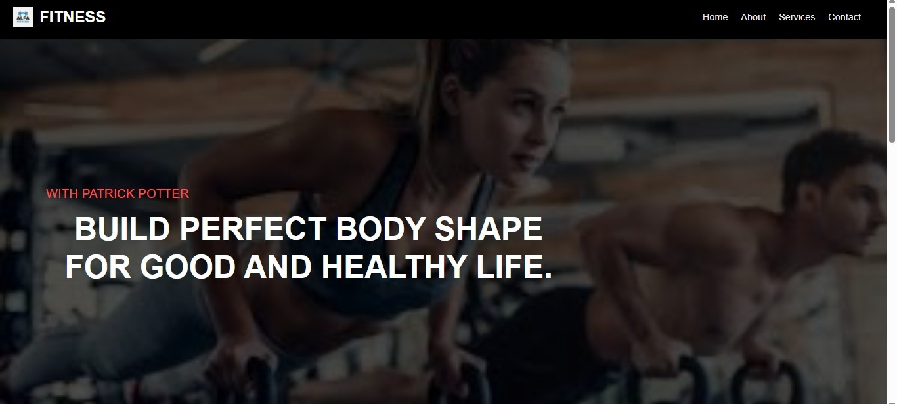

**Fig 1.1** Home Page of Gymnasium system

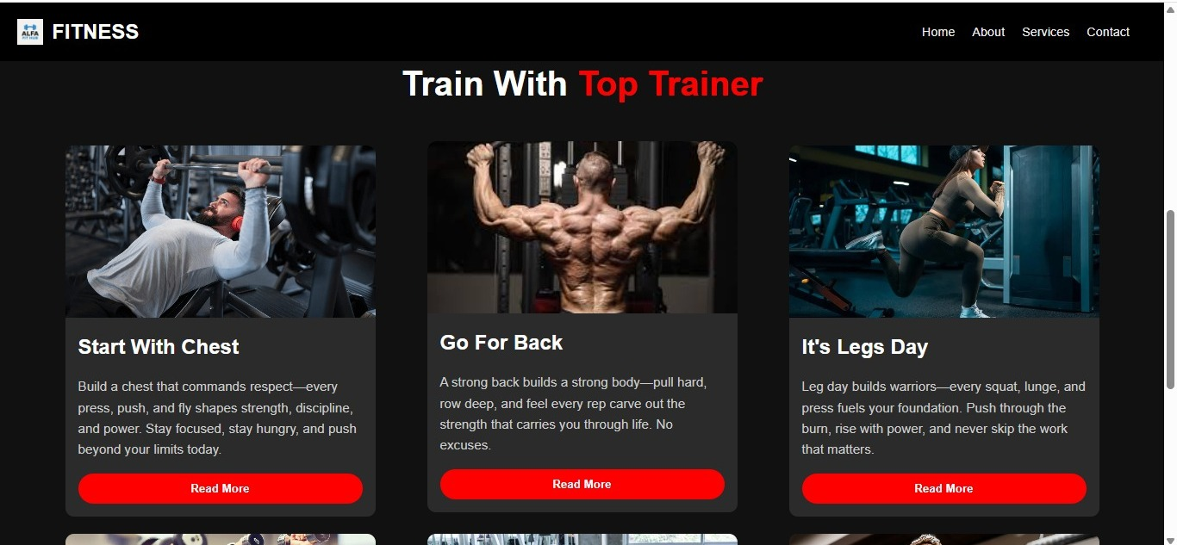

**Fig 1.2** Category Page of Gymnasium system

**APPLICATIONS**

* This website can be used by user in all over the world.
* This website can be handling by admin for updating content.
* Admin can monitor the activities of user.
* User can manage their content in one particular session.
* This website can reduce the time and effort for the user.
* This website provides easy interface to user.
* It reduces pen-paper effort.

**CONCLUSION**

Regular physical activity is one of the most important things you can do for your health. Being physically active can improve your brain health, help manage weight, reduce the risk of disease, strengthen bones and muscles, and improve your ability. The purpose of the gymnasium construction planning of the city gymnasium is to enable people to live a healthy life and improve the quality of life. Therefore, the concept of health must be implemented in the gymnasium construction planning process.

**FUTURE SCOPE**

* Correct club management software and select many options from system.
* By leveraging your software to engage members.
* Lot time consuming now a days due to this lots of time get as owner.
* Also, after some time this website add features and many more new things by which user interact with website.
* Member can use website freely and easily no complex thing to run website.

**REFERENCES**

[1]. "Node.js Design Patterns" by Mario Casciaro and Luciano Mammino – Second Edition, Packt Publishing, 2020.  
[2]. "Express in Action: Writing, building, and testing Node.js applications" by Evan Hahn, Manning Publications, 2016.  
[3]. "MongoDB: The Definitive Guide" by Kristina Chodorow – Third Edition, O'Reilly Media, 2019.  
[4]. "Learning JavaScript: JavaScript Essentials for Modern Application Development" by Ethan Brown, O'Reilly Media, 2016.  
[5]. "Eloquent JavaScript: A Modern Introduction to Programming" by MarijnHaverbeke – Third Edition, No Starch Press, 2018.  
[6]. "HTML and CSS: Design and Build Websites" by Jon Duckett, Wiley, 2011.  
[7]. "JavaScript and JQuery: Interactive Front-End Web Development" by Jon Duckett, Wiley, 2014.  
[8]. "Pro MERN Stack: Full Stack Web App Development with Mongo, Express, React, and Node" by Vasan Subramanian, Apress, 2019.  
[9]. "Full-Stack Web Development with MongoDB and Node" by Mithun Satheesh and Bruno Joseph D'mello, Packt Publishing, 2015.

[10]. "Mastering Node.js" by SandroPasquali, Packt Publishing, 2013.  
[11]. "Beginning Node.js" by Basarat Ali Syed, Apress, 2014.  
[12]. "Node.js Web Development" by David Herron – Fifth Edition, Packt Publishing, 2020.  
[13]. "Learning Web Design" by Jennifer Niederst Robbins – A Beginner’s Guide to HTML, CSS, JavaScript, and Web Graphics, O'Reilly Media, 2018.  
[14]. "CSS: The Missing Manual" by David Sawyer McFarland, O’Reilly Media, 2015.  
[15]. MDN Web Docs – <https://developer.mozilla.org/> (For HTML, CSS, JavaScript documentation)  
[16]. Node.js Official Documentation – https://nodejs.org/en/docs/  
[17]. MongoDB Official Documentation – <https://www.mongodb.com/docs/>  
[18]. Express.js Guide – <https://expressjs.com/>