# **Automatic Load Sharing of Transformers Using a Microcontroller with Protection Mechanisms**

## Mr Sibananda Mishra1, Mr Amlan Sahu2, Mr Niranjan Sahoo3, Mr Tapan Kumar Jena4, & Mr Swabhiman Mohapatra5 Department of Electrical and Electronics Engineering, Gandhi Institute for Technology (GIFT), Bhubaneswar, Odisha, India

**Abstract:**

This paper presents the design and implementation of **an automatic load-sharing system for transformers using a microcontroller** to enhance the transformer reliability in power distribution systems. In modern **power grids**, **transformer overloads** are a significant concern because they can lead to **increased maintenance costs**, **damage to equipment**, and even **power outages**. This project addresses this issue by introducing an intelligent system that **dynamically distributes loads** across two transformers based on real-time data, ensuring **optimal performance** and an **extended transformer lifespan**. The **microcontroller-based system** integrates key features, such as **overcurrent protection**, **under/over voltage detection**, and **thermal sensors** to prevent overload situations. The system monitors the electrical parameters and controls relays or circuit breakers to automatically adjust the load between transformers and safeguard the system from failure. By employing this approach, the **automatic load-sharing system** provides a **cost-effective** and efficient solution to ensure an uninterrupted power supply and to **prevent transformer damage**. This advancement is a step toward **smart power distribution** in modern **electrical grids** and industrial applications.

**Keywords:** Load Sharing, Transformers, Microcontroller, Protection System, Overload Prevention, Smart Grid, Automation.

**1. Introduction:**

Transformers are essential static devices in power distribution systems, responsible for transmitting electrical energy between circuits by varying the voltage levels without changing the frequency. Based on the principle of mutual induction, transformers are considered the "heart" of the power system, ensuring reliable power delivery to consumers. However, with increasing population growth and electrical demands, traditional power infrastructure often faces the threat of transformer overload. Overloads lead to excessive heating, insulation failures, and transformer breakdowns, causing expensive maintenance and extended downtime. Efficient transformer load management is critical for preventing thermal damage, ensuring system stability, and extending the lifespan of transformers. Conventional methods often rely on manual load adjustments, making them prone to errors and inefficiency. This creates a pressing need for automated and intelligent systems that are capable of real-time load management. Additionally, transformers are vulnerable to various environmental and electrical hazards such as transmission line failures, system faults, and sudden load surges. Overloaded transformers also contribute to voltage regulation problems, increased losses, and lower power factors. To address these challenges, this study proposes an innovative system for automatic load sharing using a microcontroller that monitors transformer load conditions and protects against overcurrent, overvoltage, undervoltage, and overheating. The system ensures balanced load distribution by dynamically switching additional transformers in parallel, thereby safeguarding against overload and improving the operational efficiency. Moreover, the integration of fault-detection mechanisms, such as thermal sensors and circuit breakers, contributes to a robust, reliable, and resilient transformer protection system that can support critical loads even under adverse conditions.

**2. Objectives:**

The primary objective of this project is to design an **automated load-sharing system** that ensures that transformers operate within their rated capacity, while preventing overloads. Key monitoring electrical parameters (current, voltage, and temperature) using **real-time sensors**. **Dynamic load distribution** between the two transformers based on monitored data. Protection mechanisms to prevent overload conditions, such as **overcurrent, under/over voltage**, and **overtemperature**. **The automatic switching** of transformers based on load-sharing algorithms ensures a **continuous and stable power supply**. To achieve these objectives, the proposed system integrates **microcontroller-based control and relay-driven protection systems**.

**3. Literature Review:**

Several manual and semi-automated load-sharing techniques have been proposed. Manual methods suffer from human error and delayed responses, whereas semi-automated systems offer limited real-time decision-making capabilities. Modern systems leverage microcontrollers for real-time load monitoring, dynamic load adjustment, and integration with a smart grid infrastructure. Recent innovations in sensors, wireless communications, and AI-based load management have further improved transformer performance.

**4. Methodology: System Design and Architecture**

The system for Automatic Load Sharing of Transformer and Its Protection is designed to improve the power distribution efficiency while ensuring transformer safety. The goal of the system is to reduce transformer overload, improve overall efficiency, and increase dependability by automating the load distribution process. This section describes the key components and principles that serve as the foundation for system design.

**Objective**: The main purpose is to guarantee that the load is evenly distributed between transformers, thereby minimizing overload conditions, maximizing operating efficiency, and increasing the reliability of the power distribution network. To achieve these goals, the system must be capable of real-time data collection, processing, and control.

**System Components & Sensors:**

The system consists of various components & sensors such as Transformer, Capacitor, Rectifier, Voltage Regulator, Piezoelectric Buzzer, Relay, DC Motor, Potentiometer,16 * 2 LCD Display, Microcontroller, NPN-Transistor, Over/Under Voltage Sensor & Over Temperature Sensor.

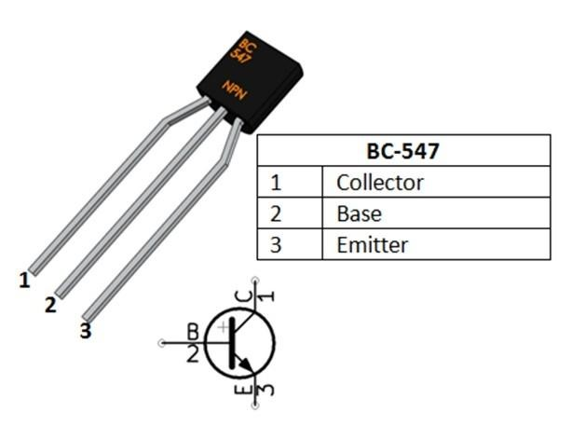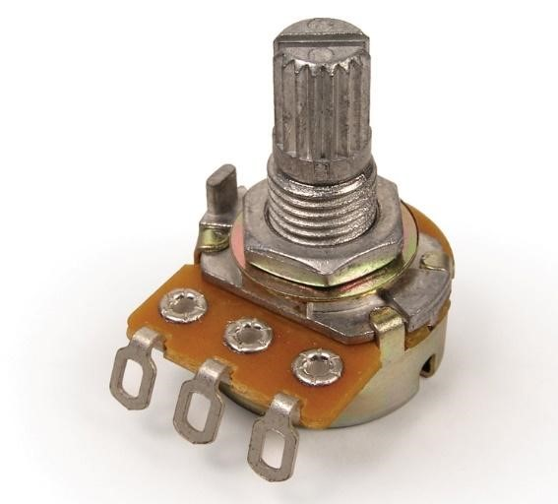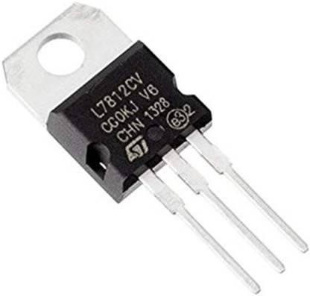

**FIG 1: NPN-Transistor** **FIG 2: Rectifier** **FIG 3: Voltage Rugulator** **FIG 4: Potentiometer**

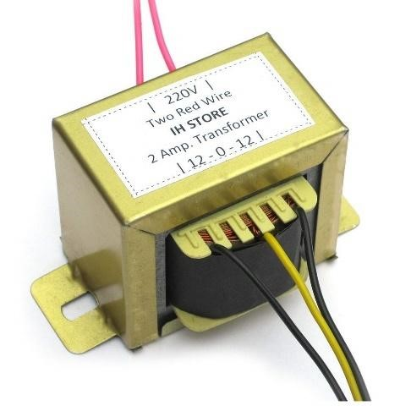

**FIG 5: Step down Transformer**

**FIG 6: DC Motor**

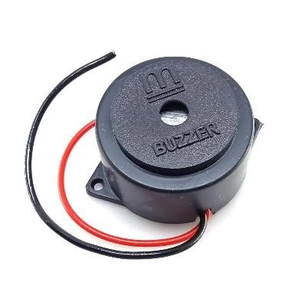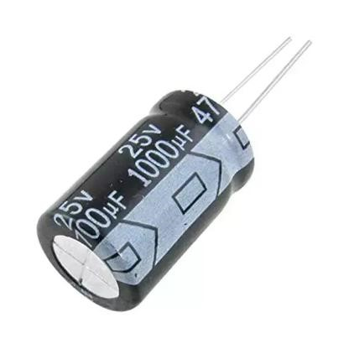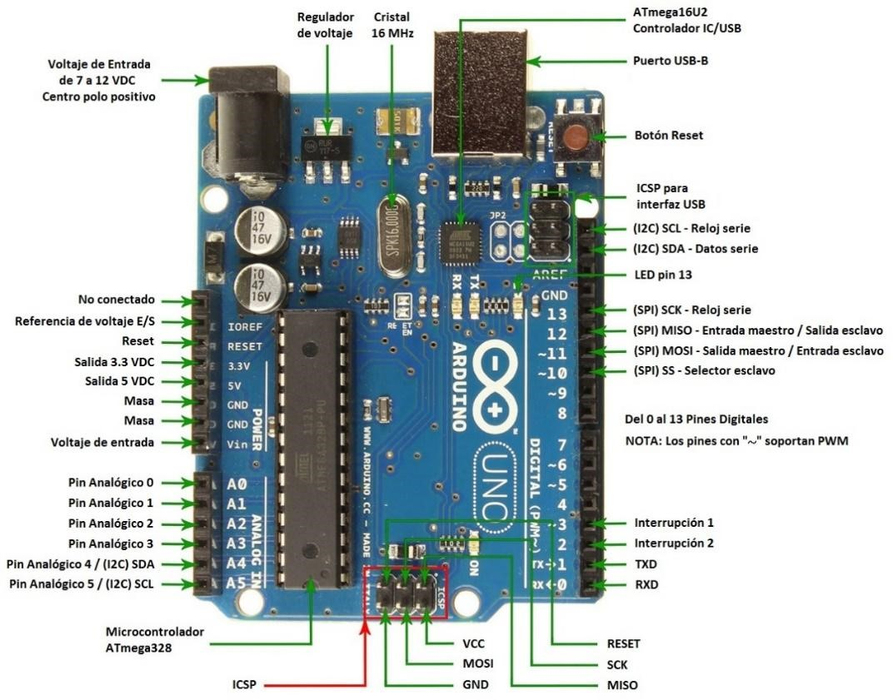

**FIG 7: Capacitor Fig 8: Electric Buzzer FIG 9: LCD Display FIG 10: Microcontroller**

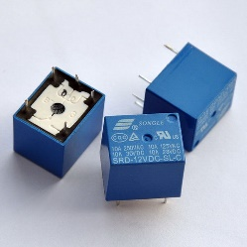 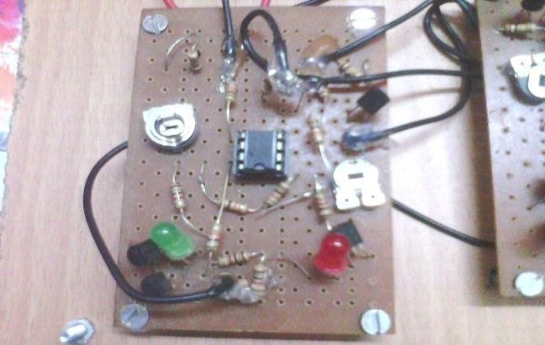

**FIG 11: Relay FIG 12: Over/Under Voltage Sensor FIG 13: Over Temperature Sensor**

**5. Block Diagram:**

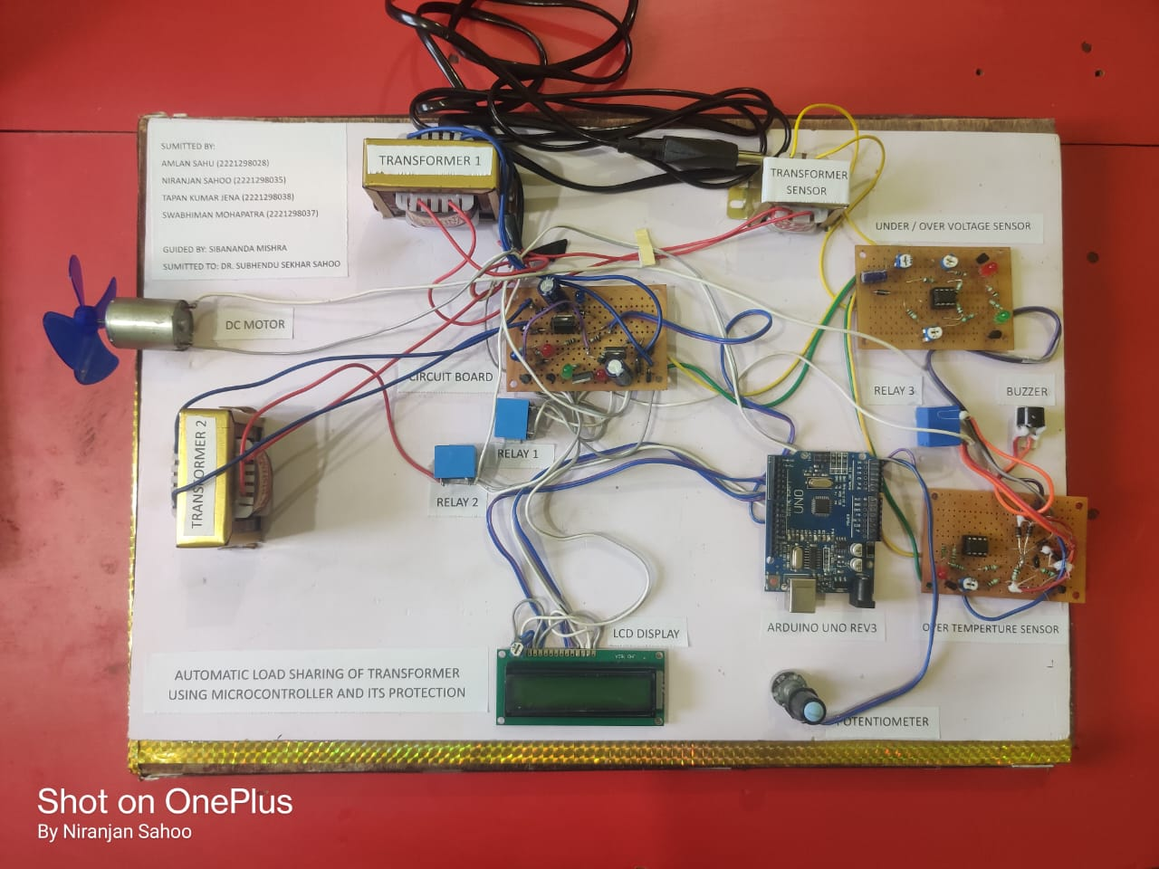

**FIG 14: Circuit Design**

**6. Problem Statement:**

Transformer overloads are a critical challenge for the stability of power distribution systems. When a transformer is subjected to currents beyond its rated capacity or experiences continuous overheating, the risk of insulation failure and internal mechanical damage significantly increases. Conventional load management practices are largely manual and reactive, relying on human intervention to detect anomalies and perform switching operations. This delayed response can lead to extended downtimes, service interruptions, and expensive repair operations. Moreover, an uneven load distribution across transformers reduces the overall system efficiency and results in economic losses. Therefore, there is a pressing need for an automated system capable of intelligent load balancing, real-time fault detection, and protective switching, without human intervention. By ensuring dynamic load redistribution and immediate corrective action, such a system can enhance the reliability, safety, and efficiency of electrical networks.

**7. Hardware Design and Implementation**

**Circuit Design:** The power section uses a 230V AC step-down to a 12V AC transformer, followed by rectification (1N4007 diodes), filtering (1000µF capacitors), and regulation (LM7812 and LM7805 ICs). The load-sensing circuit uses a **Power Supply:** Step-down transformers reduce 230V AC to 12V DC. A bridge rectifier and capacitors filter it into DC, regulated to 12V for relays and 5V for the Arduino Uno. **Relay Control:** Relays (12V, SPDT) are triggered based on load sensing to the connect/disconnect transformers. **Protection Circuits:** LM393 comparators detect under/over voltage conditions, while thermistors and LM393 op-amps monitor the temperature. Alarms and shutdowns are triggered by threshold breaches. **Relay Driver Circuit: -** NPN transistors (BC547) were used to drive the relays. Protection diodes prevent back EMF damage. **Microcontroller Programming: -** The Arduino program monitors the analog inputs from sensors and controls relays accordingly. The LCD output provides the user with real-time feedback regarding the load percentage and transformer status.

**8. Results and Analysis**

**Experimental Setup:** The system was tested under a range of operational conditions, including normal load, overload, voltage variations, and thermal stress. Under normal load conditions, the primary transformer is maintained during operation without triggering alarms or load transfers. Upon deliberately introducing an overload condition, the ACS712 sensor accurately detected the increase in current, and the Arduino microcontroller immediately initiated the load transfer to the secondary transformer with an observed switching time of less than one second. Similar results were obtained during the thermal tests, where the DHT11 sensor detected excessive heating and successfully prompted the system to switch automatically.

**Observations:** The voltage monitoring functionality of the ZMPT101B sensor maintained high accuracy with minor deviations of less than 5% compared to standard multimeter readings. The integration of the ESP8266 module provides real-time data visualization over IoT platforms, enhances operational transparency, and enables predictive maintenance planning. However, minor limitations such as electromagnetic interference affecting the sensor readings and slight relay mechanical delays were noted, suggesting potential areas for improvement. Future enhancements could involve integrating artificial intelligence-based predictive algorithms for advanced fault diagnosis and expanding the system to simultaneously support multiple transformer units.

**9. Discussion:**

The automatic load-sharing system demonstrated significant improvements in reliability compared to traditional manual systems. Quick detection of overloads and faults combined with automatic reconfiguration prevents downtime. Integrating microcontroller technology ensures scalability and remote-control possibilities, aligning with smart grid development.

**10. Future Work:**

Future improvements may include the integration of wireless communication modules such as Zigbee or GSM to enable remote load monitoring and control. Machine-learning models can be incorporated for predictive maintenance and forecasting overloads based on historical data. Iot-enabled dashboards allow utilities to access transformer health metrics in real time from any location. Renewable energy sources, such as solar or wind energy, can also be integrated into the system to enhance sustainability. Moreover, cloud-based analytics platforms can offer deep insights into transformer behaviour and suggest preventive actions automatically.

**11. Conclusion:**

Automatic load sharing of transformers using a microcontroller significantly enhances the system robustness by preventing overload and thermal failure. The proposed system minimizes human intervention, ensures real-time fault detection, and extends transformer lifespan. It is suitable for industrial, commercial, and rural power-distribution systems.

**12. References:**

[1] A. Sahu, N. Sahoo, T. K. Jena, S. Mohapatra, "Automatic Load Sharing of Transformers Using a Microcontroller and Its Protection," B. Tech Project Report, GIFT, BPUT, 2025.

[2] M. Sedighizadeh and M. S. Naderi, "Applications of Microcontrollers in Power System Protection," IEEE Transactions on Smart Grid, vol. 5, no. 4, pp. 1930-1937, 2019.

[3] M. E. El-Hawary, "Smart Grids and Microgrids: Advances and Challenges," IEEE Potentials, vol. 35, no. 1, pp. 6-10, 2016.

[4] H. Farhangi, "The Path of the Smart Grid," IEEE Power and Energy Magazine, vol. 8, no. 1, pp. 18-28, 2010.

[5] D. Cheng, "Transformer Protection and Management in Power Systems," Elsevier, 2014.