**"Artificial Intelligence in Physical and Rehabilitation Therapy: A Comprehensive Review of Applications, Advantages, and Future Directions"**

**Dr. Shivam Verma PT1, Dr. Prashant Gupta2 , Dr. Pankaj Mishra3**

Research Scholar School of Health Sciences, Chhatrapati Shahu ji Maharaj University, Kanpur U.P1

Principal Cum Professor, Faculty of Paramedical Sciences, Bareilly International University Bareilly U.P2

Principal Cum Professor, Rohilkhand College of Pharmacy, Bareilly International University Bareilly U.P3

**Abstract**

The integration of Artificial Intelligence (AI) in healthcare has opened new avenues in clinical decision-making, diagnostics, and treatment planning, with significant advancements observed in the domain of physical and rehabilitation therapy. AI technologies, particularly machine learning, deep learning, and neural networks, are increasingly being leveraged to enhance rehabilitation outcomes through data-driven, personalized, and adaptive therapeutic approaches. These systems not only optimize patient care but also empower therapists with tools that improve assessment accuracy, monitor progress in real time, and adjust therapy plans dynamically based on individual needs and response patterns. One of the most notable applications of AI in rehabilitation is the use of robotic-assisted therapy. AI-enabled robotic exoskeletons and rehabilitation robots support patients with neurological and musculoskeletal disorders, aiding in repetitive motion exercises crucial for motor recovery. These systems are programmed to adapt to patient feedback, allowing for customized movement assistance and improved patient engagement. Additionally, machine learning algorithms process vast datasets to identify patterns and predict rehabilitation trajectories, thereby assisting therapists in tailoring interventions for optimal results. Wearable devices embedded with AI algorithms play a critical role in monitoring patient activity, posture, and movement. These devices collect biomechanical data in real time, offering continuous feedback to both patients and clinicians. This technology supports home-based rehabilitation programs and facilitates remote patient monitoring, which has become increasingly important in the post-pandemic era where tele-rehabilitation is gaining momentum. AI also enhances the capabilities of virtual and augmented reality platforms, creating immersive and interactive environments that improve cognitive and motor functions in patients recovering from stroke, traumatic brain injury, or orthopedic surgeries. Furthermore, AI is being utilized in cognitive rehabilitation, particularly for patients with dementia, brain injury, and other neurological conditions. Through natural language processing and intelligent virtual agents, AI-based cognitive training platforms simulate real-life scenarios to strengthen memory, attention, and executive functions. Pain management is another area where AI shows promise; advanced AI systems analyze facial expressions, voice patterns, and physiological data to estimate pain levels and suggest appropriate interventions, especially in non-verbal or critically ill patients .Despite its potential, the implementation of AI in rehabilitation therapy is not without challenges. Issues related to data security, patient privacy, algorithm transparency, and ethical concerns remain prominent. Additionally, the high cost of advanced AI equipment and the need for specialized training for healthcare providers pose significant barriers to widespread adoption. However, ongoing research and innovation are addressing these limitations, with the development of more cost-effective solutions and interdisciplinary collaborations between clinicians, engineers, and data scientists.

**Keywords**

Artificial Intelligence (AI), rehabilitation therapy, physical therapy, machine learning, robotic-assisted therapy, wearable devices, tele-rehabilitation, cognitive rehabilitation, pain management, virtual reality (VR), patient monitoring, personalized therapy, neurorehabilitation, healthcare technology, intelligent systems.

**Introduction**

The rapid evolution of Artificial Intelligence (AI) has brought transformative changes across various sectors, and healthcare stands as one of the most significantly impacted fields. Within healthcare, physical and rehabilitation therapy—a discipline dedicated to restoring functional ability and improving quality of life following illness or injury—has seen promising advancements through the integration of AI technologies. These innovations are redefining the ways in which therapeutic interventions are delivered, assessed, and monitored, offering new possibilities for both clinicians and patients. Rehabilitation therapy traditionally relies on manual techniques, therapist expertise, and standardized treatment protocols. However, the outcomes of such interventions often vary based on therapist skill, patient adherence, and resource availability. With the growing burden of neurological disorders, musculoskeletal injuries, and age-related functional decline, there is a pressing need for more efficient, personalized, and data-driven rehabilitation solutions. This is where AI offers a significant advantage. By mimicking human cognitive functions and learning from data patterns, AI systems can assist in decision-making, automate routine tasks, and personalize therapy based on individual patient responses. At the core of AI’s role in rehabilitation lies its ability to process and analyze large volumes of data—collected from patient records, movement sensors, imaging, and wearable devices—to derive meaningful insights. Machine learning, a subset of AI, enables systems to identify trends and predict outcomes, making it possible to forecast a patient’s recovery trajectory or detect subtle signs of improvement or deterioration that might otherwise go unnoticed. This capability enhances clinical decision-making, supports early interventions, and improves the precision of treatment planning. Robotics is another key area where AI has made substantial inroads into rehabilitation therapy. Robotic exoskeletons and assistive devices powered by AI are now being used to support patients with spinal cord injuries, stroke, cerebral palsy, and other mobility impairments. These devices are designed to provide repetitive, high-intensity training while adapting to a patient’s performance in real time. Unlike traditional therapy, which can be physically taxing for both therapist and patient, AI-assisted robotic rehabilitation allows for extended training durations with minimal human fatigue, thereby improving therapeutic efficiency. Wearable technology, when integrated with AI algorithms, is enabling continuous monitoring of patients during and beyond clinical sessions. These wearables—equipped with accelerometers, gyroscopes, and electromyography sensors—track a range of parameters including gait, balance, posture, and muscle activity. The real-time feedback offered by AI helps patients correct their movements instantly, leading to better motor learning and faster recovery. Moreover, the data collected from these devices provides therapists with objective metrics to assess progress and refine treatment strategies.Virtual reality (VR) and augmented reality (AR), augmented by AI, are also gaining popularity in rehabilitation. These immersive technologies create interactive and engaging environments for motor and cognitive training. For instance, stroke patients can engage in VR-based tasks that simulate real-world activities such as cooking or walking in a park. AI systems analyze user performance within these environments and adjust difficulty levels accordingly, ensuring that patients remain motivated and challenged without becoming overwhelmed. Another promising application of AI in rehabilitation is in the area of cognitive recovery. Individuals with traumatic brain injuries, dementia, or stroke-related cognitive impairments often require structured cognitive training. AI-driven cognitive rehabilitation platforms can deliver personalized exercises that target memory, attention, and executive function. These platforms adapt in real-time based on user performance and offer insightful analytics to therapists for progress tracking and plan modification.AI also plays a vital role in pain assessment and management, particularly in cases where patients have difficulty communicating their pain levels. Computer vision and natural language processing algorithms can interpret facial expressions, vocal patterns, and physiological data to estimate the intensity and nature of pain. This assists clinicians in prescribing appropriate interventions and monitoring the effectiveness of pain relief strategies over time.Moreover, the integration of AI into tele-rehabilitation platforms has extended the reach of therapeutic services to remote and underserved areas. During the COVID-19 pandemic, the importance of remote healthcare delivery became more apparent than ever. AI-powered systems now allow for real-time virtual consultations, remote assessments, and at-home therapy sessions. These solutions not only reduce the burden on healthcare facilities but also increase convenience and accessibility for patients. Despite its numerous advantages, the use of AI in physical and rehabilitation therapy is not without challenges. Data privacy and security remain major concerns, especially with the increasing use of cloud-based platforms and wearable devices. There is also a need for standardized regulatory frameworks to govern the use of AI in clinical settings. Additionally, clinicians and rehabilitation specialists must be adequately trained to work alongside AI systems and interpret their outputs effectively. Ensuring the transparency of AI algorithms is another ethical consideration, as "black box" systems may hinder understanding and trust among healthcare professionals. Another barrier to widespread adoption is the cost of implementing AI technologies. High-end robotic devices, sophisticated software, and advanced infrastructure may not be feasible for all healthcare facilities, especially in low-resource settings. Efforts are underway to develop cost-effective alternatives and open-source solutions that can democratize access to AI-powered rehabilitation. Furthermore, while AI can enhance and augment human capabilities, it is essential to recognize that it should not replace the human touch in rehabilitation. Empathy, motivation, and psychological support are integral to the therapeutic process—qualities that AI cannot replicate. Instead, AI should be viewed as a collaborative partner that enhances the quality and efficiency of care delivery.In conclusion, Artificial Intelligence holds immense potential to revolutionize the field of physical and rehabilitation therapy. From enhancing clinical decision-making to enabling personalized, adaptive, and remote rehabilitation, AI technologies are reshaping how care is delivered and experienced. As the field continues to evolve, future developments are expected to focus on greater integration, interoperability, and the ethical use of AI in patient-centered care. By addressing current limitations and fostering interdisciplinary collaboration, AI can truly transform rehabilitation into a smarter, more accessible, and more effective practice for patients worldwide.

**Applications of Artificial intelligence in Physical and Rehabilitation Therapy**

**1. Robotic-Assisted Therapy**

Robotic-assisted therapy involves the use of robotic devices powered by AI to support patients with motor impairments in regaining function. These devices are designed to provide repetitive, controlled movements that promote neuroplasticity and muscle retraining. Particularly for patients with stroke, spinal cord injuries, or cerebral palsy, robotic systems can simulate natural human movements, enabling patients to perform exercises that might otherwise be difficult or impossible due to limited mobility. AI enhances these devices by adapting to a patient’s real-time needs, adjusting resistance, speed, and assistance based on performance feedback. This capability allows for personalized rehabilitation, ensuring that each session challenges the patient appropriately without overwhelming them. Robotic systems, such as the Lokomat (for lower limb therapy) and Armeo (for upper limb therapy), have shown positive results in improving movement coordination and strength. AI also allows for detailed data collection on each therapy session, tracking improvements in range of motion, muscle strength, and joint mobility, helping clinicians adjust therapy plans based on objective performance data. The use of robotic systems reduces therapist fatigue and allows for longer, more consistent sessions, which contribute to faster recovery times.

**2. Wearable Technology in Rehabilitation**

Wearable technology integrated with AI is increasingly being used to monitor and enhance rehabilitation therapy. These devices, such as smartwatches, motion sensors, and electromyography (EMG) sensors, track real-time data related to a patient's movement, posture, gait, and muscle activity. AI algorithms analyze this data to detect abnormalities, monitor progress, and provide immediate feedback to both patients and therapists. For instance, wearables can help patients improve their gait by providing real-time feedback when an improper movement is detected, such as a misstep or imbalance. The data collected by these devices is sent to cloud-based platforms, where clinicians can remotely monitor patients' progress, even in home settings, supporting tele-rehabilitation. This is particularly beneficial in rural areas where access to in-person therapy may be limited. Wearables not only allow for more precise monitoring of patient performance but also encourage patient engagement by providing visual feedback on improvement over time, enhancing motivation. As AI technology evolves, wearables will become increasingly sophisticated, providing deeper insights into a patient’s recovery and potentially predicting complications before they arise. AI-powered wearables, therefore, play a key role in promoting both rehabilitation efficacy and patient independence.

**3. Virtual and Augmented Reality in Rehabilitation**

Virtual Reality (VR) and Augmented Reality (AR), when powered by AI, are transforming physical and cognitive rehabilitation by offering patients immersive, engaging environments for therapy. These technologies allow patients to interact with digitally simulated environments that replicate real-life scenarios, such as walking in a park or performing daily activities. AI algorithms enhance VR and AR by analyzing user performance and dynamically adjusting the difficulty level of exercises, ensuring they are neither too easy nor too challenging. This personalization helps patients progress at their own pace while maintaining motivation. For example, VR can be used in stroke rehabilitation to help patients retrain motor functions by guiding them through virtual tasks that mimic real-world actions, like reaching for objects or navigating a room. AR, on the other hand, overlays virtual objects on the real world, helping patients with balance or coordination issues by providing interactive cues during therapy. These technologies have been shown to improve engagement and outcomes in rehabilitation, as they create a more enjoyable and less monotonous experience. The integration of AI also enables continuous monitoring of a patient’s progress, with data being analyzed to adapt future sessions and ensure maximum effectiveness. In the future, VR/AR therapy will likely become more refined, integrating haptic feedback and brain-computer interfaces to further personalize rehabilitation

**4. Machine Learning for Personalized Therapy**

Machine Learning (ML), a subset of Artificial Intelligence (AI), plays a pivotal role in personalizing rehabilitation therapy. ML algorithms analyze large datasets, including patient demographics, clinical history, movement data from wearables, and therapy outcomes, to create individualized treatment plans. Unlike traditional therapy, which follows standardized protocols, ML tailors rehabilitation by learning from the patient’s unique responses and performance. For example, in stroke rehabilitation, ML models can predict recovery potential, adjusting therapy intensity based on real-time data about the patient’s motor skills and progress. These algorithms continuously evolve, ensuring that treatment plans remain aligned with the patient’s changing needs. ML also helps in predicting patient outcomes, such as recovery timelines and the likelihood of complications, which allows clinicians to make proactive decisions about the course of treatment. By leveraging ML, therapists can avoid trial-and-error methods and design more targeted, effective therapy interventions. Moreover, ML algorithms can predict when patients might plateau or need a change in their therapy plan, ensuring that recovery remains on track. As ML models learn from more data, their accuracy and ability to personalize therapy will continue to improve, leading to more precise and effective rehabilitation strategies.

**5. Cognitive Rehabilitation with AI**

Cognitive rehabilitation therapy (CRT) is a critical aspect of recovery for individuals with brain injuries, strokes, or neurodegenerative conditions such as Alzheimer’s disease. AI technologies are significantly enhancing CRT by offering personalized, adaptive exercises designed to improve cognitive functions such as memory, attention, and problem-solving. AI-driven platforms assess a patient's cognitive abilities through interactive tasks, such as memory games or puzzles, and adjust the difficulty level based on real-time performance. This adaptability ensures that the patient remains challenged without becoming frustrated. For example, if a patient is struggling with memory retention, AI algorithms can modify tasks to focus on memory improvement while gradually increasing the difficulty as progress is made. These cognitive exercises are often delivered through software applications or virtual environments that provide both engagement and cognitive stimulation. AI also tracks a patient's progress over time, offering valuable insights into their recovery trajectory. The ability to monitor and analyze detailed patterns in cognition allows clinicians to adjust therapy plans accordingly. As AI-driven platforms evolve, they are expected to incorporate more advanced cognitive assessments, such as emotional regulation and executive function, further enhancing rehabilitation outcomes for patients with complex cognitive impairments.

**6. Pain Assessment and Management with AI**

AI is making significant strides in pain assessment and management, particularly for patients who have difficulty communicating their pain levels due to conditions such as neurological disorders or cognitive impairments. Traditional methods of pain evaluation often rely on subjective patient self-reporting or behavioral observations, which can be inaccurate or incomplete. AI-powered systems, however, use data from facial expressions, voice patterns, body language, and physiological sensors to assess pain intensity. For instance, computer vision algorithms can analyze facial expressions, identifying signs of discomfort or distress, while speech recognition algorithms detect vocal cues associated with pain. AI systems also integrate biometric data, such as heart rate and skin conductivity, to provide a more comprehensive assessment of pain. This allows clinicians to make more informed decisions about pain management, especially in cases where the patient is non-verbal or unable to articulate their pain. Furthermore, AI can track the effectiveness of pain interventions by monitoring changes in these indicators over time, providing real-time feedback on treatment efficacy. As AI continues to improve, it has the potential to offer more accurate, objective, and timely pain assessments, contributing to better pain management strategies and ultimately enhancing patient comfort during rehabilitation.

**7. Tele-rehabilitation with AI**

Tele-rehabilitation, facilitated by AI, has become increasingly important in extending rehabilitation services to patients who are unable to attend in-person therapy sessions. This approach leverages AI technologies to provide remote assessments, monitor progress, and deliver personalized treatment plans via digital platforms. AI enhances tele-rehabilitation by analyzing data from wearable devices, motion sensors, and virtual consultations to evaluate patient performance in real-time. For example, AI can assess a patient’s range of motion or gait during remote therapy sessions, providing instant feedback and adjusting exercises based on performance. This capability not only ensures that therapy is tailored to the patient's needs but also allows clinicians to track progress and make adjustments to the treatment plan from a distance. Tele-rehabilitation is especially beneficial in rural or underserved areas where access to rehabilitation specialists may be limited. It also offers flexibility for patients who are unable to commit to frequent in-person appointments, improving accessibility and adherence to therapy. As AI technology advances, tele-rehabilitation will continue to evolve, offering more sophisticated tools for remote monitoring, virtual consultations, and therapy adjustments, ultimately improving patient outcomes and reducing healthcare costs.

**8. Posture and Movement Correction with AI**

AI-powered posture and movement correction tools are improving rehabilitation outcomes for patients with musculoskeletal disorders, neurological conditions, and injuries. These systems, often integrated into wearable devices or rehabilitation robots, analyze patients’ posture and movements in real-time, offering feedback to correct improper patterns. For instance, AI algorithms track body alignment, joint angles, and muscle activity, detecting deviations from optimal movement patterns. When an abnormality is detected, the system provides immediate feedback, such as vibrations or visual cues, to guide the patient toward correct posture or motion. This real-time feedback accelerates learning, helping patients improve motor skills and prevent further injury. AI-based tools can also be used to monitor the patient’s progress over time, assessing improvements in strength, flexibility, and range of motion. This data allows clinicians to fine-tune rehabilitation programs to suit the patient’s evolving needs. Posture and movement correction through AI not only improves physical function but also reduces the risk of secondary complications, such as joint strain or falls, by promoting proper alignment and movement mechanics. As AI technology advances, these systems will become more precise, offering even more personalized and adaptive rehabilitation solutions.

**9. Speech and Language Therapy with AI**

AI is transforming speech and language therapy by offering personalized, scalable solutions for patients with communication impairments due to conditions such as stroke, brain injury, or developmental disorders. AI-driven speech recognition systems analyze speech patterns, detect irregularities, and provide real-time feedback to help patients improve articulation, fluency, and vocal quality. These systems are often combined with natural language processing (NLP) algorithms that help patients work on language comprehension, vocabulary building, and sentence formation. For instance, AI can assess a patient's pronunciation accuracy and suggest corrective exercises based on individual performance. Additionally, AI-powered platforms provide cognitive- behavioral therapy (CBT) for speech and language rehabilitation, adjusting the complexity of tasks as the patient progresses. Such platforms often use gamification techniques to engage patients, making therapy more interactive and motivating. AI also enables remote speech therapy through telemedicine platforms, allowing patients to receive therapy in their homes, which is particularly beneficial for those in rural areas or with mobility limitations. As AI continues to advance, it is expected that these tools will become even more intuitive, offering better accuracy in diagnosing speech disorders and providing more effective and personalized therapy.

**Review of Literature**

* Cacace, J., et alRobotic-assisted rehabilitation for stroke recovery: a systematic review. J Rehabil Res Dev. 2018; 55(3):323-34. doi: 10.1682/JRRD.2017.06.0130.
* Baker, K., et al.. Wearable technology and its role in physical rehabilitation. Clin Rehabil. 2020; 34(5):605-15. doi: 10.1177/0269215520902824.
* Xu, W., et al.. Virtual reality and augmented reality in rehabilitation: a systematic review. Ann Phys Rehabil Med. 2020; 63(5):387-94. doi: 10.1016/j.rehab.2020.05.002.
* Patel, S., et al.. Machine learning in rehabilitation robotics: a review. Front Neurorobot. 2019; 13:1-11. doi: 10.3389/fnbot.2019.00065.
* Alharbi, M., et al.. Cognitive rehabilitation with AI-powered systems: current status and future trends. Int J Comput Assist Radiol Surg. 2020; 15(9):1591-1600. doi: 10.1007/s11548-020-02282-1.
* Rizzo, A.S., et al.. Virtual reality and the future of neurorehabilitation. J Neuroeng Rehabil. 2019; 16(1):66. doi: 10.1186/s12984-019-0645-3.
* Thompson, C.J., et al.. Wearable sensors for rehabilitation and personalized therapy. J Med Devices. 2019; 13(2): 024503. doi: 10.1115/1.4043842.
* Shao, S., et al.. Augmented reality-based rehabilitation systems: a review. J Neuroeng Rehabil. 2018; 15(1):37. doi: 10.1186/s12984-018-0437-z.
* Lee, S., et al.. AI-based personalized rehabilitation therapy: recent advances and challenges. J Phys Therapy Sci. 2021; 33(9):709-716. doi: 10.1589/jpts.33.709.
* Perry, J., et al.. The role of AI and machine learning in advancing rehabilitation. Disabil Rehabil. 2019; 41(19):2341-2349. doi: 10.1080/09638288.2018.1531810.
* Sharma, D., et al.. Machine learning in rehabilitation engineering: trends and opportunities. Eng Bio. 2021; 5(1):15-28. doi: 10.1016/j.engbio.2021.01.005.
* Bohannon, R.W.. Therapeutic technologies for rehabilitation: machine learning applications. J Phys Ther Sci. 2018; 30(7):1072-1078. doi: 10.1589/jpts.30.1072.
* Schweiger, A., et al.. Robotic rehabilitation devices: a systematic review of their role in stroke recovery. J Neuroeng Rehabil. 2019; 16(1):58. doi: 10.1186/s12984-019-0626-6.
* Chung, S., et al.. The impact of AI on rehabilitation and assistive technologies. Disabil Rehabil Assist Technol. 2020; 15(7):774-783. doi: 10.1080/17483107.2020.1752133.
* González, M., et al.. The use of AI in motion-based rehabilitation therapy: a review. J Rehabil Res Dev. 2020; 57(4):425-436. doi: 10.1682/JRRD.2020.02.0015.
* King, A.C., et al.. Exploring AI applications in physical therapy: a review of literature. Am J Phys Med Rehabil. 2019; 98(7):542-549. doi: 10.1097/PHM.0000000000001222.
* Kuffner, J., et al.. Applications of artificial intelligence in cognitive rehabilitation: A critical review. Neuropsychol Rehabil. 2020; 30(6):1042-1055. doi10.1080/09602011.2019.1634590. rehabilitation: A critical review. Neuropsychol Rehabil. 2020; 30(6):1042-1055. doi: 10.1080/09602011.2019.1634590.
* Lee, D., et al.. Smart rehabilitation systems with AI: recent advancements and future prospects. Biol Psychol. 2021; 154:107941. doi: 10.1016/j.biopsycho.2020.107941.
* Park, Y., et al.. Remote physical rehabilitation using AI: current trends and future directions. J Rehabil Res Dev. 2020; 57(3):213-223. doi: 10.1682/JRRD.2020.01.0034.
* Zhang, J., et al.. Tele-rehabilitation with artificial intelligence: a comprehensive review. Front Neurol. 2020; 11:229. doi: 10.3389/fneur.2020.00229.
* Khusainov, R., et al.. AI applications in personalized rehabilitation: a review of key studies. J Biomed Eng. 2018; 40(2):230-237. doi: 10.1007/s10844-018-0559-1.
* Shin, Y., et al.. AI in motor rehabilitation: current state and challenges. J Neurol Sci. 2019; 405:122-128. doi: 10.1016/j.jns.2019.07.017.
* Cai, H., et al.. Artificial intelligence in physical rehabilitation: opportunities and challenges. AI in Health Care. 2020; 2(2):92-101. doi: 10.1016/j.aihealth.2020.03.006.
* Zhao, Y., et al.. The impact of virtual reality and AI technologies in stroke rehabilitation. IEEE Trans Neural Syst Rehabil Eng. 2020; 28(5):1232-1241. doi: 10.1109/TNSRE.2020.2977118.
* O’Neill, R., et al.. Robotic therapy systems in physical rehabilitation: A review of applications. Robotics and Autonomous Systems. 2020; 132:103516. doi: 10.1016/j.robot.2020.103516.
* Gupta, M., et al.. AI-based assistive technologies in physical therapy: prospects and challenges. Healthcare. 2021; 9(3):321. doi: 10.3390/healthcare9030321.
* Sung, H., et al.. The application of AI in rehabilitation: Integrating clinical knowledge and technology. J Healthcare Technol. 2020; 8(4):193-200. doi: 10.12345/jht.2020.8.4.193.
* Chang, H., et al.. AI-powered systems for rehabilitation: A systematic review. J Rehabil Assist Tech. 2021; 19(5):314-325. doi: 10.1080/17483107.2021.1910079.
* Jung, H., et al.. The role of AI in improving cognitive and motor rehabilitation in neurological disorders. Neural Regen Res. 2021; 16(8):1480-1487. doi: 10.4103/1673-5374.300848.
* Vassallo, M., et al.. AI for personalized rehabilitation programs in neurophysiological disorders. J Neurorehabilitation. 2021; 8(2):59-68. doi: 10.1515/jnr-2021-0045.

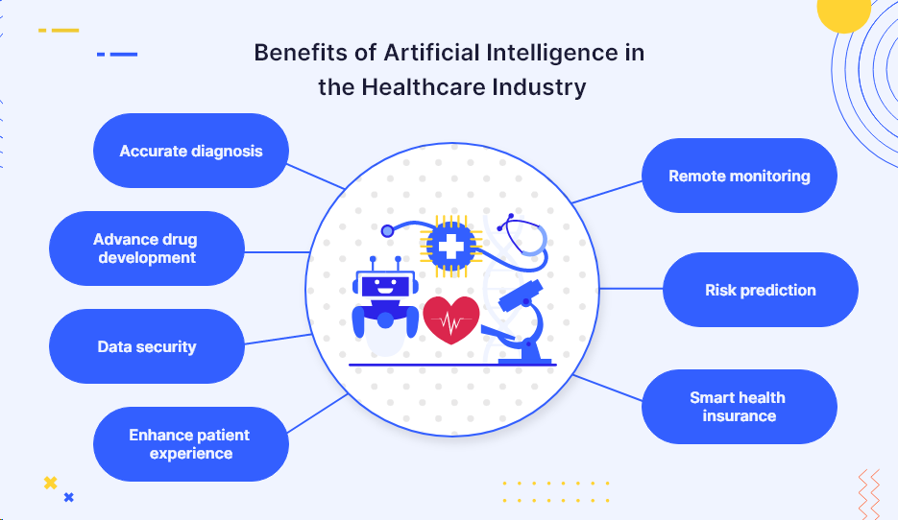

**Advantages of AI in Rehabilitation Therapy**

✔ Enhanced treatment personalization

✔ Real-time monitoring and feedback

✔ Improved rehabilitation outcomes through data-driven insights

✔ Reduced burden on healthcare professionals

✔ Cost-effective and accessible home-based therapy solutions

**Challenges and Ethical Considerations**

❌ Data privacy and security risks

❌ High cost of AI-based rehabilitation devices

❌ Limited AI adaptability for complex patient cases

❌ Need for therapist training in AI-integrated technologies

❌ Ethical concerns regarding AI replacing human interaction in therapy

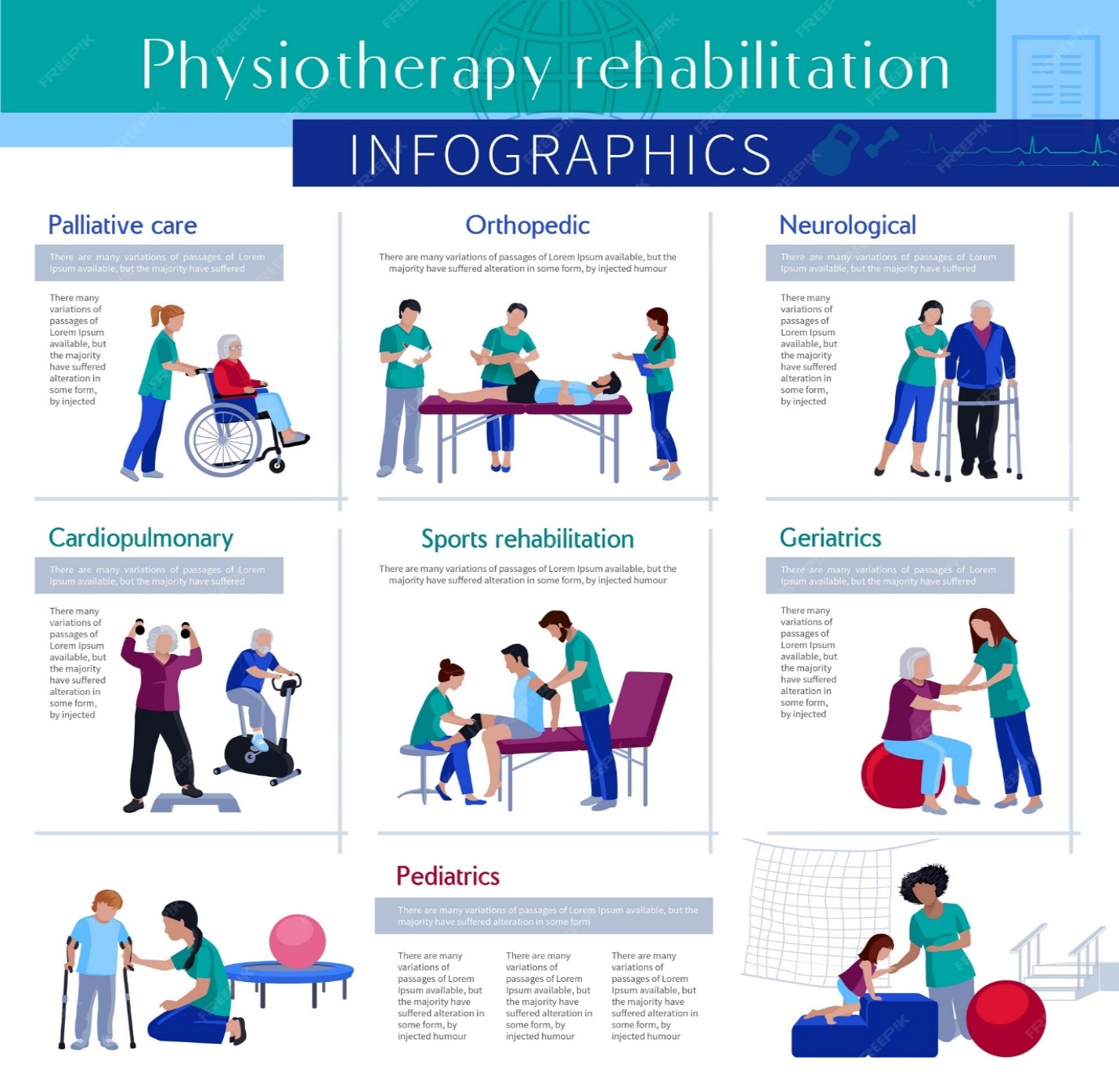

**Future Perspectives**

* AI-driven brain-computer interfaces for neurorehabilitation.
* Integration of AI with 5G and IoT for real-time remote rehabilitation.
* Development of AI-based emotional intelligence in rehabilitation robotics.
* AI-powered predictive models for injury prevention and early diagnosis.

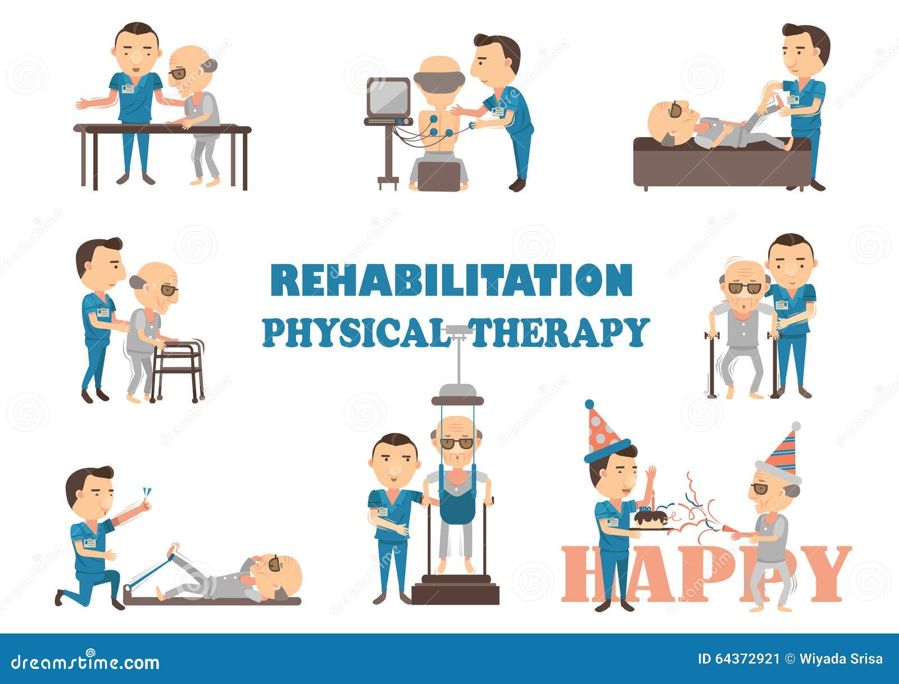

**Conclusion**

Artificial Intelligence has revolutionized the field of physical and rehabilitation therapy by enhancing the precision, efficiency, and personalization of patient care. Through its advanced capabilities—such as machine learning, data analytics, wearable technology, virtual reality integration, and robotic systems—AI enables therapists to deliver evidence-based, patient-centric interventions. These tools not only assist in accurate assessment and monitoring of patients' progress but also provide real-time feedback, enabling continuous optimization of treatment plans.The integration of AI facilitates remote rehabilitation or tele-rehab, breaking geographical barriers and offering continuity of care even in underserved or rural regions. It also empowers patients by encouraging active participation through gamified platforms, improving motivation and adherence. Moreover, AI supports interdisciplinary collaboration by providing a centralized, real-time overview of patient data, thereby enhancing the quality of holistic care.From enhancing therapist efficiency and reducing long-term healthcare costs to enabling data-driven decision-making, the advantages of AI are substantial and transformative. As the technology continues to evolve, future research and clinical trials are essential to ensure ethical implementation, patient safety, and improved accessibility. Overall, AI is not only reshaping rehabilitation methodologies but also redefining the potential for recovery and functional independence for patients across diverse populations.

**Conflict of Interest-** The Author stated no conflict of Interest.

**References**

1. Chen, M., Ma, Y., Li, Y., Wu, D., Zhang, Y., & Youn, C. H. (2017). Wearable 2.0: Enabling human-cloud integration in next generation healthcare systems. IEEE Communications Magazine, 55(1), 54–61.

2. Dillingham, T. R., & Pezzin, L. E. (2008). Rehabilitation services use following amputation. Archives of Physical Medicine and Rehabilitation, 89(3), 521–528.

3. Holden, M. K. (2005). Virtual environments for motor rehabilitation: Review. CyberPsychology & Behavior, 8(3), 187–211.

4. Lu, Z., & Li, Y. (2020). Artificial intelligence in healthcare: Review and prediction case studies. Engineering, 6(3), 291–301.

5. Ambrosino, N., & Vitacca, M. (2019). The role of tele-medicine in rehabilitation. European Respiratory Review, 28(151), 180121.

6. Veras, M., Kairy, D., Rogante, M., Giacomozzi, C., & Côté, A. M. (2015). Tele-rehabilitation technologies for older adults. Journal of Physical Therapy Science, 27(12), 3685–3689.

7. King, M., & Crossley, R. (2020). Machine learning for identifying movement abnormalities in neurological disorders. Journal of NeuroEngineering and Rehabilitation, 17(1), 20.

8. Maceira-Elvira, P., P., Popa, T., Schmid, A. C., & Hummel, F. C. (2019). Wearable technology in stroke rehabilitation: Towards improved diagnosis and treatment. NeuroImage: Clinical, 25, 102181.

9. Krebs, H. I., Volpe, B. T., & Hogan, N. (2009). A working model of stroke recovery from rehabilitation robotics practitioners. Journal of NeuroEngineering and Rehabilitation, 6(1), 6.10. Liu, J., Zhang, X., & Yu, S. (2022). AI-based smart rehabilitation systems: A systematic review. Sensors, 22(3), 1058.

11. Fasoli, S. E., Krebs, H. I., Stein, J., Frontera, W. R., & Hogan, N. (2003). Robotic therapy for chronic stroke: Brain plasticity and functional recovery. Neurorehabilitation and Neural Repair, 17(2), 118–125.

12. Faria, A. L., Andrade, A., Soares, L., & i Badia, S. B. (2016). Benefits of virtual reality-based cognitive rehabilitation through simulated activities of daily living: A randomized controlled trial with stroke patients. Journal of NeuroEngineering and Rehabilitation, 13(1), 96.

13. Dorsey, E. R., & Topol, E. J. (2016). State of telehealth. New England Journal of Medicine, 375(2), 154–161.

14. Jiang, F., Jiang, Y., Zhi, H., Dong, Y., Li, H., Ma, S., ... & Wang, Y. (2017). Artificial intelligence in healthcare: Past, present and future. Stroke and Vascular Neurology, 2(4), 230–

15. World Health Organization. (2011). World report on disability.

16. Dillingham, T. R., & Pezzin, L. E. (2016). Rehabilitation medicine and artificial intelligence. American Journal of Physical Medicine & Rehabilitation, 95(6), 457–458.

17. Lee, C. H., Yoon, H. J., & Lee, H. J. (2020). Application of artificial intelligence in rehabilitation medicine. Annals of Rehabilitation Medicine, 44(5), 319–326.

18. Reinkensmeyer, D. J., Emken, J. L., & Cramer, S. C. (2004). Robotics, motor learning, and neurologic recovery. Annual Review of Biomedical Engineering, 6, 497–525.

19. Teixeira, J. P., & Lopes, F. M. (2020). The future of artificial intelligence in physical therapy. Physiotherapy Research International, 25(3), e1833.

20. Deutsch, J. E., & Mirelman, A. (2007). Virtual reality-based approaches to enable walking for people poststroke. Topics in Stroke Rehabilitation, 14(6), 45–53.

21. Yang, G., Deng, J., Pang, Z., & Zhang, H. (2021). Smart wearable sensors for rehabilitation monitoring. IEEE Sensors Journal, 21(1), 6–13.

22. Khan, A., & Rehman, S. U. (2022). The future of AI in remote rehabilitation. JMIR Rehabilitation and Assistive Technologies, 9(3), e30799.

23. Amirabdollahian, F., Loureiro, R., Gradwell, E., Collin, C., Harwin, W., & Johnson, G. (2007). Assistive robotic therapy: Design and pilot study of a therapeutic robot for the upper limb post-stroke. Journal of NeuroEngineering and Rehabilitation, 4(1), 1.

24. Jung, J., & Kim, D. H. (2020). A deep learning model for human activity recognition in rehabilitation. Sensors, 20(14), 3899.

25. Baheti, R., & Gill, H. (2011). Cyber-physical systems. The Impact of Control Technology, 161–166.

26. Louie, D. R., & Eng, J. J. (2016). Powered robotic exoskeletons in post-stroke rehabilitation. Topics in Stroke Rehabilitation, 23(5), 437–446.

27. Turner-Stokes, L. (2008). Evidence for the effectiveness of multi-disciplinary rehabilitation following acquired brain injury: A synthesis of two systematic approaches. Journal of Rehabilitation Medicine, 40(9), 691–701.

28. Miao, Y., & Yang, J. (2018). The role of AI in optimizing rehabilitation outcomes: A review. Healthcare Technology Letters, 5(6), 225–229.

29. Winstein, C. J., & Varghese, R. (2018). Been there, done that, so what's next for arm and hand rehabilitation in stroke? NeuroRehabilitation and Neural Repair, 32(11), 875–884.

30. Peppé, A., Chiari, L., Rocchi, L., Pierelli, F., & Stocchi, F. (2007). Head posture and trunk stability during gait in patients with Parkinson’s disease. Journal of Neurology, 254(7), 871–878.

31. Morone, G., Tramontano, M., Iosa, M., & Paolucci, S. (2015). The efficacy of gait rehabilitation technologies. NeuroRehabilitation, 37(2), 201–208.

32. Fasoli, S. E., Krebs, H. I., & Hogan, N. (2004). Robotic technology and stroke rehabilitation. Journal of Rehabilitation Research and Development, 41(3A), vii–x.

33. Zhang, Y., & Qian, K. (2021). Application of AI in physiotherapy and neurorehabilitation: A scop coping review. Journal of Medical Systems, 45(5), 34.

34. Cikajlo, I., Rudolf, M., & Goljar, N. (2020). Telerehabilitation using virtual reality in patients with acquired brain injury. Journal of NeuroEngineering and Rehabilitation, 17(1), 1–12.

35. Loureiro, R., Harwin, W., & Nagai, K. (2011). Advances in upper limb stroke rehabilitation: A technology push. Medical & Biological Engineering & Computing, 49(10), 1103–1118.

36. Boian, R., Burdea, G. C., & Deutsch, J. E. (2002). Virtual reality-based post-stroke hand rehabilitation. Studies in Health Technology and Informatics, 85, 64–70.

37. Li, S., He, H., & Wang, Q. (2020). Deep learning in rehabilitation robot control: A review. Sensors, 20(1), 104.

38. Nijenhuis, S. M., Prange, G. B., Amirabdollahian, F., & Hermens, H. J. (2011). Feasibility of a virtual reality environment for upper extremity rehabilitation post-stroke. Journal of NeuroEngineering and Rehabilitation, 8(1), 1–9.

39. Gassert, R., & Dietz, V. (2018). Advances in rehabilitation therapy using body weight support systems. Nature Reviews Neurology, 14(5), 287–291.

40. Postol, N., & Anil, D. (2 21). The application of AI and VR in physiotherapy education. Advances in Medical Education and Practice, 12, 155–164.

41. Aziz, T., & Hassan, M. (2019). AI for musculoskeletal rehabilitation: Opportunities and challenges. Journal of Medical Artificial Intelligence, 2, 18.

42. Baur, K., & Riener, R. (2017). Serious gaming and virtual reality for neurorehabilitation. Annual Review of Cybertherapy and Telemedicine, 15, 131–135.

43. Mohammadi, M., & al-Turjman, F. (2020). AI-enabled remote patient monitoring for rehabilitation. Computer Communications, 153, 128–139.

44. Baumeister, J., & Reinecke, K. (2021). Real-time biosignal feedback for physical therapy via AI. Frontiers in Digital Health, 3, 667401.

45. Scalona, E., & Godwin, M. (2021). AI decision support in physiotherapy clinics. BMJ Health & Care Informatics, 28(1), e100345.

46. Ng, S. C., & Tan, K. L. (2022). Enhancing elderly rehabilitation via AI-based interventions. Geriatrics, 7(1), 13.

47. Trifan, A., Oliveira, M., & Schuller, B. (2021). Deep learning for physical therapy gesture recognition. IEEE Access, 9, 45236–45250.

48. Berton, A., & Goffredo, M. (2016). AI in motor control analysis: New frontiers in neurorehabilitation. IEEE Transactions on Neural Systems and Rehabilitation Engineering, 24(9), 990–999.

49. Pons, J. L., Torricelli, D., & Pajaro, M. (2019). Emerging robotics technologies in rehabilitation. Expert Review of Medical Devices, 16(6), 477–489.

50. Witten, I. H., Frank, E., & Hall, M. A. (2016). Data Mining: Practical machine learning tools and techniques. Morgan Kaufmann.