AUTOMATIC POWER FACTOR CONTROLLER

# Prof.M.M.Ansari1, Pratik Shegokar2, Yash Sane3, Kartik Shegokar4, Mahesh Patil5.

Department Of Electrical Engineering1,2,3,4,5

Smt. Indira Gandhi College of engineering ,Navi Mumbai Pin-501301

**Abstract:** In industrial power systems, maintaining an optimal power factor is essential for efficiency and cost- effectiveness. This project presents a 3-phase Power Factor Improvisor using an Arduino Mega, CTs (Current Transformers), and PTs (Potential Transformers). When the PF drops below 0.93 due to inductive loads like choke coils, capacitors from a capacitor bank are switched in parallel with the load to restore the PF to

0.98. The system continuously monitors PF and applies real-time corrections, improving energy efficiency and reducing penalties. A combination of resistive (100W bulbs) and inductive loads (tube lights with choke coils) is used for testing. The project provides an automated solution for industries, optimizing power usage and minimizing unnecessary energy wastage.

*Keywords— Power Factor, Arduino Mega, Reactive Power, LCD Display*

# Introduction

Power factor correction is an essential requirement in industrial power distribution. A low PF leads to increased current draw, causing excessive heating, higher power losses, and inefficiency in the electrical system. To counter this, industries use capacitor banks to improve PF, but manual correction systems often suffer from inefficiencies. . Problems of power quality in industrial plants are growing due to the increasing number of rectifier controlled motors and the overall increase of harmonics and inter harmonics [1]. Our approach focuses on designing an automated power factor correction system for 3-phase loads using an Arduino Mega. Capacitors generally are the most economical means to improve power factors. Power factor correction is the term given to a technology that has been used since the turn of the 20th century to

restore the power factor to as close to unity as is economically stable. [3] The system continuously monitors PF using CTs and PTs, detecting drops below

0.93 due to Inductive loads. When required, it switches capacitors in Parallel to the load, restoring PF to 0.98 dynamically. This automated approach ensures improved power utilization, reduces penalties imposed by energy providers, and enhances overall system efficiency. The project involves testing with resistive and inductive loads. The system integrates sensors for real-time monitoring, enabling quick capacitor switching decisions based on predefined

## LITERATURE REVIEW

* The International Journal of Engineering Trends and Technology (IJETT) on the topic of“Power Factor Improvement using dual Boost Converter” The author published by Prof. D. D. Ahire.The paper involves simulation of power electronics analysis of the current and voltage waveforms. The Apfc incorporated a breaker switch capacitor bank into a small design using a low- cost sensing element and an intelligent control device. The device provided more accurate voltage control and power factor correction than traditional shunt capacitor bank installation
  + The International Journal of Innovations in Engineering Research and Technology (IJIERT) published the topic of design and simulation of an active power factor controller using a "Boost Converter" by Sujata Nazarkar. The decoupling allows for more control freedom by utilizing a freewheeling interval. Current stress was increased by reducing inductor-current ripple and Improving current handling capability at heavy loads, demonstrating a fast transient response. The Boost PFC converter is much simpler and has better dynamic

Performance than the PCCM boost PFC converter against load disturbance while maintaining low input current distortion.

# Methodology

The project is implemented using an Arduino Mega microcontroller that continuously monitors power factor using CTs (Current Transformers) and PTs (Potential Transformers). The correction mechanism follows these steps: Power Factor Measurement: CTs and PTs provide real-time voltage and current readings. Threshold Detection: If PF drops below 0.93, the system identifies the need for correction.

Capacitor Activation: The Arduino triggers relays to add capacitors in parallel with the load.

Continuous Monitoring: The system ensures PF reaches

0.98 and prevents overcorrection. Data Logging: PF readings are stored for further analysis and optimization.

Where:

T = Time period of one AC cycle (e.g., 20 ms for 50 Hz)

Calculate:

PF = Cos(θ)

Capacitor Bank Control Logic: Capacitor Bank Control Logic:

1. If PF >= 0.95: - CB1 OFF - CB2 OFF,
2. If 0.85 <= PF < 0.95: - CB1 ON - CB2 OFF,
3. If PF < 0.85: - CB1 ON - CB2 ON.

# Circuit Diagram

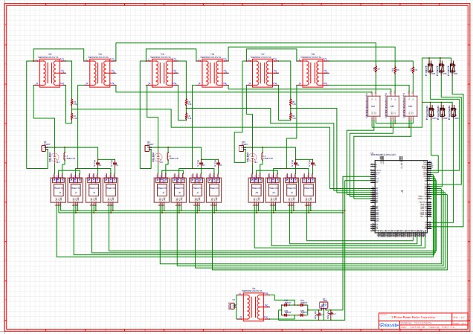

## Fig No:02

Steps:

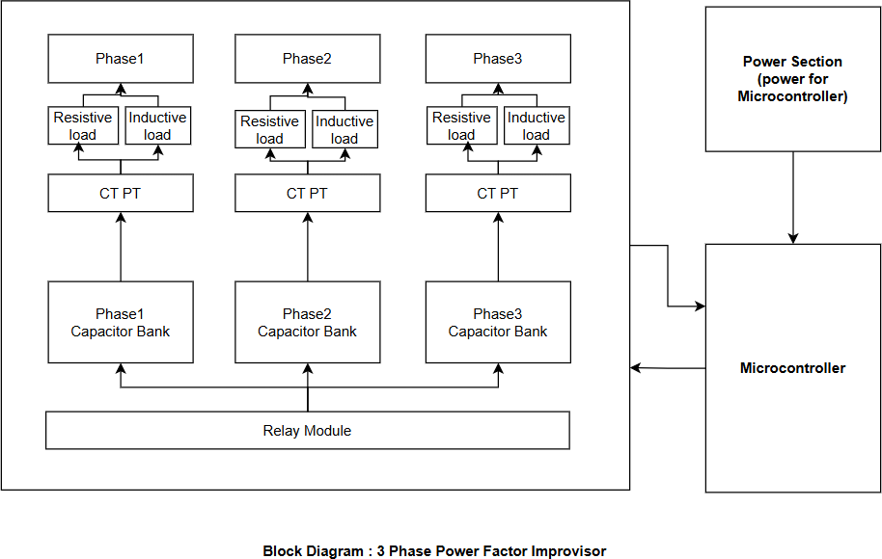**Fig No: 01**

The improviser consists of CTs and PTs that measure electrical parameter and feed the data to an arduino Mega. The microcontroller processes the data and determines whether the power factor required correction. If the PF fails below set threshold, relays activate capacitor banks, improve PF. The system operates continuously, ensuring optimal performance in industrial

Sample V(t) and I(t) at high rate (~1kHz or more) Detect zero-crossings of voltage and current signals Calculate time difference (Δt) between their zero crossings

Use this to calculate phase angle φ:

applications. When inductive load causes the PF to drop below 0.93, the system automatically switches capacitor bank in parallel to correct PF up to 0.98. The arduino Mega processes input from the sensor, executes predefined formulas, and trigger relays to engage the capacitors accordingly. The system ensures seamless correction without manual intervention.

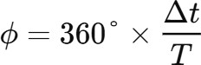

# Result

The implementation of Automatic Power Factor Controller using Arduino yielded promising results in optimizing power factor and improving energy efficiency. Through the integration of Arduino microcontroller technology with capacitive load banks, the system effectively monitored and adjusted the power factor of the connected load. By continuously analyzing the phase difference between voltage and current signals, the Arduino controller dynamically controlled the insertion of capacitors to achieve the desired power factor. This automated approach eliminated the need for manual intervention, reducing operational costs and enhancing system reliability.

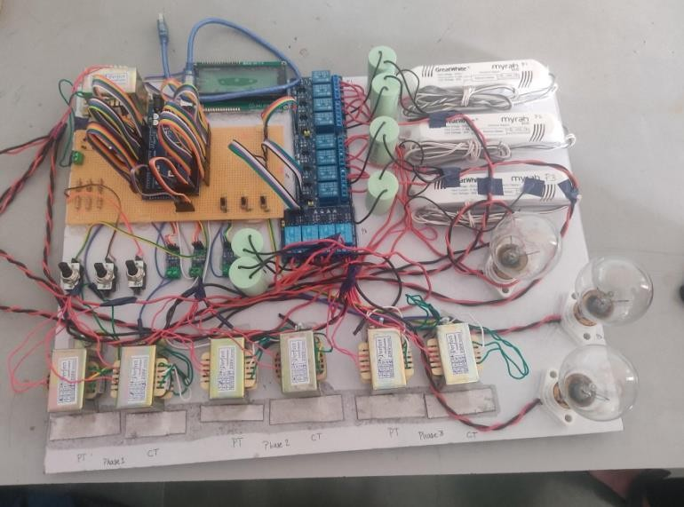Furthermore, the real-time monitoring capabilities of the Arduino-based controller provided valuable insights into power factor trends and system performance. With the ability to display power factor values before and after correction on an LCD screen, operators gained visibility into the effectiveness of power factor correction efforts.

# Conclusion

The 3-phase power Factor improvers effectively improves power efficiency by dynamically correcting PF using capacitor banks, by automating the correction process, the system ensure reduced e3nergy losses, lower electricity cost, and extended equipment lifespan, the use of CTs and PTs for real-time monitoring enhances reliability And precision. This project offers a scalable and cost-effective solution for industries and commercial power systems, paving the way for smart energy management and grid optimization.

## REFERENCES

1. Attia K., Youssef M., Tantawy M., Bekheet, “Power factor correction for intermittent and fluctuating loads,”

ISSN, Volume 2, Issue 2, pp. 289, 2003

1. Gusseme K. and Melkebeek J. A. (2002), “Design issues for digital control of boost power factor correction converters,” *IEEE International Symposium on Industrial Electronics*
2. ISSN: 2278-0181 IJERTV4IS040174 4.0 Vol. 4 Issue

04, April-2015 ‘Automatic Power Factor Control Equipment using Micro Controller’ Abhinav C K Basil George Nevin Jose Vysakh Bharathan

[4]. Mr. Musthafa P., Mr. M. Sivasubramanian, Mr. K. Sakthidhasan, “Analysis of Dynamic Power Factor Correction Using Flexible AC Transmission Systems [5]. Dr. Kurt Schipman and Dr. Francois Delince, The importance of good power qualityǁ, ABB power quality Belgium.

[6]. Robert. F. Coughlin, Frederick. F. Driscoll, Operational amplifiers and linear integrated circuits, 6thEdition, chapter