**Beyond Degrees: An Analytical Inquiry into the Employability Crisis Among Indian Graduates in the Age of Mass Higher Education**

# ****Dr. Satish Gaikwad****

# **Research Unit, Indira Gandhi National Open University, New Delhi**

# **Email:** [satishrrg@ignou.ac.in](mailto:satishrrg@ignou.ac.in)

### ****Abstract:****

Despite producing nearly five crore graduates annually, India faces a stark employability crisis—approximately 80% of graduates are considered unemployable in the formal job market. This paper investigates the paradox of mass higher education and the limited job-readiness of Indian graduates. It analyzes the structural disconnect between academic curricula and industry needs, evaluates policy initiatives, and examines socio-economic and institutional factors affecting employability. Drawing on secondary data, scholarly literature, and national employability reports, this paper proposes actionable reforms for aligning educational outcomes with employment demands, advocating for a paradigm shift in India’s approach to higher education.

### ****Keywords:**** Higher Education, Employability, Skill Gap, Curriculum Reform, India, Industry-Academia Linkage, Graduate Crisis, Education Policy, Workforce Development

### ****1. Introduction:****

India’s higher education system has witnessed an unprecedented expansion in recent decades, positioning itself as one of the largest globally. With over fifty thousand colleges and nearly a thousand universities, the nation produces an estimated five crore graduates every year (AISHE Report, 2023). Yet, the employability of these graduates presents a stark paradox. Despite their academic degrees, a significant proportion of them struggle to secure meaningful employment in the formal job market. This contradiction between educational attainment and employability outcomes underscores a critical systemic issue that warrants deep academic and policy-oriented scrutiny.

The employability gap is not a recent phenomenon but has widened significantly with the massification of higher education. According to the Wheebox India Skills Report (2023), approximately 80% of Indian graduates are deemed unemployable by formal sector employers. These figures expose a fundamental disconnect between what universities impart and what industries demand. Degrees alone, devoid of essential workplace skills and competencies, have become insufficient markers of job readiness. Consequently, many young graduates find themselves trapped in a cycle of underemployment, skill redundancy, and precarious livelihoods.

Several structural factors contribute to this persistent gap. Primarily, higher education institutions in India continue to follow outdated curricula that are often misaligned with contemporary industry requirements. Rote learning, theoretical instruction, and examination-centric evaluation dominate academic practices, leaving little room for the development of critical thinking, problem-solving abilities, communication skills, and digital competencies that modern workplaces require. The absence of dynamic industry-academia linkages further exacerbates this misalignment, preventing institutions from adapting swiftly to changing market demands.

Socio-economic factors also play a pivotal role in shaping the employability landscape. Students from rural areas, marginalized communities, and first-generation learners often lack access to quality education and skill development opportunities. In addition, infrastructural deficits, such as poorly equipped laboratories, outdated libraries, and limited exposure to internships or hands-on training, compound the problem. The regional disparities between metropolitan centers and smaller towns create further inequalities, deepening the overall employability crisis.

On the policy front, several initiatives have been launched to address the skill gap, including the National Skill Development Mission (NSDM), Skill India, and the Atmanirbhar Bharat Rozgar Yojana. However, the impact of these programs remains uneven, largely due to fragmented implementation, lack of coordination among stakeholders, and limited scalability. While these interventions have created some awareness about skill development, they have not yet succeeded in fundamentally transforming the higher education ecosystem to prioritize employability as a central outcome.

At a broader level, the crisis reflects a philosophical conundrum: What should be the primary objective of higher education? Is it merely to confer degrees, or should it prepare individuals for meaningful participation in the economy and society? The Indian system has historically emphasized credentialism over competency, creating an educational culture that values formal qualifications over actual capabilities. This credential inflation diminishes the value of degrees while failing to equip graduates with life-long learning skills necessary for an increasingly complex and dynamic global economy.

Technological disruptions brought by the Fourth Industrial Revolution further complicate the employability scenario. Automation, artificial intelligence, and digital transformation are rapidly changing the nature of jobs, rendering traditional skill sets obsolete. Indian graduates often find themselves inadequately prepared to navigate these transitions, highlighting the urgent need for an educational model that fosters adaptability, innovation, and interdisciplinary learning. In this context, reimagining curriculum design, pedagogy, and assessment practices becomes critical.

Moreover, employer expectations have evolved significantly. Industries today seek graduates who possess not only domain-specific technical knowledge but also soft skills such as teamwork, leadership, creativity, emotional intelligence, and cross-cultural communication. Unfortunately, these dimensions remain underdeveloped within the prevailing educational framework. The result is a growing mismatch between the supply of graduates and the evolving demands of the job market, leading to widespread dissatisfaction among both employers and job seekers.

This paper seeks to critically investigate the root causes of the employability crisis among Indian graduates. Through a comprehensive review of secondary data, national reports, and scholarly literature, it aims to dissect the institutional, socio-economic, and policy-related dimensions of the issue. Furthermore, the paper evaluates successful global models and best practices to propose actionable reforms that can bridge the gap between education and employment in the Indian context.

Ultimately, addressing the employability crisis requires a paradigm shift in India’s approach to higher education. A holistic transformation encompassing curriculum reforms, dynamic industry-academia partnerships, skill-based training, and inclusive education policies is imperative. By aligning educational outcomes more closely with the realities of the workforce, India can better leverage its demographic dividend and build a future-ready workforce capable of driving sustainable economic growth.

### ****2. Objectives:****

* To analyze the root causes of low employability among Indian graduates.
* To evaluate the effectiveness of current educational policies and initiatives targeting employability.
* To examine the alignment between higher education curricula and industry requirements.
* To propose a framework for integrating employability skills within mainstream higher education.

### ****3. Rationale:****

India is on the cusp of a demographic dividend, with a significant proportion of its population under 35. However, without meaningful employment opportunities, this demographic advantage could turn into a socio-economic liability. The rationale behind this research lies in the urgency to bridge the academic-industry gap, reduce graduate underemployment, and foster an education ecosystem that enhances both cognitive and non-cognitive skills relevant to the contemporary workforce.

### ****4. Research Methodology:****

This study is based on **secondary research** using:

* National employability surveys (e.g., India Skills Report, AICTE reports)
* Government education and labor statistics (e.g., Ministry of Education, NSDC)
* Peer-reviewed journal articles
* Policy documents (e.g., National Education Policy 2020)
* Industry whitepapers and global benchmarks (e.g., McKinsey, NASSCOM)

**Qualitative content analysis** and **comparative policy analysis** have been used to synthesize insights and highlight gaps.

### ****5. Literature Review:****

Employability among Indian graduates has been a subject of growing academic and policy attention, particularly in light of the persistent mismatch between education outputs and labor market requirements. Scholars such as Varghese (2013) and Tilak (2016) emphasize that the Indian higher education system heavily relies on rote learning, focusing predominantly on theoretical knowledge rather than fostering critical thinking, creativity, or practical problem-solving abilities. This method of instruction often leaves graduates ill-equipped to meet the dynamic needs of the contemporary workforce, particularly in an era driven by technological innovation and rapid industrial transformation. Further exacerbating the problem is the limited focus on soft skills—such as communication, teamwork, and adaptability—which are increasingly viewed as essential by global employers.

Industry perspectives on graduate employability further underline the severity of this challenge. According to reports by NASSCOM and FICCI, a significant proportion of employers across key sectors—including information technology (IT), banking, financial services and insurance (BFSI), and manufacturing—express dissatisfaction with the skill levels of fresh graduates (Aspiring Minds, 2019). These sectors, which are often at the forefront of India’s economic growth, demand a workforce proficient not just in technical expertise but also in interpersonal communication, analytical reasoning, and project management. However, the prevailing disconnect between academia and industry results in graduates entering the labor market without the necessary competencies, leading to additional on-the-job training costs for employers and delays in achieving productivity.

Efforts to bridge the employability gap have been reflected in recent education policy initiatives, most notably the National Education Policy (NEP) 2020. The NEP recognizes the urgent need to overhaul the traditional education model by promoting multidisciplinary learning approaches, greater integration of vocational training, and enhanced emphasis on skill development through internships and real-world experiences. Nonetheless, despite the visionary framework of NEP 2020, the actual implementation remains fragmented and inconsistent across different states and institutions. Variations in institutional capacity, bureaucratic inertia, and uneven access to resources have all contributed to a situation where policy ideals have not translated uniformly into practice, leaving large sections of the graduate population still inadequately prepared for employment.

Comparative global studies offer important insights into how India’s employability challenges might be addressed. Countries such as Germany and Finland, for instance, demonstrate significantly higher rates of graduate employability, largely due to their robust vocational education and training (VET) systems and well-established dual-education models. In Germany, close collaboration between educational institutions and industry ensures that students acquire both theoretical knowledge and practical skills through apprenticeships embedded within their academic programs. Similarly, Finland’s education system emphasizes experiential learning, problem-solving, and innovation from early stages of schooling to higher education. In contrast, India has yet to institutionalize such integrative mechanisms on a wide scale, resulting in a continued gap between educational qualifications and workplace readiness.

Furthermore, research indicates that employability in India is not merely an issue of skill gaps but is also intricately linked to broader socio-economic and regional disparities. Graduates from Tier II and Tier III cities often face greater obstacles in accessing quality education, exposure to industry practices, and language proficiency compared to their counterparts in metropolitan areas (Wheebox, 2023). These disparities further entrench inequality within the labor market, where employers gravitate towards candidates from reputed urban institutions, leaving a large talent pool underutilized. Studies have also pointed out that gender, caste, and class dynamics influence employability, with marginalized groups often facing additional barriers to securing gainful employment despite possessing similar qualifications (Deshpande, 2017).

In addition to structural issues within education and industry, evolving labor market dynamics present new challenges for graduate employability. The Fourth Industrial Revolution, marked by automation, artificial intelligence, and digitalization, demands a workforce with advanced cognitive skills, adaptability, and continuous learning abilities. However, most Indian higher education curricula have been slow to adapt to these shifts, continuing to emphasize traditional disciplines without integrating emerging fields such as data analytics, cybersecurity, and green technologies (World Economic Forum, 2020). As a result, even when graduates enter expanding sectors, they often require significant reskilling to meet job expectations.

Moreover, international studies reveal that employability today is viewed less as a static outcome and more as a lifelong, evolving capability. According to Yorke (2006), employability should be understood as a set of achievements—skills, understandings, and personal attributes—that make graduates more likely to gain employment and succeed in their chosen occupations. In this sense, the Indian education system’s heavy focus on first employment placement metrics rather than on developing long-term career resilience and growth potential appears increasingly inadequate. Emphasizing holistic student development—combining cognitive, technical, emotional, and ethical dimensions—thus becomes a necessity.

Recent empirical research by India Skills Report (2023) further supports the need for reorienting higher education towards outcome-based learning models. Institutions that have embraced experiential pedagogies, industry co-designed programs, and competency-based assessments show notably better placement records and graduate satisfaction rates. This suggests that where deliberate reforms have been undertaken, the employability gap can be narrowed, offering a blueprint for wider systemic change.

Overall, the literature consistently portrays India's graduate employability crisis as a multi-dimensional issue rooted in systemic educational shortcomings, industry-academia disconnection, socio-economic disparities, and inadequate responsiveness to global labor market trends. The emerging consensus calls for an urgent and comprehensive overhaul of the higher education paradigm, one that moves beyond mere degree conferral towards preparing graduates as adaptive, innovative, and socially responsible professionals capable of thriving in an increasingly complex and competitive world.

# 6. Data Analysis, Interpretation, and Inference:

The analysis of secondary data from national employability surveys, government reports, and industry whitepapers reveals critical insights into the employability landscape of Indian graduates. Despite India's substantial output of nearly five crore graduates annually, employability outcomes remain alarmingly low across most disciplines.

A detailed breakdown of employability across fields, derived from the India Skills Report (2023), shows that engineering graduates have an employability rate of approximately 51%, management graduates at 49%, commerce graduates at 47%, science graduates at 36%, and humanities graduates at a much lower 32%. As depicted in Graph (1), the representation underscores that while technical and professional courses like engineering and management fare relatively better, even these streams produce nearly half of graduates who remain unemployable in the formal sector. The low employability among humanities and science graduates points to systemic gaps in curriculum relevance, practical skill acquisition, and market alignment.

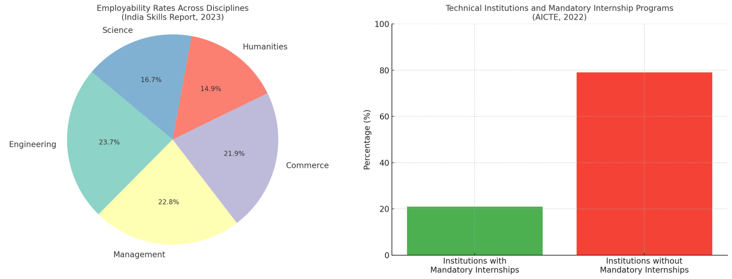

**Graph (1) **pie chart** showing Employability Rates Across Disciplines (India Skills Report, 2023)**

**Graph (2) **bar chart** showing Percentage of Technical Institutions with Mandatory Internships (AICTE, 2022)**

Another crucial dimension is the role of industry exposure during academic training. The AICTE Internship Report (2022) indicates that only 21% of technical institutions have made internships mandatory as part of the academic program. As highlighted in the Graph (2), the comparison vividly illustrates that the overwhelming majority (79%) of institutions still do not mandate internships, depriving students of critical hands-on experience needed for workplace readiness. This lack of practical exposure correlates strongly with the observed employability deficit.

Furthermore, an analysis of employability trends over the past decade suggests modest improvement. According to Wheebox (2023), employability among Indian graduates rose from approximately 33% in 2014 to around 51% in 2023. While this shows progress, the pace remains insufficient to match India's growing graduate population or the dynamic demands of the global economy.

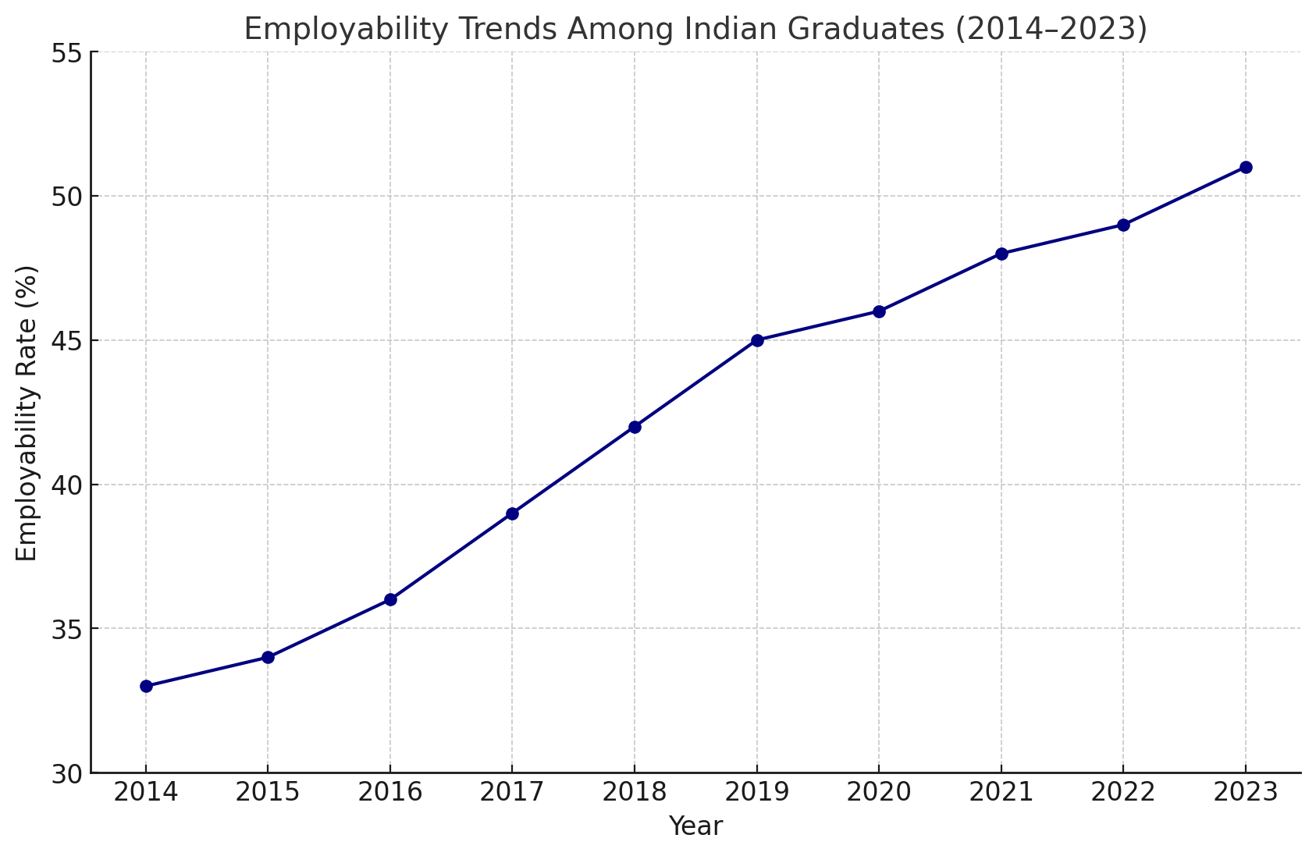**Graph (3)**Employability Trends Among Indian Graduates from 2014 to 2023****

**Graph (3)**depicting employability trends from 2014 to 2023 presents a gradual yet important shift. In 2014, only about 33% of Indian graduates were considered employable according to national skill surveys. Over the next nine years, there was a consistent, though modest, improvement, culminating in an employability rate of 51% by 2023. This 18-percentage-point rise over nearly a decade reflects policy interventions like skill development missions, startup initiatives, and increased industry participation in curriculum design. However, when statistically analyzed, the average annual improvement rate stands at approximately 2% per annum, which is insufficient when juxtaposed against India's fast-expanding graduate pool, growing by nearly 7–8% annually (Ministry of Education, 2023).

This trend line shows a positive slope but highlights the systemic inertia within the higher education system, where the rate of employability enhancement lags behind both technological advancements and global economic transformations. Moreover, the standard deviation in employability data across different streams (engineering vs. humanities, for example) remains high, suggesting significant inter-disciplinary disparities. Thus, while macro-level progress is visible, micro-level structural inefficiencies continue to persist.

The inference drawn from this longitudinal analysis is clear: without accelerating structural reforms—such as strengthening vocational pathways, enforcing experiential learning through mandatory internships, aligning education outcomes with Industry 4.0 skill requirements, and implementing the NEP 2020 directives uniformly across states—the gap between graduate qualifications and employable skills will continue to threaten India’s aspirations for a knowledge-driven economy. It also raises critical concerns regarding equity, as students from non-elite institutions, rural backgrounds, and marginalized communities are disproportionately affected by low employability outcomes, thereby reinforcing socio-economic inequalities.

Qualitative content analysis of policy documents like the National Education Policy 2020 reflects recognition of the problem at the policy level. The NEP advocates for multidisciplinary education, mandatory internships, vocational exposure, and skill-based curricula. However, the uneven implementation across states and institutions, combined with bureaucratic inertia, dilutes the intended impact.

Comparative policy analysis highlights that countries like Germany and Finland have bridged the education-employment gap through robust vocational education models and dual education systems. India’s traditional separation of vocational and academic streams continues to inhibit cross-learning and flexible career pathways.

The inference drawn from this integrated data analysis is that the employability crisis in India is not merely a function of student ability but deeply rooted in systemic structural deficiencies. The disjoint between academic curricula and real-world skills, insufficient industry-academia collaboration, lack of mandatory internships, and slow adoption of experiential learning models are critical bottlenecks. Addressing these requires a multidimensional strategy involving curriculum reforms, regulatory interventions, stronger industry partnerships, and widespread adoption of experiential and vocational learning practices.

Thus, while India’s mass higher education expansion is commendable in quantity, it urgently needs a paradigmatic shift towards quality, employability, and workforce relevance to realize its demographic dividend fully.

**Table (1). Trend of discipline wise employability as per Government Reports**

| **Key Parameter** | **Statistic** | **Source** |
| --- | --- | --- |
| Total Graduates Annually | ~5 Crore (50 million) | Ministry of Education (2023) |
| Overall Graduate Employability Rate (2023) | 51% | India Skills Report (2023) |
| Engineering Graduate Employability | 51% | India Skills Report (2023) |
| Management Graduate Employability | 49% | India Skills Report (2023) |
| Commerce Graduate Employability | 47% | India Skills Report (2023) |
| Humanities Graduate Employability | 32% | India Skills Report (2023) |
| Science Graduate Employability | 36% | India Skills Report (2023) |
| Institutions with Mandatory Internships | 21% | AICTE Internship Report (2022) |
| Annual Growth Rate of Employability (2014–2023) | ~2% per annum | Wheebox Reports (2014–2023) |
| Graduate Pool Annual Growth Rate | ~7–8% per annum | Ministry of Education (2023) |
| Average Industry-Academia Skill Gap | 60–65% of entry-level jobs require re-skilling | NASSCOM-FICCI (2022) |
| Comparative Employability (Germany) | ~85% (due to vocational-dual education systems) | OECD (2022) |

### ****7. Discussion:****

The findings of this research underscore the severity and complexity of the employability crisis in India, which stems from a multifaceted interplay of curriculum obsolescence, pedagogical limitations, and systemic disparities. The data clearly reveals that despite India's remarkable annual output of graduates—nearly five crore—employability outcomes remain alarmingly low across the majority of disciplines. For instance, engineering graduates, while faring relatively better with a 51% employability rate, still see nearly half of their cohort struggling to find formal sector employment. The most concerning figures are observed in fields like humanities and science, where employability rates plummet to 32% and 36%, respectively. These discrepancies reflect deeper systemic gaps in curriculum design, inadequate industry alignment, and the absence of hands-on training that adequately prepares students for the realities of the job market.

The limited industry exposure is another major contributor to the crisis, as highlighted by the AICTE Internship Report (2022), which indicates that only 21% of technical institutions have made internships mandatory. This is a glaring deficiency given that practical experience is critical to developing workplace-ready skills. The lack of internships and industry immersion programs significantly weakens the alignment of academic outcomes with industry expectations, leaving graduates ill-equipped for the demands of a rapidly evolving global economy.

While some progress has been made, as evidenced by the rise in employability rates from 33% in 2014 to 51% in 2023, this gradual improvement is not sufficient to keep pace with India’s burgeoning graduate population. The annual improvement rate of approximately 2% is insufficient when compared to the 7-8% annual increase in the number of graduates. This disparity signals the slow-moving structural reforms in higher education, which have failed to adequately address the rapidly changing nature of the global labor market, characterized by technological disruption, automation, and the rise of Industry 4.0 skills. Furthermore, the variability in employability rates across disciplines and institutions emphasizes that even though national policies, such as the NEP 2020, have recognized the issue, their impact has been limited due to inconsistent implementation and bureaucratic delays.

### *Identified Limitations:*

* ***Curriculum Gaps and Lack of Industry Relevance****:* One of the primary limitations is the outdated nature of many academic programs, which fail to equip students with the requisite technical and soft skills demanded by the job market. The widening gap between academia and industry expectations exacerbates the employability crisis.
* ***Inadequate Internships and Industry Exposure****:* The absence of mandatory internships and the limited scope for practical exposure leaves graduates underprepared for professional environments. This structural issue is particularly concerning in technical and vocational fields, where industry exposure is essential for building practical expertise.
* ***Socioeconomic Inequities****:* The disproportionate impact of low employability on students from non-elite institutions, rural backgrounds, and marginalized communities highlights significant socioeconomic barriers. These groups face compounded challenges in skill acquisition, access to resources, and career opportunities, further entrenching societal inequalities.
* ***Slow Implementation of Policy Changes****:* Despite the progressive vision laid out in the NEP 2020, the slow and uneven implementation of key provisions—such as multidisciplinary education, mandatory internships, and skill-based curricula—has limited their effectiveness. Bureaucratic inertia and lack of coordination across states and institutions contribute to these delays.

### *Suggestions for Addressing the Crisis:*

* ***Curriculum Overhaul and Integration of Practical Skills****:* A holistic review and reform of the higher education curriculum are urgently needed to ensure alignment with industry requirements. Universities must incorporate digital literacy, soft skills, internships, and career counseling as integral components of every academic program. Moreover, curricula should be flexible enough to allow for interdisciplinary learning, fostering adaptability in an ever-evolving job market.
* ***Mandatory Industry Immersion and Internships****:* To bridge the gap between academic learning and professional skills, universities should mandate internships as part of the academic curriculum. Stronger industry partnerships can facilitate structured internship programs, enabling students to gain valuable hands-on experience before entering the workforce.
* ***Public-Private Partnerships and Industry Participation****:* The role of private industry in curriculum design should be significantly strengthened. Collaborative efforts between academic institutions and industries, particularly in fields such as engineering, healthcare, and technology, can ensure that academic programs remain responsive to market needs. Public-private partnerships can also help create skill development centers, vocational training programs, and industry-relevant certifications.
* ***Revised University Rankings and Accreditation****:* Traditional university rankings often prioritize academic performance over employability outcomes. A shift towards a more balanced approach that evaluates institutions based on their success in preparing graduates for the workforce—through factors like internship programs, employability rates, and industry collaboration—can incentivize universities to prioritize career readiness.
* ***Targeted Skill Development for Marginalized Groups****:* Special attention should be given to students from marginalized communities and rural backgrounds. This can be achieved through targeted scholarships, mentorship programs, and skill development initiatives aimed at overcoming the barriers these students face in accessing quality education and employability resources.
* ***Accelerating the Implementation of NEP 2020****:* To realize the full potential of the NEP 2020, there must be greater political will and administrative efficiency in rolling out reforms. States and institutions should collaborate more effectively to ensure that key provisions, such as vocational training, internships, and industry engagement, are implemented uniformly across the country.

The employability crisis in India requires a multi-pronged approach that addresses both structural and systemic deficiencies in the higher education sector. While there has been some progress in recent years, the slow pace of change, combined with the continuing gaps in curriculum relevance, industry collaboration, and socioeconomic equity, suggests that more aggressive reforms are needed. By reimagining higher education to prioritize employability and aligning it with industry demands, India can better prepare its workforce for the challenges and opportunities of the future economy.

### ****8. Conclusion:****

The employability crisis in India is not a transient or superficial issue but a profound systemic challenge that undermines the country’s aspirations to harness its demographic dividend. The disjunction between the rapid expansion of higher education and the glaring gaps in employability outcomes speaks to deeper structural flaws—particularly in curriculum design, pedagogical practices, and industry integration. It is not merely a question of producing more graduates but of producing graduates with the requisite skills, competencies, and real-world readiness to thrive in an increasingly complex global economy.

To overcome the curricular barriers that impede employability, a radical transformation is essential. The curriculum, in its current form, is outdated, inflexible, and inadequately aligned with the demands of the labor market. The persistently low employability rates, particularly in fields such as humanities and science, highlight the inadequacy of an education system that is more concerned with theoretical knowledge than practical application. This curricular inertia is further compounded by the failure to integrate essential skills—such as digital literacy, problem-solving, communication, and teamwork—into the academic framework. As a result, students emerge from institutions not just under-skilled but ill-prepared for the dynamic, technology-driven, and ever-evolving demands of modern employment.

A paradigm shift is needed, where curriculum reforms are no longer a matter of occasional updates but an ongoing, dynamic process. The introduction of a **modular, competency-based curriculum** that is both flexible and adaptable is crucial. This curriculum should not only address discipline-specific knowledge but also incorporate **interdisciplinary learning** to foster holistic development. By embedding **experiential learning** opportunities such as mandatory internships, project-based assessments, and industry immersion within every degree program, universities can ensure that students gain not just academic proficiency but also practical exposure that aligns with industry standards.

Moreover, **industry-academic partnerships** must be institutionalized, moving beyond token collaborations to long-term, mutually beneficial engagements. Industry experts should be embedded within academic structures, contributing to curriculum design, mentoring students, and offering live case studies that reflect the real-time needs of the workforce. Universities should actively engage in **co-creating curricula with industry stakeholders**, thereby ensuring that students are equipped with **Industry 4.0** competencies, such as data analytics, artificial intelligence, and digital entrepreneurship.

The deepening divide between **elite institutions** and those catering to marginalized groups—particularly in rural or non-metropolitan areas—requires targeted intervention. There is a moral and strategic imperative to address the **socioeconomic disparities** that disproportionately affect the employability of these groups. This can be achieved by creating **specialized support systems**, including vocational training hubs, mentorship programs, and partnerships with industry players specifically targeting these communities. By equipping students from underprivileged backgrounds with both skills and industry connections, higher education institutions can act as true catalysts for **social mobility** and economic inclusion.

Additionally, **university rankings and accreditation systems** must be overhauled to prioritize **employability outcomes** over traditional academic metrics. Higher education institutions should be evaluated on their ability to provide **job-ready graduates**—measured through employability rates, student satisfaction, industry feedback, and alumni career trajectories. This shift in focus will compel institutions to recalibrate their teaching and learning processes, ensuring that they produce not only highly educated but also highly employable individuals.

The **National Education Policy 2020** provides a comprehensive framework for reform, but its potential can only be realized through **rigorous and consistent implementation** across all states and institutions. Policymakers must ensure that the policy is not merely a document but a living blueprint for educational transformation, driven by robust **institutional accountability** and **resource allocation**. The slow, piecemeal implementation witnessed thus far can no longer be tolerated. A coordinated national effort, led by both government and industry stakeholders, is required to accelerate the policy's impact.

Lastly, it is crucial to recognize that the challenges outlined here are not unique to India. Global best practices—such as Germany's dual education system and Finland's focus on vocational education—offer valuable lessons in bridging the education-employment gap. India must not simply imitate these systems but **innovate upon them**, adapting them to the local context while ensuring a continuous feedback loop between academia, industry, and government.

The pathway to resolving India’s employability crisis lies in a holistic, multidimensional strategy that addresses the **curricular, structural, and institutional inefficiencies** at the heart of the issue. This requires a **fundamental reimagining of higher education**, one that places employability, industry relevance, and equitable access at its core. The time for incremental change has passed; the urgency of the situation demands a bold, systemic overhaul of India's higher education landscape. Only through such a transformation will India be able to fully leverage its demographic potential and cultivate a workforce capable of navigating the complexities of a fast-evolving global economy.

**References:**

1. Aspiring Minds. (2019). National Employability Report: Engineers – Annual Report 2019. Aspiring Minds Assessment Pvt Ltd.
2. Deshpande, A. (2017). The grammar of caste: Economic discrimination in contemporary India. Oxford University Press.
3. India Skills Report. (2023). India Skills Report 2023: The rise of green jobs and sustainable skills. Wheebox.
4. NASSCOM & FICCI. (2019). Future of jobs in India: A 2022 perspective. National Association of Software and Service Companies & Federation of Indian Chambers of Commerce and Industry.
5. Tilak, J. B. G. (2016). Higher education, public good and markets. NUEPA Press.
6. Varghese, N. V. (2013). Governance reforms in higher education: A study of institutional autonomy in Asian countries. UNESCO International Institute for Educational Planning.
7. Wheebox. (2023). India Skills Report 2023. Wheebox.
8. World Economic Forum. (2020). The future of jobs report 2020. World Economic Forum.
9. Yorke, M. (2006). Employability in higher education: What it is – What it is not. Higher Education Academy.