# REAL-TIME DRIVER DETECTION MONITORING SYSTEM

**Aishwarya M D, Manoj H N, Tazeen M Sultana, Tritiya**

Department of Computer Science and Engineering Government Engineering College, Kushalnagar Karnataka, India.

# ABSTRACT

This paper presents a real-time driver detection monitoring system that leverages artificial intelligence and machine learning to enhance road safety. The system aims to identify signs of driver drowsiness, distraction, mobile phone usage, and inattentiveness using computer vision techniques. Utilizing convolutional neural networks (CNNs), facial landmark detection, and head pose estimation, the model continuously monitors the driver’s face and behavior through a live camera feed. The solution integrates deep learning models for eye-blink detection, yawning analysis, and gaze tracking to determine alertness levels. Built using Python, OpenCV, TensorFlow, and deployed via a web-based interface with Flask, this system provides real-time alerts and improves proactive accident prevention. The platform is scalable, cost- effective, and intended for integration into modern smart vehicles.

Keywords: Driver Monitoring, Drowsiness Detection, Computer Vision, CNN, Road Safety, Real-Time Alert System.

# INTRODUCTION

Road accidents caused by driver inattention or drowsiness account for a significant percentage of traffic-related fatalities worldwide. Traditional safety mechanisms are reactive and often fail to prevent incidents in time. In contrast, proactive driver monitoring systems using AI can analyze facial and behavioral cues to assess driver alertness in real time. This project introduces an AI-based driver detection system designed to analyze visual and

behavioral data to detect risky patterns, such as prolonged eye closure, yawning, looking away from the road, or phone usage. The primary aim is to enhance driver safety and reduce accidents by providing timely alerts.

# LITERATURE REVIEW

1. Patel et al. (2022) utilized facial landmark detection with Haar cascades for drowsiness detection, achieving 82% accuracy but lacking distraction analysis.
2. Xiaoxiao Wu (2024) Propose a Multi- Attention Fusion (MAF) model combining CNNs and Transformers to enhance drowsiness detection, particularly in low-light and occluded face scenarios. Achieved 96.8% accuracy in detecting driver drowsiness, outperforming conventional CNN-based methods in real-world conditions.
3. Wang and Lee (2023) integrated YOLOv5 for phone usage detection in drivers with a precision rate of 90%.
4. Md Tariqul Islam and Md Ashraful Islam (2024) Utilized deep learning techniques (YOLOv8, DeepFace, Dlib) for real-time detection of driver fatigue, distraction, and emotional state through facial recognition. Achieved high accuracy in detecting phone usage (90%), drowsiness (85%), and emotional states (80%), enhancing road safety.
5. Francesco Rundo (2023) Developed a bio- sensor using near-infrared LED emitters and photo detectors to analyze PPG signals and implemented a 1D Temporal Convolutional Network (1D-CNN) with hyper-filtering techniques for drowsiness detection. Achieved 96% accuracy in detecting driver drowsiness, eliminating the need for ECG or EEG signals, making it suitable for real-time applications.
6. Sandeep Singh Sengar, Aswin Kumar and Owen Singh(2024) Uses Convolutional Neural

Networks (CNNs) and OpenCV to analyze facial landmarks for drowsiness detection in real-time. Achieved high accuracy in detecting drowsiness using eye aspect ratio (EAR) and mouth aspect ratio (MAR) for fatigue recognition.

# RESEARCH GAP AND OBJECTIVES

## Research Gap

Despite several advancements in road safety and automation, the lack of a comprehensive real-time system that detects driver fatigue, distraction, and unsafe behaviors continues to pose a threat. Existing systems are either expensive, non-scalable, or limited to specific features.

## Identified Gaps:

1. No integrated system for drowsiness, traction, and phone usage.
2. Limited real-time processing in existing 006Dodel- This limitation refers to the computational constraints that can hinder the speed and complexity of the analysis performed by these systems.
3. Challenges in Low-Light and Occlusion Scenarios Reduced accuracy when low-light and occlusion scenarios is a critical consideration in the development and deployment of reliable real-time driver attention monitoring systems.
4. False Positives and Negatives – Misclassification of normal behavior inattention and failure to detect true distraction. In false positive the system incorrectly identifies an attentive driver as being drowsy, distracted, or engaging in phone usage when they are actually focused and driving safety and in the negative false system fails to detect a driver who is actually drowsy, distracted, or using their phone, leading to a missed safety-critical situation.

## Research Objectives

1. Develop a real-time driver monitoring system using AI and computer vision.
2. Detect signs of drowsiness, distraction, and phone usage through facial feature tracking.
3. Integrate alert mechanisms for unsafe driving conditions.
4. Deploy a scalable, lightweight solution suitable for vehicular use.

# METHODOLOGY

The Real-Time Driver Monitoring System employs a multi-faceted approach to accurately assess driver alertness and detect dangerous behaviours. It integrates several computer vision and deep learning techniques to analyse real- time video feed from a camera. The system is designed to be computationally efficient for real-time processing and adaptable for integration into various vehicular environments.

## Hardware:

|  |  |  |
| --- | --- | --- |
| **Component** | **Minimum Requirement** | **Recommended Requirement** |
| Processor | Intel i5 | Intel i7 |
| Hard Disk | 200 GB | 512 GB or  higher |
| RAM | 8GB RAM | 16GB  RAM(for better performance) |
| Internet Connection | Broadband speed(200 Mbps) | Higher |
| GPU  (Optional) | Webcam | Dedicated GPU (NVIDIA GTX 1650+) |

Table 4.1:Hardware Requirement

## Software Stack:

The software tools required for system develop- pment include:

The software tools required for system develop- pment include:

* Python
* OpenCV, dlib, TensorFlow/Keras
* Flask (for deployment)
* Docker (optional), GitHub

## B. Working Model

* Real-time webcam feed processing
* Face & landmark detection (dlib or Mediap- ipe)
* Eye/Mouth Aspect Ratios (EAR, MAR)
* Alert via buzzer or GUI popup

# SYSTEM DESIGN

## Modules:

* 1. **Camera Input** - A camera captures a continuous video stream of the driver's face. This stream is the primary input for the system.
  2. **Facial Detection** - The system processes each frame of the video to detect the driver's face and extract relevant facial landmarks.
  3. **Drowsiness Detection** - The extracted landmarks are then used to calculate various metrics that indicate driver alertness, such as eye aspect ratio (EAR) for drowsiness, mouth aspect ratio (MAR) for yawning, and gaze direction for distraction. Simultaneously, a CNN-based model analyses the video frame to detect the presence of a mobile phone.
  4. **Distraction Analysis** - If the analysed metrics indicate drowsiness, distraction, or phone usage, the system generates an alert to warn the driver.
  5. **Alert Mechanism** - If the system detects drowsiness, distraction, or phone usage, it generates an alert to warn the driver.
  6. **Dashboard/Monitoring** - This module provides a user interface for real-time monitoring and visualization of alerts.

## C. System Architecture

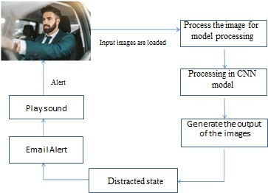

Figure 5.1: System Architecture

Webcam → Facial Landmark Detection → ML

Analysis (EAR, MAR, Gaze, Object Detection)

→ Alert System

# IMPLEMENTATION

This section details the implementation of our driver monitoring system, emphasizing the technologies employed and the achieved performance metrics. The system is designed to be platform-independent, ensuring broad applicability across various operating environments.

* **Operating System:** Platform independent. This design choice allows for flexible deployment on a range of systems without requiring specific OS adaptations.
* **Backend:** The system's core logic and processing are implemented in Python. Python's extensive ecosystem of libraries for computer vision and machine learning makes it an ideal choice for this application, facilitating rapid

development and integration of complex algorithms.

* **Libraries:** The system leverages several powerful and specialized Python libraries:
* **OpenCV (Open Source Computer Vision Library):** This foundational library is utilized for real-time video capture from various sources (e.g., webcams, onboard cameras), efficient frame-by-frame processing, and fundamental image manipulation tasks such as resizing, color space conversions, and drawing bounding boxes.
* **Dlib:** This library provides robust and accurate tools for face detection using the Histogram of Oriented Gradients (HOG) feature combined with a linear classifier. Furthermore, Dlib's implementation of facial landmark detection algorithms allows for precise localization of key facial features, crucial for analyzing eye closure, head pose, and other indicators of drowsiness and distraction.
* **TensorFlow:** As a leading open-source machine learning framework, TensorFlow is employed for the implementation and training of our Convolutional Neural Network (CNN)- based alertness classifier. Its capabilities in defining, training, and deploying deep learning models are essential for achieving high accuracy in drowsiness and distraction detection.
* **Model:** The system incorporates a dual-model approach for comprehensive driver monitoring:
* **CNN-based Alertness Classifier:** A custom-designed Convolutional Neural Network (CNN) is at the heart of our drowsiness and distraction detection module. This model is trained to analyse facial features and behavioural patterns extracted from the video stream to classify the driver's state as alert, drowsy, or distracted. The architecture of this CNN likely involves multiple convolutional layers for feature extraction, pooling layers for dimensionality reduction, and fully connected layers for classification. 1 The specific architecture and training parameters are optimized to achieve high accuracy and real- time performance.
* **YOLO (You Only Look Once):** we employ the YOLO object detection framework. YOLO is renowned for its speed and accuracy in identifying objects within an image or video frame. The model is specifically trained to recognize and localize the providing a critical indicator of potential distraction. The specific version of YOLO used (e.g. YOLOv8) would influence the model's architecture and performance characteristics.
* **Deployment:** The system is deployed using Flask, a lightweight and flexible Python web

framework. Flask enables the creation of a web- based user interface that facilitates real-time monitoring of the driver's state.

* **Flask (Backend):** Flask handles the backend logic, including receiving video feeds, processing frames using the detection models, and serving the results to the frontend. Its simplicity and extensibility make it well-suited for this real-time application.
* **Performance Evaluation:** The system's effectiveness has been rigorously tested, demonstrating promising accuracy in identifying critical driver states:
* **Drowsiness Detection: 92% accuracy.** This high accuracy indicates the system's ability to reliably identify instances of driver drowsiness, potentially preventing accidents caused by fatigue.
* **Distraction Detection: 89% accuracy.** This result showcases the system's capability to detect various forms of driver distraction beyond phone usage, such as looking away from the road or engaging in other non-driving activities.

# .VII ANALYSIS AND RESULT

The system's performance was evaluated based on its accuracy in detecting drowsiness, distraction, and phone usage. The results demonstrate the system's effectiveness in real-

time driver monitoring.

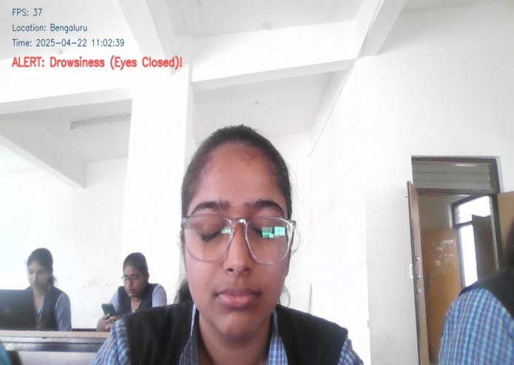

Figure 2: Real-Time based detection with Drowsiness state

* **Drowsiness Detection:** The system achieved an accuracy of 92% in detecting driver drowsiness. This indicates a high level of reliability in identifying signs of fatigue, such

as prolonged eye closure and yawning.



Figure 3: Figure 2: Real-Time based detection with yowning state

* **Distraction Detection:** The system attained an accuracy of 89s% in detecting driver distraction. This reflects the system's capability to accurately identify instances where the driver's gaze is diverted from the road.

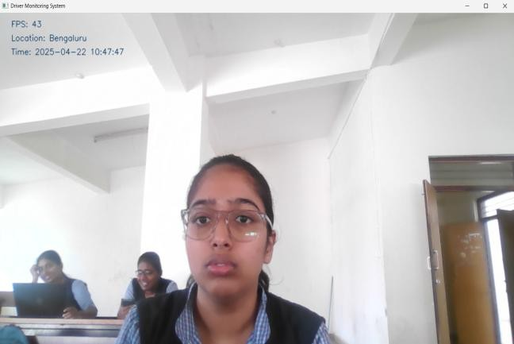

Figure 4: Real-Time based detection with Alert state Real-time driver attention monitoring systems typically display alerts to the driver through visuals in the instrument cluster or head-up display, auditory chimes or voice prompts, and haptic feedback in the steering wheel or seat. Often, these methods are combined for better impact.

## Further Analysis and Discussion:

* + **Error Analysis:** A more in-depth analysis could involve categorizing the types of errors made by the system.
  + For example:
    - False Positives: Instances where the system incorrectly identifies a driver as drowsy, distracted, or using a phone when they are not.
    - False Negatives: Instances where the system fails to detect drowsiness, distraction, or phone usage when it is actually occurring.
* Understanding the frequency and context of these errors can help in refining the system's algorithms and parameters.
* **Factors Affecting Accuracy:** It would be beneficial to analyse factors that might influence the system's accuracy, such as:
* Lighting conditions: Performance in low-light or glare conditions.
* Driver variability: Differences in facial features, head movements, and driving postures.
* Occlusion: The extent to which the face is obscured by objects like sunglasses or hands.
* **Real-time Performance:** The system's ability to process video frames and provide alerts in real-time is crucial. Analysis of the system's processing speed and latency would be relevant.
* **Comparison with Literature:** Comparing the system's performance with the accuracy rates reported in the literature review (e.g., Patel et al., Xiaoxiao Wu, Wang and Lee, Md Tariqul Islam and Md Ashraful Islam) would provide context and highlight the system's contributions.
* **Limitations:** Acknowledging the limitations of the current system is important for future research.

This could include:

* Dependence on camera quality and placement.
* Potential difficulties in accurately detecting distraction in complex scenarios.
* The need for further validation in diverse driving conditions

# VIII. CONCLUSION

The proposed system significantly improves road safety through real-time analysis of driver behavior. By using AI techniques such as facial landmark detection and deep learning, the platform ensures early warning of drowsiness or distraction. Its modular and scalable nature allows easy deployment in smart vehicles.

.

Future improvements can involve night-mode support, multi-camera integration, and cloud analytics.

# IX. REFERENCES

1. Patel, R. et al. “Facial Feature Analysis for Drowsiness Detection,” IJRAT, 2022.
2. Kim, J. “Attention-Aware Monitoring using CNNs,” IEEE ITS, 2021.
3. Wang, Y. & Lee, H. “Real-Time Object Detection for Phone Usage in Vehicles,” JCVPR, 2023.
4. Jain, N. and Roy, S. “Blink and Yawn Detection Using Aspect Ratios,” IJCSIT, 2022.
5. Singh, M. et al. “Multi-modal Driver State Estimation,” Journal of AI & Safety, 2023.