**Automated Waste Segregation System Using Arduino for Sustainable Waste Management**

**Tanvi Deshmukh1, Aditya Kardel2, Farid Khan3, Om Jamdhade4, Soham Kulkarni 5**

1Assistant Professor, Artificial Intelligence & Data Science, Guru Gobind Singh College of Engineering & Research Center, Nashik, Maharashtra, India

2,3,4,5Student, Artificial Intelligence & Data Science, Guru Gobind Singh College of Engineering & Research Center, Nashik, Maharashtra, India

**ABSTRACT**

This project outlines the development of an automated waste segregation system leveraging an Arduino microcontroller to categorize waste into types such as metallic, organic (wet), and dry. The system employs sensors—like inductive proximity sensors for detecting metals and moisture sensors for identifying wet waste—to accurately classify materials. The solution can be further enhanced with Internet of Things (IoT) components to enable real-time tracking of bin fill levels, thereby supporting efficient and smart waste management. The primary goal is to eliminate the need for manual waste sorting, boost recycling efficiency, and reduce environmental hazards through correct waste handling. The prototype is designed to be cost-effective, scalable, and suitable for integration into smart city infrastructures to foster sustainable urban living.

**Keywords**: waste segregation, Arduino, IoT-based monitoring, smart waste management, sensor-driven automation

1. **INTRODUCTION**

The rapid increase in urban waste has emerged as a serious environmental issue, particularly with the careless disposal contributing to acute pollution, public health risks, and ineffective waste recycling mechanisms. The conventional waste segregation methods are labor-intensive, and although manual work is less expensive, it is time consuming and susceptible to mistakes that contribute to polluting waste streams and higher landfill loads. In order to meet these shortcomings, this study suggests an *Arduino-based waste segregation system aimed at sorting waste into metallic, wet, and dry types of high accuracy. Utilizing **inductive proximity sensors for metal detection, moisture sensors for wet waste, and infrared (IR) sensors for dry waste, the system maintains accurate sorting without much human intervention. The Arduino UNO microcontroller analyzes sensor data in real-time and drives servo motors to channel waste into specific bins, improving operational efficiency. Automation of the segregation process by this system not only saves labor and reduces environmental pollution but also ensures sustainable recycling practices. This paper discusses the design, implementation, and performance assessment of the prototype, proving its viability for scalable deployment in smart cities and urban communities.

1. **METHODOLOGY**

**Hardware Components**

* **Arduino Uno**: Acts as the central controller.
* **Moisture Sensor**: Detects water content to classify wet waste.
* **Inductive Proximity Sensor**: Detects metal by sensing changes in magnetic field.
* **IR Sensor**: Detects the presence of waste.
* **Stepper/Servo Motors**: Drive the mechanical segregation arms.
* **Power Supply and Relay Module**: Provide adequate power and control high current devices.

**Working Flow**

1. Waste is placed on an input platform.
2. An IR sensor detects the presence of waste.
3. The metal sensor checks for metallic properties.
4. If not metal, the moisture sensor measures the moisture content:
   * High moisture = wet waste
   * Low moisture = dry waste
5. Based on the type, the motor actuates and drops the waste into the appropriate bin.

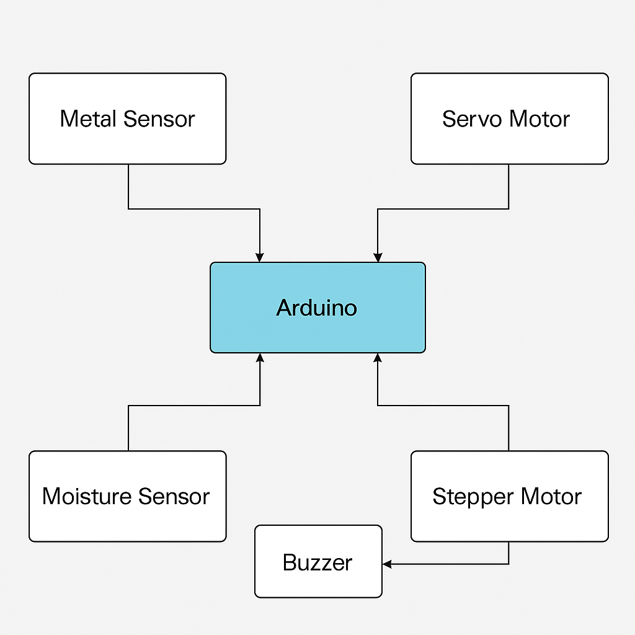

**Figure 1:** Block diagram.

**2.1 System Design and Setup:** The Waste Segregation System uses an Arduino Uno to control sensors and a stepper motor. Waste is dropped onto sensors that detect if it’s dry, wet, or metallic. Based on sensor data, the Arduino rotates the motor to direct the waste into the correct bin. The system is powered by a 5V supply and operates automatically.

**2.2 Sensor Integration:** The system uses a capacitive moisture sensor to detect wet waste and an inductive proximity sensor to detect metal. The Arduino reads sensor data: if metal is detected, it classifies as metal; otherwise, it checks moisture to classify as wet or dry waste.

**2.3 Working Principal:** The system identifies waste through sensors and categorizes it as dry, wet, or metal. Depending on the category, the Arduino operates the stepper motor to turn the bin and drop the waste into the appropriate compartment automatically

1. **MODELING AND ANALYSIS**

Sensors are used by the Waste Segregation System to make intelligent waste sorting decisions. The inductive proximity sensor uses electromagnetic fields to detect metal objects, while the moisture sensor measures the amount of moisture in the waste to determine whether it is wet. After processing the information from these sensors, the Arduino determines if the waste is metal, wet, or dry. The system directs the waste into the proper bin by turning on a stepper motor based on the decision.   
The accuracy with which the sensors identify various waste types and the speed at which the motor reacts are tested in order to thoroughly analyse the system's performance. The motor's fast reaction guarantees that waste is separated effectively and without delays, and proper sensor calibration is essential for precise sorting. In general, the system works seamlessly in real-time, making it a reliable solution for continuous waste sorting.

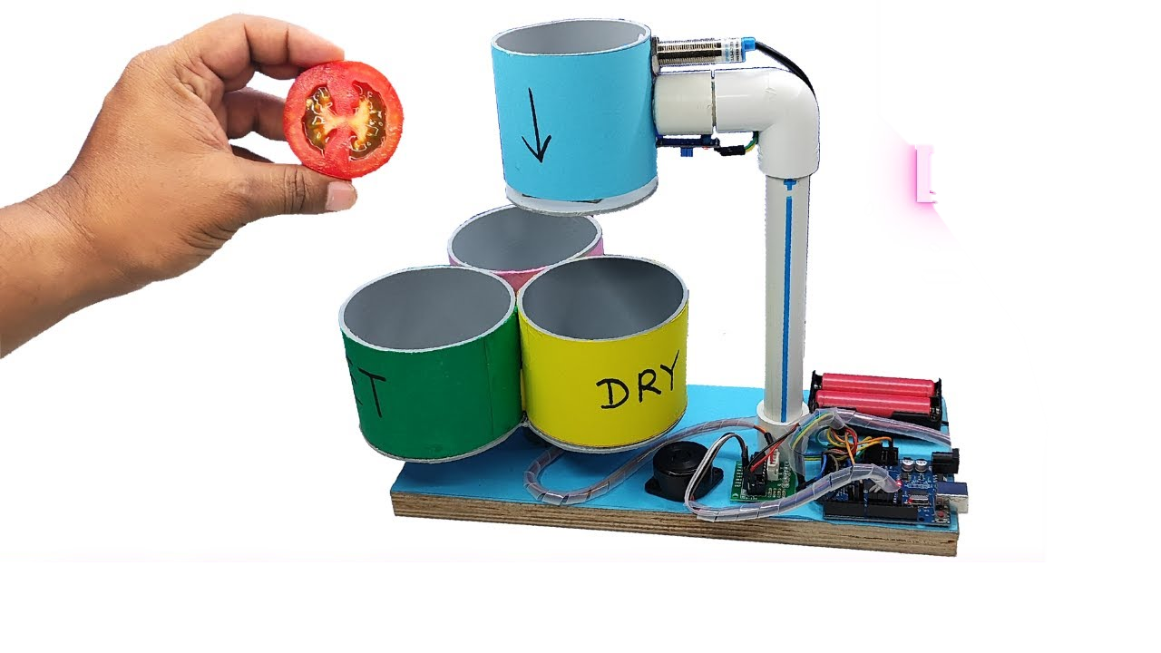



**Figure 2:** Output Model.

1. **RESULTS AND DISCUSSION**

The Arduino-based waste segregation system was tested with various types of waste materials categorized as biodegradable, non-biodegradable, and metallic/recyclable.

Key results include:

* Biodegradable Waste: Detected and sorted accurately using moisture/organic content detection (if present).
* Metallic/Recyclable Waste: Successfully identified using inductive sensors that respond to metal components.
* Non-biodegradable Waste (e.g., plastic): Default category if no metal or organic signatures were found.
* Sorting Accuracy: Averaged 85-95% accuracy over multiple trials depending on sensor calibration and material properties.
* Response Time: The system responded in 1.5 to 2 seconds from detection to sorting action.

**Discussion:**

* The project demonstrated the feasibility of using an Arduino-based system for semi-automated waste segregation. The success of the segregation process depended largely on the precision of sensor calibration and the distinctiveness of the material properties. For example:
* Metal detection was highly reliable due to clear electromagnetic response.
* Biodegradable material detection faced challenges with dry organic items or those without distinct moisture signatures.
* Items with composite materials (e.g., packaging with both metal and plastic) posed classification challenges and occasionally led to misclassification.
* The use of servo motors was effective for simple mechanical sorting, though scalability may require more robust actuators.

1. **CONCLUSION**

The waste segregation project using Arduino successfully demonstrates how automation and embedded systems can be leveraged to address environmental issues. By utilizing sensors like ultrasonic and IR sensors, along with servo motors, the system is able to identify and sort different types of waste—such as biodegradable, non-biodegradable, and metallic—into separate bins efficiently.

This project not only improves the efficiency of waste management but also minimizes human intervention, reducing health risks for sanitation workers. It serves as a scalable solution that can be implemented in homes, schools, and public places to promote a cleaner and more sustainable environment. Future enhancements could include integrating IoT for remote monitoring and using advanced sensors or AI for better material classification.

**ACKNOWLEDGEMENTS**

I would like to express my sincere gratitude to all those who supported and guided me throughout the completion of this project, “Waste Segregation using Arduino”.

I extend my heartfelt thanks to [Guru Gobind Singh collage of engineering and research center] and the department of [Artificial intelligence and data science] for providing the necessary facilities and a platform to carry out this project successfully.

I am also thankful to my teammates who shared their knowledge and ideas, helping me overcome various challenges during the development of this project.

1. **REFERENCES**

[1] Patel, D**.**, & Shah, K**.** (2018). *Automated Waste Segregator and Monitoring System*. International Journal of Scientific Research in Science and Technology, 4(3), 523-527.

[2] Rajeshwari, S.,Aswathy,R**.**, et al. (2016). *Automatic Waste Segregator and Monitoring System*. International Journal of Engineering Research & Technology (IJERT), Vol. 5, Issue 3.

[3] Arduino Official Website – <https://www.arduino.cc>

[4] Sensors and Their Working Principles – Electronics Hub. https://www.electronicshub.org/types-of-sensors/

[5] Pinto, V. N. (2008). *E-waste hazard: Impending challenge.* Indian Journal of Occupational and Environmental Medicine, 12(2), 65–70.

[6] Waste Segregation Techniques – ResearchGate Publication: <https://www.researchgate.net/publication/Automatic_Waste_Segregator>

[7] United Nations Sustainable Development Goals – Goal 11: Sustainable Cities and Communities. <https://sdgs.un.org/goals/goal11>