**EFFECTIVENESS OF DANGEROUS GOODS PACKAGING IN AIR TRANSPORTATION, TS India Logistics Solution**

**Prince Christudas**

Student, MBA in Shipping and Logistics Management (SLM),

Vel’s Institute Of Science, Technology And Advanced Studies (VISTAS), Chennai, Tamil Nadu, India

**Dr. D. Anitha Kumari**

Programme Coordinator, MBA in Shipping and Logistics Management (SLM),

VISTAS, Chennai, Tamil Nadu, India

**Mr. Prince Lazarus**

CII (Confederation of Indian Industry) Faculty, MBA in Shipping and Logistics Management (SLM),

VISTAS, Chennai, Tamil Nadu, India

**ABSTRACT**

The transportation of dangerous goods (DG) by air presents significant safety and regulatory challenges due to the hazardous nature of these materials. This research investigates the effectiveness of packaging practices in air transportation, with a focused case study on TS India Logistics Solution. Primary data was collected from 23 industry professionals, including logistics managers, cargo handlers, and safety officers, and supplemented with secondary data from regulatory manuals and academic literature. The analysis evaluates the performance of current packaging materials, labeling accuracy, and compliance with international regulations such as IATA and ICAO standards. The investigation revealed that although regular pre-shipment inspections are common, issues like incomplete labeling, occasional packaging damage, and inconsistent compliance remain widespread. Findings emphasize the need for improved staff training, adoption of innovative packaging technologies, and stricter enforcement of packaging protocols to enhance safety and operational efficiency. This study highlights key gaps and suggests areas for future improvement, offering practical insights to industry professionals. Despite the limited sample size, the research contributes valuable recommendations to strengthen the effectiveness of dangerous goods packaging in air transport and ensures safer handling of hazardous materials within the global logistics network.

1. **INTRODUCTION (Font-Times New Roman, Bold, Font Size -12)**

Air transportation is crucial for connecting markets globally, facilitating rapid and efficient movement of goods. Among the cargo transported by air, dangerous goods (DG) present unique challenges due to their hazardous nature. Dangerous goods include chemicals, explosives, flammable liquids, gases, radioactive materials, and biological agents, all of which require stringent safety protocols during transportation. The safe handling and transportation of these materials are governed by international and national regulations such as those established by the United Nations (UN), International Civil Aviation Organization (ICAO), International Maritime Organization (IMO), and other authorities.

The packaging of dangerous goods plays a critical role in ensuring their safe transit. Proper packaging minimizes risks such as spills, leaks, fires, or contamination, protecting aircraft, crew, passengers, and the environment. Effective packaging also ensures compliance with regulations, reduces financial losses, and maintains supply chain reliability. With advancements in materials and technologies, there is an increasing focus on improving packaging effectiveness through innovations like fire-resistant containers, smart sensors, and sustainable materials.

Current research highlights the need for continuous improvement in dangerous goods packaging. Despite stringent regulations, incidents involving improper packaging still occur, often due to human error, inconsistent enforcement of standards, or inadequate materials. Emerging challenges, such as the transport of lithium-ion batteries, require enhanced packaging solutions to address new risks.

This study aims to assess the effectiveness of dangerous goods packaging in air transportation, identify existing gaps, and suggest improvements to enhance safety, compliance, and efficiency. The research will explore current practices, regulatory frameworks, technological innovations, and real-world case studies, contributing to a safer and more resilient air transport system

1. **METHODOLOGY**

The methodology for this research focuses on evaluating the effectiveness of dangerous goods packaging in air transportation. Keywords such as "dangerous goods," "air transportation," and "packaging effectiveness" guide the approach.

**2.1 Research Design**

The research adopts a descriptive and exploratory design to accurately portray existing practices and identify areas for improvement. Descriptive analysis helps in understanding compliance levels, packaging methods, and risk management strategies, while exploratory analysis highlights emerging trends and technological innovations.

**2.2 Data Collection Methods**

Primary data is collected through structured questionnaires administered to 50 industry professionals, including cargo handlers, safety officers, and logistics managers. Secondary data is obtained from industry reports, regulations, academic articles, and case studies. The combination ensures comprehensive insights into the current state of dangerous goods packaging.

**2.3 Sampling Technique**

Purposive sampling is used to select respondents with specific experience in dangerous goods handling and packaging. This method ensures that the data collected is relevant and credible, drawing from professionals knowledgeable in regulatory compliance and operational challenges.

**2.4 Questionnaire Design**

The questionnaire is structured into three sections: demographic information, current practices and compliance, and challenges with suggestions for improvement. Both closed and open-ended questions are used to gather quantitative and qualitative data.

**2.5 Limitations of the Study**

The study's limitations include a relatively small sample size, potential response bias, geographical restrictions, and reliance on self-reported data. These factors may affect the generalizability of the findings.

1. **RESULTS AND DISCUSSION**

**Table 1.1.** Frequency of Handling Dangerous Goods Shipments

|  |  |  |  |
| --- | --- | --- | --- |
| SN. | PARTICULARS | FREQUENCY | PERCENTAGE |
| 1 | DAILY | 8 | 34.8% |
| 2 | WEEKLY | 10 | 43.5% |
| 3 | MONTHLY | 2 | 8.7% |
| 4 | RARELY | 3 | 13% |
|  | TOTAL | 23 | 100% |

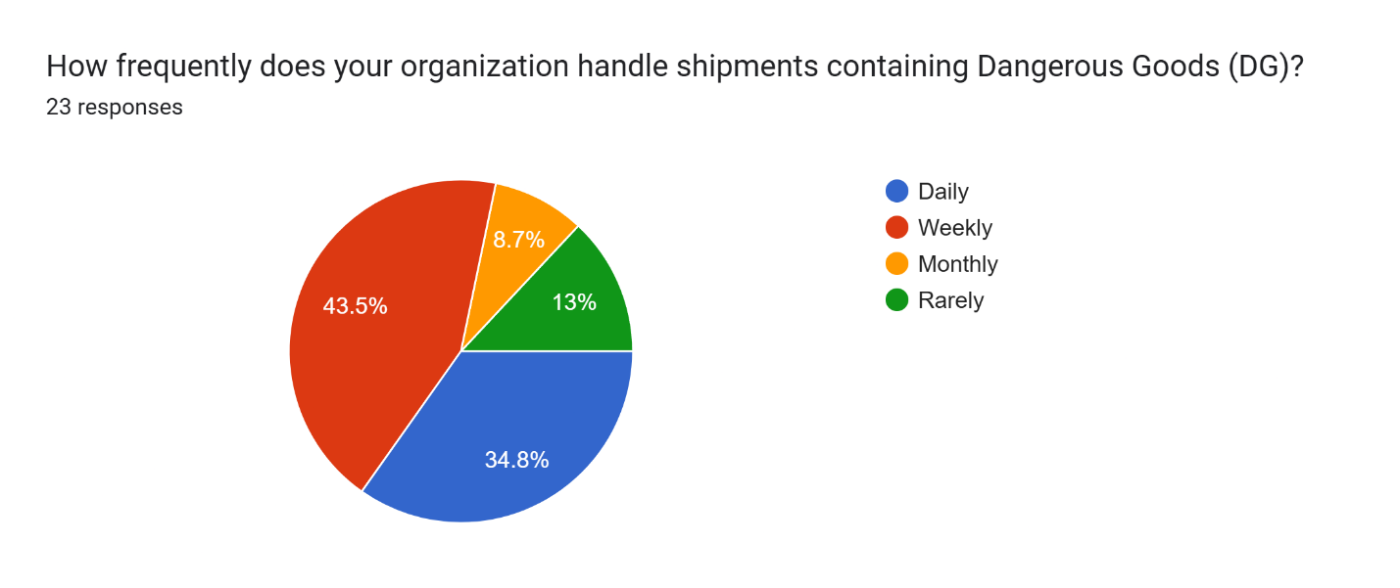

**Figure 2.1:** Frequency of Handling Dangerous Goods Shipments

Most respondents, 43.5%, handle dangerous goods on a weekly basis, while 34.8% deal with them daily. A smaller portion reported handling DG monthly (8.7%) or rarely (13%).

**Interpretation:**

Dangerous goods are clearly a routine part of operations for many, with over three-quarters managing such shipments on a regular basis. This frequency demands a high level of consistency in safety protocols, proper packaging, and updated training. Organizations involved in daily or weekly handling are likely to be more aligned with international standards like IATA DGR. However, those with infrequent exposure may face challenges in maintaining compliance without regular practice or refresher programs.

**Table 1.2.** DG Packaging Compliance Issues

|  |  |  |  |
| --- | --- | --- | --- |
| SN. | PARTICULARS | FREQUENCY | PERCENTAGE |
| 1 | FREQUENTLY (EVERY WEEK) | 5 | 21.7% |
| 2 | OCCASIONALLY (1–2 TIMES A MONTH) | 13 | 56.5% |
| 3 | VERY FREQUENTLY (ALMOST DAILY) | 2 | 8.7% |
| 4 | NEVER | 3 | 13% |
|  | TOTAL | 23 | 100% |

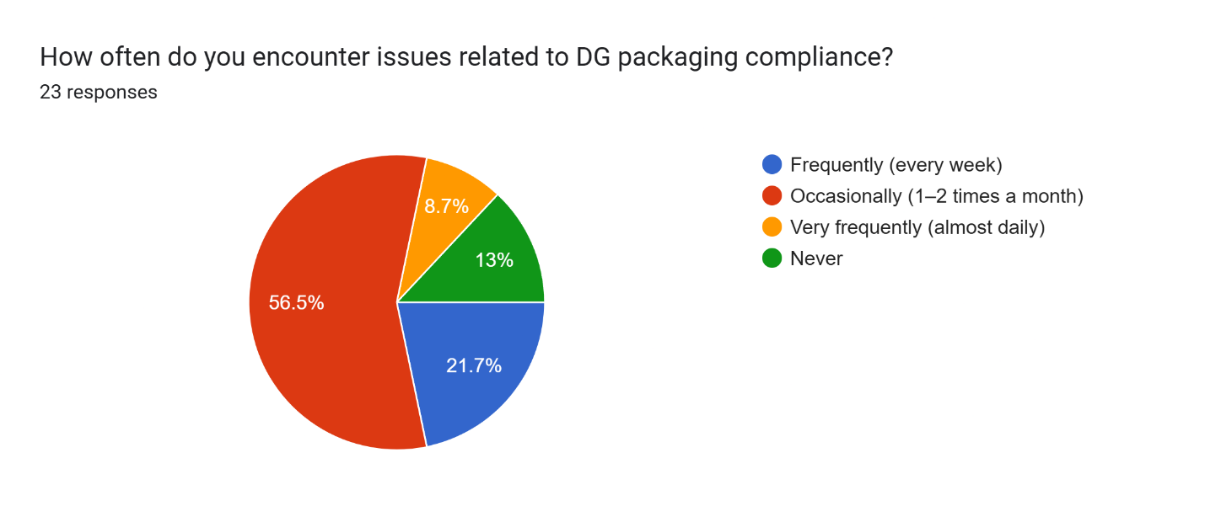

**Figure 2.2:** DG Packaging Compliance Issues

The majority, 56.5%, encounter packaging compliance issues occasionally, around 1–2 times a month. 21.7% face such problems frequently on a weekly basis, and 8.7% deal with them almost daily. Interestingly, 13% reported never facing any issues.

**Interpretation:**

While a small number claim zero issues, most respondents do encounter compliance challenges to some degree. This points to ongoing gaps in training, awareness, or packaging processes. The fact that nearly a third face issues frequently or very frequently raises concerns about the overall consistency in adhering to DG packaging regulations. These findings highlight the importance of continuous audits, staff upskilling, and possibly investing in smarter packaging solutions to minimize non-compliance and associated risks.

**Table 1.3.** Most Common DG Packaging Issue

|  |  |  |  |
| --- | --- | --- | --- |
| SN. | PARTICULARS | FREQUENCY | PERCENTAGE |
| 1 | DAMAGED PACKAGING | 4 | 17.4% |
| 2 | INCOMPLETE/MISSING LABELS | 16 | 69.6% |
| 3 | NON-COMPLIANCE WITH ICAO/IATA RULES | 3 | 13% |
| 4 | WRONG PACKAGING TYPE | 0 | 0 |
|  | TOTAL | 23 | 100% |

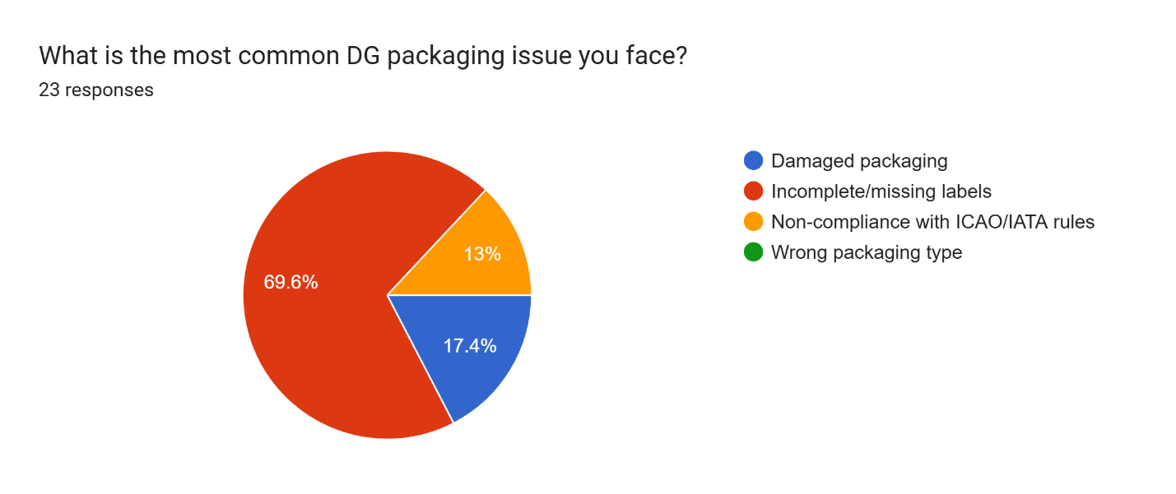

**Figure 2.3:** Most Common DG Packaging Issue

A significant 69.6% of respondents said that incomplete or missing labels are the most common issue with dangerous goods (DG) packaging. Another 17.4% pointed to damaged packaging, while 13% cited non-compliance with ICAO/IATA regulations. Interestingly, no one reported using the wrong type of packaging.

**Interpretation:**

Labeling issues clearly top the list, highlighting a widespread need for better training and more thorough checks during the labeling and documentation process. Since proper labeling is critical for identifying, handling, and responding to DG shipments, this is a serious concern. On the bright side, it's good to see that incorrect packaging types aren’t a problem. Still, the reports of damage and regulatory non-compliance suggest there’s room to improve quality control and ensure stricter adherence to IATA Dangerous Goods Regulations (DGR).

**Table 1.4.** Time Required to Resolve DG Packaging Issues

|  |  |  |  |
| --- | --- | --- | --- |
| SN. | PARTICULARS | FREQUENCY | PERCENTAGE |
| 1 | LESS THAN 1 DAY | 7 | 30.4% |
| 2 | 1 – 2 DAYS | 10 | 43.5% |
| 3 | 3 – 5 DAYS | 6 | 26.1% |
| 4 | MORE THAN 5 DAYS | 0 | 0 |
|  | TOTAL | 23 | 100% |

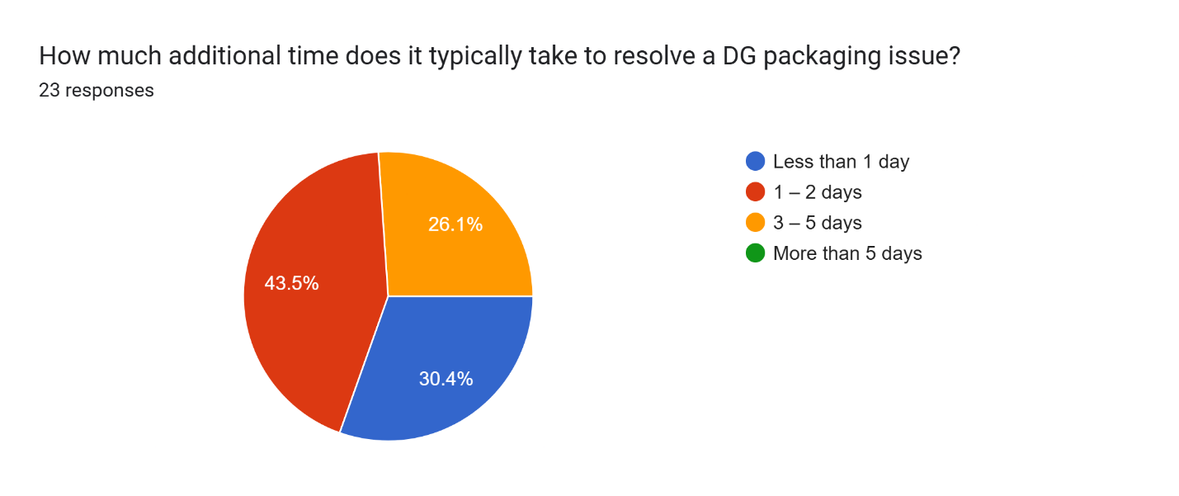

**Figure 2.4:** Time Required to Resolve DG Packaging Issues

Nearly half of the respondents (45.5%) said it usually takes 1 to 2 days to resolve a DG packaging issue. About 30.4% are able to fix problems in under a day, while 26.1% said it takes them between 3 to 5 days. Notably, no one reported delays beyond five days.

**Interpretation:**

Most DG packaging issues get sorted out fairly quickly—typically within two days. That’s a good sign that many companies have systems in place to respond efficiently when problems come up. However, the fact that over a quarter of respondents need up to five days points to some possible bottlenecks—whether that's due to limited resources, packaging supply issues, or administrative slowdowns. In the fast-paced world of air transport, even a few days of delay can ripple through the supply chain. Tightening up compliance processes and focusing on prevention could help shorten turnaround times even more.

**Table 1.5.** Average Cost Incurred Due to DG Packaging Issues

|  |  |  |  |
| --- | --- | --- | --- |
| SN. | PARTICULARS | FREQUENCY | PERCENTAGE |
| 1 | LESS THAN ₹1,000 | 1 | 4.3% |
| 2 | ₹1,000 – ₹5,000 | 9 | 39.1% |
| 3 | ₹5,000 – ₹10,000 | 10 | 43.5% |
| 4 | MORE THAN ₹10,000 | 3 | 13% |
|  | TOTAL | 23 | 100% |

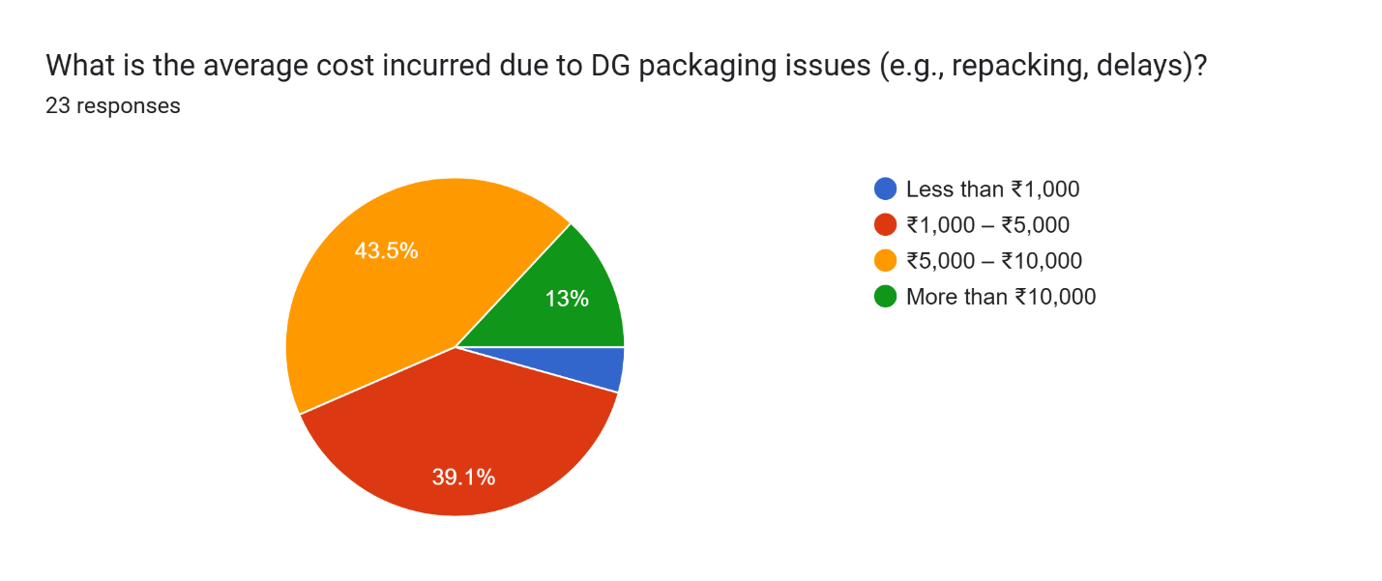

**Figure 2.5:** Average Cost Incurred Due to DG Packaging Issues

The biggest chunk of respondents—43.5%—said they typically spend between ₹5,000 and ₹10,000 to resolve a single DG packaging issue. Another 39.1% reported costs between ₹1,000 and ₹5,000, while 13% said each incident cost them more than ₹10,000. Only a small group (4.3%) managed to keep costs below ₹1,000.

**Interpretation:**

DG packaging problems aren't just about compliance—they hit the wallet too. Most companies end up spending anywhere from ₹1,000 to ₹10,000 per issue, and a notable 13% are dealing with even higher costs. These expenses can stack up quickly when you factor in things like repacking, delays, fines, and potential product damage. It’s a clear sign that investing upfront—in better materials, proper training, and consistent processes—can save serious money in the long run by preventing these issues altogether.

**Table 1.6.** Effectiveness of Packaging Materials in Preventing Leaks or Spills

|  |  |  |  |
| --- | --- | --- | --- |
| SN. | PARTICULARS | FREQUENCY | PERCENTAGE |
| 1 | VERY INEFFECTIVE | 2 | 8.7% |
| 2 | SOMEWHAT EFFECTIVE | 11 | 47.8% |
| 3 | EFFECTIVE | 7 | 30.4% |
| 4 | VERY EFFECTIVE | 3 | 13% |
|  | TOTAL | 23 | 100% |

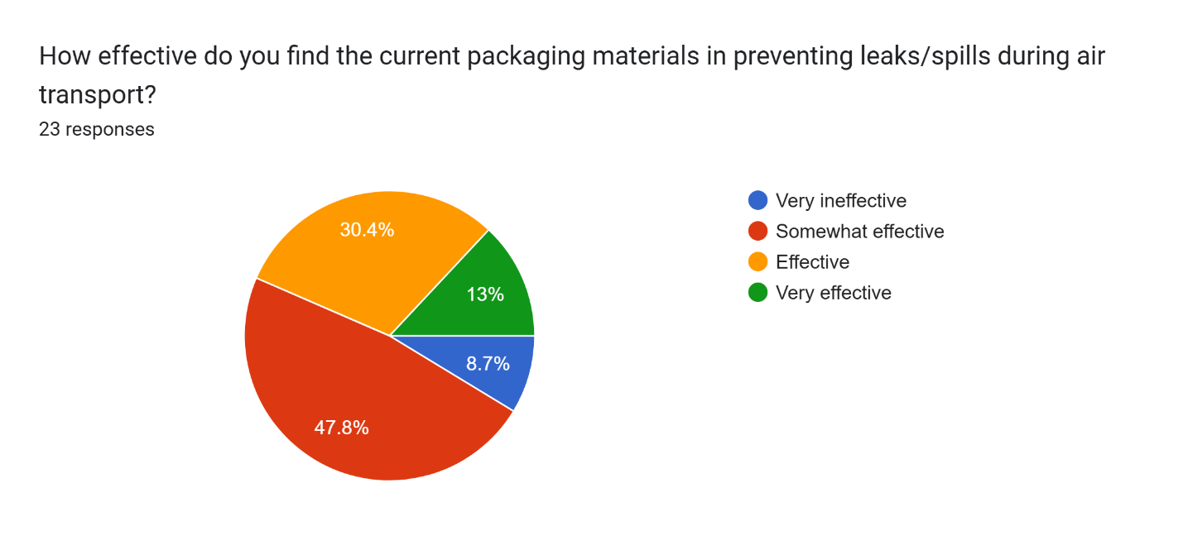

**Figure 2.6:** Effectiveness of Packaging Materials in Preventing Leaks or Spills

Almost half of the respondents (47.8%) felt that current packaging materials are only somewhat effective at preventing leaks or spills. About 30.4% rated them as effective, and just 13% said they’re very effective. On the flip side, 8.7% believed the materials are very ineffective.

**Interpretation:**

The feedback paints a mixed picture. While the materials seem to do an okay job overall, many users aren’t fully confident in their reliability, especially when it comes to high-stakes situations like air transport. The fact that nearly half find them only “somewhat effective,” and a few consider them outright ineffective, is concerning. Leaks or spills in DG shipments can lead to serious safety risks and costly consequences. This points to a clear need for better packaging solutions—whether through upgraded materials, stricter quality checks, or improved compliance with IATA DGR standards to boost safety and reliability.

**Table 1.7.** Frequency of Pre-Shipment Packaging Inspections

|  |  |  |  |
| --- | --- | --- | --- |
| SN. | PARTICULARS | FREQUENCY | PERCENTAGE |
| 1 | EVERY SHIPMENT | 17 | 73.9% |
| 2 | WEEKLY | 6 | 26.1% |
| 3 | MONTHLY | 0 | 0 |
| 4 | RARELY | 0 | 0 |
|  | TOTAL | 23 | 100% |

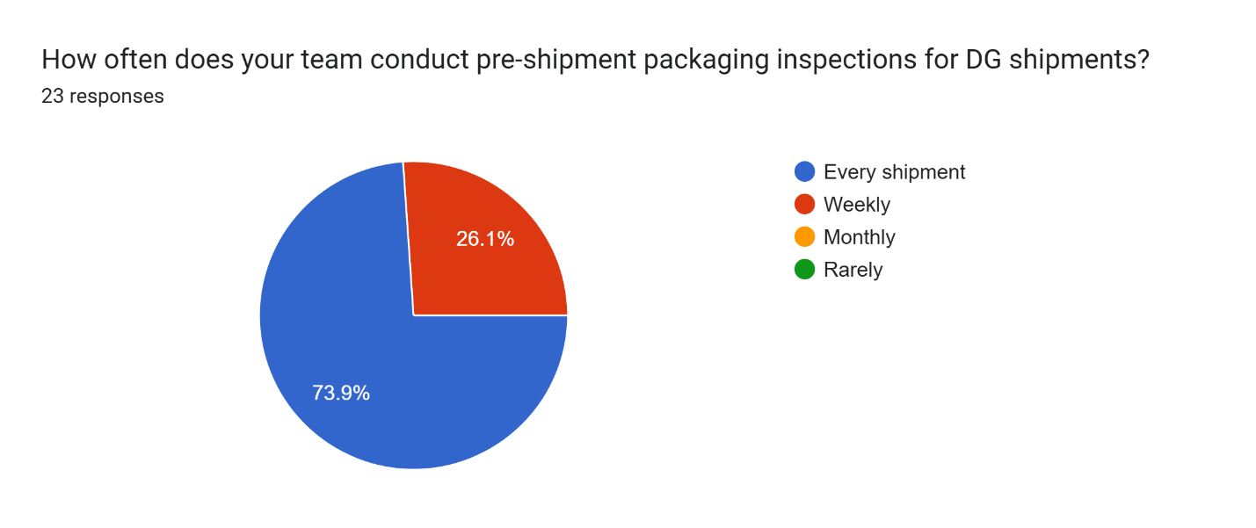

**Figure 2.7:** Frequency of Pre-Shipment Packaging Inspections

A solid 73.9% of respondents said they inspect DG packaging before every shipment. The remaining 26.1% conduct these checks on a weekly basis. Notably, no one reported doing inspections monthly or only occasionally.

**Interpretation:**

This is a great sign—it shows that most organizations are taking DG packaging seriously by performing routine inspections before every shipment. That level of diligence reflects a strong focus on safety, compliance, and minimizing risk. Weekly checks are still a good effort, but they might not catch issues in time, especially for operations handling large volumes. The complete absence of monthly or rare inspections reinforces the idea that those involved in air transport of dangerous goods understand the critical importance of thorough packaging checks.

**Table 1.8.** Percentage of DG Shipments Requiring Repacking

|  |  |  |  |
| --- | --- | --- | --- |
| SN. | PARTICULARS | FREQUENCY | PERCENTAGE |
| 1 | 0 – 10% | 8 | 34.8% |
| 2 | 11 – 25% |  | 47.8% |
| 3 | 26 – 50% |  | 17.4% |
| 4 | MORE THAN 50% |  | 0 |
|  | TOTAL | 23 | 100% |

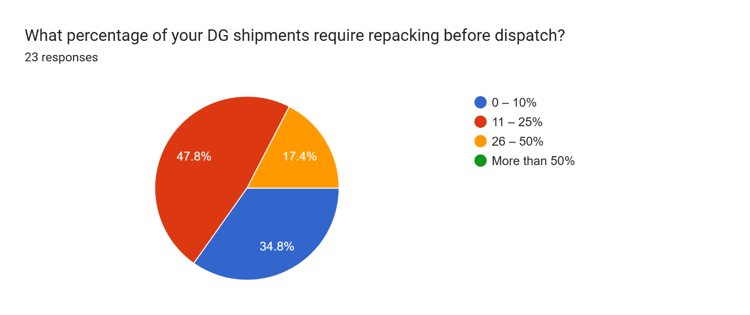

**Figure 2.8:** Percentage of DG Shipments Requiring Repacking

Nearly half of the respondents (47.8%) said that 11–25% of their dangerous goods (DG) shipments need to be repacked before dispatch. Another 34.8% reported needing to repack only 0–10% of shipments. Meanwhile, 17.4% said that 26–50% of their shipments require repacking. No one reported needing to repack more than half of their DG shipments.

**Interpretation:**

Repacking is a recurring part of DG shipping operations, especially for up to a quarter of shipments. It’s promising that over a third of respondents keep repacking to a minimum, but the fact that almost half are repacking up to 25% of shipments points to potential issues, like initial packaging errors, outdated compliance practices, or damage during handling. The good news is that no one is facing extreme repacking volumes, which shows the situation is manageable. Still, there’s room to improve. Better packaging practices, updated training, and closer attention to compliance could help more teams reduce repacking rates, saving both time and money.

**Table 1.9.** Use of Third-Party Experts or Certified Packers for DG Packaging

|  |  |  |  |
| --- | --- | --- | --- |
| SN. | PARTICULARS | FREQUENCY | PERCENTAGE |
| 1 | ALWAYS | 4 | 17.4% |
| 2 | SOMETIMES | 9 | 39.1% |
| 3 | RARELY | 9 | 39.1% |
| 4 | NEVER | 1 | 4.3% |
|  | TOTAL | 23 | 100% |

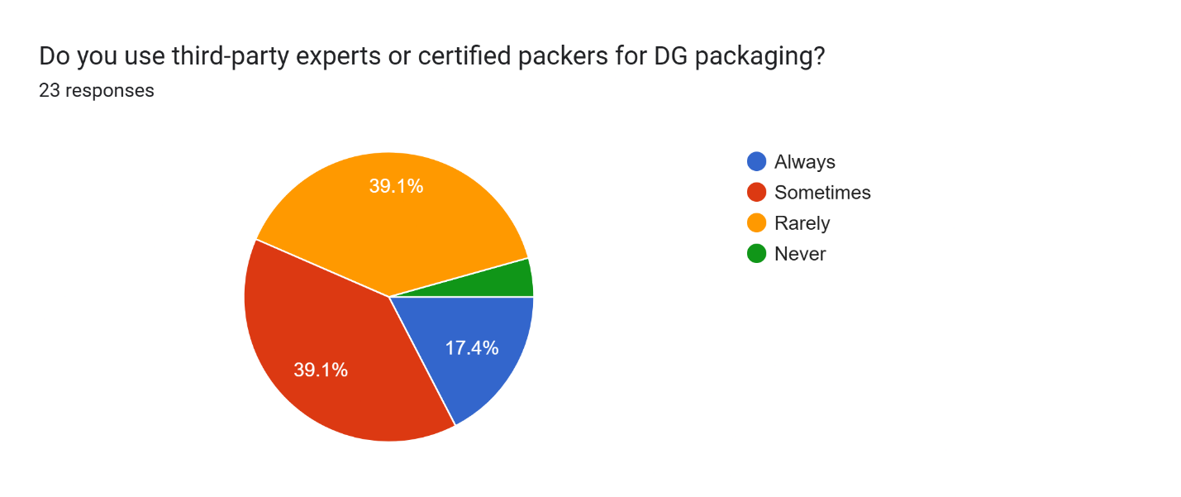

**Figure 2.9:** Use of Third-Party Experts or Certified Packers for DG Packaging

About 39.1% of respondents said they sometimes rely on third-party experts or certified packers for DG packaging, while another 39.1% use them rarely. 17.4% reported using them all the time, and 4.3% never use such services.

**Interpretation:**

For most organizations, turning to third-party experts or certified packers is more of an occasional or rare choice. This suggests that while companies recognize the benefits of external expertise, they often prefer to handle packaging internally, possibly due to cost, availability, or having trained in-house staff. The 17.4% who always use certified packers likely do so for high-risk shipments or because of strict internal policies focused on safety. The small group that never uses third-party services might face risks of non-compliance or mistakes if their internal teams aren't properly certified or trained. This could be an area for improvement, where forming partnerships with certified packers could help boost safety and ensure better compliance across the board.

**Table 1.10.** Frequency of Staff Training in DG Handling and Packaging Regulations

|  |  |  |  |
| --- | --- | --- | --- |
| SN. | PARTICULARS | FREQUENCY | PERCENTAGE |
| 1 | ANNUALLY | 9 | 39.1% |
| 2 | EVERY 6 MONTHS | 11 | 47.8% |
| 3 | EVERY 2 YEARS | 1 | 4.3% |
| 4 | NOT REGULARLY | 2 | 8.7% |
|  | TOTAL | 23 | 100% |

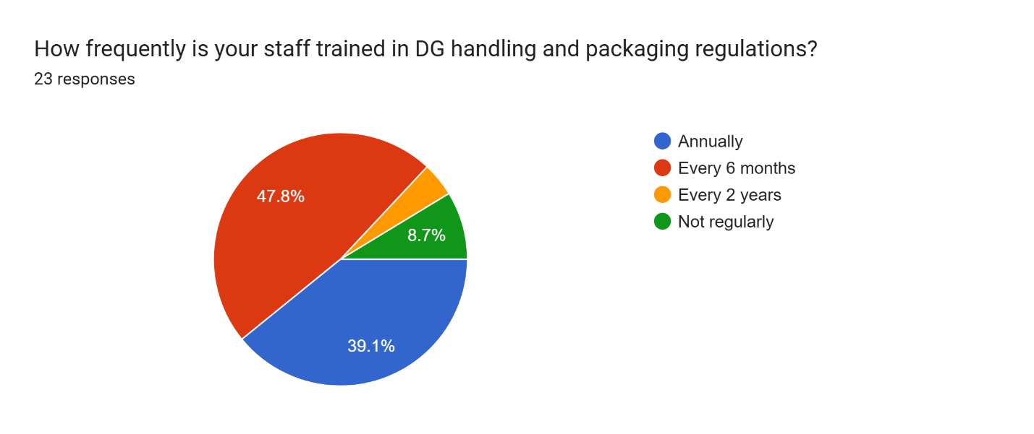

**Figure 2.10:** Frequency of Staff Training in DG Handling and Packaging Regulations

The majority of respondents—47.8%—train their staff every six months, while 39.1% conduct training annually. Only 4.3% update training every two years, and 8.7% admitted that their staff don’t receive regular training.

**Interpretation:**

Training is clearly a priority for most organizations involved in handling dangerous goods, with nearly 90% offering refresher courses at least once a year. This is a positive indicator of their commitment to safety and staying up-to-date with regulatory changes, especially given the constantly evolving nature of DG packaging standards under IATA DGR and ICAO regulations. However, the small percentage of organizations that either train infrequently or only every two years could be leaving themselves vulnerable to compliance gaps or operational risks. Given the complexities and potential dangers of air transport for hazardous materials, more frequent training—ideally every six months or even quarterly for high-risk sectors—could significantly improve accuracy in handling and reduce costly incidents.

**Table 1.11.** Biggest Challenge in Maintaining Packaging Compliance

|  |  |  |  |
| --- | --- | --- | --- |
| SN. | PARTICULARS | FREQUENCY | PERCENTAGE |
| 1 | LACK OF AWARENESS | 4 | 17.4% |
| 2 | HIGH PACKAGING COSTS | 4 | 17.4% |
| 3 | FREQUENT CHANGES IN REGULATIONS | 10 | 43.5% |
| 4 | HUMAN ERROR | 5 | 21.7% |
|  | TOTAL | 23 | 100% |

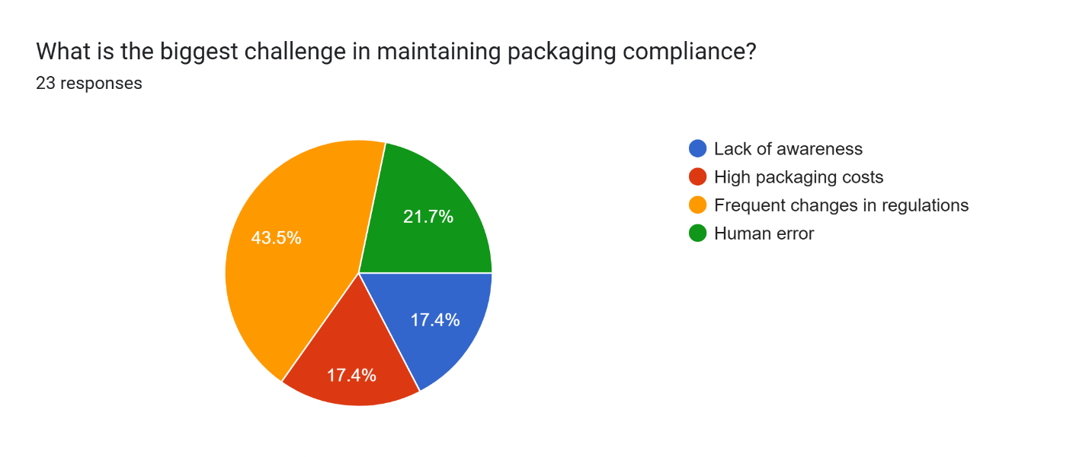

**Figure 2.11:** Biggest Challenge in Maintaining Packaging Compliance

The biggest challenge, according to 43.5% of respondents, is keeping up with frequent changes in regulations. Another 21.7% pointed to human error, while 17.4% each cited lack of awareness and high packaging costs.

**Interpretation:**

The main concern—frequent regulatory changes—reflects the difficulty many organizations face in staying updated with ever-evolving international standards, like those from IATA DGR and ICAO. This constant change means that training, documentation, and operational procedures need to be continuously revised, making compliance feel like a moving target.

While human error isn’t the top issue, it still poses a significant risk. With the high stakes involved in DG packaging, even small mistakes can lead to serious consequences, highlighting the need for thorough training, strong quality control systems, and perhaps even automation in certain areas.

Interestingly, awareness and cost are secondary concerns, though still important. The relatively low focus on cost might suggest that most organizations are willing to invest in safety. However, for smaller companies or those with tighter margins, cost could still be a hidden challenge.

These data points to a growing need for standardized digital compliance tools, automated alerts for regulatory updates, and enhanced staff training to address both evolving regulations and human error.

**Table 1.12.** Most Common Packaging Material Used for DG Shipments

|  |  |  |  |
| --- | --- | --- | --- |
| SN. | PARTICULARS | FREQUENCY | PERCENTAGE |
| 1 | FIBERBOARD BOXES | 11 | 47.8% |
| 2 | STEEL DRUMS | 6 | 26.1% |
| 3 | PLASTIC CONTAINERS | 5 | 21.7% |
| 4 | COMPOSITE PACKAGING | 1 | 4.3% |
|  | TOTAL | 23 | 100% |

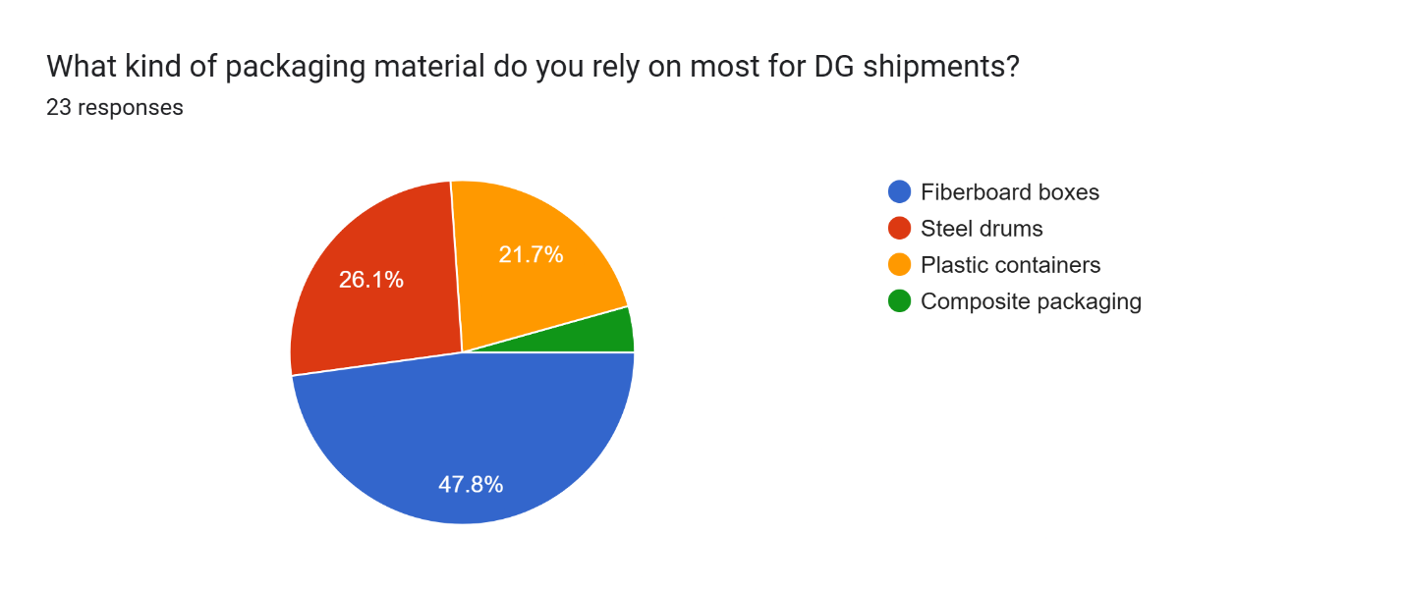

**Figure 2.12:** Most Common Packaging Material Used for DG Shipments

The most common packaging material used by respondents is fiberboard boxes, with 47.8% of companies using them for their dangerous goods shipments. Steel drums come in second at 26.1%, followed by plastic containers at 21.7%, and a smaller group (4.3%) using composite packaging.

**Interpretation:**

Fiberboard boxes dominate, which aligns well with UN-certified packaging standards. These boxes are lightweight, cost-effective, and compliant, making them a popular choice for smaller hazard classes and inner packaging. Their popularity could also be due to the ease of labeling and marking required for regulatory compliance, making them a practical option for many types of dangerous goods.

Steel drums and plastic containers are used when more durable containment is needed, particularly for bulk liquids or highly reactive substances. These materials offer better resistance to pressure, corrosion, or impact—key factors for safely transporting certain types of dangerous goods.

Composite packaging, though offering the benefits of dual-layer protection, is less common. This might be due to higher costs, complexity, or because it’s not needed for most shipments in the sample.

Overall, while most companies are following industry standards, there's an opportunity to explore more advanced or smart packaging solutions, especially for shipments requiring enhanced safety or environmental resistance. As more materials like lithium batteries are shipped, we may see a shift toward fire-resistant and tech-enabled packaging in the future.

**Table 1.13.** Confidence in Packaging Methods Meeting IATA/ICAO Standards

|  |  |  |  |
| --- | --- | --- | --- |
| SN. | PARTICULARS | FREQUENCY | PERCENTAGE |
| 1 | VERY CONFIDENT | 11 | 47.8% |
| 2 | SOMEWHAT CONFIDENT | 9 | 39.1% |
| 3 | UNSURE | 3 | 13% |
| 4 | NOT CONFIDENT | 0 | 0 |
|  | TOTAL | 23 | 100% |

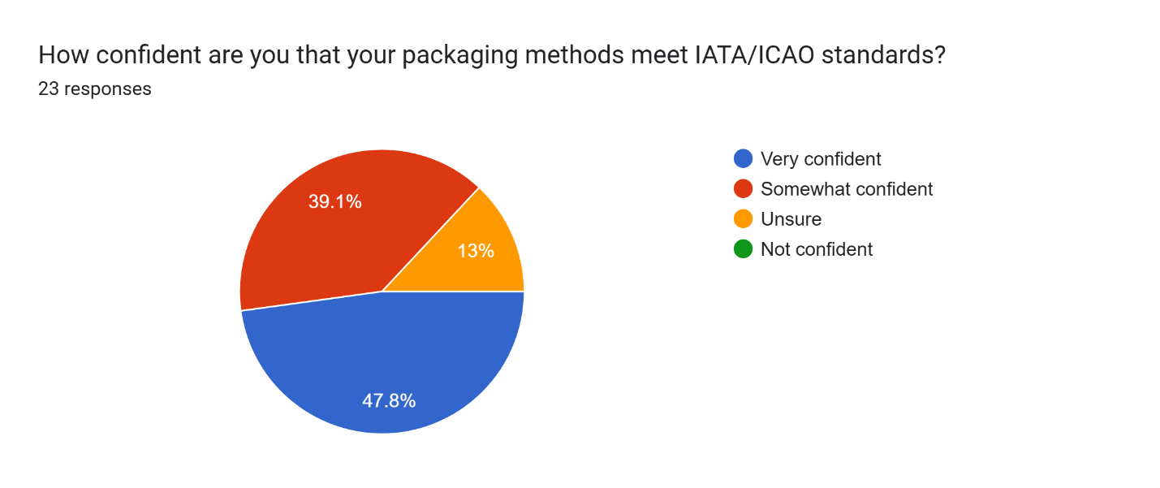

**Figure 2.13:** Confidence in Packaging Methods Meeting IATA/ICAO Standards

A strong 47.8% of respondents are very confident that their packaging methods meet IATA/ICAO standards, while 39.1% are somewhat confident. 13% are unsure, but no one reported feeling unconfident about their packaging compliance.

**Interpretation:**

This is a positive indicator of regulatory compliance, with over 85% of respondents expressing at least some level of confidence in their ability to meet the stringent standards set by IATA and ICAO. Given the complex and ever-changing nature of dangerous goods transportation, this is encouraging.

However, the 13% who are unsure may point to gaps in knowledge, a reliance on outdated procedures, or a lack of regular audits. To address this uncertainty, organizations could benefit from more frequent self-assessments, third-party audits, or investing in updated training to boost confidence in their compliance.

Overall, while most respondents feel they're on track with meeting the necessary standards, it's essential to maintain ongoing efforts to stay up to date with regulatory changes to ensure safety and avoid potential penalties.

**Table 1.14.** Frequency of Concerns Raised by Customs or Airline Authorities About DG Packaging

|  |  |  |  |
| --- | --- | --- | --- |
| SN. | PARTICULARS | FREQUENCY | PERCENTAGE |
| 1 | NEVER | 5 | 21.7% |
| 2 | OCCASIONALLY | 15 | 65.2% |
| 3 | FREQUENTLY | 3 | 13% |
| 4 | VERY FREQUENTLY | 0 | 0 |
|  | TOTAL | 23 | 100% |

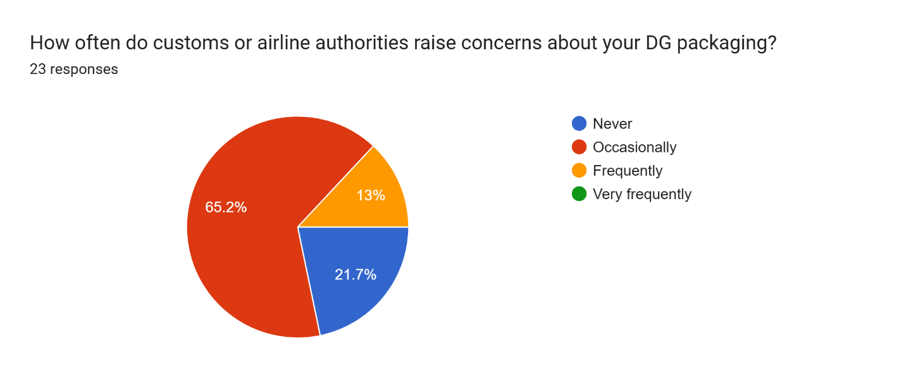

**Figure 2.14:** Frequency of Concerns Raised by Customs or Airline Authorities About DG Packaging

A majority of respondents (65.2%) report that customs or airline authorities raise concerns about their DG packaging occasionally. 21.7% said they never face concerns, while 13% deal with concerns frequently. No one reported concerns being raised very frequently.

**Interpretation:**

The fact that most respondents experience occasional issues with packaging compliance suggests that while they’re likely following regulations, there’s still room for improvement. The 13% who face concerns frequently could be dealing with more significant issues around consistency, adherence to guidelines, or evolving regulations. These could stem from fluctuating packaging practices, gaps in staff training, or misunderstandings of new or updated rules.

The 21.7% who never face concerns might be operating with high confidence in their packaging methods, or they may have developed a strong working relationship with authorities, possibly making their shipments less scrutinized. However, this could also signal a lack of audits or checks, which could be risky over time.

This data underscores the importance of proactive self-regulation, continuous training, and closer collaboration with airlines or customs to ensure full alignment with global standards. Even occasional compliance concerns can lead to delays, fines, or reputational damage, so it’s crucial to stay vigilant.

**Table 1.15.** Percentage of DG Shipments Delayed Due to Packaging-Related Documentation Errors

|  |  |  |  |
| --- | --- | --- | --- |
| SN. | PARTICULARS | FREQUENCY | PERCENTAGE |
| 1 | 0 – 10% | 9 | 39.1% |
| 2 | 11 – 25% | 12 | 52.2% |
| 3 | 26 – 50% | 2 | 8.7% |
| 4 | MORE THAN 50% | 0 | 0 |
|  | TOTAL | 23 | 100% |

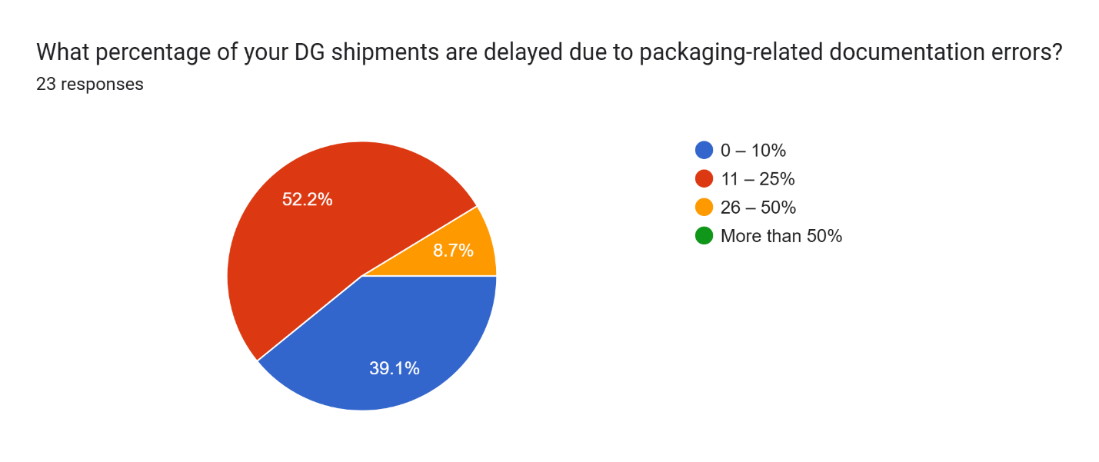

**Figure 2.15:** Percentage of DG Shipments Delayed Due to Packaging-Related Documentation Errors

Over half of respondents (52.2%) report that 11–25% of their DG shipments are delayed due to packaging-related documentation errors. 39.1% face delays in only 0–10% of shipments, while 8.7% experience delays in 26–50% of shipments. No one reported delays affecting more than 50% of their shipments.

**Interpretation:**

Packaging-related documentation errors are a significant issue for many organizations, but not an overwhelming one. The majority experience delays in up to 25% of shipments. These errors are often due to incorrect or incomplete paperwork, mislabeling, or failing to meet regulatory requirements—all of which can cause delays at various points in the logistics process.

While 39.1% of respondents face delays in a relatively small portion of their shipments, the 52.2% who report delays in 11–25% represent an area where improvements could be made. These errors may point to issues with the documentation review process, insufficient training, or miscommunications between departments.

The 8.7% who experience delays in 26–50% of their shipments face a more serious concern. This group might need to implement stronger checks, more thorough training, or more reliable systems for ensuring documentation accuracy.

Reducing these documentation errors could lead to significant improvements in efficiency and minimize disruptions in the supply chain. Streamlining documentation processes and leveraging digital tools for compliance checks could help reduce the frequency of delays caused by packaging errors.

**Table 1.16.** Penalties or Fines Due to Improper DG Packaging

|  |  |  |  |
| --- | --- | --- | --- |
| SN. | PARTICULARS | FREQUENCY | PERCENTAGE |
| 1 | NO | 1 | 4.3% |
| 2 | LESS THAN ₹10,000 | 10 | 43.5% |
| 3 | ₹1,00,000 – ₹2,50,000 | 8 | 34.8% |
| 4 | MORE THAN ₹2,50,000 | 4 | 17.4% |
|  | TOTAL | 23 | 100% |

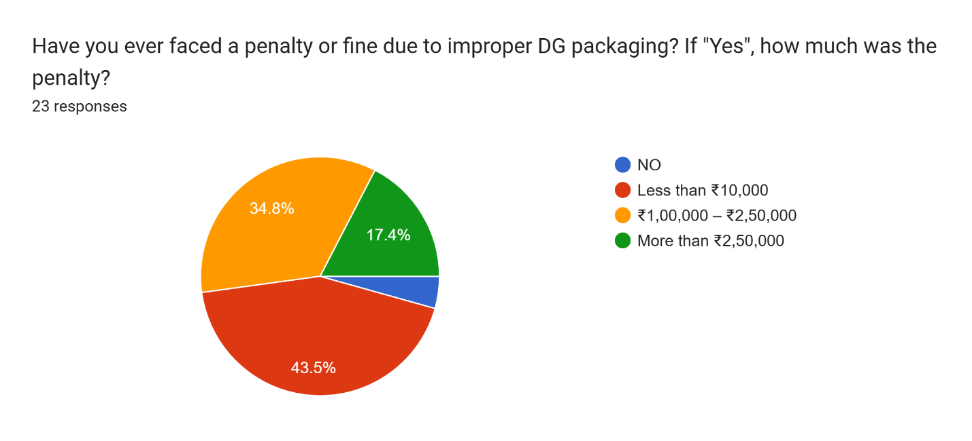

**Figure 2.16:** Penalties or Fines Due to Improper DG Packaging

About 43.5% of respondents reported that they haven’t faced any penalties or fines due to improper DG packaging. Among those who did incur penalties, 43.5% faced fines of less than ₹10,000, 34.8% had fines ranging from ₹1,00,000 to ₹2,50,000, and 17.4% received fines exceeding ₹2,50,000.

**Interpretation:**

It’s encouraging that nearly half of the organizations (43.5%) have avoided penalties, suggesting that many are likely compliant with packaging standards or have solid risk mitigation processes in place. However, the other 43.5% who did face fines indicate that non-compliance is still a common issue, even among well-established organizations. The fines, especially those in the ₹1,00,000 to ₹2,50,000 range, can have a significant financial impact, highlighting that there may be recurring issues with packaging processes or a lack of strict adherence to regulations.

The 17.4% who faced fines above ₹2,50,000 signal a more serious compliance failure. These larger fines could be the result of major packaging errors or significant violations of IATA/ICAO standards, often involving safety or environmental risks. Such breaches can not only disrupt operations but also damage a company’s reputation.

The fact that a significant portion of respondents still face penalties underscores the importance of continuous vigilance in packaging procedures. Keeping both staff and third-party handlers up-to-date on the latest regulations and compliance requirements is essential. This could also point to the need for investing in regular training, audits, and compliance checks to minimize the risk of costly mistakes.

**Table 1.17.** Primary Source of Packaging Compliance Guidance

|  |  |  |  |
| --- | --- | --- | --- |
| SN. | PARTICULARS | FREQUENCY | PERCENTAGE |
| 1 | IN-HOUSE SOP/MANUAL | 4 | 17.4% |
| 2 | IATA DGR BOOK | 17 | 73.9% |
| 3 | EXTERNAL DG CONSULTANTS | 1 | 4.3% |
| 4 | AIRLINE/CARGO AGENT GUIDANCE | 1 | 4.3% |
|  | TOTAL | 23 | 100% |

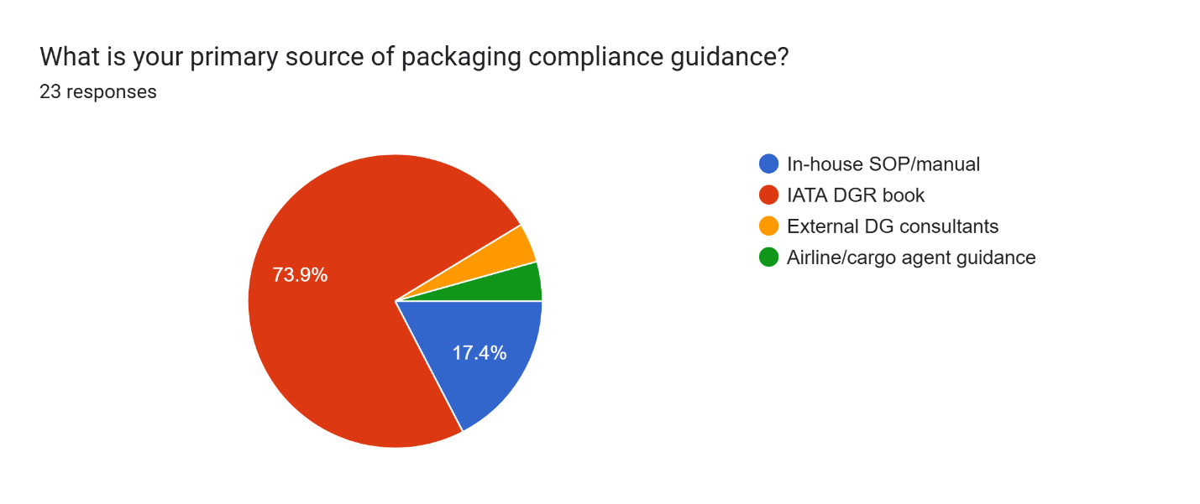

**Figure 2.17:** Primary Source of Packaging Compliance Guidance

The majority of respondents (73.9%) rely on the IATA Dangerous Goods Regulations (DGR) book as their primary source of packaging compliance guidance. 17.4% follow their in-house Standard Operating Procedures (SOPs), 4.3% consult external DG consultants, and another 4.3% rely on guidance from airlines or cargo agents.

**Interpretation:**

The heavy reliance on the IATA DGR book (73.9%) highlights its essential role in helping organizations stay compliant with global packaging and transportation standards for dangerous goods. The DGR book offers detailed and comprehensive guidelines on packaging, labeling, marking, and documentation, making it a vital tool for any company involved in shipping hazardous materials.

17.4% of respondents who use in-house SOPs suggest that some companies have developed their own internal guidelines to address specific needs or local regulations. While this can offer flexibility, it also means these organizations may be handling compliance on a more localized level, which could lead to inconsistencies when managing international shipments.

The 4.3% who turn to external DG consultants or airline/cargo agents likely do so for additional expertise or specialized knowledge. External consultants bring deep insights into ever-changing regulations and can provide customized training or audits. The small percentage of respondents using this method suggests that most organizations feel confident managing compliance in-house or using standardized resources like the DGR book.

This data underscores the importance of a solid compliance framework, whether it’s based on trusted industry standards like the IATA DGR or internal procedures. The fact that so many rely on the DGR book reinforces its critical role in maintaining safety and compliance in dangerous goods transportation.

**Table 1.18.** Need for Innovation or Regulation to Improve DG Packaging

|  |  |  |  |
| --- | --- | --- | --- |
| SN. | PARTICULARS | FREQUENCY | PERCENTAGE |
| 1 | STRICTER REGULATIONS | 4 | 17.4% |
| 2 | BETTER MATERIALS/INNOVATION | 3 | 13% |
| 3 | IMPROVED TRAINING | 10 | 43.5% |
| 4 | INCREASED INSPECTIONS | 1 | 4.3% |
| 5 | ALL THE ABOVE! | 5 | 21.7% |
|  | TOTAL | 23 | 100% |

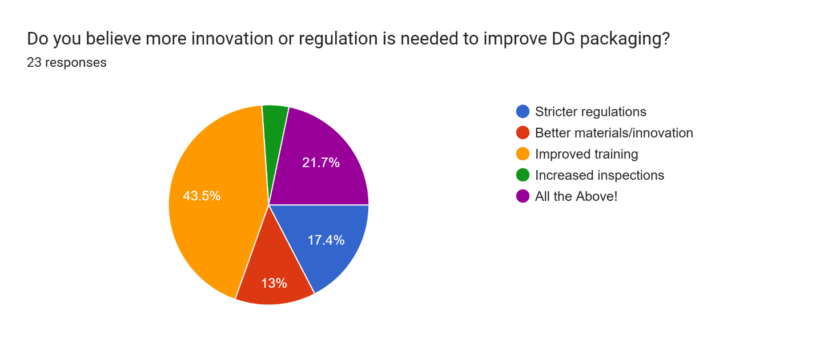

**Figure 2.18:** Need for Innovation or Regulation to Improve DG Packaging

When it comes to improving DG packaging, 43.5% of respondents believe the key factor is better training. 21.7% feel that a combination of stricter regulations, better materials, innovation, improved training, and more inspections is needed. 17.4% advocate for stricter regulations, 13% think better materials and innovation are the solution, and 4.3% suggest more frequent inspections.

**Interpretation:**

The strong focus on improved training (43.5%) highlights the recognition that human error and lack of awareness are significant contributors to DG packaging issues. Proper training on regulatory requirements, safe handling, and packaging techniques is essential to minimizing mistakes and improving compliance. Regular updates and training on changes in regulations could go a long way in reducing errors and increasing safety.

The 21.7% who selected "All of the Above" suggest a more comprehensive approach. This viewpoint stresses that while training is crucial, there’s also a need for innovation in packaging materials, stricter regulations, and more frequent inspections to address the complex challenges involved in the transport of dangerous goods.

Stricter regulations (17.4%) and improved materials/innovation (13%) were also mentioned as important. These responses point to the need for continuous updates in both legal frameworks and packaging technologies to keep pace with the evolving nature of hazardous materials. Interestingly, fewer respondents (4.3%) felt that increased inspections were the most critical factor, indicating that while inspections are important, they aren’t seen as the top priority compared to measures like training and innovation.

Overall, the results suggest that respondents understand the multifaceted nature of the challenge and see a combination of improved training, updated regulations, technological advancements, and inspections as essential to ensuring safe and compliant DG packaging practices.

1. **CONCLUSION**

This study concludes that while there is general awareness and a conscious effort to comply with regulations for dangerous goods packaging in air transportation, notable shortcomings persist, particularly in areas such as labeling accuracy, staff training, and the prompt handling of packaging-related issues. Incomplete or incorrect labeling emerged as the most common challenge, often leading to delays and increased operational costs. Although many of the packaging materials in use are considered moderately effective, there is a growing need for more dependable solutions, especially for high-risk goods like lithium batteries. The uneven adoption of new technologies and inconsistencies in adhering to international standards further complicate the packaging process. To enhance overall effectiveness, the industry must adopt a comprehensive strategy that includes better training programs, stricter enforcement of global standards, and proactive investment in advanced packaging technologies. Ultimately, the secure and efficient handling of hazardous materials is not only a regulatory requirement but also a vital responsibility that safeguards people and maintains the integrity of global supply chains.

1. **ACKNOWLEDGEMENTS.**

I am very much grateful to our Chancellor, **Dr. Ishari K Ganesh, Dr. A. Jothi Murugan**, Pro Chancellor – Planning & Development, **Dr. Arthi K Ganesh**, Pro-Chancellor – Admin and **Dr. Preethaa Ganesh**, Vice President, Vels Group of Institutions, for giving us an opportunity to study and encouraging us in all our efforts throughout the program.

I would like to express my deep gratitude to our Vice Chancellor, **Dr.S.Sriman Narayanan**, Pro Chancellor **Dr. M. Bhaskaran**, our Registrar, **Dr. P.Saravanan** and **Dr. A. Udayakumar**, Controller of Examinations for all their endeavor in educating us in this esteemed organization.

I wish to express my gratefulness to **Dr. Jaysree Krishnana**, Director, School of Management Studies, VISTAS, and **Dr. P.G. Thirumagal**, Professor & Head of the department -MBA, VISTAS for the encouragement and guidance during the Project.

I wish to express my humble thanks to **Dr. D. Anitha Kumari** - Associate Professor, my internal guide and Programme Coordinator, MBA Shipping and Logistics Management, School of Management Studies, VISTAS, for nurturing with a conducive environment and for her professional insights and updates to complete my project successfully.

I wish to express my humble thanks to my External Guide, **Mr. Prince Lazarus** with Designation for her guidance throughout the Project.

I would also like to thank my Company Guide, **Mr. C. Venkatraman**, Managing Partner, TS India Logistics Solution, Alandur, Chennai, and Mr. P. C. Shanmuganathan, Branch Manager, TS India Logistics Solution, Alandur, Chennai for providing the necessary resources and environment to carry out this project effectively.

My heartfelt appreciation goes to my family and friends for their unwavering support and motivation throughout the journey.

Lastly, I am grateful to all the individuals and sources whose contributions have enriched the content and quality of this project.

1. **REFERENCES**
2. International Civil Aviation Organization (ICAO). (2020). Technical Instructions for the Safe Transport of Dangerous Goods by Air. 2021-2022 Edition. ICAO.
3. International Air Transport Association (IATA). (2020). Dangerous Goods Regulations (DGR). 62nd Edition. IATA.
4. United Nations. (2019). Recommendations on the Transport of Dangerous Goods: Model Regulations. 21st Edition. United Nations Economic and Social Council.
5. Seabay Cargo. (2023). Dangerous Goods in Air Transport.
6. Chem-Tran. (2019). Hazardous Materials and Dangerous Goods Transportation.
7. Eturbonews. (2020). Air Cargo Safety and Dangerous Goods Handling in the Aviation Industry.
8. U.S. Department of Transportation. (2020). Hazardous Materials Regulations (HMR). Title 49 of the Code of Federal Regulations (CFR), Parts 171-180.
9. Taylor, J. (2021). Logistics and Supply Chain Management in Dangerous Goods Transportation. Journal of Logistics and Transport Safety, 28(4), 345-362.
10. Mishra, A. & Verma, R. (2020). Packaging Solutions for Dangerous Goods: A Global Review. International Journal of Packaging Technology, 35(2), 112-126.
11. Yung, W. & Shaw, J. (2018). The Role of Packaging in Reducing Air Cargo Risks for Dangerous Goods. Safety in Air Transport Journal, 15(3), 202-215.