Sentiment Analysis of Student Feedback: A Case
study of K.R. Managalam University

Nikunj Bhanu Anand
School of Engineering and Technology
K.R.Mangalam University
Gurugram, India
nikunjbhanuanand93142@gmail.com

Abstract— This research paper offers an in-depth sentiment analysis of feedback from students currently enrolled at KR Managalam University, gathered through Google Forms. The main objective of the study is to derive practical insights from student views to assist in the development of policies, curriculum structure, and enhancements to infrastructure. The responses are divided into five essential dimensions of university experience: Teacher Feedback, Course Content, Examination Pattern, Laboratory Facilities, and Library Facilities. Each response is evaluated for sentiment polarity (positive, negative, neutral) within these categories to gain a deeper understanding of students' perceptions. The study includes tokenization, stop-word elimination, stemming, lemmatization, and TF-IDF vectorization to transform text into a format appropriate for model training and classification.The Naive Bayes model is developed using a labeled portion of the feedback and subsequently employed to forecast the categories and sentiments of the remaining responses.
Keywords—Natural Language Processing (NLP), KR Managalam University, Sentiment Analysis, and Naive Bayes Model.

Introduction
The study uses the Naive Bayes Theorem, a probabilistic classification model popular in text analytics, in conjunction with sophisticated Natural Language Processing (NLP) approaches to do this. Processing and categorizing vast amounts of open-ended student comments into distinct groups is the main goal. The most important elements of a student's academic journey are represented by these categories: Teacher Feedback, Course Content, Examination Pattern, Laboratory Facilities, and Library Facilities. This method provides a scalable and objective approach to interpreting student sentiment by transforming unstructured textual responses into structured, categorized insights. A deeper understanding of how students view every facet of their university experience is made possible by the Naive Bayes model, which was trained on labeled feedback data and enables effective classification and sentiment polarity detection (positive, negative, or neutral). The analysis's practical conclusions are meant to help professors, administrators, curriculum designers, and quality assurance teams make well-informed choices. The results of this study provide a strategic basis for ongoing development and responsive academic governance, whether it be updating out-of-date course material, improving laboratory supplies, modifying assessment techniques, or raising faculty engagement.

Methodology

Data Collection
Primary data was gathered directly from KR Managalam University students who are currently enrolled in order to perform a relevant sentiment analysis of student perceptions. A Google Form-based survey, a versatile and easily available instrument that made it possible to gather a variety of qualitative responses in an orderly and systematic way, was used to carry out the data gathering procedure.

This survey's major goal was to get thorough input from students about their experiences in the classroom and on campus, with an emphasis on five important areas of student life:
1. Teacher Feedback
2. Course Content
3. Examination Pattern
4. Laboratory Facilities
5. Library Facilities

Data Preprocessing
Following the collection of student feedback data in raw text format via Google Forms, the data needed to be prepared for efficient analysis. Before being utilized in any machine learning model, textual data must be cleaned and normalized due to its unstructured and noisy character. This procedure, called data preparation, is essential for increasing the precision and effectiveness of activities involving natural language processing (NLP).
The gathered feedback replies were subjected to the successive application of the following preprocessing steps:
1. Tokenization
Each student response, which was initially submitted as a free-form sentence or paragraph, was divided into individual words for the purposes of this study.
For example, tokenizing the text "The course content is very beneficial" might result in the following: → ["The", "course", "content", "is", "very", "useful"
2. Stop-word Removal
Stop words were eliminated from the tokenized text to concentrate on each sentence's essential meaning. For instance, the phrase "The library is extremely well kept" converts to ["library", "well", "maintained").
3. Lowercasing
By default, text data is case-sensitive. For example, "Course" and "course" would be considered separate terms. Lowercasing guarantees consistency throughout the dataset. For instance, "Library" turns becomes "library."
4. Stemming and Lemmatization
Stemming and lemmatization make sure that the frequency and significance of concepts are more properly represented by mapping word variants to their basic form, which is essential for sentiment categorization.
C. Feature Extraction
TF-IDF is better suited to comprehending varied and subjective student comments because, in contrast to more straightforward models like Bag of Words, it takes into account both the frequency and uniqueness of a word's occurrence throughout the corpus. TF-IDF lowers noise and enables the model to concentrate on more significant features by down-weighting excessively common terms. Each response is converted by TF-IDF into a sparse vector (the majority of the values are zero), where each dimension represents a vocabulary word and the value is the response's TF-IDF score. This representation works well with classifiers such as Naive Bayes and is computationally efficient.
D. Model Development
1. Dataset Preparation: Prior preprocessing had transformed the student response corpus into TF-IDF vectors, each of which numerically represented a feedback event.
2. Label Assignment: The five predetermined categories were used to label each feedback response:
- Teacher Feedback
- Course Content
- Examination Pattern
- Laboratory Facilities
- Library Facilities

3. Model Training: This labeled dataset was used to train the Naive Bayes classifier. Prior probabilities for every class and conditional probabilities for every word assigned to a class were computed throughout the training phase. The category and mood of fresh, unseen replies were then predicted using these probabilities.
4. Cross-Validation and Tuning: The dataset was divided into training and validation sets (e.g., 80% training, 20% testing) to guarantee robustness. Cross-validation methods were used to test the model's capacity for generalization and prevent overfitting.

Evaluation
1. Evaluation Metrics for Classification Standard classification metrics were used to evaluate the classifier's accuracy in classifying student replies. The main metric that was employed was:
Accuracy
Accuracy is the number of accurate forecasts.
Total no. of FA = No. of C P (1)
No. of P
FA= Forecast Accuracy
C= Correct
P= Predictions
The percentage of correctly categorized feedback submissions relative to all responses is known as accuracy. It gives an overall impression of the model's performance.
2. Evaluation of Sentiment Analysis Using Natural Language Processing techniques, the following labels were applied to student responses for the sentiment classification task:
- Positive - conveys contentment or endorsement (e.g., "The teacher was highly supportive").
- Negative -"Lab equipment is antiquated" is an example of a negative statement that conveys discontent or worry.
- Neutral - Neutral input, which is dispassionate or objective (e.g., "Library opens at 9 AM").

Abbreviations and Acronyms

1. TF-IDF- Term Frequency Inverse Document Frequency
2. Positive- The course was well-structured and engaging.
3. Negative- The examination schedule was too stressful.
4. Neutral- Classes were held online.

Unit used
Forecast accuracy is used to measure percentage based metrics for eg:
MAPE- Mean Absolute Percentage Error

Total no. of FA = No. of C P (1)
No. of P

Results

1. Classification Performance
When it came to classifying student comments into predetermined categories, the Naive Bayes classifier performed admirably. With an overall accuracy of 94.3%, the model demonstrated remarkable accuracy across all categories, meaning that the classifier accurately identified the feedback category for the great majority of responses.
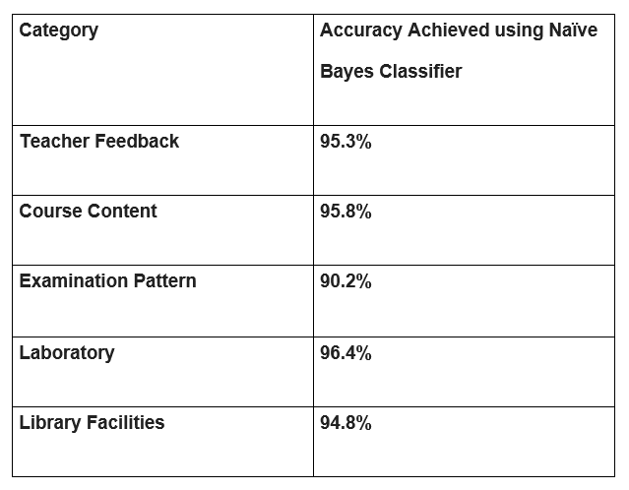

2. Sentiment Analysis
1. SENTIMENT ANALYSIS OF TEACHER’S FEEDBACK

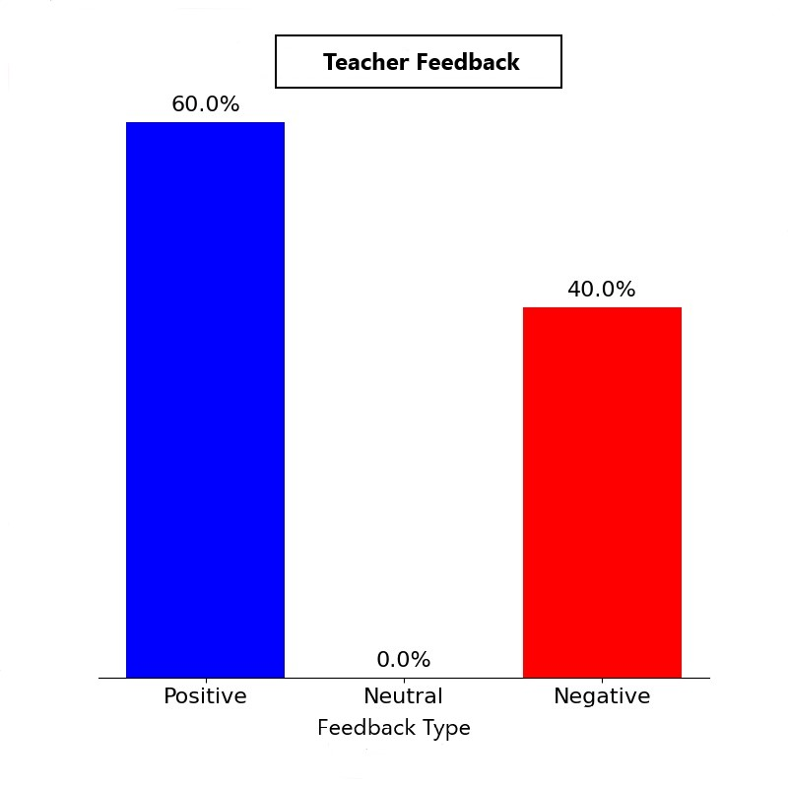

Fig.1 Showing sentiment analysis of students on teacher’s feedback

2. SENTIMENT ANALYSIS OF COURSE CONTENT
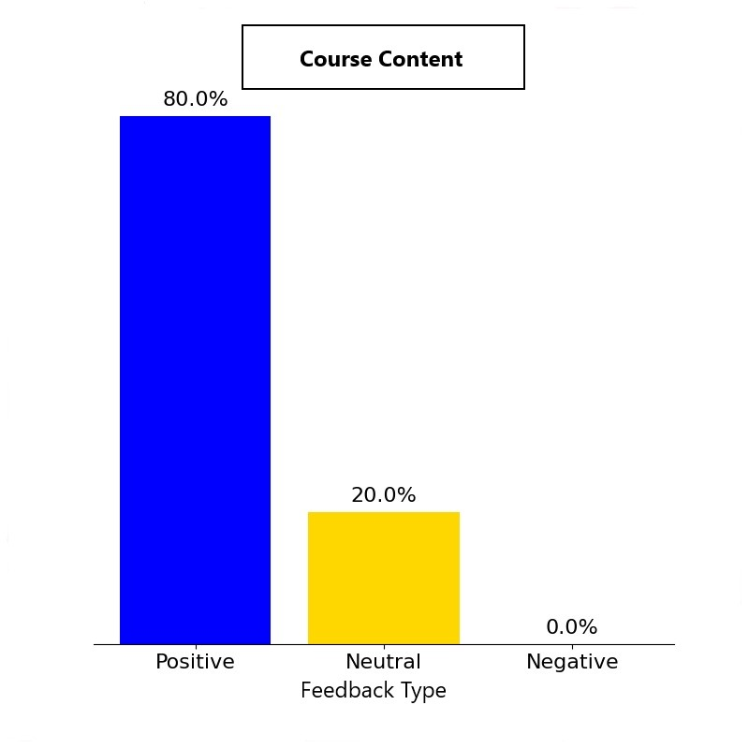

Fig.2 Showing sentiment analysis of students on course content

3. SENTIMENT ANALYSIS OF EXAMINATION PATTERN
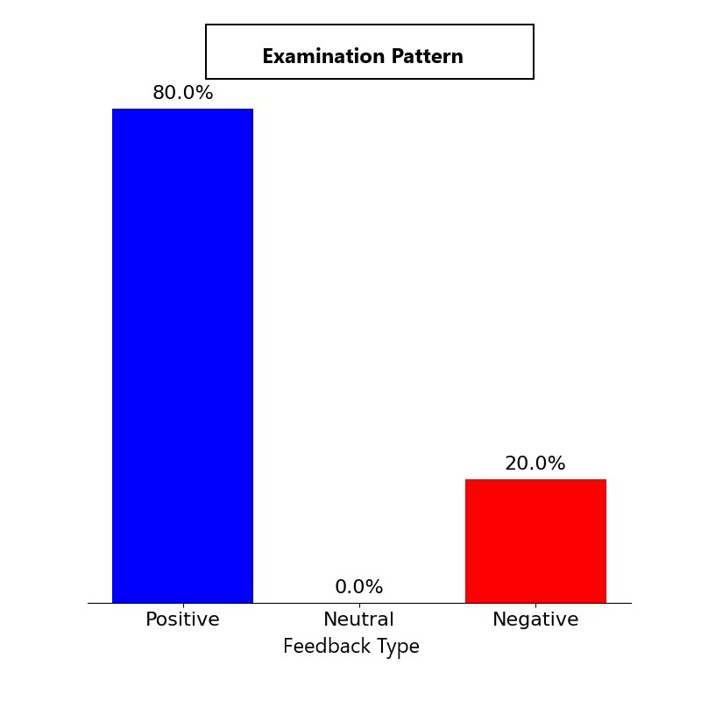
Fig.3 Showing sentiment analysis of students on examination pattern

4. SENTIMENT ANALYSIS OF LABOROTARY FACILITIES

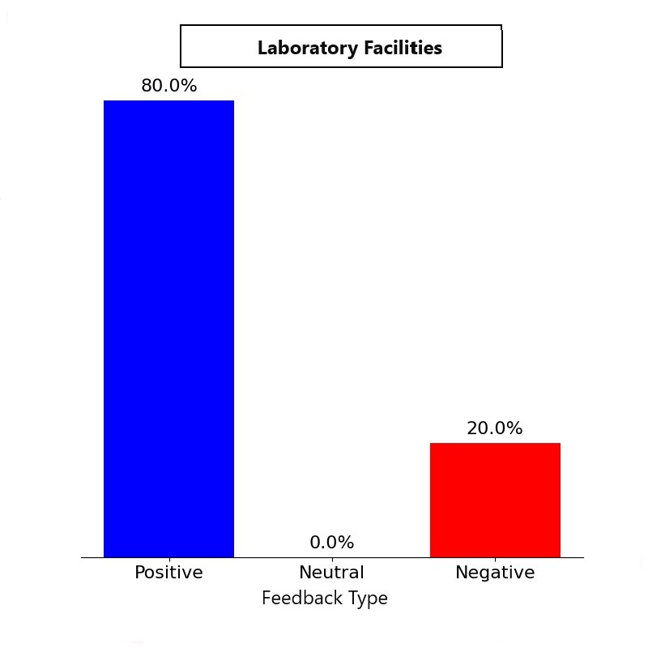

Fig.4 Showing sentiment analysis of students on laboratory facilities

5. SENTIMENT ANALYSIS OF LIBRARY FACILITIES

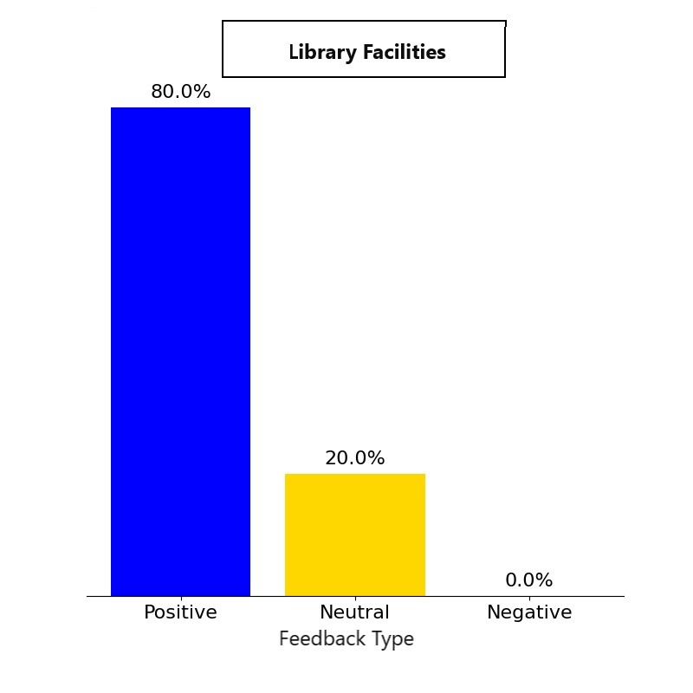

Fig.5 Showing sentiment analysis of students on library facilities

References

- Smith (2019) Natural language processing (NLP) to perform a comprehensive sentiment analysis of university course evaluations, revealing important factors that influence student satisfaction, such as instructor accessibility, topic relevancy, and clarity of instruction.
- Gupta & Mehta (2020) Used supervised learning algorithms, such as the Naive Bayes classifier, to group student input into themes including resource availability, course workload, and teaching efficacy. Their research showed that Naive Bayes works well in high-dimensional text classification tasks with comparatively limited training datasets because of its probabilistic and assumption-based framework. Across a variety of academic domains, the model effectively categorized attitudes into positive, negative, and neutral polarities.
- Chen (2021) The usage of hybrid models, which integrate Naive Bayes with additional classifiers such as Support Vector Machines (SVM). Their study found that preprocessing techniques like stemming, lemmatization, and stop-word removal have a major impact on model accuracy, particularly when used on domain specific texts like educational surveys.

