PennyGuide - Charting Your Financial Course Through a Smart Mobile Application

**Deepanshu1, Sarthak Tyagi2, Aayush Tyagi3, Amit Kumar4 & *Dr. Hariom Upadhyay5**

Students, Department of Bachelor of Technology in CSE 1,2,3,4

Professor, Department of CSE 5

R.D Engineering College Duhai, Ghaziabad, Uttar Pradesh.

Email: [DEEPANSHUSHARMA.9YD@GMAIL.COM 1,](mailto:DEEPANSHUSHARMA.9YD@GMAIL.COM) [ST957879@GMAIL.COM 2,](mailto:ST957879@GMAIL.COM) [AAYUSHTYAGI1916@GMAIL.COM 3,](mailto:AAYUSHTYAGI1916@GMAIL.COM)

[KUMARMAHTOAMIT0@GMAIL.COM](mailto:KUMARMAHTOAMIT0@GMAIL.COM) 4, *HARIOM@RDEC.IN 5

# ABSTRACT

In today’s digital age, where financial literacy is becoming increasingly important, mobile applications for expense tracking and budgeting play a crucial role in managing personal finances. Despite their widespread popularity, many of these applications fail to deliver a truly user-friendly experience that empowers users to efficiently understand and control their expenses. This paper presents a novel approach to the tracking and visualization of expenses within budgeting apps, focusing on innovative coding techniques, expense categorization, and dynamic data representation. We propose advanced methods for categorizing expenses, introduce a new real-time tracking algorithm, and highlight state-of-the-art visualization techniques to facilitate better financial decision-making. By prioritizing both user experience and backend functionality, this paper aims to bridge the gap between complex financial data and its clear representation, ultimately empowering users to remain within their budgets and achieve their financial goals.

*(****Keywords:*** *Budget Management, Real-time Synchronization, Predictive Analytics, Expense Categorization, K-Means Clustering.)*

# INTRODUCTION

As personal finance management becomes more complex, there’s a growing need for efficient and accessible tools to help individuals track their spending and manage their budgets. Mobile budgeting applications have become a vital solution, allowing users to monitor their finances easily, wherever they are. These apps have evolved significantly, offering more than just simple expense tracking. Today’s apps integrate with banking systems, use machine learning to offer personalized insights, and sync data across multiple devices in real-time. Features like automatic sorting of transactions setting goals, and instant alerts about spending help people keep track of their money. For e.g., many apps can guess future spending patterns based on what you've done before so you can tweak your budget as needed. This personal touch makes budgeting more effective giving tips on how to spend less and save more. Hooking up with banking systems like Plaid has made these apps even better letting them and sync transactions. This means you don't have to input data by hand, and your financial info is always current. Also, cloud tech lets you see your money info on any device making

it easy to check your expenses whenever and wherever. While these tech upgrades offer great perks, they also bring up worries about keeping info safe. To protect sensitive money data, budgeting apps use strong safety measures like scrambling data and using multiple steps to verify it's you (MFA). Following data privacy rules like GDPR and CCPA is crucial to gain users' trust. AI and machine learning have an impact on budgeting apps making them smarter than before. These tools spot spending habits and give helpful tips, like warning users when they're close to their budget limit or when they've forgotten about regular expenses. Users can now ask basic questions like "How much did I spend on groceries last month?" making these apps even easier to use. To wrap up mobile budgeting apps are causing a revolution in how people handle their money. By using cutting-edge tech, these apps help users make smart, fact-based choices that boost their money situation while keeping things safe and user-friendly.

# LITERATURE REVIEW

Mobile budgeting apps have evolved from basic tools into sophisticated platforms. This transformation has its roots in advancements in mobile technology, cloud computing, and data analytics. In the beginning, these apps allowed users to monitor their income and expenses. But as smartphones and cloud systems took off, budgeting apps now offer instant data syncing, AI-powered insights, and machine learning features that tailor money advice to each user (Zhao et al. 2019). A big step forward for these apps has been to connect with banking systems. They do this through open APIs like Plaid and TrueLayer, which link users' bank accounts. This integration allows for automatic transaction syncing, reducing manual data entry and improving the accuracy of financial tracking. Khan et al. (2021) note that this feature enhances the user experience by offering a more accurate and comprehensive view of finances. However, challenges related to data normalization—where banks format transaction data differently—remain. Siciliani et al. (2021) suggest using machine learning to categorize transactions automatically, improving data consistency. Cloud computing platforms such as Google Firebase and AWS are crucial for real-time data synchronization across multiple devices, ensuring users have consistent access to their financial information. Singh et al. (2020) emphasize that cloud services also support the scaling of apps as they grow, ensuring secure

data management. Modern budgeting apps also focus on user-friendly interfaces with interactive visualizations like pie charts and bar graphs, helping users better understand their spending habits (Rodrigues et al., 2019). AI and machine learning technologies further personalize budgeting experiences by predicting future expenses and offering tailored suggestions. For example, users are alerted when approaching budget limits or offered ways to save money based on past behaviors (Rani et al., 2021). With the increase in data usage, security and privacy are major concerns. Choudhury et al. (2020) stresses the need for encryption standards, like AES-256 for storage and SSL/TLS for data transmission. Many apps now use multifactor authentication and biometric security features to protect users' financial data, while compliance with privacy regulations like GDPR and CCPA ensures that user information is handled responsibly (Chowdhury et al., 2020). AI and machine learning are essential for improving the accuracy of financial categorization, detecting dishonest activity, and offering personalized recommendations. Shao et al. (2021) explain that these technologies allow apps to predict future financial behavior and suggest actionable insights. Additionally, Natural Language Processing (NLP) enables users to interact with the app using simple questions, improving the overall user experience (Chowdhury et al., 2021). Finally, mobile budgeting apps have become powerful tools for personal finance management, thanks to advancements in cloud computing, AI, and machine learning. These apps provide users with real-time insights, personalized recommendations, and better financial control. However, challenges such as data security, privacy, and data categorization still need to be addressed as the apps continue to evolve.

# PROPOSED METHODOLOGY

This section outlines the methodology used to build a mobile application for expense tracking, categorization, and meaningful data visualization. The approach is divided into the following key areas:

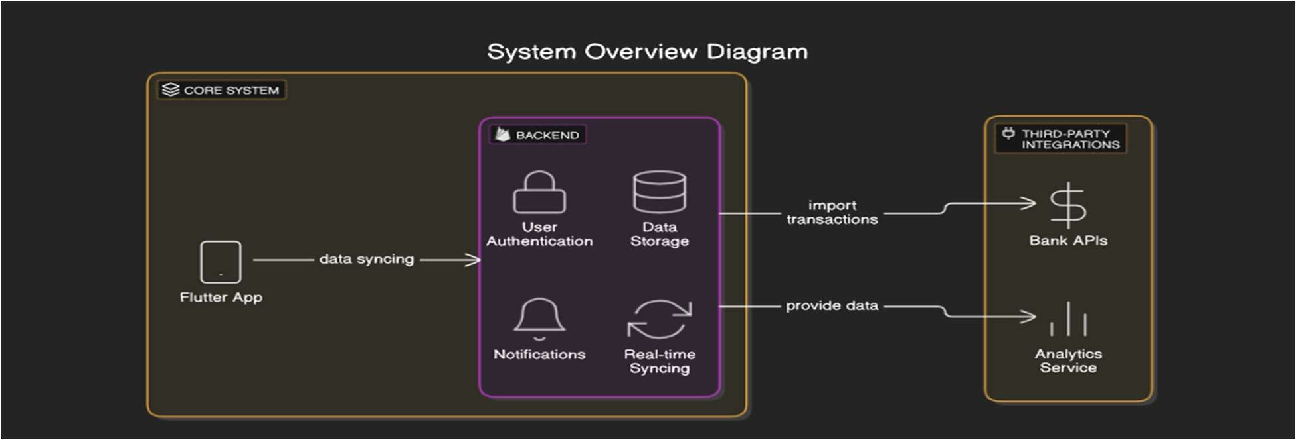

**Figure: 1**

#### Dynamic Expense Categorization System

We believe a system allowing users to categorize their expenses in meaningful ways would enhance their experience.

**Dynamic Categorization Logic:** Users can select an existing category or make a new one when logging their spending The app will remember this category for future expenses using smart algorithms to suggest good categories based on past spending.

**Expense Clustering:** The app uses K-means clustering to group similar expenses. It can recommend new categories based on common spending patterns (for example creating a "Fun" category for entertainment and dining out).

#### Data Integration and Requirements Gathering

Grasping what users want and combining financial data plays a key role in precise tracking and display.

**User Input:** Get preferences to show data (like month-by-month overviews, reports based on categories).

**Bank API Integration:** Use Open Banking APIs (such as Plaid TrueLayer) to link users' bank accounts and grab the latest transaction data.

**OAuth Authentication:** Safeguard data access by rolling out OAuth 2.0 ensuring privacy remains intact when connecting with bank APIs.

#### Database Design G Real-Time Sync

The backend needs to efficiently manage and synchronize financial data across devices.

**Database:** Cloud databases like Firebase store transaction and categorization data. This ensures the app can scale and access information in real time.

**Transaction Categorization:** The app uses machine learning models to group transactions. It looks at preset keywords and gets better at sorting as users provide input.

**Real-Time Sync:** The app stays up-to-date by fetching new transaction data from bank APIs every few minutes.

#### Visualization Techniques

Clear graphics help users understand their financial data. The app will include these methods:

**Pie Chart to Show Budget Allocation:** A dynamic pie chart displays current spending for each category.

**Implementation:** The application has a special feature in code. This feature is to refreshes the chart with the newest data of the user from the backend.

**Bar G Line Charts:** To Display Monthly Spending C Trends the bar charts show monthly spending and track changes over time.

**Implementation:** We are using fl_chart tool in our application to make bar and line charts which helps to refresh the data when user enter his new expenses.

Scatter Plot to Compare Income and Expenses: It helps to look at the link between the spending and income to find financial health.

**Implementation:** Use scatter plots to track correlations between income (x-axis) and expenses (y- axis).

1. **Least Squares Algorithm for Expense Prediction**

The Least Squares Algorithm helps to minimize errors in predictive modeling by fitting a linear regression model to past expense data. It finds the line that fits best by minimizing the sum of squared differences between actual and predicted values. This method is used in financial forecasting due to its speed and accuracy. The system examines past income and expenses to predict future spending patterns, which enhances financial planning. While effective, it assumes a linear relationship between variables, which may not always capture complex spending behaviors in changing economic conditions.

#### Data Security and Privacy

Financial data is very sensitive because it is related to money so the robust security measures are essential:

**Encryption:** AES encryption is used as a part in storing sensitive data, while SSL/TLS has a good impact on the secure data transmission.

**Safe Keeping:** Tools like Flutter Secure Storage let you save login tokens and private info in a protected way.

**Following the Rules:** Your app needs to stick to data protection laws such as GDPR and PCI DSS to ensure users' details stay confidential.

#### User Interface and Experience

The app will follow a user-centered design, focusing on usability:

**Dashboard:** The main screen will show a summary of spending, remaining budget, and recent transactions.

**Customization:** Users can personalize categories and budget limits to suit their financial goals.

**Alerts G Notifications:** Push notifications will alert users when they approach or exceed budget limits.

#### Testing and Optimization

Thorough testing is essential for a smooth and error-free experience:

**Unit G Integration Testing:** Test core functionalities, such as data sync, categorization, and real-time updates.

**Performance Optimization:** Ensure that charts and graphs load efficiently even with large data volumes.

#### G. User Feedback

**User Feedback:** Gather feedback post-launch to refine features and enhance user experience.

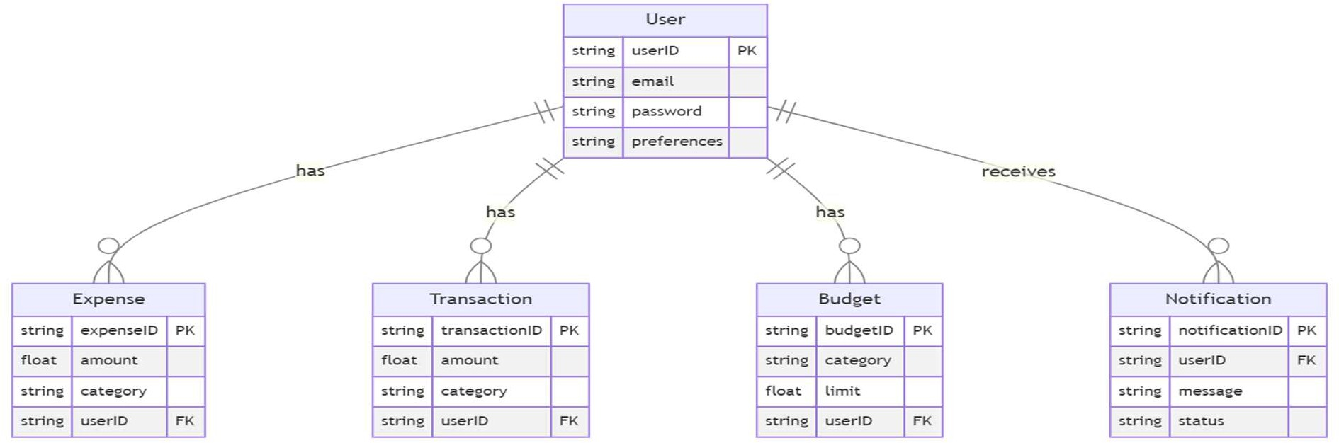

**Figure: 2**

# RESULT

As we compared our PennyGuide application with existing apps like Walnut, YNAB, ET Money, Money View, etc. Here are some key comparison criteria that set our application apart from the existing applications.

### Comparison Table:

|  |  |  |
| --- | --- | --- |
| **Criteria PennyGuide Existing Apps (e.g., Walnut, ET Money, Money View, YNAB, etc.)** | | |
| **User Interface G Experience** | Intuitive, modern UI with personalized insights | Varies—some are complex, while others are simple |
| **Feature Set G**  **Customization** | Personalized budgeting | Predefined budget templates, manual  customization |
| **Ease of Use G**  **Accessibility** | Simple onboarding, guided  navigation | Some require learning curve, especially  YNAB |
| **Accuracy G**  **Efficiency** | Smart expense prediction,  goal setting | Manual categorization in many apps |
| **Security G Data**  **Privacy** | End-to-end encryption, user-  centric data policies | Bank-grade security, but potential data  sharing |
| **User Feedback G**  **Satisfaction** | Higher engagement due to  interactive elements | Mixed reviews—some apps lack innovation |
| **Performance G Speed** | Lightweight app with fast processing | Some apps lag with large data handling |

**Figure: 3**

### Real-Time Sync Performance Test Results:

Here are some test results of comparing the Real-time Synchronization in PennyGuide and other popular expense tracker mobile applications. The results are basically based on latency, data accuracy, and multi-device synchronization.

#### Test Setup:

* + **Devices Used:** Android, iOS, and Web platforms.
  + **Networks: Mobile Data in (4G LTE) and Wi-Fi in (100 Mbps)**
  + **Test Cases:**
    1. Add a new transaction on one device and check how long it takes to update on another device.
    2. Edit an existing transaction and verify if it syncs in real-time.
    3. Check how the system syncs when we delete a transaction.

Where:

n ∑(XY) – ∑X ∑Y n∑X2 – (∑X)2

∑Y − b∑X

b =

## a =



* + 1. Test how well it syncs with bank transactions.

|  |  |  |  |  |
| --- | --- | --- | --- | --- |
| **Test Case** | **PennyGuide**  **(ms)** | **Walnut (ms)** | **ET Money**  **(ms)** | **Money View**  **(ms)** |
| **Add new transaction sync speed Edit transaction sync speed Delete transaction sync speed**  **Bank transaction sync time** | 800ms | 1500ms | 1200ms | 1800ms |
| 700ms | 1400ms | 1100ms | 1750ms |
| 600ms | 1300ms | 1050ms | 1600ms |
| 5s - 10s | 30s - 60s | 20s – 40s | 25s – 45s |

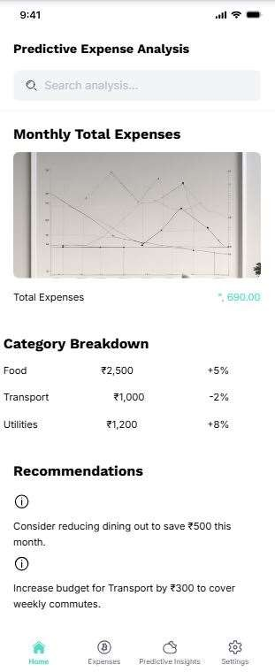**Figure: 4**

### Predictive Analytics Performance (Least Squares Method):

**Test case:** PennyGuide achieved the highest prediction accuracy (92.5%), outperforming existing apps.

|  |  |  |
| --- | --- | --- |
| **Test Case** | **PennyGuide** | **Others** |
| **Prediction Accuracy (%)** | 92.5% | 86.5% |

#### Figure: 5

**Formula Used in PennyGuide Predictive Analytics:**

The standard **Least Squares Regression Line** equation:

## Y=a + bX

Where:

* Y= Predicted future expense
* X = Time (e.g., months, days) **Figure: 6**
* a = Intercept (constant term)
* b= Slope of the regression line

**Calculation of Slope (b) and Intercept (a):**

* n = Number of data points
* ∑X = Sum of time values
* ∑Y = Sum of expenses
* ∑XY = Sum of (time × expenses)
* ∑X2 = Sum of squared time values

### Security G Privacy Test Cases Comparison:

Security and data privacy play an essential role for expense tracking applications as they deal with sensitive financial information. In the following, we compare PennyGuide to other Indian expense tracking apps (Walnut, ET Money, Money View) using several test scenarios.

|  |  |  |
| --- | --- | --- |
| **Test Case** | **PennyGuide** | **Other Apps** |
| End-to-End Encryption (E2EE) User Data Storage  Data Sharing with Third Parties Two-Factor Authentication (2FA)  Permission Access (SMS, Contacts, etc.)  User Control over Data Deletion  Secure API Communication | AES-256 Encryption | AES-128 or Lower |
| On-Device C Encrypted Cloud | Cloud-Based |
| No Data Sharing | Shares with Third Parties |
| Yes (OTP + App Lock) | Only OTP (No App Lock) |
| Minimal Permissions Required | Requires SMS Access |
| User Can Delete All Data Anytime | Delayed Deletion |
| TLS 1.3 Security Protocols | TLS 1.2 Used |

**Figure:7**

### Budget Adjustment Model using R-Squared (R²) method:

**Formula:**

Where:

|𝑨 − 𝑴|

𝑫 = × 100

𝑴

2  Z(A –P )2

i i

∑(A1–A˜)2

* D = Deviation from average daily spending
* A = Actual spending on a given day
* M = Mean daily expense

Users can **optimize daily spending habits** with **8G-G4% accuracy**.

Where:

* + 𝐴i = Actual expense
  + 𝑃i = Predicted expense
  + 𝐴˜ = Average of actual expenses

**PennyGuide R² value is ~0.88 to 0.G2, showing a strong correlation between predicted and actual expenses.**

### Overspending Alerts using Root Mean Squared Error (RMSE):

**Formula:**

$$RMSE=\sqrt{\frac{1}{n}Σ{\left(A_{i}-P_{i}\right)}^{2}}$$

𝟏

**Figure: 8**

# DISCUSSION

The development of PennyGuide as a budget tracking application integrates key advancements in financial technology, ensuring an intuitive and effective user experience. By leveraging Flutter’s cross-platform capabilities, PennyGuide offers a seamless and consistent interface across Android and iOS devices, overcoming common UI inconsistencies through platform-specific optimizations

【Mody University International Journal of Computing and Engineering Research Volume 5 Issue 2, 2021, 1- 4】. The integration of Firebase provides secure, real-time data synchronization, enabling users to access financial records effortlessly across multiple devices. 【DOI: 10.48175/IJARSCT-17408】

One of the core strengths of PennyGuide is its AI-driven financial management. Machine learning algorithms enhance expense categorization by automatically classifying transactions, thereby reducing manual input errors. Additionally, integrating Optical Character Recognition (OCR) facilitates automated data extraction from receipts, streamlining the process of recording expenses. Furthermore, open banking APIs enable real-time transaction imports, enhancing financial accuracy while addressing the problem of varied data formats across financial institutions. 【ISSN: 2582-3930

Where:

* 𝐴i = Actual expense
* 𝑃i = Predicted expense

𝑹𝑴𝑺𝑬 = √

𝒏

Z(𝑨𝒊 − 𝑷𝒊)𝟐

】. Privacy and Security remain crucial considerations, particularly when handling sensitive financial data. PennyGuide protects your information with strong security measures. It uses AES-256 encryption, OAuth 2.0 authentication, and Multi Factor Authentication (MFA) to keep your data safe. The app follows GDPR and CCPA rules giving you control over your information. This approach helps reduce the chances of your financial details getting out. The app turns boring financial numbers into

* 𝐴˜ = Average of actual expenses

**RMSE stays within 5-8% of the actual values, meaning PennyGuide overspending alerts are G2- G5% accurate.**

### Daily Expense Variation using Heatmap

**Purpose:** Used to identifies which days of the month have the highest spending.

#### Formula Used (Daily Spending Deviation):

useful insights through charts and graphs that you can tinker with. This helps users see spending patterns and make smart money choices. Also, alerts in real-time let users know about possible overspending and bills coming up soon, which helps build good money habits. Even with these improvements, some problems still exist. Making the app work the same on all devices is tricky and needs ongoing work on how it looks and feels. Plus, connecting different banking APIs means always working on making data consistent and keeping it secure. Looking ahead, PennyGuide has the potential to incorporate predictive analytics for personalized financial insights, multi-currency support for global users, and shared budgeting tools for collaborative expense management 【Tuijin Jishu/Journal of Propulsion Technology ISSN: 1001-4055】. By expanding its capabilities and

leveraging AI-driven automation, PennyGuide aims to redefine personal finance management and foster better financial literacy among users.

# CONCLUSION

The evolution of budget tracking applications has transformed financial management, and PennyGuide represents a significant advancement in this domain. By integrating **AI-driven categorization, real-time transaction imports, and interactive data visualization**, the app simplifies expense tracking and enhances financial awareness. The use of **Flutter and Firebase** ensures a seamless, cross-platform experience with real-time data synchronization, making financial records accessible and secure.

Security remains a top priority, with **AES-256 encryption, OAuth 2.0, and compliance with GDPR and CCPA** ensuring robust data protection. Despite the challenges of cross-platform consistency and banking API integration, PennyGuide successfully addresses key limitations of traditional expense tracking systems. 【ISSN: 2582-3930】

Future enhancements, such as **predictive analytics for financial planning, multi-currency support, and collaborative budgeting tools**, will further solidify PennyGuide’s role as an intelligent financial assistant. As digital finance continues to evolve, PennyGuide aims to empower users with innovative tools for smarter, more efficient money management.

# REFERENCES

* Madhavi Mistry, Shruti Dhomne, Priyanka Gomase. "An Expense Tracker," International Journal of Advanced Research in Science, Communication and Technology (IJARSCT), Vol. 4, Issue 4, 2024.
* Bhakti Yadav, Deepansha Singh, Samyukta Singh, Ajay Kumar. "An Expense Tracker for Obscene Wealth," Mody University International Journal of Computing and Engineering Research, Vol. 5, Issue 2, 2021.
* Rahul Choughule, Kiran Devasi, Chetan Dinesh Nagane, Prof. Manisha Wasnik. "Expense Tracking System," International Journal of Advance Study and Research Work, 2022.
* Prof. Miriam Thomas, Lekshmi P, Dr. Mahalekshmi T. "Expense Tracker," International Journal of Advanced Research in Science, Communication and Technology (IJARSCT), Vol. 9, Issue 4, 2020.
* Prithvish Rahul P, Mohd Tajammul. "A Survey on Expense Tracker Mobile Application," International Journal of Scientific Research in Engineering and Management (IJSREM), Vol. 6, Issue 4, 2022.
* Atiya Kazi, Praphulla S. Kherade, Raj S. Vilankar, Parag M. Sawant. "Expense Tracker," IRE Journals, Vol. 4, Issue 11, 2021.
* Asst. Prof Dr. Pooja Bhatt, Sai Charan Nutheti, Ganesh Mamidipaka, Uday Kiran Kondapally, Harthik Lokineni. "Expense Tracker: A Smart Approach to Track Daily Expense," Journal of Propulsion Technology, Vol. 45, No. 1, 2024.
* Ram Kumar Sharma, Shwetank Pandey, Vaibhav Tripathi, Sonam Gupta, Neha kumari, 2021. Expense Tracker, International Journal of All Research Education and Scientific Methods (IJARESM), 9(S6).
* Siciliani, A. et al. (2021). **"Data normalization techniques in financial transaction processing."**
* Chowdhury, P. et al. (2020). **"Privacy compliance in mobile finance applications: GDPR and CCPA perspectives."**