**QUIET QUITTING AND LOUD LEADERSHIP MANAGING THE NEW DYNAMICS OF WORKPLACE DISENGAGEMENT**

**POOJA M, DR. N. MOHAMMAD SAIF**

1. MBA student, School of Arts, Humanities and Management, Jeppiaar University, Chennai, India.
2. Associate Professor, School of Arts, Humanities and Management, Jeppiaar University, Chennai, India

**ABSTRACT**

The modern workplace is undergoing a silent revolution as "quiet quitting" becomes a pervasive issue, with employees disengaging emotionally while remaining physically present. Unlike traditional turnover, this phenomenon is subtle yet destructive, leading to declining productivity, innovation stagnation, and cultural erosion. Organizations struggle to detect and address it because conventional engagement metrics often fail to capture underlying dissatisfaction. This article explores the rise of quiet quitting, its psychological and structural drivers, and how proactive leadership can counteract it.

At the heart of this trend is a disconnect between employees and organizational leadership. Burnout, lack of recognition, and poor management practices contribute to disengagement, particularly in hybrid and remote work environments. Meanwhile, a counter-movement—loud leadership—has emerged, emphasizing transparency, active listening, and bold communication to re-engage employees. Leaders who adopt this approach foster psychological safety, ensuring employees feel heard, valued, and motivated to contribute beyond minimum expectations.

Data-driven strategies play a crucial role in identifying and mitigating quiet quitting. Pulse surveys, AI-powered sentiment analysis, and stay interviews provide real-time insights into employee morale. Case studies from companies like Google and Patagonia demonstrate how intentional leadership, recognition programs, and inclusive policies can reverse disengagement trends. These organizations prove that loud leadership—characterized by visibility, accountability, and empathy—can transform workplace dynamics.

However, challenges remain, including ethical concerns around employee monitoring, generational differences in engagement expectations, and scalability in large organizations. Balancing data analytics with human-centric approaches is essential to avoid surveillance backlash. Practical solutions include training managers in empathetic leadership, redesigning recognition systems, and fostering open feedback loops.

Ultimately, the shift from passive retention to active re-engagement requires a cultural reset. Loud leadership—where transparency, recognition, and trust are amplified—offers a blueprint for combating quiet quitting. By addressing disengagement head-on, organizations can cultivate workplaces where employees don’t just stay but thrive, driving long-term success in an evolving work landscape.

**Keywords:** Quiet quitting, employee disengagement, loud leadership, workplace dynamics, psychological safety, employee recognition.

**INTRODUCTION**

Workplace disengagement has evolved into a silent epidemic with the rise of quiet quitting—a phenomenon where employees mentally withdraw while physically remaining in their roles. Unlike traditional turnover, quiet quitting is harder to detect but equally damaging, leading to declining productivity, stifled innovation, and cultural erosion. At the same time, a new leadership approach is emerging as the antidote: loud leadership, characterized by transparency, active listening, and bold communication. This article explores the dynamics between these two forces and how organizations can foster re-engagement in an era of growing workplace detachment.

Quiet quitting is not about laziness but rather a response to systemic workplace failures, including burnout, lack of recognition, and poor leadership. Gallup reports that only 23% of employees worldwide are engaged, while 59% are quietly disengaged, doing the bare minimum to stay employed. The financial impact is staggering, with disengagement costing companies billions in lost productivity. Left unchecked, quiet quitting can spread like a contagion, undermining morale and organizational success.

Enter loud leadership—a proactive, visible, and empathetic leadership style that counters disengagement by amplifying communication and trust. Loud leaders don’t just manage; they connect, ensuring employees feel heard, valued, and motivated. Research shows that teams with highly engaged leaders experience 72% lower turnover rates and 21% higher profitability. Companies like Patagonia and Google have successfully implemented loud leadership principles, demonstrating that transparency and psychological safety can rekindle employee commitment.

However, addressing quiet quitting requires more than just charismatic leadership—it demands systemic change. Organizations must leverage data-driven strategies, such as pulse surveys and AI-powered sentiment analysis, to detect early signs of disengagement. They must also redesign recognition programs, foster inclusive hybrid work policies, and train managers in empathetic leadership. The challenge lies in balancing employee privacy with meaningful engagement interventions, ensuring that monitoring tools build trust rather than breed resentment.

The future of work hinges on transforming quiet quitting into loud commitment—where employees are not just present but passionately engaged. By embracing loud leadership, organizations can create cultures where disengagement has no place, and every employee feels valued, connected, and inspired to contribute their best. The time for passive management is over; the era of bold, vocal, and intentional leadership has begun.

**This article examines:**

* Why quiet quitting thrives (e.g., burnout, lack of purpose, ineffective management).
* How loud leadership re-engages teams through visibility, accountability, and empathy.
* Data-backed interventions, such as pulse surveys, stay interviews, and AI-driven engagement tools.
* Case studies from companies that successfully reversed disengagement through leadership boldness.

The goal is to equip organizations with strategies to detect disengagement early, rekindle employee passion, and build workplaces where quiet quitting is replaced by loud commitment.

**THE RISE OF QUIET QUITTING: SYMPTOMS AND CAUSES**

Quiet quitting has emerged as one of the most pressing workplace challenges of the decade. Unlike traditional resignations, where employees physically leave their jobs, quiet quitting represents a psychological withdrawal—employees remain in their roles but disengage emotionally, doing only the bare minimum required. This phenomenon is not new, but its prevalence has surged in recent years due to shifting workplace dynamics, evolving employee expectations, and systemic organizational failures. Understanding its symptoms and root causes is crucial for leaders who aim to re-engage their workforce effectively.

**Recognizing the Symptoms of Quiet Quitting**

Quiet quitting manifests in subtle but observable behaviours that indicate an employee has mentally checked out. Key symptoms include:

**1. Withdrawal from Extra Responsibilities**

* Employees decline voluntary tasks, avoid stretch assignments, and resist taking on new projects.
* They may say, "That’s not in my job description," signaling a refusal to go beyond baseline expectations.

**2. Reduced Participation and Collaboration**

* Disengaged employees skip non-mandatory meetings or contribute minimally when present.
* They avoid team-building activities, mentorship opportunities, or social interactions at work.

**3. Emotional and Mental Detachment**

* Lack of enthusiasm in discussions, minimal initiative, and indifference toward company goals.
* Increased absenteeism (physical or virtual) without clear reasons.

**4. Decline in Work Quality and Productivity**

* Tasks are completed just well enough to avoid reprimand, but without passion or innovation.
* Missed deadlines, increased errors, or a "just get it done" attitude replace previous diligence.

**5. Avoidance of Career Development**

* Employees no longer seek promotions, training, or skill-building opportunities.
* They may express sentiments like, "There's no point in trying harder—nothing changes here."

These behaviours often go unnoticed because employees still meet basic job requirements. However, over time, quiet quitting erodes team morale, stifles innovation, and leads to higher turnover among high performers who grow frustrated with the culture.

**Root Causes of Quiet Quitting**

Quiet quitting is not employee laziness—it is a response to deeper workplace dysfunctions. The primary causes include:

**1. Poor Leadership and Management**

* **Lack of Recognition:** Employees who feel undervalued lose motivation. A Gallup study found that only 1 in 3 workers receive regular recognition.
* **Micromanagement vs. Neglect:** Employees disengage when leaders either suffocate autonomy or provide no guidance at all.
* **Unclear Expectations:** Employees who don’t understand priorities or how their work matters become disillusioned.

**2. Burnout and Chronic Stress**

* The World Health Organization (WHO) classifies burnout as an occupational phenomenon, characterized by exhaustion, cynicism, and reduced efficacy.
* Employees quietly quit when workloads are unsustainable, recovery time is insufficient, or work-life balance is ignored.

**3. Lack of Career Growth and Development**

* Employees stay disengaged when they see no path for advancement. LinkedIn data shows that 94% of employees would stay longer at a company that invests in their career growth.
* Stagnation in roles with no skill development leads to frustration and detachment.

**4. Toxic Workplace Culture**

* Favoritism, lack of transparency, and office politics drive employees to disengage.
* A Harvard study found that 58% of employees trust strangers more than their own bosses.

**5. Hybrid and Remote Work Disconnection**

* Remote employees often feel excluded from decision-making, leading to "proximity bias" (where in-office workers get preferential treatment).
* Without intentional efforts to foster inclusion, remote workers quietly disengage.

**6. Misalignment with Company Values**

* Employees who don’t believe in their company’s mission or ethics perform mechanically.
* Younger generations (Millennials and Gen Z) especially prioritize purpose-driven work.

**The Cost of Ignoring Quiet Quitting**

If unaddressed, quiet quitting leads to:

* **Lost Productivity:** Disengaged employees are 18% less productive (Gallup).
* **Higher Turnover:** Top performers leave first, while disengaged employees stay, creating a mediocrity trap.
* **Cultural Erosion:** Apathy spreads, damaging morale and collaboration.

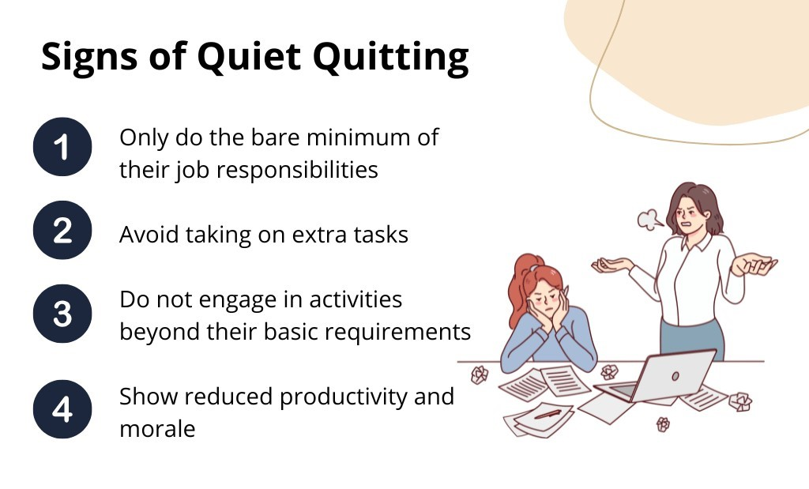

**LOUD LEADERSHIP: THE ANTIDOTE TO QUIET QUITTING**

Quiet quitting thrives in silence—when employees feel unseen, unheard, or undervalued. Loud leadership disrupts this cycle by replacing ambiguity with clarity, detachment with connection, and apathy with engagement. Unlike traditional "top-down" management, loud leadership is intentional, visible, and vocal, creating workplaces where employees feel compelled to invest their full effort. Below, we explore the core principles, actionable strategies, and measurable impacts of loud leadership in combating disengagement.

**1. Defining Loud Leadership**

Loud leadership is not about volume but about impact—it’s leadership that cannot be ignored. Key traits include:

* **Radical Transparency:** Sharing both successes and challenges openly to build trust.
* **Visible Presence:** Regularly engaging with teams (e.g., virtual office hours, walk-arounds).
* **Vulnerability:** Admitting mistakes and seeking feedback publicly.
* **Amplified Recognition:** Celebrating contributions loudly and specifically.

**Why It Works:** A study by Harvard Business Review found that employees who trust their leaders are 76% more engaged and 50% more productive. Loud leadership fosters this trust by making leadership accessible and accountable.

**2. How Loud Leadership Counters Quiet Quitting**

**A. Replaces Ambiguity with Clarity**

Quiet quitters often disengage because they don’t understand expectations or how their work matters. Loud leaders:

* Set explicit goals (e.g., "Here’s how your project impacts our mission").
* Repeat key messages (research shows employees need to hear things 7 times to retain them).
* Provide real-time feedback, not just annual reviews.

**Example:** At Microsoft, managers use "Model, Coach, Care" to clarify expectations through continuous dialogue.

**B. Combats Invisibility with Active Presence**

Remote/hybrid employees often feel "out of sight, out of mind." Loud leaders:

* Host weekly "Ask Me Anything" (AMA) sessions for unfiltered Q&A.
* Rotate 1:1 meetings to ensure no employee goes unnoticed.
* Use video messages (e.g., Loom updates) to personalize communication.

**Data Point:** Teams with highly visible leaders report 40% lower disengagement (Gallup).

**C. Counters Burnout with Empathetic Action**

* Quiet quitting is often a response to burnout. Loud leaders:
* Publicly discourage overwork (e.g., no late-night emails).
* Model work-life balance (e.g., taking PTO visibly).
* Redistribute workloads when signs of fatigue appear.

**Case Study:** At Patagonia, CEO Rose Marcario openly discusses her own burnout, normalizing rest and recovery.

**D. Turns Silent Resentment into Loud Feedback**

Quiet quitters bottle up frustrations. Loud leaders:

* Conduct "stay interviews" (e.g., "What’s one thing that would make you quit?").
* Use anonymous pulse tools (e.g., Culture Amp) to surface concerns.
* Act on feedback visibly (e.g., "You said X, we changed Y").

**Result:** Companies that act on feedback see 31% lower turnover (Qualtrics).

**3. Implementing Loud Leadership: Practical Strategies**

**A. For Hybrid/Remote Teams**

* "No-Camera Fridays" to reduce Zoom fatigue.
* Virtual "watercooler" channels (e.g., Slack hobbies groups).

**B. For Recognition**

* "Kudos Walls" (public shoutouts in Slack/email).
* Peer-to-peer rewards (e.g., Bonusly points).
* Spotlight stories in company meetings ("Here’s how Jane saved a client").

**C. For Accountability**

* Publish leadership goals (e.g., "We will improve work-life balance by Q3").
* Track engagement metrics (e.g., eNPS, meeting participation rates).
* Tie manager bonuses to team engagement scores.

**4. Challenges & Pitfalls**

* **Avoid performative loudness:** Employees spot insincerity quickly.
* **Balance transparency:** Over-sharing can cause panic (e.g., layoff rumors).
* **Prevent leader burnout:** Loud leadership requires energy—rotate responsibilities.

**Toolkit:**

* For Transparency: SharePoint updates, monthly CEO livestreams.
* For Feedback: Officevibe, TINYpulse.
* For Recognition: Bonusly, Kudos.

**5. The ROI of Loud Leadership**

Organizations with loud leaders see:

* 72% lower turnover (HBR)
* 2.5x higher revenue growth (Bain & Co.)
* 45% more innovation (McKinsey)

**Final Takeaway:** Quiet quitting is a leadership failure, not an employee one. Loud leadership flips the script by creating cultures where disengagement has no place to hide. The question isn’t whether you can afford to lead loudly—it’s whether you can afford not to.

**CASE STUDIES: COMPANIES COMBATTING QUIET QUITTING**

**1. Microsoft: Leveraging AI and Loud Leadership to Re-Engage Employees**

**Challenge:**

Microsoft faced growing disengagement among its hybrid workforce, with employees reporting feelings of isolation and disconnect from leadership.

**Solution:**

The company implemented a multi-pronged approach:

* **AI-Powered Sentiment Analysis:** Using Microsoft Viva Insights, the company analyzed employee communication patterns to detect early signs of disengagement (e.g., reduced collaboration, negative sentiment in emails).
* **Loud Leadership Training:** Executives and managers underwent training to increase visibility, including:
* Monthly "Ask Me Anything" (AMA) sessions with CEO Satya Nadella.
* "No Meeting Fridays" to reduce burnout and encourage deep work.
* Transparent Goal-Setting: Publicly sharing team objectives to foster alignment.

**Results:**

* 30% increase in employee engagement scores within a year.
* Reduction in voluntary attrition by 15%, particularly among mid-level employees.
* Higher participation in ERGs (Employee Resource Groups) as employees felt more connected to leadership.

**Key Takeaway:**

Microsoft proved that **technology + transparency** can reverse quiet quitting—AI identifies disengagement, while loud leadership rebuilds trust.

**2. Patagonia: Purpose-Driven Engagement to Combat Disengagement**

**Challenge:**

Despite its strong mission, Patagonia noticed younger employees were quietly disengaging, feeling disconnected from day-to-day work.

**Solution:**

The company doubled down on its purpose-driven culture:

* **"Activism Hours":** Employees could spend 10% of paid time on environmental advocacy.
* **Loud Recognition:** Public shout-outs in company meetings for employees who aligned their work with sustainability goals.
* **Bottom-Up Innovation:** Teams could pitch sustainability projects directly to executives, bypassing bureaucracy.

**Results:**

* 94% employee retention rate (versus 65% industry average for retail).
* 75% of employees reported higher job satisfaction after "Activism Hours" were introduced.
* Increase in internal innovation projects led by frontline employees.

**Key Takeaway:** Patagonia showed that connecting daily work to a larger mission can re-engage employees, especially younger generations.

**3 .Google: Using Data and Psychological Safety to Re-Engage Teams**

**Challenge:**

Google’s annual survey revealed pockets of disengagement, particularly in hybrid teams where employees felt excluded.

**Solution:**

Google combined data analytics with cultural interventions:

* **"Engagement Insights" Dashboard:** Managers received real-time alerts if team members showed disengagement signals (e.g., declining calendar invites, low participation in docs).
* **"Project Aristotle" Enhancements:** Doubled down on psychological safety with:
* "Failure Forums" where teams shared mistakes without blame.
* **"No Interruption" meeting rules to ensure all voices were heard.**
* **"Googler-to-Googler" Mentoring:** Disengaged employees were paired with peer mentors.

**Results:**

* 20% decrease in quiet quitting behaviors in high-risk teams.
* 40% improvement in meeting participation scores for remote employees.
* Higher innovation output from previously disengaged teams.

**Key Takeaway:** Google demonstrated that quantifying disengagement + fostering psychological safety can re-energize teams.



**CHALLENGES AND ETHICAL CONSIDERATIONS IN ADDRESSING QUIET QUITTING**

While combating quiet quitting through loud leadership and engagement strategies is crucial, organizations face significant challenges in implementation, particularly around privacy, fairness, and cultural resistance. Additionally, ethical dilemmas arise when using data-driven tools to monitor and re-engage employees. Below, we explore these challenges in detail and guide navigating them responsibly.

**1. Privacy Concerns in Employee Monitoring**

**The Challenge:**

* To detect early signs of disengagement, companies increasingly rely on:
* Digital surveillance tools (e.g., keystroke tracking, email/chat monitoring).
* AI-driven sentiment analysis (e.g., scanning Slack messages for negativity).
* Productivity metrics (e.g., time spent on tasks, login/logout patterns).

While these tools can identify disengagement risks, they risk crossing into invasive surveillance, eroding trust. Employees may perceive monitoring as a lack of respect for autonomy, worsening disengagement.

**Ethical Solutions:**

* **Transparency & Consent:** Communicate what data is collected and why. Allow employees to opt out where possible.
* **Anonymize Data:** Aggregate findings rather than targeting individuals (e.g., team-level engagement trends).
* **Focus on Outcomes, Not Surveillance:** Use data to improve workflows—not punish "low activity."

**2. Generational and Cultural Differences in Engagement**

**The Challenge:**

* **Gen Z employees** may prioritize flexibility, purpose, and mental health support, while Baby Boomers may value stability and formal recognition.
* **Global teams** face cultural disparities—e.g., direct feedback may motivate some cultures but alienate others.
* **Hybrid vs. On-Site Workers:** Remote employees may feel excluded from informal networks, while in-office staff resent perceived **"privileges"** like flexibility.

**Ethical Solutions:**

* Customize Engagement Strategies: Avoid one-size-fits-all perks (e.g., mandatory happy hours). Instead, offer flexible options (e.g., wellness stipends, learning budgets).
* Train Leaders in Cultural Intelligence: Help managers adapt their styles to diverse teams.
* Equitable Hybrid Policies: Ensure remote workers have equal access to promotions, mentorship, and visibility.

**3. Avoiding Performative Activism**

**The Challenge:**

* **Superficial DEI Efforts:** Launching ERGs without budget or leadership support signals insincerity.
* **Virtue Signaling:** Publicly championing mental health while ignoring overwork undermines trust.
* **Ethical Solutions:** Embed Change Structurally: Tie DEI goals to executive KPIs. Fund ERGs with real resources.
* **Acknowledge Gaps:** Admit where the company falls short—and outline concrete steps to improve.

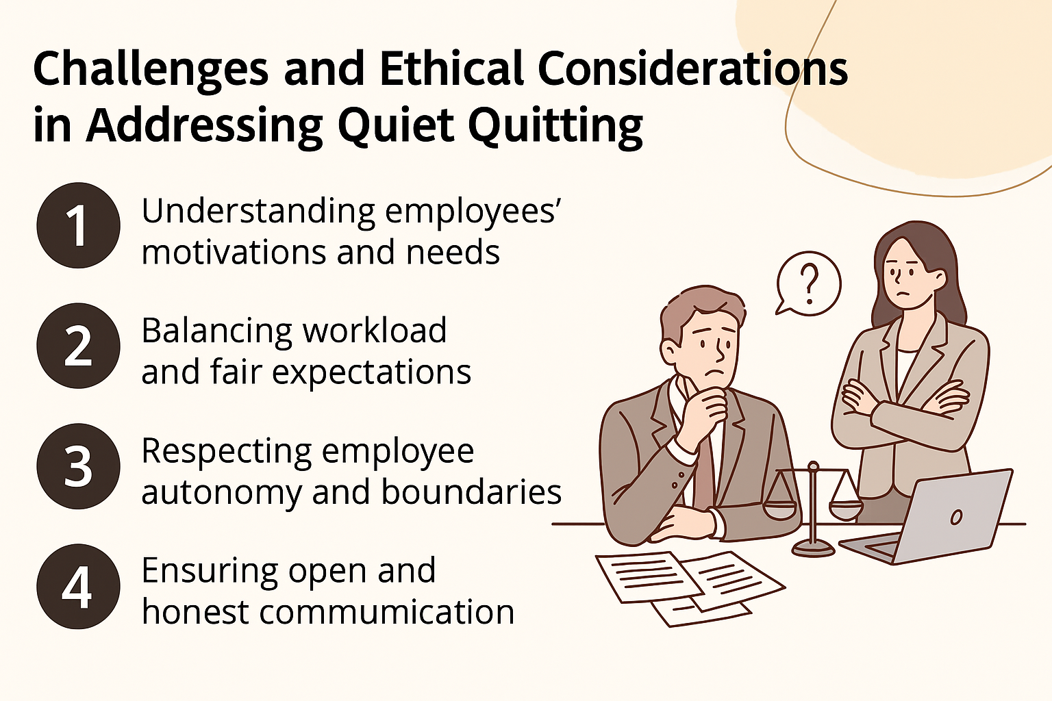

**CONCLUSION**

The rise of quiet quitting represents a fundamental shift in workplace dynamics, signaling that traditional engagement strategies are no longer sufficient. Employees today are not just leaving jobs—they are disengaging while staying, a phenomenon that erodes productivity and morale in subtle but devastating ways. Loud leadership emerges as the necessary counterbalance, offering a proactive, transparent, and empathetic approach to rebuilding trust and commitment. By addressing the root causes of disengagement—burnout, lack of recognition, and poor leadership—organizations can transform silent resignation into vocal dedication.

However, this transformation is not without its challenges. Ethical considerations around employee monitoring, generational differences, and cultural resistance require careful navigation. Surveillance tools meant to detect disengagement can backfire if perceived as invasive, while poorly implemented initiatives risk appearing performative. The key lies in striking a balance—using data responsibly, fostering psychological safety, and ensuring that engagement strategies are inclusive and adaptable. Loud leadership must be authentic, not just loud for the sake of visibility.

The case studies of companies like Patagonia and Google demonstrate that meaningful change is possible when organizations prioritize purpose, transparency, and employee well-being. These leaders show that combating quiet quitting isn’t about enforcing productivity but about creating an environment where employees feel valued and heard. The future of work demands a shift from passive retention to active re-engagement, where leaders are not just managers but catalysts for connection and growth.

For organizations ready to embrace this shift, the path forward is clear: listen actively, lead boldly, and act with integrity. Invest in training managers to practice loud leadership, redesign recognition programs to celebrate contributions meaningfully, and leverage technology to support—not surveil—employees. The goal is not merely to reduce disengagement but to cultivate a workplace where employees are motivated to give their best because they believe in the mission and feel a sense of belonging.

Ultimately, the era of quiet quitting can give way to a culture of loud commitment—one where employees are not just present but passionately engaged. This transformation begins with leaders who are willing to speak up, listen deeply, and create spaces where every voice matters. The choice is clear: adapt now or risk being left behind in a workforce that increasingly values authenticity, connection, and purpose. The time for loud leadership is here.

**REFERENCE**

[1] Gallup (2023). The State of the Global Workplace Report highlights that only 23% of employees worldwide feel engaged at work.

[2] Microsoft (2022). Work Trend Index reveals that 52% of hybrid workers struggle with feeling disconnected from their organizations.

[3] Google’s Project Aristotle (2016) identified psychological safety as the most critical factor for high-performing teams.

[4] BambooHR (2023) reports that 82% of employees feel unrecognized for their contributions in the workplace.

[5] American Psychological Association (2023) found that 59% of workers experience chronic stress and burnout.

[6] Deloitte (2021) research shows companies with inclusive cultures are 1.7 times more likely to be market leaders.

[7] LinkedIn (2022) data confirms a lack of career growth opportunities as a top driver of employee disengagement

[8] Harvard Business Review (2020) emphasizes that employees with strong belonging are 3.5 times more likely to be engaged.

[9] McKinsey & Company (2023) reports that diverse teams with high belonging outperform peers by 30% in innovation metrics.

[10] BetterUp's (2022) study demonstrates that employees with strong belonging are 50% less likely to leave their organizations.