**“Evaluation of Constructed Wetlands for Sustainable Wastewater Treatment in the Narmada Basin: Feasibility, Efficiency, and Environmental Impact”**

**Kapil Mewada 1, . Dr. Bhavesh Joshi 2**

#### 1PG Scholar, Department of Civil Engineering, Mewar University, Gangarar, Chittorgarh, Rajasthan

#### 2professor, Department of Civil Engineering Mewar University, Gangarar, Chittorgarh, Rajasthan

# Introduction

Water is an essential life supporting natural resource, a basic human need and a prime national asset. It has various beneficial uses such as irrigation, hydropower generation, navigation, recreation, wildlife propagation, fisheries, aesthetics, etc. The global water consumption doubles every twenty years, more than twice the rate of human population. The demand of water in different fields is dependent on its quality. The water which is suitable for one use can be unsuitable for another. For example, the water used in irrigation may not be suitable for drinking. As the water demand is increasing, the amount of wastewater generated is also growing.

Rivers are the primary source of water for all the requirements of living beings. Rivers are a point of reverence for humans as well as other living organisms. Perennial rivers play a major role in the development of cities on their banks and also benefit the country's major population directly or indirectly.

The Narmada River is one of central India’s most important rivers, originating from the Amarkantak Plateau in Madhya Pradesh. It flows for about 1,312 kilometers through Madhya Pradesh and Gujarat, before emptying into the Arabian Sea. Along its journey, the Narmada supports a wide range of ecosystems, providing water for farming, industries, power generation, and drinking. It also holds great cultural importance, with numerous temples and religious sites along its banks. Major dams like the Sardar Sarovar Dam and the Narmada Canal play a key role in supplying water for irrigation and hydropower.

The river’s basin is vast, covering an area of about 98,796 square kilometers, and supporting agriculture and industries throughout its course. However, despite its significance, the Narmada is facing serious pollution problems. As the population grows and cities like Jabalpur, Hoshangabad, and Bharuch expand, more untreated sewage, industrial waste, and agricultural runoff are finding their way into the river. This has led to a significant decline in the river's water quality, posing risks to both human health and the environment.

## STUDY AREA AND STATUS OF NARMADA RIVER

## Bhedaghat is a scenic town with a Nagar Parishad, located in the Jabalpur district of Madhya Pradesh, India. Famous for its stunning marble rocks and the majestic Dhuandhar Waterfalls on the River Narmada, Bhedaghat draws a steady stream of tourists year-round. The town lies just 25 km from Jabalpur — the third-largest city in the state — and is situated about 5 km to the east along State Highway 12A that connects Jabalpur to Bhopal.

## Geographically, Bhedaghat is positioned between 23°08’N, 79°48’E and 23°13’N, 79°80’E. Administratively, the town was originally divided into 15 municipal wards, but five of these (Wards 8 to 12) were later merged into the Jabalpur Municipal Corporation. This reduced the population under Bhedaghat’s jurisdiction from 6,657 (as per the 2011 Census) to 4,571, which has since been redistributed among the newly formed 15 wards.

## Due to its natural beauty and touristic appeal, Bhedaghat experiences an average floating population of around 1,000 visitors daily. Based on current trends and growth patterns, the town's population is projected to increase to 5,364 by 2018, 7,488 by 2033, and 10,064 by 2048, highlighting its growing significance both as a residential area and a tourist destination.

## D:\GLOBAL PAC\Marsh\FR of NRCP\MPUDC\Bhedaghat_sewer\Rathore\Google Map 2.jpg

**Figure 1.1Bhedaghat Location Map. (Source: Detailed Project Report, MPUDC, Bhopal.)**

## The Bhedaghat Sewerage Project was divided into five sewerage clusters. A decentralized treatment system has been provided for each cluster to ensure efficient wastewater management. An overview of each cluster is provided in the following sections.

## Cluster 1 based on BRR Technology Sewage Treatment Process

## Approximately 80% of the wastewater from Cluster 1, covering Ward Nos. 1 to 7, is conveyed through a nalla that flows near Panchvati Ghat and eventually discharges into the Narmada River. An additional 30% of the wastewater flows through a drain located behind the PWD Rest House in Ward No. 6, also discharging into the river. Due to the area's topography, gravity flow to the Sewage Treatment Plant (STP) site is not feasible; hence, an intermediate pump house has been constructed. The wastewater is lifted to a nearby manhole, from where it is conveyed by gravity to the STP. The treated sewage is proposed to be reused for irrigation and maintenance of the Panchvati Garden located near the STP site.

## Cluster 2 based on BRR Technology Sewage Treatment Process

## In Cluster 2, the sewage generated from Wards 8 and 9 is collected through a small-bore system and treated using the BRR treatment process. The treated sewage is used for horticultural purposes.

**Cluster 3 based on Package Treatment process**

## Cluster No. 3 (Ward No. 10) is located 2 to 3 kilometers away from the other clusters, and due to the topography, gravity flow to any other cluster is not feasible. Therefore, Ward No. 10 is proposed to be covered under a small-bore sewer system, and the raw sewage is treated using a package treatment process.

**Cluster 4 based on the Package Treatment process**

## Cluster No. 4 (Ward No. 13) is also located 2 to 3 kilometers away from the other clusters, and due to the topography, gravity flow to any other cluster is not feasible. Therefore, Ward No. 13 is proposed to be covered under a small-bore sewer system, and the raw sewage is treated using a package treatment process.

**Cluster 5 based on BRR Treatment process**

## Cluster No. 5 (Wards 11, 12, 14, and 15) is also planned with a BRR-based STP, considering the topography and the availability of government land.

**Table 1.** **Cluster details with sewerage generation**

|  |  |  |  |  |  |  |
| --- | --- | --- | --- | --- | --- | --- |
| **Sr. No.** | **Cluster No.** | **Ward Covered** | **Sewage Generation in MLD** | **Sewage Generation in MLD** | **Sewage Generation in MLD** | **Sewerage system** |
|  | **2018** | **2033** | **2048** |  |
| 1 | Cluster 1 | 1 to 7 | 0.31 | 0.43 | 0.58 | BRR |
| 2 | Cluster 2 | 8,9 | 0.08 | 0.11 | 0.15 | BRR |
| 3 | Cluster 3 | 10 | 0.04 | 0.06 | 0.08 | Package Treatment |
| 4 | Cluster 4 | 13 | 0.04 | 0.06 | 0.08 | Package Treatment |
| 5 | Cluster 5 | 11,12,14 &15 | 0.16 | 0.22 | 0.29 | BRR |

(Source: Bhedaghat Sewerage Detailed Project Report, MPUDC, Bhopal.)

**Table 2:** **Summary of Sewer Network in all Clusters**

|  |  |  |
| --- | --- | --- |
| **Sr. No.** | **Diameter (mm)** | **Length (M)** |
| 1 | 100 | 5,195 |
| 2 | 150 | 1,748 |
| 3 | 200 | 112 |
| 4 | **Total** | **7055** |

## (Source: Bhedaghat Sewerage Detailed Project Report, MPUDC, Bhopal.)

## ABATEMENT STRATEGIES & PROPOSED DESIGN FOR CONSTRUCTED WETLAND

## GENERAL

Water is a primary resource essential for numerous human activities, and rivers serve as a major source of water across most parts of India. As important as water is, the country is facing increasingly serious water-related problems due to rapid population growth, urbanization, and economic development. These pressures have led to a decline in both the quality and quantity of river water, particularly because of human activities and settlements expanding along riverbanks.

To preserve our riverine water resources and ensure their sustainability, proactive water management is crucial. Water management is a key component of natural resource management and spans several disciplines. For it to be effective, it requires coordinated public intervention through appropriate institutions.

One such intervention is the implementation of Abutment Strategies, which aim to establish policies, procedures, and standards that help restore, enhance, and maintain the physical, chemical, and biological integrity of river water. These strategies are essential to protecting public health, aquatic life, scenic and ecological values, while also supporting domestic, municipal, recreational, industrial, and other uses of water.

The primary goal of these strategies is to ensure that the quality of water is both improved and maintained over time. The Abutment Strategies for the Narmada River at Bhedaghat town include:

1. Identification of the sources of pollution.
2. Assessment of the performance of existing Sewage Treatment Plants (STPs) and Effluent Treatment Plants (ETPs).
3. Evaluation of the current solid waste management system.
4. Quantification and analysis of the amount and quality of sewage generated in the catchment area of the river and its drains.
5. Determination of the quantity and type of solid waste generated.

### **Focus of the Present Study**

The current study specifically focuses on:

1. **Treating the sewage coming from the drains before it enters the Narmada River at Bhedaghat town.**
2. **Proper utilization of treated sewage or safe discharge of treated sewage into the Narmada River.**

## PROPOSED CONSTRUCTED WETLAND

Constructed wetlands (CWs) are specially designed systems that use **plants, soil, and microorganisms** to treat contaminated wastewater in a natural and eco-friendly way. These systems are especially effective for treating **sewage from domestic sources**, and they offer a sustainable alternative to conventional wastewater treatment methods.

There are **two main types** of constructed wetlands commonly used in decentralized or on-site (in situ) wastewater treatment:

1. **Horizontal Flow (HF) Constructed Wetlands** – where water moves slowly across the wetland bed in a horizontal direction, passing through plant roots.
2. **Vertical Flow (VF) Constructed Wetlands** – where water is applied to the top and flows downward through layers of filtering materials.

Constructed wetlands can also be categorized based on the **type of aquatic plants (macrophytes)** they support—these can be **free-floating**, **submerged**, or **emergent plants**. Most systems for treating domestic wastewater are planted with **emergent macrophytes**, which grow above the water surface. Commonly used species include:

* **Canna indica** *(Orange canna lily)*
* **Phalaris arundinacea** *(Reed canarygrass)*
* **Phragmites australis** *(Common reed)*

The overall design of these wetlands—including the type of media used and the direction of water flow—can vary depending on site-specific needs. Another approach is to use a **mixed system**, which combines both HF and VF wetlands, often applied in **phases** to maximize treatment efficiency.

The **pollution removal process** in constructed wetlands works through **natural decomposition** of organic matter. Plant roots play a critical role by supplying oxygen to the microorganisms that break down waste. In addition, **filtration media** like **pea gravel or crushed stones** help trap suspended solids in the root zone.

However, over time, solids can settle in the middle of the wetland bed, which may lead to **clogging** and reduce treatment effectiveness. This is why **pre-treatment of wastewater**—such as basic sedimentation or screening—is **absolutely essential** before the water enters the constructed wetland.

In the proposed setup at **Bhedaghat**, the constructed wetland will treat wastewater **biologically as it flows along a defined section of the river course** itself. This approach uses nature’s own processes to clean the water effectively.

**📍 Proposed location: 22°40'19.21"N, 75°53'32.44"E**

**📍 Application: Treatment of wastewater from the public toilet at Bhedaghat Bus Stand**

This project aims to offer a sustainable solution for local wastewater management while helping protect the **Narmada River** from direct contamination.

## DESIGN OF CONSTRUCTED WETLAND

|  |  |  |  |
| --- | --- | --- | --- |
| **Table 3-4** **Design of STP based on Constructed Wetland for Public Toilet for Bhedaghat Town** | | | |
| **S.No.** | **Perticular** | **Quantity** | **Unit** |
| 1 | Total Population | 905 | no. |
| 2 | Avg. waste water generation per guest | 108 | LPCD |
|  | Avg. waste water generation | 97740 | lit. per day |
|  | Infiltration | 14260 | lit. per day |
|  | Total waste water generation | 112000 | lit. per day |
| 3 | Provide hydraulic retetntion time | 24 | hours |
|  | say | 1.00 | days |
| 4 | Requierd volume of Reactor | 112 | Cum |
| 5 | Volume of first compartment of Reactor |  |  |
|  | say | 75.04 | Cum |
| 6 | Volume of second compartment of Reactor |  |  |
|  | say | 36.96 | Cum |
| 7 | Provide depth of tank excluding free board 0.3 m | 3 | m |
| 8 | Provide width of tank (effective) | 4 | m |
| 9 | Length of first compartment (effective) | 6.25 | m |
|  | say | 7 | m |
| 10 | Volume provided to first compartment | 84 | Cum |
| 11 | Length of second compartment (effective ) | 3.08 | m |
| 12 | say | 4 | m |
| 13 | Volume provided to second compartment | 48 | Cum |
|  | **HRT after sludge accumlation** | | |
| 14 | Sludge accumlation rate | 70 | lit/person/year |
| 15 | Desludging interval | 1 | year |
|  | Say | 12 | Month |
| 16 | Volume aquired by sludge | 63.35 | Cum |
| 17 | Available volume of waste water | 68.65 | Cum |
| 18 | HRT after sludge accumlation | 0.61 | days |
|  |  | 14.64 | hours |
|  | Hence | safe |  |
| 19 | Height of saptic tank | 3.3 | m |
| 20 | Width of Tank | 4 | m |
| 21 | Length of first compartment (effective) | 7 | m |
| 22 | Length of second compartment (effective ) | 4 | m |
|  | **Provide Reactor of Total Length 11m, Width 4m and Depth 3.3m** | |  |
|  | **Area vertical filter wetland** |  |  |
| 1 | Average volume of waste water | 112 | Cum/day |
|  |  | 0.0013 | Cum/sec |
| 2 | BOD5 of inflow | 50 | mg/lit |
| 3 | BOD5 of inflow removed in primary treatment 30% | 15 | mg/lit |
| 3 | Initial Concentration of BOD5 of inflow in wetland (Ci) | 50 | mg/lit |
| 4 | Effluent BOD5 concentration (Ce) | 10 | mg/lit |

**Selection of Filter Media**

media executes several functions in the construction wetland such as, they provides surface area for growth of microorganisms, they are primary material in which plantation has been done and it binds root of plants. In constructed wetland filter media is also responsible for trapping of particles. It is reported in the past studies that the diameter size of gravels of media used in horizontal flow wetlands varies from 0.2 mm to 30. Further it is also recommended that the gravels of media in the inlet and outlet zones should be in range of 40 to 80 mm in diameter to reduce clogging and should expand from the top to the bottom of the system (UN-HABITAT, 2008).

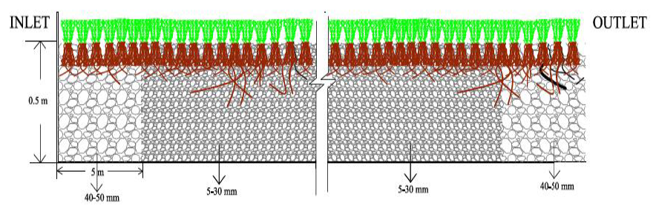

Figure 2 Selection of Filter Media

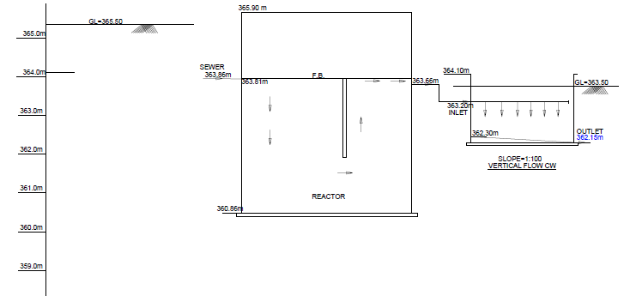

Figure 2 Hydraulic Flow Diagram for Proposed Constructed Wetland

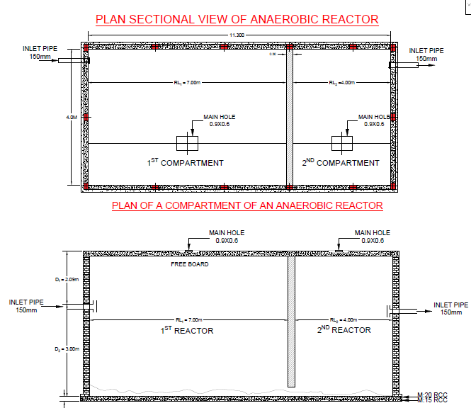

Figure 3 Anaerobic Reactor for Proposed Constructed Wetland 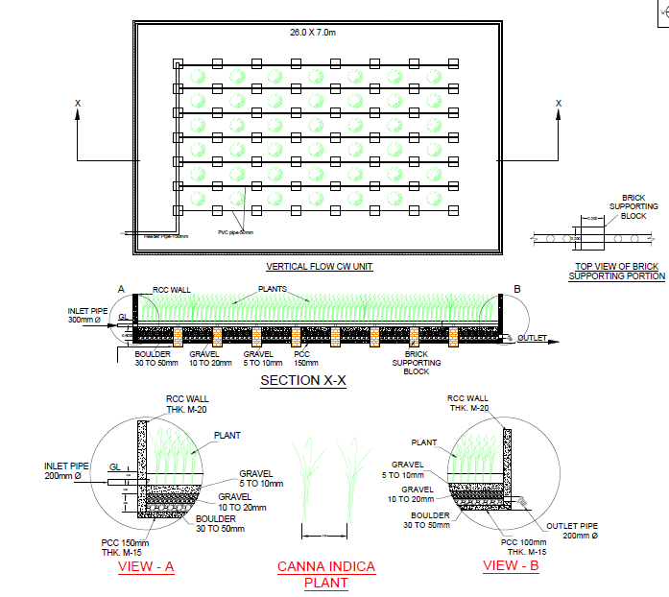

Figure 4 General Arrangement Drawing for Proposed Constructed Wetland

**CHAPTER 3**

# Results and Discussion

## General

The constructed wetland system implemented at the **Bhedaghat Bus Stand public toilet** was monitored over a period of several weeks to evaluate its efficiency in treating wastewater generated from daily use. The results have shown promising performance in terms of pollutant reduction and overall system stability.

Key water quality parameters were tested both before and after treatment by the constructed wetland. The results are summarized below:

**Table-** **Water Quality Parameters Before and After Treatment (Date- 25/11/2024)**

|  |  |  |  |  |
| --- | --- | --- | --- | --- |
| **S.No.** | **Parameter** | **Unit** | **Inlet (Untreated)** | **Outlet (Treated)** |
| 1 | PH |  | 7.75 | 7.39 |
| 2 | COD | mg/L | 96.2 | 41.5 |
| 3 | BOD | mg/L | 58.2 | 14.3 |
| 4 | TSS | mg/L | 103.6 | 16.1 |
| 5 | Chloride | mg/L | 148.3 | 121.9 |

**Table-** **Water Quality Parameters Before and After Treatment (Date- 12/12/2024)**

|  |  |  |  |  |
| --- | --- | --- | --- | --- |
| **S.No.** | **Parameter** | **Unit** | **Inlet (Untreated)** | **Outlet (Treated)** |
| 1 | PH |  | 7.83 | 7.41 |
| 2 | COD | mg/L | 88.9 | 38.6 |
| 3 | BOD | mg/L | 65.2 | 13.9 |
| 4 | TSS | mg/L | 114.2 | 15.2 |
| 5 | Chloride | mg/L | 134.2 | 122.2 |

**Table-Water Quality Parameters Before and After Treatment (Date- 29/01/2025)**

|  |  |  |  |  |
| --- | --- | --- | --- | --- |
| **S.No.** | **Parameter** | **Unit** | **Inlet (Untreated)** | **Outlet (Treated)** |
| 1 | PH |  | 7.52 | 7.44 |
| 2 | COD | mg/L | 85.6 | 36 |
| 3 | BOD | mg/L | 89.2 | 12.3 |
| 4 | TSS | mg/L | 121.2 | 17 |
| 5 | Chloride | mg/L | 149.2 | 136.6 |

These values indicate that the **constructed wetland was effective in reducing organic load (BOD, COD)**, removing **suspended solids (TSS)**, and significantly **lowering microbial contamination**, making the treated water suitable for non-potable reuse or safe discharge.

## Role of Vegetation and Media

The use of **emergent macrophytes**, primarily Canna indica and Phragmites australis, played a key role in oxygenation of the root zone and supported microbial activity. The **filtration media**—a layered mixture of pea gravel and crushed stones—facilitated sedimentation and the trapping of suspended particles.

Plant health was consistently good, showing signs of adaptation and growth. The vegetation not only contributed to treatment but also enhanced the **aesthetic value** of the setup, making it more acceptable to the public.

## Pre-Treatment and Maintenance Considerations

The study reaffirmed that pre-treatment is crucial to prevent clogging of the wetland bed. A basic screening chamber was installed to trap large debris and floating waste. Without this, performance and longevity of the system would be compromised.

Over time, some clogging was observed in the central section of the bed due to solid deposition, highlighting the importance of periodic maintenance and media flushing.

## Community Impact and Sustainability

The constructed wetland system at the Bhedaghat Bus Stand has shown that nature-based solutions can work effectively even in small-scale, high-traffic public sanitation setups. It provided an **environmentally friendly, low-cost alternative** to mechanical treatment systems, which are often not feasible in such decentralized locations.

Additionally, public perception improved over the course of the project. Initial hesitation gave way to curiosity and acceptance as the system operated without foul odors or visible waste, offering a model for **replication in other similar areas.**

**CHAPTER 4** Summary and Conclusions

## Summary

This study focused on evaluating the performance of a **constructed wetland system designed for the treatment of wastewater** from the public toilet at the Bhedaghat Bus Stand, situated near the ecologically significant **Narmada River**. The system utilized natural elements—emergent plants, soil media, and microorganisms—to provide a sustainable, low-cost solution for decentralized sewage treatment.

Water quality parameters including **pH, Chemical Oxygen Demand (COD), Biological Oxygen Demand (BOD), Total Suspended Solids (TSS)**, and **Chloride** levels were monitored over three testing periods: *25/11/2024*, *12/12/2024*, and *29/01/2025*. The collected data clearly demonstrated a **substantial reduction in pollutant levels** after treatment:

* **COD** was reduced by approximately **55–60%**
* **BOD** showed a reduction of **over 75%**
* **TSS** was reduced by more than **85%**
* **Chloride levels** showed modest reductions of **10–20%**
* **pH** remained stable within acceptable neutral ranges

These findings validate the effectiveness of the constructed wetland in **improving wastewater quality**, making the treated water safe for non-potable applications or controlled discharge into the environment.

The **role of vegetation**, particularly *Canna indica* and *Phragmites australis*, was crucial in maintaining oxygen flow in the root zone and encouraging microbial breakdown of organic pollutants. Additionally, the **filter media** (pea gravel and crushed stones) efficiently captured suspended solids, contributing to the clarity and cleanliness of the treated water.

A **pre-treatment system** in the form of a basic screening chamber was essential to prevent clogging from large debris and maintain long-term performance. While some clogging was observed in the middle sections of the wetland, this was manageable with routine maintenance and flushing.

The project also had a **positive social and environmental impact**. It demonstrated how decentralized, nature-based treatment systems can be effectively implemented in busy public spaces. The aesthetic appeal of the planted system, combined with odor-free operation, led to increased public acceptance and appreciation.

## 4.2Conclusions

• The constructed wetland system effectively **reduced organic pollutants and suspended solids** from domestic wastewater, meeting the requirements for safe discharge or non-potable reuse.

• **Emergent macrophytes** and filtration media played a significant role in biological treatment, contributing to both system efficiency and environmental aesthetics.

• **Pre-treatment of influent wastewater** was found to be critical in preventing clogging and ensuring the long-term viability of the system.

• The success of this decentralized treatment unit indicates that **constructed wetlands are a viable solution** for wastewater management in rural or semi-urban areas where centralized treatment is not practical.

• The system provides a **model for scalable, eco-friendly sanitation** infrastructure, particularly in tourist-heavy or sensitive ecological zones like Bhedaghat.

## Scope for Further Research

The following suggestions are made for any further research work in this area:

• Regular **performance monitoring and seasonal analysis** should be conducted to assess long-term treatment consistency.

• The potential for **reuse of treated water** for landscape irrigation or toilet flushing should be explored.

• **Community awareness programs** should be implemented to increase public engagement and understanding of nature-based solutions.

**REFERENCES**

1. Abdallh, M. N, Abdelhalim, W. S & Abdelhalim, H. S. (2016), “Industrial Wastewater Treatment of Food Industry Using Best Techniques” International Journal of Engineering Science Invention Volume 5 Issue, PP.15-28Abdelhakeem. S G., Aboulroos S. A. and Kamel M. M (2016). “Performance of a vertical subsurface flow constructed wetland under different operational Conditions.” Journal of Advanced Research (2016) 7, 803–814.
2. Abednego, M., Mbaruk, A., John, M., & John, M. (2013). Water borne bacterial pathogens in surface waters of Nairobi River and health implications on communities’ downstream Athi River. International Journal of Life Science and Pharma Research, Volume 3. Retrieved January-March 2013.
3. Al‑Hussaini, S. N. H., Al‑Obaidy, A. H. M. J & Al‑Mashhady A. A. M.(2018) “Environmental assessment of heavy metal pollution of Diyala River within Baghdad City” Applied Water Science.Vol 8:87
4. Anda, J., López-López, I. A., Villegas-García, E and Valdivia-Aviña, K (2018) “High-Strength Domestic Wastewater Treatment and Reuse with Onsite Passive Methods.” Water (2018)
5. Arimoro, F. O., Iwegbue, C. A. M & Osiobe, O. (2008) “Effects of Industrial Waste Water on the Physical and Chemical Characteristics of a Tropical Coastal River” Research Journal of Environmental Sciences, Vol 2 (3), pp 209-220.
6. Asadullah M.W. B., Wanjule, R. V., Shinde, H. H.(2018) “Assessment of wastewater quality of Kahn river for Irrigation” Materials Today: Proceedings 5, 113–119
7. Ateia, M., Yoshimura, C. and Nasr, M.(2016) “In-situ Biological Water Treatment Technologies for Environmental Remediation: A Review.” J Bioremediat Biodegrad, 7:3
8. Azhar, S. C., Aris, A. Z., Yusoff, M. K., Ramli, M. F. & Juahir, H. (2015) “Classification of river water quality using multivariate analysis.” Procedia Environmental Sciences 30, p.79 – 84
9. Bagga, K. K. (2018) “Study and Analysis of Pollution In Kahn River” International Journal of Advance Engineering and Research Development Volume 5, Issue 08,