**STUDY OF URBAN AIR QUALITY - A CASE STUDY NATIONAL CAPITAL TERRITORY OF “DELHI”**

**Swadeep Mourya 1, . Dr. Bhavesh Joshi 2**

#### 1PG Scholar, Department of Civil Engineering, Mewar University, Gangarar, Chittorgarh, Rajasthan

#### 2professor, Department of Civil Engineering Mewar University, Gangarar, Chittorgarh, Rajasthan

**Abstract**-In this thesis, the concentration of five main air pollutants is determined by the help of the open source analysis tools software “R”. The research is focus on how the concentration of pollutant changes in the absence and presence of vehicle during the 24 hour a day and diurnal variation. Seasonal variation on the concentration change in the month of Diwali taking R K Puram location in Delhi. A correlation test also performs between PM2.5 and PM10. Statistical analysis shows that the during winter months, the concentration build up is high due to inversion phenomena leading to low mixing height. Ozone value is high during summer months due to high solar insolation, which converts NOx in to Ozone. NOx value is high during winter months due to 2 reasons, inversion phenomena and use of room heating devices that emits NOx. The concentration in the pre Diwali month is greater than that of Diwali d both exceed up to the extreme dangerous level and it is found that 54.45% of PM10 is PM2.5. Finer size PM is generated mostly by vehicular emission and therefore on daily average, it can be stated that vehicular emission contributes 54% of PM2.5 of the PM10.

1. **INTRODUCTION**

Delhi, the capital city of India, having a population of 18.2 million people spread over 1484 km² is one of the most polluted cities of the world. It is estimated that about 3,000 MT of air pollutants are emitted every day in Delhi. The contribution of air pollution in Delhi are emissions from vehicles (67%), Coal based thermal power plants (13%), industrial units (12%) and domestic (8%) Central pollution control board. During the last 15 years there is a steep increase in the vehicular population in Delhi which has contributed to majority in the air pollution emissions. Variety of pollutants is emitted into the atmosphere by natural and anthropogenic sources, of which particulate matters, oxides of nitrogen are having the significant role and increasing impact on urban air quality. It has been found that and NO x concentrations are within the permissible limits in many areas but PM10 and PM2.5 concentrations are generally exceeding the limits as per Indian air quality guidelines. All atmospheric substance that is not gases but may be suspended droplets, solid particle or mixture of the two is generally referred to as particulates. Particulate matter causes respiratory problems like asthma, reduction in visibility and cancer. Oxides of nitrogen cause respiratory problem, asthma, lung irritation and pneumonia. Higher concentration of oxides of sulphur causes bronchitis. It also causes acid rain, sulphurous smog and reduced atmosphere visibility. Combination of particulate matter with sulphur oxides is more harmful than either of them separately. Ozone is produced in the upper atmosphere by solar reaction. Small concentration of this gas diffuses downward and become the major concern in air pollution. It causes irritation of eyes nose and throat, headache in man.

1. **Objective(s) of the study**

Air Quality Data Analysis - Comparison of spatially and temporally varying data using statistical tools (t-test), Correlation of data, uncertainty of result.

1. **Scope of study**
2. Estimation of emissions of NOx, NO, Ozone and PM in all grid sources using different methods.
3. Collection and analysis of daily ambient air quality data of study pollutants at various monitoring sites of Central Pollution Control Board (CPCB).
4. Concentration contribution of pollutants due to commercial and non-commercial Vehicles to urban air quality through air quality models.
5. Validation of models with observed data of Central Pollution Control Board (CPCB).
6. Application of models to determine concentration of air pollutants due to Diesel operated vehicles, (each type of vehicles separately) to ambient air quality of Delhi.

**Methodology**

**a. Monitoring Locations:**

Sampling of the specific sites of the Delhi (R.k.puram, Alipur, Karol Bagh, Pitampura ,Shahdara , Delhi , new delhi) was done for the status examine of ambient air quality. It is very important to know that the various factors related to it and depends on the location of sampling station, size of the site sampling, duration and rate of sampling.

**b. Different types of air quality monitoring equipment used:**

High Volume Sampler, Speciation sampler, Federal Reference Method (FRM) Sampler, WINS impactor, Equipment based on inertial impactor principle Air Quality Monitoring for urban environment - Point measurement, Path measurement (DOAS-OPSIS), continuous air quality monitoring.

**c. Analytical design:**

The method for sampling of particulate pollutants is based on the size of the particulates to be sampled. Suspended particulate matter (SPM) and Respirable suspended particulate matter (RSPM) were analysed using Respirable Dust Sampler (RDS) APM 460 and operated at an average flow rate of 1.0-1.5 m³ min-1. Pre-weighted glass fibers filter paper (GF/A) of whatman and cup were used as per standard methods. The Respirable particulate matter (RSPM) was collected on glass fiber filter paper and suspended particulate matter was collected by gravity settling method. Samples were collected continuously for 48 hrs. every week at 1-hourly intervals. The sampling and analysis method was followed in accordance to USEPA Method.

NOx were measured with help of RDS APM 460 with gaseous attachment APM 411 by sucking air into appropriate reagent for 48 hrs. every week at 1-hourly intervals and after air monitoring it procured into lab and analysis for the concentration level. NOx were collected by bubbling the sample in a specific absorbing sodium hydroxide for NOx solution at an average flow rate of 0.2-0.5 min-1. The impinger samples were put in ice boxes immediately after sampling and transferred to a refrigerator until analysed. The concentration of NOx was measured with standard method of Modified Jacob- Hochheiser method (1958).

Ozone contained air sample is scrubbed counter recurrently in a wetted wall absorbed by a 2 % solution of buffered, neutral potassium iodide in water. The yellow colour of the solution is measured photometrically and recorded continuously on strip chart recorded.

**RESULTS**

Statistical analysis was carried out using open source software ‘R’ version 3.1. Particulate Matter data was analysed for performing ANOVA to predict statistical significance of monthly variation in concentration of particulate matter. This can only be done for this particular case as concentration is more or less same for all the months as observed above.

To perform ANOVA data should be normally distributed. As data was not observed to be normal a log transformation was performed on data. Figures show density, quartile and histogram plots for particulate matter before and after transformation of data.

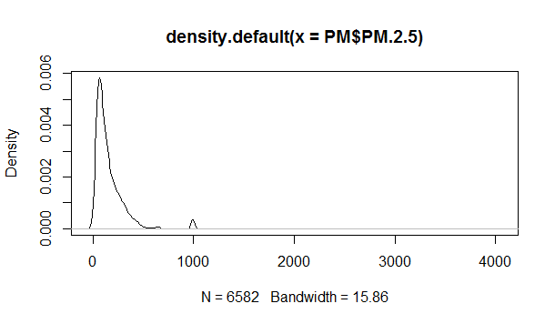

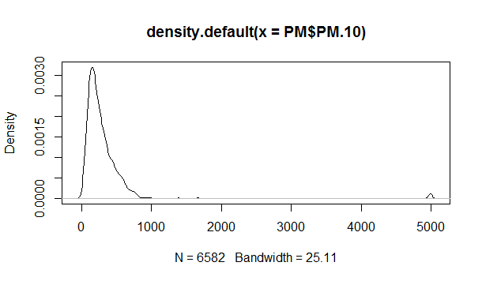

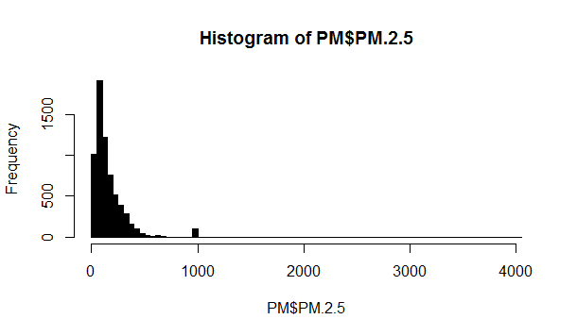

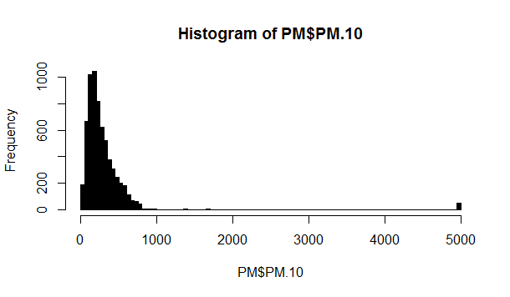

PM2.5

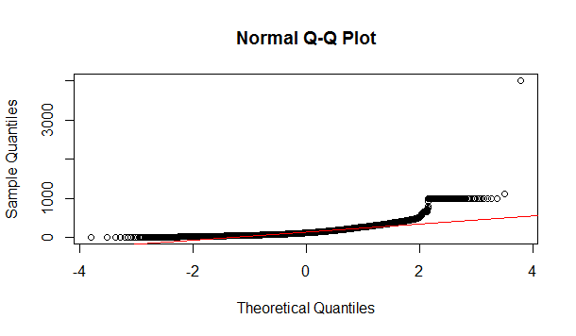

PM10

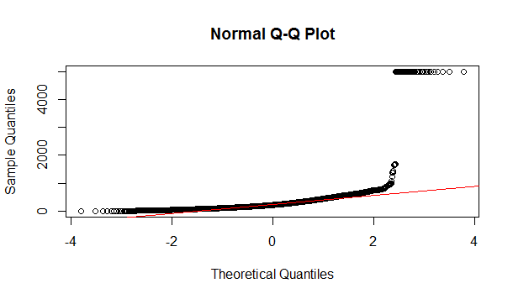

TRANSFORMED FIGURE

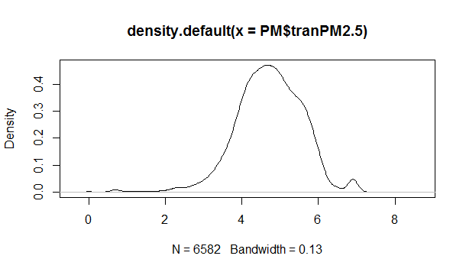

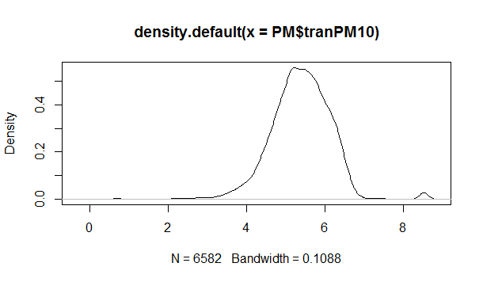

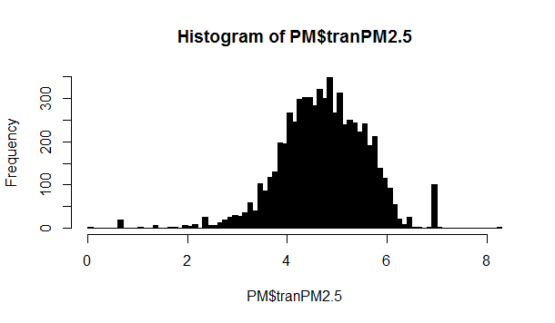

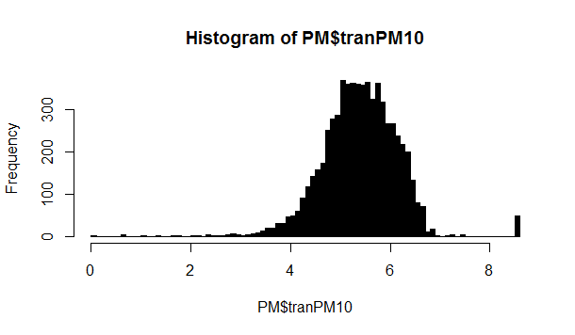

PM2.5

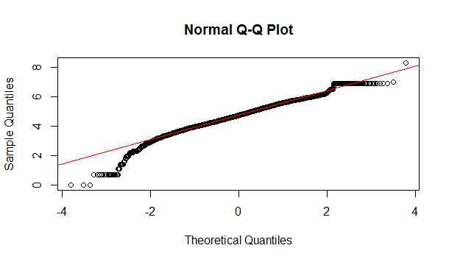

PM10

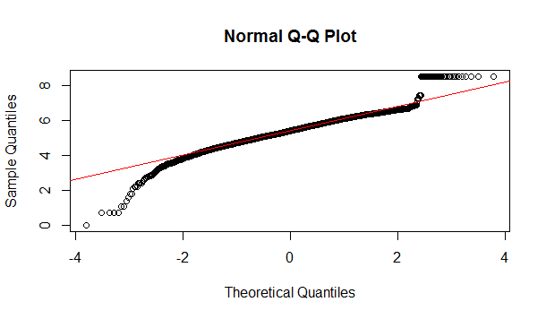

There was a statistically significant difference between groups as determined by one-way ANOVA. A Tukey post-hoc test revealed that the concentration of PM10 was statistically significant for various months. There were no statistically significant differences between months as shown below.

JUN-APR 0.9381471

SEP-AUG 0.9084800

FEB-DEC 0.9871600

JAN-DEC 0.6284186

OCT-DEC 1.0000000

OCT-FEB 0.9571384

OCT-JAN 0.8728664

MAY-JUN 0.8790138

There was a statistically significant difference between groups as determined by one-way ANOVA. A Tukey post-hoc test revealed that the concentration of PM2.5 was statistically significant for various months. There were no statistically significant differences between months as shown below.

JUN-APR 0.9999481

MAY-APR 0.5643308

JUL-AUG 0.1571046

SEP-AUG 0.9988992

OCT-DEC 0.9998860

NOV-JAN 0.8767935

OCT-JAN 0.1883258

MAY-JUN 0.3786768

MAY-MAR 0.8414743

CONCLUSION

This chapter summarises the results and discussions by concluding the findings and making recommendation for possible further research.

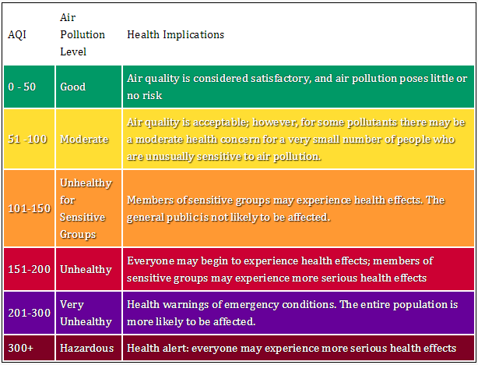

**1.** **Is there any monthly variations.**

PM10 and PM2.5 varies in a similar way on monthly basis. During winter months, the concentration build up is high due to inversion phenomena leading to low mixing height. Ozone value is high during summer months due to high solar insolation, which converts NOx in to Ozone. NOx value is high during winter months due to 2 reasons, inversion phenomena and use of room heating devices that emits NOx.

Rain ends by September and wind speed lowers down. The post monsoon period is of very low ventilation and therefore pollutant accumulation is obvious. This can be seen from the box-whisker plot shown below. October to February, which is winter and shows relatively high pollution concentration compared to other months. Sun starts rising during march leading to increased mixing height thereby providing large ventilation leading to lower pollutant concentration. However, it can be noticed that there is a spurt in PM10 concentration during April and is attributed to winds from western part of the subcontinent. During rain period, the PM10 levels are relatively low due to natural cleaning mechanism (rainout and washout) available.

**2. Concentration in the month of Diwali.**

In pre Diwali month the concentration of PM2.5 found to be lie between (250 to 300 µg/m³)

And in the month of Diwali the concentration found to be (200 to 250 µg/m³).

For PM10 the concentration found to be (600 to 700 µg/m³) in pre Diwali and (400 to 500 µg/m³) in Diwali.

NO2 concentration in this period found to be moderate between (60 to 80 µg/m³).

O3 concentration at this time shows the air quality is satisfactory (40 to 60 µg/m³).

**3. Correlation between PM10 and PM 2.5**

In order to find the relationship between PM10 and PM2.5, a scatterplot of the two is created and is shown in Fig. 3. It is found that 54.45% of PM10 is PM2.5. Finer size PM is generated mostly by vehicular emission and therefore on daily average, it can be stated that vehicular emission contributes 54% of PM2.5 of the PM10.

**4. Diurnal variation of particulate matter**

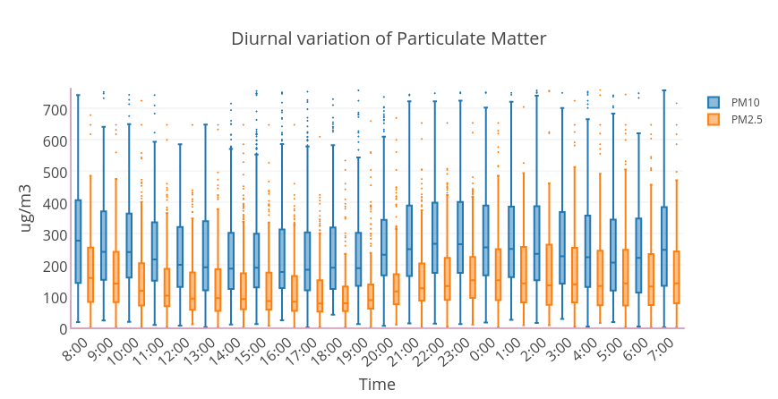

**Fig.** shows the diurnal variation of PM10 and PM2.5. It can be seen that both the parameters exceed the regulatory limit value of 100 and 60 g/m3. The figure shows the diurnal variation clearly separating day and night. It is observed that though the emission level starts rising at 08:00 AM due to increased vehicular movement, however, the ambient air concentration remains at lower level due to increased ventilation owing to larger mixing depth available. As the sun rises, it burns off the inversion and the mixing height increases, thereby providing large vertical space for dispersion of pollutants. By evening, gradually the vehicular movements goes on increasing up to 10:00 PM as the office goers return home, however, by this time the inversion sets in, thereby restricting the vertical movement of pollutants causing higher concentration of pollutants. Thus in general the pollutant level in Delhi remains higher at night compared to day time. On the contrary, the same data for a cleaner city may not exhibit similar pattern. The night time concentration of PM pollutant may be lesser than that of day time.

**REFERENCE**

1. Rao M.N. and Rao H.N.V., Air pollution, Tata McGraw Hill Publishing Company Limited.
2. CPCB (Central pollution Control Board), **THE ENVIRONMENT (PROTECTION) ACT, 1986.**
3. **Determination of Air Quality Index Status in Industrial areas of Visakhapatnam, India Srinivas J. 1 and Purushotham A.V.2** 1Department of Civil Engineering, JNTU Kakinada, Andhra Pradesh, INDIA 2MSN Degree College, Kakinada, Andhra Pradesh, INDIA.
4. **Status of Ambient Air Quality of the Residential, Commercial, Heavy Traffic Street and Sensitive Areas of Jhansi City, Bundelkhand (India)** Saurabh K. Yadav, Vinit Kumar, *M.M.Singh , **Antriksh Kumar Jain, **Deepshikha Sharma and Jamshed Zaidi Institute of Environment and Development studies, Bundelkhand University Jhansi- 284 128 (U.P.) India *Department of Geology, Bundelkhand University Jhansi- 284 128 (U.P.) India **J.K.Cement works, Bagalkot, Karnataka ***Department of Applied Sciences, Satya College of Engineering and Technology, Mitrol, Palwal-India.
5. **INTERNATIONAL JOURNAL OF ENGINEERING SCIENCES & RESEARCH TECHNOLOGY Monitoring of ambient Air Quality in India - A Review Devendra Dohare*, Vijayant Panday** *Assistant Professor, Department CE & AMD, S.G.S.I.T.S Indore, India P.G. Student Environmental Engineering, Department CE & AMD, S.G.S.I.T.S Indore, India.
6. **Human health risks in national capital territory of Delhi due to air pollution Ajay Singh Nagpure 1, Bhola Ram Gurjar 2, Jc Martel 3** 1 Center for Science, Technology and Public Policy, Hubert H. Humphrey School of Public Affairs, University of Minnesota, Minneapolis, MN 55455, USA 2 Department of Civil Engineering, Indian Institute of Technology Roorkee 247667, India 3 School of Public Affairs, University of Colorado at Denver, Denver, CO 80203, USA.
7. **International Journal of Advanced Engineering Technology E-ISSN 0976-3945 IJAET/Vol.I/ Issue II/July-Sept.,2010/106-114 Research** **Article- ANALYSIS OF AMBIENT AIR QUALITY USING AIRQUALITY INDEX – A CASE STUDY** Prakash Mamta*, Bassin J.K Address for correspondence *Council of Scientific and Industrial Research, National Environmental Eng. Research Institute, Delhi Zonal Laboratory, A-93/94, Naraina Industrial Area, New Delhi-India.