**LIBRARY MANAGEMENT SYSTEM**

**Charushila Patil1, Adan Shaikh2, Murtuza Shaikh3**

1Assistant Professor, Artificial Intelligence & Data Science, Guru Gobind Singh College of Engineering & Research Center, Nashik, Maharashtra, India

2,3,Student, Artificial Intelligence & Data Science,Guru Gobind Singh College of Engineering & Research Center, Nashik, Maharashtra, India

**ABSTRACT**

The Library Management System is a software application designed to automate and streamline the operations of a library (Python Software Foundation [1]). It provides a comprehensive solution for managing books, users, and library transactions efficiently. The system enables users to register, log in, search for books, borrow and return books, and view their transaction history (TkDocs [2]). Librarians and administrators can add new books, update book details, manage user accounts, and monitor issued and returned books, using development support and examples from Stack Overflow and GitHub communities (Stack Overflow [3]; GitHub [4]). The system is developed using Python with a MySQL database for backend data storage, ensuring data integrity and quick access (Python Software Foundation [1]). A user-friendly graphical interface enhances usability, making the system accessible even to users with minimal technical knowledge (TkDocs [2]).

Keywords: Authentication, Book Management, Database, Library System

1. **INTRODUCTION**

Libraries play a vital role in the educational and cultural development of any community. They serve as a repository of knowledge and offer a structured way to store, manage, and disseminate information (Python Software Foundation [1]). Traditionally, library operations such as book issuance, returns, and record-keeping were handled manually, leading to errors, inefficiencies, and significant time consumption.

The objective of this project is to develop a user-friendly, reliable, and secure Library Management System using Python and MySQL (Python Software Foundation [1]). This system will allow users to register, search for books, borrow or return them, and manage their accounts conveniently. Librarians will benefit from simplified book management and automated tracking, enhancing overall operational efficiency (TkDocs [2]).

In recent years, the need for digital transformation in libraries has grown exponentially. With the increasing volume of books and users, manual systems have proven to be inadequate for maintaining accurate records, handling user queries efficiently,

or scaling up to meet modern demands (Stack Overflow [3]). As a solution, a computerized Library Management System (LMS) is not only a necessity but also a cornerstone for creating a smarter academic environment.

This project aims to bridge that gap by providing an interactive and dynamic Library Management System built with Python for the front-end and logic layer, and MySQL as the back-end database (Python Software Foundation [1]; GitHub [4]). The system leverages PyMySQL for database connectivity, ensuring seamless integration between the application and the database. The GUI is developed using Tkinter, Python’s standard GUI toolkit, making it accessible even to users with minimal technical expertise (TkDocs [2]).

Building upon this foundation, the system incorporates role-based access to differentiate functionalities available to users and librarians. Librarians can add new books, update book details, manage user records, and monitor transactions in real time, while general users are allowed to search the library catalog, borrow and return books, and view their borrowing history (GitHub [4]). This division of privileges ensures operational control while maintaining ease of access for all users. The system also includes validation checks and user feedback mechanisms to reduce input errors and guide users through various processes effectively (Stack Overflow [3]).

One of the notable features of the system is its real-time synchronization with the MySQL database, which ensures that all records—such as issued books, returned books, and newly added inventory—are immediately updated and reflected in the system (Python Software Foundation [1]). This eliminates redundancy and ensures consistency across the platform. Moreover, the system can be deployed over a local network, allowing multiple terminals to access the library data simultaneously (GitHub [4]).

1. **METHODOLOGY**
2. *Review Stage*

In the review stage, the Library Management System was subjected to internal evaluation and verification processes. The initial version of the project was tested for basic functionalities such as user registration, login authentication, book addition, issuance, and return operations. Bugs identified during unit testing and integration testing were documented.

The testing phase played a crucial role in ensuring the reliability, accuracy, and stability of the Library Management System. After completing the initial development cycle, the system underwent a comprehensive internal review that included unit testing, integration testing, and user acceptance testing (UAT).

1. *Final Stage*

The final version was organized into a two-column format for documentation, including relevant figures and tables to illustrate system architecture and database design. All components — user interface, backend logic, and database interactions — were thoroughly validated for consistency . The project was then submitted for evaluation, complete with proper documentation, screenshots, ER diagrams, and sample outputs to demonstrate the functionalities.

The final version of the Library Management System was systematically documented and formatted to ensure clarity, professionalism, and ease of understanding for evaluators and future developers. The project documentation was structured in a two-column format, aligning with academic and institutional standards, and included a comprehensive collection of visuals and structured data representations.

1. **MODELING AND ANALYSIS**

The Library Management System (LMS) is designed to automate library operations like user authentication, book management, transaction handling, and record viewing (Python Software Foundation [1]). The system architecture consists of a User layer interacting through a Graphical User Interface (GUI) (TkDocs [2]), an Application layer managing core functionalities, and a MySQL Database layer ensuring secure data storage. Users can easily log in, manage books, issue or return them, and view transaction histories through the GUI, while the database handles all back-end operations like storing user credentials, book details, and transaction records, with additional development support from platforms like Stack Overflow [3] and GitHub [4].

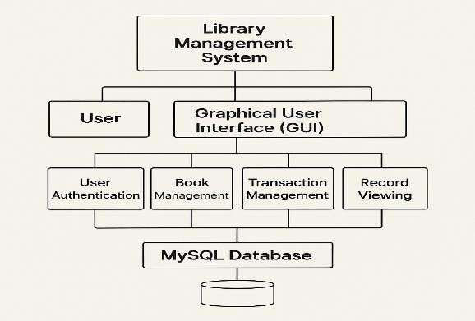

1. **Result And Discussion**

The system achieves its objectives by ensuring efficient book management and secure user authentication, with Python and Tkinter forming the core technologies (Python Software Foundation [1]; TkDocs [2]). The use of MySQL as the backend database provides fast, reliable data operations, while additional insights and problem-solving support from developer communities like Stack Overflow [3] and GitHub [4] helped strengthen the system's design. Overall, the project meets functional requirements, providing a fully working model for managing basic library activities with clear, structured workflows.

The developed Library Management System successfully provides users with a simple and interactive interface, as seen in the library menu and system screens. The "Library System" interface allows users to register, login, and exit easily, ensuring a smooth start for new and existing users. Upon logging in, users are directed to the "Library Menu," where they can add new books, view the book list, delete books, or logout. Each function is clearly presented with color-coded buttons, enhancing user experience and navigation[1].

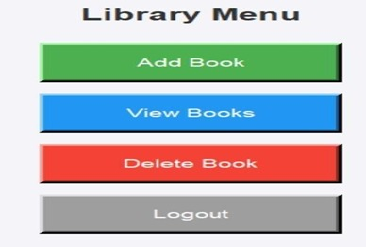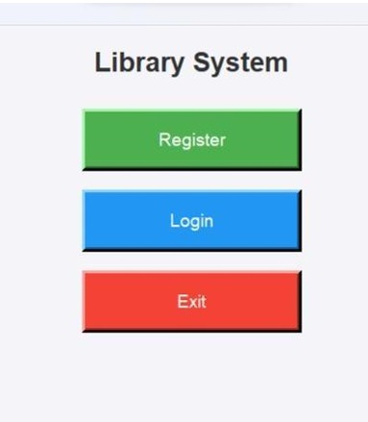

1. **Conclusion**

The development of the Library Management System marks a significant step toward modernizing traditional library operations by effectively replacing manual processes with an automated, structured, and scalable solution. Built using Python for the application logic and Tkinter for the graphical interface, with MySQL as the backend database, the system successfully delivers a seamless experience for both library staff and users. It not only facilitates efficient book management, user registration, borrowing, and returns, but also ensures real-time data consistency through secure database connectivity. By integrating role-based access control and user-friendly validation features, the system maintains operational transparency and minimizes errors, creating a robust platform capable of supporting growing library demands. Furthermore, the use of comprehensive documentation and community resources (Python Software Foundation [1]; TkDocs [2]; Stack Overflow [3]; GitHub [4]) during development reflects a commitment to building a future-ready, easily maintainable system. As libraries continue to evolve with the digital age, solutions like this Library Management System will be critical in fostering smarter academic environments, improving information accessibility, and supporting the cultural and educational growth of communities.

1. **Acknowledgment**

We express our sincere gratitude to the Department of Artificial Intelligence and Data Science, [Your College/University Name], for their valuable guidance, support, and encouragement throughout the development of this project. We also thank our peers and reviewers for their insightful feedback, which helped improve the quality and functionality of the Library Management System, supported by resources such as Python documentation (Python Software Foundation [1]), Tkinter tutorials (TkDocs [2]), and community-driven advice and examples from Stack Overflow [3] and GitHub repositories [4].

1. **REFERENCES**

[1] Python Software Foundation, "Python 3 Documentation," *Python.org*. [Online]. Available: <https://docs.python.org/3/>. [Accessed: Apr. 27, 2025].

[2] TkDocs, "Tkinter GUI Programming," *TkDocs*. [Online]. Available: <https://tkdocs.com/>. [Accessed: Apr. 27, 2025].

[3] Stack Overflow, "Community Forums for Developers," *Stack Overflow*. [Online]. Available: <https://stackoverflow.com/>. [Accessed: Apr. 27, 2025].

[4] GitHub, "Code Repositories and Educational Content on Library Management Systems," *GitHub*. [Online]. Available: <https://github.com/>. [Accessed: Apr. 27, 2025].