IoT-BasedDigitalLPGGasCylinderTrolleyto PreventHazardswithVoice-ControlledFeatures

|  |  |  |
| --- | --- | --- |
| 1*SK.Sadulla | 2*K.Sriya | 3*M.Ankitha |
| *COE,Dept.ofECE* | *UGStudent,Dept.ofECE* | *UGStudent,Dept.ofECE* |
| *KKR&KSRInstituteofTechnology* | *KKR&KSRInstituteofTechnology* | *KKR&KSRInstituteofTechnology* |
| *andSciences(Autonomous)* | *andSciences(Autonomous)* | *andSciences(Autonomous)* |
| *Guntur,AndhraPradesh,India.* | *Guntur,AndhraPradesh,India.* [*kedarisriya@gmail.com*](mailto:kedarisriya@gmail.com) | *Guntur,AndhraPradesh,India* [*21jr1a0477@gmail.com*](mailto:21jr1a0477@gmail.com) |

4*N.LakshmiJhansi 5*K.RajithaSri

*UGStudent,Dept.ofECE UGStudent,Dept.ofECE*

*KKR & KSR Institute of Technology KKR&KSRInstituteofTechnology and Sciences (Autonomous) and Sciences (Autonomous) Guntur, Andhra Pradesh, India. Guntur,AndhraPradesh,India* [*21jr1a0480@gmail.com*](mailto:21jr1a0480@gmail.com)[*21jr1a0464@gmail.com*](mailto:21jr1a0464@gmail.com)

***Abstract*—** Liquefied Petroleum Gas (LPG) cylinders are integral to modern kitchens, but their improper handling can result in hazardous accidents. This paper presents the design and development of an intelligent, IoT-enabled LPG cylinder trolley aimed at enhancing household safety. The proposed system incorporates features such as gas leakage detection, fire detection, continuous monitoring of cylinder weight, and automated alerts through a mobile application and web server. An innovative voice-controlled system enables users to remotely switch the gas regulator on and off using simple commands. Integrated load sensors track the gas quantity to prevent weight-related scams by agencies and issue timely refill notifications. Additionally, Bluetooth-controlled mobility simplifies cylinder handling. This system offers a comprehensive solution to mitigate gas-related risks and automate essential safety measures, ensuring convenience and protection for users.

**Keywords:** IoT, LPG, Load Cell, NodeMCU, Gas Leakage Detection, Voice Control, Blynk, Smart Safety Systems.

**1. Introduction**

In today’s households, LPG cylinders are a fundamental necessity for cooking and other daily activities. As per recent studies, the consumption of LPG in India increased by approximately 84% between 2011–12 and 2021–22, with a major share attributed to domestic users. Despite its widespread use, LPG cylinders pose significant risks if not managed properly, often leading to accidents related to gas leakage or fire hazards. The increasing number of gas-related incidents highlights the urgent need for smart monitoring and safety solutions.

To address these concerns, we propose an IoT-driven, digitally enhanced gas cylinder trolley that integrates multiple safety features. Unlike traditional monitoring systems, this prototype offers real-time gas leakage detection, weight monitoring, voice-controlled regulator operation, and Bluetooth-controlled movement. The system continuously tracks the weight of the cylinder and updates the user via a mobile app and cloud platform. Additionally, it ensures automatic booking notifications when the cylinder is nearing depletion. By combining smart sensors, wireless technologies, and user-friendly mobile integration, the system aims to create a safer, more intelligent kitchen environment.

Liquefied Petroleum Gas (LPG) plays an indispensable role in both domestic and commercial environments, primarily used for cooking and heating applications. In India, LPG consumption has surged significantly over the last decade, recording an 84% increase between 2011–12 and 2021–22, with approximately 76% of the consumption attributed to domestic households. This widespread dependence on LPG cylinders necessitates stringent safety measures to prevent potential hazards such as gas leakages, explosions, and accidental fires.

Despite the growing infrastructure supporting LPG distribution, accidental gas leakages remain a serious concern. Many incidents are reported each year due to undetected leaks, faulty regulators, worn-out pipes, and improper handling of cylinders. These accidents not only pose threats to property but also to human life. The traditional manual checking methods, such as the soap solution test for leak detection and manual monitoring of cylinder weight, are neither reliable nor efficient in today’s fast-paced lifestyles. Moreover, negligence or delayed detection often results in catastrophic outcomes.

With the advancement of the Internet of Things (IoT), opportunities have emerged to build intelligent, real-time monitoring systems that can automate these safety checks and notify users proactively. Integrating IoT into daily-use appliances like LPG cylinders transforms them into smart systems capable of real-time status monitoring, predictive maintenance, and remote control.

The primary objective of this project is to design and implement a **smart LPG cylinder trolley** that enhances household safety through modern technology. The proposed system integrates gas leakage detection, weight monitoring, automated gas booking notifications, and voice-controlled operation of the gas regulator. By using a NodeMCU microcontroller combined with sensors like MQ-6 (for gas detection) and a Load Cell with HX711 amplifier (for weight monitoring), the system ensures constant surveillance of the cylinder’s status. Additionally, Bluetooth control allows easy movement of the heavy cylinder, making it user-friendly for elderly and physically challenged individuals.

Another innovative feature is the voice-controlled operation through integration with Google Assistant and IFTTT services. This ensures that users can remotely turn the gas regulator ON or OFF using simple voice commands, even when they are away from home. The use of the Blynk IoT platform further adds flexibility by allowing users to monitor gas levels and receive leakage alerts via a smartphone application.

Thus, the system offers a complete solution for the modern smart home: it reduces human effort, prevents hazards through early detection, automates critical operations, and enhances the overall convenience and safety associated with LPG usage.

**2. Methodology**

**The proposed system focuses on integrating multiple sensing and control components into a unified smart trolley for LPG cylinder management. A NodeMCU microcontroller, based on the ESP8266 Wi-Fi module, serves as the core controller, interfacing with various sensors and actuators.**

**System Workflow:**

1. **Gas Leakage Detection: An MQ-6 gas sensor is placed near the cylinder to monitor any leakage. If leakage is detected, it triggers alerts through the mobile application, LCD display, buzzer, and email notifications.**
2. **Weight Monitoring: A load cell sensor, along with an HX711 amplifier, continuously measures the weight of the cylinder. This data is transmitted to a mobile app and cloud server for real-time monitoring.**
3. **Voice-Controlled Regulator: Using IFTTT (If This Then That) and Google Assistant integration, users can operate the gas regulator through voice commands such as "Activate Regulator On" or "Activate Regulator Off."**
4. **Bluetooth-Controlled Mobility: The trolley is mounted on wheels and equipped with an HC-05 Bluetooth module, allowing users to control its movement via a smartphone app.**
5. **Safety Automation: Upon detecting gas leakage, the system automatically cuts off the regulator and the main power supply, significantly reducing the risk of fire hazards.**

**A block diagram representation summarizes the system’s architecture, showing the interaction between the NodeMCU, sensors, Bluetooth module, and IoT platform (Blynk).**

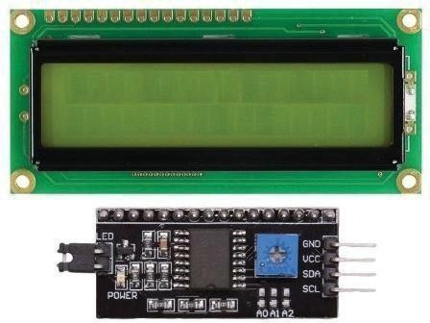

**Fig.1.NodeMCU**

## MQ-6gassensor

MQ-6 gas is used to detect Natural Gases which is a very Sensitive material. This sensor consists of SnO2 i.e the Tin oxidesensitivelayerusedtosensetheconcentrationofgases.it is very sensitive to propane, butane, and LPG gas. It works on theprincipleofchemo-resistormeanswhenitdetectsthegasits resistivity will change and current conduction varies accordingly.Theheatingcoilisconnectedinthesensorusedto burn in the sensing layer so that the efficiency and sensitivity will increase.It consists of fourpins in the module.1.VCC

1. GND 3. D0 4. A0. The function of the D0 pin is to describe the presence of gas only not the concentration. To find the presence and concentration of gas A0 pin of sensor used with NodeMCU.

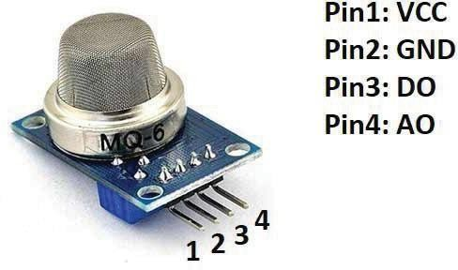

**Fig.3.MQ-6GasSensor‘**

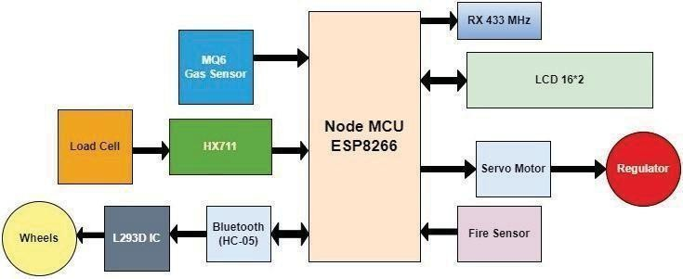

**Fig.2.BlockDiagram**

## LoadCell

Aload cellthatfallsin thecategoryofapassivetransducer converts the force into an electrical signal form. Change in electricalsignaldependsupontheappliedforceontheloadcell. if the applied force increases then the electrical signal changes accordingly.TheloadcellusedwithinpairofHX711amplifiers is shown in Fig. 4. As the signal generated by the cell is very less difficult to detect by the NodeMCU. So to increase the strength of the signal an amplifier is used in the circuit.

## E. BLYNKIoTApplication

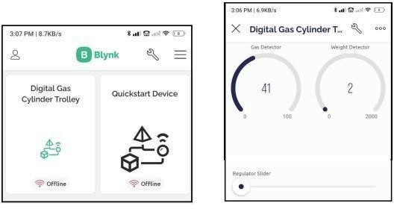Blynk is an IoT platform for iOS or Android smartphones thatareused tocontrolArduino,RaspberryPi,andNodeMCU via the Internet.” This application is used to compile and provide therequired address on the available widgets to create a graphical interface or human-machine interface (HMI)”.

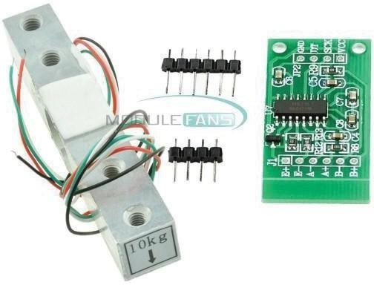**Fig.4.LoadcellandHX711amplifier**

## LCDDisplay

LCD stands for Liquid Crystal Display which is a display unit. Itsmainfunctionistoshowthe resultsonthe screen.Itis available invarious sizes, so in thispaper16*2display isused to print the outcomes. It has 16 columns and 2 rows. LCD can work in 8-bit mode and 4-bit mode. In 4-bit mode, the data is transferred through the D4-D7 pins of the display, and in 8-bit mode, data is transferred using the D0-D7 pin of the LCD. So in this process, it consumes alotofpins, to avoid this problem I2C module interfaced with LCD and Node MCU.



**Fig.5.LCDandI2Cmodule**

**Fig.6.DigitalgascylindertrolleyonBlynkApp**

## WeighingMachine

This setup will continuously monitor the weight of the cylinder. In this prototype, we used a weight machine with having load sensor of 5 Kg with the amplifier circuit HX711 usedtoenhancethestrengthofthesignalgeneratedbytheload cell. The signal generated by the load sensor is very small in naturewhichisimpossibletosendthesignaltoNodeMCU.So, we use the amplifier with a sensor and then connect it to the microcontroller.theWeighingmachineisspeciallydesignedto measure the weight of an LPG cylinder.

## VoiceControlledRegulator

The gas regulator will be controlled using a servo motor in case of an emergency. So in this research, the regulator can be controlledusingourvoicecommands.Thistargetwasachieved using IFTTT and google home applications. To turn on the Regulator command use: ”OK Google! Activate Regulator On”. Similarly, the command used to turn off the regulator is ”OKGoogle!ActivateRegulatorOff”.Thiscommandisshown in Fig.7.

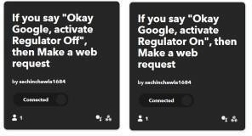

**Fig.7.Commandusedtoturnonandturnoffthe regulator**

## BLYNKIoTApplication

Blynk is an IoT platform for iOS or Android smartphones thatareusedtocontrolArduino,RaspberryPi,andNodeMCU via the Internet.” This application is used to compile and provide the required addresson the available widgets to create a graphical interface or human-machine interface (HMI)”.

## WeighingMachine

This setup will continuously monitor the weight of the cylinder. In this prototype, we used a weight machine with having load sensor of 5 Kg with the amplifier circuit HX711 usedtoenhancethestrengthofthesignalgeneratedbytheload cell. The signal generated by the load sensor is very small in naturewhichisimpossibletosendthesignaltoNodeMCU.So, we use the amplifier with a sensor and then connect it to the microcontroller.theWeighingmachineisspeciallydesignedto measure the weight of an LPG cylinder.

## VoiceControlledRegulator

The gas regulator will be controlled using a servo motor in case of an emergency. So in this research, the regulator can be controlledusingourvoicecommands.Thistargetwasachieved using IFTTT and google home applications. To turn on the Regulator command use: ”OK Google! Activate Regulator On”. Similarly, the command used to turn off the regulator is ”OKGoogle!ActivateRegulatorOff”.Thiscommandisshown in Fig.7.

## BluetoothControlledTrolley

The complete system is mounted on wheels that can move manually or it can be Bluetooth controlled. HC-05 Bluetooth shown in Fig.9 is used with NodeMCU and basically works in the 2.4 GHz band. As the cylinder is placed on the trolley it becomes heavy and not so easy to manage. So to reduce the effort this trolley can be controlled using a simple application called as BT controlled app. This app is available free of cost. The feature of this app is mentioned in Fig.10

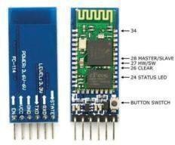

**Fig.8.HC-05BTModule**

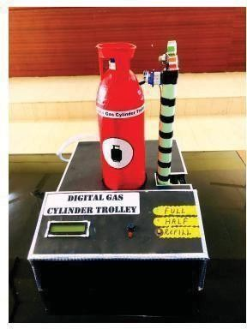

**Fig.9. Digitalgas CylinderTrolleyModel**

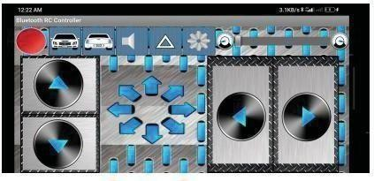

**Fig.10.BTcontrolledApp**

**3. Hardware Description**

**3.1 NodeMCU Microcontroller**

**The NodeMCU is an open-source platform equipped with an ESP8266 Wi-Fi chip. It features 16 GPIO pins and one analog pin, making it ideal for connecting multiple sensors and modules. Its in-built Wi-Fi capability allows seamless IoT integration, facilitating real-time updates and cloud communication.**

**3.2 MQ-6 Gas Sensor**

**The MQ-6 sensor detects gases like propane, butane, and LPG. It operates on a chemo-resistive principle, where its resistance changes with varying gas concentrations. The sensor provides both digital (presence) and analog (concentration) outputs, which are interpreted by the NodeMCU to trigger appropriate safety measures.**

**3.3 Load Cell and HX711 Amplifier**

**The load cell is a passive transducer that converts the mechanical force (cylinder weight) into an electrical signal. As the signal generated by the load cell is minimal, an HX711 amplifier is used to boost the signal strength before feeding it to the microcontroller. This enables accurate and real-time weight monitoring.**

**3.4 LCD Display with I2C Module**

**A 16×2 LCD display, paired with an I2C adapter, is used to present system outputs like current cylinder weight, gas leakage alerts, and refill notifications. The I2C interface reduces the number of pins required, simplifying circuit design.**

**3.5 Blynk IoT Application**

**Blynk provides a user-friendly platform for real-time monitoring and control of the LPG cylinder system. Using Blynk’s mobile app, users can view cylinder status, receive leakage notifications, and control the gas regulator remotely.**

**3.6 Bluetooth Module (HC-05)**

**The HC-05 Bluetooth module enables wireless control of the trolley's movement. Operating in the 2.4 GHz range, it pairs easily with smartphones and allows users to maneuver the heavy LPG cylinder trolley with minimal effort.**

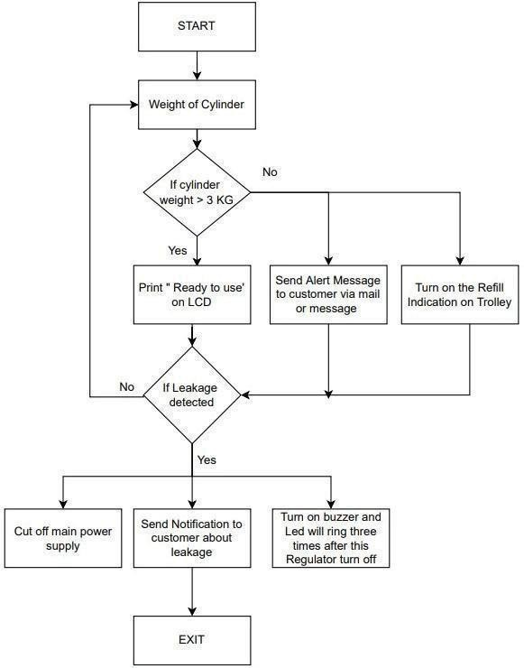**Fig.11.FlowChart**

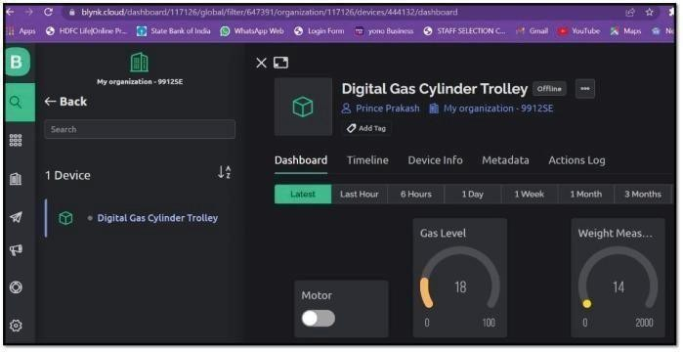

**Fig.12.Blynkcloudwebserver**

A relay is an electro-mechanical switch used to control electrical and electronic appliances. As shown in Fig. 12 BLYNKcloudservershowstwogaugesandonecontrolswitch.

One gauge is used as a gas sensor and the second is used as a weight sensor. Sensors continuously monitor and analyze the raw data andupdate iton theserver. Controlswitch used to on and off the regulatoras perthe customer’s requirement. Inany case,if customersforgottoturnoffthe regulatorthentheycan off from any location in the world.

# PRACTICALRESULT

After the completion of this model, certain facts come into observationi.echangingofvoltagewithanappliedloadonthe load cell. Changing the voltage of the gas sensor as it detects the gas and rotation of the servo motor at a certain angle with gas detection.

## loadcellvsVoltage

The load cell which is used to calculate the weight of the cylinder using the HX711 amplifier will show linear characteristicswiththeoutputvoltage.Astheweightincreases, the load cell will generate more voltage as shown in Table 1. The weight ofthecylindershownontheLCDattachedto the model and the same result will also be updated on the BLYNK cloud server. The results generated by the sensor are given in Fig.13.

## GasSensor ResistivityVsVoltage

Thegassensorisusedtomeasuretheconcentrationofgases present in the environment. Different gas sensors are available for different gases. The value of the resistor changes as the concentration of gas varies. It shows the inverse relationshipn168 between resistivity and concentration of gases. With the change of resistance, the output voltage produced by the sensor also changes.

**TABLEI. APPLIEDWEIGHTONLOADCELLVSOUTPUT**

**VOLTAGEGENERATED**

|  |  |  |
| --- | --- | --- |
| **S.No.** | **AppliedWeight** | **VoltageGenerate(mV)** |
| 1 | 1Kg | 9.6mV |
| 2 | 2Kg | 18.2mV |
| 3 | 3Kg | 26.9mv |
| 4 | 4Kg | 35.8mv |
| 5 | 5Kg | 44.9mv |

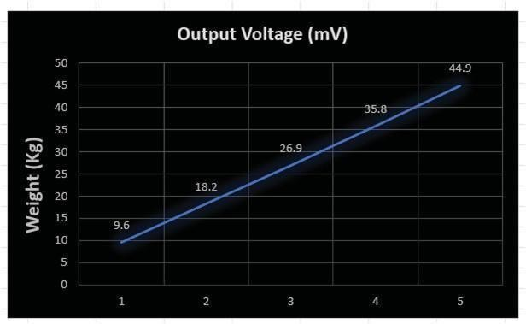

**Fig.13.AppliedweightVsOutputVoltage**

## AlertsandNotifications

Our paper mainly focuses on the alerts and notification producesinacriticalsituationtoavoidanyhazards.Customers will get the notification via e-mail. The screenshot has been attached to the Figure.

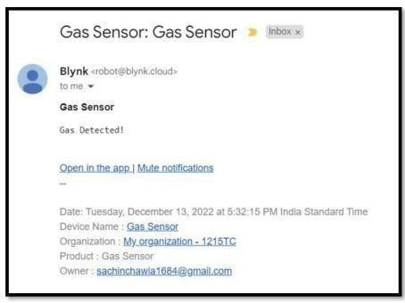

**Fig.14.GasDetectionNotificationonE-mail**

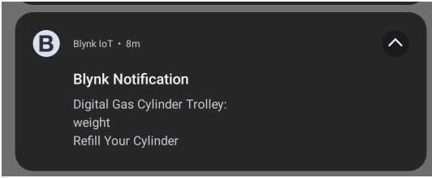

**Fig.15.NotificationonBlynkApp**

Secondly the alert notification on the LCD in case of Refilling your cylinder. Screenshot attached in Fig.15

It will notify via email or on LCD if the leakage of gas is detected.Thisresearchfocused todesignaneconomicproduct design with more safety tips. To make it more economical we use NodeMCU with WIFI capability to remove the concept of aGSMmodulewhichreducesthecostofhardware.Bluetooth- controlledtrolleyincludedforeasymovementandaccessibility using a simple BT app.

# CONCLUSION

This paper presents a smart, IoT-based LPG gas cylinder trolley designed to enhance safety and convenience. It effectively detects gas leaks, monitors cylinder weight, and allows voice-controlled operation of the regulator. The system is affordable, easy to use, and ensures timely alerts to prevent hazards, making it ideal for modern households.

* 1. **ACKNOWLEDGMENT**

AuthorsareverygratefulandthankfultotheDirector,Principal andOrganizationoftheKKRandKSRInstituteofTechnology andSciences,Gunturfortheirinspirationalsupporttocarryout this paper work.

* 1. **REFERENCES**

1. L.Fraiwan,K.Lweesy,A.Bani-Salma,andN.Mani,“AWirelessHomeSafety Gas Leakage Detection System”,” in Proceeding of FirstMiddleEast Conference on Biomedical Engineering, 2011, pp. 11–14.
2. Rajitha and T. Swapna, “Security alert system using GSM for gasleakage”, International Journal of VLSI and Embedded Systems- IJVES,Vol.03, Issue 04, pp.173-175, 2012.
3. S.SivajothiKavithaandS.Senthilkumar,“AWirelessGasLeakage andLevel Detection with Refilling Renewal System,” InternationalJournalof Advanced Research in Electrical, Electronics and InstrumentationEngineering, vol. 4, pp. 2095–2100, 2015.
4. K.Keshamoni and S. Hemanth, “Smart Gas Level Monitoring, Bookingand Gas Leakage Detector Over IoT,” in 2017 IEEE 7th InternationalAdvance Computing Conference (IACC), 2017.
5. V. Gabriel, M. Da Silva Medeiros, A. Santos, and C. Edmilson, “Smart- Gas: Asmartplatform for cooking gas monitoring,” IEEE First SummerSchool on Smart Cities, pp. 97–102, 2017.
6. Shraddha Suresh Tanksale, Prof. A.S. Mali and Dr. B.T. Salokhe,“Automated Unified Trolley System for LPG Leakage Detection withSafety Measures and Refill Booking”. International Journal ofEngineering and Management Research, Volume-8, Issue-3, June 2018,pp:224-228.
7. Srivastava,A.K.,Thakur,S.,Kumar,A.,Raj,A.(2019).IoT- BasedLPGCylinder Monitoring System. 2019 IEEE International Symposium onSmart Electronic Systems (iSES),2019
8. S. Shrestha, V. P. K. Anne, and R. Chaitanya, “IoT Based Smart GasManagement System,” in 2019 3rd International Conference on Trendsin Electronics and Informatics (ICOEI), 2019.
9. ZawLin Oo, Theint WinLai, AungMoe,“IoT Based Low-cost PhysicalProtection and Alarm System for Gamma Irradiation Facility”.ConferenceonScienceandTechnologyDevelopment(CSTD- 2019), Oct31- Nov 1, 2019.
10. Zaw Lin Oo, Theint Win Lai, Aung Moe, “IoT Based LPG Gas LevelDetection Gas Leakage Accident Prevention with Alert System,” inBalkan Journal ofElectrical Computer Engineering,Vol.9, No.4,2021.

.