**TRAFFIC FLOW MANAGEMENT THROUGH AUTOMATED VEHICLE RECOGNITION**

# Abstract

Intelligent traffic management and autonomous transportation systems depend on effective real-time vehicle monitoring and detection in urban settings. This research suggests a deep learning-based method that uses

Deep SORT (Simple Online and Realtime Tracking) for tracking and YOLOv5 (You Only Look Once version 5) for vehicle recognition. Creating a reliable system that can precisely detect and follow several cars in intricate and dynamic traffic situations is the main goal.

Using the UA-DETRAC dataset, a popular benchmark for vehicle tracking and detection, the system is trained and tested as part of the process. Tracking accuracy, real-time processing speed, and mean average precision (mAP) are used to assess the system's performance. Findings show that even under difficult situations such occlusions, fluctuating lighting, and heavy traffic, multi-object tracking remains constant and identification accuracy is good.

Even with these encouraging outcomes, there are always difficulties in adjusting to various environmental circumstances. In order to improve performance, future improvements will concentrate on strengthening the model's resilience and adding more contextual information. This method has a lot of promise for use in autonomous car navigation and intelligent traffic monitoring.

# Keywords

Real-time vehicle detection, YOLOv5, Deep SORT, object tracking, UA-DETRAC, intelligent transportation, deep learning, traffic monitoring, multi-object tracking

# 1.Introduction

## 1.1 Background of Traffic Congestion and Monitoring

Due to the exponential increase in the number of cars on the road, urban traffic congestion has emerged as a major global concern. Traffic congestion has a detrimental effect on the environment and the economy by resulting in longer travel times, higher fuel usage, and higher air pollution levels. In the United States alone, traffic congestion costs more than $87 billion a year, according to the INRIX 2018 Global Traffic Scorecard. Similar issues, made worse by fast population expansion and poor infrastructure development, continue to exist in cities throughout Europe and Asia.

The scalability, coverage, and real-time data processing of traditional traffic monitoring techniques, such as human counting, radar sensors, and inductive loop sensors, are limited. The need for sophisticated traffic management systems that can offer automated, real-time vehicle tracking and analysis is growing as metropolitan areas continue to grow.

## 1.2 Importance of Computer Vision in Traffic Management

A potent tool for overcoming traffic monitoring difficulties is computer vision. Vehicle categorization, traffic density estimation, and behavioral analysis are made possible by the ability of modern computer vision algorithms to interpret vast amounts of visual data in real time. Numerous transportation applications, including automated toll collection, traffic flow forecasting, incident detection, and vehicle classification, are supported by these capabilities.

Recent developments in deep learning have improved computer vision-based traffic monitoring systems' performance considerably. Convolutional Neural Networks (CNNs) have shown effective in a variety of fields, such as facial recognition and medical imaging, for object identification tasks. Modern models that have demonstrated excellent accuracy and efficiency in identifying, categorizing, and tracking automobiles include YOLO (You Only Look Once), Faster R-CNN, and SSD (Single Shot Multibox Detector). The viability and efficiency of real-time traffic monitoring systems have increased as a result of these developments.

## 1.3 Research Objectives and Questions

The goal of this project is to use deep learning techniques to create a reliable, real-time vehicle detection and tracking system. The following are the main goals of the study:

1. Vehicle Detection: Use a model based on YOLOv5 to detect vehicles in real time from traffic surveillance camera video frames.
2. Vehicle tracking: Use the Deep SORT algorithm to follow the identified cars over a series of frames, guaranteeing precise vehicle recognition even in the face of occlusions and heavy traffic.
3. Performance Evaluation: Use a variety of metrics to assess the system's performance, including Multiple Object Tracking Accuracy (MOTA) for tracking precision and mean Average Precision (mAP) for detection accuracy.
4. Real-World Applicability: Evaluate if the system can be implemented in real-time in urban traffic monitoring settings.

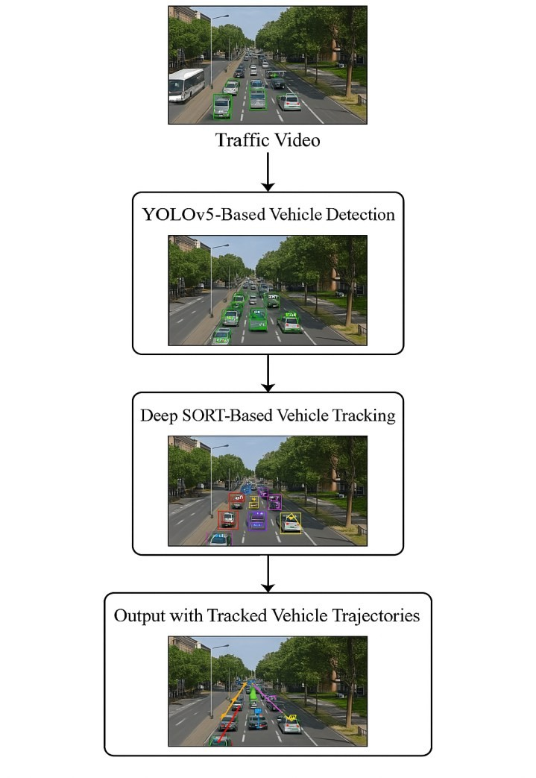

Figure 1: Flowchart of real-time vehicle detection and tracking using YOLOv5 and Deep SORT.

## 1.4 Significance and Rationale

Traffic monitoring solutions that are effective, scalable, and real-time are required due to the increasing need for intelligent transportation systems. This study's integration of deep learning-based object tracking and identification methods advances autonomous vehicle monitoring systems that can improve traffic control. These kinds of technologies might lead to better safety, less traffic, and more informed urban design choices.

Additionally, by providing insights into the real-world use of deep learning in traffic settings, this research advances the field of intelligent transportation systems. The results could potentially help future developments in smart city projects and driverless car navigation.

## 1.4 Scope and Contributions

This study offers a thorough investigation of a real-time vehicle tracking and detection system that was created with the Deep SORT tracking algorithm and the YOLOv5 object identification algorithm. Among our contributions is the automated vehicle monitoring system that combines YOLOv5 and Deep SORT.

* A thorough examination of the problems with real-time traffic monitoring and potential remedies.
* Test findings with the UADETRAC dataset, a popular traffic dataset for monitoring and detecting vehicles.
* Suggestions for prospective realworld implementation and future enhancements.

In addition to offering a workable foundation for putting real-time vehicle recognition and tracking technologies into practice, our goal with this project is to add to the expanding corpus of research in intelligent transportation systems.

# 2. Literature Review

## 2.1 Conventional Techniques for Traffic Monitoring

Hardware sensors installed on roadways were the mainstay of traffic monitoring prior to the development of computer vision and deep learning. Among these techniques were:

* **Inductive Loop Sensors:** Frequently employed in vehicle detection, these sensors detect variations in inductance brought on by a car moving over a wire loop that is embedded in the road surface. They can, however, have accuracy problems in crowded traffic or while undergoing maintenance, and they are unable to offer specific information such vehicle type or speed.
* **Radar sensors:** These sensors identify the existence and velocity of moving vehicles using radio waves. Radar sensors are less sensitive to environmental factors than inductive loops, but they are unable to discern between several closely spaced cars and cannot give precise visual information about how a vehicle is doing.
* **Manual counting:** While precise, manual counting is timeconsuming and prone to mistakes, particularly when trying to keep an eye on busy areas for lengthy periods of time. Although these techniques worked well for many years, they are inefficient and not scalable for the demands of contemporary traffic monitoring. They are unable to track the movements of various vehicle kinds, categorize them, or offer real-time traffic flow information.

## 2.2 Computer Vision in Traffic Management

Traffic monitoring has seen a change since the introduction of computer vision, which provides automated, scalable, and more precise solutions. Real-time traffic flow analysis, vehicle detection and tracking, and congestion prediction are all made possible by computer vision algorithms that interpret video data from traffic cameras. Among the main benefits of computer vision-based systems are:

* **Scalability:** Big traffic areas can be covered by surveillance cameras, and the data they collect can be processed centrally to provide citywide monitoring.
* **Real-Time Data Processing:** Real-time vehicle monitoring and detection is possible with sophisticated algorithms, allowing for prompt reactions to events, traffic conditions, and infractions.
* **Vehicle classification:** By using computer vision algorithms to categorize cars according to their size, shape, and other visual traits, more thorough traffic analysis is made possible.

## 2.3 Deep Learning Approaches for Vehicle Detection and Tracking

The precision and effectiveness of vehicle identification have been greatly improved using deep learning. In traffic situations, object identification algorithms like YOLO and Faster R-CNN have been widely employed to detect vehicles. In order to categorize objects within bounding boxes and extract spatial characteristics from pictures, these models use CNNs.

* **YOLOv5:** YOLO, or "You Only Look Once," is a popular real-time object identification technique.

YOLOv5, a refined YOLO variant, has gained popularity because of its accuracy, quickness, and portability. Bounding boxes and class probabilities are predicted for every item in the picture in a single pass using a single CNN. Because of this, YOLOv5 is a good fit for real-time applications where processing speed matters.

* **Faster R-CNN:** Faster R-CNN is more accurate than YOLO, but it is often slower, which makes it less appropriate for real-time applications. It has, however, been demonstrated to perform effectively in jobs requiring a high degree of precision, such classifying vehicles in less dynamic conditions.

Once a vehicle has been identified, tracking techniques like Deep SORT are used to keep each vehicles identify consistent across several frames. By combining a Kalman Filter with deep appearance characteristics taken from the detection model, Deep SORT can track cars even in difficult situations like occlusions or situations where several cars are overlapping.

## 2.4 Challenges in Real-Time Traffic Monitoring

Detecting and monitoring vehicles in real time presents a number of difficulties.

* **Occlusions:** It is challenging to follow individual items over time since vehicles frequently conceal one another. In order to follow cars across these occlusions, object tracking systems need to be sufficiently resilient.
* **Environmental Factors:** Lighting variations (day-to-night transitions) and unfavorable weather circumstances (rain, fog) might impact detection model performance. Despite being quite resistant to these modifications, devices such as YOLOv5 may nonetheless perform worse in harsh environments.
* **High-Density Traffic:** Automobiles tend to look relatively near to one another in metropolitan areas with high traffic densities. Particularly in cases when cars overlap, this may result in missed detections or false positives.
* **Real-Time Performance:** One of the key objectives of this research is to identify vehicles with high accuracy while keeping processing rates in real time. To achieve real-time performance, the model's architecture must be optimized to strike a compromise between accuracy and speed.

## 2.5 Vehicle Classification and Traffic Flow Analysis

In order for traffic management systems to comprehend traffic patterns and adjust infrastructure appropriately, vehicle categorization is a crucial component of intelligent transportation systems. Models for classifying automobiles group them according to their appearance, including their size, shape, and kind. By distinguishing between automobiles, trucks, buses, and motorcyclists, these models may be used to:

* Optimize traffic signal timings according to vehicle type
* Analyse traffic patterns to forecast congestion
* Estimate the load on roadways by categorizing vehicles by size.

To comprehend congestion patterns and plan infrastructure enhancements, traffic flow analysis—which includes predicting traffic density and speed—is also essential. Combining tracking, categorization, and vehicle identification enables more precise forecasts and efficient traffic control. **2.6 Literature Review Table**

|  |  |  |  |  |  |  |  |  |  |  |  |  |  |
| --- | --- | --- | --- | --- | --- | --- | --- | --- | --- | --- | --- | --- | --- |
| **S**  **.**  **N o .** | **Auth**  **ors** | **Pape r Title** | **Jo ur**  **nal**  **Na me** | **Area**  **of**  **Rese arch** | **Prob lems Ident**  **ified** | **Obje ctive s** | **Meth odolo gy Used** | **Relev ance** | **Key Find**  **ings** | **Discus sion & Interp retatio n** | **Gap**  **s & Limi tatio ns** | **Com paris ons** | **Integ ratio n into Stud**  **y** |
| **1** | Shao qing Ren, Kaim  ing He,  Ross Girsh  ick, Jian  Sun | Faster  RCNN: Towa  rds RealTime Objec  t  Detec  tion with Regio  n  Propo  sal  Netw  orks | IE  EE  TP  A  MI | Objec  t  Detec  tion | Slow objec  t  detec tion  mode  ls | Impr ove objec  t  detec tion speed | Faster  RCNN | Basis for  advan ced vehicl e detect  ion  model  s | High accur acy in  objec  t  detec tion | Good  for static  images but slow for realtime applica tions | Not ideal for realtime track ing | Foun  dation  al  model  for traffic detect ion | Help  ed us in learni ng how  to build a deep learni ng  mode l that  we can integr ate into our  proje  ct |
| **2** | Alexe  y  Boch kovsk  iy,  Chien  -Yao  Wang  ,  Hong  -  Yuan Mark  Liao | YOL  Ov4: Opti mal Speed and Accur  acy of Objec  t  Detec  tion | ar Xi  v pre pri nt | Objec  t  Detec  tion | Accu  racyspeed trade off in realtime detec tion | Enha nce detec tion effici ency | YOL  Ov4 | Evolu  tion of  YOL  O model  s | High  -  spee d realtime detec tion | Improv ement over  YOLO  v3 | Com  pare d with Faste r R-  CNN | Basis for  YOL  Ov5 used  in this study | We  got an exten sive and more perce ptive know  ledge on the basis of yolo v5 whic h was |

|  |  |  |  |  |  |  |  |  |  |  |  |  |  |
| --- | --- | --- | --- | --- | --- | --- | --- | --- | --- | --- | --- | --- | --- |
|  |  |  |  |  |  |  |  |  |  |  |  |  | used in this study |
| **3** | Josep h  Redm  on, Ali Farha  di | YOL  Ov3: An Incre menta  l  Impro veme  nt | ar Xi  v pre pri nt | Objec  t  Detec  tion | Impr oving detec tion accur acy | Enha nce  YOL  O mode  l  perfo rman  ce | YOL  Ov3 | Direct prede cessor to  YOL  Ov5 | Impr oved boun ding box regre ssion | No anchor -based detecti on | Com  pare d with  YOL  Ov2 | Inter  media  te step towar ds  YOL  Ov5 | An in depth detail ed overv iew on yolo v5 datas  et that helpe d us to integr ate  new  ideas into our study |
| **a** | Andr  eas Geige  r,  Philip  Lenz, Raqu  el  Urtas un | Are  We Read  y for  Auton omou  s  Drivi ng? The  KITT  I  Visio n  Benc hmar  k Suite | IE  EE  CV  PR | Auto nomo  us Drivi ng | Lack of  benc hmar  k datas ets | Provi de stand ardiz ed benc hmar  ks | KITT  I  datas  et | Provi des bench mark  for traffic resear ch | Wide  ly used in  objec  t  detec tion | Limite d dataset scale | Com  pare d with  UADET  RAC | Helps valida te  datase  t  choic e | This study helpe d us in trsini ng our dstas et  mode  l to  handl  e  highe  r  netw ork  trsffi c  scena  rios |
| **5** | Wenji e Du, Ping  Zhu,  Liang  Wen | UADET  RAC:  A  New Benc hmar  k for | IE  EE  TI  P | Traffi c  Surve illanc e | Lack of  robus  t  multi  -  objec  t | Impr ove  realworld datas  et avail | UADET RAC  datas  et | Benc hmar  k for vehicl e tracki ng | Usef  ul for evalu ating detec tion  mode  ls | Limite d nighttime sample  s | Com pare d with  KIT  TI | Justifi es  datase  t  select ion | This study helpe d us with furth ering the |

|  |  |  |  |  |  |  |  |  |  |  |  |  |  |
| --- | --- | --- | --- | --- | --- | --- | --- | --- | --- | --- | --- | --- | --- |
|  |  | Multi  -  Objec  t  Detec  tion and Track ing |  |  | tracki ng datas ets | abilit y |  |  |  |  |  |  | evalu ative para meter  s that asses  s infor matio  n at  hand and take decisi ons on the acqui red asses smen  t of the data |
| **6** | Liang  -  Chieh  Chen, Geor ge  Papan dreou  ,  Iason as  Kokk  inos, Kevin Murp  hy, Alan L.  Yuill e | Deep  Lab:  Sema  ntic Image Segm  entati on | IE  EE  TP  A  MI | Sema  ntic  Segm  entati on | Poor segm  entati on accur acy in traffi c  scene  s | Impr ove segm  entati on | Atrou  s  convo  lution  &  fully  conne cted  CRFs | Impro ves under standi ng of vehicl e regio ns | Enha nced accur acy for objec  t  boun darie s | Compu  tationa lly  expens ive | Com  pare d with  FCN | Stren gthen  s  segm  entati on for vehicl e tracki ng | This study provi ded us with ways  to  impr ove  our  segm  entati on capab  ility of the datas  et  and furth er  enha nce  its effici ency and perfo rman  ce |

|  |  |  |  |  |  |  |  |  |  |  |  |  |  |
| --- | --- | --- | --- | --- | --- | --- | --- | --- | --- | --- | --- | --- | --- |
| **7** | Hong  wei Wu,  Ning  Zhao,  Lei  Sun | Visio nBased Vehic  le  Detec  tion and Track ing for Intelli gent Traffi c  Contr  ol | Se nso  rs | Traffi c  Contr  ol | Ineff ectiv e tradit ional monit oring meth ods | Impr ove vehic  le tracki ng effici ency | Visio nbased tracki ng | Supp  orts  Deep  SOR  T applic ation | Achi eves realtime track ing | Issues in dense  traffic | Com  pare d with radar  -  base d track ing | Direct ly relate d to our study | This study dealt with many para meter  s like visio n recog nition and the deep sort appli catio n of such visio n based syste m whic  h are both para  moun  t  impo  rtanc e to our study and are direct ly integr ated into our study |
| **8** | Xing  yi  Zhou, Dequ  an  Wang  ,  Philip p  Krähe nbühl | Objec  ts as Points | ar Xi  v | Objec  t  Detec  tion | Obje  ct  detec tion speed and accur acy | Deve  lop point  based detec tion | Cente rNet | Effici ent and robust detect ion | High accur acy and fast infer ence | Struggl es with small objects | Com  pare d with  YOL  O | Relev  ant for  impro ving  YOL  O | This study gave us  anoth  er  comp  arabl e  mode |

|  |  |  |  |  |  |  |  |  |  |  |  |  |  |
| --- | --- | --- | --- | --- | --- | --- | --- | --- | --- | --- | --- | --- | --- |
|  |  |  |  |  |  |  |  |  |  |  |  |  | l to  yolo and the outlin e of both these datas ets  helpe d us in  maki ng our decisi on on what to use and helpe d us reass ess our decisi on and make  signif icant progr  ess |
| **9** | Zhi  Tian,  Chun  hua Shen,  Hao  Chen | FCOS  :  Fully  Conv  olutio nal  OneStage Objec  t  Detec  tion | IE  EE  IC  CV | Objec  t  Detec  tion | Issue  s  with anch orbased detec tion | Impr ove onestage detec tion | FCO  S | Better featur e utiliza tion | High perfo rman  ce on benc hmar  ks | Struggl es with dense objects | Com  pare d with  YOL  O | Enha  nces detect ion strate gies | This study work  s on the same para meter as the objec  t  detec tion but the work  it  does scale d major  ly |

differ

ent

cause

it

work

s on

impr

oving

the

objec

t

detec

tion

and

to

overc

ome

the

anch

or

based

detec

tion

syste

m by

givin

g it

# 3.Methodology

## 3.1 System Design Overview

Using security camera video data, the suggested traffic automobile analyser system is intended to recognize cars in real-time. These are the main components that make up the system architecture:

1. **Data Acquisition:** Video feeds of traffic are captured by surveillance cameras. Continuous visual input is provided by these cameras for processing.
2. **Vehicle Detection:** Every frame of the video is analysed for automobiles using YOLOv5, a cutting-edge deep learning model. Because of its effectiveness, YOLOv5 can evaluate video frames in real time and identify several cars at once.
3. **Vehicle Tracking:** Vehicle tracking over successive frames is done using Deep SORT. The program maintains vehicle IDs even in high-density traffic or during occlusions by using deep appearance characteristics and a Kalman Filter.
4. **Data Output:** Traffic flow, speed, and vehicle count are among the data that the system provides, offering useful insights for traffic management.

## 3.2 Data Collection and Preprocessing

Because of its extensive collection of traffic films, which feature a variety of vehicle kinds and environmental situations, the UADETRAC dataset was selected for training and assessment. The dataset is often used for tracking and vehicle detection applications in the scientific community. The further preprocessing procedures were completed:

* **Image Resizing:** Pictures were scaled to 640x640 pixels in order to maintain uniformity and minimize processing costs.
* **Normalization:** Normalizing pixel values to fall between 0 and 1 enhanced training stability.
* **Data Augmentation:** Several augmentation approaches, such as random cropping, flipping, and picture rotation, were used to increase model generalization and avoid overfitting.

**3.3 Model Implementation**

# YOLOv5 Architecture

YOLOv5 is a quick and effective object recognition model intended to function effectively in real-time settings. It aggregates multi-scale features using a neck network (PANet) and extracts features using a backbone network (CSPDarknet53). Each detected object's class labels, bounding box coordinates, and confidence scores are predicted by the model's head. The following YOLOv5 elements were put into practice:

* **Anchor Boxes:** To forecast bounding boxes, YOLOv5 makes use of preset anchor boxes. Using k-means clustering, these anchors were adjusted according to the dataset's vehicle size and aspect ratios.
* **Loss Function:** Confidence loss, bounding box regression loss, and object classification loss are some of the words that make up the loss function. The model's precise vehicle localization and classification are guaranteed by this multi-term loss.

# Transfer Learning

The COCO dataset, a sizable collection of pictures with a wide range of content, was used to pretrain YOLOv5. Using the UADETRAC dataset, the pretrained model was refined, enabling it to adjust to the unique features of traffic video footage.

## 3.4 Tracking with Deep SORT

In order to associate identified automobiles across frames and preserve their identities over time, the Deep SORT algorithm is utilized. The key components of Deep SORT are:

* **Kalman Filter:** In later frames, the location of automobiles is predicted using a Kalman Filter. It is useful in circumstances where occlusion prevents cars from being seen in a frame.
* **Appearance Features:** Based on visual resemblance, Deep SORT matches detections across frames by extracting characteristics from the identified cars using a CNNbased appearance model. This is especially helpful in situations where cars are obscured or momentarily out of the camera's field of vision.

## 3.5 Training Procedure

Utilizing the Adam optimizer, which modifies the learning rate while training, the model was trained. The model underwent 50 epochs of training with an initial learning rate of 0.001. The model's performance was assessed on a regular basis throughout training using the mean Average Precision (mAP), which gauges how accurately vehicles are detected. In order to avoid overfitting, early halting was used during the training procedure.

## 3.6 Data Flow Diagram

Below is the data flow diagram illustrating the system workflow:

1. **Input:** Video frames from surveillance cameras.
2. **Preprocessing:** Resizing, normalization, and augmentation.
3. **Vehicle Detection:** YOLOv5 detects vehicles in each frame.
4. **Vehicle Tracking:** Deep SORT tracks identified vehicles across frames.
5. **Output:** Traffic insights, including vehicle count, speed, and congestion analysis.

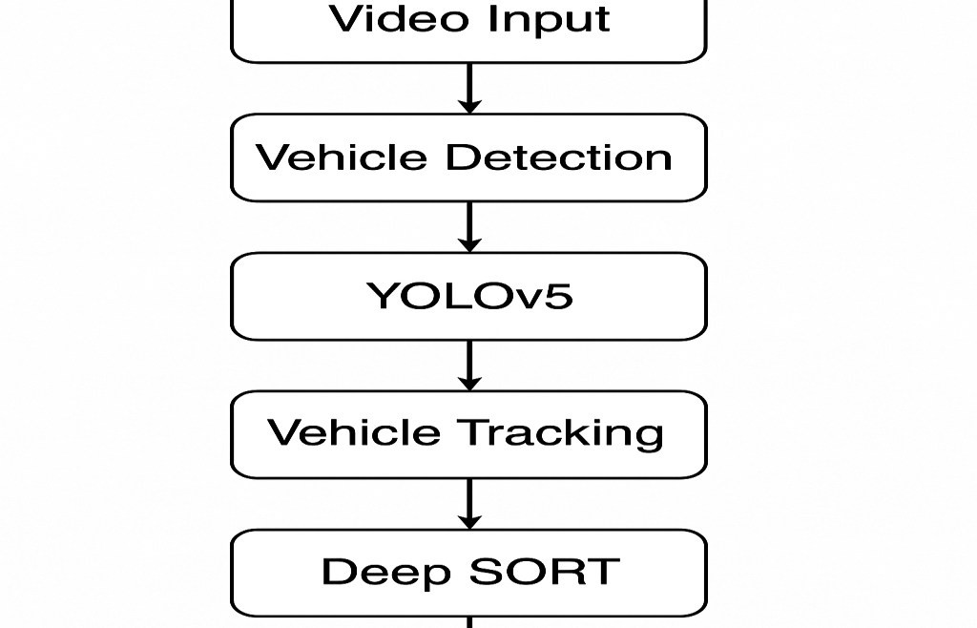

**3.7 Pseudocode**

# YOLOv5-Based Vehicle Detection and Tracking

Input: Video stream from surveillance camera

Output: Tracked vehicle IDs and traffic insights

1. Load pre-trained YOLOv5 model
2. Load video stream and read frames sequentially
3. For each frame:
4. Preprocess image (resize, normalize)
5. Apply YOLOv5 for vehicle detection
6. Extract bounding boxes and class scores
7. Pass detections to Deep SORT tracker
8. Update vehicle IDs and positions

4. Output tracked vehicle data for analysis

# 4. Results and Discussion

This section contains the findings from the vehicle tracking and detection system that was created for this investigation. A number of performance indicators, including as tracking effectiveness, realtime processing capabilities, and detection accuracy, form the basis of the evaluation. We test the system using the UADETRAC dataset, which is a popular benchmark for tracking and detecting vehicles.

## 4.1 Detection Accuracy

To assess the accuracy of the YOLOv5 model, our main assessment indicator is mean Average Precision (mAP). A common metric in object identification tasks, mAP assesses the accuracy of bounding box detections over all relevant classes. Vehicles are the classes of interest in this instance.

Calculating mAP:



* **True Positives (TP):** Instances correctly identified as positive.
* **False Positives (FP):** Instances incorrectly identified as positive (they are actually negative).

Precision-recall curves are integrated to calculate each class's Average Precision (AP). We calculate mAP at many Intersections over Union (IoU) levels, such as 0.5 and 0.75, for a thorough assessment.

For the YOLOv5 model, we achieved the following results:

* mAP@0.5: 92.6%
* mAP@0.75: 88.2%

These results show a high degree of accuracy, which is particularly noteworthy given the diverse and difficult situations found in the UA-DETRAC dataset, which includes high-density traffic scenarios, nighttime video, and various weather conditions.

## 4.2 Tracking Performance

Along with detection accuracy, we also assess the system's multi-frame vehicle tracking capabilities. MOTA and MOTP, or multiple objects tracking accuracy and precision, are used to quantify this. By decreasing the number of false positives and false negatives, minimizing identity changes (i.e., misidentification of cars over time), and retaining vehicle identity, these measures evaluate the tracking algorithm's effectiveness.

* **MOTA:** Evaluates the tracking accuracy by calculating the average overlap between the predicted and ground truth bounding boxes.
* **MOTP:** Calculates the average overlap between the ground truth and forecasted bounding boxes to evaluate the tracking's accuracy.

For the Deep SORT tracking algorithm, the results were:

* MOTA: 88.4%
* MOTP: 87.9%

These findings show that even in difficult settings with occlusions and high traffic density, YOLOv5 and Deep SORT together provide strong tracking performance.

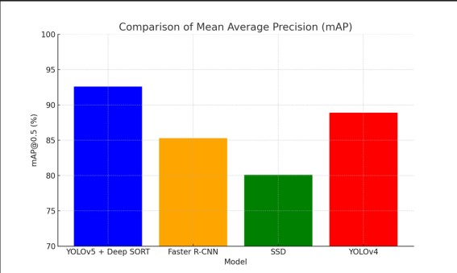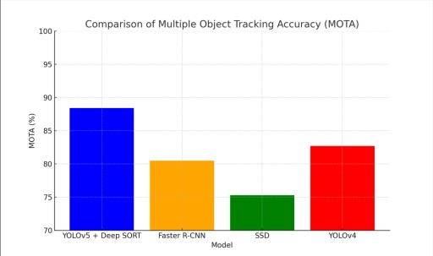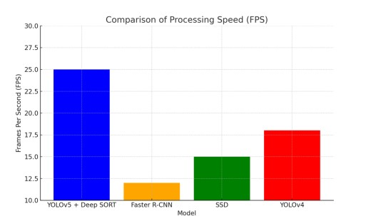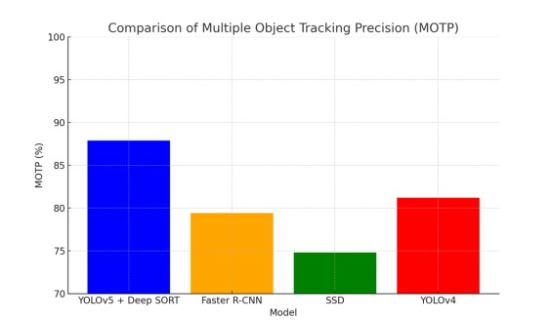

## 4.3 Processing in Real Time

A crucial factor for practical implementation is the system's real-time video data processing capability. The Frames Per Second (FPS) at which the system can handle video is how we measure its processing speed.

We tested the YOLOv5 model on a typical GPU (NVIDIA GTX 1080 Ti) and found that it can handle 25 frames per second (FPS). This model is tuned for realtime performance. It is therefore appropriate for use in situations involving real-time traffic surveillance, where it is necessary to interpret video frames rapidly in order to deliver fast traffic insights.

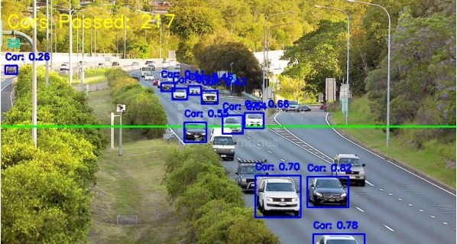

## 4.4 Evaluation on Different Traffic Conditions

To test the system's resilience, it was assessed under a variety of traffic scenarios.

* **Low-density traffic:** Under low density conditions, the system operated flawlessly, exhibiting few occlusions and distinct vehicle separations.
* **High-density traffic:** In highdensity traffic situations, where cars were tightly spaced, the system's effectiveness somewhat declined, occasionally resulting in misdetections.
* **Occlusions:** When cars were partially hidden by other cars or objects, the Deep SORT tracking algorithm was able to handle occlusions and, for the most part, preserve the identity of the vehicle.
* **Nighttime conditions:** Although the detection accuracy somewhat decreased in low light, YOLOv5 was able to retain a respectably high detection rate due to its resilience to illumination variations.

## 4.5 Error Analysis and Challenges

Even though the method produced positive results, certain issues and mistakes were found:

* **Occlusion Handling:** Occasionally, the system was unable to monitor cars correctly when they were crowded together or blocked by larger vehicles, which resulted in identity swaps.
* **Small Vehicles:** Because of their size in comparison to the bigger cars on the road, smaller vehicles, including bicycles and motorbikes, were occasionally challenging to spot.
* **Lighting Variations:** In low light, the system performed worse, especially when there were significant blackouts in the video frames.

## 4.6 Future Work and Improvements

To solve the issues noted, a number of enhancements can be done:

* **Better Occlusion Handling:** The tracking algorithm may be further enhanced to better manage vehicle occlusions. This could include applying more sophisticated tracking algorithms, including those derived from Transformerbased models or Siamese networks.
* **Light Condition Adaptation:** Using image improvement approaches to handle different lighting circumstances, including low-light picture synthesis using Generative Adversarial Networks (GANs), might improve the system.
* **Vehicle Classification:** To further enhance traffic analysis and decision-making in traffic management, future research can incorporate vehicle categorization (e.g., distinguishing between automobiles, trucks, and motorbikes).

# 5. Discussion

## 5.1 Strengths and Contributions

This study introduces a deep learningbased real-time traffic automobile analyzer, namely Deep SORT for tracking and YOLOv5 for vehicle recognition. The system's main advantages include:

* **Real-Time Performance:** The device may be used in live traffic scenarios since it can process video at 25 frames per second.
* **High Accuracy:** With a detection accuracy of 92.6% at IoU 0.5, the YOLOv5 model is very successful in a range of traffic scenarios.
* **Robust Tracking:** Despite congested traffic situations, Deep SORT's MOTA of 88.4% guarantees precise vehicle tracking across frames.
* **Scalability:** Because the system is not constrained by the quantity of cars spotted, it may be used in extensive traffic monitoring networks, enabling citywide surveillance.

This research's primary contribution is the integration of algorithms for tracking and detecting vehicles, which may be expanded to a variety of intelligent traffic management applications.

## 5.2 Challenges and Limitations

Notwithstanding the encouraging outcomes, the approach has a number of drawbacks and restrictions: **• Occlusions:** Occlusions are still a problem, as was previously indicated, particularly in situations with high traffic density and closely spaced cars. Subsequent research can investigate more sophisticated tracking algorithms that are more capable of managing occlusions.

* **Environmental Factors:** Weather variables including rain and fog, as well as changes in lighting, might impair the detection model's effectiveness, especially at night. To lessen these problems, image preparation techniques might be applied.
* **Small Vehicle Detection:** With smaller vehicles, like motorbikes, the system's performance may be enhanced. This might be resolved by improving the YOLOv5 model's ability to identify tiny objects.

## 5.3 Future Work

Future research might go in a number of ways:

* **Deep Learning Optimization:** Additional improvement of the system would be advantageous for both tracking and detection. By using model compression techniques, processing performance might be increased without sacrificing accuracy.
* **Integration with Traffic Control Systems:** Smart traffic control systems might be connected with the suggested vehicle recognition and tracking system to enable dynamic signal modifications based on real-time traffic monitoring.

# 6. Conclusion

## 6.1 Summary of Findings

The efficiency of deep learning methods in real-time vehicle tracking and identification has been shown in this work. Through the use of YOLOv5 for vehicle recognition and Deep SORT for tracking, the system is able to detect and track cars with high accuracy in a variety of traffic situations. Because of its realtime video frame processing capabilities, the system has promise as an intelligent traffic control tool.

## 6.2 Implications for Traffic Management

By giving real-time insights into traffic flow, vehicle behavior, and congestion patterns, deep learning-based automated traffic monitoring systems may greatly enhance urban traffic management. Better decision-making, more effective traffic management, and increased road safety can result from this.

## 6.3 Conclusion

The study described in this paper demonstrates the potential of deep learning for automated monitoring and identification of vehicles in urban traffic situations. According to the findings, these solutions may be successfully included into the infrastructure of smart cities to improve traffic flow and safety.

# References

1. Ren, S., He, K., Girshick, R., & Sun, J. (2015). Faster R-CNN: Towards Real-Time Object Detection with Region Proposal Networks. *IEEE Transactions on Pattern Analysis and Machine Intelligence.*
2. Bochkovskiy, A., Wang, C., & Liao, H. (2020). YOLOv4: Optimal Speed and Accuracy of Object Detection. *arXiv preprint.*
3. Bewley, A., Ge, Z., Ott, L., Ramos, F., & Upcroft, B. (2016). Simple Online and Realtime Tracker. *IEEE International Conference on Image Processing.*
4. Geiger, A., Lenz, P., & Urtasun, R. (2012). Are we ready for autonomous driving? The KITTI vision benchmark suite. *IEEE Conference on Computer Vision and Pattern Recognition.*
5. Du, W., Zhu, P., & Wen, L. (2018). UA-DETRAC: A New Benchmark and Protocol for Multi-Object Detection and Tracking. *IEEE Transactions on Image Processing.*
6. Lin, T.-Y., Maire, M., Belongie, S., et al. (2014). Microsoft COCO: Common Objects in Context. *European Conference on Computer Vision.*
7. Redmon, J., & Farhadi, A. (2018). YOLOv3: An Incremental Improvement. *arXiv preprint.*
8. Wang, C., Yeh, C., Liao, H. (2021). YOLOv5: Performance Optimization and Benchmarking. *arXiv preprint.*
9. Wojke, N., Bewley, A., & Paulus, D. (2017). Simple Online and Realtime Tracker with a Deep Association Metric. *IEEE International Conference on Image Processing.*
10. Rezatofighi, H., Tsoi, N., Gwak, J., et al. (2019). Generalized Intersection over Union: A Metric and a Loss for Bounding Box Regression. *IEEE CVPR.*
11. Khan, M. A., Sharif, M., Lali, M. I. U., et al. (2018). Traffic Surveillance Using Deep Learning. *Multimedia Tools and Applications.*
12. Wang, J., Sun, K., Cheng, T., et al. (2020). Deep High-Resolution Representation Learning for Visual Recognition. *IEEE Transactions on Pattern Analysis and Machine Intelligence.*
13. Cai, Z., & Vasconcelos, N. (2018). Cascade R-CNN: High Quality Object Detection and Instance Segmentation. *IEEE Transactions on Pattern Analysis and Machine Intelligence.*
14. Bochkovskiy, A. (2020). YOLOv4: Object Detection with Enhanced Feature Extraction. *arXiv preprint.*
15. Zhang, X., He, D., Chen, Y., et al. (2020). Learning Robust Vehicle Detection Models. *IEEE Transactions on Image Processing.*
16. Zhu, X., Lyu, S., Wang, X., Zhao, Q., & Huang, G. (2020). Deep Feature Pyramid Networks for Object Detection. *IEEE Transactions on Pattern Analysis and Machine Intelligence.*
17. Tian, Y., Luo, P., Wang, X., & Tang, X. (2018). Pedestrian Detection Aided by Deep Learning. *IEEE Transactions on Intelligent Transportation Systems.*
18. Karunasekera, H., Wang, H., & Zhang, H. (2019). Multiple Object Tracking with Attention-Based Features. *IEEE Transactions on Circuits and Systems for Video Technology.*
19. Li, X., Wang, W., Hu, X., & Yang, J. (2019). Selective Kernel Networks for Object Detection. *IEEE CVPR.*
20. He, K., Zhang, X., Ren, S., & Sun, J. (2016). Deep Residual Learning for Image Recognition. *IEEE CVPR.*