**HOTEL BOOKING SYSTEM**

**Saima Nawlakha, Rinku Mahajan, Srushti Mahajan, Prof. Jyoti Choudhary**

Department of Computer Science and Engineering, Thakur Shiv Kumar Singh Memorial Engineering College Burhanpur(MP)

**ABSTRACT**

The Hotel Room Booking Website is an innovative online platform that aims to streamline the hotel reservation process by providing a user-friendly interface for searching, selecting, and booking hotel rooms. This system allows users to easily navigate through available accommodations, access detailed information on room types, pricing, and amenities, and make real-time reservations. Additional features include user registration, login, booking history, and room availability management for hotel administrators. The project focuses on digitizing traditional hotel reservations, enhancing efficiency and accessibility through the use of modern web technologies. By automating the booking process and centralizing crucial information, the platform not only minimizes human error but also significantly improves customer satisfaction and convenience for both users and hotel management.

**INTRODUCTION**

The Hotel Room Booking System is a comprehensive software application designed

to streamline and automate the process of booking rooms in hotels. In today’s fast-paced

world, both hotel staff and customers demand efficient and user-friendly systems to manage room reservations, check availability, and handle payments. This project addresses these needs by offering a digital solution that enhances operational efficiency, reduces manual errors, and improves the overall customer experience.

The system allows users to browse available rooms based on their preferences, make bookings in real-time, and receive instant confirmation. On the administrative side, hotel managers can monitor room occupancy, manage reservations, update room availability, and generate reports. By integrating essential features such as user registration, payment gateway support, and booking history, the system provides a complete and reliable platform for both guests and hotel staff.

This project not only demonstrates practical implementation of database management and user interface design but also highlights the importance of digital transformation in the hospitality industry.

# **APPLICATIONS**

**Simplified Reservation Process**: Customers can easily book rooms online, select preferred dates, room types, and make payments, making the booking process faster and more efficient.

**Real-time Room Availability**: Ensures that customers are provided with accurate information about available rooms, avoiding double bookings and improving operational efficiency.

**Customer Account Management**: Customers can manage their profile, track booking history, and modify or cancel reservations, enhancing convenience and control.

**Automated Billing and Payment**: Automates the payment and billing process, reducing human errors and ensuring customers can securely pay online using various payment methods.

**Admin Management Tools**: Allows hotel staff to manage room inventory, monitor bookings, track payment statuses, and handle cancellations, providing complete control over operations.

# **LIMITATIONS**

* **Limited Real-Time Data Sync**

The system may not reflect real-time room availability if there are bookings from offline sources.

* **Basic Filtering Options**

Users cannot filter hotels based on advanced preferences like pet-friendly, smoking/non-smoking rooms, or nearby attractions.

* **No Payment Gateway Integration**

Currently, the website does not support online payment; bookings are confirmed manually or via email.

* **No User Reviews or Ratings**

Users cannot leave reviews or rate their stay, which can reduce trust for new users.

* **Lack of Multi-Language Support**

The platform is only available in one language, which may limit usability for international users.

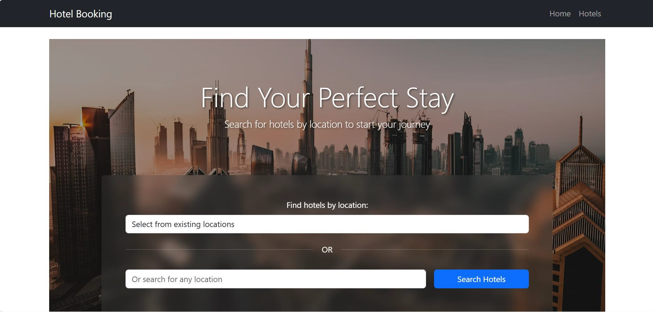 **RESULT**

**Fig 1.1 Home Page**

**CONCLUSION**

The Hotel Room Booking Website we developed successfully streamlines the process of finding and reserving hotel rooms online. With a user-friendly interface, secure booking system, and responsive design, the platform ensures a smooth experience for both customers and hotel administrators.

Key features like room availability checking, booking confirmation, and user account management contribute to a reliable and efficient service.

# **FUTURE SCOPE**

* Integrate voice assistants like Alexa or Google Assistant for hands-free booking.
* Include payment gateway integration for secure and easy online payments.
* Use AI to suggest rooms based on user preferences and past bookings.
* Provide real-time availability updates and notifications.
* Allow admin to analyse user data and chatbot performance using dashboards.
* Add support for multiple languages so users can interact in their preferred language.