**RENTORA**

**Parikshit Chouhan, Diksha shinde, Prof. Kiran Tayde**

Department of Computer Science and Engineering, Thakur Shiv Kumar Singh Memorial Engineering College Burhanpur(MP)

**ABSTRACT**

Rentora is an online marketplace that connects property owners with individuals seeking rental accommodations. The platform enables users to easily list, manage, and book properties, providing a seamless experience for both renters and homeowners. Rentora leverages modern technologies like React for the frontend, Node.js and Express for the backend, and MongoDB for data storage, ensuring a reliable and secure environment. The system supports secure payment processing through Cashfree and user authentication via JWT.

**Keywords** - Mobile App, Property, Images, GPS.

**INTRODUCTION**

Rentora provides a platform where property owners can list their available rentals, making it easier for potential renters to find suitable housing options. By offering features like property listings with photos, location and details. Rentora simplifies the rental process and fosters transparency between landlords and tenants. The platform might also include tools for managing payments this makes it a comprehensive solution for the rental market.

**LITERATURE REVIEW**

The Journal of Real Estate, 1991. Each year some residential real estate agents distinguish themselves by superior performance. Leading Residential real estate sale Agent and market performance: Loading residential real estate, The Journal of Real Estate in 1991 describes Each year some residential real estate agents distinguish themselves by superior performance.[5] Equality and time to sale in the real estate market: Proposed a pro-cyclical link between sale value and price [Equality & Search] [1994]. On the distinctive and puzzling features of the housing market is the dramatic variation in real price and sale value over time [3]. The URBAN LAND Market Rents & prizes, Micro mic Analysis of property markets in 1996 describes Market of land and houses are often to as completely product Differentiate because search product sold in the market is unique [4]. Rental Housing: Essential option for the poor in developing countries, Housing the poor [2011]. How people experience it in cities How do land lords workout their rental arrangement.[2].

**RESULT**

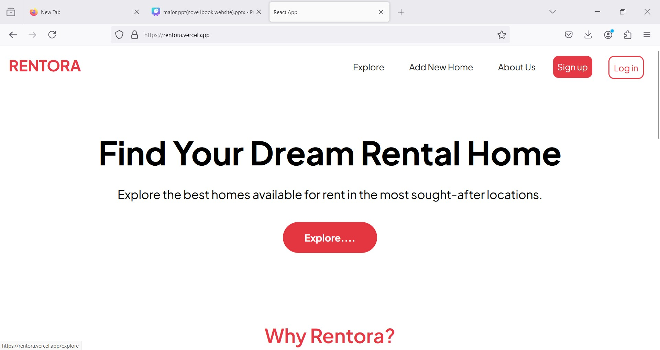

**Fig 1.1** Home Page of Rentora

**APPLICATION**

Rentora is a user-friendly online marketplace designed for both homeowners and individuals seeking rental accommodations. It offers a simple, secure, and efficient platform where users can easily rent out their homes or find suitable places to stay.

**LIMITATIONS**

* Free-tier hosting on Vercel and Render can lead to slower loading times, especially under high traffic.
* Cash free may not support all regions and requires payment verification, adding steps for users.
* Lack of messaging makes coordination between renters and hosts more challenging.
* Limited filtering and search features can make it harder to find specific types of listings.

**ADVANTAGES**

1. Greater efficiency.

2. Security of data.

3. Minimize manual data entry.

4. Minimum time needed for the various processing.

5. Better Service.

6. Minimum time required.

7. User friendly and interactive. This application will help the owner and seller to overcome difficulties

**CONCLUSION**

Rentora offers a convenient and secure platform for renting and finding accommodations, catering to both property owners and seekers. Effectively resolving the property issues is important to the buyer’s or seller’s relation, the Property rent sale application will be an important tool for provides buyers & sellers of specific property association and social sellers. Finally, the main goal of project is to create a good relationship between buyer’s and a seller. This work shows that a property rent sale application can really help buyer and seller to offer good quality of service in property rent and sale. In future, the functionalities given by AREA can be upgraded by expansion of more element. For example, notice message highlight can be added to advise clients when new property is free, Advanced Search can be added to empower search of property by state or nearby government, or to look for property closest to client in light of indicate scope of kilometre from current client's area.

**FUTURE SCOPE**

* **Advanced Search:** Add filters for location, price, and amenities.
* **In-App Messaging:** Enable direct communication between renters and hosts.
* **Improved Infrastructure:** Move to dedicated servers for faster loading.
* **Flexible Payments:** Support Multiple payment methods and gateways.
* **Enhanced Security:** Add data encryption and two- factor authentication.
* **Booking Management:** Introduce features for cancellations and refunds

**REFERENCES**

[1] Determination of rental value for residential properties : A land owner perspective for boarding homes [Built Environment] [2016].

[2] Rental Housing : Essential option for the poor in developing countries [Housing the poor] [2011].

[3] Equality and time to sale in the real estate market : Proposed a pro-cyclical link between sale value and price [Equality & Search] [1994].

[4] The URBAN LAND Market : Rents & prizes [Microecons mic Analysis of property markets] [1996].

[5] Leading Residential real estate sale Agent and market performance : Loading residential real estate ,The Journal of Real Estate [1991].

[6] Cooper, M. (1998), Ideas to develop a literature review, vol. 3, page, 39.

[7] Levin, K. (1999), Database Management.

[8]Gommans, H.P., Njiru, G.M. and Owange, A. N. (2014), Rental House Management System. International Journal of Computer Science and Mobile Computing.

[9]Nathan V., Fangwu W., David F. and Andrew M. (2010), Apartment Management System Analysis and Design Information Systems Analysis and Design Spring Quarter 2010 [10]Nusrat M. and Nawshin T. (2016), Home Rental System Implementation constraint satisfaction problem. Thesis, Department of computer science and engineering, BRAC University.