**Job Portal**

**Diksha Aapte, Yash Navgrahe, Tushar Sonawane, Prof. Neha koge**

Department of Computer Science & Technology, Thakur Shivkumar Singh Memorial Engineering College, Burhanpur (MP)

**ABSTRACT**

Job portal is an application that connects employers and job seekers where employers are the source of the resources and the job seeker can find and apply for their targeted job. This website can also provide information about online jobs. The customer can get the online registration. The Job Portal web application can be used by any employee to apply job and any employer can post to job. All job openings will be made available online, allowing employers to easily post their vacancies on the platform. The system is designed to streamline the review and management of job applications through the web interface, ensuring efficient handling of the entire recruitment process.

**INTRODUCTION**

Online Job portal system is an application that connects employers and job seekers where employers are the source of the resources and the job seeker can find and apply for their targeted job. In the Online Job portal system, we use PHP and MySQL database. This is the project that keeps records of the employer, jobseeker, and administrator. The online Job portal system has three modules i.e. Jobseeker, Employer, and Admin.

A computerized online Job Search System is developed to facilitate the General administration system to manage the various information of the Job Seeker and Employer and the processes involved in a placement company. So, that organization can access accurate information quickly and easily as and when required, thereby improving its operational efficiency & effectiveness.

**LITERATURE SURVEY**

Traditional job-seeking methods are often slow, stressful, and challenging, lacking in quality and efficiency. Job seekers have to invest a significant amount of time and effort in gathering information, preparing applications, and considering costs associated with the process. However, the emergence of online job portals has revolutionized the job-seeking landscape, providing a faster and more convenient alternative. The Internet has become a powerful tool for job seekers, offering numerous websites that advertise job vacancies across various industries and skill sets. Moreover, the Internet plays a crucial role in human resource planning and development, with many organizations utilizing computer technology and the Internet for recruitment purposes. It is important to note that while the Internet has streamlined the job-seeking process, it has not completely replaced traditional methods. Offline methods, such as networking, referrals, and direct application submissions, still hold value in certain scenarios. However, the convenience and accessibility provided by online job portals have made them a primary resource for job seekers in today's digital era.

**METHODOLOGY**

To develop a multi-user login website for an online job portal using HTML, CSS, JavaScript, Bootstrap, Python, and Django, the following methodology can be followed:.

1. **Requirements Gathering**

Gather the requirements for the website, including features, user roles (job seekers, recruiters), and functionality.

1. **User Interface Design**

Design the user interface using HTML, CSS, and Bootstrap to create an intuitive and visually appealing website layout. Utilize JavaScript for client-side interactivity.

**RESULT**

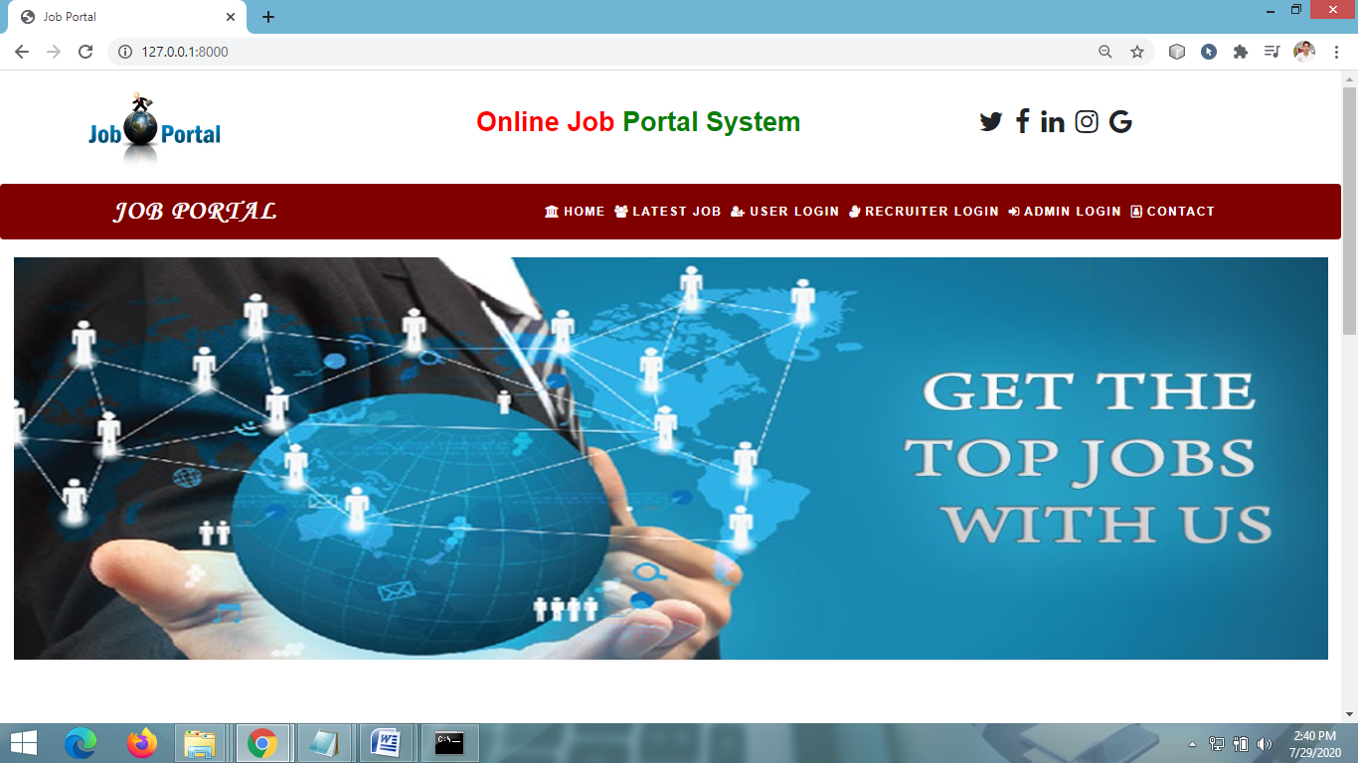

**Fig 1.1** Home Page of Job portal

**SYSTEM REQUIREMENTS**

The hardware requirements for the system are as follows:

**Processor:** Intel Core i3 or above. A quad-core processor is recommended. A quad-core processor consists of four independent units called cores that can read and execute CPU instructions simultaneously, providing faster processing speed for programs that support parallel processing.

**RAM:** A minimum of 500MB RAM is required. RAM, or random-access memory, is a type of computer memory that allows the CPU to quickly access and retrieve data. It is essential for running programs and multitasking efficiently. Having an adequate amount of RAM ensures smooth performance and prevents system slowdowns.

**Hard Disk Space**: A minimum of 2GB of hard disk space is required. A hard disk drive (HDD) is a magnetic storage device used for long-term data storage. It provides ample space for storing operating system files, software, and user data. The 2GB requirement is the minimum storage capacity needed for the system, but it is advisable to have a larger hard drive for storing additional files and programs.

**MODULES**

Job portals typically consist of several modules or components that work together to provide a comprehensive platform for job seekers, employers, and recruiters. The specific modules may vary depending on the job portal's design and target audience. Here are some common modules found in job portals. The Home page Module is the main page having . The user login is for logging the user. The recruiter login is for the recruiter, job list, user home page, admin home page. These modules are for job portal working.

**FUTURE SCOPE**

This web application involves almost all the basic features of the online job portal system. The future implementation will be online help for the users and chatting with a website administrator. Develop a more advanced and feature-rich software for the job portal, providing additional functionalities and services. Host the platform on online servers to ensure global accessibility, allowing users from anywhere in the world to access the job portal. Integrate multiple load balancers to distribute the system's workload efficiently, ensuring smooth performance and handling high traffic. Implement a master and slave database structure to reduce the database queries overload, enhancing the system's performance and responsiveness. Establish a backup mechanism to regularly backup the codebase and database on different servers, ensuring data integrity and security.

**CONCLUSION**

This project covers only the basic features required. It streamlines the process of result calculation and visualization for both students and faculty members. Our project focuses on creating an efficient and user-friendly system to manage project work with well-organized code. The main objective of software planning is to establish a framework that allows managers to make accurate estimates at the start of the project and continuously update them as the project evolves. This iterative approach ensures that estimations remain realistic and aligned with the project's progress.

**REFERENCE**

* + [**https://www.geeksforgeeks.org/python-django/**](https://www.geeksforgeeks.org/python-django/)
  + [**https://www.javatpoint.com**](https://www.javatpoint.com/)
  + [**https://www.python.org/**](https://www.python.org/)
  + [**https://www.tutorialspoint/**](https://www.tutorialspoint/)
  + Two scoops of Django for 1.11 by *Daniel Greenfield and Audrey Greenfield* Lightweight Django *by Elman and Mark Lavin*
* Pinjari, M., De, N., Kokne, R., Siddiqui, A., & Chitre, D. (2019). Online Job Portal. International Research Journal of Engineering and Technology.
* Mithun, G. (2020). A Project Report On Job Portal (Doctoral dissertation, CMR Institute of Technology. Bangalore).
* Khan, M. S., & Khan, M. S. (2015). Online job portal (Doctoral dissertation, University of Management and Technology Lahore).
* Chowdhury, A. R., Areias, A. C., Imaizumi, S., Nomura, S., & Yamauchi, F. (2018). Reflections of employers' gender preferences in job ads in India: an analysis of online job portal data. World Bank Policy Research Working Paper, (8379).