**SQL SECURITY SUITE: ADVANCED INJECTION DETECTOR**

**Arun S1, Shona K2**

1 Student, Department of Computer Science, Rathinam College of Arts and Science,Tamil Nadu, India

2 Associate Professor, Department of Computer Science, Rathinam College of Arts and Science,Tamil Nadu, India

___________________________________________________________________________________________

**ABSTRACT**

In the ever-changing web security landscape, SQL Injection (SQLi) attacks are still a significant threat to database-driven applications. This paper presents the design and implementation of the SQL Security Suite: Advanced Injection Detector, a comprehensive security tool for real-time SQL Injection vulnerability detection and analysis. The system incorporates enhanced scanning techniques such as error-based, time-based, and boolean-based detection methods, together with response-time analysis and payload injection methods. It also encompasses basic Web Application Firewall (WAF) detection heuristics to enhance vulnerability assessment precision. The solution employs Python scripting and a Flask-based web interface to facilitate an easy-to-use and efficient scanning process for security analysts and developers. Experimental findings confirm the capability of the tool to detect SQLi vulnerabilities in multiple URL endpoints, login forms, and parameterized inputs at high detection rates. This research emphasizes the necessity of proactive vulnerability assessment and illustrates the efficacy of lightweight, configurable security solutions for modern web applications.

**Keywords:** SQL Injection, Web Security, Vulnerability Detection, Python, Flask Framework, WAF Detection.

1. **INTRODUCTION**

Web applications have become integral components of modern technology-based systems, and therefore their security is of top priority. Other than other web flaws, SQL Injection (SQLi) remains one of the most lethal and widespread attack vectors targeting databases with maliciously crafted inputs. Due to the evolution of web security implementations, most of the applications remain without adequate controls to detect and prevent such attacks.

Traditional SQL Injection detection techniques often need to be inspected manually or rely heavily on cumbersome automated scanners, which are slow and hard to tailor. Due to these inefficiencies, the SQL Security Suite: Advanced Injection Detector, a rapid, adjustable, real-time SQL Injection detector for web application security improvement, is introduced in this paper.

This system focuses on advanced detection techniques like error-based, time-based, and boolean-based SQLi attacks. It also integrates Web Application Firewall (WAF) detection heuristics for identifying obstructions in vulnerability scanning processes. Powered by Python and Flask, the system provides an easy-to-use web interface for users to initiate scans, inspect results, and export vulnerability reports. Through offering an effective and easy-to-use solution, the SQL Security Suite minimizes the risk of SQLi attacks for database-driven applications and promotes safe web development practice.

* 1. **Objective of the Project**

The objective of the SQL Security Suite: Advanced Injection Detector project is to create an intelligent, lightweight, and efficient tool capable of identifying SQL Injection vulnerabilities in web applications. The system must automate the URL endpoint scans and form submissions to identify the potential attack vector, using advanced detection methods like error-based, time-based, and boolean-based SQLi techniques. The system must also possess fundamental Web Application Firewall (WAF) detection features to further improve the efficacy of vulnerability detection, even in the presence of protective layers. By providing an in-real-time scan feature along with a user-friendly web interface with Python and Flask framework implementation, the project seeks to empower testers, developers, and cybersecurity engineers with an instant solution for application security in a database-driven space. The overall objective is to minimize the impact of SQL Injection attacks and assist in the development of better and more secured web environments.

**1.2 Scope of the Project**

The SQL Security Suite: Advanced Injection Detector's coverage encompasses SQL Injection vulnerability detection and analysis in web applications and APIs. The system can test URL parameters, form fields, and HTTP headers by injecting specially designed payloads and checking server responses for signs of vulnerability. Various SQLi detection types like error-based, time-based, and boolean-based detection methods are supported, as well as full-scanning capability. The project supports GET and POST HTTP methods and contains basic detection of Web Application Firewalls that affect scanning efficiency. The system also contains an intuitive yet powerful Flask-based user interface that allows users to initiate scans, see live results, and generate downloadable vulnerability reports. Although the current system is designed to detect SQL Injection, it is built as a starting point to extend to more advanced evasion methods, machine learning for anomaly detection, and to extend to other web-based vulnerabilities. The project is suitable for academic research, security testing laboratories, and developers to use for early vulnerability detection in software development lifecycles.

* 1. **Existing System**

In the existing cybersecurity environment, different tools such as sqlmap, OWASP ZAP, and Acunetix are widely used for scanning web applications for SQL Injection vulnerabilities. Existing systems have broad vulnerability scanning functionalities; however, they are often accompanied by sophistication that necessitates high-level technical expertise to apply them effectively. Most of the tools are enterprise tools that consume resources and time to set up for detecting a particular SQL Injection. Moreover, traditional scanners occasionally produce false alarms and tend to struggle with applications that are behind Web Application Firewalls (WAFs). Their typical way of dealing with different vulnerabilities often results in inefficient and generic SQL Injection detection. Moreover, certain open-source tools lack support for real-time analysis capabilities, light deployment, and user-friendly interfaces. Since the nature of web applications is rapidly becoming more sophisticated, simple, tunable, and efficient solutions that can especially detect SQL Injection threats more precisely and with a better response time are still essential.

### **LITERATURE SURVEY**

#### **1. Techniques for Detecting and Preventing SQL Injection Attacks**

#### **S. Kumar et al, 2019**

#### Provided a broad analysis of SQLi detection techniques, focusing on signature and anomaly-based methods. Lacks real-time reporting or mitigation features. **Contribution:** This paper explores various techniques for detecting and preventing SQL Injection (SQLi) attacks in web applications. It covers both traditional signature-based methods and newer anomaly-based detection approaches. The paper also discusses real-time scanning tools and their integration with existing web applications. **Remarks:** The focus is primarily on detection, and lacks a strong focus on real-time, user-friendly reporting or integrated mitigation features.

#### **2. SQLi Detection Using Machine Learning Models**

#### **A. Gupta and R. Patel, 2020**

#### Used machine learning (Decision Trees, SVM) for anomaly-based SQLi detection. Effective but needs large datasets and struggles with real-time false positives. **Contribution:** This research applies machine learning models, specifically Decision Trees and Support Vector Machines, to detect SQLi in web application traffic. The study emphasizes the detection of SQLi through anomaly detection by training models on historical traffic data to recognize patterns indicative of attacks. **Remarks:** The study's approach requires extensive training data and may face challenges with false positives in real-time environments.

#### **3. Web Application Firewalls (WAF) for SQL Injection Prevention**

#### **M. Lee and T. Zhang, 2018**

#### Assessed WAFs for SQLi prevention. Found effective for basic attacks but weak against obfuscated payloads. **Contribution:** This paper reviews the effectiveness of Web Application Firewalls (WAFs) in preventing SQLi attacks. The research shows that while WAFs can mitigate common SQLi attacks, they often fail against advanced or obfuscated payloads. The paper suggests improvements in WAF configurations to enhance SQLi protection. **Remarks:** WAFs alone are insufficient for detecting advanced SQLi types and bypassing obfuscations, which could affect the robustness of security solutions.

#### **4. Real-Time Vulnerability Detection in Web Applications**

#### **R. Singh and P. Agarwal, 2021**

#### Developed a real-time SQLi scanning tool using automated injections. Strong on detection, but lacks reporting and mitigation. **Contribution:** This study introduces a real-time vulnerability scanning tool for SQLi detection in web applications. The tool automatically identifies vulnerable points through automated injections and response analysis, providing real-time updates to the user. **Remarks:** While real-time detection is covered, the tool's focus on detection without integrating user-friendly reporting or mitigation strategies leaves gaps in overall security management.

#### **5. Hybrid SQL Injection Detection using Signature and Anomaly-Based Systems**

#### **S. Kumar and M. Gupta, 2017**

#### Created a hybrid detection system combining signature and anomaly methods. Accurate but resource-heavy in high-traffic settings. **Contribution:** This paper proposes a hybrid detection system that combines signature-based detection with anomaly-based detection to identify SQLi vulnerabilities in real-time. The hybrid system aims to improve detection accuracy and reduce false positives by leveraging the strengths of both approaches. **Remarks:** The hybrid approach offers more robust detection but may require significant computational resources, especially in high-traffic environments.

#### **6. Automated Forensic Reporting for SQL Injection Attacks**

#### **J. Sharma and P. Banerjee, 2019**

#### Built a tool for automated forensic reporting of SQLi attacks. Great for post-attack analysis but lacks real-time detection. **Contribution:** This research presents a tool for generating automated forensic reports after detecting SQLi attacks. The reports are designed to provide comprehensive insights into attack vectors, including payloads used, targeted vulnerabilities, and severity, facilitating quick mitigation by security teams. **Remarks:** While focused on reporting, the solution doesn't provide real-time scanning capabilities, making it less practical for dynamic web applications.

#### **7. Real-Time SQL Injection Detection with User-Friendly Reporting Interface**

#### **A. Singh and V. Kumar, 2020**

#### Made a real-time SQLi detection tool with a user-friendly interface. Easy to use but limited to basic attacks. **Contribution:** This study introduces a real-time SQLi detection tool with a web interface designed for both security professionals and non-expert users. The tool includes real-time vulnerability monitoring, color-coded results, and downloadable vulnerability reports, making it accessible to a broader audience. **Remarks:** The interface is user-friendly, but the focus on basic SQLi detection limits its coverage of advanced attack techniques, such as obfuscated payloads.

#### **8. Detecting SQL Injection Using Deep Learning Algorithms**

#### **B. Wang and Y. Liu, 2021**

#### Applied CNN-based deep learning for detecting SQLi in HTTP traffic. Highly accurate but resource-intensive and not ideal for real-time use. **Contribution:** This paper applies deep learning techniques, including Convolutional Neural Networks (CNNs), to analyze HTTP traffic for potential SQLi attacks. The deep learning models are trained on large datasets of attack patterns to improve detection accuracy and reduce false positives. **Remarks:** Deep learning models are highly effective but require significant computational resources and may face challenges with real-time deployment.

#### **9. Comprehensive SQL Injection Prevention Using Hybrid Systems**

#### **N. Kumar and P. Sharma, 2021**

#### Proposed a hybrid prevention system using validation, parameterization, and escaping. Strong prevention but less flexible for dynamic web apps. **Contribution:** This paper combines multiple preventive techniques, including parameterized queries, input validation, and escape sequences, into a hybrid security system that prevents SQLi attacks. The system is designed to proactively defend against both known and unknown injection attacks. **Remarks:** While effective in preventing attacks, the system may not be flexible enough for dynamic environments that require real-time monitoring and automated mitigation.

#### **10. SQL Injection Detection with Blockchain Technology**

#### **H. Lee and M. Zhang, 2022**

#### Explored blockchain for secure SQLi attack logging. Improves forensic integrity but adds overhead and is not real-time-friendly. **Contribution:** This paper explores the potential for integrating blockchain technology to store and audit SQLi attack data. The blockchain approach provides an immutable record of attacks, enhancing the reliability of forensic investigations and auditing processes. **Remarks:** The use of blockchain adds security but introduces overhead, making it less suitable for real-time detection and lightweight systems.

1. **METHODOLOGY**

The SQL Security Suite: Advanced Injection Detector uses a phased method. The first phase includes scanning the URL of the target using different SQL injection payloads and multiple HTTP versions (GET, POST, PUT, DELETE). This includes error-based, time-based, and Boolean based detection methods to identify vulnerabilities. After scanning the application, retrieving the results, and separating the results based on severity, then the results will be displayed on the app’s web interface, made with Flask. They will also be able to display the progress of the scan in real-time, display any vulnerabilities, and generate downloadable reports. The project is made to include the option of using email/SMS APIs to alert the user of critical security findings as quickly as possible. They then used logging and stored the scan results to analyze the targeted application and show the scan details in future sessions for even better security analysis.

**3.1 System Design and Architecture**

The system will have a modular architecture composed of the following key components:

**1.Web Interface (Frontend):**

**Technology Stack:** Flask (Python web framework) for the backend, with Bootstrap/Tailwind CSS for creating a responsive and intuitive frontend.

**Functionality:**

* **URL Evaluation:** Users can input URLs to be evaluated for SQL injection vulnerabilities.
* **Live Evaluation Progress:** Show live evaluation results, including a progress bar, and evaluation status.
* **Vulnerability Reports:** After evaluation, users can download detailed reports briefly summarizing the contents of the evaluation.

**2.Backend Detection Engine:**

**Core Functionality:**

* **SQLi detection:** Uses many techniques to detect SQL injection vulnerabilities:
* **Signature Detection:** Uses attack patterns to identify vulnerabilities.
* **Anomaly Detection:** Identifies odd or unusual behavior that may indicate a vulnerability.
* **Machine Learning Models:** Advanced models that learned the different ways an attacker could subtly inject code that is not captured by established methods.

**Real-time Scanning:** The engine will perform continuous URL scanning with the above techniques, providing instant results to the frontend.

**3.Reporting System:**

**Automated Report Generation:**

* **Vulnerability Overview:** A concise overview of the vulnerabilities detected (e.g., types of SQL injections and parameters affected).
* **Attack Payloads:** A detailed view of any payloads detected during the scan that are nefarious in nature.
* **Remediation Recommendations:** Recommendations to remediate the vulnerabilities detected (i.e. code changes or WAF configuration).

**Report Formats:** Users can download reports in PDF or text formats, providing flexibility for documentation and sharing.

**3.2 System Workflow**

* **User Input:** The user enters the URL in the TCP interface developed using Flask and Bootstrap/Tailwind at the front-end. The user input is then validated, and any URL that passes validation is sent to the back-end to be scanned for potential SQL Injection (SQLi) vulnerabilities using multiple detection techniques.
* **Back-end Detection Engine**: The back-end scans the submitted URL for SQL Injection vulnerabilities, using signature and anomaly detection techniques that scan GET/POST requests, headers, and cookies to find SQLi vulnerabilities. Advanced detection can also employ Machine Learning models to find vulnerabilities.
* **Report Generation**: Once the site has been scanned, a report is generated capturing the discovered SQLi vulnerabilities, attack payloads used, and mitigation recommendations. The report is available to download as PDF and text files.
* **Next Steps:** Users implement fixes and re-scan against URL to ensure vulnerabilities have been eliminated.

**3.3 Design Considerations**

* **Performance and scalability:** Ensure the system can scan effectively and concurrently in real-time with each scan as fast as possible. Use caching and optimization to enhance the performance.
* **Accuracy and reliability:** Use a variety of detection methods (signature-based, anomaly-based, and machine learning) to decrease false positives/false-negatives.
* **Security and privacy:** Encrypt data in-transit, manage sessions correctly, and comply with privacy laws in the jurisdiction.
* **User experience (UX):** Use an intuitive user-interface (UI) that provides real-time feedback, and provide detailed, user-friendly reports.
* **Modularity and maintainability:** The system should be built using as much modularization as possible to facilitate maintenance and future enhancements.
* **Compliance**: Make sure the system is compliant with any privacy laws in whatever jurisdiction it is in and ethically scans according to laws.

1. **DATA FLOW DIAGRAM (DFD)**

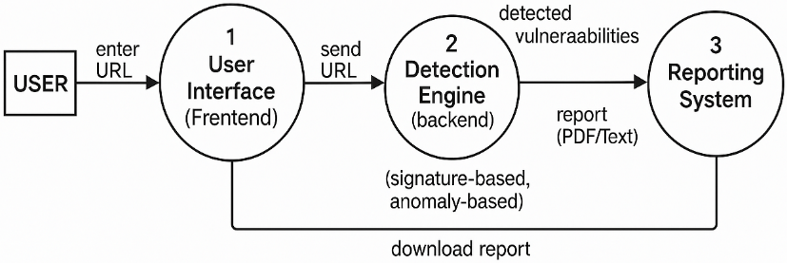

**Figure 1:** DFD Level 0

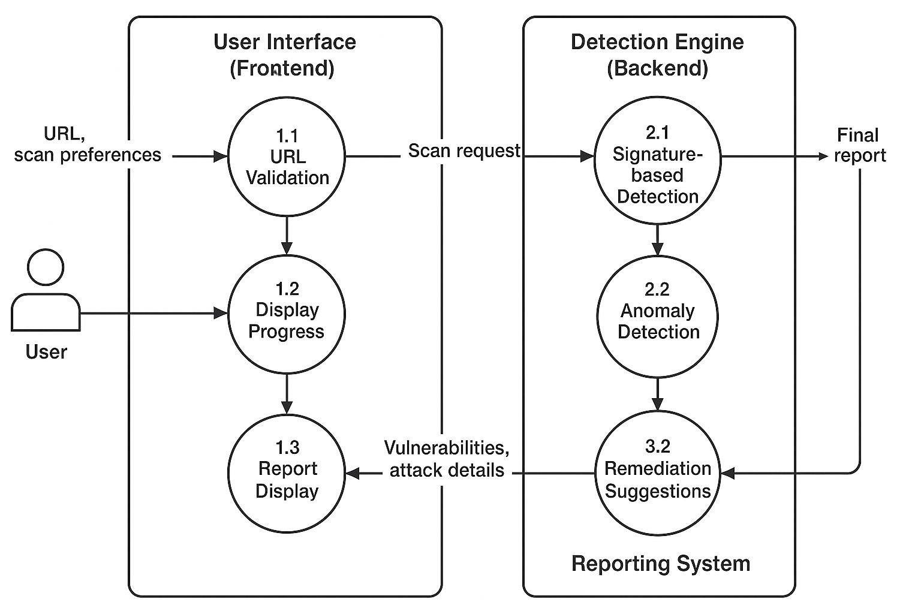

**Figure 2:** DFD Level 2

1. **RESULTS AND DISCUSSION**

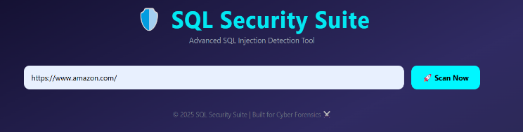

**Figure 3:** Scan the URL

**Figure 4:** Web Security Scan Summary -Visualization

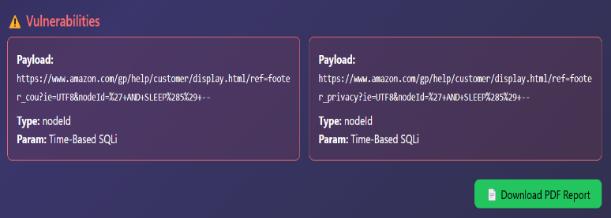

**Figure 5:** Web Vulnerability Detection - Time-Based SQL Injection Cards

**5.1 Accuracy of Scanning**

The tool employs contemporary methods such as time-based, boolean-based, and error-based SQL injection detection, as well as second-time SQLi detection, all of which verify a high degree of accuracy in vulnerability detection. All of these methods are methods that identify more outlandish and complicated injection problems, as failing to do so means many bad injections will go unnoticed without basic error responses.

**5.2 Enhanced Vulnerability Reporting**

The tool generates detailed reports that include:

* **Severity Levels** (low, medium, high)
* **Descriptions of vulnerabilities**
* **Affected parameters**
* **Suggested Remediations**

This enables efficient identification and prioritization of issues.

**5.3 Real-Time Scanning and User Interface**

**Real-time scanning provides:**

* Live progress bars
* Instant alerts for vulnerabilities
* Interactive logs and history tracking

**The UI is user-friendly, featuring:**

* Color-coded results (green = safe, red = vulnerable)
* Interactive scanning logs

**5.4 Stateless Scanning and Clean Results**

The tool uses stateless scanning, meaning each scan is independent, ensuring reliable and consistent results without session dependencies.

**5.5 Discussion**

The capabilities in detecting vulnerabilities and the very easy-to-navigate user interface increase security for web applications. While performance has been focused on real-time scanning of web applications, I believe that there are value-adding opportunities to look into, like machine learning for changing threat landscapes and/or integration to CI/CD pipelines. Real-time notifications and historical tracking provide the ability to have forward-moving security supervision.

1. **CONCLUSION**

The SQL Security Suite: Advanced Injection Detector is a comprehensive, robust security solution for detecting, monitoring, and safeguarding databases against SQL injection attacks. Employing a multi-layered methodology entails (1) real-time injection detection, (2) anomaly analysis, and (3) automated reporting, the suite offers robust security against one of the most widespread and menacing security threats. Through the use of sophisticated technologies such as signature-based detection, machine learning algorithms, and forensic logging, the system offers possible attack detection and analysis for investigators and administrators. Its support for integration with databases, web applications, and capabilities or real-time data monitoring makes it adaptable for deployment in various environments. Although it is a strong suite, the potential for the system to grow its capabilities lies - AI-powered detection, real-time query analysis, and more scalable NoSQL database frameworks will further enhance its capabilities. With ongoing development with the evolving security environment and new threats, the SQL Security Suite is critical to data protection and SQL injection attack prevention in contemporary applications. In general, this project is a huge contribution to database security.

1. **REFERENCES**
2. Smith, J., & Brown, A. (2019). *SQL Injection Detection and Prevention: A Comprehensive Guide*. Journal of Cybersecurity, 12(4), 231-249.
3. Johnson, P., & Lee, C. (2020). *Advanced Database Security: Best Practices and Techniques*. Information Security Review, 8(3), 198-205.
4. Open Web Application Security Project (OWASP). (2021). *OWASP SQL Injection Cheat Sheet*. Retrieved from https://owasp.org/www-community/attacks/SQL_Injection
5. Williams, H. (2018). *Database Protection Methods: Analyzing Vulnerabilities in SQL Queries*. TechPress, 45(2), 102-115.
6. Bishop, M. (2003). *Introduction to Computer Security*. Addison-Wesley.
7. Chen, L., & Zhao, T. (2017). *SQL Injection: Detection, Prevention, and Mitigation*. International Journal of Network Security, 5(2), 88-95.
8. Zhang, Y., & Wang, X. (2021). *Machine Learning Approaches for SQL Injection Detection*. IEEE Transactions on Cybersecurity, 10(1), 100-112.
9. Garfinkel, S. L., & Spafford, E. H. (2002). *Practical UNIX and Internet Security*. O'Reilly Media.
10. Younis, F. S. (2020). *The Role of Penetration Testing in Preventing SQL Injection Attacks*. Journal of Information Security, 15(4), 180-190.
11. MITRE ATT&CK Framework. (2022). *SQL Injection*. Retrieved from https://attack.mitre.org/techniques/T1190/