**A STUDY ON IMPACT OF CELEBRITY ENDORSEMENTS ON CONSUMER BUYING PATTERNS**

Rahul M1,Mrs Naveena M2,

1MBA Student, School of Arts, Humanities and Management, Jeppiaar University, Chennai, India.

2Associate Professor, School of Arts, Humanities and Management, Jeppiaar University, Chennai, India.

1***rahul070399@gmail.com***,

2***naveenasweth15@gmail.com***,

**ABSTRACT**

A popular marketing tactic that has a big impact on customer behavior, brand impression, and purchase intention is celebrity endorsement. Numerous studies point to important characteristics that affect how successful celebrity endorsements are, such as popularity, credibility, trustworthiness, knowledge, attractiveness, and brand congruence. Trustworthiness is frequently the most important of these, influencing customer perceptions and promoting favorable word-of-mouth. Both skill and beauty are crucial, especially when it comes to establishing an emotional bond with customers and raising the perceived caliber of the promoted product.  
  
This study looks at trust, purchasing decisions, and preferred endorsement channels in order to better understand how celebrity endorsements affect customer behavior.  
  
**Key words:** consumer behavior, primary data, descriptive and inferential analysis, celebrity endorsement

**INTRODUCTION**

Studies have shown that celebrity endorsements have a beneficial effect on customer behavior, making them an important part of the FMCG sector. Beginning in the 19th century, the technique has grown into a multi million-dollar industry where companies use celebrities' attractiveness to increase the exposure and desirability of their products. Businesses spend a lot of money on celebrity endorsements because they think that well-known personalities draw attention, help brands stand out in the media, and increase brand recall.  
  
Celebrity endorsement affects customers' intents to buy as well as their opinions about commercials and brands. The legitimacy of the endorser, which is frequently determined by perceived attractiveness, dependability, and experience, is what makes this tactic so successful. In order to increase persuasive impact and consumer-based brand equity, endorsers give the businesses they represent symbolic and aspirational connections.

Multiple endorsements and excessive exposure, however, might weaken trust and cause customers to doubt the veracity of recommendations. Some celebrities have responded by starting their own businesses, serving as spokespersons and entrepreneurs, and fusing product marketing with personal branding.  
  
Social media has also changed the game by facilitating deeper interaction and converting customers into brand advocates. As businesses negotiate these relationships, choosing the ideal celebrity or developing a relatable spokesperson becomes essential to fostering trust and influencing the purchasing decisions of customers.  
  
Additionally, in the age of digital marketing and social media, the influence and reach of celebrity endorsements have   
  
expanded at an exponential rate. Celebrities have quick access to millions of fans, which personalizes and engages endorsements.Because of this direct connection, brands are able to develop product-centered narratives and tailored ads that complement the celebrity's values and persona.  
  
Celebrity endorsements can also greatly improve brand identification and recall. When a product is linked to a well-known person, consumers are more likely to remember it, making a lasting impression that may affect their choice to buy. But the genuineness of the collaboration and the fit between the brand's ideals and the celebrity's persona are crucial to the success of these endorsements.  
  
All things considered, celebrity endorsements are now a crucial component of contemporary marketing tactics, providing companies with a special chance to reach the fan base of well-known people and instill in them a sense of trust, aspiration, and attractiveness.

**Objectives**

The Specific Objectives of the Study Are:

1. To determine the connection between consumer purchase intention and celebrity qualities (such as knowledge, credibility, and attractiveness).
2. To investigate how long-term loyalty, brand perception, and customer trust are affected by celebrity endorsements.
3. To evaluate how well celebrity endorsements influence customer behavior in comparison to non-celebrity endorsements.
4. To suggest important tactics that companies can use to minimize any hazards and optimize the effect of celebrity endorsements.

**REVIEW OF LITERATURE**

Consumer Trust and Celebrity Attributes Numerous studies emphasize how consumer perceptions of endorsed brands are influenced by celebrity qualities including dependability, beauty, and knowledge. According to Ohanian's (1990) Source Credibility Model, a celebrity's credibility has a big impact on consumers' intentions to make a purchase. Erdogan (1999) also underlined that people are more inclined to believe recommendations from celebrities who are seen as genuine and informed. The Effects of Celebrity Likeability and Familiarity According to research by Kamins (1990), likeability and familiarity with celebrities improve brand memory and have a favorable effect on consumer sentiments. This supports the Match-Up Hypothesis, which holds that for an endorsement to be successful, the endorser's personality and the brand's image must match.. According to research by Amos et al. (2008) and Spry et al. (2011), knowing a celebrity boosts customer engagement and the likelihood that they would make a purchase. Celebrity Endorsements' Effect on Purchase Intention Customers develop emotional bonds with celebrities, which increases their propensity to make a purchase, according to a 2004 study by Silvera and Austad. Roy (2012) also noted that young customers, especially teens, who are more influenced by aspirational figures, are greatly impacted by celebrity endorsements.  
  
The efficacy of celebrity endorsements in comparison to non-celebrity endorsements Studies like those by Agrawal and Kamakura (1995) indicate that although celebrity endorsements increase brand recognition, they do not always translate into better sales. Because of their perceived relatability and authenticity, non-celebrity endorsements—especially those obtained through influencer marketing—can occasionally result in higher levels of customer trust (Schimmelpfennig & Hollensen, 2016).The dangers of celebrity endorsements Celebrity endorsements have risks despite their benefits. Research by Till and Shimp (1998) emphasizes how a brand's reputation can be harmed by unfavorable press surrounding a celebrity. Likewise, Bergkvist and Zhou (2016) emphasize how crucial crisis management plans are for companies that use celebrity endorsements.  
  
The Impact of Celebrity Knowledge on Brand Trust:Spry, Pappu, and Bettina (2011) examined how a celebrity's knowledge in a certain industry (e.g., athletes promoting sports products) enhances customer trust and brand credibility. Consumers frequently develop parasocial interactions (one-sided emotional bonds) with celebrities, which affects their brand loyalty and purchase decisions, according to Chung and Cho (2017).Celebrity endorsements and social media engagement: According to Djafarova and Rushworth (2017), younger consumers are more receptive to social media influencers since they are seen as more relatable than traditional celebrities. McDonald (2002) studied the relationship between brand recall and many celebrity endorsements. The study found that while utilizing multiple celebrity endorsers can help firms become more credible and reinforce their messages, it can also cause confusion for consumers if the endorsers have contradictory values.  
  
The Influence of Culture on Celebrity Endorsements: Choi and Rifon (2012) pointed out that different cultures have different levels of success with celebrity endorsements, with collectivist cultures (like China and India) reacting better to them than individualistic cultures (like the USA and the UK). Agrawal and Kamakura (1995) studied the halo effect in celebrity endorsements, which is the phenomenon whereby people project favorable opinions of a celebrity onto a brand, hence boosting buy intent.The Role of Gender in Endorsements: According to Boyd and Shank (2004), men and women react to endorsements in different ways. Men place greater emphasis on achievement and knowledge, while women value emotional appeal and credibility. Celebrity endorsements' financial influence was demonstrated by Elberse and Verleun (2012), who discovered that brands that used celebrity endorsements saw an average 4% boost in sales.  
  
Luxury vs. Mass Market businesses: Hung, Chan, and Tse (2011) investigated how, because of their exclusivity and aspirational appeal, luxury businesses gain more from celebrity endorsements than do mass-market brands.

The Function of Bad Press in Endorsements: Zhou and Whitla (2013) discovered that bad press about celebrities can damage a brand's reputation, particularly if the celebrity is directly linked to the product. Consumer Skepticism Toward Celebrity Endorsements: According to Obermiller and Spangenberg (1998), customers who have a high level of skepticism toward advertising are more likely to doubt the legitimacy of celebrity endorsements, which lessens its impact. Wang et al. (2017) found that celebrity endorsements had an impact on impulsive buying behavior, particularly in the fashion and cosmetics industries where consumers are motivated by emotional appeal.  
  
The Effect of AI-Powered Virtual Influencers: Miao, Wei, and Lu (2022) investigated the new phenomenon of AI-powered virtual influencers and discovered that while they work well with Gen Z customers, they don't have the same emotional bond as actual celebrities. The Function of Endorsements in Ethical Consumerism: According to White, Habib, and Hardisty (2019), customers react favorably when celebrities promote ethical brands (such as sustainable goods) since it increases the legitimacy of the brand. Celebrities and Political Brand Endorsements: In their 2017 study, Knoll and Matthes examined the ways in which celebrity endorsements in political campaigns can affect voter behavior and showed that their impact goes beyond promotional goods.

With industry assessments like BCG (2023) forecasting further growth in the upcoming years, Q-Commerce's future in India is bright. According to the survey, the main target audiences for large companies would be high-income customers, tier-1 markets, and metro areas. But in order for Q-Commerce to flourish sustainably, businesses need to make investments in strategic alliances, technology development, and legal compliance.

**RESEARCH METHODOLOGY**

**Primary Data**

The research is conducted using questionnaires by observing and collecting data. The theory is built on the basis of field visits and the results of the analysed data.

**Secondary Data**

Secondary data sources such as magazines, journals, and books are used to construct theories.

**Sample**

The sample size consists of 50 respondents' opinions from users in Bengaluru,Udupi and Sangli district.

**Instruments**

To analyse the data, percentage analysis is used to arrive at a conclusion for the present study

**Research Gap**

Even with a wealth of research on celebrity endorsements and how they affect consumer behavior, there are still a number of holes in the body of knowledge:

* Efficiency in Various Customer Segments The majority of current research focuses on young customers, especially millennials and teenagers. Studies examining the reactions of various age groups, ethnic origins, and socioeconomic strata to celebrity endorsements are scarce, nevertheless.
* The function of virtual influencers and artificial intelligence One new trend is the use of AI-powered virtual influencers to promote brands. Nevertheless, compared to traditional celebrities, little is known about how consumers view and react to endorsements from non-human creatures.
* Cultural and Regional Variations in the Effectiveness of Endorsements The majority of study focuses on Western markets, but little is known about how cultural variations affect how consumers react to celebrity endorsements in developing nations.

**Data analysis and interpretations**

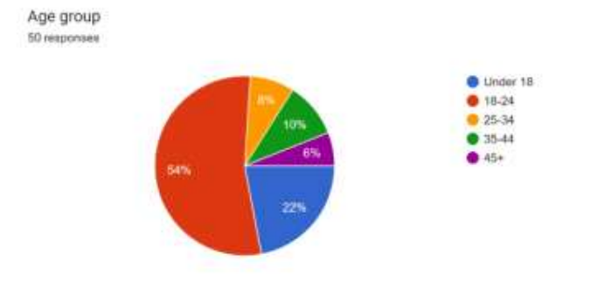

**Interpretation Fig 1 :**

The bulk of respondents (54%) are between the ages of 18 and 24, suggesting that young adults are the main group impacted by celebrity endorsements. A lower proportion of the population is older, indicating that younger consumers should be the target of marketing campaigns aimed at endorsements.

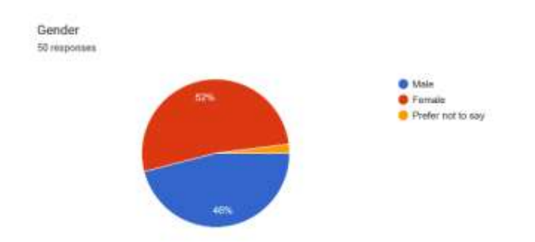

**Interpretation Fig 2 :**

Male respondents (46%) and female responders (52%) are almost evenly divided, with only a small percentage choosing not to divulge. This implies that celebrity endorsements are about equally appealing to men and women.

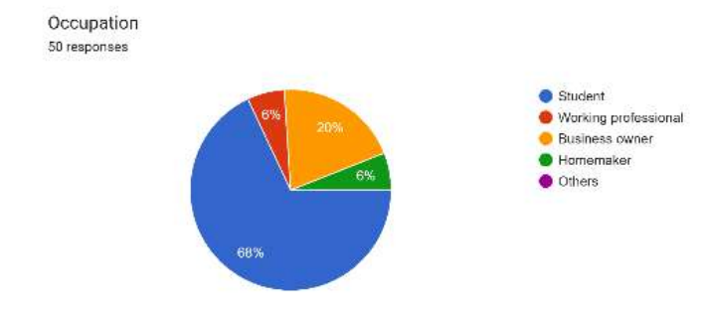

**Interpretation Fig 3 :**

The majority of respondents (68%) are students, with working professionals coming in second (20%). This suggests that younger audiences—especially those who are still in school—are more likely to use products that are promoted by celebrities. This implies that celebrity marketing techniques can be advantageous for companies aiming to attract students and young professionals.

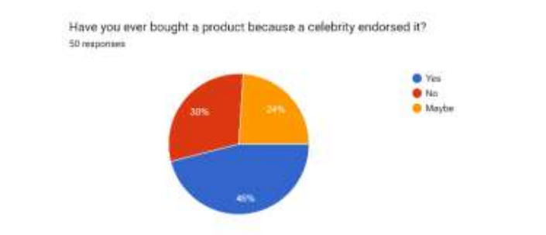

**Interpretation Fig 4 :**

The effectiveness of celebrity influence on consumer behavior is demonstrated by the fact that almost half (46%) of respondents acknowledge having bought a product as a result of a celebrity endorsement. But 30% are still dubious, suggesting that endorsements by themselves might not always be convincing.

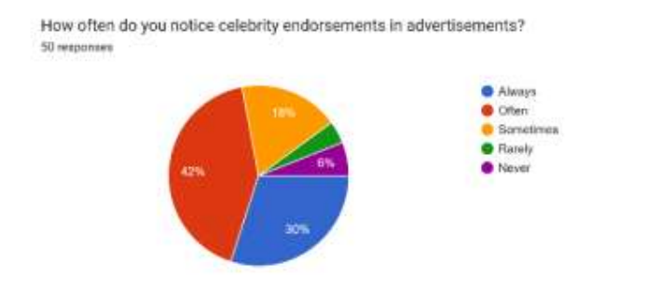

**Interpretation Fig 5 :**

Celebrity-driven ads are very conspicuous, as evidenced by the fact that a sizable percentage (42%) frequently see them and 30% always do. A tiny percentage (6%), however, never or never notice them, suggesting some degree of ad fatigue or apathy.

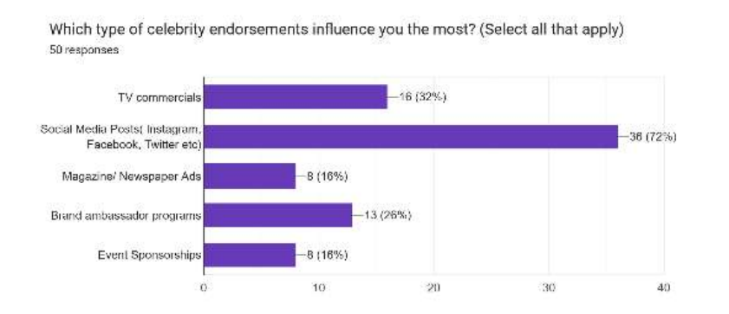

**Interpretation Fig 6 :**

The potency of digital marketing is demonstrated by the fact that social media posts (72%) have the most influence, followed by TV ads (32%), and brand ambassador programs (26%). Conventional strategies, such as magazine advertisements (16%) and event sponsorships (16%), have less of an effect.

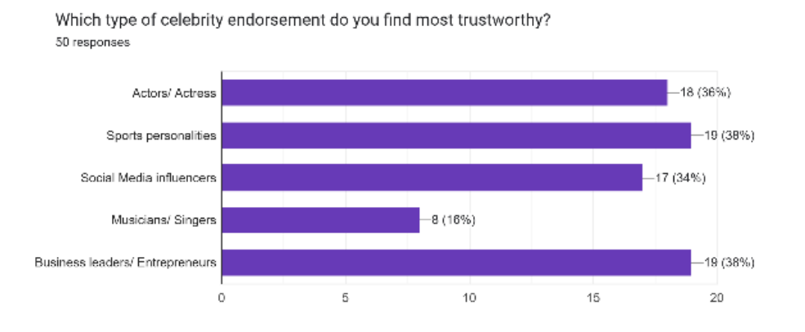

**Interpretation Fig 7 :**

The most trusted people are athletes (36%) and corporate executives (38%), closely followed by actors (36%), while social media influencers and singers are ranked lower. This implies that the efficacy of celebrity endorsements is significantly influenced by knowledge and credibility.

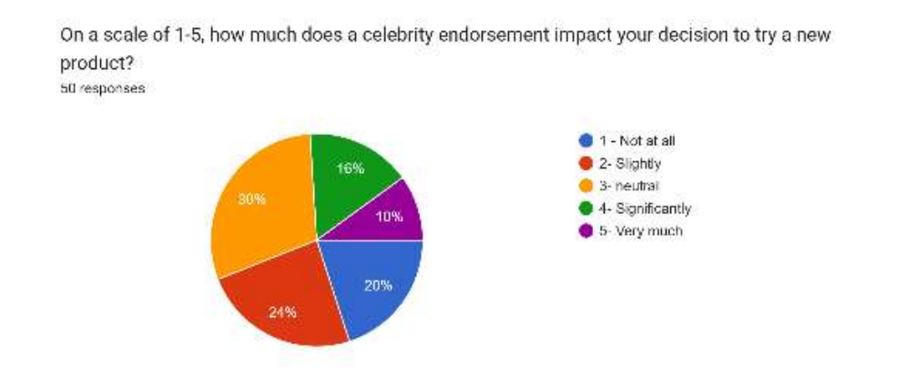

**Interpretation Fig 8 :**

30% of respondents said they were greatly impacted, while another 30% said they were neutral, indicating that while endorsements have a substantial impact, they are not the only determining factor. The fact that only sixteen percent claim to be completely uninfluenced attests to the effectiveness of celebrity marketing.

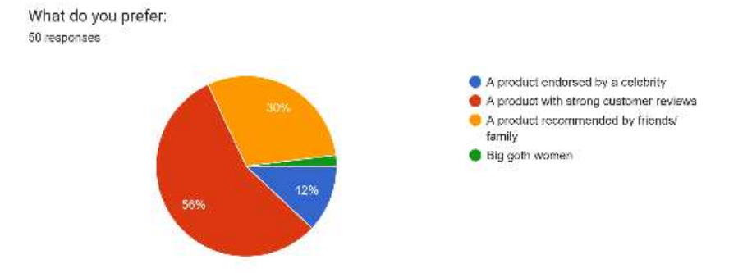

**Interpretation Fig 9 :**

Credibility from actual users trumps celebrity influence, as evidenced by the majority (56%) preferring products with strong customer evaluations compared to just 12% favoring celebrity-endorsed products. The significance of personal trust in purchase decisions is demonstrated by the high value placed on recommendations from friends and family (30%).

**RESEARCH FINDINGS**

1. Audience demographics and composition:

* Young adults make up the greatest consumer base influenced by celebrity endorsements, as evidenced by the fact that 54% of respondents are between the ages of 18 and 24.
* It is implied that younger viewers in academic settings are more interested in celebrity-driven content because students (68%) make up the majority of the occupation group.
* With a little majority of women (52%) over men (46%), the gender distribution is fairly balanced, indicating that celebrity influence appeals to both sexes with a minor bias toward women.

1. Purchase Patterns and the Influence of Celebrities:

* There is a noticeable influence on consumer behavior, as nearly 46% of respondents acknowledged purchasing a product as a result of a celebrity endorsement.
* Celebrity endorsements raise awareness, but they don't necessarily result in prompt action, as evidenced by the 30% of respondents who were undecided ("Maybe").

1. Celebrity endorsements' visibility:

* According to 42% of respondents, they "often" see celebrity sponsorships, and 30% say they "always" notice them, demonstrating how obvious these endorsements are.
* Celebrities are regularly included in marketing channels, as evidenced by the fact that only 6% of respondents said they "rarely" noticed endorsements.

1. Dependability of Celebrity Support:

* The most reliable celebrity endorsers are thought to be sports figures (38%) and company executives/entrepreneurs (38%).
* The rising influence of digital artists is reflected in the high level of trust that social media influencers (34%) enjoy.
* Singers and musicians (16%) had the lowest ranking, possibly as a result of their sponsorships being seen as commercialized.

1. Preferred Influence Channels:

* The most popular platform for celebrity endorsements is social media (72%), which reflects the trend toward digital marketing and fan interaction.
* The effectiveness of traditional advertising is declining, as evidenced by the lower influence of traditional media such as TV commercials (32%), and magazine/newspaper ads (16%).

1. Influence on Purchasing Choices:

* The majority of respondents gave celebrity endorsements a 3 (Neutral, 30%) rating on a scale of 1 to 5, indicating that although they raise visibility, endorsements aren't usually the decisive element.
* Just 10% of respondents gave the impact a 5 (Very Much) rating, suggesting that high influence is restricted to a specific demographic.

1. Customer Preferences:

* 56% of respondents said they give more weight to products with positive customer reviews than to celebrity endorsements when making judgments about what to buy.
* Celebrity endorsements are actively preferred by just 12% of consumers, indicating that peer recommendations and real user experiences are more effective in fostering confidence.

**CONCLUSION**

Celebrity endorsements are now a crucial part of contemporary marketing, helping companies become more visible, more credible, and able to affect consumer behavior. This study emphasizes that although endorsements raise brand recognition and provide aspirational value, their actual influence on consumer choices differs based on a number of variables, including relevancy, authenticity, and trustworthiness of the celebrity-brand link. While singers and entertainment celebrities are typically regarded with greater mistrust, consumers are more likely to believe endorsements from those who are seen as informed and trustworthy, such as sports celebrities and corporate executives.

According to 72% of respondents, social media is the most effective route for celebrity endorsements, demonstrating the expanding power of digital platforms. This change emphasizes the value of online connection, where companies may use influencer partnerships, direct customer contacts, and aesthetically appealing content to strengthen the case for endorsements. Brands must embrace digital-first strategies that appeal to today's tech-savvy consumers while traditional advertising channels like print and broadcast media are losing ground.  
  
However, celebrity endorsements do not always ensure customer trust or prompt purchase action, despite their prominence and persuasiveness.Real user experiences appear to have a bigger impact on purchasing decisions, as seen by the fact that over half of respondents (56%) said they preferred products with positive customer ratings over those promoted by celebrities. Although almost 50% of the participants admitted to purchasing a product as a result of a celebrity's endorsement, a sizable percentage expressed no opinion, suggesting that endorsements by themselves might not be enough to increase conversions.  
  
Brands should concentrate on developing relatable and genuine marketing in order to optimize the impact of celebrity endorsements. Credibility and trust can be increased by choosing endorsers who truly share the brand's values and messaging. A more engaging experience for customers can also be produced by combining interactive material, authentic customer testimonials, and celebrity endorsements.To forge deeper emotional bonds with their audience, brands should use peer recommendations, influence marketing, and community-driven promotions in addition to star power.  
  
In summary, celebrity endorsements are still a potent marketing tool, but their effectiveness hinges on how well they are carried out. Brands can establish significant connections with their target audience by utilizing digital engagement, emphasizing authenticity, and combining endorsements with reliable consumer analytics. In addition to improving brand perception, a well-rounded marketing strategy that blends celebrity attraction with sincere client trust will foster enduring customer loyalty and steady business growth.

**RECOMMENDATIONS**

1. Make Use of Social Media Initiatives:

* Brands should give priority to collaborations with celebrities and influencers on social media sites like YouTube, Instagram, and TikTok, as 72% of respondents said that social media posts have the biggest impact on them.
* To encourage participation and genuineness, produce interactive content like Q&A sessions, behind-the-scenes movies, and product demos.

1. Variety in Celebrity Selections:

* Since business leaders and entrepreneurs (38%) and sports celebrities (38%) are seen as the most reliable, brands ought to partner with individuals who are well-known for their authority in these domains.
* Take into account micro-influencers with specialized audiences for wider appeal, as they frequently have closer personal ties with their followers.

1. Integrate Genuine Reviews with Endorsements:

* Use a hybrid approach that blends celebrity endorsements with real customer testimonies, as 56% of shoppers favor positive customer evaluations over celebrity endorsements.
* Inspire celebrities to combine personal narratives with promotional material to share their sincere product experiences.

1. Put Genuineness Above Glamour:

* Focus on developing ads that emphasize authenticity rather than glamour, as 30% of respondents are ambivalent about the influence of endorsements.
* Show celebrities using the product in everyday situations or through "day-in-the-life" content to humanize the endorsement.

1. Increase Visibility Through a Variety of Channels:

* Despite social media's dominance, conventional media should not be overlooked.
* Campaigns should be integrated into periodicals, TV ads, and event sponsorships to strengthen brand messaging and establish credibility across a range of consumer touchpoints.

1. Make Use of Peer Suggestions:

* Encourage user-generated content and referral schemes to increase word-of-mouth marketing because peer suggestions have more sway.
* Launch initiatives such as "Share Your Experience" competitions, where consumers may narrate their product experiences, with celebrities highlighting particularly noteworthy submissions.

1. Assess and Modify:

* Examine engagement data on a regular basis to determine which celebrity collaborations appeal most to the intended demographic.
* Make sure future campaigns are in line with changing trends and consumer preferences by using these data to improve them.

**REFERENCES**

1. Farooq, O., Ahmed, A., and Mir, F. A. (2018). A Pakistani viewpoint on how celebrity endorsements affect consumers' purchasing decisions. ResearchGate.
2. A Viewpoint From Pakistan on the Influence of Celebrity Endorsement on Consumers: https://www.researchgate.net/publication/326347178
3. N. Klaus (2010). An analysis of consumer attitudes and gender in relation to celebrity endorsements. http://www.researchgate.net/publication/46511087_Celebrity_Endorsements_A_Gender_and_Consumers%27_Attitudes by ResearchGate
4. Weerasiri, S., Dissanayaka, R., Priyankara, R., & Jinadasa, M. (n.d.). Celebrity support and customer intent to purchase in connection with perfume TV commercials. Publisher: David.   
   /index.php/Home/Article/index?id=29456.html <https://davidpublisher.com>
5. Pradhan, B., and A. Pokharel (2018). influence of celebrity endorsements on Kathmandu customers' purchasing decisions for fast-moving consumer products. 3(1), 1–12, Journal of Business and Social Sciences Research. View 20954 at https://nepjol.info/index.php/jbssr/article
6. Mohamed, R. N., Borhan, H., Musaa, R., and Muda, M. (2014). The efficiency of celebrity entrepreneurs' endorsements and advertising. Social and Behavioral Sciences Procedia, 130, 11–18. S1877042814029127 https://www.sciencedirect.com/science/article/pii
7. Tangen, D., and J. Temperley (2006). Consumer perceptions of celebrity endorsements are influenced by the Pinocchio factor. ProQuest. CBL=5240902&pqOrigsite=gscholar https://www.proquest.com/openview/643475ffcb736889807662fc545de65b/1
8. Chen, C. C., and K. S. Freeman (n.d.). lessens the influence of celebrity consent. Journal of Media Technologies and Communication Online. The article "Wither the Impact of Celebrity Endorsement" (https://www.ojcmt.net/article)
9. Çatlı, Ö., Korkmaz, S., & Sertoğlu, A. E. (2014). An empirical study conducted in Turkey looked at how consumers' purchasing intentions were affected by endorser trustworthiness. doij.org/article/97f7b00c2357476f96d0adfb121d6afd