Tourism Management System For Mp

**Harshita Chawla, Kratika Govindjiwala, Krishna Govindjiwala, Prof. Ayushi Malvi**

Department of Computer Science & Technology, Thakur Shivkumar Singh Memorial Engineering College, Burhanpur (MP)

**ABSTRACT**

The Tourism Management System for Madhya Pradesh is an innovative web-based platform designed to enhance the tourism experience in the state of Madhya Pradesh, India. Madhya Pradesh, known as the "Heart of India," boasts a rich cultural heritage, historical landmarks, and diverse wildlife. This system serves as a comprehensive guide for tourists, providing easy access to information about popular tourist destinations, accommodations, cultural heritage, events, and local attractions. It offers features like itinerary planning, online bookings, and real-time updates, helping tourists plan their visit efficiently.

**INTRODUCTION**

This research paper presents the development of a Tourism Management System for Madhya Pradesh, a region rich in historical, cultural, and natural attractions, which is experiencing a surge in interest from both domestic and international tourists. Recognizing the limitations of traditional tourism management methods, the system offers a centralized and user-friendly platform designed to enhance accessibility and efficiency for tourists, tour operators, and government officials.

The platform integrates essential services such as destination information, accommodation bookings, transportation options, local events, and cultural attractions, thereby streamlining processes related to trip planning, booking, and feedback collection. This initiative represents a significant advancement in the digital transformation of Madhya Pradesh's tourism sector, ultimately aiming to provide a more organized, efficient, and enjoyable experience for all stakeholders involved.

**OBJECTIVE OF PROJECT**

* There are some basic objectives of the Tourism Management System for MP:
* To provide tourists with complete information about destinations in Madhya Pradesh.
* To make trip planning and booking easy through an online platform.
* To promote the culture, heritage, and natural beauty of Madhya Pradesh.
* To offer a user-friendly system for both tourists and tourism officials.
* To ensure safety and convenience for travellers with emergency and support features.
* To improve the overall travel experience in Madhya Pradesh.
* To encourage more domestic and international tourists to visit the state.

**LIMITATIONS**

* + - * **Internet Access:**  
        The website requires a **stable internet connection**, which may be an issue in remote or rural areas.
      * **Language Barriers:**  
        While it may support multiple languages, there could still be **language gaps** for some regional or international tourists.
      * **Updates and Accuracy:**  
        **Real-time data** (like availability and pricing) may not always be 100% accurate if service providers fail to update their information on time.
      * **Limited Coverage for Remote Areas:**  
        Some **remote or less popular destinations** may not be fully represented or have limited online services available.
      * **Technical Issues:**  
        Like any online system, it may face **technical glitches** or downtime, affecting accessibility for tourists.
      * **Data Privacy and Security:**  
        **Personal and payment data** of tourists need to be protected, which requires continuous security measures.
      * **Initial Awareness and Adoption:**  
        Tourists and local businesses might be **slow to adopt** and trust the system in the beginning.

**APPLICATIONS**

* + - * **Online Travel Planning:**  
        Tourists can browse destinations, create itineraries, and plan trips with ease.
      * **Destination Information Access:**  
        Provides details about historical sites, wildlife parks, cultural events, festivals, and local attractions.
      * **Tour Guide Integration:**  
        Connects travellers with certified local guides and curated tour packages.
      * **Tourist Feedback System:**  
        Allows users to share reviews and suggestions to improve services.
      * **Emergency Assistance and Support:**  
        Provides access to nearby police stations, hospitals, and helplines during travel

**FEASIBILITY STUDY**

A feasibility analysis is a test of the system proposal according to its workability, impact on organization, ability to meet user needs and effective use of resources. The objective of the feasibility analysis is not to solve the problem but to acquire sense of its scope.

**Steps in feasibility analysis:**

1. Form a project team and appoint a project leader.
2. Prepare system flowcharts.
3. Enumerate potential proposed Systems.
4. Define and identify characteristics of proposed system.
5. Determine and evaluate performance and cost effectiveness of each proposed system.

**RESULTS**

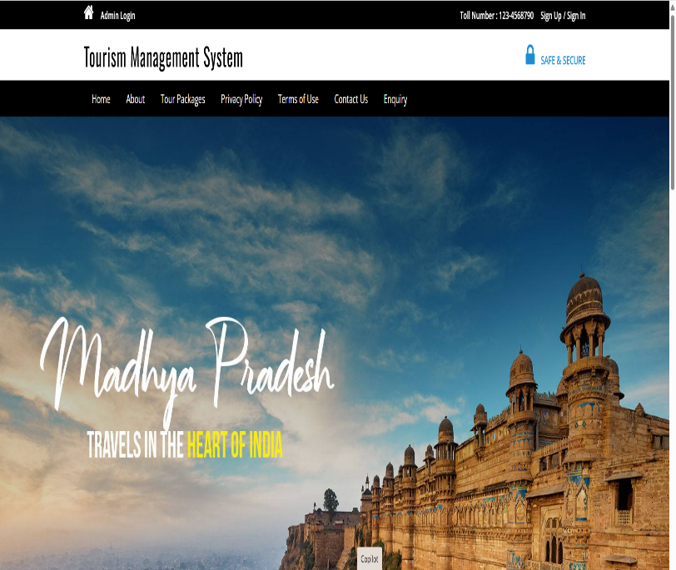

**Fig (a) Home Page Tourism Management System.**

**DESCRIPTION**

This website is a comprehensive Tourism Management System developed to promote and streamline tourism services across Madhya Pradesh. It provides a centralized platform where tourists can explore top destinations, view detailed travel packages, book accommodations, and get assistance from local guides. The site offers a secure login system for tourists, administrators, and travel agents, each with role-specific features. Tourists can browse popular attractions such as Khajuraho, Sanchi, Pachmarhi, and Kanha National Park, while also planning trips using real-time booking and itinerary tools. Designed with user experience and accessibility in mind, the website helps enhance tourism in Madhya Pradesh by making travel planning more convenient, transparent, and digital-first.

**CONCLUSION**

• **Empowering Users**: The system provides a platform for tourists, travel agents, and administrators to easily manage travel bookings, itineraries, and user accounts.

• **User-Friendly Interface:** It offers an intuitive and accessible interface, addressing the problem of complex and confusing interfaces found in previous systems.

• **Comprehensive Services:** The platform includes features for browsing and booking travel packages, managing itineraries, and handling payments, providing a complete tourism management solution.

• **Secure and Scalable:** The system is designed with robust security features to protect user data and financial transactions, while being scalable to handle increasing users and content.

• **Solution to Existing Problems:** It overcomes common challenges such as fragmented information, poor user experience, and difficulty accessing resources in previous tourism systems.

• **Technologically Advanced**: Utilizes modern web technologies like PHP, MySQL, and responsive front-end frameworks, ensuring a seamless and efficient system.

• **Support for Users:** The system supports tourists, travel agents, and administrators by providing streamlined processes, secure transactions, and easy management tools.

• **Future Potential:** The platform has great potential for future expansion, including the addition of new features, such as real-time tracking, AI-driven recommendations, and integration with other tourism resources.

**FUTURE SCOPE**

**1.Package Expansion:**

Adding more travel packages and modules that cover diverse aspects of tourism, including adventure tourism, eco-tourism, cultural experiences, and luxury travel.

**2**.**Mobile Application:**

Developing a mobile app version of the system for enhanced accessibility, allowing tourists, travel agents, and administrators to manage bookings, view itineraries, and make payments while on the go.

**3**.**AI Integration:**

Introducing AI-driven features such as personalized travel recommendations based on user preferences, past bookings, and travel behavior, as well as optimized itinerary planning.

**4**.**Global Reach:**

Expanding the platform to support multiple languages and currencies, enabling international tourists to easily browse, book, and manage travel packages across the globe.

**5.Collaboration with Local Businesses and Service Providers:**

Partnering with local hotels, restaurants, and attractions to provide exclusive deals, experiences, and activities for travelers, offering them more personalized and localized options.

**6.Gamification:**

Adding gamified elements like loyalty points, badges, or rewards for users who book multiple packages, refer friends, or complete specific tasks on the platform, encouraging greater engagement.

**REFERENCES**

**1. Official Tourism Websites**  
Madhya Pradesh Tourism Department. (n.d.). *Official Tourism Website*. Retrieved from [http://www.mptourism.com](http://www.mptourism.com/)

Incredible India. (n.d.). *Tourism in India*. Retrieved from [http://www.incredibleindia.org](http://www.incredibleindia.org/)

**2. Books on Tourism Management**  
Page, S. J. (2020). *Tourism Management* (6th ed.). Routledge.

**3. Research Papers and Journals**  
Singh, R., & Sharma, M. (2019). Digital platforms and their role in tourism management: A case study of India. *International Journal of Tourism Research, 21*(2), 112-125. https://doi.org/10.1002/jtr.2259

**4. Statistical Data Sources**  
Ministry of Tourism, Government of India. (2022). *Tourism Statistics of India 2022*. Government of India. Retrieved from [http://www.tourism.gov.in](http://www.tourism.gov.in/)

**5. Articles on Tourism Technology**  
Jones, A. (2021, March 15). The future of tourism: How technology is transforming travel experiences. *Tech Travel Magazine*. Retrieved from [https://www.techtravelmag.com](https://www.techtravelmag.com/)

**6. News Articles**  
Sharma, V. (2023, February 25). How digital transformation is reshaping the tourism sector in India. *The Economic Times*. Retrieved from https://economictimes.indiatimes.com