User Engagement and Satisfaction in BizGuide:
A Case Study of Entrepreneurial Resource Utilization
Amit Shah, Ketan Mahajan, Prof. Kiran Tayde
Department of Computer Science and Engineering, Thakur Shiv Kumar Singh Memorial Engineering College Burhanpur (M.P.)

ABSTRACT
The BizGuide is an innovative interactive digital mentor designed to assist both aspiring and established entrepreneurs in navigating the complexities of business development. Utilizing advanced artificial intelligence technologies, the platform offers personalized guidance, resources, and real-time feedback tailored to individual user needs. Key features include business planning tools, financial modeling support, market analysis insights, and access to curated educational materials. By simulating the expertise of experienced mentors, BizGuide promotes self-paced learning and enhances decision-making skills, fostering entrepreneurial growth. This project seeks to democratize access to mentorship, equipping users with actionable insights and practical tools necessary for launching, managing, and scaling their ventures. Furthermore, the platform bridges the gap between traditional mentorship and modern technology, promoting innovation and inclusivity within the entrepreneurial landscape.
INTRODUCTION
The Bizguide is an innovative AI-powered platform designed to support entrepreneurs throughout their business journey by offering personalized advice, interactive tools, and industry-specific resources.

This platform provides real-time, conversational guidance tailored to the unique needs of each entrepreneur, addressing their specific industry, goals, and challenges. Key features include a comprehensive knowledge hub with curated resources, automated business planning tools, goal tracking, and performance metrics. Entrepreneurs can utilize templates for business plans, pitch decks, and financial forecasts, as well as engage in scenario-based decision simulations to enhance their strategic thinking. Additionally, networking tools facilitate connections with mentors, investors, and fellow entrepreneurs, promoting collaboration and shared learning. By harnessing advancements in AI, natural language processing, and data visualization, the Bizguide delivers actionable insights and continuous support, targeting aspiring entrepreneurs, startup founders, and growth-stage businesses. This platform democratizes access to business expertise, significantly improves entrepreneurial success rates, and fosters innovation by addressing critical challenges such as market validation, funding, and scaling. Ultimately, the Interactive Digital Mentor serves as an essential partner for entrepreneurs seeking to refine their ideas or expand their businesses globally.

OBJECTIVE OF PROJECT
- The objective of this Project is to create a dynamic, AI-driven platform that supports entrepreneurs across various stages of their business journey by providing personalized guidance, resources, and tools. This platform aims to empower entrepreneurs to transform their ideas into successful businesses while overcoming common challenges with confidence and efficiency.
- The mentor is designed to deliver tailored advice and recommendations based on an entrepreneur’s industry, goals, and business stage. By leveraging artificial intelligence, natural language processing, and data analytics, it offers interactive decision-making tools, real-time feedback, and actionable insights. Entrepreneurs can access curated resources such as business plan templates, financial forecasting tools, and market analysis reports, enabling informed and strategic decision-making.
- Additionally, the platform seeks to foster collaboration and learning by connecting users with mentors, investors, and fellow entrepreneurs. It also emphasizes goal tracking and performance monitoring, providing continuous feedback to help users stay aligned with their objectives.
- By democratizing access to expertise and resources, this project aims to improve entrepreneurial success rates, promote innovation, and create a supportive ecosystem where businesses can thrive and contribute to global economic growth.

Applications of Interactive Digital Mentor for Entrepreneurs
1. Business Idea Validation:
- Helps entrepreneurs assess the feasibility of their ideas using market research tools, customer surveys, and validation frameworks.
2. Strategic Planning:
- Assists in creating detailed business plans, marketing strategies, and operational roadmaps tailored to specific industries.
3. Financial Management:
- Provides tools for budgeting, financial forecasting, and cash flow management to ensure sustainability and growth.
4. Skill Development:
- Offers training modules on essential entrepreneurial skills like leadership, negotiation, marketing, and fundraising.
5. Market Research and Analysis:
- Equips entrepreneurs with AI-driven tools to analyse market trends, customer behaviour, and competitor strategies.
6. Networking and Collaboration:
- Connects users with mentors, peers, investors, and industry experts, fostering collaboration and support.
7. Resource Accessibility:
- Centralizes access to templates, case studies, video tutorials, and other essential resources for entrepreneurs.
8. Decision-Making Support:
- Provides scenario-based simulations to help entrepreneurs practice and improve their decision-making skills.
9. Funding Assistance:
- Guides users in identifying funding opportunities, preparing investor pitches, and connecting with potential backers.

LIMITATIONS
- Limited Industry Coverage.
- Dependence on Input Quality.
- No Legal or Financial Liability.
- Static Resource Pool (Initial Version).
- Language Support.
- AI Limitations.
- No Real-time Market Data Integration.

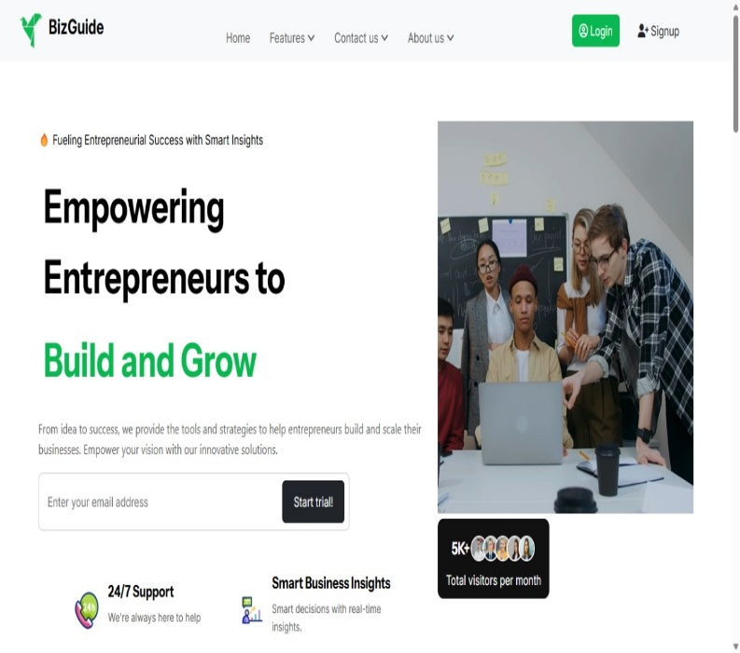
RESULT

Fig1.1 BizGuide Home Page

DEMONSTRATIONS
The Interactive Digital Mentor for Entrepreneurs project presents a comprehensive digital platform aimed at supporting entrepreneurs through a user-friendly interface and robust functionalities. This paper provides a visual overview of the system, detailing its home page where users can register, log in, and explore various mentorship features. The secure authentication process allows users to create personalized accounts, leading them to an interactive dashboard that serves as the main access point for essential tools such as an AI-powered chatbot and a suite of learning resources. The chatbot facilitates real-time interactions, offering tailored advice on critical aspects of business development, including planning, marketing, and funding strategies. The platform also includes diverse learning modules comprising articles, templates, and videos to foster entrepreneurial growth. Additionally, the goal tracking feature empowers users to set and monitor their business objectives effectively. Administrative capabilities are highlighted through an admin panel that enables user management and content updates. The project's responsive design is showcased through a mobile view snapshot, ensuring accessibility across various devices. This research underscores the potential of digital mentorship in enhancing entrepreneurial success through interactive and personalized support.

CONCLUSION

    - Empowering Entrepreneurs: The project provides a platform for entrepreneurs to access educational resources and mentorship, helping them develop their skills.
    - User-Friendly Interface: It addresses the issue of complex interfaces, offering an intuitive and accessible user experience.
    - Comprehensive Learning: The platform provides interactive learning tools such as video lectures, notes, assignments, and discussion forums, enabling personalized learning experiences.
    - Secure and Scalable: The system is designed with robust security measures and scalability, ensuring the platform can grow and handle increasing users.

    - Solution to Existing Problems: The project overcomes the challenges faced by previous platforms, such as lack of information and difficulty in accessing resources.
    - Technologically Advanced: Utilizes modern web technologies, including PHP, MySQL, and front-end frameworks, to create a seamless and efficient system.

FUTURE SCOPE
- Course Expansion: Adding more courses and modules covering diverse aspects of entrepreneurship, including finance, marketing, and leadership.
- Mobile Application: Developing a mobile app version for better accessibility and user engagement on the go.
- AI Integration: Introducing AI-driven personalized mentoring and course recommendations based on user progress and interests.
- Global Reach: Expanding the platform to support multiple languages and reach a broader, international audience.
- Collaboration with Industry Experts: Partnering with established entrepreneurs and experts to offer webinars, masterclasses, and live sessions.
- Gamification: Adding gamified elements to enhance engagement and provide users with incentives for completing learning modules.
- Certification Programs: Offering accredited certifications for course completion to add value to users' entrepreneurial journeys.
REFERENCES
- Books:
- Kauffman, S. (2015). The Lean Startup: How Today's Entrepreneurs Use Continuous Innovation to Create Radically Successful Businesses. Crown Business.
- Osterwalder, A., & Pigneur, Y. (2010). Business Model Generation: A Handbook for Visionaries, Game Changers, and Challengers. Wiley.
- Articles:
- Ratten, V. (2014). "The role of entrepreneurship education in developing entrepreneurial mindsets," Education + Training, 56(8/9), 900-912.
- Rizvi, S. (2013). "Digital mentoring: A new era for entrepreneurs," Journal of Entrepreneurship and Innovation, 6(2), 45-52.
- Websites:
- TechCrunch. "The Role of Technology in Entrepreneurship." TechCrunch
- Entrepreneur.com. "How to Create a Digital Mentorship Program for Entrepreneurs." Entrepreneur
- Reports:
- World Economic Forum. (2020). "The Future of Jobs Report 2020." World Economic Forum.
- Global Entrepreneurship Monitor. (2021). Global Report. GEM.
- Online Resources:
- Government Databases and Websites
- Industry Reports and Market Research
- Educational Resources and Business Plan Templates
- Marketplaces for Entrepreneurs
- Entrepreneurial Communities and Forum

