Wireless Charging of Electrical Vehicle While Driving

Project Guide : PROF. Nishant B. Joshi

# Priyanshu Barve

Student of Electrical Engineering Department,

Smt. Indira Gandhi College of Engineering, Mumbai University, Navi Mumbai, Maharashtra, India.

# Harsh Patil

Student of Electrical Engineering Department,

Smt. Indira Gandhi College of Engineering, Mumbai University, Navi Mumbai, Maharashtra, India.

## Bhavesh Gaikwad

Student of Electrical Engineering Department,

Smt. Indira Gandhi College of Engineering, Mumbai University, Navi Mumbai, Maharashtra, India.

## Sushant Thite

Student of Electrical Engineering Department,

Smt. Indira Gandhi College of Engineering, Mumbai University, Navi Mumbai, Maharashtra, India.

***Abstract—As an alternate form in the road transportation system, electric vehicle (EV) can help reduce the fossil-fuel consumption. However, the usage of EVs is constrained by the limited capacity of battery. Wireless Power Transfer (WPT) can increase the driving range of EVs by charging EVs in motion when they drive through a wireless charging lane embedded in a road. The amount of power that can be supplied by a charging lane at a time is******limited.***

1. Introduction

The reduction of fossil fuels and the need to reduce urban pollutants have made electric vehicles as an appropriate alternative to domestic combustion engines. Electric vehicles can act as a source of energy by using vehicle-to-home (V2H) and vehicle-to-grid (V2G) capabilities. The V2G capability allows vehicles to act as a mobile storage device which can inject the storage energy into the grid [3]. The V2G capability allows for active power regulation, reactive power support, load modulation, flow harmonic filtering and peak charge correction.

However, it is important to note that the economic benefits of V2G capability depend on how to charge and discharge electric vehicles. If the charging process is not controlled, charging time periods will intersect with the peak load time of the distribution system, thereby increasing peak load, and the distribution system faces with problems such as overload, excessive loss of power and voltage violation. Therefore, charging patterns should be designed in such a way to persuade users to transfer charge periods to off-peak periods. The effects of the presence of plug-in hybrid electric vehicles (PHEV) have been studied in several articles.

In this paper, various strategies for coordinating the charging/discharging of PHEVs are proposed in electric vehicle parking with V2G capability. The proposed strategies include constraints on the amount of power exchange the distribution system, as well as the random and unpredictable nature of quantities. Finally, the impact of each strategy on the amount of parking dividend is analyzed.

1. Methodology

To develop a wireless power transfer (WPT) system for electric vehicles, we began by designing a system based on inductive coupling, where power is transferred through magnetic fields between two coils—one embedded in the ground (transmitter) and the other installed underneath the vehicle (receiver). The entire setup is supported by power electronics that convert standard electrical power into high-frequency alternating current, which is better suited for efficient wireless transmission. Choosing the right type of resonant circuit—either series-series or series-parallel—was a key step in ensuring consistent energy transfer across a practical range and distance

A vital part of the system is the control and communication mechanism. This allows the transmitter and receiver to constantly exchange information—such as charge status and any alignment issues—through wireless communication protocols like Bluetooth or Zigbee. We also integrated safety features to detect foreign objects, regulate temperature, and automatically shut down the system if any issues are detected.

To test our design, we ran simulations using tools like MATLAB/Simulink to model how the system would perform under real-world conditions. After this, we built a small-scale prototype to validate our results and make any necessary adjustments. Finally, we evaluated the system based on key performance metrics, including energy transfer efficiency, how well it handled misalignment, overall charging time, and whether it met safety and electromagnetic compatibility standards.

1. Functional Block Diagram

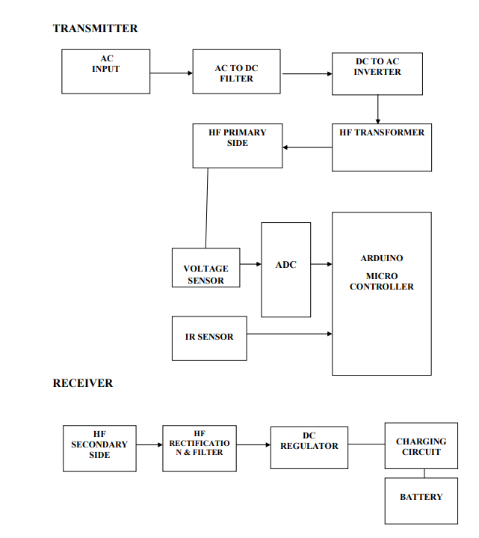

Fig.1. Functional block of WPT of Electrical Vehicle

1. ARDUINO UNO

Arduino is an open-source project that created microcontroller-based kits for building digital devices and interactive objects that can sense and control physical devices. The project is based on microcontroller board designs, produced by several vendors, using various microcontrollers. These systems provide sets of digital and analog input/output (I/O) pins that can interface to various expansion boards (termed shields) and other circuits. Stepdown Transformer

1. Electromechanical Relay

A relay is a basic electromechanical switch. A Relay is an electrical device that connects or separates two circuits, similar to how we manually open or close a circuit. Instead of a human action, a relay sends an electrical signal to an electromagnet, which connects or separates another circuit. When an electromagnet is powered by electricity, it creates an electromagnetic field around itself. A switches is used to deliver direct current (DC) to the load. The relay's

electromagnet is composed of a copper coil and an iron core. When the magnetic coil is charged with direct current (DC), it begins to attract the contact, as illustrated. This is known as relay energizing. When you remove the supply, it returns to its previous place. This is referred to as relay de-energization.

1. IR Sensor

An **IR (Infrared) sensor** is an electronic device that detects infrared radiation (heat) or light emitted from objects in its field of view. In the context of this wireless power transfer system for electric vehicles, the IR sensor is primarily used for **vehicle detection**. It helps identify whether a car is properly aligned and present above the transmitter coil before initiating the charging process.

1. LCD Display

The **LCD (Liquid Crystal Display)** is used in the wireless power transfer system to provide real-time visual feedback to the user. It acts as a simple and effective interface that displays important system information such as **charging status, voltage levels, vehicle detection status, errors, or completion messages**. By using an LCD, the user can easily monitor whether the vehicle is properly aligned, if the charging has started, or if any faults have been detected.

1. Battery

Batteries are a collection of one or more cells whose chemical reactions create a flow of electrons in a circuit. All batteries are made up of three basic components: an anode (the ‘-’ side), a cathode (the ‘+’ side), and some kind of electrolyte (a substance that chemically reacts with the anode and cathode).

1. AC Source

It is a device that can deliver variable power and frequency to a load. An alternating current (AC) power source generates an current is alternating that may be used to power or test another piece of device by imitating electrical grid disruptions, the presence of harmonics, transients, or other occurrences that might lead an equipment under test (DUT) to break down.

1. Transmitting And Receiving Coils

The **transmitting and receiving coils** are the heart of the wireless power transfer system. These coils are responsible for creating and capturing the magnetic field that transfers energy wirelessly between the power source and the electric vehicle's battery.

1. Circuit Diagram

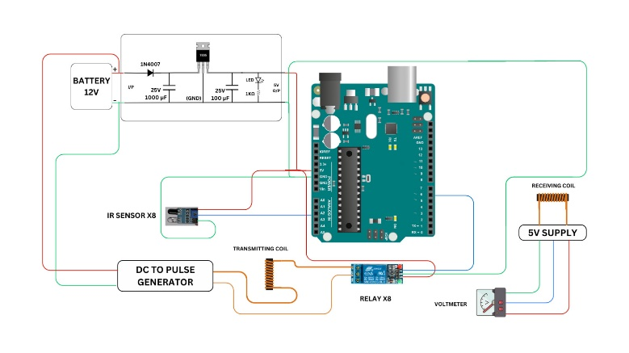

Fig.2 Circuit diagram of WPT of Electrical vehicles

The wireless power transfer (WPT) system for electric vehicles is divided into two main sections: the **transmitter** and the **receiver**. The process begins at the transmitter side, where an AC power source provides the input. This alternating current is first converted into direct current using an AC to DC filter, which also helps smooth out any voltage fluctuations. The filtered DC power is then fed into a DC to AC inverter, which converts it into high-frequency alternating current. This high-frequency AC is essential for efficient wireless transmission and is sent through a high-frequency transformer that transfers energy to the primary coil, creating a magnetic field necessary for inductive coupling.

To ensure the system operates safely and efficiently, a voltage sensor continuously monitors the voltage levels, and an IR sensor detects the presence of a vehicle above the coil. These sensor signals are processed through an Analog-to-Digital Converter (ADC) and sent to an **Arduino microcontroller**, which acts as the control unit of the entire system. The Arduino is responsible for interpreting sensor data, making decisions on when to activate or deactivate power transfer, and maintaining overall control of the transmission process. It adds a layer of intelligence and safety by preventing charging unless a vehicle is properly aligned.

On the receiver side, a secondary coil captures the magnetic energy wirelessly transmitted from the primary coil. This high-frequency AC is then passed through a rectification and filter circuit, converting it back into DC. A DC regulator ensures that the voltage level is appropriate for charging. The regulated power is finally sent to a charging circuit, which safely charges the vehicle’s battery. Throughout the system, the use of the Arduino microcontroller allows for smart monitoring, better efficiency, and responsive control, making the WPT system more reliable and user-friendly.

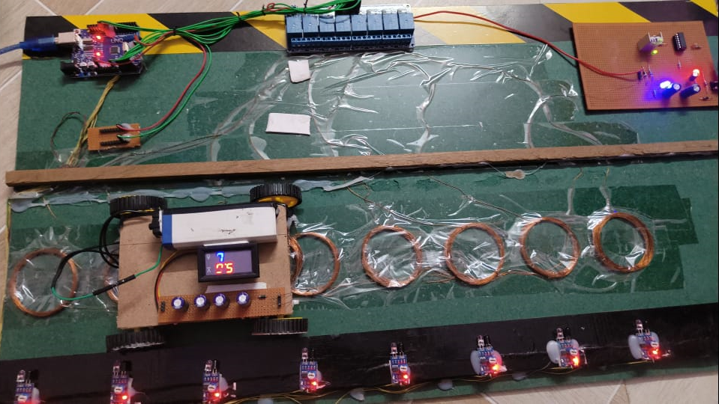

Fig.3 WPT unit

1. Expected Outcome

The primary expected outcome of this project is the successful development and demonstration of a working **wireless power transfer system** that can charge an electric vehicle battery without the need for physical connectors. The system will be capable of efficiently transferring power over a short distance using inductive coupling, with a well-designed transmitter and receiver coil arrangement.

By incorporating an **Arduino microcontroller**, the system will offer smart control features such as vehicle detection using IR sensors, voltage monitoring, and safety mechanisms like automatic shut-off in case of misalignment or abnormal voltage levels. The microcontroller will also manage real-time data processing and decision-making, making the system more intelligent and user-friendly.

The prototype is expected to demonstrate a **stable, efficient, and safe power transfer** from the transmitter to the receiver, with minimal energy loss. Additionally, the system will provide a proof-of-concept that wireless charging for EVs can be implemented in a cost-effective and scalable manner, potentially reducing dependency on plug-in charging stations and improving user convenience.

Overall, the project aims to showcase the feasibility of integrating wireless charging into future electric vehicle infrastructure, promoting cleaner, more efficient, and contactless energy solutions.

1. Application

The wireless power transfer system developed in this project has several practical and impactful applications, particularly in the field of electric mobility. One of the most significant uses is in **electric vehicle (EV) charging**, where this technology can eliminate the need for physical charging cables, offering a safer, cleaner, and more convenient alternative. This is especially useful in public charging stations, parking lots, and residential garages, where drivers can simply park their vehicles over a charging pad and allow the system to charge the battery automatically. Additionally, the system can be integrated into **dynamic charging infrastructure**, where EVs can be charged while in motion over specially equipped road segments, potentially extending driving range without frequent stops.

1. Future Scope

The future scope of wireless power transfer (WPT) technology in electric vehicles is vast and promising. As the demand for electric vehicles continues to grow, there will be an increasing need for more efficient, user-friendly, and automated charging solutions. This project can be further developed by improving power transfer efficiency, increasing the charging distance, and enabling high-power fast charging capabilities. Advanced control systems and AI-based monitoring could be integrated to enhance safety, performance, and adaptability under varying conditions. Another exciting area is **dynamic wireless charging**, where vehicles can be charged while in motion on specially designed roads, reducing downtime and increasing range.

1. Conclusion

In this system, we are presenting the Wireless Power Transmission. As the electric vehicle in the market is increasing. We can use the wireless charging system to charge our vehicles. This system shows the efficiency and implementation of the charging station in future technology. This paper also covers future technology like payment through RFID tags and self-serviced entry and exit gate to maintain congestion at the station. This will be helpful for those who are doing research in the field of wireless power transmission. And many had came up with the greatest invention like charging mobile wirelessly, and other electronic gadgets too. This could be the future scope for developing the charging station, As electric vehicle are increasing in demand.

**References**

1. L. Cheng, Y. Chang, Q. Wu, W. Lin and C. Singh, “Evaluating charging service reliability for plug-in EVs from the distribution network aspect,” IEEE Transactions on Sustainable Energy. IEEE, vol. 5, pp.1287-1296, 2014.
2. N. Xu and Y.Chung, “Reliability evaluation of distribution systems including vehicle-to-home and vehicle-to-grid,” IEEE Transactions on Power Systems. IEEE, vol. 31, pp.759-768, 2016.
3. A. Alahyari, M. Fotuhi-Firuzabad and M. Rastegar, “Incorporating customer reliability cost in PEV charge scheduling schemes considering vehicle-to-home capability,” IEEE Transactions on Vehicular Technology. IEEE, vol.64, pp. 2783- 2791, 2015.
4. M. Ansari, A. Al. Awami, E. Sortomme and M. Abido, “Coordinated bidding of ancillary services for vehicleto-grid using fuzzy optimization,” IEEE Transactions on Smart Grid. IEEE, vol. 6, pp. 261-270, 2015.
5. S. Habib, M. Kamran and U. Rashid, “Impact analysis of vehicle-to-grid technology and charging strategies of electric vehicles on distribution networks--a review,” Journal of Power Sources. Elsevier, vol. 277, pp.205- 214, 2015.