Automatic Seed Sowing and Pesticide Spraying Robot

¹Sejal Adle, ²Keshar Rasekar, ³Bhavesh Dhote, ⁴Tejas Wadbudhe, ⁵Ms.Prachi D. Pendke

¹,²,³,⁴Student’s PCE Nagpur

⁵ Assistant Professor PCE Nagpur

1. [sejaladle@gmail.com](mailto:sejaladle@gmail.com)
2. [rasekarkeshar@gmail.com](mailto:rasekarkeshar@gmail.com)
3. [bhaveshdhote2003@gmail.com](mailto:%20bhaveshdhote2003@gmail.com)
4. [wadbudetejas@gmail.com](mailto:wadbudetejas@gmail.com)
5. [prachi21bajaj@gmail.com](mailto:%20prachi21bajaj@gmail.com)

# Abstract

Agricultural automation has become essential to enhance efficiency and productivity while reducing labor-intensive tasks. Traditional seed sowing and pesticide spraying methods often face challenges such as uneven seed distribution, excessive pesticide usage, and high dependency on manual labor. To address these issues, this research proposes an **Automatic Seed Sowing and Pesticide Spraying Robot**, designed to optimize precision farming. The system is built using a microcontroller-based architecture, integrating sensors, actuators, and motor-driven mechanisms to ensure accurate seed placement and uniform pesticide distribution. The robot employs a DC motor-driven seed dispensing unit, a sprayer pump for pesticide application, an ultrasonic sensor for obstacle detection, and a Bluetooth module for remote control. This paper discusses the detailed design, implementation, and testing of the proposed system, demonstrating its effectiveness in improving agricultural efficiency while minimizing resource wastage.

**Keywords:** Arduino nano, Motor driver, Pesticide pump, Lcd display, Bluetooth module.

# Introduction

Farming is one of the most important activities for food production, but traditional methods of seed sowing and pesticide spraying require a lot of time and effort. When done manually, these tasks can lead to uneven seed distribution, excessive pesticide use, and high labor costs. These challenges make farming less efficient and can result in lower crop yields. To improve productivity and reduce the burden on farmers, there is a need for smart and automated solutions that can perform these tasks more accurately and efficiently.

This project, called **Automatic Seed Sowing and Pesticide Spraying Robot**, is designed to help farmers by using modern technology to automate these essential farming activities. The system includes a microcontroller to control the seed dispenser and pesticide sprayer, along with sensors to detect obstacles and ensure smooth operation. By using this robot, farmers can save time, reduce labor costs, and minimize resource wastage, leading to better crop growth and higher efficiency. This research focuses on the design, working, and benefits of the system in making farming easier and more effective.

# Related Work

Several Many researchers have worked on improving farming methods using automation and robotics. **Sharma and Patel (2018)** developed a basic seed sowing machine that improved seed distribution compared to manual methods. **Gupta et al. (2019)** introduced a robotic system for pesticide spraying, which helped reduce excessive chemical usage. **Verma and Singh (2020)** combined seed sowing and pesticide spraying in a single automated system, making farming more efficient and reducing labor costs. These studies have shown that automation can make agriculture faster, more precise, and less dependent on manual labor.

More recent research has focused on making agricultural robots smarter and more reliable. **Kumar and Yadav (2021)** worked on improving the accuracy of seed placement using sensor-based control systems. **Mishra and Rao (2022)** designed a system with obstacle detection to ensure smooth movement in the field. **Jain et al. (2023)** explored the use of wireless communication to allow remote monitoring and control of farming robots. These studies provide a strong foundation for our **Automatic Seed Sowing and Pesticide Spraying Robot**, which integrates advanced sensors and automation to improve farming efficiency and reduce resource wastage.

# System Design and Architecture

* 1. **Hardware Components**

The Automatic Seed Sowing and Pesticide Spraying Robot is built around the following key hardware components:

* + 1. **Microcontroller (ATmega328P)** – The core processing unit that controls the entire system, interpreting sensor data and executing commands for seed sowing and pesticide spraying operations with precision.
    2. **12V Motor** – A DC motor responsible for driving the movement of the chassis or controlling the mechanical seed-sowing mechanism, ensuring consistent operation across varied terrains.
    3. **12V Power Supply** – Provides the primary power source for the system, ensuring stable and continuous operation of all electrical and mechanical components during fieldwork.
    4. **Voltage Regulator (IC 7805)** – Regulates the 12V input down to a stable 5V output for microcontroller and other low-voltage components, protecting sensitive electronics from voltage spikes.
    5. **LCD Display (16x2)** – A user-interface display used to show real-time system information such as temperature, humidity, s
    6. praying status, and Bluetooth connectivity, enhancing system monitoring.
    7. **DHT11 Temperature & Humidity Sensor** – Monitors environmental conditions to determine optimal times for pesticide spraying and seed sowing, increasing agricultural efficiency and reducing waste.
    8. **Bluetooth Module (HC-05)** – Enables wireless communication between the system and a smartphone or remote device, allowing remote control and real-time data monitoring in the field.
    9. **Relay Module (5V / SPDT)** – Acts as an electronic switch to control the high-power 12V diaphragm pump using signals from the microcontroller, ensuring safe and efficient spraying.
    10. **Motor Driver (L298)** – Dual H-Bridge motor driver that allows control of the 12V DC motor's speed and direction via the microcontroller, essential for navigation and precision seed placement.
    11. **12V Diaphragm Pump** – A compact and efficient pump that pressurizes and delivers pesticides through the nozzle, enabling uniform and controlled spraying over crops.
    12. **1mm Nozzle** – A precision spray nozzle that ensures fine and even distribution of pesticides over the target area, minimizing wastage and enhancing coverage.
    13. **PCB (Glass Panel)** – Custom-etched Printed Circuit Board that interconnects all electronic components neatly and securely, improving durability and system reliability in agricultural environments.
    14. **Chassis (MS Chassis)** – A sturdy metal frame that houses and supports all hardware components, designed to withstand outdoor conditions and rough terrain during field operations.
    15. **Wheels** – Provide mobility to the chassis, enabling smooth and guided movement during seed sowing and pesticide spraying operations.
    16. **Miscellaneous (Wires, LEDs, Nuts, Bolts, etc.)** – Essential accessories used for assembly, power distribution, system indication, and mechanical stability, ensuring the complete integration of the system.

# Pin Configuration Overview

The following table outlines the pin configuration for the microcontroller (ATmega328P) and its connection to other components:

|  |  |
| --- | --- |
| **Component** | **ATmega328P Pin No.** |
| LCD Display (16x2) (RS, EN, D4, D5, D6, D7) | 12, 11, 5, 4, 3, 2 |
| DHT11 Temperature & Humidity Sensor | 7 |
| Bluetooth Module (HC-05) (TX/RX) | 10 / 9 |
| Relay Control (5V SPDT) | 8 |
| Motor Driver (L298) (IN1, IN2, IN3, IN4) | 6, 7, A1, A2 |
| 12V Motor | Controlled via L298 Motor Driver |
| Diaphragm Pump (Controlled via Relay) | Connected through Relay Module |
| Select Button | A0 |
| Reset Button | RESET (Physical Button) |
| Up Button | A3 |
| Down Button | A4 |

# Circuit Operation

The system operates as follows:

* + 1. Power Supply and Voltage Regulation: The entire system is powered by a 12V power supply. To ensure compatibility with sensitive electronic components, a **7805 voltage regulator** steps down the voltage to 5V. Two regulators are used to distribute load between components. **Electrolytic capacitors (1000µF and 100µF)** are connected across the regulator output to smooth voltage fluctuations, providing a stable and noise-free supply to the microcontroller and sensors.
    2. Microcontroller (ATmega328P) Control: The **ATmega328P microcontroller** serves as the brain of the system, coordinating all operations. It processes data from the **DHT11 sensor**, receives commands from the **Bluetooth module (HC-05)**, controls the **motor driver (L298)** for seed dispensing, and manages the **relay module** for activating the pesticide spray pump. The microcontroller also drives the **16x2 LCD display**, updating real-time data such as environmental conditions and system mode.
    3. Mode Selection and User Input: Physical buttons are used to toggle between **Seed Sowing**, **Pesticide Spraying**, and **Idle** modes. Inputs are read by the ATmega328P through analog pins, enabling manual control. Alternatively, users can send commands via Bluetooth for wireless operation.
    4. Motor and Movement Control (L298 Motor Driver): The **L298 motor driver** receives PWM signals from the microcontroller to control a **12V DC motor**. This motor is used for both forward motion of the chassis and seed dispensing mechanisms. Direction and speed are modulated based on selected mode and terrain.
    5. Pesticide Spraying Mechanism (Relay + Diaphragm Pump): For pesticide spraying, the microcontroller triggers a **5V SPDT relay** that powers a **12V diaphragm pump**. When activated, the pump pushes fluid through a **1mm nozzle**, generating a fine mist over the crops. Spraying duration and frequency are programmable through code or remote control.
    6. Environmental Monitoring (DHT11 Sensor): The **DHT11 temperature and humidity sensor** continuously monitors environmental conditions. Data from the sensor is used to decide whether spraying is suitable at that moment, preventing wastage and ensuring efficiency.
    7. Wireless Control and Data Feedback (HC-05 Bluetooth Module): The **HC-05 Bluetooth module** provides wireless communication between the system and a mobile application. This enables users to send commands remotely, receive sensor readings, and switch between modes without physical interaction.
    8. Data Display (16x2 LCD Display): The **16x2 LCD module** is used to display real-time information including system status, temperature, humidity, and operational mode. This provides immediate feedback to the user and assists in monitoring field activity.
    9. System Stability and Noise Protection: **Capacitors** placed at strategic points in the circuit prevent voltage ripples and ensure smooth operation. The **7805 regulator** safeguards against overvoltage, protecting the ATmega328P and connected modules from damage due to power surges or instability*.*

# Circuit Diagram

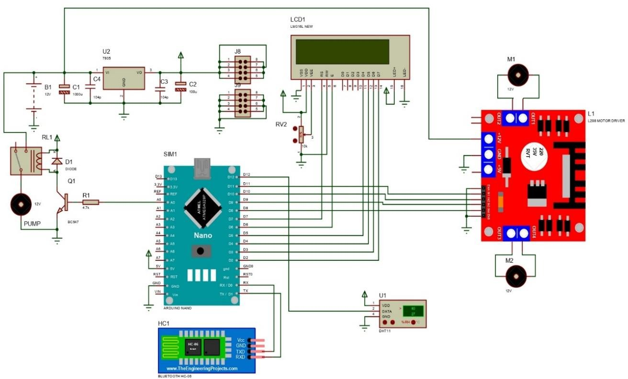

The complete circuit diagram of the **Automatic Seed Sowing and Pesticides Spraying System** is illustrated in the figure below. The diagram outlines the interconnection of all essential components with the **ATmega328P microcontroller**, including the **motor driver (L298)**, **relay module**, **Bluetooth module (HC-05)**, **DHT11 sensor**, **LCD display**, and **pumping mechanism**.

It clearly depicts how the **12V power supply** is regulated using **7805 voltage regulators** and stabilized with capacitors to deliver safe operating voltages to different modules. The diagram also shows how control signals are routed from the microcontroller to the **DC motor** for movement and seed sowing, and to the **relay** for activating the **pesticide spraying pump**.

This comprehensive layout ensures synchronized operation between seed dispensing, spraying, and environmental sensing functions—providing a smart, automated solution for modern agricultural applications.

# System Workflow

The **Automatic Seed Sowing and Pesticide Spraying Robot** operates through a sequential and automated workflow designed for effective agricultural deployment. The following steps describe the system’s functionality:

1. **Startup and Initialization:** When the robot system is powered on, all essential modules including motors, sensors, and the microcontroller (such as Arduino or PIC) are initialized. This prepares the system for operation by ensuring proper communication and readiness of all hardware components.
2. **Field Navigation:** The robot begins autonomous movement across the agricultural field using motor control regulated by the microcontroller. Navigation is achieved either through a line-following sensor, which enables path tracking, or via a GPS module for large-scale field automation.
3. **Seed Sowing Mechanism:** At regular intervals determined by either a wheel encoder or a timer, a DC motor-driven seed dispensing unit is activated. The mechanism creates a hole in the soil, drops one or more seeds into it, and optionally uses a mechanical arm to lightly press the soil over the seeds to ensure proper planting.
4. **Pesticide Spraying Mechanism:** Simultaneously, or based on a timed routine, the pesticide spraying unit is activated. A pump motor controls the flow of pesticide through spray nozzles, ensuring an even distribution of pesticide over the crops as the robot moves along the field.
5. **Loop Process:** The robot continues its operations by repeatedly executing the seed sowing and pesticide spraying tasks while navigating forward, ensuring complete coverage of the designated field area.
6. **Stop Condition:** The robot halts its operation when the entire field has been covered, a manual stop command is issued, or in the event of specific conditions such as low battery voltage or system error detection.

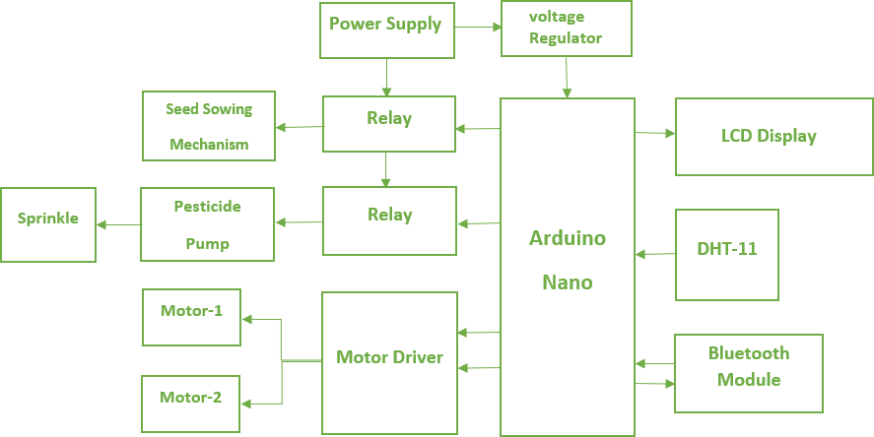

# Results and Discussion

The Automatic Seed Sowing and Pesticide Spraying Robot effectively combines seed dispensing and pesticide spraying in a single, low-cost system. Controlled by a microcontroller, it supports different operational modes for flexible use.

Field tests showed the robot operated efficiently on small and medium-sized farms. It accurately sowed seeds at set intervals and sprayed pesticide evenly across crops. Line-following sensors ensured smooth navigation, and obstacle detection allowed safe operation.

The robot is affordable and made with easily available parts, making it suitable for small farmers. Future improvements may include solar power, mobile app control, and AI-based smart navigation.

The following table displays the temperature and humidity conditions during the requirements.

|  |  |
| --- | --- |
| **Temperature** | **Humidity** |
| 36 | 39% |
| 39 | 35% |
| 40 | 33% |
| 41 | 33% |
| 42 | 31% |
| 44 | 31% |

|  |  |
| --- | --- |
| **Temperature** | **Humidity** |
| 45 | 27% |
| 39 | 36% |
| 39 | 37% |
| 40 | 33% |
| 42 | 31% |
| 43 | 31% |

|  |  |
| --- | --- |
| **Temperature** | **Humidity** |
| 38 | 34% |
| 39 | 36% |
| 40 | 34% |
| 41 | 32% |
| 42 | 30% |
| 43 | 29% |

Table no.1 Table no.2 Table no. 3

* Table no.1 shows the temperature and humidity of **(Normal Temperature).**
* Table no.2 shows the temperature and humidity of **(Application 1 seed sowing).**
* Table no.3 shows the temperature and humidity of **(Application 2 pump spraying).**

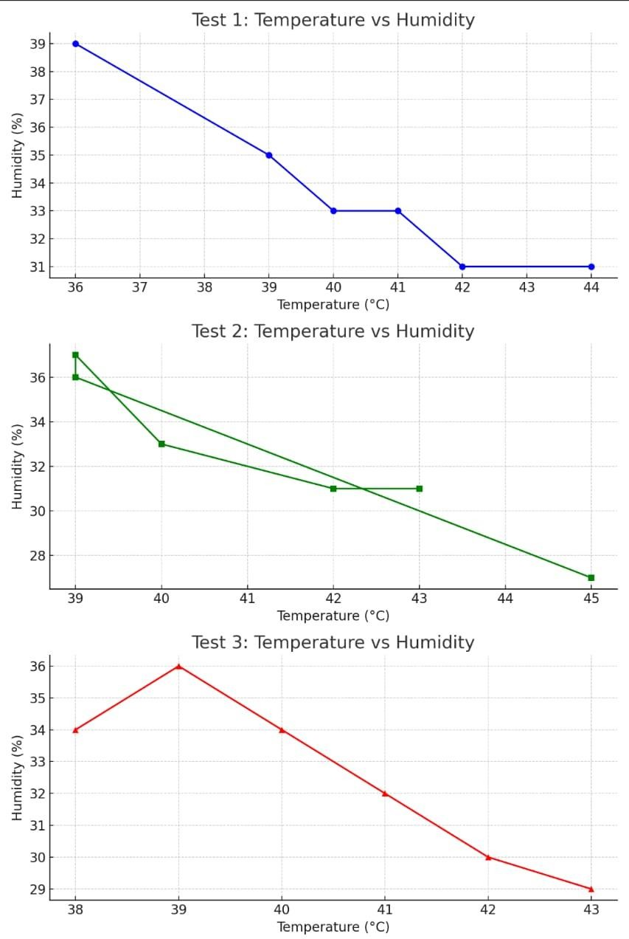

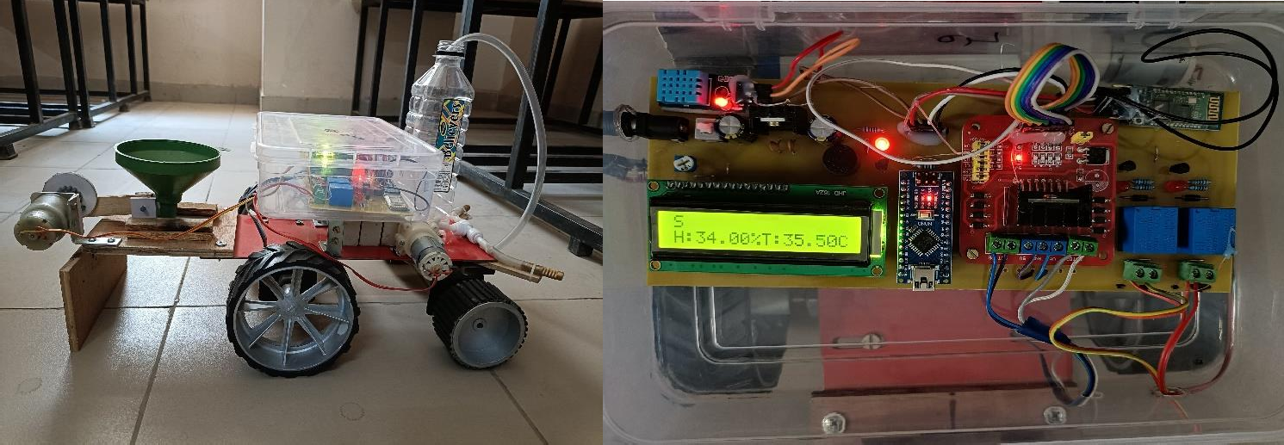

**Fig 1. Physical Structure of the Project Fig 2. Control System Circuit**

# Conclusion

This project introduces a practical and cost-effective solution for automating seed sowing and pesticide spraying in agriculture. Utilizing a microcontroller-based control system, along with DC motors, navigation sensors, and spraying mechanisms, the robot efficiently performs critical farming tasks with minimal human intervention. The integration of multiple operating modes allows flexibility based on field requirements, while the modular design supports easy customization and maintenance. The system proves to be highly beneficial for small and marginal farmers, reducing labor dependency and improving operational efficiency. Future enhancements may include solar-powered functionality, AI-based route optimization, and wireless connectivity for real-time remote control and monitoring.

# References

[1] Anil Dhanawade1 , A. O Mulani2 , Anjali. C. Pise3, *“Smart farming using IOT based Agri BOT”,* ISSN:1827-7160 Volume 28 Issue 1, 2024.

[2]P. Bhagya Sri1 , CH. Gayathri2 , K. Amruta Renuka Sri Sai3, Ch. Jaya Sri Ramya4 , E. Venkata Teja5, “*IOT agricultural robot for automatic ploughing,seeding and sprinkling”,* ISSN : 2347-7180 Vol-13, Issue-3, March 2023.