**Consumer Behavior and Satisfaction in Internet Banking: A Review with Reference to Madhya Pradesh**

**Anushka Jain1, Dr. Swapna Pillai2, Dr. Harsh Sharma3**

1Research Scholar, IPER, Bhopal

2Professor, Department of Commerce, BSSS, Bhopal

3Professor, IPER, Bhopal

**Abstract**

The rapid advancement of internet technology has transformed traditional banking practices into more flexible and user-friendly digital services. This review paper explores consumer behavior and satisfaction towards internet banking, with special reference to selected districts of Madhya Pradesh. The study highlights key factors influencing consumer adoption, such as ease of use, trust, perceived risk, and digital literacy. It also discusses dimensions of consumer satisfaction, including service quality, usability, security, and customer support. Through a review of recent studies and available data, the paper identifies gaps in the existing literature, particularly regarding rural consumer experiences and trust-building mechanisms. The findings suggest that while internet banking adoption is growing in urban areas of Madhya Pradesh, rural districts still face challenges related to infrastructure and awareness. The review concludes by emphasizing the need for localized strategies to enhance customer satisfaction and promote inclusive digital banking services.

**Keywords:** Internet Banking, Consumer Behavior, Customer Satisfaction, Madhya Pradesh, Digital Banking Adoption

**1. Introduction**

In the last few decades, the growth of internet banking has changed the way people access financial services. The convenience of banking from home or on a mobile device has attracted a wide range of customers across India. Madhya Pradesh, being a mix of urban and rural areas, shows an interesting pattern in how people adopt and feel satisfied with internet banking services.This review paper aims to understand consumer behavior and satisfaction with internet banking, focusing on studies and insights related to Madhya Pradesh. It highlights the factors that influence consumers' use of internet banking and identifies areas where service providers can improve customer experience.

**2. Internet Banking: An Overview**

Internet banking, also called online banking, refers to the use of the internet to perform banking activities like checking account balances, transferring money, paying bills, and applying for loans. It eliminates the need for physical visits to the bank, saving both time and effort for customers.

Despite its advantages, internet banking also presents challenges, such as concerns over security, technical difficulties, and the lack of personal interaction that some customers value. Especially in semi-urban and rural parts of Madhya Pradesh, low digital literacy and poor internet infrastructure can limit access to these services.

|  |  |  |
| --- | --- | --- |
| **Features** | **Traditional Banking** | **Internet Banking** |
| **Accessibility** | Limited to bank hours | 24/7 availability |
| **Physical presence** | Required | Not required |
| **Transaction Speed** | Moderate to slow | Fast |
| **Personal Interaction** | Face-to-face | Virtual only |
| **Risk Factors** | Less cyber risk, more paperwork | Cybersecurity risks |

**Table 1: Comparison of Traditional vs Internet Banking**

**Conceptual Framework**

**Visual Diagram**

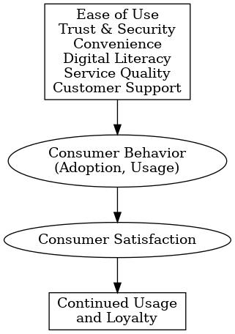

**Explanation:**

* Factors like ease of use, trust, and service quality **influence** how consumers behave towards internet banking (whether they adopt and use it frequently).
* Consumer behavior **directly impacts** their **satisfaction**.
* Higher satisfaction leads to **continued usage**, **positive word-of-mouth**, and **loyalty**.

**3. Consumer Behavior in Internet Banking**

Consumer behavior in internet banking is influenced by multiple factors. Some major factors include:

* **Ease of Use**: Platforms that are simple and user-friendly encourage higher adoption.
* **Trust and Security**: Consumers must feel that their personal and financial information is safe.
* **Convenience**: Ability to transact at any time without standing in queues.
* **Awareness and Digital Literacy**: Knowledge about using internet banking affects adoption, especially in rural areas.
* **Socio-Demographic Factors**: Age, gender, education, income level, and occupation play important roles.

Different studies have shown that younger and more educated individuals are more likely to adopt internet banking. Meanwhile, rural consumers often hesitate due to trust issues and lack of familiarity with technology.

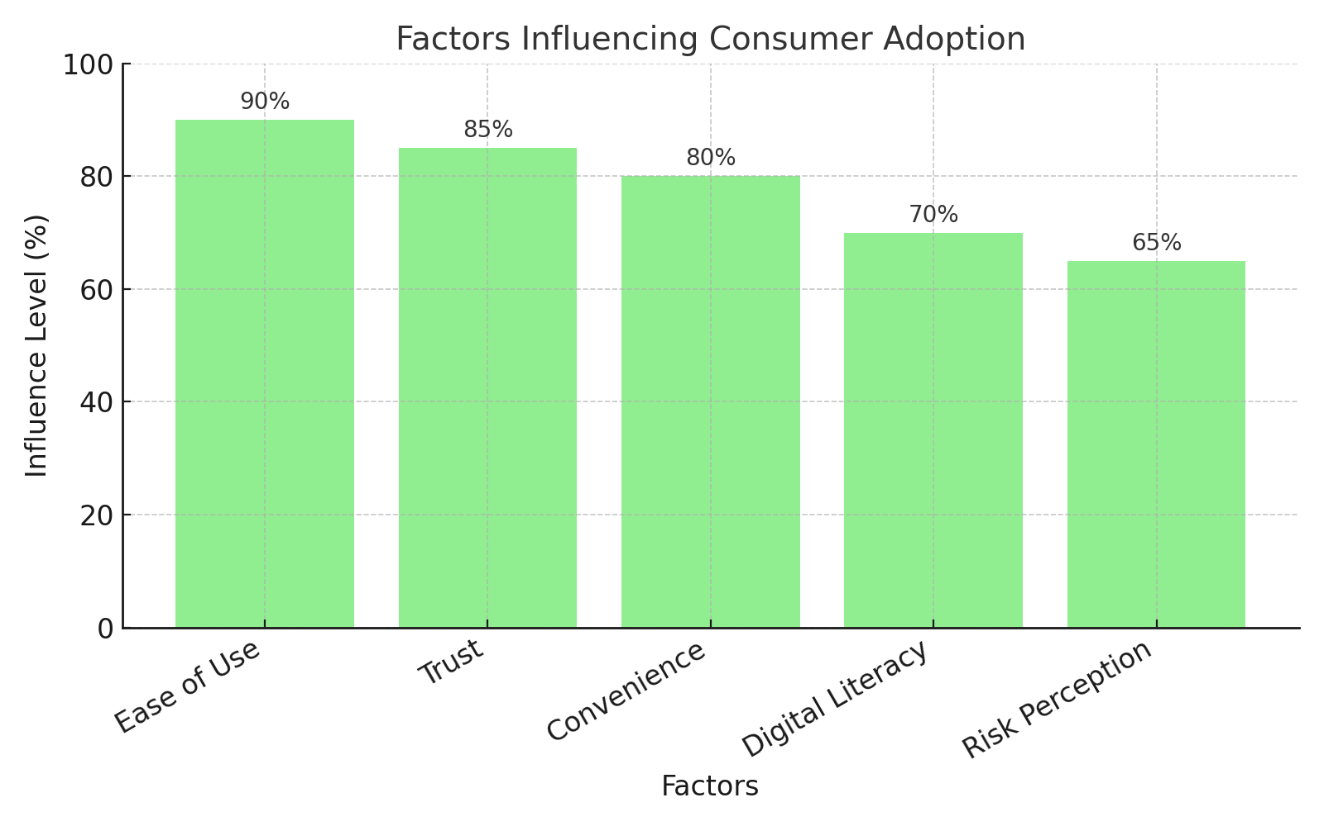

# **Graph 1: Factors Influencing Consumer Adoption**

|  |  |  |
| --- | --- | --- |
| **Demographic Variable** | **Higher Usage Group** | **Lower Usage Group** |
| **Age** | 20–40 years | Above 50 years |
| **Education** | Graduates and above | Primary education level |
| **Income** | Middle and high income | Low income |
| **Location** | Urban and semi-urban areas | Rural areas |

**Table 2: Demographic Variables vs Internet Banking Usage Trends**

**4. Consumer Satisfaction in Internet Banking**

Consumer satisfaction depends on how well the service meets their expectations. In internet banking, the main areas that influence satisfaction are:

* **Service Quality**: Speed and reliability of online services.
* **Website/App Usability**: Easy navigation, clear instructions, and attractive design.
* **Security Measures**: Availability of features like OTPs, encryption, and fraud detection.
* **Customer Support**: Quick resolution of complaints or technical issues.
* **Customization**: Personalized services and recommendations.

However, dissatisfaction may occur due to server downtimes, technical glitches, security breaches, or complicated interfaces.

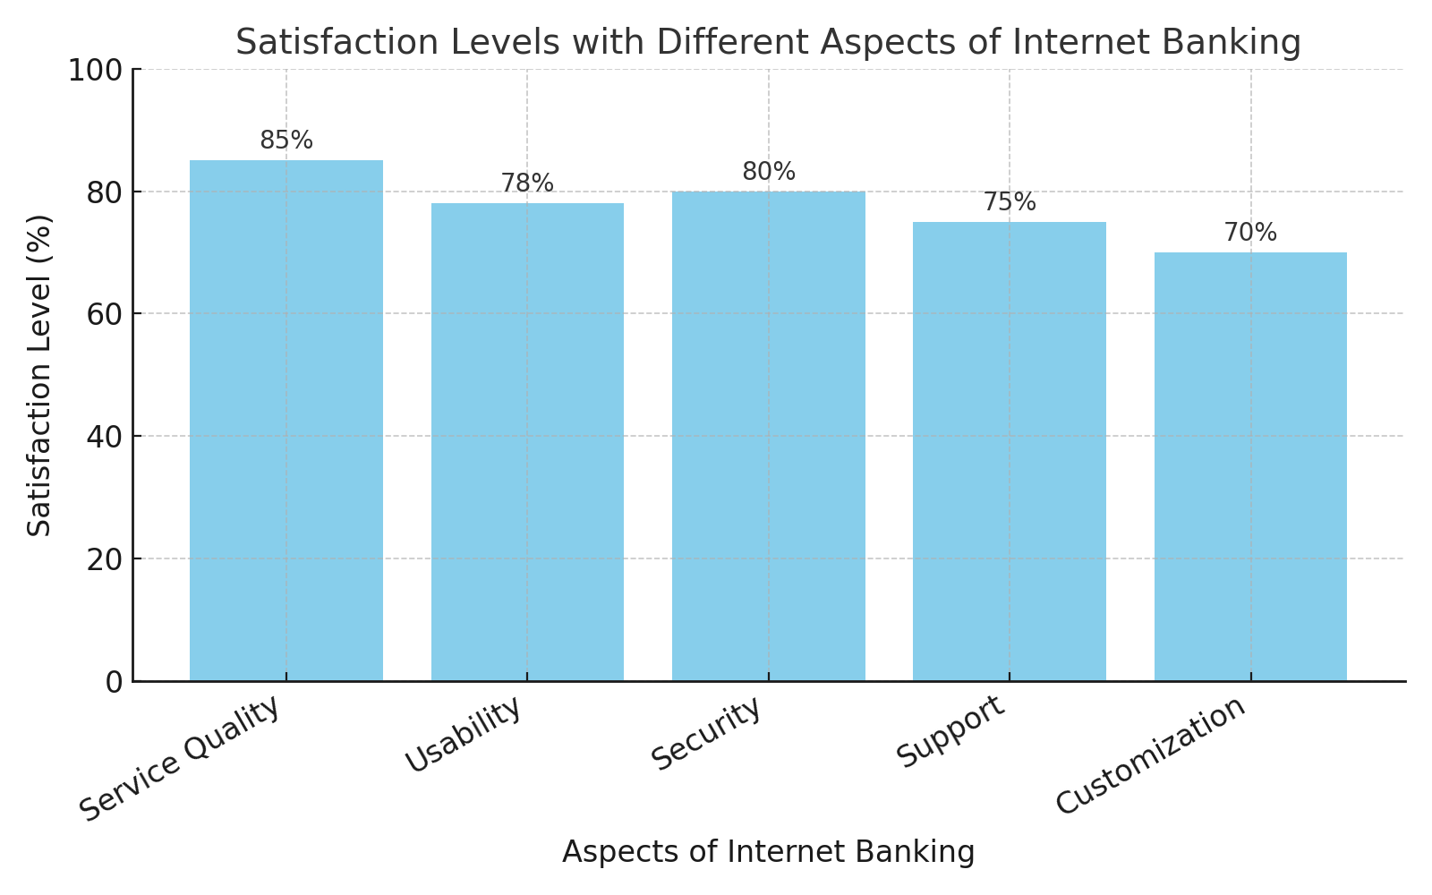

# **Graph 2: Satisfaction Levels with Different Aspects of Internet Banking**

**5. Studies and Findings from Madhya Pradesh**

Several studies conducted in Madhya Pradesh reveal mixed results regarding internet banking usage:

* Urban consumers in cities like Bhopal and Indore show high adoption rates due to better internet infrastructure and awareness.
* In rural districts, despite increasing mobile penetration, internet banking adoption remains low because of trust issues and lack of digital skills.
* Awareness programs and improved banking apps designed in regional languages have started bridging the gap, but challenges remain.

### **Summary of Reviewed Studies**

| **Study** | **Country / Region** | **Focus Area** | **Key Findings** |
| --- | --- | --- | --- |
| Sharma (2023) | Indore, Madhya Pradesh | Impact of internet banking service quality on customer satisfaction | Identified five key service quality dimensions—website ease of use, comfort, accessibility, confidence, and responsiveness—that positively influence customer satisfaction. |
| Shailender & Tomar (2023) | Chhindwara, Madhya Pradesh | Customer perceptions of e-banking services in rural areas | Found significant differences in customer satisfaction between public and private sector banks, with public banks facing more challenges in service delivery. |
| Devi Ahilya University (2018) | Indore, Madhya Pradesh | Customer perception toward internet banking | Revealed that education level and type of employment significantly affect customer satisfaction, while age and gender do not. |
| Khan & Mahapatra (2008) | India | Service quality evaluation in internet banking | Identified seven quality dimensions, with customers most satisfied with reliability, accessibility, privacy/security, responsiveness, and fulfillment, but least satisfied with user-friendliness. |
| Bashir & Madhavaiah (2015) | India | Consumer attitude and behavioral intention towards internet banking adoption | Demonstrated that perceived usefulness, ease of use, trust, and enjoyment are direct determinants of attitude towards internet banking, influencing behavioral intentions. |
| Chhabra (2018) | Punjab & Chandigarh, India | Service quality's impact on trust, satisfaction, and loyalty in internet banking | Found that efficiency, reliability, responsiveness, and website design significantly influence customer trust and satisfaction, leading to loyalty. |
| Sardana & Bajpai (2020) | Delhi, India | E-banking service quality and customer satisfaction | Identified trust and privacy as the most critical factors influencing e-banking service quality perceptions. |
| Kamboj & Singh (2018) | India | Customer satisfaction with digital banking and demographic factors | Highlighted that slow internet speed and lack of security features are major concerns, affecting customer satisfaction across different demographics. |
| Fozia (2017) | India | Comparative study on customer satisfaction in internet banking | Emphasized the importance of multiple regression analysis in understanding overall customer satisfaction in internet banking. |
| Ashoka et al. (2017) | Rural India | Consumer perception and satisfaction towards internet and mobile banking | Noted challenges in internet and mobile banking adoption in rural areas, with concerns over security and accessibility affecting satisfaction. |

**6. Gaps Identified in Literature**

While there have been numerous studies on internet banking at the national level, gaps remain when it comes to focused research in Madhya Pradesh. The main gaps are:

* Lack of studies comparing rural and urban consumer experiences in depth.
* Limited research on the impact of language barriers in internet banking.
* Few studies addressing trust-building strategies for first-time users in rural areas.
* Need for gender-specific analysis, as women's adoption patterns differ.

These gaps open opportunities for further research to create better, more inclusive banking platforms.

**7. Conclusion**

Internet banking has transformed the way banking services are accessed, but consumer behavior and satisfaction levels vary widely based on demographic and regional factors. In Madhya Pradesh, while urban areas show encouraging signs of adoption, rural districts still lag behind due to multiple barriers. Banks need to focus on improving digital literacy, enhancing trust through better security measures, and offering services that are easy to use across diverse consumer groups. Future studies focusing on rural-urban comparisons and specific consumer needs can help shape better banking strategies.

**8. References**

1. Sharma, G. (2023). Internet banking service quality and its impact on customer satisfaction in Indore district of Madhya Pradesh. *Academia.edu*.
2. Shailender, & Tomar, A. (2023). Exploring customer perceptions of e-banking services in rural Madhya Pradesh: A comparative analysis of public and private sector banks in Chhindwara district. *Well Testing Journal*, 32, 31–36.
3. Devi Ahilya University. (2018). Study of customer perception toward internet banking in Indore. *Research Review International Journal of Multidisciplinary*, 3(1).
4. Khan, M. S., & Mahapatra, S. S. (2008). Service quality evaluation in internet banking: An empirical study in India. *International Journal of Indian Culture and Business Management*, 2(1), 30–46.
5. Bashir, I., & Madhavaiah, C. (2015). Consumer attitude and behavioural intention towards internet banking adoption in India. *Journal of Indian Business Research*, 7(1), 67–102.
6. Chhabra, K. (2018). Does service quality matter in the context of internet banking? A perceptual analysis of India’s internet banking customer’s perception regarding service quality, trust, satisfaction, and loyalty. *Journal of Commerce and Accounting Research*, 7(3), 52–60.
7. Sardana, S., & Bajpai, V. N. (2020). E-banking service quality and customer satisfaction: An exploratory study on India. *International Journal of Services and Operations Management*, 36(2), 223–247.
8. Kamboj, N., & Singh, G. (2018). Customer satisfaction with digital banking in India: Exploring the mediating role of demographic factors. *Indian Journal of Computer Science*, 3(2).
9. Fozia, D. (2017). Analyzing customer satisfaction of internet banking: A comparative study in India. *Global Journal of Management and Business Research*, 17(C3), 5–8.
10. Ashoka, M. L., Rakesh, T. S., & Madhushree, S. (2017). Consumer perception and satisfaction towards internet banking and mobile banking with reference to nationalized banks in rural India. *International Journal of Asian Business and Information Management*, 8(4), 29–40.