Comparative study Of HPLC and UPLC in the Pharmaceutical quality control

**Sakshi Rajendra Kulkarni 1, Aniket Sharad Salunke2 , Prof. Madhuri Ramdas Shirsath3,**

**S.V.S Institute of Pharmacy Mungase , Malegaon , Nashik.**

# ABSTRACT:

Recent developments in pharmaceutical analysis have introduced chromatographic media featuring a 1. 7 μm particle size along with a liquid handling system capable of functioning with such columns at significantly higher pressures. This innovation, known as Ultra performance liquid chromatography (UPLC), utilizes sub 2 micron particles and exceptionally high pressure (up to 100 MPa is achievable in a UPLC system) and has shown enhancements in method sensitivity, resolution, and speed in comparison to traditional HPLC. The UPLC system permits a reduction in analysis time by as much as nine times when contrasted with chromatographic systems utilizing 5 μm size particle packed analytical columns. When comparing with 3μm size particle packed analytical columns, the analysis time is reduced by approximately three times. This review paper highlights the distinctions between HPLC and UPLC, the validation of analytical methods, and the applications, advantages, and disadvantages of both HPLC and UPLC.

# KEYWORDS:

High performance liquid chromatography, ultra performance liquid chromatography, resolution, sensitivity, efficiency .

# INTRODUCTION

Chromatography is a laboratory method for separating mixtures. Chromatography is likely the most significant analytical technique available to contemporary chemists. Its influence derives from its ability to quantitatively identify numerous individual components present in mixtures through the use of a single analytical process. A precise analytical method must be employed for the stability testing of drug substances that will measure the active pharmaceutical ingredients (API) without being affected by degraded products, process impurities, and other possible contaminants [1]

# PRINCIPLE:

The separation principle in HPLC and UPLC relies on the van Demeter equation. It elucidates the relationship between flow rate and plate height.

The formula is H=A + B/ u + C u

Where H = Height Equivalent to Theoretical Plate (HETP); A = Eddy diffusion; B = longitudinal or axial diffusion; C = mass transfer of the solute; u = the flow rate (linear velocity) of the mobile phase. The A term pertains to the size of the particles in the packing material. Its measurement is influenced by the quality of the packing in the chromatographic bed. Furthermore, it is associated with the consistency or inconsistency of the flow to and around a particle. The A term does not depend on velocity. Its value is minimized when the particles in the packed column are both small and uniform. The B term indicates axial diffusion or the inherent diffusion behavior of the analyte within the bulk mobile phase and on the stationary phase. It diminishes as the flow rate of the mobile phase [linear velocity] increases. This phenomenon is lessened at higher flow rates, resulting in this term being divided by u. The C term relates to both the linear velocity of the mobile phase and the square of the particle diameter. It represents how analyte molecules interact with the internal surface of the stationary phase and their diffusion distance into and out of the packing material's pores. [2,3]

## Factors influencing separation:

### Parameters impacting efficiency:

* Column length
* Particle diameter
* Particle size distribution
* Flow rate

### Parameters impacting retention factor:

* Eluent type
* Eluent composition
* Type of stationary phase
* Analyte nature

### Parameters influencing selectivity:

* Type of stationary phase
* Analyte nature
* Additives in eluent
* Temperature
* Eluent composition (for ionizable analytes)
* The efficacy of the column packing, along with the particle size and column dimensions, contribute to the efficiency of the column. Longer columns result in narrower peaks (indicating greater efficiency), but they also substantially lengthen the analysis time, which should be obvious. Smaller particles typically offer greater surface area, resulting in improved separations and producing narrower peaks. 3 An increase in temperature lowers the solvent's viscosity, which decreases back pressure and also reduces retention. In isocratic chromatography, a temperature rise of 10°C results in approximately a 20% decrease in retention time. Efficiency increases (the shape of the peaks improves) as the flow rate reduces, but baseline resolution between the relevant peaks cannot be achieved. Properties of the stationary phase, such as hydrophobicity, polarity, and the base silica's characteristics, are crucial for the physicochemical interactions with the analyte, thus influencing the separation's selectivity. [4, 5]

## High-Performance Liquid Chromatography

High-Performance Liquid Chromatography (HPLC) is also referred to as High-Pressure Liquid Chromatography. HPLC is a widely used analytical method, and it is utilized for the identification, separation, and quantification of each component in a mixture. The stability-indicating techniques of HPLC are utilized in isolating various drug-related impurities that occur during the manufacturing or synthesis of pharmaceutical products [6]

## Ultra Performance Liquid Chromatography

Ultra Performance Liquid Chromatography (UPLC) contributes to the enhancement of three aspects: speed, chromatographic resolution, and sensitivity analysis. UPLC techniques employ fine particles, specifically less than 2. 5 μm, which reduces the column length. Additionally, solvent usage is minimized, resulting in time savings. UPLC operates on chromatographic principles by utilizing columns packed with smaller particles and higher flow rates to conduct separations. Smaller particles can be employed to push speed and peak capacity to new limits. For this separation mechanism, the principle utilized is the Van Deemter equation:

H = A + B/v + Cv

where, H – reduced plate height, a non-measurable representation of band broadening, where: A – Eddy mixing B – Axial diffusion C – Mass transfer of the solute v – linear velocity.

The aforementioned equation illustrates the relationship between linear velocity (flow rate) and plate height (column efficiency). Using this equation, we can understand that with the use of smaller particles, efficiency increases; however, this will result in a rapid rise in backpressure, as most HPLC systems can only function up to 400 bars. To expedite the analysis without sacrificing efficiency and while maintaining an acceptable loss of loads, short columns filled with 2 μm particles are utilized [7]

## Comparison between HPLC and UPLC Systems

|  |  |  |
| --- | --- | --- |
| **Parameter** | **UPLC** | **HPLC** |
| Particle Size | < 2 μm | 3-5 μm |
| Operating Pressure | Up to 15,000 psi | Up to 6,000 psi |
| Column Length | 50-150 mm | 150-250 mm |
| Internal Diameter | 2.1 mm | 4.6 mm |
| Flow Rate | 0.2-1 mL/min | 1-5 mL/min |
| Injection Volume | 1-10 μL | 10-100 μL |
| Analysis Time | 2-10 min | 10-50 min |
| Resolution | Excellent | Good |
| Sensitivity | Superior | Good |
| Solvent Consumption | Lower | Higher |

**Current development in chromatography HPLC**

* Techniques relying on a form of HPLC separation still surpass all other assays, as they have for more than The vast majority of these are straightforward, isocratic, reversed-phase methods that utilize UV detection.
* Occasionally, more innovative methods, frequently based on new separation modes or the application of more

selective detection systems, such as diode array and fluorescence detectors or mass spectrometers, are utilized.

* Coupled LC-MS has gained traction as electrospray ionization and atmospheric pressure ionization interfaces have become increasingly dependable at higher throughput volumes [8]

# UPLC

* employs a new type of column temperature-control module;
* uses instrument dead volume and corresponding extra-column band broadening;
* implements gradient delay volume (also referred to as ‘dwell volume’);
* offers an improved detector data-acquisition rate;
* recognized for a heightened system-pressure drop beyond 1400 bar;
* mobile-phase temperature is raised (>60°C);
* particle size decreased (<1.5 μm) or particle-size distribution modified;
* makes use of sub-2 μm superficially porous particles (SPPs) [8]

## Advantages of HPLC:

* Sensitivity and precise quantitative analysis.
* Capable of separating non-volatile and thermally unstable compounds.
* HPLC possesses the capacity to separate and identify compounds that can be found in any liquid sample at

trace concentrations as low as parts per trillion.

* Reduction in mobile phase volume usage by at least 80% in comparison to HPLC.
* Shortened run time and operational costs.
* A smaller injection volume is necessary.
* Enhanced Signal to Noise ratio (S/N) due to decreased band broadening, thus improving sensitivity.
* Thanks to improved chromatographic peak resolution, the issue of ion suppression from co-eluting peaks is significantly minimized.
* Accelerated resolving power.
* The elevated column temperature reduces mobile phase viscosity, leading to a higher diffusion coefficient

without a considerable loss in efficiency and an increase in column back pressure. [9,10]

## Disadvantages of HPLC:

* Co-elution, adsorbed compounds, expense, and complexity.
* Increased back pressures relative to traditional HPLC that shortens the lifespan of the columns.
* Particles smaller than 2 μm are primarily non-regenerable, thus have limited applicability. [11]

## Advantages of UPLC:

* Decrease in consumption of mobile phase volume by at least 80% compared to HPLC.
* Decreased run time and cost of operation.
* Lower injection volume is required.
* Greater Signal to Noise ratio (S/N) due to the reduction in band broadening thereby increasing the sensitivity.
* Because of better chromatographic peak resolution, the problem of ion suppression from co-eluting peaks is greatly reduced.
* Faster resolving power.
* The higher column temperature minimizes the mobile phase viscosity resulting in the high diffusion

coefficient without significant loss in efficiency and increase in column back pressure. [12,13,14,15]

## Disadvantages of UPLC:

* Higher back pressures compared to conventional HPLC which decreases the life of the columns.
* The particles of less than 2 μm are mostly nonregenerable therefore, have a narrow use. [16]

## Applications of HPLC:

* Drug analysis
* Testing for stability
* Chiral separations
* Screening at high-throughput
* Examination of pollutants and food-related compounds
* Bioanalytical separations as seen in proteomics
* Analysis of steroids
* Studies on forced degradation and impurity analysis [17,18,19]

## Applications of UPLC:

* Quality Control (QC) for raw materials, in-process, and final products
* Development and validation of methods
* Studies on Forced Degradation (FDS)
* Testing for dissolution and
* Studies on Bioequivalence/Bioanalysis
* Studies on toxicity
* Monitoring of therapeutic drugs
* Examination of contaminants in foods
* Mapping of peptides
* Analysis of pesticides found in groundwater
* Detection of metabolites [20,21,22]

# WORKING

**Working of HPLC**

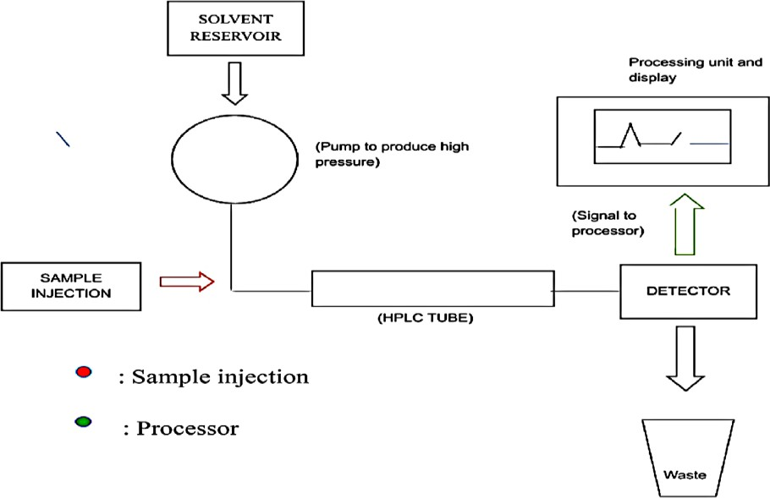

**Instrumentation**

1. **Solvent Reservoir**:

Mobile phase substances are stored in a glass reservoir. The mobile phase, or solvent, in HPLC is usually a mixture of polar and non-polar liquid components whose specific concentrations are adjusted based on the composition of the sample.

## Pump:

A pump draws the mobile phase from the solvent reservoir and pushes it through the system's column and detector. Depending on various factors including column dimensions, particle size of the stationary phase, the flow rate and composition of the mobile phase, operating pressures of up to 42000 kPa (approximately 6000 psi) can be generated.

## Sample Injector:

The injector can be either a single injection or an automated injection system. An injector for an HPLC system should provide injection of the liquid sample within the range of 0. 1–100 mL of volume with high reproducibility and under high pressure (up to 4000 psi).

## Columns:

Columns are typically constructed from polished stainless steel, are between 50 and 300 mm long and have an internal diameter of between 2 and 5 mm. They are commonly packed with a stationary phase with a particle size of 3–10 μm. Columns with internal diameters of less than 2 mm are often referred to as microbore HPLC columns. Ideally, the temperature of the mobile phase and the column should be maintained constant during an analysis.

## Detector:

The HPLC detector, located near the end of the column, identifies the analytes as they come out of the chromatographic column. Commonly employed detectors include UV spectroscopy, fluorescence, mass- spectrometric, and electrochemical detectors.

## Data Collection Devices:

Signals from the detector can be recorded on chart recorders or electronic integrators that vary in complexity and in their ability to process, store, and reprocess chromatographic data. The computer correlates the response of the detector to each component and formats it into a chromatograph that is easy to read and interpret.

## Degasser:

The eluent used for LC analysis may contain gases like oxygen that are invisible to our eyes. The presence of gas in the eluent is detected as noise and leads to an unstable baseline. Commonly used methods include sparging (bubbling of inert gas), the use of aspirators, distillation systems, and/or heating and stirring.

However, these methods are not convenient, and also when the solvent is left for a certain duration (e. g. , during long analyses), gas will slowly dissolve back. A degasser utilizes specialized polymer membrane tubing to eliminate gases. The many tiny pores on the surface of the polymer tube allow air to pass through while preventing any liquid from flowing through the pore. By positioning this tubing in a low-pressure container, it creates pressure differences inside and outside the tubing (higher pressure inside the tubing). This difference allows the dissolved gas to move through the pores and escape. Compared to traditional batch-type degassing, the degasser can operate online, making it more convenient and efficient. Many new HPLC systems come equipped with a degasser.

## Column Heater:

The LC separation is often greatly affected by the temperature of the column. To achieve consistent results, maintaining stable temperature conditions is essential. Additionally, for certain analyses, such as those involving sugars and organic acids, enhanced resolutions can be achieved at higher temperatures (50 to 80°C). Maintaining a stable temperature is also critical for obtaining repeatable results, even when analyses are performed at approximately room temperature. Small variations in temperature can lead to different separation results. Hence, columns are typically housed within a column oven (column heater). [23,24,25,26,27,28]

## Working of UPLC

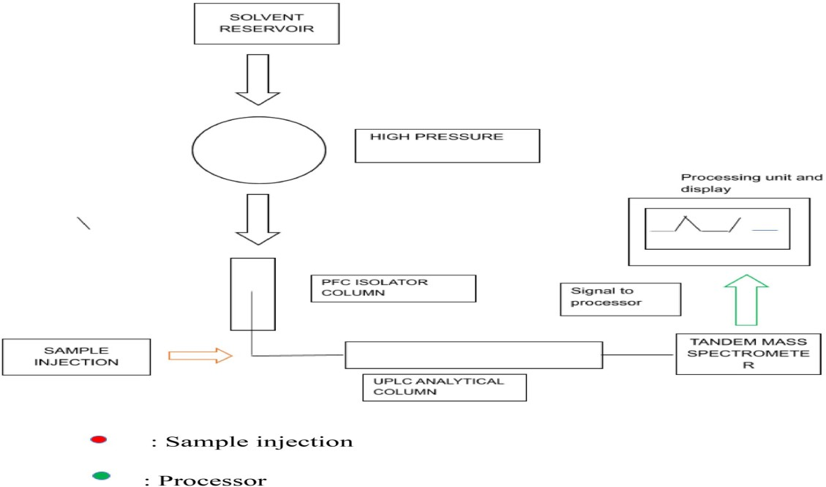

**Instrumentation**

* 1. Sample Injection
  2. Pumping Equipment
  3. UPLC columns
  4. Detectors

## Sample Injection:

In UPLC, the combination of samples is essential. Both automatic and manual traditional injection valves are not designed to endure high pressure. To protect the column from significant pressure fluctuations, the injection technique should primarily be free of pulses. Moreover, the device's swept volume should be minimized to reduce band broadening. A large sample volume is needed for a swift injection cycle to maximize the advantages of UPLC's speed. To improve sensitivity, it is necessary to use low-volume injections with minimal carryover. Direct injection methods can also be used for biological materials.

## Pumping Equipment

An optimal UPLC pump should convey solvent through a 15 cm column packed with 1. 7 μm particles at a

pressure of approximately 15,000 psi to achieve the best flow rate and performance. Two main categories exist:

* 1. Pump operating under constant pressure
  2. Pumping processes that maintain constant flow while applying constant pressure

The constant flow pump is the most frequently employed in UPLC applications. Pump operating under constant pressure Column packing42 In most UPLC setups, a reciprocating pump is utilized.

## UPLC Columns:

Increased resolution in a column containing 1. 7μm particles results from enhanced efficiency. A bonded phase that provides selectivity and retention is essential for separating the components of a sample. UPLC separations can produce four bonded phases.

1. Straight-chain alkyl columns, ACQUITY UPLCTM BEH C8
2. Straight-chain alkyl columns, ACQUITY UPLCTM BEH C18
3. The polar group column, ACQUITY UPLC BEH Shield RP18,
4. ACQUITY UPLC BEH Phenyl (phenyl group linked via a C6 alkyl to the silyl functionality)

## Detectors:

UPLC analysis employs visible and UV detectors. Absorbance or concentration sensitivity detectors are typically utilized to identify analytes. In UPLC, reducing the flow cell capacity is vital to maintaining the concentration and integrity of the signal. Similarly, conventional flow cells with lower volume would decrease the path length, which impacts signal strength according to Beer’s Law. A smaller cross-section signifies a shorter light path, and transmission decreases as noise increases. Consequently, using a traditional HPLC flow cell would lower the sensitivity of UPLC. The precision component The tunable UV/visible detector cell is a light-guided flow cell that relies on optical fiber. The flow cell employs an internal reflectance mode to efficiently transfer light through a 500 mL container while maintaining the path length at 10 mm. The system’s tubing and connectors are strategically positioned to minimize

dispersion and utilize leak detectors that communicate with the software to notify the user of potential issues.

# TYPES OF DETECTORS:

## UV (Ultraviolet/visible):

This detector recognizes biological elements that absorb light within the wavelength range of 190 to 800 nm. It can be altered to detect particular visible or UV wavelengths. Its improved functionality may be beneficial for trustworthy and advanced life analysis applications in pharmacology, agribusiness, environmental conservation, and petrochemicals. Accuracy is guaranteed by the light-guided flow cell, which resembles optical fiber in the tunable UV-visible detection cell. With a compact 500 mL volume, the intrinsic reflectance mechanism of the flow cell efficiently transmits light along its 10 mm channel length. The system's tubing and connections are neatly arranged to ensure minimal dispersion and to activate drop detectors, which connect with the software to notify the user of possible issues. UPLC is the most efficient method to achieve the sensitivity and specificity provided by mass spectrometry. When combined with Waters MS Technologies' low dispersion performance and rapid detection, the performance attributes of UPLC could significantly enhance detection capability.

## Photodiode Array (PDA) Detector:

This detector functions within the wavelength range of 190–800 nm and delivers simultaneous, enhanced optical detection. It offers unprecedented trace impurity identification and quantification due to its spectral analytical features. It allows for accurate chemical identification and co-elution detection while simultaneously operating in two and three dimensions. This detector is extensively used in pharmaceutical research and development.

## Fluorescence (FLR) Detector:

The sensitivity and selectivity of this detector render it valuable for applications based on fluorescence. UPLC technology provides benefits for analyzing vitamins, illicit substances, polynuclear aromatic hydrocarbons (PAHs), and materials that demonstrate chemiluminescent properties, such as fluorescence and phosphorescence.

## Evaporative Light Scattering Detector:

This detector type is versatile and widely used; it can even detect substances such as lipids, synthetic polymers, artificial polymers, and carbohydrates that do not absorb UV light. ELSD is a specific technique that employs UV light to detect non-UV-absorbing substances separated by liquid chromatography.

## Refractive Index (RI) Detector:

An RI is a universal detector utilized when a material exhibits little or no UV absorbance. These detectors comprise components like sugars, alcohols, fatty acids, excipients, and pharmaceutical formulations for

therapeutic applications. Additionally, low-molecular weight polymers are characterized. The main drawback of this detector is its low sensitivity. [29,30,31,32]

## Comparative Analysis of HPLC and UPLC

The contrast between HPLC and UPLC can be evaluated across several key parameters:

### Resolution and Sensitivity:

UPLC provides enhanced resolution and sensitivity in comparison to HPLC owing to its smaller particle dimensions and increased pressure, leading to sharper peaks and improved separation of compounds.

### Speed and Efficiency:

UPLC markedly decreases analysis duration, usually accomplishing separations in minutes, while HPLC may take longer because of its reduced resolution and larger particle dimensions. UPLC also permits higher throughput, rendering it suitable for extensive drug testing.

### Cost and Accessibility

HPLC has existed for many years and is more universally accessible with lower initial setup expenses. UPLC, as a more recent technology, necessitates greater investment in equipment and is less common in certain laboratories because of its elevated cost.

### Column Life and Maintenance:

The smaller particle dimensions employed in UPLC columns raise the likelihood of clogging and necessitate careful upkeep. Conversely, HPLC columns are more durable and have a longer lifespan, though they might not achieve the same level of efficiency as UPLC.

# CONCLUSION

In conclusion, both High-Performance Liquid Chromatography (HPLC) and Ultra Performance Liquid Chromatography (UPLC) are crucial analytical techniques widely used in pharmaceutical, environmental, and chemical industries. While HPLC has been a reliable and established method for decades, UPLC has emerged as a more advanced technique, offering significant improvements in speed, resolution, and sensitivity due to the use of smaller particle sizes and higher operating pressures.

UPLC systems enable faster analyses, enhanced separation efficiency, and superior sensitivity, making them particularly valuable for high-throughput testing, method development, and the analysis of complex samples with higher resolution requirements. However, UPLC's higher operational costs and potential for increased column wear and maintenance need to be considered when choosing between the two methods.

HPLC remains a valuable option for many laboratories due to its lower setup costs, established protocols, and longer column life. It continues to be suitable for routine analysis where high throughput and ultra-high resolution are not critical. Ultimately, the choice between HPLC and UPLC depends on the specific needs of the analytical task, balancing factors such as resolution, speed, cost, and the complexity of the samples being analyzed.

# REFERANCE

1. Rogatsky E. 2D or not 2D. Column-switching techniques, multidimensional separations and chromatography: Approaches and definitions. *J Chromate Separation Techniq*. 2012;03:08.
2. Hamid Khan, Javed Ali. UHPLC: Applications in Pharmaceutical Analysis. Asian J. Pharm. Ana. 2017 May; 7(2):124-131.
3. Roge AB, Firke SN, Dhane RM, Gunjkar VJ, Vadvalkar SM. Novel achievement of HPLC: UPLC. Int. J. Pharm. Tech. Res. 2011 Jul-Sep; 3(3):1423-1429.
4. Malviya R, Bansal V, Pal OP, Sharma PK. High performance liquid chromatography: a short review. Journal of global pharma technology. 2010 Jun; 2(5):22-6.
5. [https://www.chromacademy.com](https://www.chromacademy.com/)
6. JoVE Science Education Database. Analytical Chemistry. High- Performance Liquid Chromatography (HPLC). JoVE, Cambridge, MA, (2019).
7. Satinder Ahuja, Michael Dong. Handbook of Pharmaceutical Analysis by HPLC. Elsevier 2005 Feb 09; 600.
8. Fekete S, Schappler J, Veuthey JL, Guillarme D. Current and future trends in UHPLC. *TrAC Trends in Analytical Chemistry*. 2014;63:2-13.
9. [https://www.chromacademy.com](https://www.chromacademy.com/)
10. JoVE Science Education Database. Analytical Chemistry. High- Performance Liquid Chromatography (HPLC). JoVE, Cambridge, MA, (2019).
11. Satinder Ahuja, Michael Dong. Handbook of Pharmaceutical Analysis by HPLC. Elsevier 2005 Feb 09; 600.
12. Chen S, Kord A. Theoretical and experimental comparison of mobile phase consumption between ultra- high-performance liquid chromatography and high performance liquid chromatography. J Chromatogr. 2009 Aug 21; 1216(34):6204- 6209.
13. Lucie Novakova, Dagmar Solichova, Petr Solich. Advantages of ultra performance liquid chromatography over high‐performance liquid chromatography: Comparison of different analytical approaches during analysis of diclofenac gel. Journal of Separation Science banner. 2006 Nov 31; 29(16):2433-2443.
14. Behnam Behrouz, et al Comparison of UHPLC and HPLC in Benzodiazepines Analysis of Postmortem Samples A Case– Control Study. Medicine. 2015 Apr 10; 94(14):e640.
15. Craige Trenerry V. Simone J. Rochfort. Ultra-performanceliquid- chromatography. Comprehensive Natural Products II, 2010.
16. Alan Xu Q. Ultra-high Performance Liquid Chromatography and its Applications, Hoboken, New Jersey, John Wiley & Sons, Inc. 2013, 304.
17. Tariq Khalil, et al HPLC Method Development and Validation for the estimation of Esomeprazole in Bulk and Pharmaceutical Dosage Form. Int. J. Drug Dev. & Res. 2012 Oct-Dec; 4(4):252- 256.
18. Kautsky M. Steroid Analysis by HPLC: Recent Applications. New York. Marcel Dekker inc. 1981 Jul 01; 424
19. Jbaliya H, Patel M, Jadeja Y, Dabhi B, Shah A. A Comparative Validation Study of Fluconazole by HPLC and UPLC with Forced Degradation Study. Chromatography Research International. 2013..
20. Gita Chawla, Chanda Ranjan. Principle, Instrumentation, and Applications of UPLC: A Novel Technique of Liquid Chromatography. Open Chemistry Journal, 2016 May 06; 3:01-16
21. Hearn M.T.W. Ion-pair chromatography on normal and reversed-phase systems. Adv. Chromatogr. 1980; 18: 59–100.
22. HPLC – Chemiguide. May 2, 2007. [www.chemguide.co.uk](http://www.chemguide.co.uk/).
23. Rao G, Goyal A. An Overview on Analytical Method Development and Validation by Using HPLC. The Pharmaceutical and Chemical Journal, 2016; 3(2): 280-289.
24. Mcpolin Oona. An Introduction to HPLC for Pharmaceutical Analysis. Mourne Training Service. 11,12.
25. Fundamentals of Analytical chemistry- Skoog, West, Holler, Crouch-2009:973.
26. Elshanawane A A, *et al.* Development and validation of HPLC method for simultaneous estimation of brimonidine tartrate and timolol maleate in bulk and pharmaceutical dosage form. J Chromatograph Separate Techniq. 2014;5:230.
27. Mrs. P. Geetha Bhavani, Mrs. A. Lakshmi Prabha, A Review Article on UPLC, International Journal of Pharmaceutical Research And Applications, Volume 6, Issue 4 July- August 2021,pg no: 1574-1575
28. Shalini B. ULTRA PERFORMANCE LIQUID CHROMATOGRAPHY: A REVOLUTIONIZED LC.2014 May 8;338-47.
29. Nahar L, Onder A, Sarker SD. A review on the recent advances in HPLC, UHPLC and UPLC analyses of naturally occurring cannabinoids (2010–2019). Phytochemical Analysis. 2020 Jul;31(4):413-57.
30. Dar AA, Arμmugam N. Lignans of sesame: purification methods, biological activities and biosynthesis–a review. Bioorganic chemistry. 2013 Oct 1;50:1-0.
31. Ilko D, Neugebauer RC, Brossard S, Almeling S, Türck M, Holzgrabe U. Impurity control in topiramate with high performance liquid chromatography: validation and comparison of the performance of evaporative light scattering detection and charged aerosol detection. Charged Aerosol Detection for Liquid Chromatography and Related Separation Techniques. 2017 Jul 21:379- 92.
32. Uliyanchenko E. Size exclusion chromatography from high performance to ultraperformance. Analytical and bioanalytical chemistry. 2014 Oct;406(25):6087-94.