**Formulation and Evaluation of Felodipine Oral Dispersible Tablet**

Phatake Divya Sanjay, Prof. Chopade B, L, Dr. Megha T. Salve

College Name: Shivajirao pawar college of pharmacy Pachegaon Tal: Newasa ,

Dist: Ahilyanagar

# Abstract

In the current study, the anti-hypertensive medication felodipine or dispersible tablets that are employed via direct compression method are modelled and evaluated in vitro using a variety of super disintegrants. Guar gum, sodium starch glycolate, and Croscarmellose sodium were used as super disintegrants in the preparation of the dispersible felodipine tablet. Other excipients included mannitol, talc, magnesium stearate, microcrystalline cellulose, and others. Precompression characteristics of the prepared dispersible tablet, such as bulk and tapped density, angle of repose, cars index, etc., were assessed. The range contains all of the parameters. Studies on postcompression characteristics such as hardness, thickness, disintegration time, dissolution, and stability were also conducted. Out of all the formulations, the F1 formulation was determined to be the most optimised. The F1 formulation had a 15-second disintegration time and a 15- minute drug release percentage of around 100.047%. The stability investigations yield excellent results as well

**Keywords**: Oraldispersible Tablet, Felodipine, Direct compression.

# Introduction

Orally disintegrating tablets are sometimes referred to as orodispersible tablets, mouth dissolving tablets, fast disintegrating tablets, rapid dissolving tablets, porous tablets, and rapid melts. Despite all of the aforementioned terms, the USP has designated these dose forms as ODTs.(1) Orodispersible tablets are those that dissolve easily in the mouth before being swallowed, according to the European Pharmacopoeia. (2)

## Objectives

* Enhancing bioavailability
* To improve patient adherence
* Preventing first pass metabolism
* For improved stability (3)

## Ideal properties of Orodispersible tablets

* Easy to transport
* Simple manufacturing process
* ODT’s are less sensitive to the environmental conditions such as temperature and pressure
* Tablets designed to be dispersed should have a high drug loading capacity.
* The method should be compatible with already-in-use processing and packaging equipment, be stable, and have a low manufacturing cost.(4)  **Materials and Equipment’s**

|  |  |
| --- | --- |
| **Sr.No.** | **Equipment’s** |
| 1. | Uv visible  Spectrophotometer |
| 2. | Weighing Balance |
| 3. | USP Type II Dissolution Test Apparatus |
| 4. | USP Disintegration Test Apparatus |
| 5. | Digital pH meter |
| 6. | FTIR Spectrophotometer |
| 7. | 8 Station Rotary Tablet  Compression Machine |
| 8. | Hardness Tester |
| 9. | Roche Friability Tester | |

|  |  |  |
| --- | --- | --- |
| **Sr.No.** | **Drug and Excipients** | **Quantity (% w/v)** |
| 1. | Felodipine | 5 |
| 2. | Guar gum | 9 |
| 3. | Crosscarmellose Sodium | 7.5 |
| 4. | Sodium Starch Glycolate | 12 |
| 5. | Mannitol | 20 |
| 6. | Microcrystalline Cellulose | 93.5 |
| 7. | Talc | 1.5 |
| 8. | Magnesium Stearate | 1.5 |
|  | Total | 150 mg |

# Result and Discussions

## Melting Point

The melting point of felodipine was found 144℃.(5) **pH**

The pH of felodipine was found to be 6.81 which were similar to its standard value i.e. 6.8(6) **Determination of λ max of Felodipine λmax of Felodipine in Methanol**

The absorption spectra in the range of (200-400nm) were obtained for felodipine in methanol.

The drug exhibited an absorption maximum of 362nm.(7)

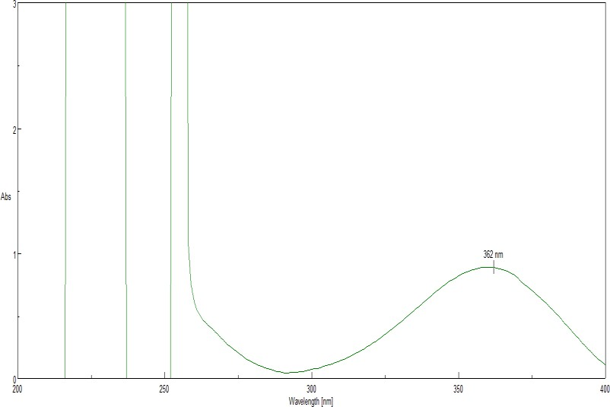

## Solubility Studies

The solubility study of felodipine was carried in distilled water and was found to be; **Saturated Solubility of felodipine in distilled water:** 0.00112mg/ml (8)

## Calibration curve of Felodipine in Methanol (362nm, R2=.09993) Table No Calibration curve of Felodipine in Methanol

|  |  |  |
| --- | --- | --- |
| **Sr.No.** | **Conc.(µg/ml)** | **Absorbance** |
| 1 | 0 | 0 |
| 2 | 2 | 0.1409 |
| 3 | 4 | 0.2862 |
| 4 | 6 | 0.4291 |
| 5 | 8 | 0.5699 |
| 6 | 10 | 0.7125 |



0.5

0.45

0.4

0.35

0.3

0.25

0.2

0.15

0.1

0.05

0

-

0.05

0



y

=

x

0.0449

-

0.0011

R²

=

0.9993



Abs

Linear

)

(

Abs



2



4



6



8



10



12



**Concentration**

**Absorbance**

## Fig.No.Calibration curve of Felodipine in Methanol Drug-excipients compatibility study by FTIR API( Felodipine)

**Fig.No.FTIR of pure Felodipine**

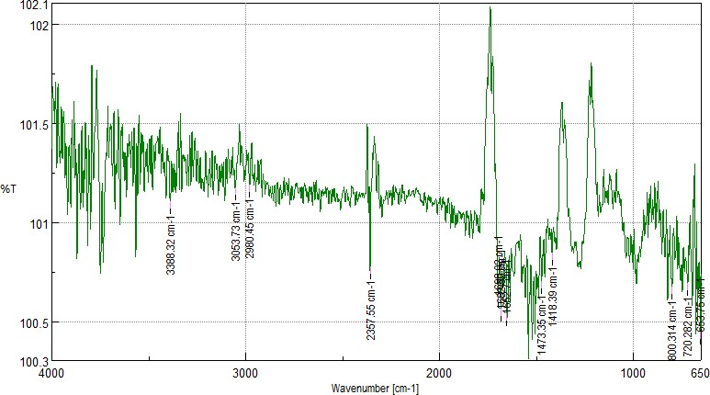

## Pre-compresssion Parameters

|  |  |  |  |  |  |
| --- | --- | --- | --- | --- | --- |
| **Formulation** | **Bulk Density**  **(gm./cm2)** | **Tapped**  **Density**  **(gm./cm2)** | **Carr’s**  **Index (%)** | **Hausners**  **Ratio** | **Angle of**  **Repose (Ɵ)** |
| F1 | 0.41 | 0.50 | 18.00 | 1.21 | 29.27 |
| F2 | 0.49 | 0.58 | 15.51 | 1.18 | 30.21 |
| F3 | 0.41 | 0.49 | 16.32 | 1.19 | 34.56 |
| F4 | 0.58 | 0.69 | 15.94 | 1.18 | 30.32 |
| F5 | 0.52 | 0.63 | 17.46 | 1.21 | 36.89 |

## Post Compression Parameters

|  |  |  |  |  |  |
| --- | --- | --- | --- | --- | --- |
| **Formulation** | **Hardness(kg/cm2) n=6** | **Friability(%) n=10** | **Thickness(mm) n=4** | **Diameter(mm) n=4** | **Weight**  **Variation**  **(%) n=20** |
| F1 | 2.8 | 0.29 | 3.40 | 7 | 1.49 |
| F2 | 2.9 | 0.31 | 3.51 | 7 | 2.63 |
| F3 | 3.1 | 0.33 | 3.56 | 7 | 4.61 |
| F4 | 3.4 | 0.36 | 3.43 | 7 | 2.94 |
| F5 | 3.3 | 0.37 | 3.45 | 7 | 5.79 |

## Post compressional Parameters

It includes Drug content, wetting time and water absorption ratio of tablet formulations.

**Table No. Post compressional Parameters (Drug content, and Water absorption ratio)**

|  |  |  |
| --- | --- | --- |
| **Formulation Code** | **Drug Content (%)** | **Water Absorption**  **Ratio (%)** |
| F1 | 99.63 | 3.26 |
| F2 | 94.2 | 4.13 |
| F3 | 96.4 | 3.86 |
| F4 | 91.7 | 6.13 |
| F5 | 93.9 | 5.20 |

## Drug Content

Drug content is mainly used to calculate the amount of pure drug present in each tablet. It ranged from 91.7 to 99.63%. F1 formulation shows highest value of drug content which is

99.63% respectively. Table number 30 shows % drug contents. ((9)

## Water absorption ratio

It includes ratios from 3.26 to 7.53 % of water absorption. Table 30 showing information of water absorption ratio(10)

## Wetting Time

From the results it is found that the wetting time of formulations are not more than 62 sec. It falls in between 25 to 62 seconds.(11) F1 formulation shows wetting time of about 25 seconds. Table number 31 shows data of wetting time. (12)

|  |  |
| --- | --- |
| **Formulation Code** | **Wetting time (sec)** |
| F1 | 25 |
| F2 | 31 |
| F3 | 36 |
| F4 | 44 |
| F5 | 47 |

## In-vitro Dispersion Time

In this a tablet was added to 10 ml of phosphate buffer solution of pH 6.8 at 37±0.5 ℃. Then time required for a tablet to form complete dispersion was measured. (13)

|  |  |
| --- | --- |
| **Formulation**  **Code** | **In-vitro Dispersion Time (sec)** |

|  |  |
| --- | --- |
| F1 | 18 |
| F2 | 21 |
| F3 | 26 |
| F4 | 24 |
| F5 | 35 |

**Table No. In-vitro** **Dispersion Time** **(F1-F9)**

## Disintegration Time

Table No. 33 shows Disintegration Time of tablet formulations. Disintegration Time of tablets is ranges from 15 to 45 sec. (14,15)DT of all formulations is listed below; Out of all the formulations F1 formulations containing guar gum (6%), crosscarmellose sodium (5%), and sodium starch glycolate (8%) respectively, shows a rapid DT which is only 15 seconds (16,17)

|  |  |
| --- | --- |
| **Formulation code** | **Disintegration Time (Sec)** |
| F1 | 15 |
| F2 | 19 |
| F3 | 22 |
| F4 | 29 |
| F5 | 33 |

**In-vitro drug release studies**

## Table No.34 Cumulative % drug release of Orodispersible Tablet of Felodipine (F1-F4)

|  |  |  |  |  |
| --- | --- | --- | --- | --- |
| **Time(sec)** | **F1** | **F2** | **F3** | **F4** |
| 0 | 0 | 0 | 0 | 0 |
| 5 | 88.40 | 88.42 | 88.40 | 77.00 |
| 10 | 94.38 | 94.45 | 94.35 | 84.86 |
| 15 | 100.047 | 96.43 | 95.03 | 91.59 |

In-vitro drug release studies were carried out by using USP Dissolution test apparatus at 50 Rpm. Dissolution profiles of tablet formulations from F1 to F4 were shown in table number.(18,19) F1 formulation contains highest concentration of disintegrtats i.e. guar gum

(6%), Crosscramellose sodium (5%), and sodium starch glycolate (8%) respectively.(20,21)

# Conclusion

The current study reveals that a great attempt has been made in order to formulate and study the drug release behavior of Felodipine Orodispersible tablets with improved rapid release and bioavailability.

From all this experimental work we can conclude;

* A drug can be easily analyzed by using UV-Visible spectrophotometry. Felodipine shows maximum absorption at 362nm in methanol. The value of linear regression coefficient was found to be 0.999, which indicates linear relationship between absorbance and concentration.
* IR studies reveals that their no significant interaction between the formulation components.
* From experimentation we can say that as the concentration of superdisintegrants increases there is increase in disintegration time and drug release behavior.
* Various combinations of superdisintegrants have a great impact on Disintegration time and drug release behavior as it improves both of them.
* The formulated tablets showed compliance for various physicochemical parameters such as disintegration, drug content and in-vitro drug release.

# References

1. M. Irfan Ahamed, D. A. (2022, March 9). Review of Fast-dissolving Tablets - A New Era in Brand-new Drug Delivery Systems. *Journal of Pharmaceutical Research International*, 41-49.
2. Patwa S, N. N. (2011, Dec 26). An Overveiw On Fast Dissolving Tablet.

*Webmedcentral*, 1-16.

1. Ved Parkash, S. M. (2011 , Oct-Dec ). Fast disintegrating tablets: Opportunity in drug delivery system. *Journal of Advanced Pharmaceutical Technology & Research, 2*(4), 223-235.
2. Sudhir Bharawaj, V. J. ( 2010, January 25). Orally Disintegrating Tablets: A Review.

*Drug Invention Today , 2*(1), 81-88.

1. Sehgal Prateek, G. R. (2012, July 12). Fast Dissolving Tablets: A New Venture in Drug Delivery. *American Journal Of Pharmtech Research, 2*(4), 253-278.
2. Poornima Sirohi Vijay, V. S. (2020, october 1). A review on mouth dissolving dosage forms. *World Journal of Pharmaceutical Sciences, 8*(10), 32-38.
3. Dr. Dilip Kumar Gupta, A. M. (2020, October). Orodispersible Tablets: An Overview Of Formulation And Technology. *World Journal Of Pharmacy And Pharmaceutical Sciences, 9*(10), 1406-1418 .
4. Preethi. S, S. P. (2019, April 1). Review on Dispersible Tablets: A New Endeavor in Drug Delivery System. *International Journal of Pharmacy and Biological Sciences, 9*(2), 1209-1222.
5. Tuhina Banerjee, V. A. (2015, April 1). A Review On Fast Dissolving Films For Buccal Delivery Of Low Dose Drugs. *International Journal of Life Sciences and Review, 1*(4), 117-123.
6. Dali Shukla, S. C. (2009, March 6). Mouth Dissolving Tablets I: An Overview of Formulation Technology. *Sci Pharm*, 309–326 .
7. Nikita K. Patel, S. I. (2015, May 01). A Review on Orodispersible Tablets – As a Novel Formulation for Oral Drug Delivery Systems. *Journal of Pharmaceutical Science and Bioscientific research, 5*(3), 286-294.
8. Satbir Singh, ,. T. ( 2018, September 15). Fast Dissolving Drug Delivery Systems: Formulation, Preparation Techniques And Evaluation. *Universal Journal of Pharmaceutical Research, 3*(4), 60-69.
9. Md.Nehal Siddiqui, G. G. ( 2010, September – October). Fast Dissolving Tablets: Preparation, Characterization And Evaluation: An Overview. *International Journal of Pharmaceutical Sciences Review and Research, 4*(2), 87-96.
10. Ashish Masih, A. K. ( 2017 , Jan 23). Fast Dissolving Tablets: A Review.

*International Journal of Current Pharmaceutical Research, 9*(2), 8-18.

1. Jaysukh J Hirani, D. A. ( 2009, April). Orally Disintegrating Tablets: A Review.

*Tropical Journal of Pharmaceutical Research, 8*(2), 161-172.

1. Ravi, G. R. (2013, March 20). A Review Article on Orodispersible tablet Formulation. *The Pharma Innovation - Journal, 2*(2), 144-153.
2. Sharma Deepak, K. D. (2012, May 15). Fast Disintegrating Tablets: A New Era In Novel Drug Delivery System And New Market Opportunities. *Journal of Drug Delivery & Therapeutics, 2*(3), 74-86.
3. Mukesh Chandra Sharma, M. L. (2022, March 18). A Review: Oral Dispersible Tablets. *International Journal of Drug Development and Research, 14*(1-5).
4. Roy, A. (N.D.). Orodispersible Tablets: A Review. *Asian Joiurnal of Pharmacerutical and Clinical Research, 9*(1), 19-26.
5. Pranjal Jain, S. J. (2014, 12 27). A Review on Orodispersible Tablet. *Current Research in Pharmaceutical Sciences, 4*(4), 99-109.
6. Sharad A More, D. S. (2012). Orodispersible Tablet- A Novel Drug Delivery System. *Journal of Pharmaceutical Science and Technology, 4*(1), 798 -806.

