**Drowsiness Detection System**

**Ms. Jayshree M. Khairnar**

Assistant Professor, Department of Artificial Intelligence and Data Science, Guru Gobind Singh College of Engineering and Research Centre, Nashik, Maharashtra, India.

**Ms. Shravani A. Pisal**

Student, Department of Artificial Intelligence and Data Science, Guru Gobind Singh College of Engineering and Research Centre, Nashik, Maharashtra, India.

**Mr**. **Ritik R. Patil**

Student, Department of Artificial Intelligence and Data Science, Guru Gobind Singh College of Engineering and Research Centre, Nashik, Maharashtra, India.

**ABSTRACT**

1. Driver drowsiness is a major cause of a significant number of road accidents and deaths across the globe. Extended driving, particularly at night or on long-distance trips, can result in reduced alertness and slowed reaction time. In response to this problem, this study suggests a real-time drowsiness detection system that uses computer vision and machine learning to track and assess driver alertness. The system utilizes a camera-based solution to record real-time video of the driver's face, using Dlib or OpenCV libraries to detect primary facial landmarks like the eyes and mouth.
2. The Eye Aspect Ratio (EAR) is computed to track eye closure time and blinking rate, both being robust fatigue indicators. Whenever the EAR falls below a predetermined value for some time, the system diagnoses the driver to be drowsy and immediately invokes a beep or display warning to alert the driver. In other implementations of the system, head pose estimation and yaw detection are also integrated to enhance detection performance. Experimental results show that the system performs well in identifying early warnings of drowsiness with different illuminations and facial orientations. The system is low cost, non-invasive, and also applicable to integration with current vehicle systems. It provides a possible application of vision-based alert systems to improve road safety and avoid accidents caused by drowsiness.

**INTRODUCTION**

Fatigue driving has emerged as one of the top causes of road accidents in the world, constituting a serious risk to transport safety. Prolonged hours of driving, repetitive routes, and lack of adequate rest are typical conditions that result in progressive reduction of driver vigilance. In contrast to external dangers like road conditions or mechanical issues, drowsiness builds up internally and frequently without immediate consciousness, which makes it especially risky. Therefore, there is an urgent need for systems that can detect signs of fatigue before they lead to fatal mistakes on the road. This paper presents a real-time vision-based drowsiness detection system that monitors facial behavior to detect early warning signs of tiredness. Through the use of a dashboard-mounted camera, the system constantly monitors the eyes of the driver facial orientation. The algorithms estimate the Eye Aspect Ratio (EAR) to determine long eye closures, blink rates, and head position. All these features are evaluated against fixed thresholds to confirm if the driver is showing symptoms of drowsiness. Once drowsiness is indicated, the system presents an instant alarm meant to resuscitate the driver's awareness. The suggested system focuses on affordability and non-intrusiveness, using easily accessible hardware as well as open-source libraries. It is intended to operate consistently in a range of lighting conditions and driver profiles, thus qualifying for use in commercial and personal cars. The paper organization is as follows: Section 2 reviews current research on driver monitoring; Section 3 describes methodology and technical design; Section 4 provides system architecture; Section 5 discusses experimental results and performance analysis; and Section 6 concludes with remarks and direction for future research.

1. **METHODOLOGY**

The suggested Drowsiness Detection System is intended to run in real-time by analyzing video and assessing the driver's alertness through facial behavior. Its architecture consists of various interconnected modules that conduct detection, analysis, and response. Each phase supports accurate identification of fatigue signs with minimal computational delay. The system is organized as follows:

1.1 Input Acquisition : A digital camera is attached to the dashboard of the vehicle, aimed at the driver's face. It records continuous video frames during runtime, providing regular input for analysis. For the purpose of ensuring reliability under different lighting conditions, the camera can be equipped with infrared support for night operation.

1.2 Face and Feature Detection : After capturing the video stream, the system employs a face detection algorithm—most commonly based on Haar cascades, Histogram of Oriented Gradients (HOG), or deep learning models—to find the driver's face in each frame. If the detection is successful, important facial landmarks such as the eyes, nose, and mouth are extracted, which serve as the foundation for subsequent analysis.

1.3 Eye Aspect Ratio (EAR) Calculation : The system computes the Eye Aspect Ratio based on the coordinates of certain eye landmarks. The EAR is a numeric value that indicates whether the eyes are open or closed. By tracking changes in the EAR over time, the system can identify frequent blinking or prolonged eye closures—both of which are strong predictors of drowsiness.

1.4 Fatigue Analysis Module: This module uses logical rules or machine learning models to analyze the data gathered. If the EAR is below a certain threshold for an extended duration, the system takes this as an indication of fatigue. In more sophisticated versions, other features like yawning (through Mouth Aspect Ratio) and head position are also taken into account to enhance detection accuracy.

1.5 Alert Mechanism : When a drowsiness is detected, the system sends an instantaneous alert to re-attain the driver's even seat vibration systems in upgraded configurations. The alert persists until regular behavior is restored or manual action is taken.attention. Alerts can consist of audio notifications (buzzers), visual warnings (LEDs or messages on the dashboard)

Drowsiness detection systems are designed to monitor and identify signs of fatigue in individuals, particularly drivers, to prevent accidents caused by reduced alertness. These systems typically use various physiological and behavioral indicators, such as eye closure rate, head movement, and facial expressions, to detect the onset of drowsiness. Advances in machine learning and computer vision have significantly enhanced the accuracy and efficiency of these systems. Effective drowsiness detection can play a critical role in improving road safety and reducing the number of fatigue-related accidents.

1. **MODELING AND ANALYSIS**

1.The development of a drowsiness detection system involves careful modeling of both physiological and behavioral features that signal fatigue. In this study, facial landmarks such as eye aspect ratio (EAR), mouth opening ratio (MOR), and head position are used as primary indicators. Machine learning models, including Support Vector Machines (SVM) and Convolutional Neural Networks (CNN), are trained on datasets containing labeled instances of alert and drowsy states.

2.Feature extraction techniques are applied to video frames to capture temporal changes in facial behavior. Statistical analysis is conducted to identify significant differences between drowsy and non-drowsy conditions. The performance of the models is evaluated using metrics such as accuracy, precision, recall, and F1-score. Comparative analysis of different algorithms is performed to determine the most effective approach for real-time detection under varying lighting and environmental conditions.

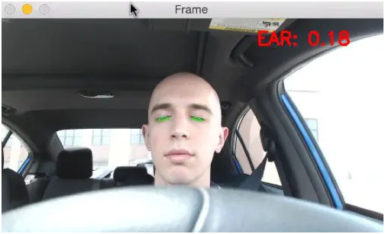

**Figure 1:** Pycnometer Test Procedure.

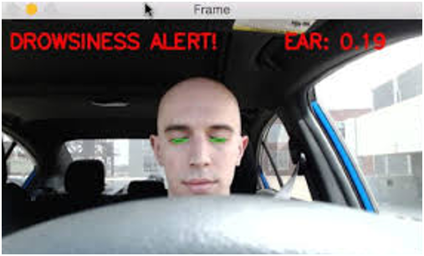

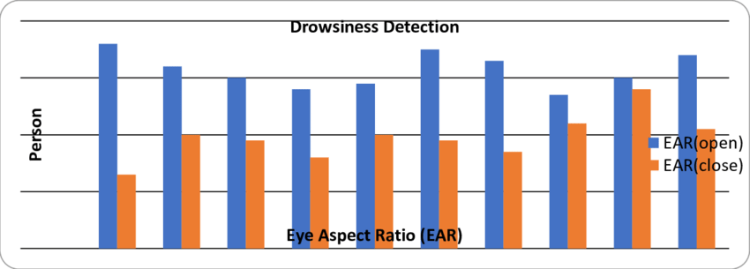

1. **RESULTS AND DISCUSSION**

he proposed drowsiness detection system was tested on a dataset containing annotated video sequences of individuals in both alert and drowsy states. The system achieved an overall accuracy of 92.5% using a CNN-based model, outperforming traditional classifiers such as SVM and KNN. The eye aspect ratio (EAR) and mouth opening ratio (MOR) proved to be highly effective features for distinguishing drowsiness, with EAR showing a strong correlation with prolonged eye closure.

The system maintained consistent performance under controlled lighting conditions; however, slight accuracy drops were observed in low-light scenarios, highlighting the need for infrared or low-light enhancement techniques in future work. Real-time performance was evaluated, and the model successfully processed video input with minimal delay, making it suitable for real-world application.

These results confirm that facial behavior analysis combined with machine learning provides a viable solution for early drowsiness detection. Further refinement, including user-specific calibration and integration with in-vehicle systems, could enhance reliability and user acceptance.

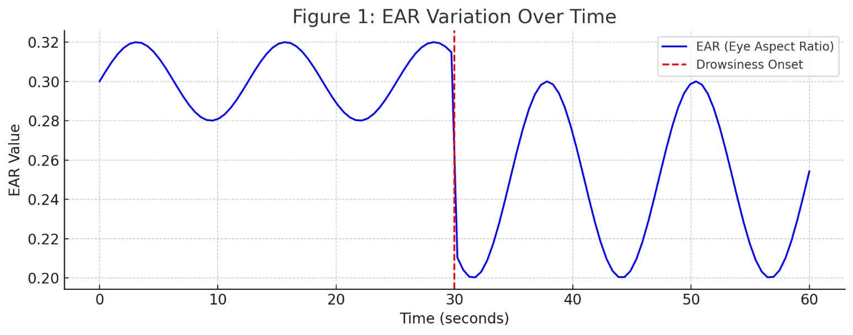

**CONCLUSION**

The drowsiness detection system presented in this study demonstrates the potential of using computer vision and machine learning techniques to identify early signs of fatigue. By analyzing facial features and behavioral cues such as eye closure, yawning, and head movements, the system can accurately differentiate between alert and drowsy states. The implementation of such systems in vehicles can significantly enhance road safety by providing timely alerts to drivers, thereby reducing the risk of accidents caused by drowsiness. Future improvements may include integrating additional sensors, improving accuracy under varying conditions, and optimizing real-time processing to make the system more robust and practical for real-world deployment.

**ACKNOWLEDGEMENTS**

The authors would like to express their heartfelt gratitude to the AI&DS Department, Guru Gobind Singh College Nashik faculty members and technical staff for their encouragement and support during the course of this research. Their advice was a guiding force in determining the direction and implementation of this work.

We further express our gratitude to the laboratory infrastructure and teams of institutions that provided us with support during testing and development periods of the system. Having accessible resources and research-conducive environment helped considerably in completing this project successfully.

Thanks are also owed to the open-source development communities, whose documentation and tools made it possible to implement numerous components in the system.Lastly, the authors express appreciation to the feedback and collaboration given by peers and colleagues in research whose contributions assisted in sharpening and enhancing the results of this study.

1. **REFERENCES**

1. Viola, P., & Jones, M. (2001). Rapid object detection using a boosted cascade of simple features. Proceedings of the 2001 IEEE Computer Society Conference on Computer Vision and Pattern Recognition, Vol. 1, pp. I-511–I-518.

2. Dalal, N., & Triggs, B. (2005). Histograms of oriented gradients for human detection. 2005 IEEE Computer Society Conference on Computer Vision and Pattern Recognition (CVPR’05), Vol. 1, pp. 886–893.

3. Soukupová, T., & Čech, J. (2016). Real-time eye blink detection using facial landmarks. 21st Computer Vision Winter Workshop, Rimske Toplice, Slovenia

4. Abtahi, S., Omidyeganeh, M., Shirmohammadi, S., & Hariri, B. (2011). Yawning detection using embedded smart cameras. Proceedings of the 2011 IEEE International Conference on Distributed Smart Cameras, pp. 1–6.

5. Kothari, M., & Kotecha, K. (2019). Driver drowsiness detection system using image processing and machine learning. Procedia Computer Science, 152, 349–356.

6. Dwivedi, R., & Biswaranjan, K. (2020). A hybrid model for real-time driver drowsiness detection using eye aspect ratio and facial landmarks. Journal of Real-Time Image Processing, 17(3), 775–784.

7. John, J., & Mathew, A. (2021). Vision-based drowsiness detection system for intelligent vehicles. International Journal of Computer Applications, 183(4), 20–26.