# LANGUAGE TRANSLATOR

# Ms.M.Sathya Mani, Sharan A, Vibin Richard D, Subramaniyan B, Sanjith R

Department of Information Technology, Bachelor of Technology, Sri Shakthi Institute of Engineering and Technology Coimbatore-641062

# ABSTRACT

A language translator is a technological solution designed to bridge communication gaps by converting text or speech from one language to another. It utilizes advanced algorithms, including machine learning and natural language processing, to ensure accuracy and context-awareness in translations. Language translators are widely used in various applications, such as real-time communication, content localization, and educational tools, empowering individuals and businesses to connect globally and access information across linguistic barriers. Modern language translators also offer features like voice recognition and text-to-speech, enabling seamless interaction and fostering inclusivity. With continuous advancements in AI, language translators aim to improve fluency, cultural nuance, and adaptability to diverse languages and dialects.

# INTRODUCTION

Language translators serve as essential tools in today's interconnected world, enabling seamless communication across diverse linguistic landscapes. By converting text or speech from one language to another, they break down barriers that often hinder understanding and collaboration. These translators leverage sophisticated technologies like artificial intelligence and machine learning to ensure translations are not only accurate but also contextually relevant. From individuals navigating foreign cultures to businesses expanding globally, language translators play a pivotal role in fostering inclusivity, accessibility, and mutual comprehension.

# Objective:

**1.Facilitate Communication:** Bridge linguistic gaps by converting text or speech between different languages.

**2.Enhance Accessibility:** Ensure information is available to people regardless of their native language.

**3.Support Global Collaboration:** Enable businesses, organizations, and individuals to work seamlessly across borders.

**4.Ensure Cultural Relevance:** Provide translations that consider cultural nuances and context for accuracy.

**5.Integrate Advanced Features:** Utilize voice recognition, text-to-speech, and real-time translation technologies for convenience.

**6.Adaptability:** Cater to diverse languages, dialects, and specialized terminology.

**7.Promote Inclusivity:** Foster mutual understanding and connection in multilingual environments.

# LITERATURE SURVEY

The process of creating a website for mental health care requires a thorough examination of the body of knowledge on chatbot technology, digital platforms, and mental health care. The purpose of this survey is to learn more about the functionality, constraints, and future development possibilities of websites related to mental health treatment.

It entails investigating the fundamentals of mental health treatment, the function of technology in resolving mental health issues, and the ways in which interactive tools and artificial intelligence (AI) might be used to offer individualized assistance. The study looks at studies on user satisfaction, chatbot efficacy for mental health, and how digital platforms might improve access to care and lessen stigma.

Through the examination of numerous sources, including research papers, journals, and case studies, the literature study offers insightful information about the state of digital mental health services today. It highlights best practices for creating platforms that are safe, easy to use, and effective while tackling issues like accessibility, cultural sensitivity, and data privacy.

This analysis is the basis for directing the creation of a website for mental health care that uses technology to empower users, encourage mental wellness, and provide a trustworthy and encouraging resource for those looking for comprehensive mental health treatment. We can better grasp the dynamic digital mental health environment and develop creative solutions to satisfy the needs of a wide range of consumers by carrying out an exhaustive literature review.

# METHODOLOGY

The development of language translation technologies necessitates a comprehensive review of existing literature on machine translation, natural language processing (NLP), and cross-linguistic communication. The purpose of this survey is to explore the functionality, limitations, and future growth prospects of language translators in facilitating global communication and understanding.

This review encompasses the foundational principles of language translation, including syntactic and semantic analysis, and investigates the role of artificial intelligence (AI) in enhancing translation accuracy and cultural relevance. Studies on user experience, the efficiency of automated translators, and their integration into diverse applications, such as education, business, and health care, are thoroughly examined. The survey also addresses challenges such as idiomatic expressions, dialectal variations, and maintaining contextual fidelity in translations.

Drawing from a wide array of scholarly articles, research reports, and case studies, this literature survey provides valuable insights into the current state of language translation technologies. It identifies best practices for designing systems that are user-friendly, context-aware, and linguistically adaptive, while addressing concerns like data privacy, cultural sensitivity, and ethical considerations.

This analysis serves as the foundation for the development of advanced language translators that aim to bridge linguistic divides, foster inclusivity, and support global collaboration. By undertaking a detailed literature review, we gain a deeper understanding of the evolving landscape of language translation technologies and can contribute to innovative solutions that meet the diverse needs of users worldwide

# Existing system:

Current language translation systems are sophisticated tools powered by natural language processing (NLP) and artificial intelligence (AI). Popular platforms like Google Translate, DeepL, and Microsoft Translator provide a range of functionalities aimed at converting text, speech, or visual inputs across multiple languages. These systems use advanced techniques like Neural Machine Translation (NMT) to improve fluency and context in translations

# Disadvantages:

1.Limited Contextual Accuracy: Struggle with maintaining cultural and contextual nuances, leading to occasional errors in meaning.

2.Challenges with Idiomatic Phrases: Difficulty accurately translating idioms, colloquial expressions, and regional language features.

3.Dependence on Internet Connectivity: Many systems require online access for optimal performance, limiting offline usability

4.Privacy Concerns: Potential risks related to data security and confidentiality, especially in cloud-based platforms.

Inadequate Support for Minority Languages: Often lack robust support for underrepresented or rare languages and dialects.

# Proposed system:

The proposed language translator system integrates advanced artificial intelligence and natural language processing technologies to create an innovative, accessible platform for seamless multilingual communication. By leveraging cutting-edge algorithms, it offers context-aware translations that preserve meaning and cultural nuances, addressing limitations of existing systems. The platform features tools such as real-time translation, voice-to-text capabilities, and offline functionality, ensuring reliable support across diverse scenarios. It prioritizes inclusivity by providing robust translations for minority languages and adaptability to specialized domains like medicine or law. With a focus on privacy, personalization, and user-friendliness, the system empowers individuals and organizations to break linguistic barriers, fostering global collaboration and mutual understanding. This transformative solution is poised to redefine language translation by enhancing accuracy, inclusivity, and the user experience.

**FLOW CHART:**

# Flow chart of the translation process. | Download Scientific Diagram

# SYSTEM REQUIREMENTS

## Software Requirements:

* HTML.
* CSS.
* JAVASCRIPT.
* PHP.
* BOOTSTRAP.
* XAMPP
* MYSQL

**Mode of Description:**

1. Home Page: Introduction to the language translator, allowing users to select languages and input text for translation.
2. Contact Us: Provides a way for users to ask questions or get support via a form, email, or phone.
3. Chatbot: Offers real-time translation assistance, helping users translate text or speech instantly.

**TRANSLATOR PAGE**

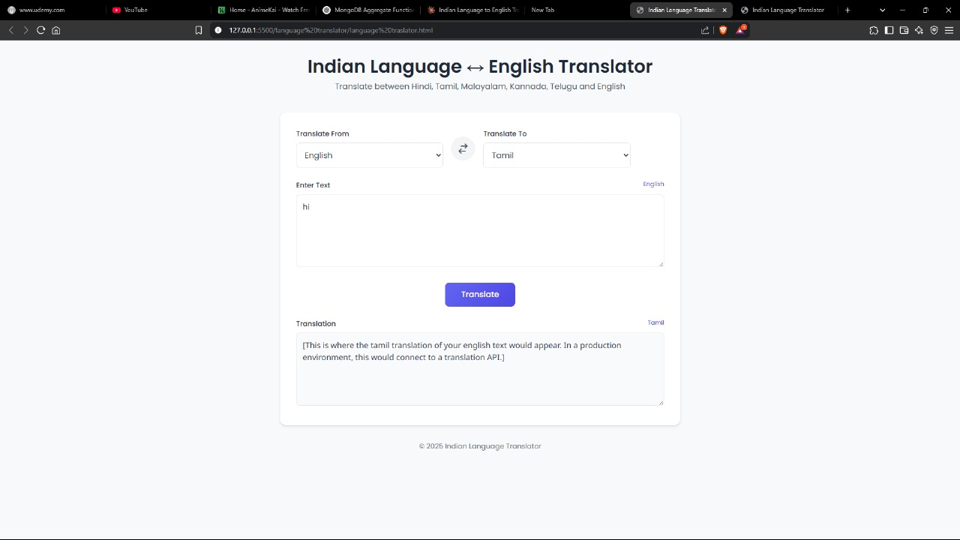

# CONCLUSION

Developing a language translator plays a crucial role in bridging communication gaps and fostering global connectivity. With the increasing need for multilingual interaction in various domains such as education, business, and healthcare, an efficient translation system can provide accurate and accessible language solutions.

By integrating advanced machine learning and natural language processing (NLP) techniques, language translators can offer users real-time, context-aware translations that enhance communication across different linguistic backgrounds. Such a system promotes inclusivity, eliminates language barriers, and enables seamless interactions among people worldwide.

Moreover, regular updates and improvements are essential to refine translation accuracy and ensure adaptability to evolving linguistic nuances. Compliance with ethical standards and data privacy regulations is critical to protect user information and maintain trust.

Ultimately, a language translator system can redefine communication, making it more efficient, inclusive, and accessible. By leveraging modern technology, it empowers users with the ability to understand and express themselves beyond language limitations, contributing to a more interconnected and informed society.

# sEFERENCES

1. Andersson, G., & Titov, N. (2014). Advantages and limitations of Internet‐based interventions for common mental disorders. *World Psychiatry, 13*(1), 4-11.
2. Mohr, D. C., Weingardt, K. R., Reddy, M., & Schueller, S. M. (2017). Harnessing behavioral intervention technologies to improve mental health outcomes. *The American Psychologist, 72*(7), 620-631.
3. Richards, D., & Viganó, N. (2013). Online counseling: A narrative and critical review of the literature. *Journal of Clinical Psychology, 69*(9), 994-1011.
4. Kallergis, G. (2019). Digital mental health interventions: An overview of the range of online programs and their outcomes. *Advances in Psychiatry, 5*(2), 123-134.
5. Firth, J., Torous, J., Nicholas, J., Carney, R., Pratap, A., Rosenbaum, S., & Sarris, J. (2017). The efficacy of smartphone-based mental health interventions: A meta-analysis of randomized controlled trials. *World Psychiatry, 16*(3), 287-298.
6. Henson, P., David, G., Albright, K., & Torous, J. (2019). Deriving a practical framework for the evaluation of mobile mental health apps: A review of methodologies. *Journal of Mental Health, 28*(1), 3-10.