# **THE DREAM STORE**

**Shrutika Sakre, Chanchal Gavande, Madhuri Bodede, Prof. Swapnil Gupta**

Department of Computer Science and Engineering, Thakur Shiv Kumar Singh Memorial Engineering College Burhanpur (M.P.)

**ABSTRACT**

"The Dream Store" an innovative e-commerce platform aimed at transforming the online fashion industry by facilitating direct connections between customers and independent designers, as well as skilled tailors. Key features include secure user authentication, product search capabilities, category-wise browsing, Wishlist and cart functionalities, online payment integration, and an admin panel for efficient management of users, orders, and inventory. This paper outlines the platform's design, functionality, and potential impact on the fashion industry, highlighting its role in promoting a more inclusive and personalized shopping experience.

**INTRODUCTION**

**“The Dream Store”** is a unique and empowering e-commerce web application developed to bridge the gap between talented individual designers and fashion-conscious customers seeking affordable, high-quality, and customizable designer wear. The platform is envisioned as a digital marketplace that not only facilitates the buying and selling of designer dresses but also promotes self-employment, especially among women who possess stitching and design skills.

In today's digital age, the demand for custom-designed fashion is growing rapidly. However, many skilled individuals lack the technical and marketing resources to reach a broader customer base. *The Dream Store* addresses this challenge by providing an easy-to-use platform where independent designers can register, upload their creations, set their own pricing, and offer customizations. At the same time, customers can explore a diverse collection of dresses, add products to their Wishlist or cart, and make secure online payments all from the comfort of their homes.

**The system includes three key user roles:**

* **Customers**, who can browse categories, view product details, choose customization options, manage their Wishlist/cart, and place orders.
* **Designers**, who can create accounts, upload dress designs, and interact with customers regarding custom requirements.
* **Administrators**, who oversee the entire system, manage user accounts, approve or reject designs, and ensure smooth operation of the platform.

**OBJECTIVE OF PROJECT**

* To develop a **user-friendly e-commerce platform** for buying and selling designer dresses.
* To provide a space for **independent designers and home-based tailors** to upload and sell their creations.
* To allow customers to **browse, customize, and purchase** dresses easily with Wishlist and cart functionality.
* To implement **secure user authentication** for customers, designers, and administrators.
* To support **customized fashion orders**, enabling customers to request specific designs or measurements.
* To build a **fully functional admin panel** to manage users, products, categories, orders, and transactions.
* To integrate **online payment gateways** for safe and smooth transactions.

**APPLICATION**

* **Online Designer Dress Store-**  
  A complete e-commerce platform for customers to buy stylish, customizable, and affordable designer clothing.
* **‍Self-Employment for Designers-**  
  Enables home-based designers, especially women, to showcase their creativity and earn income by uploading and selling their dress designs.
* **Custom Clothing Orders-**  
  Allows customers to request personalized outfits based on their size, style, fabric, or design preferences.
* **Virtual Boutique for Local Tailors-**  
  Acts as a digital boutique for small-scale tailors who want to reach a wider market without needing a physical store.
* **Online Order Management-**  
  Provides a complete solution for placing, tracking, and managing fashion product orders.
* **Admin Control Panel-**  
  Helps admins manage user roles, product listings, payments, and deliveries through a centralized dashboard.
* **Digital Marketplace for Fashion Entrepreneurs-**  
  Supports small business owners in the fashion industry by giving them access to online tools, customers, and payment systems.

**LIMITATION**

* **Basic Security Implementation:**  
  The current system uses standard login authentication but lacks advanced security features such as encryption, two-factor authentication (2FA), and role-based access control.
* **Manual Inventory Management:**  
  Product availability must be updated manually by admins or designers. Real-time inventory synchronization and alerts are not yet in place.
* **No Integrated Logistics System:**  
  The platform does not currently support real-time shipping or delivery tracking via third-party courier services.
* **Limited Payment Gateway Support:**  
  Online payments are either simulated or connected to a basic test gateway. Integration with secure, production-ready gateways (e.g., Razor pay, PayPal, Stripe) is pending.
* **Lack of Real-Time Communication:**  
  There is no built-in chat or messaging system for direct interaction between customers and designers or customer support.
* **Limited Business Intelligence Tools:**  
  The system lacks dashboards, sales analytics, and user behavior tracking tools for performance monitoring and decision-making.

**FEASIBILITY STUDY**

### **1. Technical Feasibility:**

* Web Development Languages like **HTML, CSS, JavaScript,** are easy to use and widely supported. Backend Framework (PHP, Python, Node.js), and database (my SQL, MongoDB) are available and completed.
* The platform can be developed and hosted using basic web technologies.  
  **Technically feasible** with available skills and tools.

**2. Economic Feasibility:**

* No major cost involved — uses free and open-source technologies.
* Basic hosting and domain charges are affordable.  
  **Economically feasible** for a student/college-level project.

### **3. Operational Feasibility:**

* Easy to use interface for customers, designers, and admins.
* Helps solve real-life problems like selling custom dresses online.  
  **Operationally feasible** and useful for real users.

### **4. Legal Feasibility:**

* No violation of laws in the basic version.
* Proper policies can be added in the future for user data and payments.  
  **Legally feasible** in its current educational scope.

### **5. Schedule Feasibility:**

* Project can be completed within the given time frame (college deadline).
* Increments help manage development within stages.  
  **Schedule feasible** for timely delivery.

**RESULT**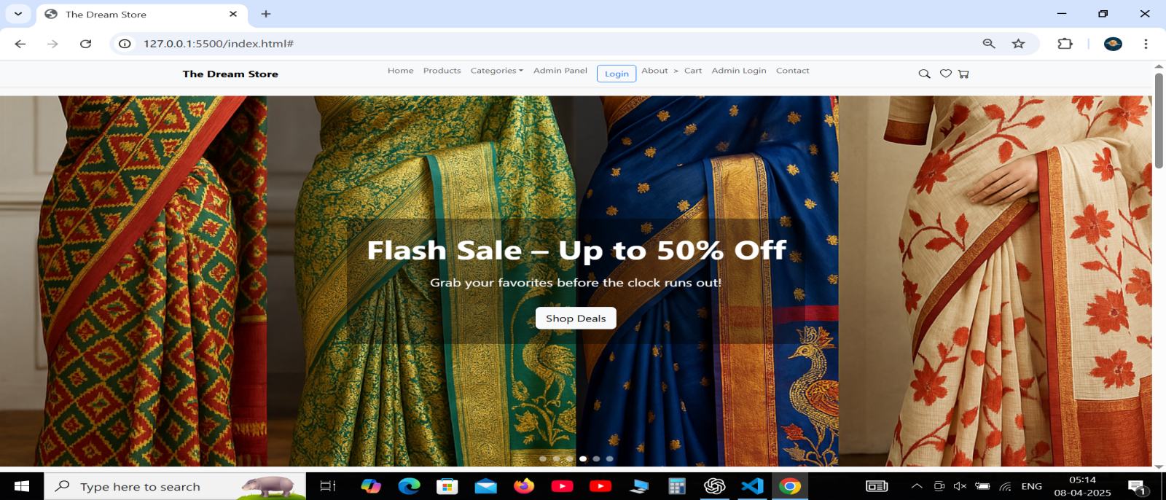

**Fig. 1.1** Home Page

**CONCLUSION**

**“The Dream Store”** project successfully bridges the gap between talented independent designers and customers seeking affordable, customizable designer wear. By offering a platform that supports user authentication, an admin panel, online payments, Wishlist, cart, and order management features, the website provides a seamless and user-friendly shopping experience. Additionally, it empowers skilled women in stitching to showcase and sell their creations, promoting self-reliance and entrepreneurship. With a responsive design and smooth functionality, “The Dream Store” stands as a comprehensive e-commerce solution that combines creativity, technology, and accessibility to meet the evolving demands of modern fashion consumers.

**FUTURE SCOPE**

* **AI-Powered Recommendations:** Implement machine learning to suggest products based on user preferences, browsing behavior, and trends.

• **Virtual Try-On (AR):** Integrate augmented reality to allow users to visualize outfits before purchasing, enhancing confidence and reducing returns.

• **Dedicated Mobile App:** Launch feature-rich Android and IOS apps for seamless shopping on the go, increasing user engagement and retention.

• **Smart Logistics Integration:** Partner with courier services to offer real-time order tracking, estimated delivery times, and flexible delivery options.

• **Multi-Language & Global Reach:** Add language options and international shipping to scale the platform beyond regional boundaries.

• **24/7 Chatbot Assistance:** Provide instant customer support through AI-powered chatbots, improving response time and customer satisfaction.

**s**• Reviews **& Ratings System:** Allow customers to rate products and designers, boosting transparency and trust within the community.

• Advanced **Analytics Dashboard:** Equip admins and designers with insights into sales trends, customer behavior, and inventory management.

• **Designer Portfolios & Promotions:** Enable designers to build portfolios, run promotions, and grow their personal brand through the platform.

• **Enhanced Security & Payments:** Upgrade to the latest security protocols and support more payment gateways for safe and flexible transactions.

**REFERENCES**

1. Bootstrap Documentation – <https://getbootstrap.com>

2. W3Schools – HTML, CSS, JavaScript Tutorials – <https://www.w3schools.com>

3. Mozilla Developer Network (MDN) Web Docs – <https://developer.mozilla.org>

4. Razor pay API Documentation (for payment integration) – <https://razorpay.com/docs/>

5. Font Awesome Icons –<https://fontawesome.com>

6. Google Fonts – <https://fonts.google.com>

7. GitHub – Open-Source E-commerce Templates and Resources – <https://github.com>

8. Stack Overflow – Community Support and Code Snippets – <https://stackoverflow.com>

9. JSON Server – Fake REST API for Development – [https://github.com/typicode/json- server](https://github.com/typicode/json-%20%20server)

10. Visual Studio Code – Code Editor – <https://code.visualstudio.com>