**Role of Loyalty Programs in Retaining Customers: A Case Study of Pharmacies and Supermarkets in Bangalore North**

**Mr. Jose Francis, Assistant Professor, Koshys Institute of Management Studies**

**Abstract**

In the context of Bangalore North—especially suburban areas like Kothanur—there is a unique blend of large retail chains and smaller, local businesses. Both pharmacies and supermarkets in this region face stiff competition, and retaining customers through well-designed loyalty programs can be a decisive factor for long-term success. However, the actual impact and effectiveness of these programs in semi-urban Indian settings remain under-researched. This study aims to bridge that gap by exploring how loyalty programs influence customer behavior, satisfaction, and retention in pharmacies and supermarkets in Bangalore North. It investigates customer preferences, demographic variations, and program design factors that contribute to the success or limitations of loyalty strategies.

**1. Introduction**

In an increasingly competitive retail environment, businesses are exploring ways to retain existing customers. Loyalty programs have emerged as a powerful tool to foster repeat business and increase customer lifetime value. Particularly in the pharmacy and supermarket sectors, loyalty programs provide incentives such as reward points, discounts, and exclusive member benefits. This study explores the role of such programs in customer retention, focusing on stores in Bangalore North—a region with a mix of branded and local retailers serving a dynamic urban population.

**2. Objectives of the Study**

* To assess the popularity and usage of loyalty programs among pharmacy and supermarket customers in Bangalore North.
* To evaluate the influence of these programs on customer satisfaction and repeat visits.
* To identify the challenges and gaps in existing loyalty programs from both customer and business perspectives.
* To suggest improvements that can enhance loyalty program effectiveness.

**3. Research Methodology**

**3.1 Research Design:** Descriptive research was conducted to gather detailed insights.

**3.2 Sample Size & Technique:** 350 respondents were selected using stratified random sampling across pharmacies ( Apollo, Med Plus) and supermarkets (Reliance Smart, More).

**3.3 Data Collection Tools:**

* Structured questionnaire (Google Forms and printed)
* Semi-structured interviews with 10 store managers

**3.4 Hypothesis of the Study**

To assess whether loyalty program usage is influenced by customer age, the following hypotheses were formulated:

Null Hypothesis (H₀): There is no significant association between the age group of customers and their usage of loyalty programs.

Alternative Hypothesis (H₁): There is a significant association between the age group of customers and their usage of loyalty programs.

**3.4 Analytical Tools:**

* Descriptive Statistics
* Bar Charts
* Satisfaction Scoring
* Chi-Square Test: To assess the association between demographic factors (age, gender) and usage of loyalty programs.

**4. Literature Review**

Loyalty programs have evolved as a key element in relationship marketing, aimed at enhancing customer retention and increasing customer lifetime value. This section explores the theories, models, and previous research that support the understanding of how loyalty programs influence consumer behavior in the retail sector.

**4.1 Concept of Customer Loyalty**

Customer loyalty refers to a customer’s commitment to repurchase a preferred product or service consistently, despite situational influences and marketing efforts by competitors (Oliver, 1999). In the retail environment, loyalty is often measured by repeat purchases and customer advocacy.

**4.2 Theoretical Frameworks Supporting Loyalty Programs**

* **Relationship Marketing Theory**: Proposed by Berry (1995), this theory emphasizes building long-term relationships with customers. Loyalty programs serve as a strategic tool to nurture these relationships.
* **Social Exchange Theory**: Blau (1964) suggested that people evaluate relationships based on cost-benefit analyses. Loyalty programs create a sense of reward and reciprocity, encouraging repeat behavior.
* **Behavioral Learning Theory**: According to Skinner (1953), reinforcement plays a key role in shaping behavior. Loyalty points, rewards, and discounts act as positive reinforcement, promoting habitual buying behavior.

**4.3 Types of Loyalty Programs**

According to Leenheer et al. (2007), loyalty programs typically fall into the following categories:

* **Point-based systems**: Earn points per purchase (e.g., MedPlus Rewards).
* **Cashback programs**: Receive a percentage of spend as money back.
* **Tiered programs**: Different levels of rewards based on frequency/spend.
* **Coalition programs**: Joint loyalty programs across multiple businesses.

**4.4 Loyalty Programs in the Indian Context**

In India, loyalty programs are gaining traction in both organized and semi-organized retail formats. A study by Rao & Sahu (2019) found that nearly 65% of Indian consumers prefer stores with loyalty programs, particularly in the grocery and pharmacy sectors. However, implementation challenges such as poor digital infrastructure, lack of personalization, and customer awareness still prevail.

Research by Bhatnagar and Sinha (2020) highlighted that Indian consumers value flexibility and transparency in loyalty programs. They are more likely to engage with programs that are easy to understand and offer tangible, timely rewards.

**4.5 Loyalty and Customer Retention**

Several studies link effective loyalty programs to improved customer retention:

* **Kumar & Reinartz (2006)** argue that customer loyalty doesn’t always equal profitability, but strategic loyalty programs can improve retention when aligned with customer value.
* **Dowling and Uncles (1997)** noted that while loyalty programs alone might not guarantee loyalty, they act as a differentiator and a retention enhancer when combined with superior service.

**4.6 Gaps Identified in Previous Research**

While many studies focus on loyalty programs in large-scale retail or e-commerce, there is limited empirical research on:

* The comparative effectiveness of loyalty programs between supermarkets and pharmacies.
* Region-specific studies, such as in Bangalore North, where demographic diversity influences consumer behavior.
* Loyalty programs in semi-urban or transitioning urban settings like Kothanur

**5. Analysis and Interpretation**

**5.1 Customer Satisfaction Index (CSI)**

On a scale of 1–10, the CSI was found to be **7.8**, indicating overall satisfaction. However, the satisfaction dropped when redemption processes were delayed or unclear.

**5.2 Awareness and Usage**

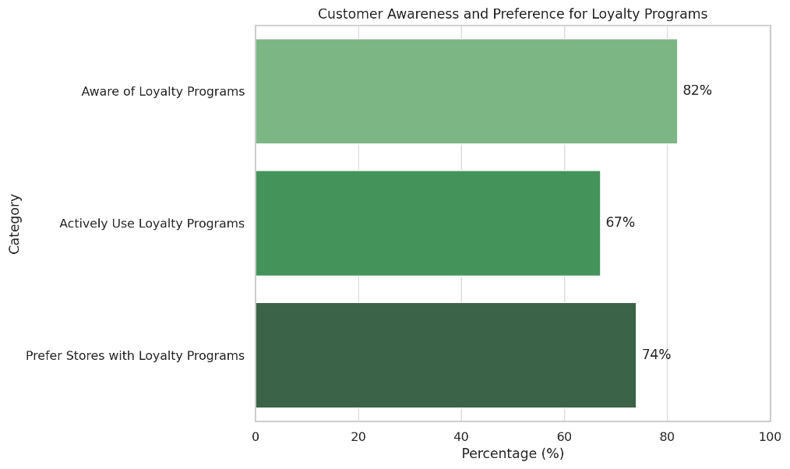

* 82% of customers are aware of loyalty programs at the stores they frequent.
* 67% of these actively use the benefits provided through membership cards or mobile apps.
* 74% prefer shopping at stores offering loyalty programs.

**5.3 Factors Influencing Loyalty**

* **Discounts & Offers**: 70% of customers say discounts attract them the most.
* **Ease of Redemption**: 55% prefer instant redemption at checkout over app-based systems.
* **Personalization**: Only 28% received customized offers—suggesting a need for improvement.

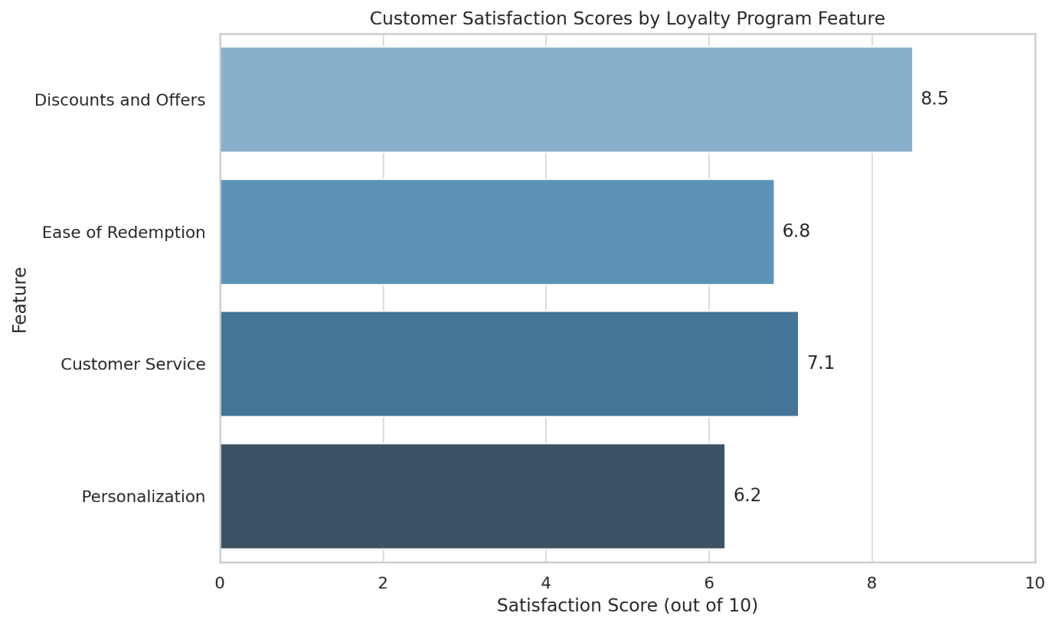

|  |  |
| --- | --- |
| **Feature** | **Satisfaction Score (out of 10)** |
| Discounts and Offers | 8.5 |
| Ease of Redemption | 6.8 |
| Customer Service | 7.1 |
| Personalization | 6.2 |

**5.4 Statistical Analysis Results**

The Chi-Square test was performed on the contingency table to assess the relationship between age groups and loyalty program usage.

**Chi-Square Test Output:**

* **Chi-Square Statistic**: 4.22
* **Degrees of Freedom**: 4
* **P-value**: 0.377

Since the p-value is greater than the 0.05 significance level, we fail to reject the null hypothesis. This suggests that there is **no statistically significant association** between age group and loyalty program usage in the context of this study.

**6. Key Findings**

* Loyalty programs significantly influence repeat purchase behavior, especially in pharmacies where customers buy monthly medications.
* Customers find value in discounts and offers but are frustrated by complicated redemption rules.
* Supermarkets with mobile apps (like Reliance Smart) showed better engagement.
* Local pharmacies struggle with digital loyalty systems and rely on manual entries or paper cards, which limits customer satisfaction.

**7. Challenges Identified**

* Lack of personalization in rewards.
* Delayed points updates or unclear expiry dates.
* Limited digital literacy among some customer segments hinders app-based program effectiveness.
* Inconsistent employee communication about loyalty schemes at the billing counter.

**8. Recommendations**

* Introduce tiered rewards systems with exclusive benefits for regular users.
* Use data analytics to offer personalized deals based on purchase history.
* Ensure seamless digital integration and auto-redemption during billing.
* Regular staff training to communicate loyalty benefits clearly to customers.

**9. Conclusion**

Loyalty programs are an impactful strategy to retain customers in Bangalore North’s pharmacy and supermarket sectors. When designed with the customer in mind—offering ease, transparency, and personalization—they foster long-term loyalty and consistent revenue. Businesses that address existing gaps and focus on tech-enabled, customer-centric models will have a clear competitive advantage.

**10. References**

* Yi, Y., & Jeon, H. (2003). Effects of loyalty programs on value perception, program loyalty, and brand loyalty. *Journal of the Academy of Marketing Science*.
* Kumar, V., & Shah, D. (2004). Building and sustaining profitable customer loyalty programs. *Journal of Retailing*.
* Oliver, R. L. (1999). Whence consumer loyalty? *Journal of Marketing*.
* Blau, P. (1964). *Exchange and Power in Social Life*.
* Rao, R., & Sahu, A. (2019). Impact of loyalty programs in Indian retail: A customer perspective. *Indian Journal of Marketing*.
* Bhatnagar, M., & Sinha, S. (2020). Indian retail loyalty: Factors influencing customer preferences. *International Journal of Retail Management*.
* Interviews with local store managers and customer surveys (2025).