**Weather Forecast Prediction: A Detailed Approach for Assessing and Analyzing Meteorological Information**

**Jayshree Khairnar¹, Ayush Lonare², Sanket Barve³, Raj Anbhule⁴, Hemant Chaure⁵, Pratik Savkar ⁶**

Assistant Professor, Artificial Intelligence & Data Science, Guru Gobind Singh College of Engineering & Research Center, Nashik, Maharashtra, India

²³⁴⁵ ⁶Students, Artificial Intelligence & Data Science, Guru Gobind Singh College of Engineering & Research Center, Nashik, Maharashtra, India

**ABSTRACT**

This study outlines the creation and design of the Advanced Weather App, a web-based platform that provides real-time, responsive weather information for cities across the globe. Created with HTML, CSS, and JavaScript, the application leverages the OpenWeatherMap API to retrieve and display live weather information, such as temperature, humidity, wind speed, UV index, and air quality index. (AQI), and sunrise/sunset times. Notable features include forecasts based on location, a dark mode for an improved user experience, and the ability for users to save their preferred cities continuously. The application prioritizes user-friendliness and performance, featuring a streamlined interface and a design that adjusts to various devices. This paper details the implementation framework, strategies for API integration, challenges faced during development, and the potential uses of the app in both personal and professional weather observation scenarios.

Keywords: Weather Forecasting, OpenWeatherMap API, Dark Mode, Air Quality Index (AQI), Location-Based Services.

1. **INTRODUCTION**

Weather conditions significantly impact everyday choices, affecting everything from travel itineraries and outdoor pursuits to agriculture and crisis readiness. As web technologies evolve rapidly and the need for accessible weather information grows, intuitive weather applications have become crucial resources for both individuals and communities. The Advanced Weather App was created to meet this demand by delivering precise, real-time weather information through a clean and user-friendly interface that works seamlessly across multiple devices.

This web application is constructed using fundamental front-end technologies—HTML, CSS, and JavaScript—and connects with the OpenWeatherMap API to retrieve extensive weather information. In contrast to simpler forecasting tools, the Advanced Weather App provides an array of features, such as temperature, humidity, wind speed, UV index, air quality index (AQI), and sunrise/sunset times. Additionally, it includes a dark mode option for improved visual comfort and enables users to save their preferred cities for easy access, creating a tailored and lasting experience.

1. **METHODOLOGY**

This study employs a hands-on, application-focused approach to demonstrate how real-time weather data can be integrated using the OpenWeatherMap API. The weather app was developed using HTML, CSS, and traditional JavaScript.. API requests were utilized to retrieve current weather conditions, forecasts, UV index, and air quality data. To improve user experience, features such as geolocation, dynamic background updates, unit conversion, theme switching, and a favorites system were integrated. LocalStorage was employed to maintain the persistence of theme preferences

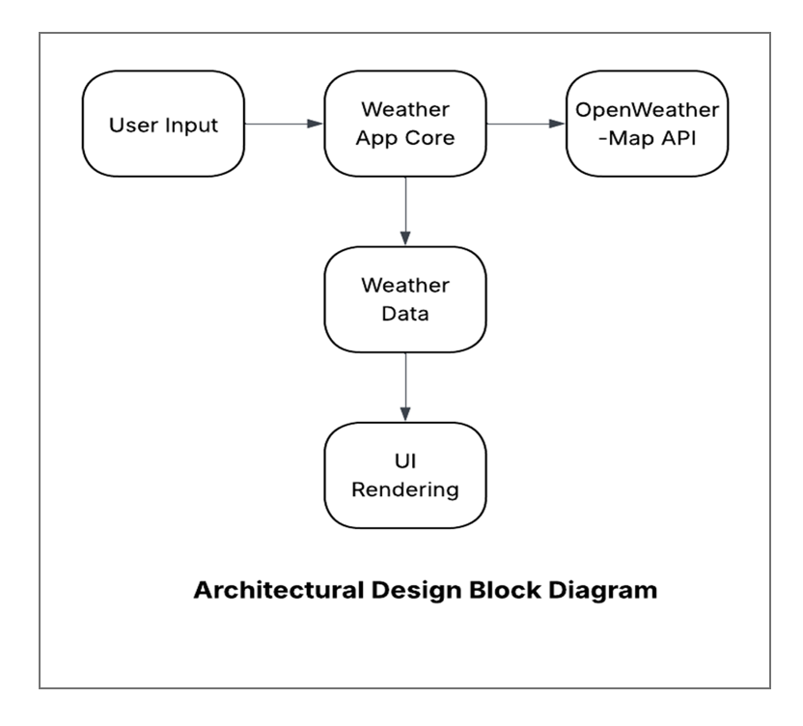

1. **RESULTS AND DISCUSSION**

A comprehensive testing procedure was implemented to verify the functionality, stability, and responsiveness of the Advanced Weather App. Unit Testing Individual JavaScript functions were tested, including those for location retrieval, data fetching from the API, parsing responses, and updating the user interface. Error handling was verified using both standard and edge-case inputs. Integration Testing The interaction between the API, user interface, and local storage was tested to guarantee seamless data flow and real-time updates. System Testing The complete application underwent testing on a variety of devices and major browsers (Chrome, Firefox, Edge, Safari). Strengths of the System:

● Lightweight and quick

● Location-based weather

● User-friendly with favorites

● Compatible across all platforms. Limitations

● Requires internet access

● Relies on the accuracy of API data

1. **CONCLUSION**

All the main points of the research work are written in this section. Ensure that abstract and conclusion should not same. Graph and tables should not use in conclusion.

The Advanced Weather App illustrates how web technologies can be skillfully combined with real-time APIs to develop a responsive and user-friendly weather forecasting tool. Created using HTML, CSS, and JavaScript, and supported by the OpenWeatherMap API, the app provides precise weather information through an organized and interactive interface. Features such as location-based forecasts, dark mode, and saved favorites improve the overall user experience. This project exemplifies the effectiveness of front-end development in addressing real-world challenges through accessible and engaging web applications.

**ACKNOWLEDGEMENTS**

The authors express their heartfelt gratitude to Prof. Jayshree Khairnar for her guidance and support during the development of this project. We also recognize the collaborative contributions of our peers in coding, testing, and enhancing the system.

1. **REFERENCES**

[**https://openweathermap.org/api**](https://openweathermap.org/api)

[**https://developer.mozilla.org**](https://developer.mozilla.org)

[**https://www.w3schools.com**](https://www.w3schools.com)

[**https://fontawesome.com**](https://fontawesome.com)

[**https://fonts.google.com**](https://fonts.google.com)