3 in 1 meter A Unified Metering System Deployed for Water And Energy Monitoring in Smart City and electricity theft

1s t Deepa S Chebbi 2nd Usha C T

*RR Institute* *of Technology , RR Institute* *of Technology ,*

*Bangalore*, India *Bangalore*, India

deepachebbi@gmail.com ushausha0806@gmail.com

***Abstract***— 3 in 1 meter a unified metering sytem deployed for water and energy monitoring in smart city and electricity theft project aims to create an integrated metering system for real-time tracking of water, fuel, and energy consumption in a smart city context. By utilizing IoT-enabled smart meters, cloud computing, and advanced data analytics, the system seeks to optimize resource management and foster sustainability. The solution features a centralized dashboard accessible by both consumers and city authorities, allowing them to monitor usage trends and detect irregularities or inefficiencies. It supports the monitoring of electricity, water, and fuel consumption while also detecting potential power theft. All consumption data is transmitted to a central server, where it is processed and used to generate a consolidated billing report. Consumers will have access to a mobile application, which provides monthly updates on their consumption and allows for easy payment through an integrated portal. The entire system leverages the principles of embedded systems and IoT technology, ensuring real-time, accurate data collection and reporting. This system not only aids in resource conservation but also promotes transparency and accountability in utility management, benefiting both consumers and municipal authorities.

**Keywords—** "Integrated metering system for water, energy monitoring, and electricity theft prevention."

1. Introduction

In the modern era, cities across the globe are evolving into smarter, more efficient environments through the adoption of advanced technologies. Among the most notable advancements in smart city infrastructure is the development and deployment of integrated metering systems, which provide a comprehensive solution for monitoring and managing utilities like water and energy. One such breakthrough is the **3-in-1 meter**, a unified metering system designed to monitor water, energy, and electricity usage, all from a single device. This innovation is particularly essential in the context of smart cities, where efficiency, sustainability, and resource management are key priorities.

The 3-in-1 metering system, a sophisticated technology, plays a crucial role in transforming urban living by streamlining the process of utility monitoring. As cities grow and become more complex, the demand for resources like water and electricity increases, making it vital to find ways to manage these utilities effectively and reduce wastage. Traditional metering systems, which monitor water and energy separately, often lead to inefficiencies and gaps in data. The integration of these systems into one device enables accurate real-time tracking,

3rd Balaramegowda B K 4th Vaibhav S Katti

*RR Institute* *of Technology , RR Institute* *of Technology ,*

*Bangalore*, India *Bangalore*, India

[balaramdarshu@gmail.com](mailto:balaramdarshu@gmail.com) vaibhavkatti541@gmail.com

providing valuable insights that can enhance decision-making and improve overall resource management.

One of the primary advantages of the 3-in-1 meter is its ability to help prevent **electricity theft**, a significant issue in many urban areas. In countries with high rates of electricity theft, utilities often face enormous financial losses due to unauthorized consumption. The 3-in-1 meter is equipped with advanced technology that can detect abnormal usage patterns, indicating possible theft. By integrating water and energy monitoring, the system allows authorities to identify unusual consumption not only in terms of electricity but also in water usage, which is often linked to unauthorized electricity usage. This multi-dimensional monitoring enables faster detection and resolution of theft, ultimately reducing revenue losses and improving the efficiency of the utility sector.

The integration of the 3-in-1 meter within smart cities offers a multitude of benefits. First, it enhances **energy efficiency** by providing both consumers and utilities with a clear, real-time picture of energy usage. Users can make informed decisions about their consumption habits, leading to potential cost savings and environmental benefits. Furthermore, utilities can use the data from these meters to identify inefficiencies in their infrastructure and optimize service delivery, ensuring that resources are used where they are needed most.

Another key aspect of the 3-in-1 metering system is its ability to contribute to **water conservation** efforts. Water is a critical resource, and its mismanagement can lead to severe shortages, especially in areas facing climate change challenges. By monitoring water consumption alongside energy use, the system provides insights into areas of high consumption, facilitating better planning and resource allocation. This dual-purpose metering system ensures that cities can track and manage both water and energy resources simultaneously, allowing for more sustainable urban development.

In addition to its practical benefits, the deployment of unified metering systems in smart cities fosters innovation in urban planning and management. With data gathered from the 3-in-1 meters, city planners can develop smarter, more efficient infrastructures, improving the quality of life for citizens while minimizing environmental impacts. As smart cities continue to grow, the need for integrated, high-tech solutions like the 3-in-1 meter will become even more pronounced, offering a future where resources are utilized sustainably, and utility management is more efficient and transparent.

1. LITERATURE REVIEW
2. In the paper “Analysis of Smart Meter Data for Electricity Consumers” the authors Grzegorz Dudek, Anna Gawlak, Mirosáaw Kornatka and Jerzy Szkutnik document about how smart meter systems are being deployed to improve grid reliability and promote energy, water, and gas efficiency while providing improved services to their customers. Smart metering which is installed in millions of households worldwide provides utility companies with real-time meaningful and timely data about electricity consumption and allows customers to make informed choices about energy, water, and gas usage. Smart meter data analytics has become an active area in research and industry. It aims to help utilities and consumers understand electricity consumption patterns. This paper provides analysis methods for load data including analysis of daily load profiles and similarity between them, analysis of load density, and analysis of seasonal and irregular components in the load time series. We evaluate our approach by analyzing smart meter data collected from 1000 households in Poland at a 15-minute granularity over a period of one year.
3. In the paper “Smart Meter for the IoT” the authors F. Abate, M. Carratù, C. Liguori, M. Ferro, and V. Paciello document about how in recent years, smart devices are increasing. These devices allow making cities smart, enabling communication not only among people but also among things, creating a new system nowadays known by the term IoT (Internet of Things).
4. In the paper “Smart Energy, water and gas Metering and Power Theft Control using Arduino & GSM” the authors Visalatchi S and Kamal Sandeep K document about how the energy, water and gas theft is a very common problem in countries like India where consumers of energy, water and gas are increasing consistently as the population increases. Utilities in electricity system are destroying the amounts of revenue each year due to energy, water, and gas theft. The newly designed AMR used for energy, water and gas measurements reveal the concept and working of new automated power metering system but this increased the Electricity theft forms administrative losses because of not regular interval checkout at the consumer's residence. It is quite impossible to check and solve theft by going every customer’s door to door.
5. In this paper, a new procedure is followed based on MICROCONTROLLER Atmega328P to detect and control the energy, water and gas meter from power theft and solve it by remotely disconnect and reconnecting the service (line) of a particular consumer. An SMS will be sent automatically to the utility central server through GSM module whenever unauthorized activities detected and a separate message will send back to the microcontroller in order to disconnect the unauthorized supply. A unique method is implemented by interspersed the GSM feature into smart meters with Solid state relay to deal with the non-technical losses, billing difficulties, and voltage fluctuation complication.
6. In the paper “Energy, water and gas Theft and Defective Meters Detection in AMI Using Linear Regression”, the authors Sook-Chin Yip, Chia-Kwang Tan, Wooi-Nee Tan, Ming-Tao Gan, and Ab-Halim Abu Bakar document about how electricity theft is always a ticklish problem faced by utilities around the world. To mitigate and detect energy, water and gas theft, utilities are leveraging on the consumers’ energy, water and gas consumption dataset obtained from advanced metering infrastructure to identify anomalous consumption patterns. However, real energy, water, and gas theft samples, as well as the distribution station smart meter readings, do not exist in Malaysia because smart grid is not fully implemented. Therefore, we design and construct a small-scaled advanced metering infrastructure test rig in the laboratory to evaluate the performance and reliability of our previously proposed linear regression-based detection schemes for energy, water and gas theft and defective meters in small grid environment. Simulations and electrical tests are conducted and the results show that the proposed algorithms can successfully detect all the fraudulent consumers and discover faulty smart meters in smart grids.
7. PROPOSED WORK

The proposed energy monitoring system is an IoT-based smart framework that aims to provide accurate, real-time insights into power and water usage, while also offering remote control and automation features. This solution effectively bridges the gap between manual monitoring and modern, connected technologies using Arduino UNO as its central unit. The integration of sensors, communication modules, and cloud-based platforms ensures that the system functions efficiently, reliably, and is accessible from virtually anywhere.

1. Central Control Unit – Arduino UNO

At the heart of the system is the Arduino UNO, a widely-used microcontroller board based on the ATmega328P chip. It serves as the brain of the entire system, coordinating the flow of data between various hardware components and the cloud interface. The Arduino continuously gathers inputs from sensors, processes the data using embedded C logic, and executes control commands for connected devices like relays.Its versatility and simplicity make it ideal for handling analog and digital inputs/outputs, which are necessary for controlling lights, fans, water pumps, and displaying information on an LCD screen.3 in 1 meter A Unified Metering System Deployed for Water and Energy Monitoring in Smart City and electricity theft

2. Power Monitoring via Sensors

To monitor electricity consumption, two essential sensors are employed:

* Voltage Sensor: This sensor measures the voltage level being supplied to the system. It converts the high-voltage AC signal into a scaled-down signal suitable for the Arduino to interpret.

* Current Sensor: This sensor detects the current flowing through the load. When current flows through a conductor, it creates a magnetic field that the sensor detects, allowing it to determine the current draw in real time.Together, these sensors provide the data needed to calculate the power consumption using the formula

formula: Power (Watts)=Voltage (V)×Current (I)

This real-time data is processed by the Arduino, which can then decide whether to trigger alerts, automate actions via relays, or upload the values to the cloud for tracking.

3. Appliance Control Using Relays

The system is designed to control multiple electrical appliances like lights, fans, and water pumps using relay modules. These relays act as electrically operated switches Based on input from sensors or remote commands from the cloud platform, the Arduino can trigger relays to turn appliances ON or OFF.For example, if a threshold power usage is crossed or if water usage is too high, the system can automatically turn off the respective device to prevent overuse or damage.

4. Water Flow Monitoring

A water flow sensor is incorporated to monitor water usage, particularly from sources like pumps or tanks. It detects the rate of water flow in liters per minute (L/min) and sends pulse signals to the Arduino. Each pulse corresponds to a fixed volume of water.This helps in identifying leaks, overuse, or irregular water flow patterns. The system can use this data for automatic shut-off or sending alerts to the user.

5. Data Visualization with LCD Display

The system is equipped with a 16x2 LCD display to provide on-site information, such as:

* Voltage and current readings

* Water flow rate

* Device status (ON/OFF)

* Alerts (e.g., overload, low flow)

This real-time visibility helps users immediately understand the system’s behavior without needing to access the cloud interface.

6. Connectivity – Cloud and GSM

a) ESP8266 WiFi Module (IoT Connectivity)

This module allows the Arduino to connect to the internet via Wi-Fi. The sensor readings and system status are uploaded to ThingSpeak and Blynk Cloud, both of which provide web and mobile-based dashboards. These platforms allow:

* Live visualization of energy/water usage

* Remote control of devices

* Setting triggers and automation rules

* Data logging and historical trend analysis

b) GSM Module (SMS Backup and Alerts)

In case the Wi-Fi connection is lost, the GSM module provides a backup communication path. It sends SMS alerts to predefined phone numbers to inform users of anomalies like high consumption, system faults, or disconnection. This ensures system reliability even in network-poor environments.

7. Cloud Platforms – ThingSpeak & Blynk

* ThingSpeak: Primarily used for real-time data logging and visualization. It offers powerful graphs and allows custom analytics using MATLAB integration.

* Blynk Cloud: Offers an interactive interface where users can control devices, monitor parameters, and set conditions from a smartphone app. It allows users to build dashboards with widgets like gauges, sliders, buttons, etc.3 in 1 meter A Unified Metering System Deployed for Water and Energy Monitoring in Smart City and electricity theft

8. System Automation and Alerts

The Arduino program contains logic to automate various responses based on sensor inputs. For instance:

* If voltage or current exceeds a safe threshold, a relay is triggered to disconnect the device.

* If water flow drops below a certain rate, the pump may be turned off.

* If no current is detected from a device that should be ON, the system flags a fault.

* Alerts are sent via SMS and/or cloud notifications.This makes the system proactive and helps avoid potential damage or energy loss.

9. Power Supply and Protection

The system is powered by a regulated 5V-12V power supply, which is distributed to various modules as per their voltage requirements. Voltage regulators ensure that each component receives the required voltage safely. Fuse protection and proper insulation are incorporated for safety.

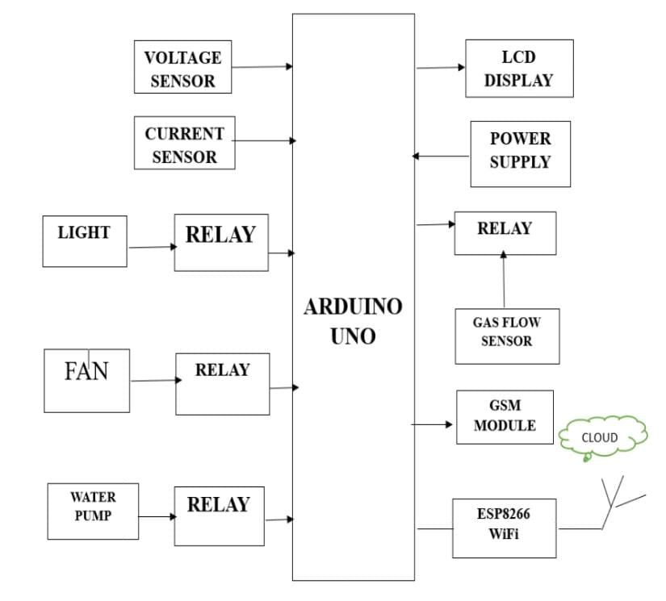

Fig 1. Block Diagram Of Proposed System

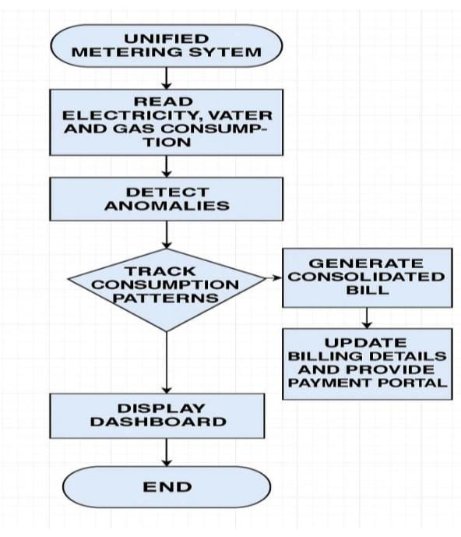

Fig 2. Implementation Of Flow Chart

1. RESEARCH DESIGN AND APPROACH

This research focuses on the development and evaluation of a Unified Metering System (UMS) aimed at integrating the monitoring of water and energy resources in smart cities while addressing issues such as electricity theft. The primary objectives of this study are to design a system that enables the simultaneous tracking of both water and energy consumption, enhances operational efficiency, and incorporates mechanisms to detect and prevent electricity theft. To achieve these goals, the research will employ a quantitative methodology, utilizing both primary and secondary data. Primary data will be gathered through field trials, where selected urban areas will be equipped with integrated smart meters for water and energy. Data will be collected over a 12-month period to analyze consumption patterns, detect anomalies indicative of theft, and evaluate the system's overall performance. Secondary data, including historical consumption and energy theft records, will provide additional insights into the challenges and potential improvements for the system.

The system will feature smart meters equipped with sensors and wireless communication modules, transmitting real-time data to a cloud-based aggregation platform. This platform will analyze the data through advanced algorithms to identify patterns, detect anomalies, and predict future consumption trends. Additionally, the system will be designed to prevent electricity theft by integrating machine learning-based anomaly detection techniques, which will flag unusual consumption behavior associated with potential theft. The research will employ a mix of descriptive statistics, predictive analytics, and comparative analysis to evaluate system performance, particularly in terms of accuracy, efficiency, and theft detection.

The effectiveness of the UMS will be measured through various performance metrics, including the accuracy of data collection, the efficiency of resource management, the system’s ability to identify electricity theft, and user satisfaction. The success of the system will be determined by its capacity to reduce operational costs, improve the reliability of resource distribution, and ensure the security of data. However, challenges such as integration issues with existing infrastructure, concerns about data privacy, and potential resistance to new technologies are expected. Despite these challenges, the research anticipates significant outcomes, including enhanced management of water and energy resources, reduced electricity theft, and a scalable system adaptable to diverse smart city contexts. The timeline for the research is structured in four phases, from system design to final evaluation, with a 12-month period for data collection and analysis. Ultimately, this study aims to contribute to the development of smart city technologies by creating an integrated solution for resource monitoring that is both efficient and secure.

1. Results

The proposed system generates a unified billing and payment method for the electricity, water and gas consumption which can be accounted for monthly usage. The system also generates

individual bills for each of them if the customer wishes to pay them at different intervals of time. If the payment is not made within the due date, the supply of that resource will be turned off until the bill is paid.

individual bills for each of them if the customer wishes to pay them at different intervals of time. If the payment is not made within the due date, the supply of that resource will be turned off until the bill is paid.

Fig 3. Result

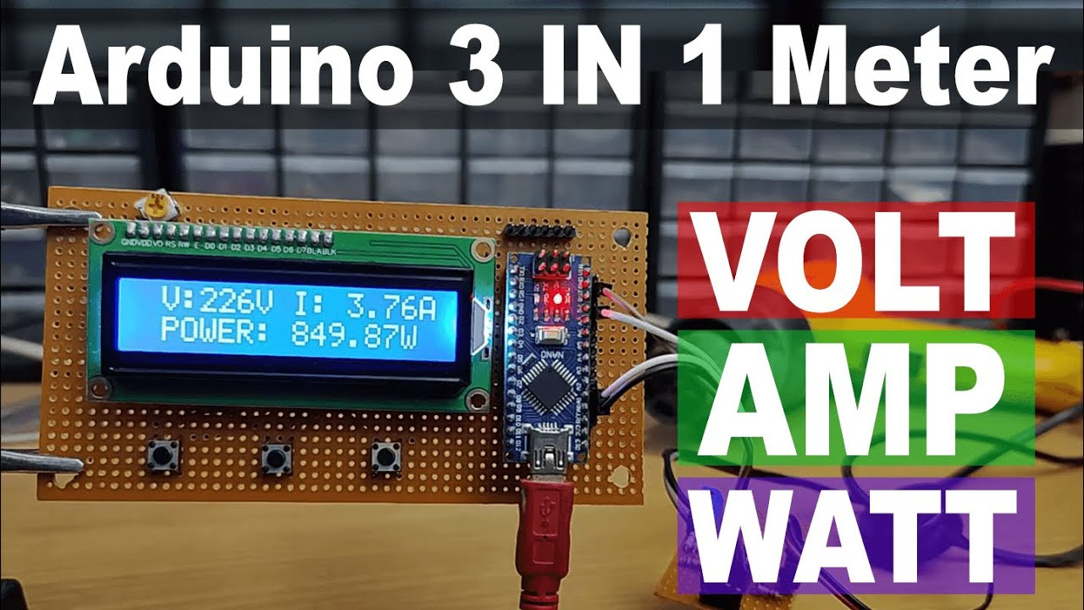

1. Limitations And Future work

Despite the promising potential of the Unified Metering System (UMS) for monitoring water and energy usage in cities, there are several limitations to consider. One significant challenge is the **integration complexity** of merging different metering systems for water and energy, especially when dealing with devices from multiple vendors Compatibility issues may arise, which could hinder smooth data transmission and system functionality. Additionally, **data privacy and security** concerns must be addressed, as the collection of real-time consumption data could make the system vulnerable to cyber threats if not properly safeguarded with encryption and secure communication protocols.

Another limitation is the **scalability** of the system, especially in large urban environments with varied infrastructure. Deployingand maintaining a unified system across a sprawling city may require substantial investment in hardware, software, and ongoing maintenance, which could be a barrier for some municipalities. Furthermore, **user acceptance** could pose a challenge, as some residents and businesses may be reluctant to adopt new metering technologies due to perceived costs, disruptions, or concerns over data misuse.

In terms of future work, there are numerous opportunities to enhance the UMS. A primary area of development would be improving the **machine learning algorithms** for anomaly detection to increase accuracy and reduce false positives. Additionally, expanding the system to include other utilities like gas and waste management could further streamline resource monitoring in smart cities. Future research could also focus on **user education and engagement** to encourage to use it

VIConclusion

In conclusion, the 3-in-1 unified metering system (ums) offers a transformative approach to managing water and energy resources in smart cities, providing real-time monitoring and efficient resource management. By integrating water and energy meters into a single system, it simplifies data collection, enhances operational efficiency, and plays a crucial role in detecting and preventing electricity theft. While challenges such as integration, data security, and user adoption remain, the system’s potential for improving sustainability and reducing resource wastage is significant, paving the way for smarter, more resilient urban infrastructures. Future developments in algorithm accuracy and scalability will further optimize the system’s impact, making it a cornerstone for the smart cities of tomorrow.

References

[1]Sun, J., Wang, Y., Liu, P., & Wen, S. (2023). Memristor-enabled neural circuit for emotion-aware smart IoT devices. IEEE Internet of Things Journal. https://doi.org/10.1109/JIOT.2023.3267778

[2] Zanaj, E., Caso, G., Dardis, L. D. N., Mohammadpour, A., Alay, Ö., & De Benedetto, M. G. (2021). Performance and energy efficiency comparison of IoT communication technologies.9(1),52.https://doi.org/10.3390/technologies9010052

[3]Sushma, N., Suresh, H. N., & Lakshmi, J. M. (2022). Design of a smart water flow meter for urban infrastructure.In ICAECT 2022 – IEEE Conf. Proc. https://doi.org/10.1109/ICAECT54875.2022.9808041

[4].Zhao, W., Liu, C., & Zhang, H. (2023). Low-cost smart energy monitoring system using IoT sensors. Sensors and Actuators A: Physical, 341, 113603. https://doi.org/10.1016/j.sna.2022.113603

[5].Bhagat, P., Sharma, A., & Chauhan, R. (2021). IoT-based smart home energy management system. International Journal of Computer Applications, 183(22), 25–29.

[6].Ramesh, K., Kumar, A., & Meena, R. (2024). An IoT-integrated energy and water monitoring solution for smart cities. Journal of Emerging Technologies and Innovative Research, 11(2), 112–119.

[7].Elavarasan, R. M., Afridhis, S., Vijayaraghavan, R., Subramaniam, U., & Kumar, N. M. (2020). A comprehensive review on renewable energy development, challenges, and policies. IEEE Access, 8, 74432–74473. https://doi.org/10.1109/ACCESS.2020.2988011

[8].Patel, A., & Desai, M. (2022). Smart irrigation and water management using IoT. International Journal of Engineering Research & Technology, 11(5), 530–535.

9.Iqbal, S., Ahmed, M., & Hussain, T. (2025). Real-time energy usage prediction using machine learning and IoT. Journal of Cleaner Energy Technologies, 13(1), 77–84.

10.Verma, S., & Kumar, D. (2020). Design and implementation of IoT-based energy and water monitoring system. International Journal of Advanced Science and Technology, 29(9), 351–359.

1. Chow, T. "Generative Pre-Trained Transformer- Empowered Healthcare Conversations: Current Trends, Challenges, and Future Directions in Large Language Model-Enabled Medical Chatbots," Biomedinformatics, vol. 4, no. 1, pp. 47-62, 2024, doi: 10.3390/biomedinformatics4010047.
2. Danilevsky, M. et al. "A Survey of the State of Explainable AI for Natural Language Processing," in Proceedings of the 1st Conference of the Asia-Pacific Chapter of the Association for Computational Linguistics and the 10th International Joint Conference on Natural Language Processing, 2020, pp. 447-459.
3. Farrahi, V. "Artificial Intelligence and Machine Learning—Powerful Yet Underutilized Tools and Algorithms in Physical Activity and Sedentary Behavior Research," Journal of Physical Activity and Health, vol. 21, no. 2, pp. 145-146, 2024, doi: 10.1123/jpah.2024-0021.
4. Gaur, R. "Building Trustworthy NeuroSymbolic AI Systems: Consistency, Reliability, Explainability, and Safety," AI Magazine, vol. 45, no. 1, pp. 159-172, 2024, doi: 10.1002/aaai.12149.
5. Gurrapu, S. "Rationalization for Explainable NLP: A Survey," Frontiers in Artificial Intelligence, vol. 6, 2023, doi: 10.3389/frai.2023.1225093.
6. Shaik, A. "A Review of the Trends and Challenges in Adopting Natural Language Processing Methods for Education Feedback Analysis," arXiv preprint arXiv: 2301.08826, 2023.
7. Singh, S. and R. Mahmood. "The NLP Cookbook: Modern Recipes for Transformer Based Deep Learning Architectures," IEEE Access, vol. 9, pp. 68929-68966, 2021, doi: 10.1109/ACCESS.2021.3077350.
8. Strang, K. and Z. Sun. "ERP Staff versus AI Recruitment with Employment Real-Time Big Data," Discover Artificial Intelligence, vol. 2, no. 1, 2022, doi: 10.1007/s44163-022-00037-1.
9. Tiwari, R. "Explainable AI (XAI) and its Applications in Building Trust and Understanding in AI Decision Making," International Journal of Scientific Research in Engineering and Management, vol. 07, no. 01, 2023, doi: 10.55041/ijsrem17592.
10. Whittlestone, J. et al. "The Societal Implications of Deep Reinforcement Learning," Journal of Artificial Intelligence Research, vol. 70, pp. 1003-1030, 2021, doi: 10.1613/jair.1.12360.
11. Zhan, L. "Optimization Techniques for Sentiment Analysis Based on LLM (GPT-3)," Applied and Computational Engineering, vol. 67, 2024, doi: 10.54254/2755-2721/67/2024ma0060.
12. R. S. Bama Krishna, S. R, S. R. Devi, P. H. Kulkarni, R. G and M. Sindhu, "Intelligent Control of Power Converters using Reinforcement Learning," 2024 Ninth International Conference on Science Technology Engineering and Mathematics (ICONSTEM), Chennai, India, 2024, pp. 1-6, doi: 10.1109/ICONSTEM60960.2024.10568800.
13. Zhao, X. "Unleashing Efficiency and Insights: Exploring the Potential Applications and Challenges of ChatGPT in Accounting," Journal of Corporate Accounting & Finance, vol. 34, no. 3, pp. 82-92, 2023, doi: 10.1002/jcaf.22663.
14. C. Cyrus, H. T and S. B. Krishna, "Detecting Cracks in Concrete Surfaces using Convolutional Neural Networks and Resnet 50," 2024 International Conference on Inventive Computation Technologies (ICICT), Lalitpur, Nepal, 2024, pp. 409-415, doi: 10.1109/ICICT60155.2024.10545023.
15. Ribeiro, M. T., Singh, S., & Guestrin, C. (2016). "Why Should I Trust You?" Explaining the Predictions of Any Classifier. *Proceedings* *of* *the* *22nd* *ACM* *SIGKDD* *International* *Conference* *on* *Knowledge* *Discovery* *and* *Data* *Mining*, pp. 1135–1144. [DOI: 10.1145/2939672.2939778]