**FORMULATION AND EVALUATION OF EXTENDED RELEASE MATRIX TABLETS OF PIRIBEDDIL**

Dighe Vaishnvi S. Prof. Chopade B.L Dr. Megha T. Salve

Shivajirao Pawar College Of Pharmacy Pachegaon Tal : Newasa Dist : Ahilyanagar

# ABSTRACT

The aim of this investigation was to develop and optimize Pirfenidone matrix tablets for sustained release application by using response surface methodology based on 3 2 factorial design. Pirfenidone is a drug that is used to treat idiopathic pulmonary fibrosis (IPF). The effects of the amounts. The observed responses were coincided well with the predicted values by the experimental design. Initially, drug-excipients compatibility studies were carried out by using Differential Scanning Calorimetry (DSC) which indicated no interaction between drug and excipients. In vitro drug release study revealed that as the amount of polymers increased, % drug release decreased. These matrix tablets followed Korsemayer –Peppas model with anomalous (non-Fickian) diffusion mechanism. The optimized Pirfenidone matrix tablets demonstrated prolonged sustained release of Pirfenidone over 8 hours.

**KEYWORDS**: Pirfenidone, direct compression, Sustained release, Optimization, response surface methodology, Factorial design

•

# INTRODUCTION

## Matrix type oral drug delivery system

Matrix tablets are monolithic systems in which drug is homogenously dispersed throughout a rate controlling medium. To control drug release hydrophobic and hydrophilic matrices have been used. Matrix type drug delivery systems releases drug by both dissolution as well as diffusion controlled mechanisms. Drug release from the system depends on different solubility properties of drug dispersed in polymers. Matrix tablets are very convenient to formulate among all the extended release dosage forms. (1)

**Classification of matrix tablets**

## Advantages of oral matrix tablets (Vyas SP et al., 2002)

* Matrix design can be manufactured using conventional processes and equipments.
* The development cost and time associated with the matrix systems is generally less and no additional capital investment is required.
* A matrix system is capable of accommodating both low and high molecular weight active ingredients with a wide range of physical and chemical

properties. (2)

## Disadvantages of oral matrix tablets (Vyas SP et al., 2002)

• Lack of flexibility to constantly changing dosage levels as required by clinical studies.

For some products that require unique release profiles (dual release or delayed plus extended release), more complex matrixbased technologies such as layered tablets are required. Dose dumping (problem only in case of membrane controlled tablet systems). Increased potential for hepatic first-pass metabolism (problems only in case of drugs that degrade by first pass metabolism. (3)  **Material and Methods**

|  |  |
| --- | --- |
| **Sr.**  **No** | **Materials** |
| 1. | Piribedil |
| 2. | PEO |
| 3. | Trehalose dihydrate) |
| 4. | PVP K 30 (Plasdone K 29/32) |
| 5. | Colloidal Silicon dioxide (Aerosil 200) |
| 6. | Sodium Stearyl fumarate |

|  |  |
| --- | --- |
| **Sr. No** | **Instruments/Equipments** |
| 1. | Digital balance |
| 2. | Hardness tester |
| 3. | Friability test apparatus |
| 4. | Vernier caliper |
| 5 | Tablet compression machine |
| 6 | Tablet dissolution tester  (USPXX IV) |
| 7. | Tap density tester |

**Flow properties of piribedil API** variability due to an uneven distribution of the Piribedil was cohesive and displayed poor drug substance in the blend, uneven bulk density flowability as evidenced by the compressibility and eventually uneven filling of die cavities on index and Hausner ratio. Poor material flow may the tablet press. Poor piribedil flow rules out the produce tablets with high weight and content use of direct compression processing.(4)

**Table: Flow properties of three lots of piribedil**

|  |  |  |  |
| --- | --- | --- | --- |
| **Precompression characteristic** | **Lot-I (D90 -11.373 μm)** | **Lot-II ( D90 -85.848 μm)** | **Lot-III (D90 -53.220 μm)** |
| Bulk density (g/mL) | 0.426 | 0.251 | 0.234 |
| Tapped density (g/mL) | 0.848 | 0.410 | 0.428 |
| Compressibility index (%) | 49.76 | 38.78 | 45.32 |
| Hausner ratio | 1.990 | 1.633 | 1.829 |

Aqueous wet granulation process was preferred was excluded because of the desire to avoid the in the present study in order to increase the flow environmental considerations involved. Hence, properties of the blend. The use of wet use of wet granulation method with aqueous granulation method with non aqueous solvent solvent, purified water, was preferred. **Identification by Fourier Transform Infrared Spectroscopy (FTIR)**

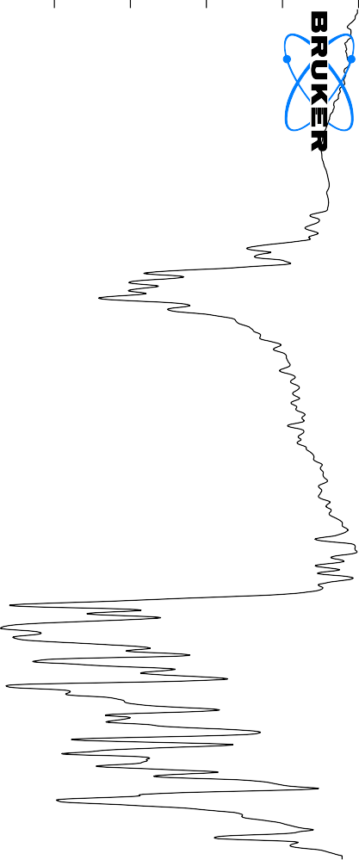

3443.62



3159.32

3109.22

3026.64

2992.73

2925.62

2888.48

2855.43

2824.96

2779.65

2617.72

2531.17

2438.61

2400.32

2307.89

2239.08

2021.88

1848.45

1773.97

1740.48

1710.06

1579.90

1546.32

1487.34

1450.71

1395.23

1352.20

1306.04

1253.78

1135.04

1107.77

1036.16

978.52

928.13

887.60

790.74

637.87

606.58

**Solubility studies of piribedil API**

The solubility of piribedil in aqueous media as a function of pH is measured and presented

## Table . Solubility of piribedil in various media with different pH

|  |  |
| --- | --- |
| **Media** | **Solubility (mg/mL)** |
| 0.1 N HCl | 0.955 |
| Acetate buffer (pH 4.5) | 0.878 |
| Purified water | 0.084 |
| Phosphate buffer (pH 6.8) | 0.148 |
| Phosphate buffer(pH 7.4) | 0.075 |

**EVALUATION OF PIRIBEDIL MATRIX TABLETS**

## Evaluation of piribedil matrix tablets with polyethylene oxide (PEO) WSR N-750

Matrix tablets were designed named as FP-1 to FP-5. Matrix granules and tablets were evaluated for various post compression characteristics. (5)

The results of TBD and LBD ranged from 0.31 ± 0.1 to 0.34 ± 0. 1g/mL and 0.25

± 0.3 to 0.27 ± 0.2 g/mL respectively. The results of compressibility index (CI) were in the range from 16.1 ± 2.1 to 20.6 ± 1.1. These results point out that flow properties and CI values of granules were superior to those of piribedil API. (6)

The hardness values of tablets were in the range of 5.5 ± 0.3 to 6.0 ± 0.1 kg/cm2. Mean thickness was in the range of 2.9 ± 0.04 to 3.1 ± 0.05 mm, range of percentage of drug content was 99.1 ± 0.1 to 100.9± 0.2 and friability was less than 1%. These results indicate that all prepared tablets were within the required quality control limits(7)

## Table: Composition and pre and post compression of Tablet

|  |  |  |  |
| --- | --- | --- | --- |
| **Formulation Ingredients** | **FP-1** | **FP-2** | **FP-3** |
| **milligram per tablet** | |  |
| Piribedil | 50 | 50 | 50 |
| PEO WSR N-750 | 30 | 40 | 50 |
| Trehalose dehydrate | 93 | 83 | 73 |
| PVP K 30 (Plasdone K 29/32) | 20 | 20 | 20 |
| Purified water | Q.S | Q.S | Q.S |
| Colloidal Silicon dioxide (Aerosil 200) | 5 | 5 | 5 |
| Sodium stearyl fumarate | 2 | 2 | 2 |
| **Total Weight (mg)** | **200** | **200** | **200** |
| **Pre compression characteristics** |  | |  |
| Loose bulk density (g/mL) | 0.25 ± 0.3 | 0.27 ± 0.2 | 0.26 ± 0.1 |

a: mean ± % deviation, n=33; b: mean ± S. D, n=20 c: mean ± S. D, n=6; d: mean ± S. D, n=6

e: mean ± S. D, n=20

## *In vitro* dissolution studies

|  |  |  |  |
| --- | --- | --- | --- |
| Tapped bulk density (g/mL) | 0.31 ± 0.1 | 0.34 ± 0.1 | 0.31± 0.2 |
| CI value (%) | 19.4 ± 1.5 | 20.6 ± 1.1 | 16.1 ± 2.1 |
| **Post compression characteristics of tablets** | |  |  |
| Friabilitya (%) | 0.3 | 0.2 | 0.5 |
| Assayb (%) | 99.1± 0.1 | 99.8 ± 0.3 | 100.9 ± 0.2 |
| Mean Thicknessc (mm) | 3.1 ± 0.05 | 3.0 ± 0.04 | 2.9 ± 0.04 |
| Hardnessd (Kg cm-2) | 5.5 ± 0.3 | 5.6 ± 0.2 | 6.0 ± 0.1 |
| Uniformity of weighte (mg) | 202 ± 1.6 | 199 ± 2.0 | 200 ± 0.8 |

All these formulations showed more than 30% release in 2 hours indicating burst release. This phenomenon may be attributed to surface erosion or initial disaggregation of the matrix tablet prior to gel layer formation around the tablet core (Ebube et al., 1997). (8)It was reported in the literature that more than 30% release of drug in the first two hours of dissolution indicates the possibility of dose dumping. Further increase of PEO WSR N-750 proportion also did not exhibit any substantial effect on drug dissolution. Therefore, to attain tablet integrity and the desired release profile, use of higher molecular weight of PEO was considered more advisable than increasing the proportion of a low molecular weight polymer.(9,10)

## *In vitro* dissolution of matrix systems with PEO WSR N-750 as a polymer (Mean ± S.D, n=3)

|  |  |  |  |  |
| --- | --- | --- | --- | --- |
| **Media** | **Time (Hours)** | **Cumulative %drug release** | |  |
| **FP-1** | **FP-2** | **FP-3** |
| **0.1**  **N**  **HCl** | **0** | 0 | 0 | 0 |
| **1** | 25.87 ± 3.6 | 29.11 ± 3.4 | 16.23± 1.6 |
| **2** | 53.24 ± 4.6 | 51.43 ± 4.8 | 35.13 ± 2.2 |
| **pH**  **6.8**    **phosphate**    **buffer** | **4** | 78.65 ± 2.8 | 74.21 ± 5.3 | 65.19 ± 2.6 |
| **6** | 98.21 ± 4.2 | 85.43 ± 2.8 | 72.22 ± 3.3 |
| **8** | -- | 97.38 ± 3.3 | 85.79 ± 3.2 |
| **10** | -- | -- | 98.17 ± 1.2 |
| **12** | -- | -- | -- |
| **16** | -- | -- | -- |
| **20** | -- | -- | -- |
| **24** | -- | -- | -- |

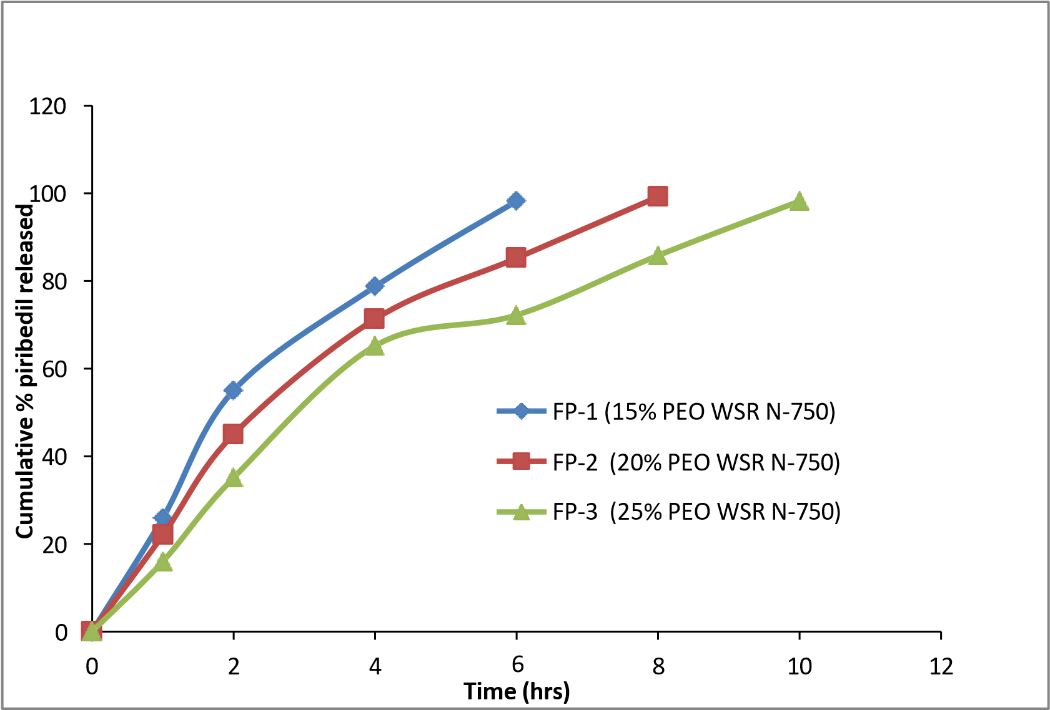

**Figure . Dissolution of piribedil from matrix tablets**

# Conclusion

ased on the bioavailabilty results, it could be inferred that greater bioavailabilty is obtained from the optimized formulation. This may be due to the presence of a high molecular weight polymer in the matrix tablet.

Calculations to determine the IVIVC relationship were carried out by both wagner nelson method and the numerical deconvolution method in this research project.

Good curvilinear relationship was observed between % drug dissolved and % drug absorbed. There is a strong positive correlation between the *in vitro* and the *in vivo* series. Hence the dissolution method adopted was a properly designed method.

Results of the present study clearly indicated that piribedil extended release formulation was successfully designed and optimized. These piribedil extended release matrix tablets can effectively prolong drug action time. This could improve the patient's pathological cognitive and sensory nerve dysfunction or neurological disorders.

**REFERENCES** 7.

1. Abbott RD, Ross GW, White LR, Sanderson WT, Bkurchfiel CM, Kashon M, Sharp DS,

Masaki KH, Curb JD. and petrovitch H. Environmental, life- style, and physical 8. precursors of clinical Parkinson‟s disease: recent findings from the Honolulu- asia Aging Study. J Neurol. 2003; 25; 30-39. 9.

1. Aulton ME, Wells T. Pharmaceutics, The science of dosage form design. London,

England, Churchill Livingstone, 1988, 430-

468. 10.

1. Baldereschi M, Di Carlo A, Vanni P, Ghetti A, Carbonin P, Amaducci L, and Inzitari D.

Lifestyle-related risk factors for Parkinson‟s disease: a population-based study. Acta Neurol Scand. 2003, 108: 239-244.

1. Bennett DA, Beckett LA, Murray AM, Shannon KM, Goetz CG, Pilgrim DM, Evans DA. Prevalence of parkinsonian signs and associated mortality in a community population of older people. N Engl J Med; 1996, 334; P71–76.
2. Bhupinder Singh, Rajiv Kumar, & Naveen Ahuja. Optimizing drug delivery systems using systematic design of experiments, Critical Reviews™ in Therapeutic Drug Carrier Systems. 2004, 22(1):27-105
3. Bolton S, Marcel Dekker. Factorial designs. In: Pharmaceutical Statistics: Practical and Clinical Applications. 1997, 3rd ed. New York.
4. Box GEP and Draper NR. Factorial design at two levels: Empirical Model- Building and Response Surfaces, John Wiley & Sons, 1987, New York.
5. Caballol N and Tolosa E. Cognitive dysfunction and dementia in Parkinson disease. Mov Disord. 2007; 22; S358.
6. Craig Charles R, Stitzel Robert E. Modern pharmacology with clinical applications, 5th edition published by Little Brown and company, New York, 1997; 381-386.

10 . Di Monte DA, Lavasani M and Manning-Bog AB. Environment factors in

Parkinson‟s disease. Neurotoxicology. 2002; 23: 487-502.