**SMART WHEELCHAIR CONTROLLING USING**

**GLOVES**

A. Sujith Kumar, S. Murali Krishna, S. Siddhardha, T. Chandu Avinash, L. Sai Nirupama, V. Gowri Sankar,

S. Thirumala Rao, Y. Lakshmana Rao

Department of EEE, GMR Institute of Technology, Rajam, India-532127

Ch. Hemanth Kumar, Sr. Assistant Professor, Department of EEE, GMR Institute of Technology,

Rajam, India-532127 hemanthkumar.ch@gmrit.edu.in

**Abstract**

The project on controlling a smart wheelchair with gloves aims to create a new way for people with disabilities to move around more freely and improve their lives. This system uses a glove that has sensors built into it to steer a motorized wheelchair, making it easy and natural to use. The glove is designed with parts like accelerometers, flex sensors, and microcontrollers that read hand movements and turn them into commands for the wheelchair. The focus is on making it accurate, using little power, and keeping it simple for users, so they can easily navigate different spaces. To achieve better accuracy and save energy while using the gloves to control the smart chair, low-energy microcontrollers, precise sensors, and effective communication tools like Bluetooth are utilized. Additionally, using energy-efficient strategies and lightweight materials for the gloves helps improve performance. Wireless communication allows for smooth data exchange between the glove and the wheelchair. To keep things safe, this project includes features that can detect obstacles and stop in emergencies. It provides a more affordable choice than regular assistive devices, meeting the demand for smart mobility options that don't break the bank. This approach could be embraced by many, giving users more freedom and movement in their everyday lives.

**Keywords:** Smart Wheelchair, Sensor-equipped glove, Assistive mobility, Hand gestures, Microcontrollers, Wireless communication, Obstacle detection, Autonomy.

**Introduction**

Mobility is essential for independence, but many people with physical disabilities struggle with this. When someone can't move freely, it can really impact their quality of life, increase reliance on others, and limit their access to important services and social connections. One way to help is through mobility devices like wheelchairs, which have been key in helping individuals with disabilities get around more easily. However, traditional manual wheelchairs can be tough to use for those with severe motor challenges since they need a lot of physical strength. Electric wheelchairs have made things easier by providing powered movement, but they often depend on joystick controls, which can still be hard for users with limited hand or arm movement [1].

With advancements in technology, there are now more promising options like intelligent wheelchairs that use assistive and adaptive controls. One exciting development is gesture-controlled wheelchairs. These use motion-sensing tech to understand commands given through simple hand or head gestures, meaning users don’t have to exert themselves physically [2]. This type of technology helps people with disabilities gain more independence as they can navigate their surroundings using easy gestures [3]. By combining artificial intelligence, sensor integration, and real-time processing, these wheelchairs can be more accurate and user-friendly, making them a good choice for those with conditions like quadriplegia or other mobility issues [4].

Gesture-controlled wheelchairs incorporate various sensor technologies like infrared sensors and even Internet of Things features to boost their accuracy and responsiveness. They work by using pre-set gesture recognition systems that convert movements into directional commands, guiding the wheelchair [5]. Recent improvements in real-time processing have also helped cut down on delays when interpreting signals, allowing for smoother operation. Aside from improving mobility, these innovations can lessen the load on caregivers, promote independence, and encourage users to take part in social and work activities [6].

Even with these advancements, some challenges remain in making gesture-controlled wheelchairs more reliable and widely available [7]. One major concern is how accurately these systems work, as unintended movements or disruptions in the environment can lead to mistakes in navigation. Cost is another hurdle, as many individuals may find it difficult to afford the latest mobility technologies. Additionally, for intelligent wheelchairs to be useful all day, they need to have efficient energy usage and long-lasting batteries [8]. Addressing these issues will require ongoing research to improve gesture recognition, manage energy better, and lower production costs, aiming to make these solutions more available and practical for everyone. Current research on gesture-controlled wheelchairs, focusing on key technologies, design approaches, and the benefits these systems can bring to those with mobility challenges[9]. By exploring what’s been achieved so far, acknowledging the limitations, and suggesting future paths, this study hopes to support the growth of smart mobility solutions that emphasize accessibility, ease of use, and safety [10].

**Literature Review**

1. Gesture Recognition and Control Mechanisms

Research on gesture-based wheelchair control has been exploring different approaches to recognize these gestures so that they work better and are easier to use. One study pointed out that gesture systems using sensors need to process information quickly to help mobility devices respond faster [1]. Another investigation focused on combining different navigation techniques and various sensor inputs to enhance the precision of wheelchair movements [2]. Altogether, these studies reveal a growing enthusiasm for developing reliable and adaptable control systems.

2. Hand Gesture-Based Wheelchair Systems

Several studies support the idea that hand gestures can effectively control wheelchairs. An earlier project used MEMS technology to detect hand movements and turn them into directional commands [5]. Further research looked into how the Internet of Things could improve communication between users and their wheelchairs, enabling remote control and monitoring [10]. Another study found that applying machine learning could lead to better gesture classification, reducing errors and speeding up responsiveness [2].

3. Head Gesture-Controlled Wheelchairs

For individuals with limited hand mobility, head gesture recognition has emerged as a helpful alternative. One study developed a wheelchair controlled by head gestures for quadriplegic patients, employing advanced sensors to accurately track head movements [3]. Another project utilized infrared sensors to enhance the accuracy and responsiveness of gesture control, demonstrating better navigation in real situations [8]. These results indicate that head gesture control can serve as an effective option for those facing significant physical challenges.

4. Challenges in Gesture-Controlled Wheelchair Implementation

Despite advancements, there are still challenges to address in gesture-controlled wheelchairs. Researchers noted that misunderstandings of gestures can occur due to factors like lighting, sensor sensitivity, and unexpected body movements [7]. Another analysis pointed out issues related to battery drain in sensor-equipped wheelchairs, emphasizing the need for improved battery management and energy-saving strategies for practical use [10]. Cost also remains a major barrier, as high-quality sensors can make these devices unaffordable for people in lower-income areas [4].

5. Future Directions and Technological Innovations

Looking forward, the goal for gesture-controlled wheelchairs is to improve sensor accuracy, enhance AI recognition models, and introduce additional control options. Some studies suggest that integrating brain-computer interfaces (BCIs) with gesture recognition could offer more control possibilities for individuals with severe disabilities [2]. Researchers are also exploring adaptive learning algorithms that can tailor gesture models to suit users' habits and preferences [3]. Innovations aimed at obstacle detection and enabling autonomous navigation are under development to boost safety and user-friendliness (8).

Gesture-controlled wheelchairs represent a significant advancement in assistive mobility, granting individuals with physical disabilities greater freedom and access. Research indicates that systems recognizing hand and head gestures are effective, backed by innovations in sensors, AI, and IoT technology [1, 2, 3]. However, challenges such as accuracy, energy consumption, and affordability still need to be addressed for more widespread application [5, 6]. Future developments in mixed control methods, AI personalization, and self-navigation are expected to make these devices even more practical and accessible [9, 10]. By addressing these challenges, gesture-controlled wheelchairs could continue to evolve into a transformative solution for those with mobility limitations.

**Objective of the project**

As of today, 2.21% of Indian population are disabled, which is nearly 630-lakh individuals. Of these people mobility impairment people are 44.73% it is a physical disorder that limits the motions in body of the person effected they can’t walk stand or else do their work by their own which brings them lot of difficulty to them as well as the people by whom they are surrounded by in order to limit their difficulty level in life this project is much needed and in their minimal work contribution for themselves.

Helps for the people who are:

1. Those who lost their lower body sense
2. Spinal cord damage
3. Arthrogryposis
4. Lost the part of limb
5. Muscular dystrophy

**Preface**

More and more people find themselves needing assistance to move around whether due to an illness or an accident as the number of those who require support grows the tools and devices available to help them must become more advanced utilizing the latest technology to improve their quality of life and help them fit into the workforce this effort aims to make mobility easier and more energetic allowing individuals with disabilities to navigate the world like those without such challenges there are already many systems out there that cater to the needs of people with varying levels of disability thanks to the high-tech advancements in electronics and robotics many mobility issues faced by certain individuals can now be addressed quite effectively the electronic solutions available are well-suited to meet the specific needs of users sadly the number of individuals facing limitations that hinder their ability to perform everyday activities continues to rise with many experiencing serious mobility challenges the type of assistive device a person requires can vary significantly based on the severity of their disability for example when it comes to wheelchair navigation different scenarios come into play for those with severe disabilities solutions may focus primarily on alternative methods such as voice commands or eye movement in such situations safety sensors become essential to help the user manage the chair by detecting obstacles alerting them to nearby objects or identifying stairs in very extreme cases there may even be a need for the wheelchair to travel certain distances on its own without any intervention from the user.

**Design Principle**

This project revolves around making a wheelchair for those with physical and visual disabilities the idea is to develop a wheelchair that can be operated by hand gestures this design is aimed at individuals who usually rely on others to help them get around with this system they can navigate independently moving from a place to the other without assistance when a person moves his hand around on the chair they simply turn off the wheelchair an Arduino uno manages the wheelchairs motors while an Arduino nano tracks hand movements with an mpu6050 sensor the information gathered is sent to the motor driver which acts according to user gestures

**Block Diagram**

ATMEGA 328P

MPU 6050

BI-DIRECTIONAL MOTOR DRIVER

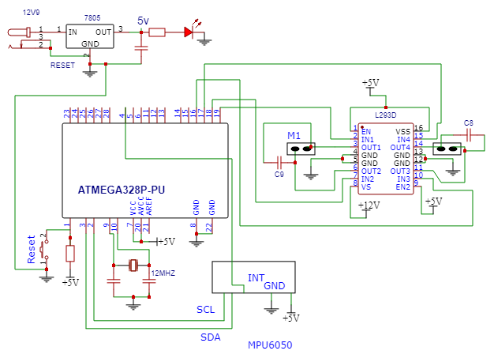**Circuit Diagram**

**Parts in the circuit diagram**

**1. 5V Regulator (Voltage Regulator)**

***Matter:***

A voltage regulator is an electronic device that maintains a constant output voltage regardless of the input voltage or changes in load. A 5V regulator, specifically, ensures that the output voltage remains steady at 5 volts, which is commonly required by various electronics, like microcontrollers and sensors.

***Working:***

Input: The regulator receives a higher input voltage, such as 12V from a battery or power supply.

Regulation: It adjusts this input down to a stable 5V, suitable for powering devices like an Arduino.

Output: The output is a constant 5V voltage, regardless of the variations in input voltage (within a specified range).

Common voltage regulators include the 7805 (linear) and LM2596 (switching).

**2. Arduino Microcontroller (e.g., Arduino UNO)**

***Matter:***

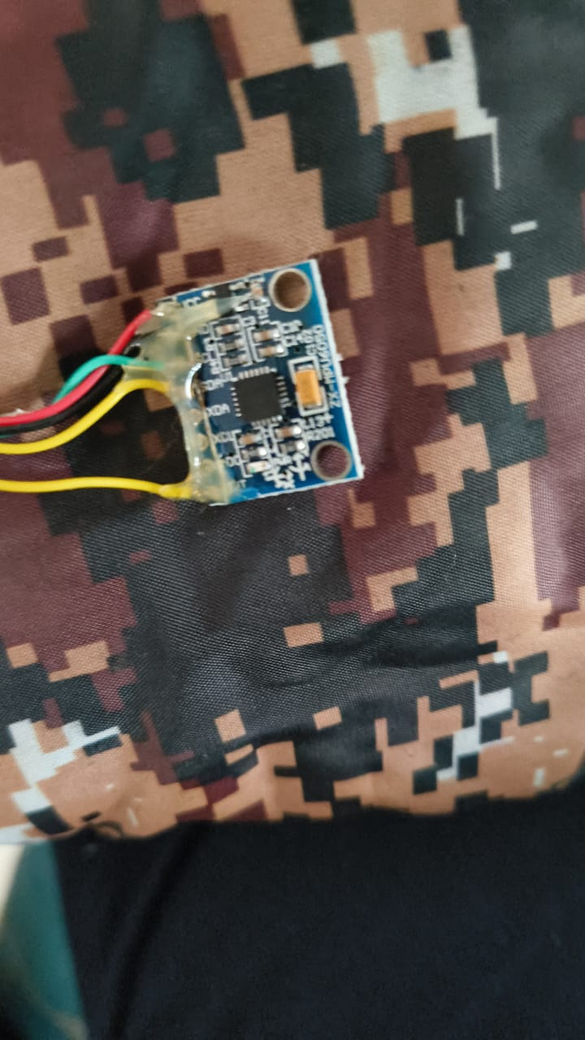An Arduino is an open-source microcontroller development board used for building interactive electronic projects. It contains a microcontroller that can be programmed to read inputs (such as sensors) and control outputs (like motors or LEDs).

***Working:***

Microcontroller: The heart of the Arduino is the microcontroller, typically an ATmega328P (in Arduino UNO). This is where the actual processing happens.

Programming: You program the Arduino using the Arduino IDE, where you write code that tells it how to behave.

Input/Output: Arduino interfaces with sensors (inputs) and actuators (outputs) through its GPIO (General Purpose Input/Output) pins. It can read digital/analog signals, process them, and produce an output, like turning an LED on or driving a motor.

Power: It can be powered via USB or an external power supply (e.g., 9V battery).

**3. L293 Motor Driver**

***Matter****:*

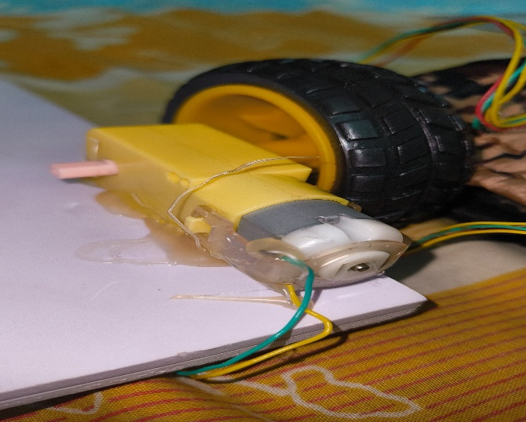The L293 is a popular H-Bridge motor driver IC that allows control of DC motors or stepper motors. It can drive motors forward or backward and even control the speed using Pulse Width Modulation (PWM).

***Working:***

Input Control: The L293 receives input from the microcontroller (like an Arduino) via its control pins, which dictate the motor's direction and speed.

H-Bridge Configuration: The IC has an H-bridge circuit inside it, which allows it to reverse the direction of the motor by changing the polarity of the voltage applied to the motor.

Power: The motor is powered separately (often with a higher voltage than the Arduino), and the L293 acts as a switch, directing the current to the motor based on the control inputs.

Speed Control: The speed of the motor can be controlled using PWM (using the Enable pin of the L293).

**4. Capacitor (467)**

***Matter:***

A capacitor is an electronic component that stores electrical energy temporarily. The number 467 may refer to a capacitor code or model, but capacitors generally don't have fixed "types" like the other components listed. Instead, they are rated by their capacitance value (in microfarads or uF), voltage rating, and type (ceramic, electrolytic, etc.).

***Working:***

Storage: A capacitor stores electrical charge when a voltage is applied across it.

Discharge: When the voltage across the capacitor is removed, it discharges its stored energy.

Filtering: Capacitors are often used in power supply circuits for filtering, smoothing out voltage fluctuations or reducing noise.

Decoupling: They are also used near sensitive ICs to filter out voltage spikes and ensure stable operation.

If you meant a 470uF capacitor (a common size), it's used for smoothing power supplies or filtering signals.

**5. Crystal Oscillator**

***Matter:***

A crystal oscillator is an electronic component that generates a precise clock signal. It uses the mechanical resonance of a piezoelectric crystal (usually quartz) to generate a consistent frequency. This is essential for accurate timing in devices such as microcontrollers and communication systems.

***Working:***

Oscillation: When voltage is applied to the crystal, it vibrates at a specific frequency determined by its physical properties (size, shape, and material).

Clock Generation: The vibration of the crystal generates an oscillating signal at a specific frequency (e.g., 16 MHz in most Arduino boards).

Precision: The crystal provides a stable frequency, which is crucial for timing operations like communication, data processing, and control of microcontrollers.

This oscillator helps in synchronizing operations within microcontrollers like the Arduino, ensuring the timing of instructions is accurate

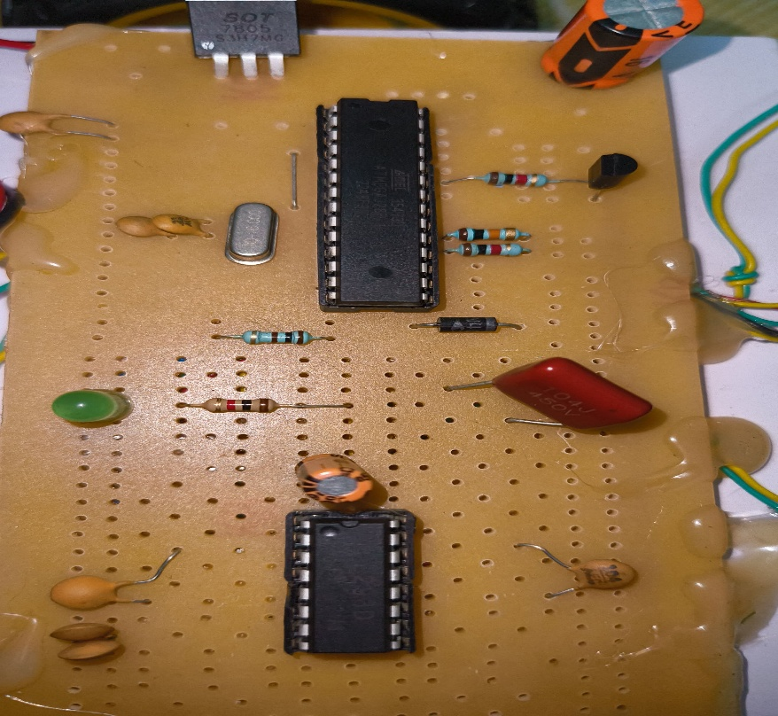

**Working of wheelchair:**

1. Putting on the Gloves

First, the user slides on the lightweight and comfy gloves, which are fitted with a variety of sensors for easy handling.

2. Activating the Sensors

Flex Sensors: These sensors run along the fingers of the gloves. They track how much each finger bends. When a finger is flexed, the change in resistance gets turned into a voltage signal.

Gyroscope and Accelerometer: These sensors sense how the hand moves and its position. They help figure out the hand's direction in space, which is important for following commands.

3. Collecting Data

As the user gestures with their fingers or moves their hand, the sensors keep gathering information. This data is sent to a microcontroller embedded in the glove or connected through wireless means.

5. Changing Signals to Actions

We take the signals we receive and convert them into actions that the wheelchair can understand. This means different gestures correspond to specific movements, like going forward, backward, turning left or right, and stopping.

6. Sending Actions Wirelessly

The microcontroller sends these actions to the wheelchair's control system using a wireless technology, like Bluetooth, Zigbee, or Wi-Fi. This lets the wheelchair be controlled in real-time without any wires getting in the way.

7. Operating the Wheelchair

Motor Control: When the control system of the wheelchair receives the actions, it turns on the appropriate motors to move the wheelchair as needed. For example:

If the command is to move forward, the motors on the wheels engage to push it ahead.

If it needs to turn, the system adjusts the speed of the wheels accordingly.

The wheelchair also has safety features to prevent sudden movements or jolts.

**Conclusion**

Looking forward, the goal for gesture-controlled wheelchairs is to improve sensor accuracy, enhance AI recognition models, and introduce additional control options. Some studies suggest that integrating brain-computer interfaces (BCIs) with gesture recognition could offer more control possibilities for individuals with severe disabilities [2]. Researchers are also exploring adaptive learning algorithms that can tailor gesture models to suit users' habits and preferences [3]. Innovations aimed at obstacle detection and enabling autonomous navigation are under development to boost safety and user-friendliness (8).

Gesture-controlled wheelchairs represent a significant advancement in assistive mobility, granting individuals with physical disabilities greater freedom and access. Research indicates that systems recognizing hand and head gestures are effective, backed by innovations in sensors, AI, and IoT technology [1, 2, 3]. However, challenges such as accuracy, energy consumption, and affordability still need to be addressed for more widespread application [5, 6]. Future developments in mixed control methods, AI personalization, and self-navigation are expected to make these devices even more practical and accessible [9, 10]. By addressing these challenges, gesture-controlled wheelchairs could continue to evolve into a transformative solution for those with mobility limitations.

**References**

1. Zahar, N., Benchekroun, D., Belhorma, B., Hermet, P., & Broeders, C. (2016). International Journal of Advanced Research. International Journal of Advanced Research. <https://doi.org/10.21474/ijar01>
2. RAVINDU, H. M., BANDARA, T., PRIYANAYANA, K. S., CHANDIMA, D. P., JAYASEKARA, A. G. B. P., & Intelligent Service Robotics Group, University of Moratuwa, Moratuwa 10400, Sri Lanka. (2023). Hybrid Navigation Decision control mechanism for intelligent Wheel-Chair. In University of Moratuwa & Centre for Advanced Robotics, Intelligent Service Robotics Group, University of Moratuwa, Moratuwa 10400, Sri Lanka (Vol. 11) [Journal-article]. https://doi.org/10.1109/ACCESS.2023.3318477 (Original work published 2023)
3. Machangpa, J. W., & Chingtham, T. S. (2018). Head gesture controlled wheelchair for quadriplegic patients. Procedia Computer Science, 132, 342–351.

<https://doi.org/10.1016/j.procs.2018.05.189>

1. Jha, P., Khurana, P., International Science Press, & Lovely Professional University. (2016). Hand gesture controlled wheelchair. In I J C T A (Vol. 41, pp. 243–249).
2. Pande, V. V., Nikita S.Ubale, Darshana P. Masurkar, Nikita R. Ingole, & Pragati P. Mane. (2014). Hand gesture based wheelchair movement control for disabled person using MEMS. In Int. Journal of Engineering Research And Applications (Vol. 4, Issue 4, pp. 152–158) [Journal-article]. <https://www.ijera.com>
3. Ramteke, A., Maski, A., Mutkure, V., Yende, S., Shewane, P. A., & Electrical Department, RTMNU/DBACER, Nagpur, Maharashtra, India. (2019). Wheelchair using automatic gesture control. In National Conference on “Advances in Engineering, Technology and Applied Sciences” - NCAETAS-2019, International Journal of Scientific Research in Science, Engineering and Technology (Vol. 5, Issue 6, pp. 338–342) [Journal-article].
4. Anilkumar, R., & M R, A. (2023). HAND GESTURE CONTROLLED WHEELCHAIR. In International Journal of Creative Research Thoughts (IJCRT), International Journal of Creative Research Thoughts (IJCRT) (Vol. 11, Issue 1, p. e642) [Journal-article]. <https://www.ijcrt.org>
5. Parvateesam, K., Sruthi, P. S., Godavari Institute of Engineering and Technology(Autonomous), Rajahmundry, India, & Aditya College of Engineering, Surampalem, Kakinada, India. (2023). Design and implementation of hand gesture controlled wheel chair for physically challenged people. In International Journal for Research Trends and Innovation (Vol. 8, Issue 6, pp. 903–905) [Journal-article]. <https://www.ijrti.org>
6. Megalingam, R. K., Rangan, V., Krishnan, S., & Alinkeezhil, A. B. E. (2016). IR sensor based Gesture Control Wheelchair for Stroke and SCI Patients. IEEE Sensors Journal. <https://doi.org/10.1109/JSEN.2016.2585582>
7. Sadi, M. S., Alotaibi, M., Islam, Md. R., Islam, Md. S., Alhmiedat, T., & Zaid Bassfar. (2022). Finger-Gesture Controlled Wheelchair with Enabling IoT. In Sensors. <https://doi.org/10.3390/s22228716>