IOT Based Smart Water Surface Cleaning System

## Sujal S. Moolya1, Yash S. Ainapure2, Shreyas S. Patil3, Ritesh S. Mane4,

## Mrs. R.V. Karoshi5

1, 2, 3, 4 Dept of Automation & Robotics

5Lecturer and Project Guide, Dept of Automation & Robotics

1, 2, 3, 4, 5 Sharad Institute of Technology Polytechnic Yadrav

***Abstract-*** It is foremost important to keep the water bodies around us to be clean. It is very terrible that huge amount of garbage is deposited on water bodies every year. Monitoring the quality of water that is present in the water bodies is also very important in today’s world. There is a group of people who keep on monitoring the changes that occurs on the surroundings who are named as Catchment Management Authorities. Catchment Management Authorities monitor and provide real-time day to day updates on environmental protection and tracking pollution sources. A cheap non-wired aquatic monitoring system will enable cost effective water quality measurement by collecting data as well as assisting catchment managers to maintain the health of aquatic ecosystem. The work deals with finding a way for the uncertain effects of the floating particles, hencec reducing the harmfulness created on behalf of the floating particles that incorporates floating materials and curbs. Our work aims to create a garbage gathering object to monitor the lakes and ponds and also measure the condition of water by measuring several parameters. In addition, it helps to understand the water pollution using data analysis. The main feature of this project is to collect of floating objects from the surface of the water into a trash container.

**Keywords:** *Water quality monitoring, aquatic ecosystem, floating garbage collection, IoT-based system, real time data collection.*

**INTRODUCTION**

Waste is an environmental problem that always arises from year to year and still cannot be resolved entirely. The problem that was addressed in this paper was the collection and handling of trash with the help of robots. Robots can be used to save the environment and maintain cleanliness and a hygienic neighbourhood. This study aims to provide an alternative solution to the problem of waste in water areas by developing robotics technology capable of operating in water areas. Having the water clean will not be beneficial to humans, animals and plants around the water also will be highly benefited. Many non-governmental organizations are taking responsibility. almost all urban water bodies in India are suffering because of pollutants and are used for disposing untreated nearby sewage and solid waste, and in many cases the water bodies have been in the end became landfills. In India, people are more in population. Population is directly proportional to pollution. Pollution in recent times had been grown at a visible rate. People have no space to throw their waste so they use water bodies as their dustbin. Nowadays, this is a very sad truth of our nation.

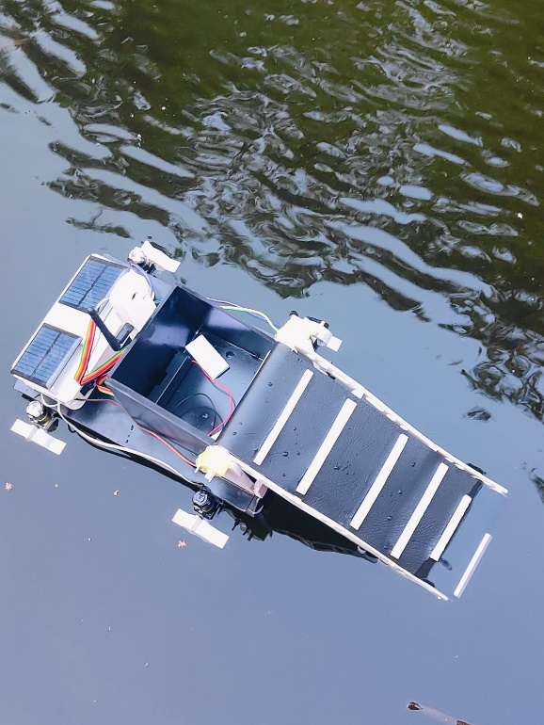

*Fig.1* *Fig.1 - 1 .*

**LITERATURE REVIEW**

The authors of the paper [1] have Enforced a process to design an expandable face waste drawing robot. This system consists of a scrap collection device which is designed in a H kind of housing and in turn it becomes fluently usable, the power unit device consists of motors on both sides of the housing, For power aeronautics battery is used for a long battery life. Graph module was also added to work over wider areas. Therefore the robot was made for collection of scrap and waste and it could be fluently and securely used with remote control.

The authors of the paper [2] have Enforced a robot system developed to collect floating plastic scrap. It can do three major tasks autonomously, i.e., voyage and discovery, shadowing, steering, grasping, and collection. The system is caddy this paper, the authors have enforced process to design an Intelligent Water Surface Cleaner Robot for collection of Floating Garbage. In this IWSCR (Intelligent Water Surface Cleaner Robot) is designed in such a way that it comprises camera on the top, for the discovery of object a frame of control system is described similar as the IWSCR and PC (particular computer) work contemporaneously for t and also, it's concentrated for junking of scrap. For communication, USB videotape class, Bluetooth & TCP/ IP are used. SMC (sliding mode regulator) is designed for vision steering and follows robust law. Dynamic grasping strategy is followed for floating objects. Hence the working of the design was completed and successfully demonstrated. Thus, IWSCR robot was made and it was suitable to perform all of its tasks efficiently.)

The authors of the paper [3] have Enforced a manner to layout an Unmanned floating waste accumulating robot. The layout of the machine is durable, mild in weight and also water-resistant. The managed unit includes an atmega328p microcontroller grounded Arduino Uno and a Bluetooth is used for conversation between faraway manager and the robot. For power force a three- cellular lithium polymer battery is used and a propeller medium is used to provide the driving force. Conveyor belt medium has been enforced to accumulate scrap and trash operation to ensure that the waste is going into the collector. A cell App was also evolved to ever manipulate the robot and its aspects. The regulator is so designed that it takes commands of propeller and conveyor belt movements grounded on Bluetooth signals. The frame of the robot is made from Polyvinyl Chloride to preserve its featherlight and inflexibility. device changed into tested and its functionality changed into analyzed.

The authors of the paper [4] presented an automated layout of a sewage remedy manufacturing facility, the use of IoT where discovery in the role of the tank is detected using ultrasonic detectors and discovery of emigration of risky feasts using MQ-a hundred thirty-five detectors, led and a buzzer. an internet operation and Android operation are used for controlling and manipulating STP. green suggests that the water is below 25%, blue indicates water function is 50%, red will indicate the water function is 75% and buzzer will symbolize the water function is 90% which means the tank is getting complete and using dc motor it's going to switch the water from the collection tank to aeration tank. CO2 and NH3 situations which are detected are displayed at the tv display. The advantage of enforcing the STP manipulate press is the discount inside the general price of handling and preserving the STP manufacturing unit. since the demand of a driving force to be present at the manufacturing facility is no longer vital. it's salutary in economic terms too.

The authors of the paper [5] have developed an IoT monitoring Setup for Wastewater treatment, wherein distinct levels of the remedy manufacturing unit may be designed and included utilizing colorful detectors to prevent manufacturing facility damage and assure the machine's secure and effective operation. To paintings with Mongoose Zilches, an ambient setup was created. A knot MCU module is hooked up to the Mongoose. due to this parameter's configuration, the device becomes operational. The whole address setup has been performed to cover the critical parameters of the factory all through the remedy procedure. The consequences can be visible inside the Mongoose press in addition to on the misplaced Platform operation log. Three essential parameters of the Wastewater treatment manufacturing facility were blanketed, and a manipulate system has been geared up to help damage.

**METHODOLOGY**

This project is about creating a smart robot that can clean waste from the surface of water bodies like lakes, ponds, or rivers. The robot floats on water and moves around using motors. It collects floating trash using a small conveyor or roller system. A live video camera (ESP32-CAM) is used to monitor the robot and control it remotely using Wi-Fi. This robot runs on rechargeable batteries and can be used in real-time cleaning applications. 1. Design and Structure The robot has a flat and waterproof structure that helps it float. It carries motors, the ESP32-CAM, battery pack, and other electronics. Two bearings are used to support the moving parts like rollers or conveyors. The design ensures that water doesn't damage the electronic parts. 2. Movement and Cleaning Mechanism The robot moves forward, backward, and can turn left or right using four 60 RPM BO motors. These are connected in pairs on each side. When one side rotates forward and the other in reverse, the robot turns easily in water. For collecting waste, two 21 RPM BO motors are used. These are slower and help rotate a conveyor belt or mesh system that picks up trash from the surface and stores it inside a container. All six motors are controlled using two L293D motor driver modules. One driver is connected to the 4 motors for movement, and the second driver controls the 2 motors used for the waste collection system. 3. Power Supply and Charging The power is supplied using three 18650 rechargeable batteries (each 2000mAh). These batteries provide enough energy to run the motors and the ESP32-CAM. To safely charge these batteries, a TP4056 charger module is used. It has safety features that protect the batteries from overcharging and over-discharging. The batteries are placed in a secure, waterproof box on the robot. 4. IoT and Camera System An ESP32-CAM module is used for video surveillance and control. It is a small board that has a built-in camera and Wi-Fi. It connects to a Wi-Fi network and sends live video to a mobile or computer. This allows the user to see where the robot is going and what it's collecting. Methodology: IoT-Based Smart Water Surface Cleaning Robot The ESP32-CAM can also receive control commands, so users can start or stop the robot, control its direction, or turn on the waste collection system from their phone using apps like Blynk or a custom website. 5. Software and Programming The robot is programmed using the Arduino IDE. The ESP32-CAM is given code to stream video, control motors, and connect to Wi-Fi. Motor drivers are connected to the ESP32's GPIO pins. The code also includes simple logic to control the movement and waste collection system, either manually or automatically. 6. Testing and Results The robot is first tested on land to check the motor wiring, battery performance, and video stream. After successful testing, it is placed in a small water body like a tank or pond. The robot is tested for movement, waste pickup, and camera streaming. If needed, adjustments are made to improve balance, speed, and connectivity. This project helps reduce water pollution in an efficient and smart way. It is low-cost and useful for cleaning small lakes, ponds, or even canals.

* **Mechanical design**

The body of the IoT-based smart water surface cleaning system is engineered to be lightweight, buoyant, and structurally efficient for aquatic environments. It utilizes a catamaran-inspired dual-hull design that enhances stability and prevents tilting during operation on water surfaces.

Constructed primarily from waterproof and corrosion-resistant materials such as acrylic sheets and plastic, the chassis houses key components including the conveyor belt mechanism, motors, and electronics. The conveyor belt is inclined and fitted with paddle-like strips that aid in collecting floating debris and channeling it into an onboard storage bin.

Solar panels are mounted on the rear section to power the system, promoting energy efficiency and sustainable operation. The system's motors are mounted inside sealed compartments to protect against water damage, while the structure ensures easy integration of sensors and IoT modules used for monitoring and remote control.

Floating paddles or waterproof propellers provide mobility, enabling the robot to navigate water bodies autonomously. The design prioritizes modularity, allowing for easy maintenance and potential future upgrades.

* **3D Model (Component)**

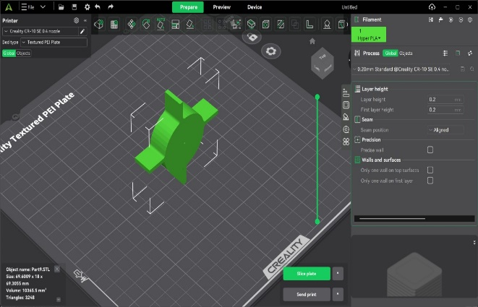

In the development of the IoT-based Smart Water Surface Cleaning System, 3D printing plays a crucial role in designing and fabricating the structural and mechanical components of the prototype. The system utilizes lightweight, customizable parts created through additive manufacturing to ensure seamless integration with the electronic and mechanical elements of the robot.

The 3D model appears to be a circular part with protruding flanges, which strongly suggests its function as a motor or wheel housing. This component is critical for securing rotating elements like propellers or paddles that enable movement and cleaning. Its shape ensures stability and proper alignment of mechanical parts, while the flanged sides make it easy to attach this part to the main frame, ensuring a compact and efficient layout.

* **DC Motors & Driver**

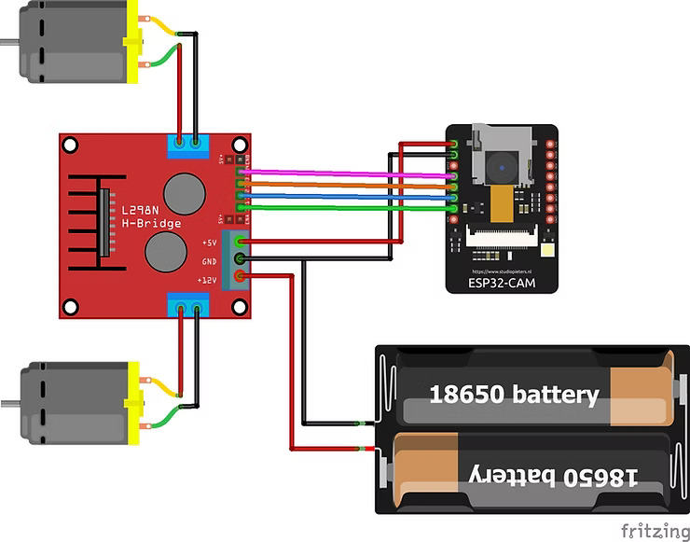

* **L298N H-Bridge Motor Driver Module**
  + Used to control the DC motors (usually for propulsion or conveyor movement).
  + Allows the ESP32-CAM to control the direction and speed of two motors independently.
* **DC Motors (x2)**
  + Drive the cleaning system – could be used for:
    - Moving the boat in water
    - Operating the conveyor belt that picks up floating waste
* **18650 Li-ion Battery Pack (x3)**
  + Provides power to the whole system.
  + Connected to power both the ESP32-CAM and the L298N motor driver.
* **Motor Control:**The ESP32-CAM sends control signals to the L298N motor driver, which drives two DC motors. These motors can be configured to:
  + Propel the cleaning boat forward/backward
  + Rotate the conveyor mechanism
* **Electronic Components**
  + - * **ESP32:**

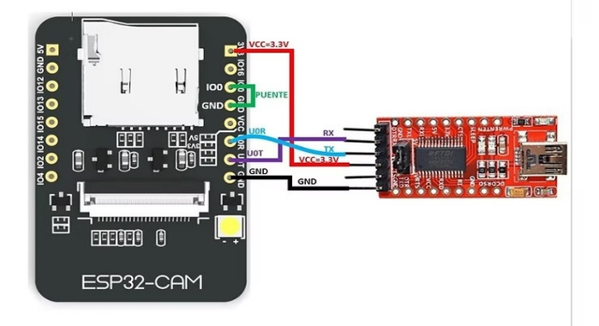

**IoT Remote Monitoring**

* The ESP32 connects to a **Wi-Fi network**.
* **Camera Surveillance (optional feature)**

The ESP32-CAM module can capture images or stream video.

* This helps monitor the system in real-time, especially in large water bodies or hard-to-reach areas.

**Power Management**

* Powered by **18650 Li-ion batteries**, recharged via **TP4056 module** (as you shared earlier).
* ESP32 can enter **deep sleep mode** when not in use to save power.
* **Software Integration**

1. **Telegram Bot:**

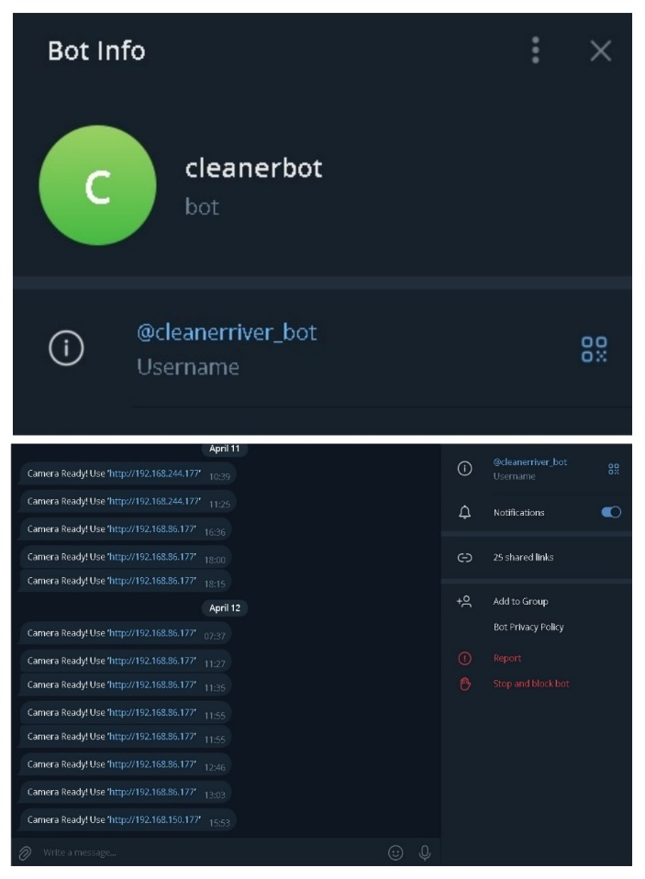

A **Telegram Bot** is a mini software that runs inside Telegram and can send/receive messages automatically. It works using the Telegram Bot API and can be controlled by users via chat commands or automated scripts. In your case, this bot acts as a **remote interface** between you and your **ESP32-CAM-based cleaning system**.

* **Real-Time Camera Feed Notification:**
* As seen in the screenshot, the bot sends a message:

**Camera Ready Use 'http://192.168.x.x'**

* This link points to the **live feed from the ESP32-CAM**.
* The ESP32 is programmed to **automatically send the stream URL to Telegram** it's ready or restarted.
* You simply click the link in Telegram to see the **live video feed of the water surface** remotely.
* **Deep learning models**

Arduino IDE (Software) :

#include "esp_camera.h"

#include <WiFi.h>

#include <HTTPClient.h>

// WARNING!!! Make sure that you have either selected ESP32 Wrover Module, or another board which has PSRAM enabled

// Adafruit ESP32 Feather

// Select camera model

const char* ssid = "Realme"; //Enter SSID WIFI Name

const char* password = "112233445566"; //Enter WIFI Password

const String botToken = "7527090952:AAHZtzIcP31PlM0EFwq9djuXy60rCaPzZfo";

const String chatID = "1008500736";

#if defined(CAMERA_MODEL_WROVER_KIT)

#define PWDN_GPIO_NUM -1

#define RESET_GPIO_NUM -1

#define XCLK_GPIO_NUM 21

#define SIOD_GPIO_NUM 26

#define SIOC_GPIO_NUM 27

#define Y9_GPIO_NUM 35

#define Y8_GPIO_NUM 34

#define Y7_GPIO_NUM 39

#define Y6_GPIO_NUM 36

#define Y5_GPIO_NUM 19

#define Y4_GPIO_NUM 18

#define Y3_GPIO_NUM 5

#define Y2_GPIO_NUM 4

#define VSYNC_GPIO_NUM 25

#define HREF_GPIO_NUM 23

#define PCLK_GPIO_NUM 22

#elif defined(CAMERA_MODEL_AI_THINKER)

#define PWDN_GPIO_NUM 32

#define RESET_GPIO_NUM -1

#define XCLK_GPIO_NUM 0

#define SIOD_GPIO_NUM 26

#define SIOC_GPIO_NUM 27

#define Y9_GPIO_NUM 35

#define Y8_GPIO_NUM 34

#define Y7_GPIO_NUM 39

#define Y6_GPIO_NUM 36

#define Y5_GPIO_NUM 21

#define Y4_GPIO_NUM 19

#define Y3_GPIO_NUM 18

#define Y2_GPIO_NUM 5

#define VSYNC_GPIO_NUM 25

#define HREF_GPIO_NUM 23

#define PCLK_GPIO_NUM 22

#else

#error "Camera model not selected"

#endif

// GPIO Setting

extern int gpLb = 2; // Left 1

extern int gpLf = 14; // Left 2

extern int gpRb = 15; // Right 1

extern int gpRf = 13; // Right 2

extern int gpLed = 4; // Light

extern String WiFiAddr ="";

void startCameraServer();

void setup()

{

Serial.begin(115200);

Serial.setDebugOutput(true);

Serial.println();

pinMode(gpLb, OUTPUT); //Left Backward

pinMode(gpLf, OUTPUT); //Left Forward

pinMode(gpRb, OUTPUT); //Right Forward

pinMode(gpRf, OUTPUT); //Right Backward

pinMode(gpLed, OUTPUT); //Light

//initialize

digitalWrite(gpLb, LOW);

digitalWrite(gpLf, LOW);

digitalWrite(gpRb, LOW);

digitalWrite(gpRf, LOW);

digitalWrite(gpLed, LOW);

camera_config_t config;

config.ledc_channel = LEDC_CHANNEL_0;

config.ledc_timer = LEDC_TIMER_0;

config.pin_d0 = Y2_GPIO_NUM;

config.pin_d1 = Y3_GPIO_NUM;

config.pin_d2 = Y4_GPIO_NUM;

config.pin_d3 = Y5_GPIO_NUM;

config.pin_d4 = Y6_GPIO_NUM;

config.pin_d5 = Y7_GPIO_NUM;

config.pin_d6 = Y8_GPIO_NUM;

config.pin_d7 = Y9_GPIO_NUM;

config.pin_xclk = XCLK_GPIO_NUM;

config.pin_pclk = PCLK_GPIO_NUM;

config.pin_vsync = VSYNC_GPIO_NUM;

config.pin_href = HREF_GPIO_NUM;

config.pin_sscb_sda = SIOD_GPIO_NUM;

config.pin_sscb_scl = SIOC_GPIO_NUM;

config.pin_pwdn = PWDN_GPIO_NUM;

config.pin_reset = RESET_GPIO_NUM;

config.xclk_freq_hz = 20000000;

config.pixel_format = PIXFORMAT_JPEG;

//init with high specs to pre-allocate larger buffers

if(psramFound())

{

config.frame_size = FRAMESIZE_UXGA;

config.jpeg_quality = 10;

config.fb_count = 2;

}

else

{

config.frame_size = FRAMESIZE_SVGA;

config.jpeg_quality = 12;

config.fb_count = 1;

}

// camera init

esp_err_t err = esp_camera_init(&config);

if (err != ESP_OK)

{

Serial.printf("Camera init failed with error 0x%x", err);

return;

}

//drop down frame size for higher initial frame rate

sensor_t * s = esp_camera_sensor_get();

s->set_framesize(s, FRAMESIZE_CIF);

WiFi.begin(ssid, password);

while (WiFi.status() != WL_CONNECTED)

{

delay(500);

Serial.print(".");

}

Serial.println("");

Serial.println("WiFi connected");

startCameraServer();

Serial.print("Camera Ready! Use 'http://");

Serial.print(WiFi.localIP());

WiFiAddr = WiFi.localIP().toString();

Serial.println("' to connect");

delay(10000);

sendTelegramMessage("Camera Ready! Use 'http://" + WiFi.localIP().toString() + "'");

}

void sendTelegramMessage(String message)

{

HTTPClient http;

String url = "https://api.telegram.org/bot" + botToken + "/sendMessage?chat_id=" + chatID + "&text=" + message;

http.begin(url);

int httpCode = http.GET();

if (httpCode > 0)

{

String response = http.getString();

Serial.println("Telegram Response:");

Serial.println(response);

}

else

{

Serial.print("Error sending message: ");

Serial.println(http.errorToString(httpCode).c_str());

}

http.end();

}

void loop() {

// put your main code here, to run repeatedly:

}

.

* **Web-API**

The **ESP32-CAM** streams live video at IP address:

* This allows the user to **monitor the environment in real-time**, especially helpful for navigating over the water surface.
* It's super useful for remote operation and ensuring the bot avoids obstacles or targets specific waste areas.

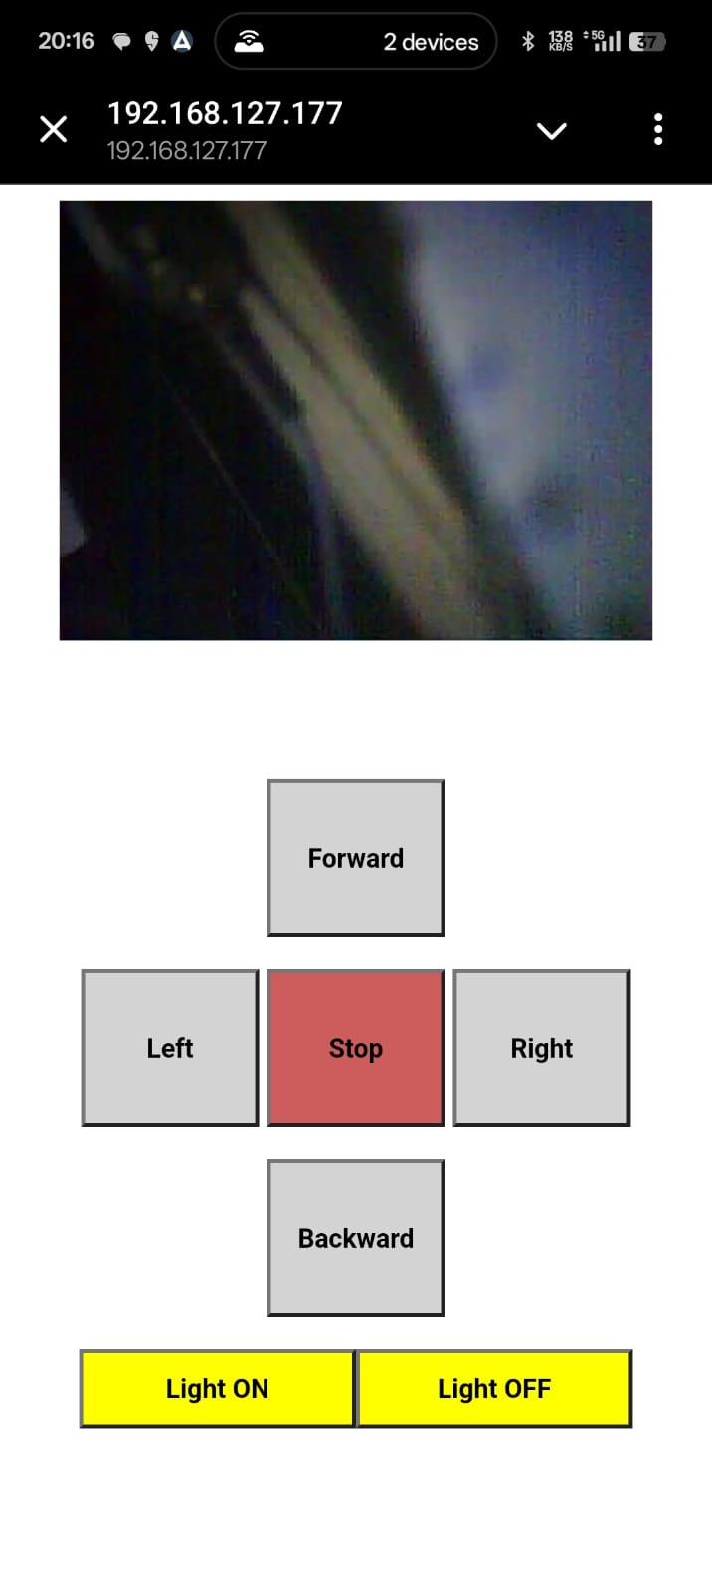

* **Control Panel (Middle Section):**

**🔼 Forward**

* Moves the bot **forward** using the L298N motor driver and DC motors.

**◀️ Left / ▶️ Right**

* Turns the bot **left or right** by controlling the motors in different directions.

**⬇️ Backward**

* Moves the bot **backward**.

**🟥 Stop**

* Immediately stops all motor movements. A safety and control feature
* **Light Control (Bottom Section):**

**Light ON / OFF:**

* These buttons **turn on or off an LED** (likely for night vision or low-light operation).
* Also controlled via **Web API** hosted on ESP32.

### **Limitations**

* **Wi-Fi Range**: Limited to the coverage of the local Wi-Fi network.
* **Manual Operation**: Currently semi-automated. Full automation with sensors and AI could further improve efficiency.
* **Payload Limit**: The cleaning mechanism’s size and weight must be managed for small water bodies.
* **Opportunities for Improvement**
* Adding **obstacle detection** (e.g., using ultrasonic sensors).
* Using **solar panels** for sustainable power.
* Enabling **GPS tracking** and cloud data storage.
* Automating path planning using **AI/ML algorithms**.
* **Conclusion**

The **IoT-Based Smart Water Surface Cleaning System** successfully demonstrates how integrating **IoT, robotics, and automation** can provide an efficient, low-cost solution for environmental cleanup. With the help of the **ESP32-CAM module**, **web-based control interface**, and **Telegram bot integration**, the system enables **real-time monitoring and remote control**, making it user-friendly and accessible.

The use of **rechargeable batteries with TP4056 modules** ensures the device is portable and suitable for various water bodies like ponds, lakes, and reservoirs. The cleaning mechanism effectively collects floating waste such as plastic and leaves, contributing to cleaner and healthier water environments.

While the current system is semi-automated, it provides a strong foundation for future upgrades such as **AI-based automation**, **solar power integration**, and **data analytics for pollution tracking**. Overall, this project showcases the practical application of smart technologies in promoting **environmental sustainability** and **smart city solutions**.

This project demonstrates the potential of IoT-based systems in solving real-world environmental problems. It is scalable, adaptable, and lays the groundwork for future

innovations in **smart waste management and environmental robotics**.

REFERENCES

1. Yujie Bai1, Shuang Yang2, Ying Wu3, Yongcan Chen4, Shiqi Pan5, Yansong Deng* College of Electrical and Information Engineering, Southwest Minzu University, Chengdu 610225, China”Expansible Surface Waste Cleaning Robot “ 978-1-7281-6136-5/20/$31.00 ©2020 IEEE
2. Shihan Kong , Manjun Tian, Changlin Qiu, Zhengxing Wu , and Junzhi Yu , Senior Member”IWSCR: An Intelligent Water Surface Cleaner Robot for Collecting Floating Garbage” , IEEE 2168-2216 c 2020 IEEE
3. Abir Akib Faiza Tasnim Disha Biswas Maeesha Binte Hashem”Unmanned Floating Waste Collecting Robot” IEEE Region 10 Conference (TENCON 2019)
4. Koripella Rishitha,S Ullas “IoT based Automation in Domestic Sewage Treatment Plant to Optimize Water Quality and Power Consumption” on
5. Computing Methodologies and Communication (ICCMC 2019)IEEE Xplore Part Number: CFP19K25-ART; ISBN: 978-1-5386-7808-4
6. [6] Ravi Kishore Kodali, Sasweth C.Rajanarayanan and Sindhuja Yadavilli Department of Electronics and Communication Engineering National Institute of Technology, Warangal2019 “ IoT Monitoring Setup for Waste Water Treatment” IEEE Region 10 Humanitarian Technology Conference Depok, Indonesia |November 12-14, 2019
7. Niramon Ruangpayoongsak, Jakkrit Sumroengrit, Monthian Leanglum”A Floating Waste Scooper Robot On Water Surface” 2017 17th International Conference on Control, Automation and Systems (ICCAS 2017) Oct. 18-21, 2017, Ramada Plaza, Jeju, Korea
8. Z. Wang, Y. Liu, Estimating hydrodynamic parameters of a lake surface cleaning robot using numerical methods, Proc. of IEEE International Conference on Robotics and Biomimetics (ROBIO), pp. 1146 – 1151, 2009.
9. M. Li, Y. He, Y. Ma, J. Yao, “Design and Implementation of a new jet-boat based Unmanned surface vehicle,” Proc. of International Conference on Automatic Control and Artificial Intelligence (ACAI), pp. 768-771,
10. M. Leanglum, N. Ruangpayoongsak, A. Phunopas, “Design and Development of the Waste Collector for a Surface Robot Cleaner,” Proc. of Industrial Engineering Network Conference (IE NETWORK), pp. 900-905, 2015.
11. Yiyang Wang “Stable Adaptive Fuzzy Control of Wastewater Treatment Plants,” Thesis by UNIVERSITY OF CALGARY, ALBERTA, April 2015.
12. E. Myatt, “A new relay for use with electronically controlled switching systems,” Proceedings of the IEE-Part B: Electronic and Communication Engineering,

vol. 109, no. 21, pp. 115–117, 1962.

1. R. K. Kodali and A. Sahu, “An iot based soil moisture monitoring on losant platform,” in Contemporary Computing and Informatics (IC3I), 2016 2nd International Conference on. IEEE, 2016, pp. 764–768.
2. M. R. Ranjbar and A. H. Abdalla, “Low-cost, real-time, autonomous water quality testing and notification system,” in IJCSNS International Journal of Computer Science and Network Security, VOL.17 No.5, May 2017
3. M.-C. Kang, K.-S. Kim, D.-K. Noh, J.-W. Han, and S.-J. Ko, “A robust obstacle detection method for robotic vacuum cleaners,” IEEE Trans.Consum.

Electron., vol. 60, no. 4, pp. 587–595, Nov. 2014.

1. S. Kumra and C. Kannan, “Robotic grasp detection using deep convolutional neural networks,” in Proc. IEEE/RSJ Int. Conf. Intell. Robot. Syst., Vancouver,

BC, Canada, Sep. 2017, pp. 769–776.