**Nanotechnology in the Corporate World: Opportunities, Risks, and Competitive Advantage**

**Lakshmi Kalyani Chinthala**

**Ageno School of Business, Golden Gate University, United States of America**

**Abstract**

Nanotechnology has emerged as a transformative force within the corporate world, offering a spectrum of opportunities that extend from product innovation to operational excellence. This paper delves into the strategic implications of nanotechnology in business, examining how it can create competitive advantages while also exploring the inherent risks and ethical challenges. By analyzing key use cases and sectors that are embracing nanoscale innovation, this research highlights how companies can harness nanotechnology to improve product performance, achieve cost efficiencies, and disrupt markets. At the same time, it underscores the need for responsible adoption, transparent communication, and adaptive risk management. The paper provides a balanced exploration of both the potential and the perils of integrating nanotechnology into corporate strategies, offering actionable insights for decision-makers aiming to capitalize on this powerful technological revolution.

Keywords: Nanotechnology, Corporate world, Business

**Introduction**

In the rapidly evolving landscape of global business, technology plays a defining role in shaping competitiveness, profitability, and long-term survival. Among the latest technological frontiers, nanotechnology stands out as a revolutionary advancement with far-reaching implications for the corporate world (Roco et al., 2011). Operating at dimensions as small as one-billionth of a meter, nanotechnology enables the design and production of materials and devices with unprecedented precision and capabilities. As this field transitions from scientific laboratories to commercial markets, it is fundamentally altering how businesses innovate, compete, and deliver value (Hulla et al., 2015).

This paper explores the intersection of nanotechnology and corporate strategy. It examines the opportunities presented by nanotechnology to enhance product functionality, streamline operations, and open new markets. Simultaneously, it critically assesses the risks and uncertainties—ranging from regulatory ambiguity to public health concerns—that accompany its adoption. The aim is to provide a comprehensive understanding of how businesses can leverage nanotechnology to gain competitive advantage while navigating its challenges with foresight and responsibility.

**Opportunities Unlocked by Nanotechnology in Business**

Nanotechnology offers businesses a vast array of opportunities that go beyond traditional innovation. Its most prominent value lies in enabling the development of products and systems that are more efficient, durable, lightweight, and intelligent. For instance, in the electronics sector, nanotech is pushing the boundaries of miniaturization, allowing companies to produce faster and more energy-efficient chips and sensors (Ferreira & Filipe, 2018).

In the pharmaceutical and healthcare industries, nanotechnology enables targeted drug delivery systems that increase treatment efficacy while minimizing side effects. These advancements translate into superior products that can command premium pricing and deliver unmatched value to customers. In sectors like energy and materials, nanotechnology is facilitating the development of high-performance batteries, solar panels, and construction materials, all of which contribute to a company’s innovation portfolio (Aydn et al., 2012).

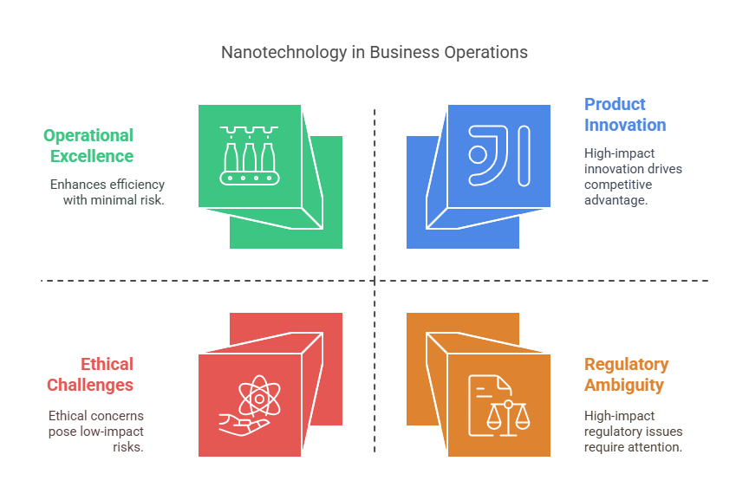

**Figure 1: Nanotechnology in business operations**

Nanotechnology also introduces opportunities for diversification. Companies that traditionally operated outside of advanced materials or life sciences are now entering these domains through strategic alliances, mergers, or R&D investments. This expansion opens new revenue streams and helps firms position themselves as leaders in emerging markets(Sood, 2010).

**Operational Efficiency and Cost Reductions**

Beyond product enhancements, nanotechnology has a profound impact on corporate operations. Nanomaterials often exhibit superior mechanical, electrical, and thermal properties that contribute to improved manufacturing processes. For example, nanocoatings can reduce machinery wear and tear, thereby lowering maintenance costs and extending equipment life (Gao et al., 2011).

Nanotech-enabled catalysts in chemical production can accelerate reactions while using fewer resources, reducing input costs and environmental impact. In logistics and packaging, smart nanomaterials can adjust to environmental conditions, protecting products from spoilage or damage and reducing waste (Toma, 2012).

These operational benefits translate directly into cost savings and improved profitability, two critical metrics for any corporation. When strategically implemented, nanotechnology can streamline value chains, reduce energy consumption, and minimize raw material usage—giving companies a leaner and more resilient operational model (Hong et al., 2010).

**Building Competitive Advantage through Nanotechnology**

Gaining a competitive edge in today’s marketplace requires more than incremental improvement; it demands differentiation and strategic foresight. Nanotechnology provides a powerful lever for companies to distinguish their offerings from competitors and set new industry benchmarks (Nath, 2014).

Firms that invest early in nanotechnology often enjoy first-mover advantages. These include brand leadership, intellectual property ownership, and the ability to set product standards before the market becomes saturated. Nanotech-driven innovations often result in superior quality, longer product lifespan, or enhanced user experience—attributes that translate into stronger brand equity and customer loyalty (Takayama, 2010).

Moreover, nanotechnology allows firms to anticipate and respond to future market trends. As sustainability, personalization, and health-consciousness become increasingly important to consumers, nanotechnology enables the development of products that align with these preferences—be it through energy-efficient gadgets, personalized medicine, or eco-friendly packaging (Roco et al., 2011).

**Flowchart**

|  |
| --- |
| **Nanotechnology in the Corporate World** |
| **↓** |
| **Opportunities** |
| **→ Nanotech transforms business** |
| **→ Product innovation, operational excellence** |
| **↓** |
| **Competitive Advantage** |
| **→ Improved product performance, cost efficiency** |
| **↓** |
| **Risks** |
| **→ Ethical challenges, public concerns, regulatory ambiguity** |
| **↓** |
| **Actionable Insights** |
| **↓** |
| **→ Responsible adoption, transparent communication, risk management** |

**Figure 2: Application of nanotechnology in corporate world**

**Risks and Uncertainties in Corporate Nanotech Adoption**

Despite its promises, the adoption of nanotechnology carries a set of complex risks that businesses must manage thoughtfully. One of the most pressing concerns is the lack of comprehensive regulation. Because nanomaterials often behave differently than their bulk counterparts, existing safety standards may not adequately cover their use or impact. This regulatory ambiguity can expose firms to legal liabilities or market withdrawal if future rules deem certain materials hazardous (Hansen, 2010).

Another significant risk lies in public perception and ethical concerns. Nanotechnology, particularly when used in food, cosmetics, or healthcare products, may trigger consumer anxiety about safety or long-term effects. Companies must proactively engage in transparent communication and public education to build trust and avoid reputational damage (Kumari & Yadav, 2013).

There are also technical risks. Many nanotechnologies are still in early stages of commercialization and may face scalability challenges or performance inconsistencies in real-world applications. This creates uncertainties in investment returns and may delay time-to-market (Floridi et al., 2018).

Intellectual property issues present another challenge. With the high rate of innovation and cross-disciplinary overlap in nanotech, patent disputes and IP fragmentation are common, potentially hampering innovation or leading to costly litigation.

**Strategic Considerations for Corporate Nanotechnology Integration**

To capitalize on nanotechnology while mitigating risks, businesses need a strategic and structured approach. First, a clear innovation roadmap must be developed that aligns nanotech initiatives with broader corporate goals. Investment in in-house R&D capabilities or collaboration with universities and research institutions can provide a strong knowledge foundation.

Second, companies should establish interdisciplinary teams that combine scientific expertise with business acumen. This hybrid approach helps bridge the gap between technological potential and commercial viability (Urze & Abreu, 2015).

Third, robust governance structures should be implemented to oversee ethical, environmental, and regulatory compliance. Risk assessment protocols, impact studies, and stakeholder consultations should be routine parts of nanotechnology project management (Hansen, 2010).

Fourth, a long-term perspective is essential. While nanotech innovations can offer rapid benefits, many applications take years to mature. Patience, persistence, and continuous learning are critical for sustaining momentum and managing uncertainties.

**Case Examples of Nanotechnology in Corporate Settings**

Numerous companies across various industries are already pioneering nanotechnology adoption. Intel and IBM are integrating nanotech into chip design to overcome the limitations of Moore’s Law. L’Oréal has invested heavily in nanotechnology for advanced cosmetic formulations that offer superior skin absorption and efficacy.

In the automotive sector, companies like Tesla and Toyota are using nanomaterials to develop lightweight, high-strength components and energy-efficient batteries. Nike, in the world of sportswear, incorporates nanotech into fabrics to enhance performance and durability (Coelho et al., 2012).

These examples demonstrate that nanotechnology is not confined to any one industry or application. It is a cross-cutting enabler of innovation that forward-thinking corporations are leveraging to maintain leadership and market relevance.

**The Global Landscape and Corporate Strategy**

Internationally, nanotechnology is becoming a strategic priority for governments and industries alike. Countries are investing in national nanotechnology initiatives, creating innovation clusters, and fostering public-private partnerships. For corporations, this presents both an opportunity and a challenge.

On one hand, firms can tap into global innovation ecosystems, access talent, and benefit from government incentives. On the other hand, they must navigate varying regulatory environments, protect intellectual property across borders, and respond to competitive pressures from international players (Föllmi et al., 2018).

A global nanotechnology strategy should include monitoring geopolitical developments, participating in standard-setting bodies, and building agile supply chains that can adapt to regional fluctuations in demand and policy.

**Conclusion**

Nanotechnology is no longer a futuristic concept—it is a present-day reality reshaping how businesses innovate, operate, and compete. The corporate world stands to gain immensely from its adoption, with opportunities ranging from product innovation to operational efficiency and strategic differentiation.

However, this transformation is not without its risks. Regulatory ambiguity, public skepticism, technical limitations, and intellectual property concerns require careful navigation. Firms must adopt a balanced approach that combines bold innovation with ethical stewardship and strategic foresight.

Ultimately, those businesses that succeed in integrating nanotechnology into their core operations will not only unlock new growth avenues but also redefine industry standards. In an increasingly complex and competitive global market, nanotechnology offers a pathway to sustained leadership, agility, and impact.

**References**

1. Aydn, A., Si̇pahi̇, H., & Charehsaz, M. (2012). Nanoparticles Toxicity and Their Routes of Exposures. In InTech eBooks. https://doi.org/10.5772/51230
2. Coelho, M. C., Torrão, G., Emami, N., & Grácio, J. (2012). Nanotechnology in Automotive Industry: Research Strategy and Trends for the Future—Small Objects, Big Impacts. Journal of Nanoscience and Nanotechnology, 12(8), 6621. https://doi.org/10.1166/jnn.2012.4573
3. Ferreira, M., & Filipe, J. (2018). Nanotechnology Applications – The Future Arrived Suddenly. 23. https://doi.org/10.1002/9783527344758.ch2
4. Floridi, L., Cowls, J., Beltrametti, M., Chatila, R., Chazerand, P., Dignum, V., Luetge, C., Madelin, R., Pagallo, U., Rossi, F., Schäfer, B., Valcke, P., & Vayena, E. (2018). AI4People—An Ethical Framework for a Good AI Society: Opportunities, Risks, Principles, and Recommendations. Minds and Machines, 28(4), 689. https://doi.org/10.1007/s11023-018-9482-5
5. Föllmi, R., Fuest, A., Meulen, P. an de, Micheli, M., Schmidt, T., & Zwick, L. (2018). Openness and productivity of the Swiss economy. Zeitschrift Für Schweizerische Statistik Und Volkswirtschaft/Schweizerische Zeitschrift Für Volkswirtschaft Und Statistik/Swiss Journal of Economics and Statistics, 154(1). https://doi.org/10.1186/s41937-018-0021-3
6. Gao, Y., Xiang, Q., Liu, J. Q., Wang, Q. Q., Tang, J., Yang, S. W., & Wu, J. (2011). Research Advance of Electrochemical Sensor Fabricated with Nanomaterials and their Application. Advanced Materials Research, 2126. https://doi.org/10.4028/www.scientific.net/amr.418-420.2126
7. Hansen, S. F. (2010). A global view of regulations affecting nanomaterials. Wiley Interdisciplinary Reviews Nanomedicine and Nanobiotechnology, 2(5), 441. https://doi.org/10.1002/wnan.99
8. Hong, Q., Li, G., Jie, X., Wu, H., & Lei, P. (2010). The Application of Nanotechnology for Green Manufacturing. Advanced Materials Research, 498. https://doi.org/10.4028/www.scientific.net/amr.148-149.498
9. Hulla, J., Sahu, S., & Hayes, A. (2015). Nanotechnology [Review of Nanotechnology]. Human & Experimental Toxicology, 34(12), 1318. SAGE Publishing. https://doi.org/10.1177/0960327115603588
10. Kumari, A., & Yadav, S. K. (2013). Nanotechnology in Agri-Food Sector [Review of Nanotechnology in Agri-Food Sector]. Critical Reviews in Food Science and Nutrition, 54(8), 975. Taylor & Francis. https://doi.org/10.1080/10408398.2011.621095
11. Nath, B. D. D. (2014). ‘Green Nanomaterial’-How Green they are as Biotherapeutic Tool. Journal of Nanomedicine & Biotherapeutic Discovery, 4(2). https://doi.org/10.4172/2155-983x.1000125
12. Roco, M. C., Mirkin, C. A., & Hersam, M. C. (2011). Nanotechnology research directions for societal needs in 2020: summary of international study. Journal of Nanoparticle Research, 13(3), 897. https://doi.org/10.1007/s11051-011-0275-5
13. Sood, A. (2010). Product Diversification. In Wiley International Encyclopedia of Marketing. https://doi.org/10.1002/9781444316568.wiem05051
14. Takayama, M. (2010). Law of Success or Failure in the High Tech Driven Market - “Revenge of Success” in the Biotech, Nanotech, and ICT Industry. In Sciyo eBooks. https://doi.org/10.5772/10402
15. Toma, H. E. (2012). Developing nanotechnological strategies for green industrial processes. Pure and Applied Chemistry, 85(8), 1655. https://doi.org/10.1351/pac-con-12-12-02
16. Urze, P., & Abreu, A. (2015). Innovation from Academia-Industry Symbiosis. In IFIP advances in information and communication technology (p. 337). Springer Science+Business Media. https://doi.org/10.1007/978-3-319-24141-8_30