**CROP DISEASE DETECTION USING MACHINE LEARNING**

**Aditya Tanpure1, Purushottam Nimbalkar2, Prathamesh Gund3, Snehal Sabale4**

1 UG, Electronic and Telecommunication Engineering, V.P.K.B.I.E.T, Baramati, 413133 Maharashtra, India

2 UG, Electronic and Telecommunication Engineering, V.P.K.B.I.E.T, Baramati, 413133 Maharashtra, India

3 UG, Electronic and Telecommunication Engineering, V.P.K.B.I.E.T, Baramati, 413133 Maharashtra, India

4 Assistant Professor, Electronic and Telecommunication Engineering, V.P.K.B.I.E.T, Baramati, 413133 Maharashtra, India

**ABSTRACT:**

Agriculture plays a vital role in sustaining human civilization, and plant diseases significantly impact crop yield, quality, and overall production. Traditional methods of identifying crop diseases are often labor-intensive and time-consuming, limiting timely intervention. With recent advancements in Machine Learning (ML), more efficient, automated, and accurate approaches for disease detection have emerged. This paper presents a comprehensive review of various ML techniques applied to crop disease detection, focusing on image processing, deep learning models, and predictive analytics. It highlights commonly used algorithms, datasets, and evaluation metrics in disease classification and early detection. The findings aim to support the development of smarter agricultural practices and enhance global food security.

**Keywords** – Machine Learning, Crop Disease Detection, Image Processing, Deep Learning, Precision Agriculture.

**INTRODUCTION:**

Agriculture plays a crucial role in sustaining the global economy and ensuring food security. However, plant diseases significantly reduce agricultural productivity and adversely affect the livelihoods of farmers, especially in developing regions. Traditional methods for identifying crop diseases are often manual, time-consuming, and dependent on expert knowledge—resources that may not be readily available in rural or resource-constrained areas.

To address this challenge, our project focuses on developing an automated crop disease detection system using Machine Learning (ML). By leveraging image processing and ML algorithms, the system can accurately detect and classify plant diseases based on leaf images. This automated approach supports early diagnosis, enables timely interventions, and helps minimize crop loss, thereby improving overall agricultural outcomes.

The proposed solution utilizes a dataset consisting of healthy and diseased plant leaf images. These images are processed using trained ML models to provide reliable predictions. Designed to be scalable and user-friendly, the system is also compatible with Internet of Things (IoT) devices such as Raspberry Pi, making it a practical and accessible tool for real-world agricultural applications

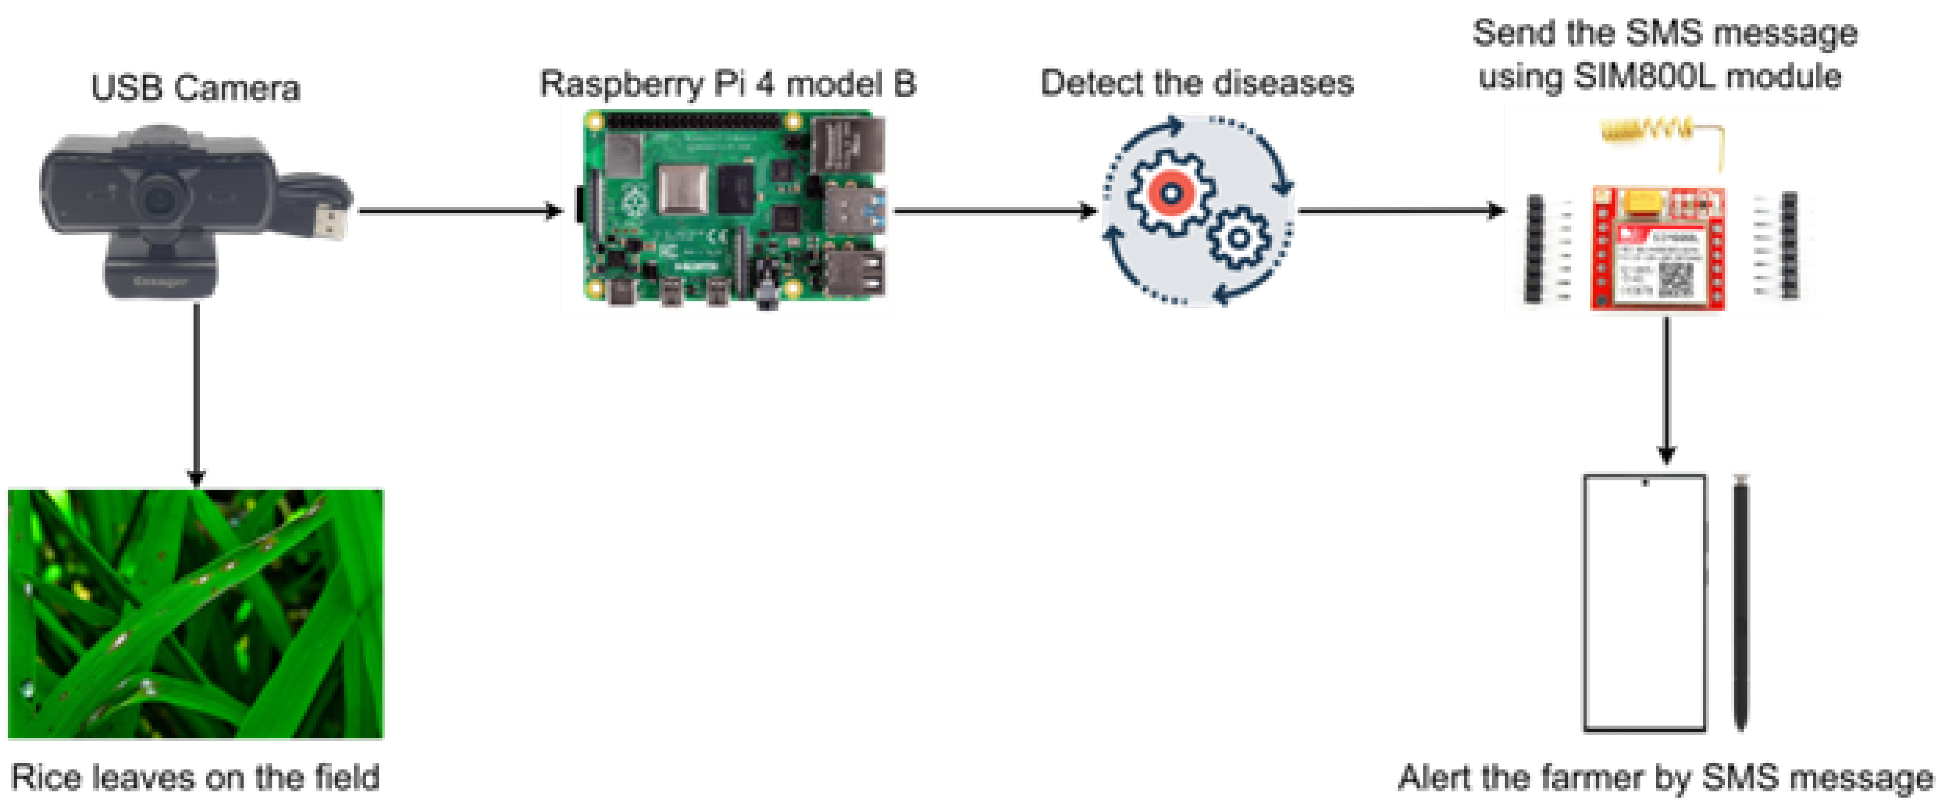

**Figure 1:** Crop Disease detection using machine learning

1. **METHODOLOGY**

This research implements a crop disease detection system using the YOLOv8 (You Only Look Once version 8) object detection model. The objective is to enable real-time detection and classification of diseases in crop leaves using a webcam and a Raspberry Pi, offering a practical and accessible solution for precision agriculture.

**2.1 Data Collection and Annotation**:

A comprehensive dataset of plant leaf images was collected, comprising both healthy and diseased specimens. Annotation was carried out using tools such as **Roboflow** and **LabelImg**, where bounding boxes were applied to highlight diseased regions. These annotated images were then prepared for training with the YOLOv8 model.

**2.2 Model Training (Jupyter Notebook)**:

The training process was conducted using **Jupyter Notebook**, where the annotated dataset was uploaded and preprocessed. The YOLOv8 model was fine-tuned through **transfer learning** on the custom dataset. Key hyperparameters, including batch size, number of epochs, and image resolution, were optimized to enhance model performance.

**2.3 Model Export and Deployment**:

Once training was complete, the best-performing model weights were exported in **.pt format**. These weights were transferred to a **Raspberry Pi**, where a custom detection script was developed using **Python** in the **Thonny IDE** for deployment.

**2.4 Real-Time Detection (Raspberry Pi + Webcam):**

A webcam was connected to the Raspberry Pi to capture live video. The trained YOLOv8 model was loaded using Python, enabling real-time inference. Detected diseases were displayed on the video stream with bounding boxes and class labels for easy identification and monitoring.

**2.5 Performance Analysis:**

The model’s effectiveness was assessed using standard metrics such as **accuracy**, **precision**, and **recall** on a validation set. Real-time performance on the Raspberry Pi was also tested to ensure responsive detection and low computational latency, making it suitable for deployment in resource-limited environments.

1. **MODELING AND ANALYSIS**

The proposed system employs a structured pipeline for real-time crop disease detection using the YOLOv8 object detection model. The process begins with the capture of leaf images using a webcam connected to a **Raspberry Pi**, making the system highly suitable for in-field deployment.

Captured images undergo a **pre-processing** stage, which involves resizing, normalization, and format conversion to ensure compatibility with the trained model. These pre-processed images are then passed into the YOLOv8 model, which was trained on a curated dataset of **3,500 labeled images** obtained from multiple sources, including:

* **PlantVillage**
* **Kaggle**
* **Field images** collected from local farms

The dataset encompasses **10 different crop diseases**, along with healthy leaf samples, enabling the model to achieve robust and reliable classification under varied conditions.

In the **post-processing** stage, the model outputs are visualized with bounding boxes and disease labels, making the results clear and easily interpretable. An optional **classification and grading** phase assesses disease severity, supporting informed decision-making in disease management.

The model's performance was evaluated using standard metrics:

* **Accuracy** – To assess overall prediction correctness
* **Precision and Recall** – To evaluate the quality of disease detection
* **F1-Score** – To balance precision and recall
* **Inference Time** – Measured on the Raspberry Pi to confirm real-time operational capability

The experimental results indicate that **YOLOv8** delivers high accuracy, rapid detection speeds, and stable performance even on low-power hardware. These characteristics make it a promising and scalable solution for **smart agriculture** and real-time crop monitoring application

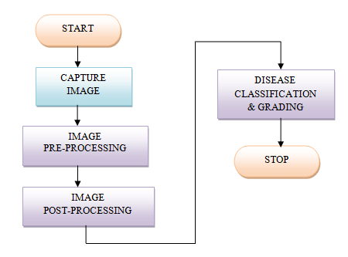

**Figure 2:** Block Diagram of Crop disease Detection Using Machine Learning.

1. **COMPONENTS**

This section outlines the key hardware components used in the development and deployment of the real-time crop disease detection system.

* 1. **Raspberry Pi 4B (4GB)**:

The **Raspberry Pi 4B (4GB RAM)** serves as the core processing unit of the system. Equipped with a **quad-core CPU** and support for Python and OpenCV libraries, it is capable of executing YOLOv8 object detection locally, without relying on cloud computing. Its GPIO pins and compact form factor make it ideal for edge-based, real-time applications. The Raspberry Pi captures input from the connected camera, runs the trained model, and performs on-device inference to detect crop diseases.

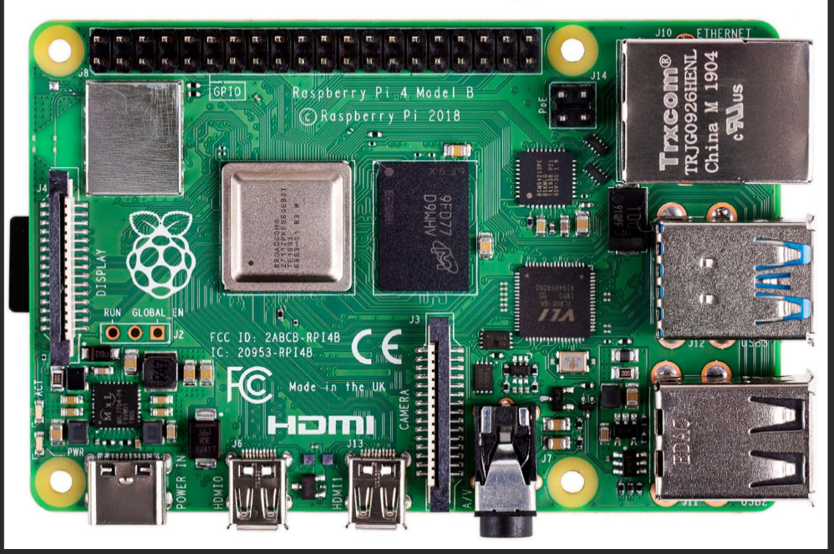

**Figure 3:** Raspberry pi

* 1. **Web Camera**:

A **USB web camera** is used to capture real-time images of crop leaves. The camera is directly connected to the Raspberry Pi and acts as the system’s input source. The captured frames are fed to the YOLOv8 model for instant detection and classification of plant diseases. This setup eliminates the need for internet connectivity or high-end GPUs, enabling cost-effective, on-field disease monitoring. It empowers farmers, especially in remote regions, to take timely action and mitigate crop damage.

.

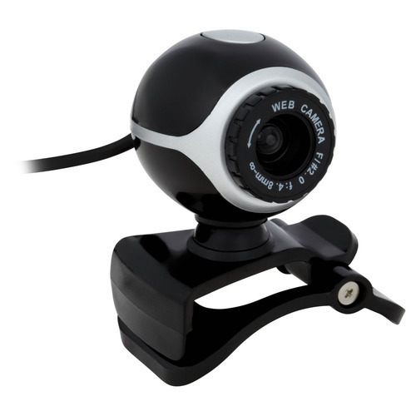

**Figure 4:** Web Camera

* 1. **Memory Card (16GB):**

A **16GB microSD card** is used as the primary storage medium for the Raspberry Pi. It contains the operating system (e.g., Raspberry Pi OS), the trained YOLOv8 model, Python scripts, and required libraries.  
Key features:

* **Type:** microSD (compatible with Raspberry Pi)
* **Capacity:** 16 gigabytes
* **Use Case:** Storing the model, OS, Python scripts, and project data
* **Speed Class:** At least Class 10 or UHS-I recommended for smooth read/write performance



**Figure 5:** microSD card

* 1. **USB Power Supply Cable**:

A **USB Type-C cable** is used to supply power to the Raspberry Pi 4B. A stable power supply (5V/3A recommended) is crucial to ensure smooth operation during real-time inference and prevent unexpected shutdowns. The USB cable can be connected to a wall adapter, power bank, or solar battery pack, making the system portable and suitable for off-grid agricultural environments.

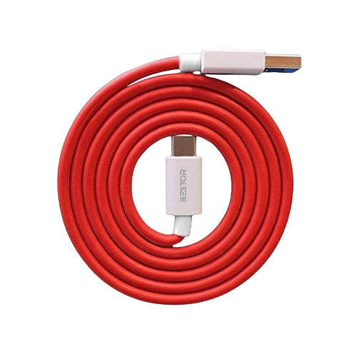

**Figure 6:** USB Type-C cable

1. **RESULTS AND DISCUSSION**

TheYOLOv8 model for tomato crop disease detection was trained over **300 epochs** on Google Colab using **GPU acceleration**, allowing the model to learn deeper and more refined features from the dataset. The initial learning rate was set to **0.0005** and dynamically increased during training to approximately **0.0016**, aiding better convergence. The total training time was approximately **5420.13 seconds**.

For real-time application, the model was deployed on a **Raspberry Pi 4B** using the **Thonny Python IDE**, integrated with a **USB webcam** for continuous, live image capture of tomato leaves.

**Model Performance Metrics**

After training for 300 epochs, the model achieved strong and reliable performance:

* **Precision:** ~**88%**  
  Indicates the model’s high accuracy in correctly detecting and classifying diseased and healthy leaves, with minimal false positives.
* **Recall:** ~**76%**  
  Reflects the model’s ability to identify most relevant disease instances, even under varied lighting and environmental conditions.
* **mAP@0.5:** ~**85%**  
  Demonstrates high localization accuracy when the Intersection-over-Union (IoU) threshold is 0.5.
* **mAP@0.5:0.95:** ~**63%**  
  Shows consistent model performance across multiple IoU thresholds, representing robust detection capabilities.

**Training Loss Metrics**

The final loss values observed after 300 epochs were:

* **Box Loss:** **1.01**
* **Classification Loss:** **0.69**
* **Distribution Focal Loss (DFL):** **0.93**

These values indicate **stable convergence**, minimal overfitting, and overall effective model learning.

**Real-Time Deployment**

Using a **Raspberry Pi** with a connected webcam, the trained model was capable of performing **real-time inference**. The system provided live detection with bounding boxes and disease labels displayed directly on the video stream, offering a responsive and interactive user experience.

This setup, despite its low power requirements, proved to be both **efficient and reliable**, making it suitable for **on-field agricultural use** where cloud connectivity is limited or unavailable.

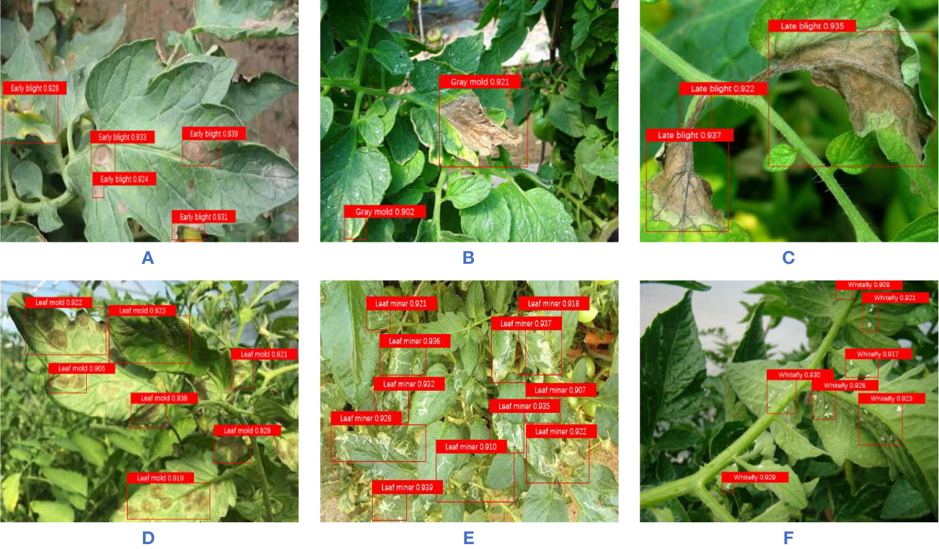

**Figure 7:** Results

1. **CONCLUSION**

**Problem Summary**

Crop diseases pose a major threat to global agricultural productivity, often spreading rapidly if not diagnosed in time. Traditional detection methods rely heavily on manual inspection and expert knowledge, which are not always accessible—particularly in rural or resource-limited regions. This often leads to delayed or incorrect diagnosis, resulting in significant yield loss and economic hardship for farmers. Thus, there is an urgent need for a fast, reliable, and automated disease detection solution that can enable early intervention and mitigate crop damage.

**Proposed Solution**

To address this challenge, we developed an automated crop disease detection system powered by machine learning. The system utilizes a webcam connected to a Raspberry Pi to capture real-time images of crop leaves, which are analyzed using a YOLOv8 object detection model trained on a curated dataset. Training was conducted using Google Colab for high-performance learning, while deployment was carried out on Thonny Python for lightweight execution. The trained model enables accurate classification of both healthy and diseased leaves in real time, empowering farmers to take timely corrective actions and safeguard their crops.

**Our Contribution**

This project combines artificial intelligence with edge computing to create a cost-effective, scalable, and portable solution for precision agriculture. By leveraging the computational efficiency of YOLOv8 and the accessibility of Raspberry Pi, our system enables in-field, real-time disease monitoring without reliance on continuous internet access. The solution is easy to use, highly adaptable, and designed for practical deployment in diverse agricultural settings. Overall, this approach promotes smart farming practices by minimizing manual labor, reducing crop loss, and supporting early-stage disease management—contributing to more sustainable and resilient agricultural ecosystems.

1. **ACKNOWLEDGEMENTS**

We would like to express our sincere gratitude to all those who have contributed to the successful completion of our project titled **“Crop Disease Detection using Machine Learning.”**

First and foremost, we extend our heartfelt thanks to **Dr. S. B. Lande**, Principal, for his unwavering encouragement, motivation, and continuous support throughout the duration of this project.

We are deeply grateful to **Dr. B. H. Patil**, Head of the Department, for his insightful guidance and constant inspiration. His expertise in both machine learning and agricultural technology played a pivotal role in shaping our understanding and approach.

Our special thanks go to our project mentor, **Prof. S. R. Sabale**, for his dedicated mentorship, technical expertise, and valuable suggestions at every stage of the project. His support and constructive feedback were instrumental in overcoming challenges and achieving our goals.

We would also like to thank our class teacher, **Prof. M. S. Gawade**, for his encouragement and for keeping us focused and motivated throughout the project journey.

Lastly, we sincerely acknowledge the cooperation and support of all faculty members, lab assistants, and our fellow classmates who assisted us directly or indirectly. Their contributions have been essential to the successful implementation of this project.

1. **REFERENCES**
2. Dolatabadian, A., Neik, T. X., Danilevicz, M. F., Upadhyaya, S. R., Batley, J., & Edwards, D. “Image-based Crop Disease Detection Using Machine Learning.” *Agronomy*, ISSN: 2073-4395, 2024.
3. Ngugi, H. N., Akinyelu, A. A., & Ezugwu, A. E. “Machine Learning and Deep Learning for Crop Disease Diagnosis: Performance Analysis and Review.” *Agronomy*, ISSN: 2073-4395, Volume 14, Issue 12, 2024.
4. Lebrini, Y., & Gotor, A. A. “Crop Disease Detection, From Leaves to Field: What We Can Expect from Artificial Intelligence.” *Agronomy*, ISSN: 2073-4395, Volume 14, Issue 11, 2719, 2024.
5. Demilie, W. B. “Crop Disease Detection and Classification Techniques: A Comparative Study of the Performances.” *Journal of Big Data*, ISSN: 2196-1115, Volume 11, Issue 1, Article 5, 2024.
6. Deputy, K. V., et al. “Crop Disease Detection Using Deep Learning Techniques on Images.” *Journal of Computer Science*, ISSN: 1549-3636, Volume 12, Issue 12, 2023.
7. Ma, L., Yu, Q., Yu, H., & Zhang, J. “Maize Leaf Disease Identification Based on YOLOv5n Algorithm Incorporating Attention Mechanism.” *Agronomy*, ISSN: 2073-4395, Volume 13, Issue 1, 2023.
8. AlArfaj, A. A., Altamimi, A., Aljrees, T., Basheer, S., Umer, M., Samad, M. A., et al. “Multi-step Preprocessing with UNet Segmentation and Transfer Learning Model for Pepper Bell Leaf Disease Detection.” *IEEE Access*, ISSN: 2169-3536, Volume 11, 2023.
9. Abbas, A., Zhang, Z., Zheng, H., Alami, M. M., Alrefaei, A. F., Naqvi, S. A. H., et al. “Drones in Crop Disease Assessment, Efficient Monitoring, and Detection: A Way Forward for Smart Agriculture.” *Agronomy*, ISSN: 2073-4395, Volume 13, Issue 1, 2023.
10. Habiba, N., Ngugi, A. E., Ezugwu, A., & Akinyelu, A. A. “Revolutionizing Crop Disease Detection with Computational Deep Learning: A Comprehensive Review.” *Laith Abualigah*, Received: 14 October 2023.
11. Borhani, Y., Khoramdel, J., & Najafi, E. “A Deep Learning-based Approach for Automated Crop Disease Classification Using Vision Transformer.” *Scientific Reports*, ISSN: 2045-2322, Volume 12, Issue 1, 2022.
12. Abdulridha, J., Ampatzidis, Y., Qureshi, J., & Roberts, P. “Identification and Classification of Downy Mildew Severity Stages in Watermelon Utilizing Aerial and Ground Remote Sensing and Machine Learning.” *Frontiers in Crop Science*, ISSN: 1664-462X, Volume 13, 2022.
13. Akbar, M., Ullah, M., Shah, B., Khan, R. U., Hussain, T., Ali, F., et al. “An Effective Deep Learning Approach for the Classification of Bacteriosis in Peach Leaves.” *Frontiers in Crop Science*, Volume 13, ISSN: 1664-462X, 2022.
14. Bhat, S. A., & Huang, N. F. “Big Data and AI Revolution in Precision Agriculture: Survey and Challenges.” *IEEE Access*, ISSN: 2169-3536, Volume 9, 2021.
15. Bayer, P. E., & Edwards, D. “Machine Learning in Agriculture: From Silos to Marketplaces.” *Crop Biotechnology Journal*, Volume 19, 2021.
16. Bedi, P., & Gole, P. “Crop Disease Detection Using a Hybrid Model Based on Convolutional Autoencoder and Convolutional Neural Network.” *Artificial Intelligence in Agriculture*, ISSN: 2589-7217, Volume 5, 2021.
17. Ramanjot, et al. “Crop Disease Detection and Classification: A Systematic Literature Review.” 2023.
18. Saleem, M. H., Potgieter, J., & Arif, K. M. “Crop Disease Classification: A Comparative Evaluation of Convolutional Neural Networks and Deep Learning Optimizers.” *Crops*, Volume 9, 2021.
19. Burdon, J. J., & Zhan, J. “Climate Change and Disease in Crop Communities.” *PLoS Biology*, ISSN: 1545-7885, Volume 18, 2020.
20. Rajasekaran, C., Arul, S., Devi, S., Gowtham, G., & Jeyaram, S. “Turmeric Crop Disease Detection and Classification Using Artificial Intelligence.” *International Conference on Signal Processing and Communication*, 2020.
21. Jasim, M. A., & Al-Tuwaijari, J. M. “Crop Leaf Disease Detection and Classification Using Image Processing and Deep Learning Techniques.” *International Computer Science & Software Engineering Conference*, 2020.