MERN Stack-Powered Academic Management
Solution

¹Desetti Srinuvasa Rao
Assistant Professor, Computer Science And Engineering
GMR Institute Of Technology
Rajam
⁴Kottalenka Sridevi
Computer Science And Enginnering Student
GMR Institute Of Technology
Rajam
⁷Marna Vinay Kumar
Computer Science And Engineering Student
GMR Institute Of Technology
Rajam

²Pandava Madhumala
Computer Science And Engineering Student
GMR Institute Of Technology
Rajam

⁵Cheera Neha
Computer Science And Engineering Student
GMR Institute Of Technology
Rajam

³Nakka Pravallika
Computer Science And Enginnering Student
GMR Institute Of Technology
Rajam
⁶Mangi Dinesh
Computer Science And Engineering Student
GMR Institute Of Technology
Rajam

Abstract— The Academic Management System is a web-based application built using the MERN stack (MongoDB, Express.js, React.js, and Node.js), designed to efficiently manage daily academic operations. It provides role-based access for three types of users: Admin, Faculty, and Students. The Admin has control over user management, class scheduling, complaint handling, and notice distribution. Faculty members can take student attendance, upload educational resources, and enter marks for performance evaluation. Students are able to view their attendance, check their academic performance, access shared materials, receive notices, and submit complaints. The system offers a clean user interface and ensures secure, organized communication among all users. Each module is integrated to support smooth workflow and data handling. By reducing manual work and centralizing key functions, the system enhances productivity and maintains accurate academic records. This application meets the essential needs of a digital school environment, making academic and administrative tasks more manageable and efficient.
Keywords— School Management System, MERN Stack, Role-Based Access,Attendance Tracking , Performance Management , Web Application

Introduction (Heading 1)
The Academic Management System is a web-based application developed using the MERN stack (MongoDB, Express.js, React.js, and Node.js) with the primary aim of digitalizing and streamlining academic and administrative activities in educational institutions. Traditional methods of managing attendance, marks, notices, and complaints often result in inefficiencies, lack of transparency, and data mismanagement. This system addresses those issues by providing role-based access where admins can manage users, post notices, and handle complaints; teachers can mark attendance, manage student marks, and view notices; and students can view their academic records, attendance, and raise concerns. The platform ensures seamless communication among users while reducing manual work and paperwork. Leveraging MongoDB for dynamic data storage, Express and Node.js for backend operations, and React for an interactive and responsive user interface, the system offers a secure, scalable, and efficient solution that enhances the digital experience of school operations and supports modern educational needs.

Literature Survey
The paper "A Framework for Developing E-learning Solutions" by K. S. Cheung and J. Lam presents a structured approach to designing and implementing effective e-learning systems. It emphasizes the integration of content management, information technology, and user-centric practices to create adaptable e-learning platforms. The framework supports diverse educational needs, such as continuing education, management training, and environmental management, by leveraging internet-based tools and portals. It highlights the importance of scalability, interoperability, and user engagement in e-learning solutions. The paper also discusses best practices and methodologies for developing e-learning systems that cater to both learners and educators in various domains.[1]

The paper "Blending Digital and Face-to-Face Interaction Using a Co-Located Social Media App in Class" by S. Govaerts et al. explores the integration of digital and in-person interactions in educational settings through a co-located social media app. The app enables students to collaborate, share ideas, and engage in discussions both digitally and face-to-face during class. It aims to enhance participation, foster social learning, and bridge the gap between online and physical classroom experiences. The study evaluates the app's effectiveness in improving engagement, interaction, and learning outcomes, highlighting its potential to create a more dynamic and collaborative educational environment.[2]

The paper "Virtual Classroom: A Lecturer-Centered Consumer-Grade Immersive Teaching System in Cyber–Physical–Social Space" by T. Shen et al. introduces an immersive teaching system designed to enhance online education. The system integrates cyber, physical, and social spaces to create an engaging, lecturer-centered virtual classroom environment. It leverages consumer-grade technologies to deliver immersive experiences, enabling real-time interaction between lecturers and students. The study highlights the system's ability to improve teaching efficiency, foster active participation, and bridge the gap between traditional and virtual learning. The paper also evaluates its performance, usability, and potential to transform online education through cost-effective, immersive teaching solutions.[3]

The paper "Toward Selection of Trustworthy and Efficient E-Learning Platform" by B. Alojaiman focuses on identifying criteria for selecting reliable and efficient e-learning platforms. It proposes a framework to evaluate platforms based on trustworthiness, usability, performance, and security. The study emphasizes the importance of user satisfaction, data privacy, and platform scalability in supporting effective learning experiences. By analyzing existing platforms, the paper highlights key factors that influence their adoption and success in educational environments. The proposed framework aims to guide educators and institutions in choosing e-learning solutions that meet diverse needs while ensuring a secure and efficient learning ecosystem.[4]

The paper "The Experience of Using a New e-Learning Tool in Architectural Studies" by P. Xiberta et al. examines the implementation and impact of an innovative e-learning tool designed for architectural education. The tool integrates interactive features, visualization techniques, and collaborative functionalities to enhance learning outcomes in architecture studies. The study evaluates its effectiveness through user feedback, focusing on usability, engagement, and its ability to support creative and technical skill development. Results demonstrate improved student satisfaction and performance, highlighting the tool's potential to transform traditional architectural education by providing a more dynamic and accessible learning experience tailored to student needs.[5]

The paper "Teaching and Learning in Cross-Disciplinary Virtual Teams" by P. E. Brewer et al. explores the challenges and benefits of collaborative learning in cross-disciplinary virtual teams. It examines how students from different fields work together in virtual environments to solve complex problems, emphasizing the development of communication, teamwork, and problem-solving skills. The study highlights the role of technology in facilitating collaboration and overcoming barriers such as time zones and disciplinary differences. Findings reveal that such team-based learning enhances critical thinking and prepares students for real-world professional scenarios, making it a valuable approach in modern education and training.[6]

The paper "Student Satisfaction Pilot Experience With Synchronous Classroom Live Streaming Styles During the COVID-19 Pandemic" by J. F. Flórez Marulanda evaluates student satisfaction with different live streaming methods used in synchronous online classrooms during the pandemic. The study investigates how various teaching styles, technological tools, and interaction levels impact student engagement and learning outcomes. Feedback from students highlights preferences for interactive and visually engaging sessions, emphasizing the importance of clear communication and technical reliability. The findings provide insights into optimizing synchronous online teaching to enhance student satisfaction and effectiveness, offering guidance for future virtual education practices.[7]

The paper "Detecting Drowsy Learners at the Wheel of e-Learning Platforms With Multimodal Learning Analytics" by R. Kawamura et al. explores the use of multimodal learning analytics to identify drowsiness in e-learning users. By analyzing data from various sources, such as facial expressions, eye movements, and engagement patterns, the system detects signs of fatigue or reduced focus in learners. The study emphasizes the importance of maintaining attention and active participation in online education. Results demonstrate the effectiveness of the approach in improving learning outcomes by addressing drowsiness in real-time, offering potential for more adaptive and responsive e-learning platforms.[8]

The paper "Comparing the Effectiveness of Video-Based Learning and Game-Based Learning Using Teacher-Authored Video Games for Online Software Engineering Education" by A. Gordillo et al. compares the effectiveness of two learning methods—video-based learning and game-based learning—specifically in the context of online software engineering education. The study evaluates how teacher-authored video games can enhance learning outcomes compared to traditional video-based instructional content. Results indicate that game-based learning provides higher levels of engagement and interactivity, leading to improved student performance and retention. The paper suggests that integrating game-based elements into online education can significantly enhance learning experiences and outcomes. [9]

The paper "Deep Learning-Based Interactive Dashboard for Enhancing Online Classroom Experience Through Student Emotion Analysis" by P. Ganesan et al. presents a deep learning-based system designed to enhance online classroom experiences by analyzing student emotions. The system uses emotion recognition techniques to track students' facial expressions and engagement levels during online sessions. An interactive dashboard provides real-time feedback to instructors, helping them adjust teaching methods based on emotional cues. The study highlights how integrating emotion analysis into online learning platforms can improve student engagement, retention, and overall learning outcomes, creating a more personalized and responsive educational environment.[10]

The paper "Enter the Virtual Classroom" by P. D. Jagger discusses the emergence and benefits of virtual classrooms in education. It explores how advancements in technology are transforming traditional learning environments into interactive, online spaces that allow for greater flexibility and accessibility. The paper highlights key features of virtual classrooms, such as real-time communication, multimedia integration, and collaborative tools, which enhance student engagement and learning experiences. It also addresses the challenges of virtual learning, such as maintaining student motivation and ensuring effective interaction. Overall, the paper emphasizes the potential of virtual classrooms to revolutionize education in the digital age.[11]
The paper "E-Learning-Based Cloud Computing Environment: A Systematic Review, Challenges, and Opportunities" by H. Eljak et al. provides a comprehensive review of the integration of cloud computing in e-learning environments. It explores how cloud technologies enhance the scalability, flexibility, and accessibility of online education platforms. The paper identifies key challenges such as security, data privacy, and the digital divide, while also highlighting opportunities for improving e-learning systems through cloud-based solutions. By analyzing existing research, the study offers insights into how cloud computing can address current limitations in e-learning and foster more efficient, collaborative, and personalized learning experiences.[12]

The paper "Personal Learning Environments: Modeling Students’ Self-Regulation Enhancement Through a Learning Management System Platform" by S. Alserhan et al. explores how personal learning environments (PLEs) within learning management systems (LMS) can enhance students' self-regulation. It presents a model that integrates various tools and resources within LMS platforms to support students in managing their learning processes. The study emphasizes the importance of personalized learning experiences that foster self-monitoring, goal setting, and motivation. By leveraging PLEs, the paper highlights how students can become more autonomous and effective learners, improving their overall academic performance and engagement in online education.[13]

The paper "Resource Sharing and Allocation Excitation Mechanism of Teaching Cloud Platform Research" by Y. Shen et al. investigates the resource-sharing and allocation mechanisms within teaching cloud platforms. It focuses on designing an excitation mechanism that optimizes the distribution of resources, such as computing power and storage, to enhance the efficiency and scalability of cloud-based educational systems. The study proposes strategies for balancing resource demand and supply, ensuring fair and efficient access for all users. By improving resource allocation, the paper aims to enhance the performance and reliability of teaching cloud platforms, supporting a more effective online learning environment.[14]

The paper "Resource Sharing and Allocation Excitation Mechanism of Teaching Cloud Platform Research" by Y. Shen et al. investigates the resource-sharing and allocation mechanisms within teaching cloud platforms. It focuses on designing an excitation mechanism that optimizes the distribution of resources, such as computing power and storage, to enhance the efficiency and scalability of cloud-based educational systems. The study proposes strategies for balancing resource demand and supply, ensuring fair and efficient access for all users. By improving resource allocation, the paper aims to enhance the performance and reliability of teaching cloud platforms, supporting a more effective online learning environment.[15]

Methodology

Design and Implementation of an E-Learning Live Streaming Application With Audio Chat
The paper titled "Design and Implementation of an E-Learning Live Streaming Application With Audio Chat" explores the development of a web-based platform that facilitates remote education by integrating live streaming and audio communication features. The application was specifically created to support under-resourced schools by allowing them to receive live lectures from institutions equipped with better facilities.
The system’s architecture includes a detailed software structure, a relational database model, and several integrated components to ensure smooth functionality. The front end of the application was built using HTML for page structure, CSS for visual styling, and JavaScript for enabling interactive client-side behavior without the need for page reloads.
On the server side, PHP was employed to manage backend operations, while the Apache web server hosted the application logic. MySQL served as the database system, storing critical information such as user data, uploaded materials, and chat histories. For live streaming and real-time audio interaction, the system utilized Adobe Flash Media Encoder to capture and encode video feeds, which were then streamed to users through Adobe Flash Media Server. The Real-Time Messaging Protocol (RTMP) was used to transmit video content efficiently over the internet. The video lectures were stored in MP4 or FLV formats, while audio recordings were saved in MP3 format.
The backend database, powered by MySQL, was structured to include multiple tables catering to different functionalities. These included tables for admin credentials, lecturer information from various schools, chat logs, audio and video lecture files, and additional documents such as PDFs and Word files used as learning resources.
For hosting and deployment, the platform was run on a WAMP server stack (Windows, Apache, MySQL, PHP), allowing local deployment within a LAN network. This setup made it possible for schools within the same network to access live or pre-recorded lectures using their web browsers.
The application's workflow begins with user access, where administrators can register users, and lecturers log in using their credentials. Lecturers initiate live sessions using the Flash Media Encoder, and these are distributed to students through the Flash Media Server. Concurrently, students can interact with lecturers and peers via the built-in chat feature. The system also allows the admin to upload learning materials such as videos, audio lectures, and documents, which students can access and download. Administrators are responsible for managing user profiles, maintaining uploaded content, and overseeing chat activities to ensure smooth operation.

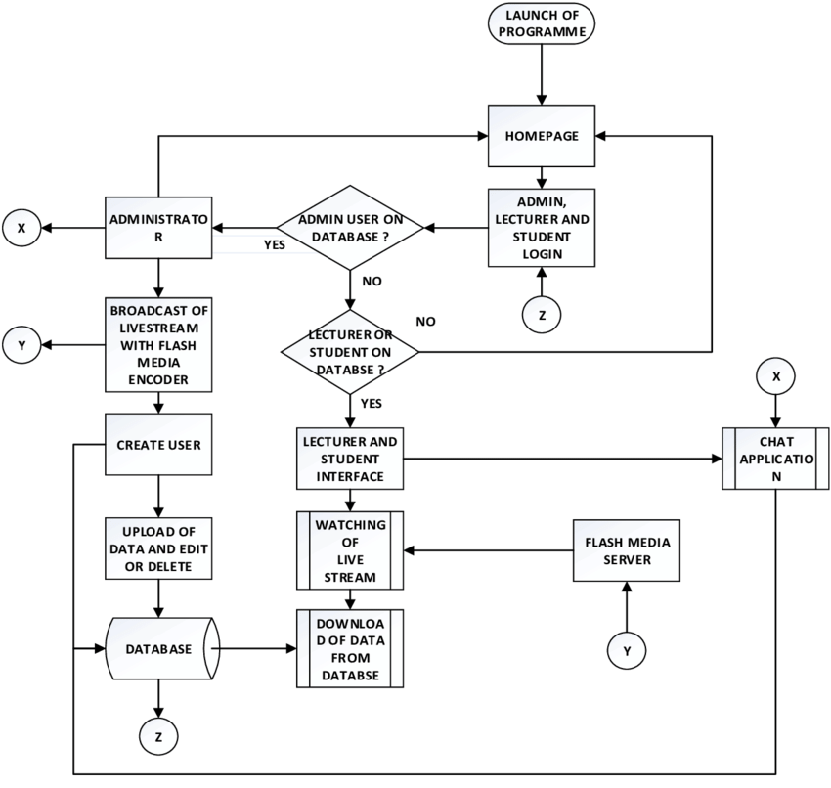

Design and Implementation of an E-learning Platform Using N-Tier Architecture
The paper outlines a comprehensive implementation of an e-learning platform built on a multi-tier (N-Tier) architecture. This architectural model segments the system into three primary layers: the Presentation Layer (User Interface), the Business Logic Layer (BLL), and the Data Access Layer (DAL). This layered approach ensures a clean separation of responsibilities, which contributes to the overall scalability, maintainability, and security of the application.
The technological stack integrates various front-end, back-end, and database components. On the front end, the user interface is developed using a combination of ASP.NET, HTML, CSS, and JavaScript, with AJAX incorporated to enable asynchronous communication, thereby enhancing the responsiveness of the platform. The business logic is managed in the backend using C# within the ASP.NET framework. This layer includes web services such as SOAP and REST to facilitate communication between different parts of the system. Additionally, class libraries in the form of DLLs are used to encapsulate reusable business logic components.
The Data Access Layer (DAL) is responsible for interacting with the database. It utilizes Microsoft SQL Server (2012 or newer) to store and manage data related to users, courses, and learning content. Data operations such as retrieval, insertion, and updating are handled using ADO.NET and executed via stored procedures to improve performance and enhance security.
The platform follows a structured N-Tier model, which isolates the presentation, business, and data layers. Security is a key focus, with role-based authentication and authorization mechanisms ensuring that only authorized users (such as Admins, Lecturers, Students, or Guests) can access specific parts of the system. Additionally, all user inputs undergo validation before processing to prevent security vulnerabilities.
The system’s workflow begins with users accessing the platform, where their roles determine their level of access. After authentication, administrators and lecturers can use the interface to manage courses and upload educational materials. The business logic layer processes these operations, which are then executed through the data access layer via secure queries and stored procedures. Students are able to browse available courses, enroll, and access resources including PDFs, videos, and audio lectures. The platform also supports live classes, assessments, and assignment submissions. System maintenance is managed by administrators, who oversee user accounts, course content, and overall system performance.
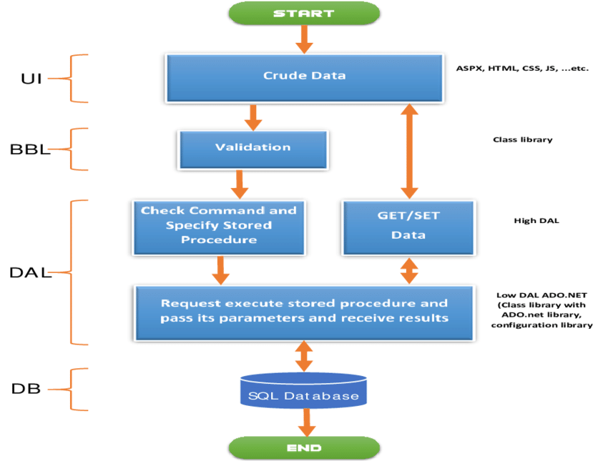

Experience of Using a New e-Learning Tool in Architectural Studies
The research conducted by P. Xiberta et al. (2022) introduces SAPIENS, a specialized e-learning platform designed to meet the educational needs of architecture students, particularly during the transition to online learning brought about by the COVID-19 pandemic. SAPIENS is built as a web-based solution, allowing users to access the platform directly via standard web browsers without requiring any additional software installations. One of its key features is its responsive design, which ensures compatibility across various devices such as desktops, tablets, and smartphones, thereby providing users with a consistent and optimized interface regardless of screen size. To accommodate a global audience, the platform supports multiple languages, allowing users to interact in their preferred language.
Given the visual nature of architectural education, SAPIENS includes a variety of image-based learning tools that help educators create and share visually rich content and assessments. This approach not only enhances the educational experience but also supports effective teaching practices within the discipline. Additionally, the platform is equipped with automatic correction features, which streamline the assessment process by offering instant feedback on quizzes and assignments, thereby reducing the workload on instructors.
The front-end of the application is constructed using HTML5 for semantic page structuring, CSS3 for modern and adaptive styling, and JavaScript for implementing interactive functionalities. Advanced user interface development is facilitated through modern JavaScript frameworks or libraries such as React.js or Angular, which support modular design and efficient state management. On the back end, programming languages like Python or Node.js handle server-side logic and data operations. These languages are supported by robust web frameworks such as Django or Express.js, which offer scalable and maintainable solutions for back-end development.
For data management, the platform utilizes relational databases like PostgreSQL or NoSQL alternatives such as MongoDB, ensuring efficient handling of user data, course content, and system operations. Integration between the front-end and back-end components is achieved using RESTful APIs or GraphQL, which also support connections with third-party tools and services. Additional development tools and practices are incorporated to enhance the platform's quality and performance. Responsive design frameworks such as Bootstrap or Foundation are employed to maintain a consistent user experience across devices. Version control systems like Git support collaborative coding and efficient project management, while cloud-based deployment services such as Heroku, AWS, or DigitalOcean provide the necessary infrastructure for hosting, scaling, and optimizing the platform’s performance.
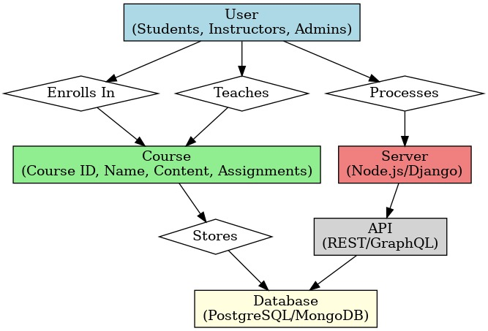

Blending Digital And Face-to-Face Interaction Using a Co-Located Social Media App In Class
In their 2018 paper, Blending Digital and Face-to-Face Interaction Using a Co-Located Social Media App in Class, S. Govaerts and colleagues introduced SpeakUp, a co-located social media application designed to enhance classroom engagement, particularly in large lecture environments. The app blends digital and in-person communication by allowing students to anonymously post and rate messages in temporary, location-specific chat rooms. This approach encourages participation from those who may feel hesitant to speak up during traditional classroom discussions. SpeakUp functions as a web-based application, ensuring cross-device compatibility through standard web browsers without requiring installation. It is also optimized for mobile use, allowing students to interact using smartphones or tablets during class sessions.
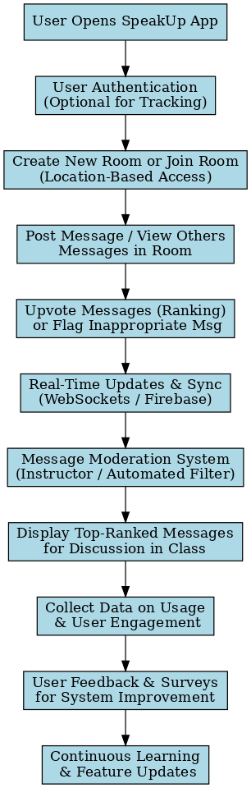

A core feature of the app is anonymous posting, which lowers the threshold for participation by removing identity-based pressure. To enhance the visibility of key contributions, SpeakUp integrates a message rating system that allows users to upvote posts, helping highlight the most relevant questions or comments for classroom discussion. Technically, the application supports real-time communication, with messages and updates reflected instantly, creating a dynamic and responsive environment. The platform also restricts access to chat rooms based on physical location, ensuring that discussions remain contextually relevant to the ongoing session.
Beyond real-time interaction, the app incorporates data collection mechanisms to monitor participation levels, message activity, and interaction trends. Additionally, user feedback is gathered through integrated survey tools to guide further development and improvements. The effectiveness of SpeakUp was evaluated through 11 case studies involving over 2,000 students, offering insight into real-world classroom implementation. The typical user experience involves accessing the platform via mobile or desktop, joining or creating a chat room tied to their current location, and participating in discussions by posting and upvoting messages. The system dynamically handles message updates and rankings in real time, with instructors or automated tools managing moderation. Finally, the platform gathers usage metrics and user feedback to refine its features and user experience over time.

Enter the Virtual Classroom
The virtual classroom system is structured into several interconnected phases, each integrating specific technologies to facilitate smooth user interaction, efficient content delivery, and effective assessments. The initial phase involves selecting a platform and managing user access. Learning Management Systems (LMS) such as Moodle, Blackboard, or Google Classroom serve as the foundation, while authentication is managed using OAuth, Single Sign-On (SSO), or Firebase Authentication. User data is securely handled and stored in databases like MySQL, PostgreSQL, or MongoDB to ensure a personalized experience. Once authenticated, users proceed to course selection and enrollment. Here, dynamic user interfaces are built using frontend frameworks like React.js, Angular, or Vue.js, and backend functionality is supported by technologies such as Node.js (with Express), Django, or Flask. Course data and enrollment status are retrieved and stored in databases like Firebase Firestore or PostgreSQL.
The next phase involves initiating virtual classroom sessions. Instructors use video conferencing platforms such as Zoom SDK, Microsoft Teams API, or Jitsi Meet to schedule classes. Real-time communication is enabled using WebRTC and Socket.io, while notifications are delivered via Firebase Cloud Messaging (FCM) or Twilio to inform students about upcoming sessions. During class participation, live video and audio interactions are facilitated using tools like OBS Studio and WebRTC. Chat features, collaboration via Firebase’s real-time database, and engagement tools such as Kahoot polls or Zoom breakout rooms promote interactive learning environments.
Content delivery and lecture management are supported through multimedia platforms like AWS S3, Google Drive, or YouTube API, allowing instructors to share educational materials in diverse formats. Digital whiteboards such as Miro, MURAL, and Microsoft Whiteboard, along with presentation tools like Google Slides, Prezi, or PowerPoint Live, are used to enhance lectures. Sessions are often recorded using built-in features and stored in cloud storage platforms like AWS S3 or Google Drive. Media processing tools like FFmpeg and YouTube API are employed to ensure smooth playback, while metadata is maintained using MongoDB or Firebase Firestore for efficient retrieval.
For student evaluation, the system integrates tools such as Google Forms, Moodle Quiz Module for auto-grading, and plagiarism detection solutions like Turnitin API or Grammarly API. Advanced AI models such as OpenAI’s GPT-4 can be leveraged for automated feedback and intelligent grading. Finally, feedback collection is facilitated through platforms like Google Forms, Typeform, or Microsoft Forms. Natural Language Processing (NLP) libraries such as NLTK and SpaCy help perform sentiment analysis on student feedback, and analytical tools like Power BI, Google Analytics, or Matplotlib are used to visualize data and guide continuous improvements to the virtual classroom experience
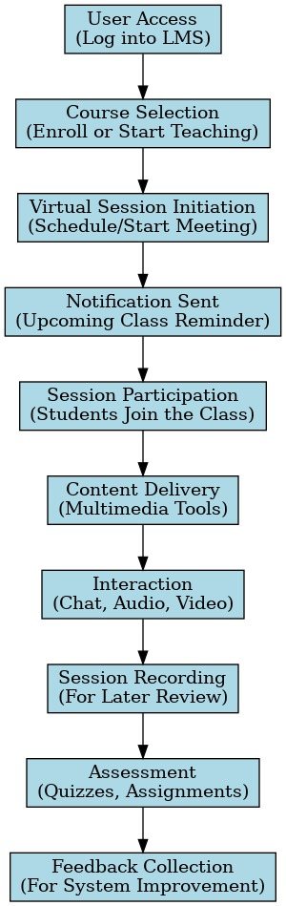

E-Learning-Based Cloud Computing Environment: A Systematic Review, Challenges, and Opportunities
The paper titled "E-Learning-Based Cloud Computing Environment: A Systematic Review, Challenges, and Opportunities" by H. Eljak et al. offers an extensive review of how cloud computing is being integrated into e-learning environments. By systematically analyzing 154 scientific publications, the study sheds light on the current trends, obstacles, and potential developments in this field. Although the paper does not delve into a particular technological implementation or provide a detailed methodology, it offers valuable observations regarding architectural frameworks, software tools, system performance, and security aspects. Among the major areas of focus, architectural concerns dominate the literature, making up about 27% of the studies. This is followed by general e-learning topics (21%), software solutions (19%), and system performance metrics (18%).
One of the significant findings of the study is the extensive adoption of public cloud models in e-learning systems, representing approximately 74% of the cases. In terms of service models, Software as a Service (SaaS) is the most commonly employed, accounting for 18% of the reviewed implementations, while Infrastructure as a Service (IaaS) and Platform as a Service (PaaS) follow at 17% and 10% respectively. The paper also identifies key challenges in implementing e-learning within cloud-based environments, particularly those related to data security, privacy concerns, and the demand for advanced technical infrastructure.
Although a specific implementation strategy is not outlined in the paper, a generalized method for developing cloud-based e-learning platforms can be described. The process typically begins with a thorough requirement analysis, which includes discussions with stakeholders such as educators, students, and technical teams to define the platform’s core functionalities—like user authentication, content management, and support for multimedia content. Following this, the platform design phase focuses on selecting an appropriate architecture, often favoring scalable models like microservices, and determining the most suitable cloud service model—SaaS, PaaS, or IaaS—based on customization and control needs.
The choice of technology stack is another critical component. Frontend development generally involves modern web technologies such as HTML5, CSS3, and JavaScript frameworks like React.js or Angular. On the backend, developers might opt for frameworks like Node.js, Django, or Ruby on Rails. Data storage is managed using relational or NoSQL databases such as MySQL, PostgreSQL, or MongoDB. Major cloud providers such as AWS, Microsoft Azure, or Google Cloud offer the infrastructure and services needed to support the system.
During the implementation phase, developers focus on building and integrating the application with cloud services, followed by comprehensive testing—including unit, integration, and user acceptance tests—to ensure stability and functionality. Deployment is often managed using CI/CD (Continuous Integration and Continuous Deployment) pipelines for smoother updates and rollouts. Security and compliance are also critical, requiring robust measures like data encryption and role-based access controls to protect sensitive information, along with ensuring compliance with educational regulations. Finally, maintaining the system involves ongoing performance monitoring and regular updates to introduce new features and enhance security, ensuring a reliable and user-friendly learning experience over time.
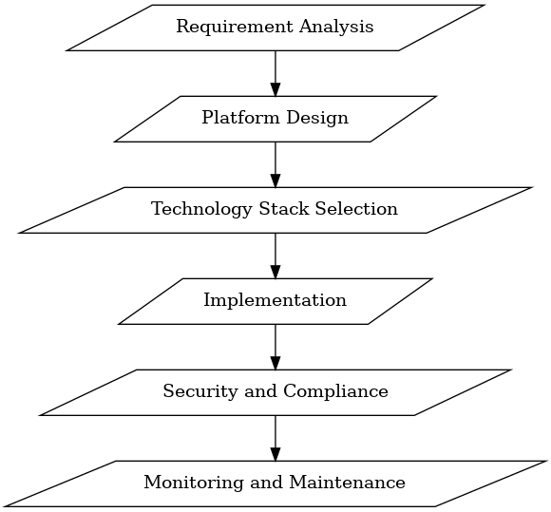

proposed methodology

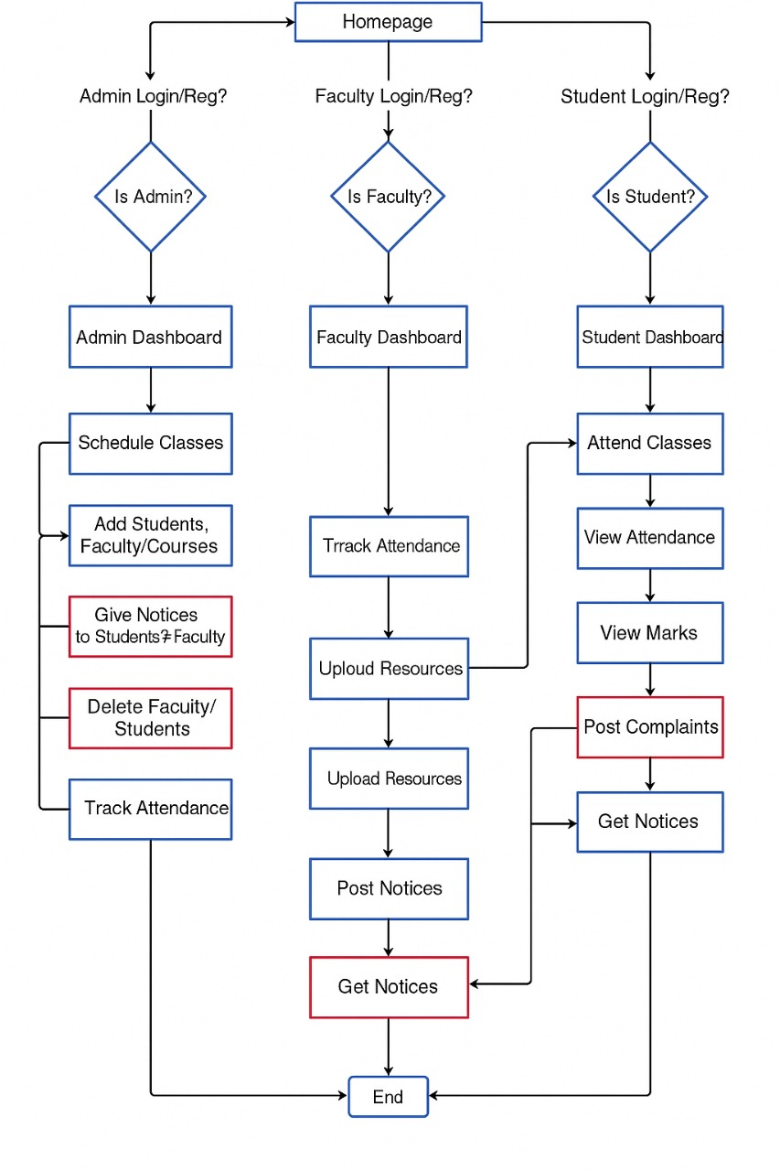
The proposed methodology of your MERN School Management System is structured to provide role-based functionalities for Admins, Faculty, and Students, ensuring efficient and secure management of school operations. The system begins from a common homepage where users can log in or register based on their roles. Admins have access to a dashboard that allows them to schedule classes, add or delete students and faculty, assign courses, and issue notices. Faculty members, upon login, are directed to a dashboard where they can track student attendance, upload academic resources, and post important notices. Students, on the other hand, are provided with a dashboard that enables them to attend classes, view attendance records, check their marks, post complaints, and receive notices. The workflow promotes seamless interaction among all users, enhances transparency, and streamlines school activities through a centralized and accessible digital platform.

implementation
Homepage serves as the entry point of the School Management System, offering a user-friendly and visually structured interface that sets the tone for the entire application. When users open the application, they are first greeted by this page, which provides clear navigation options to log in based on their roles—Admin, Teacher, or Student. It is designed using React.js, ensuring a responsive layout that works well across various devices and screen sizes
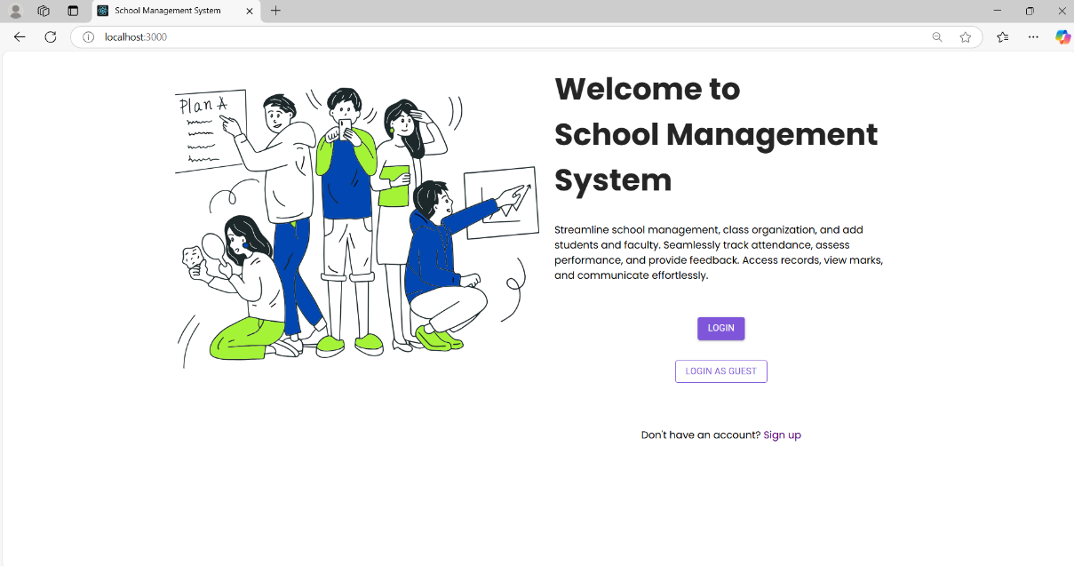

Login and Signup features are essential for secure access to the School Management System. The Signup page allows new users (Admins, Teachers, or Students) to register by entering their details, which are stored in MongoDB through the backend built with Node.js and Express.js. Passwords are safely hashed using bcrypt.js for security.
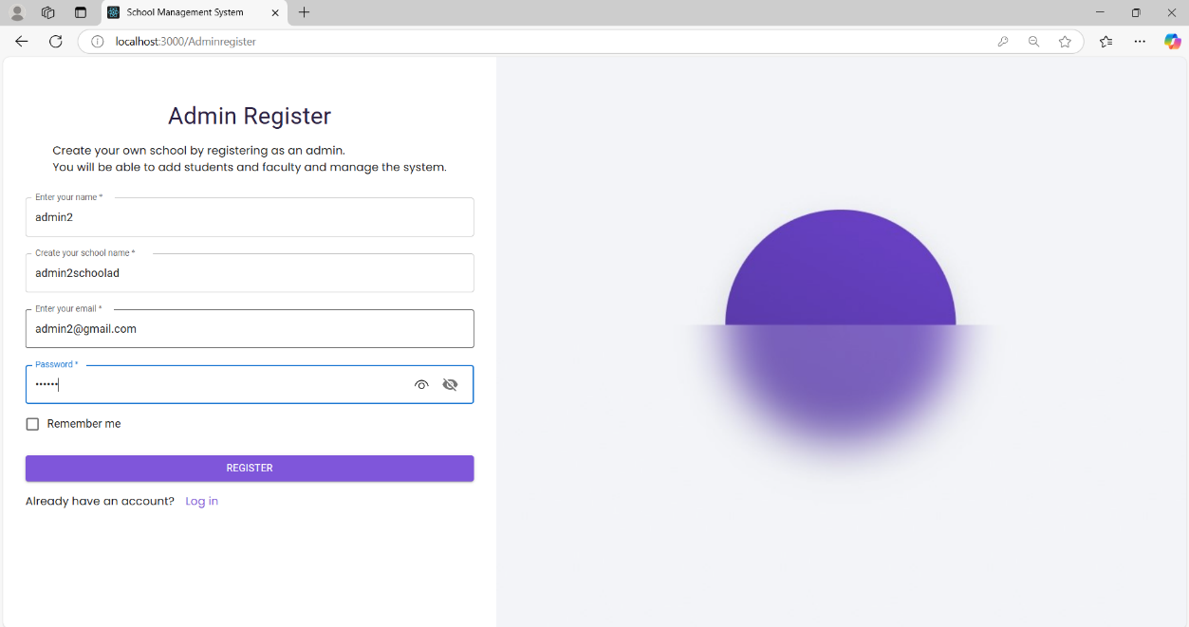

Login page verifies user credentials and uses JSON Web Tokens (JWT) for authentication. Once logged in, users are redirected to their specific dashboards using React Router, based on their role. All data is sent and received through Axios API calls, ensuring smooth communication between frontend and backend. This system ensures that only authorized users can access role-specific features.

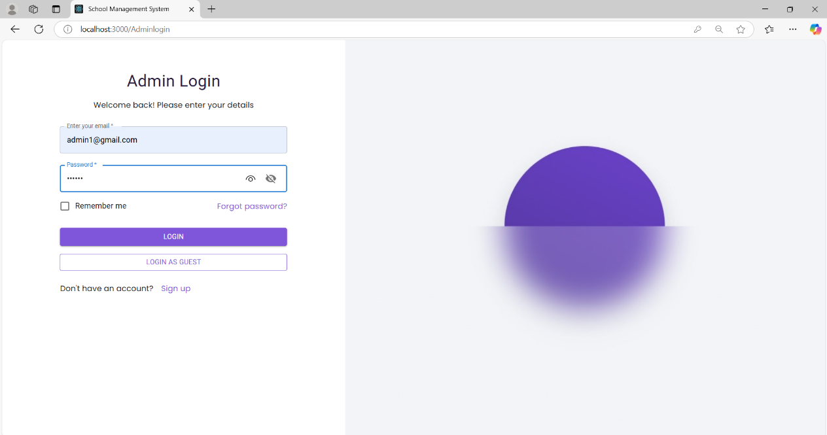

Admin Dashboard is a central control panel designed exclusively for administrators to manage and oversee the core activities of the School Management System. After successful login, admins are redirected to this dashboard, which presents a clean and organized layout built using React.js with efficient routing handled by React Router. The dashboard provides intuitive navigation options, allowing the admin to perform a variety of tasks with ease and precision.
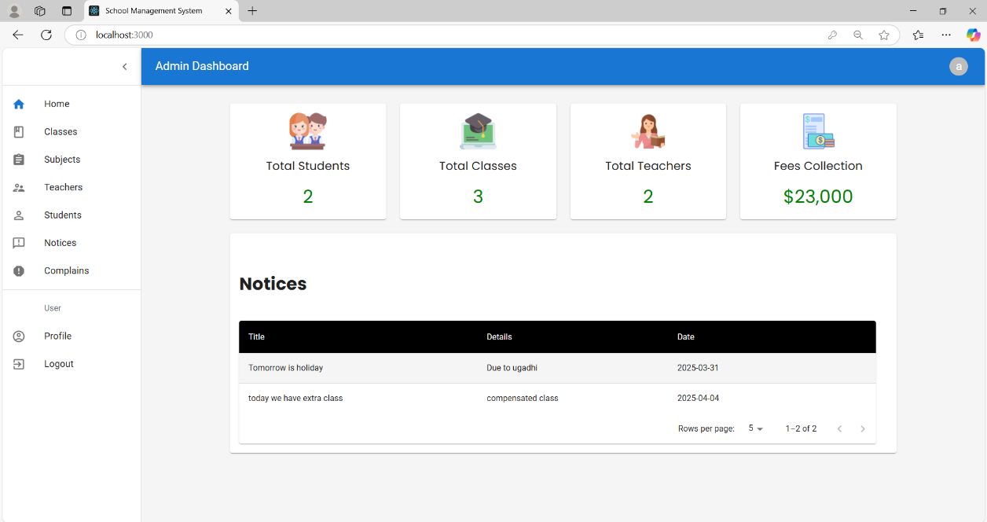

Teacher dashboard allows teachers to track attendance, assess student performance, and provide feedback. It features performance visualization through charts, direct communication with students, and an easy way to manage class activities. Teachers can mark attendance, input grades, and interact with students, enhancing the teaching and learning experience.
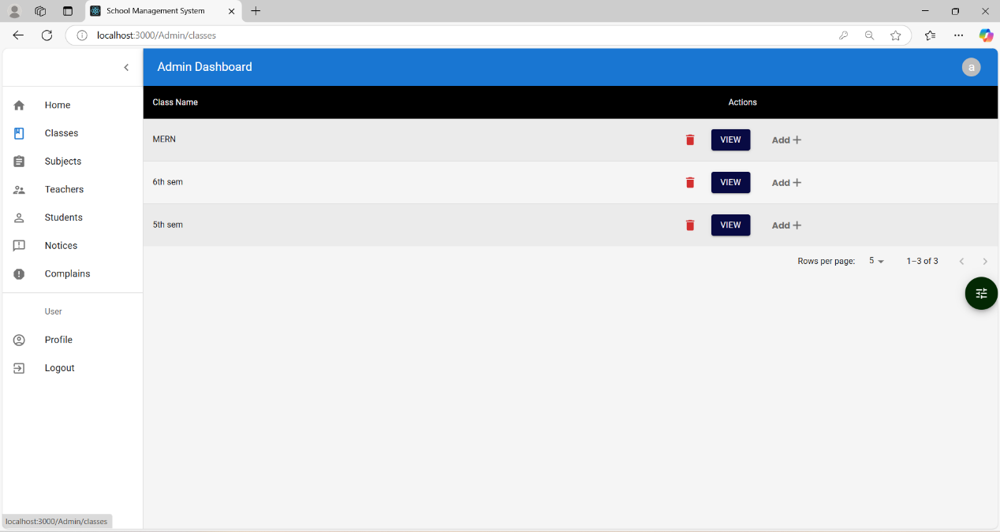
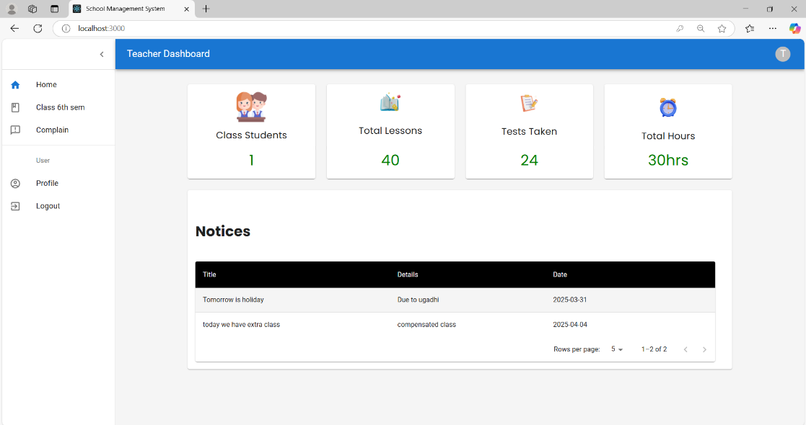

Student dashboard allows students to view their personal details, class schedules, attendance records, and academic performance. They can check marks, receive feedback from teachers, and track their progress over time. The dashboard also provides notifications and announcements for smooth communication. It offers a user-friendly interface for students to stay informed and organized.
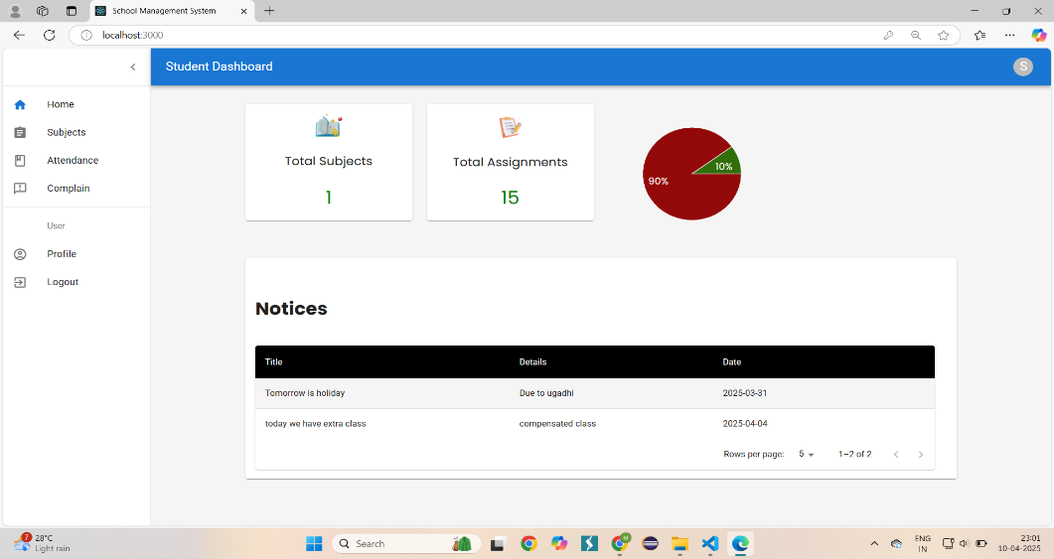

Logout feature allows students to securely exit their account from the system. It ensures that their session ends properly, protecting personal and academic information from unauthorized access.
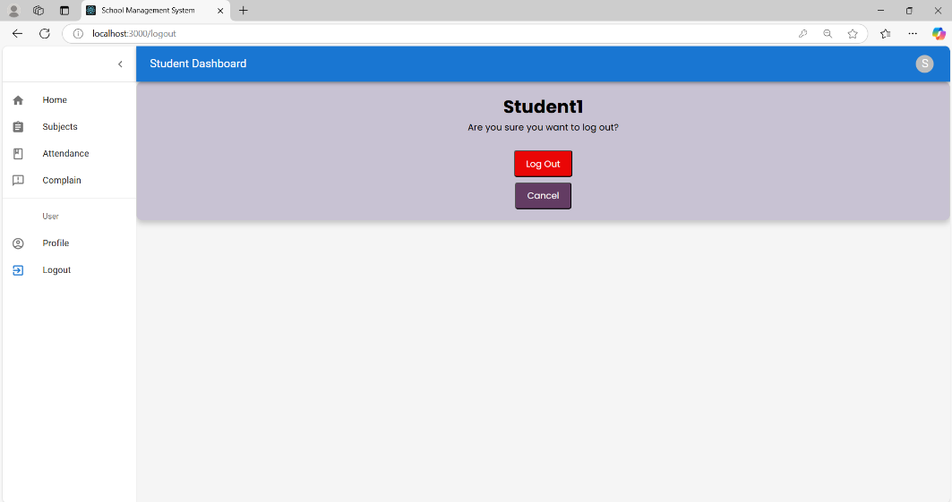

Admin Dashboard allows the admin to post important notices that are instantly visible to teachers and students. It also provides access to view and manage complaints submitted by users, helping maintain smooth communication.
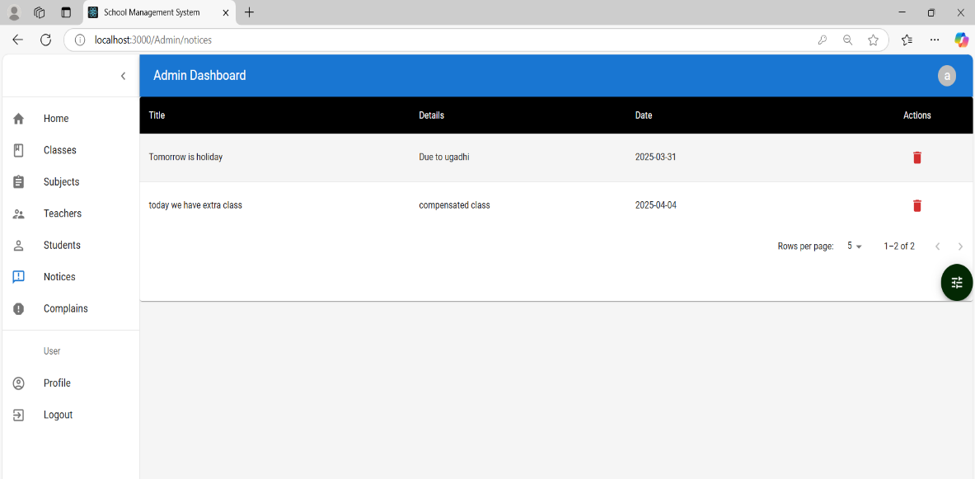

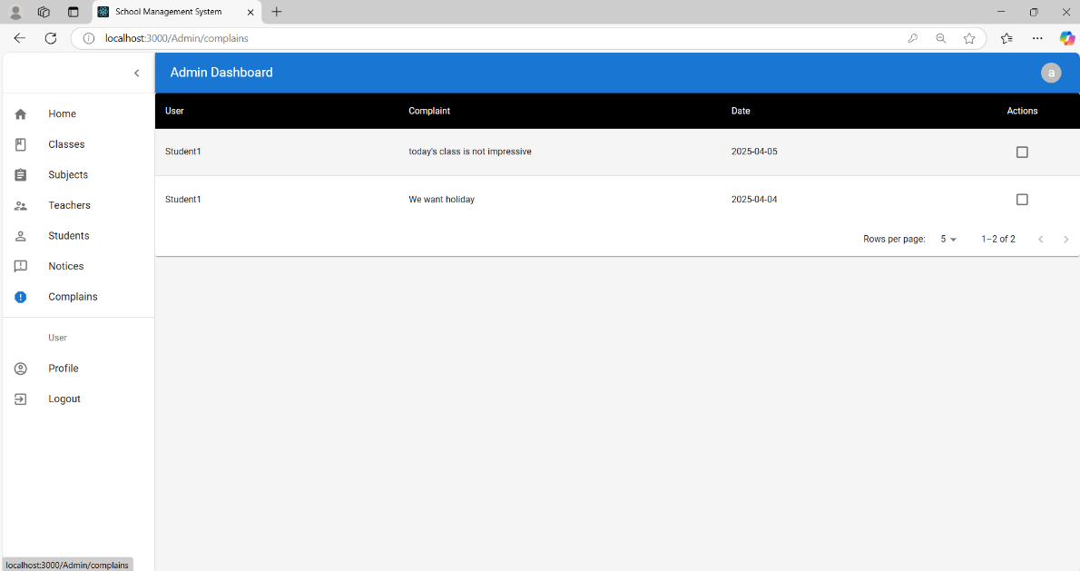

V1. RESULTS AND DISCUSSIONS

The system efficiently supports role-based access for Admins, Teachers, and Students, ensuring that each user is provided with relevant functionalities tailored to their roles, such as managing attendance, tracking performance, and handling feedback. This approach not only enhances the system’s security by restricting unauthorized access to specific features but also streamlines the user experience. The interface is designed to be clean, intuitive, and user-friendly, allowing users to navigate and operate the system without confusion or the need for extensive training. Real-time updates, such as recording attendance or entering marks, work smoothly and confirm the strong synchronization between the frontend and backend components. The backend, powered by MongoDB, enables fast and efficient storage and retrieval of large volumes of student and institutional data, supporting the system's performance and scalability. Furthermore, the successful online deployment of the project demonstrates its stability, reliability, and readiness for real-world usage, while also opening opportunities for future enhancements and integration of additional features as needed.

conclusion

The MERN Academic Management System is a full-stack web application built using MongoDB, Express.js, React.js, and Node.js. It provides a structured and efficient way to manage school operations by offering different roles—Admin, Teacher, and Student—with dedicated access and features. The system includes modules for attendance, performance tracking, student feedback, and more, making it easier for school staff to manage day-to-day tasks. Although the project is not yet deployed, it is well-structured and ready for future deployment and scaling. With further enhancements like fee management, parent login, and notifications, it can become a complete solution for modern school management needs.

References
- K. S. Cheung and J. Lam, "A Framework for Developing E-learning Solutions," 2009 Fifth International Conference on Semantics, Knowledge and Grid, Zhuhai, 2009, pp. 294-297, doi: 10.1109/SKG.2009.44.
- S. Govaerts, A. Holzer, B. Kocher, A. Vozniuk, B. Garbinato and D. Gillet, "Blending Digital and Face-to-Face Interaction Using a Co-Located Social Media App in Class," in IEEE Transactions on Learning Technologies, vol. 11, no. 4, pp. 478-492, 1 Oct.-Dec. 2018, doi: 10.1109/TLT.2018.2856804
- T. Shen, S. -S. Huang, D. Li, Z. Lu, F. -Y. Wang and H. Huang, "VirtualClassroom: A Lecturer-Centered Consumer-Grade Immersive Teaching System in Cyber–Physical–Social Space," in IEEE Transactions on Systems, Man, and Cybernetics: Systems, vol. 53, no. 6, pp. 3501-3513, June 2023, doi: 10.1109/TSMC.2022.3228270.
- B. Alojaiman, "Toward Selection of Trustworthy and Efficient E-Learning Platform," in IEEE Access, vol. 9, pp. 133889-133901, 2021, doi: 10.1109/ACCESS.2021.3114150
- P. Xiberta, S. Thió-Henestrosa, J. Fontàs and I. Boada, "The Experience of Using a New e-Learning Tool in Architectural Studies," in IEEE Access, vol. 10, pp. 87008-87021, 2022, doi: 10.1109/ACCESS.2022.3198977 .
- P. E. Brewer, A. Mitchell, R. Sanders, P. Wallace and D. D. Wood, "Teaching and Learning in Cross-Disciplinary Virtual Teams," in IEEE Transactions on Professional Communication, vol. 58, no. 2, pp. 208-229, June 2015, doi: 10.1109/TPC.2015.2429973
- J. F. Flórez Marulanda, "Student Satisfaction Pilot Experience With Synchronous Classroom Live Streaming Styles During the COVID-19 Pandemic," in IEEE Revista Iberoamericana de Tecnologias del Aprendizaje, vol. 17, no. 3, pp. 301-306, Aug. 2022, doi: 10.1109/RITA.2022.3191285 .
- R. Kawamura et al., "Detecting Drowsy Learners at the Wheel of e-Learning Platforms With Multimodal Learning Analytics," in IEEE Access, vol. 9, pp. 115165-115174, 2021, doi: 10.1109/ACCESS.2021.3104805
- A. Gordillo, D. López-Fernández and E. Tovar, "Comparing the Effectiveness of Video-Based Learning and Game-Based Learning Using Teacher-Authored Video Games for Online Software Engineering Education," in IEEE Transactions on Education, vol. 65, no. 4, pp. 524-532, Nov. 2022, doi: 10.1109/TE.2022.3142688
- P. Ganesan, S. Kumar Jagatheesaperumal, I. Gobhinath, V. Venkatraman, S. N. Gaftandzhieva and R. Z. Doneva, "Deep Learning-Based Interactive Dashboard for Enhancing Online Classroom Experience Through Student Emotion Analysis," in IEEE Access, vol. 12, pp. 91140-91153, 2024, doi: 10.1109/ACCESS.2024.3421282
- P. D. Jagger, "Enter the Virtual Classroom," in ITNOW, vol. 55, no. 2, pp. 46-47, June 2013, doi: 10.1093/itnow/bwt021.
- H. Eljak et al., "E-Learning-Based Cloud Computing Environment: A Systematic Review, Challenges, and Opportunities," in IEEE Access, vol. 12, pp. 7329-7355, 2024, doi: 10.1109/ACCESS.2023.3339250.
- S. Alserhan, T. M. Alqahtani, N. Yahaya, W. M. Al-Rahmi and H. Abuhassna, "Personal Learning Environments: Modeling Students’ Self-Regulation Enhancement Through a Learning Management System Platform," in IEEE Access, vol. 11, pp. 5464-5482, 2023, doi: 10.1109/ACCESS.2023.3236504.
- Y. Shen, G. Yu, X. Liu, W. Zhang, W. Zhang and C. Zhao, "Resource Sharing and Allocation Excitation Mechanism of Teaching Cloud Platform Research," in IEEE Access, vol. 12, pp. 155218-155233, 2024, doi: 10.1109/ACCESS.2024.3482729
- A. García-Holgado, A. Vázquez-Ingelmo, F. J. García-Peñalvo and M. R. Conde, "Improvement of Learning Outcomes in Software Engineering: Active Methodologies Supported Through the Virtual Campus," in IEEE Revista Iberoamericana de Tecnologias del Aprendizaje, vol. 16, no. 2, pp. 143-153, May 2021, doi: 10.1109/RITA.2021.3089926

