## ABSTRACT

ChemicalOxygenDemand(COD)andBiologicalOxygenDemand(BOD)playimportantrole indetermining the qualityofwastewater. Hence it is necessaryto calculate COD and BODof water before setting up of wastewater treatment plant. Algae has been used for decades for variouspurposes.Itisoneoftheimportantcharacteristicsistonitrogen,phosphorusetc.,which are harmful for drinking and other purposes but theyact as food for algae. Thus in this study COD and BOD analysis is done for sterilized and non-sterilized wastewater after and before treatingitwithalgaeininversefluidizationunderaerobiccondition,fordifferenttimeinterval and found that percentage reduction in COD and BOD for sterilized wastewater gives greater value than non-sterilized water the reason for this difference being the decrease in the competition between algae and other micro-organism which are present in raw wastewater. And COD % reduction is 65-70 % and BOD % reduction is 68.75- 70.5%.

Keywords:ChlorellaScenedesmus,COD,BOD,wastewater,inversefluidizationunit

## CHAPTER-1



## INTRODUCTION

* 1. Inverse fluidization process

Among many conventional processes available for wastewater treatment, inverse fluidisation process, which is a three-phase fluidisation process, has been widely used for many applications such as hydro-treating and conversion of heavy petroleum and synthetic, crystallization, food processing, biomedical engineering, methanol production, treatment of municipal sewage wastewater, and similarly many processes. Some of the benefits which one’s process can gain if this unit is used are: easy to handle, less consumption of power, low space requirement, less chemical waste, and eco-friendly as it does not produce any chemical as its waste after the process. Indeed, the most significant feature of it is high efficiency as compared to the other conventional fluidization processes.

The name inverse fluidisation comes from the direction of flow of liquid and gas which depends upon the density of the particle. Here, the liquid is fed continuously from the top using a pump if it is a continuous process, and gas is released from using a sparger from the bottom after it has been compressed in a compressor. Thus, it makes the process a counter-current flow process. In this counter-current flow process, the density of the particle is lesser than that of the liquid, which is in a continuous phase.

With the rapid growth in population and industrialization, it is leading to the depletion of natural resources and causing major environmental problems such as water pollution, soil pollution, etc. The environmental problem which is of our concern is water pollution, which is mainly caused due to the discharge of heavy metals from steel, dairy, and fertilizer industries and nitrogen, phosphorus, sulphides, and chlorides. Due to the rapid use of nitrogen in fertilizer industries, an excessive amount of it may cause several health-related problems and causes eutrophication and acidification of water bodies. To overcome this process, there are various methods which have been used for decades, but the question that arises is: which process is more economical and offers numerous benefits over others.

* 1. Why inverse fluidization technique and not the conventional one?



* + - The bio film thickness which grows very fast on the surface of the solid particle ,if provided proper conditions. Sometimes it also happens that bio film thicknes increases so much that it causes bloom and proper mixing and growth of film is degraded. Thus some new particle have to be added to provide new surface to the biomass from time to time. The advantage of IFBR lies here that it controls bio film thickness in a very narrow range.
    - Due to power failure sometimes it needs to start the fluidization process from the beginning itself but with the IFBR this problem is almost sorted out as we can re- fluidize the process.
    - The growth of microorganism is very faster as seen from the literature survey due to high mass transfer rate.
    - Carry over of particleis minimized due to low particle or solid attrition.
  1. Type of Algae and why it is used in waste water treatment process.
     + Algae involves a process which is very similar to the green plants, and the most common process in plants is photosynthesis. Algae absorbs sunlight, which is a source of carbon dioxide for it, and converts it into oxygen, and photosynthesis takes place through chlorophyll present in it. Algae size varies from single-cell to branched size of visible length. Some of the algae which grow in wastewater are Chlorella sp., Spirulina sp., Microactinium sp., and some more.
     + The treatment of wastewater can be achieved by biodegradation of it using bacteria or algae. Biodegradation converts organic matter into smaller molecules which requires oxygen for the process. And the supply of oxygen is tedious and costly. Thus, it is better to use natural abundance sources of oxygen, which can give a lot of benefits apart from biodegradation. Algae absorbs various compounds and nutrients such as nitrogen, phosphorus, and metals required for its growth**.**

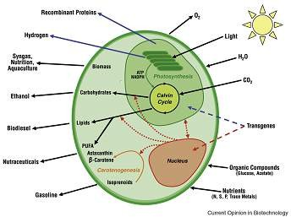

Figure-1: Structure of algae and basics compounds produced by algae (Source: Oilgae.com)

In all other conventional method for wastewater treatment which does not uses algae the treatment process produces lots of sludge which eventually goes to off-site for its disposal and maintaining sludge which is diurnal and seasonal is a costly process. Some of the benefits which is prominent in today’s century are reduction in green-house -gases and production of useful products from end product which is a highly rich nutrient containing algae itself and can further be used for production of bio fuel and diet supplementary. Aeration is an energy intensive process and accounts for 45-70 % of total energy cost of treatment plant. Algae consumes CO2 in a larger amount than it is released during the process. ChlorellaScenedesmus is one among the fastest growing genus of single celled green algae, includes 14%-22% of lipid, 51%-58% of protein, 12%-17% of carbohydrates, and 4%-5% of nucleic acid.

Algae can act as a bio-filter for nutrient laden, CO2 laden, and can convert low oxygen water into highly rich oxygen water. Thus any wild algae can be grown in the area where the wastewater is reserved. End use of algae can be in production of biodiesel or biofuel as compared to soyseed (60-100gallons), coconut (230 gallons), and palmoil(500 gallons) can produce 5000 or more gallons per acre of area.

* 1. Biological Oxygen Demand (BOD) and Chemical Oxygen Demand (COD)



COD test is used to measure the amount of organic compounds in water. In other words, we can say that it is the amount of oxygen required to chemically oxidize the pollutants. The applicable range of COD is 3–900 mg/ml.

BOD test is used to determine the amount of oxygen required by the microorganisms to break the organic material present in the sample at a particular temperature over a specific period of time. Generally, the time taken for the test is 5 days at a temperature of 20 degrees Centigrade. It is also a principal test which predicts the biodegradability of any water or wastewater sample.

The efficiency of wastewater is measured by measuring the effluent BOD and influent BOD of the sample taken. Any effluent to be discharged into the water should have BOD less than 30 mg/ml.

COD value is always greater than BOD value. It is found from the research that the COD values for domestic and industrial wastewater is about 2.5 times the BOD value. The ratio of BOD to COD, if greater than 0.8, then it is considered that the water is highly polluted and amenable to biological treatment.

**1.5 Objective of the Process**

Inverse fluidization is a process where solids, whose density is lower than the continuous liquid phase, are fluidized by a downward flow of the liquid. This is the opposite of conventional fluidization, where a fluid (liquid or gas) is passed upwards through the solids. Inverse fluidization is used in various applications, including wastewater treatment and biochemical engineering.

In inverse fluidization, a bed of solid particles is suspended in a continuous liquid phase due to a downward flow of the liquid. This is possible because the solid particles are lighter than the liquid, causing them to float.

How it works:

As the liquid flows downwards through the particle bed, it creates a drag force on the particles, causing them to move and become suspended in the fluid. The velocity of the downward flow needs to be sufficient to overcome the buoyant force of the particles and fluidize the bed.

**Advantages of Inverse Fluidization:**

Inverse fluidization offers several advantages over conventional fluidization, including:

High mass transfer rates: The downward flow can enhance the contact between the liquid and solids, leading to faster mass transfer.

Minimum solids attrition: The downward flow can reduce the wear and tear on the solid particles compared to upward flow.

Low energy consumption: Lower fluid velocities are often needed to fluidize the particles, resulting in less energy usage.

**Applications:**

Inverse fluidization is particularly useful in wastewater treatment, where it can be used to treat both anaerobic and aerobic wastewater. It can also be used in biochemical engineering for various processes involving liquid-solid interactions.

**Hydrodynamic characteristics:**

The hydrodynamics of inverse fluidization, such as pressure drop, bed expansion, and minimum fluidization velocity, are often studied to optimize the process for different applications. These parameters are influenced by factors like flow rate, bed height, and particle properties.

**Types of inverse Fluidization Process:**

 Inverse fluidization can be categorized into two main types: two-phase and three-phase.

**Two-phase inverse fluidization:**

This type involves a liquid and a solid phase, with the solids being suspended by the downward flow of the liquid.

It's used in various applications, including wastewater treatment, where it can be an efficient system for biological wastewater treatment.

Examples include using a liquid-solid inverse fluidized bed (LSIFB) with low-density particles like PE (polyethylene) or activated carbon suspended in a liquid phase.

**Three-phase inverse fluidization:**

This type involves a liquid, solid, and gas phase.

It can be achieved by using upward gas flow to drive the downward liquid flow, which then fluidizes the low-density solid particles.

This is often used in bubble-induced inverse fluidized beds (BIFBs) where gas bubbles rising in a liquid cause a downward liquid flow, suspending the solids.

Examples include bubble-induced three-phase inverse fluidized beds (BIFBs) where low-density particles are fluidized by a downward liquid flow induced by rising gas bubbles.

**Other considerations:**

In some inverse fluidized beds, the solid particles may have biofilm on their surface, which can affect the minimum fluidization velocity.

The hydrodynamic characteristics of inverse fluidized beds, such as bed expansion and pressure drop, can be studied to optimize their operation.

The flow regimes in inverse fluidized beds can include fixed bed, initial fluidization, complete fluidization, and circulating fluidization, similar to conventional fluidized beds.

**Inverse fluidization for biomedical waste:**

Biomedical waste is the one which are generated in hospitals and health care facilities during diagnosis and treatment of either human beings or animals. These wastes may be either in the form of solid or liquid. The liquid waste generated from a health care facility is usually of type: infectious waste containing blood and body fluids, laboratory wastes, etc.; chemically hazardous waste such as formaldehyde, mercury, solvents, radioactive isotopes, etc.; pharmaceutical liquid waste of discarded/unused/expiry date medicines; photographic chemicals, etc Of these liquid waste, pharmaceutical liquid wastes account for the largest volume of waste produced by hospitals.

The pharmaceutical based liquid biomedical wastewater contains organic or inorganic solids and microbial contaminants which can be measured by the BOD and COD tests. Most of the hospitals have effluent treatment plant facility which involves primary, secondary and tertiary treatment processes. Most of the existing systems and technologies being used in handling liquid biomedical waste are failing to address the problem of effective management of liquid waste. Treatment of biomedical pharmaceutical wastewater by inverse fluidized biofilm reactors is one of the promising technologies where it overcomes all the limitations of all other conventional reactors.

Inverse bio-fluidization is a technique which utilizes low density bio-particles. Fluidization can take place either by upward co-current flow of both gas and liquid phase or by downward movement of liquid and upward countercurrent movement of gas phase. In the first case, fluidization is done by the upward flow of gas which makes the bed of particles to expand downwards and in the second case, fluidization is achieved by downward flow of liquid phase. When the liquid flow is not sufficient to fluidize the particles, inverse fluidization can also be achieved by upward flow of gas. Inverse fluidized bed biofilm reactor (IFBBR) can easily maintain the thickness of biofilm inside the reactor by particle-particle collision and particle-wall collision than conventional fluidized bed biofilm reactor (FBBR) . IFBBR has greater contact between gas-liquid phases, lesser mass transfer resistance, larger surface area for bioparticles, rapid formation of biofilm over support particles and hence have higher biodegradation efficiency for the waste-water treatment processes. Hence, IFBBR can effectively be used in the bio-treatment of pharmaceutical biomedical wastewater due to its high energy performance, low pressure drop, high gas hold up and high heat and mass transfer rates. Many researchers have studied the hydrodynamic characteristics of fluid flow in inverse fluidized bed reactor and studied the optimal operational parameters with respect to air velocity, gas hold up, bed volume, aspect ratio, etc.

Still studies are very limited in comparing the flow dynamics and biodegradation effects of pharmaceutical biomedical wastewater in IFBBR. Analyzing the mixing characteristics of the fluid in the treatment system plays a vital role as it affects both the efficiency of the treatment process and the hydrodynamic behavior of the reactor. Studying the hydrodynamic behavior of the liquid flow helps to determine the residence time and distribution of fluid flow inside the reactor.

Good mixing promotes the degradation rate making the reactor system to approach ideal state. In order to achieve a good fluidized reactor design, it is important to study the flow characteristics of the fluid inside the reactor. To overcome the limitation occurred in the real reactors, it is essential to design a reactor with less non-ideal effects such as short-circuiting, dead zones, etc. These non-ideal defects lower the performance of the reactor in either pilot plant or industrial scale.

All these defects in the flow dynamics can be identified by evaluating the residence time distribution and there by the degree of dispersion of the flow elements inside the inverse fluidized bed reactor.

In this research work, IFBBR performance was evaluated for treating liquid biomedical pharmaceutical wastewater by studying the flow dynamics of the fluid during the biodegradation process. The flow characterization inside the reactor was done by performing residence time distribution studies with various volume ratios of settled bed height to reactor working volume (Vb/Vr) and different superficial velocities (Ug) such as: for (i) Vb/Vr = 0.10, Ug = 0.089 m/s, 0.095 m/s and 0.099 m/s (ii) Vb/Vr = 0.20, Ug = 0.216 m/s, 0.220 m/s and 0.224 m/s (iii) Vb/Vr = 0.30, Ug = 0.274 m/s, 0.278 m/s and 0.281 m/s. The study revealed that the flow behaviour of IFBBR approached plug flow condition for (Vb/Vr) ratio of 0.20 with Ug of 0.220 m/s showing higher plug flow index and lower dispersion value compared to all others. The results were validated by carrying out degradation experiments in IFBBR using with same ratios of (Vb/Vr) and superficial velocities and reported the reductions in COD, TDS, TSS during the process of wastewater treatment. Thus, present study has been attempted to investigate the flow dynamic behavior of IFBBR and to compare with the experimental validation for the treatment of liquid biomedical pharmaceutical wastewater in the reactor.

**Objective of Inverse Fluidization in Waste water Treatment:**

The main objective of inverse fluidization in wastewater treatment is to enhance biological wastewater treatment by controlling excess biomass and ensuring efficient mass transfer. It achieves this by utilizing low-density bioparticles that are fluidized downwards, unlike traditional fluidized bed reactors where fluidization is upward. This downward fluidization promotes better biofilm formation, facilitates solid-liquid separation, and improves overall treatment efficiency.

**Biomass Control:**

In conventional fluidized bed reactors, excessive biomass growth can lead to bioparticle washout. Inverse fluidization helps control this by using low-density particles that are fluidized downwards, preventing the buildup of excessive biomass.

**Improved Mass Transfer:**

The downward fluidization in inverse fluidization creates a more efficient mass transfer between the liquid and solid phases, enhancing the rate of pollutant removal.

**Biofilm Formation:**

The collisions between particles and reactor walls in inverse fluidization promote biofilm formation on the bioparticles, which are crucial for biological wastewater treatment.

**Solid-Liquid Separation:**

The downward flow in inverse fluidization can also facilitate the separation of solid particles from the liquid, improving the clarity of the treated wastewater.

**Enhanced Treatment Efficiency:**

Overall, inverse fluidization leads to better pollutant removal rates, reduced energy consumption, and improved treatment efficiency compared to conventional fluidized bed reactors.

## CHAPTER-2



LITERATURESURVEY

1. **Chan et al in 2013** worked on heavy metal uptake by three types of algae Chlorella sp., Spirulina sp., and other algae found in wastewaters of industries. They used untreated and autoclaved effluents as a substrate and observed that microalgae removed up to 81.7% of copper and 94.1 % of zinc and also found that higher heavy metal removal is obtained in autoclaved effluents because the presence of microbes in untreated effluents put negative impact on the removal efficiency.
2. **Deviram et al in 2011** used the microbial mats for the study using different species of algae such as Ulvasp., Cladophorasp. And Chlorella sp. And observed COD and BOD in three different types of process free cell process, batch process and continuous process and found that better results were developed in continuous process with 52.1(COD) and 50.8(BOD) along with changes in dissolved oxygen (DO) and pH*.*
3. **Kimetal.in2010** studied the capability of Chlorella vulgaris to remove nitrogen in the form of ammonia and ammonium ion from local wastewater. The waste water effluent leaving the plant was found to include high concentrations of nitrogen (7.7± 0.19 mg/L) (ammonia (NH3) and ammonium ion (NH4+)) and total inorganic carbon (58.6±0.28 mg/L) at pH 7, and to be suitable for growing Chlorellavulgaris. When Chlorellavulgaris was cultivated in a batch mode under a closed system, half of the nitrogen concentration was dramatically removed in 48 h after a 24h lag-phase period.
4. **Kothari et al in 2012** studied the physical and chemical parameters of dairy wastewater quality such as nitrates, sulphides, phosphates, chlorides and hardness.They founded that nitrogen and phosphate removal is achieved to be 49 % and 83% respectively.
5. Sheek Hetalin in 2012 investigated the treatment efficiency of wastewater by using single or mixed cultures of cyanobacteria, and they found that single culture was better than mixed culture. The lower efficiency of mixed culture is due to competition between cultures for nutrients and also found that organic matter removal (COD) is between 20–57.1%.
6. **Sokol et al. in 2009** performed the wastewater treatment process in an inverse fluidization unit using biomass and observed the changes in COD value with time (in hours) for various ratios of settled bed volume to the reactor volume (Vb/VR) and air velocity (Ug).
7. **Sriram et al in 2012** highlighted a review on the current scenario in the cultivation of microalgae in wastewater for nutrient removal.
8. **Yadavalli et al. in 2013** studied the removal of organic content and nutrients from dairy effluents by chlorella sp., and euglena sp. In both open and closed systems and found that NH4, +N was reduced to 96% by Chlorella sp. than Euglena sp.
9. **Zhigang et al. in 2013** studied the effect of light-emitting diode’s wavelength and intensities on the microalgae biological wastewater treatment system. They found that the optimum light intensity is 2000 μmol/m²·s and experimental illumination time is 120 h. And the species was successfully able to purify under this optimum condition.
10. **Azzam, A.M., Heikel, Y.A., 1989** studied the effect of Molasses stillage 1s a by product of the sugar cane Industry in Egypt. Candida utilis and Paecilomyces variotii were used separately and in a mixed culture for treatment of this still age and biomass production. A two steps aerobic batch process has been adopted. The distillery waste water was treated with C. utilis 1n the first step and with P.. variotii 1n the second step, which was carried out on the supernatant from the first step.
11. **Bajhaiya, A.K., Ziehe, J., If, T.D., Pittman, J.K., 2017** Microalgae are diverse microorganisms that are of interest as novel sources of metabolites for various industrial, nutritional, and pharmaceutical applications. Recent studies have demonstrated transcriptional engineering of some metabolic pathways. We propose here that transcriptional engineering could be a viable means to manipulate the biosynthesis of specific high-value metabolic products.

12 **Barrocal,V.M.,García-Cubero M.T., González-Benito2010** Cultivation of [Spirulina maxima](https://www.sciencedirect.com/topics/agricultural-and-biological-sciences/spirulina-maxima) in media containing [vinasse](https://www.sciencedirect.com/topics/earth-and-planetary-sciences/vinasse) from [beet molasses](https://www.sciencedirect.com/topics/engineering/beet-molasses) fermentation has been studied in both batch cultures and a photobioreactor. The results obtained in [batch tests](https://www.sciencedirect.com/topics/engineering/batch-test) showed that *S. maxima* was able to grow in Schlösser media containing up to 5 g/L of [vinasse](https://www.sciencedirect.com/topics/engineering/vinasse) or alkaline diluted [vinasse](https://www.sciencedirect.com/topics/agricultural-and-biological-sciences/vinasse) (5 g/L). [Biomass concentrations](https://www.sciencedirect.com/topics/engineering/biomass-concentration) ranging from 3.5 and 4.8 g/L, productivities from 0.15 to 0.24 (g/L d) and specific growth rates about 0.1 d−1 were found.

13 **Ashokkumar, V., Chen, W.H., Kamyab, H., Kumar, G., Al-Muhtaseb, A.H., Ngamcharussrivichai, C., 2019** This study demonstrated the utilization of municipal sewage for high biomass production at large scale and achieved highest biomass yield of 46.3 tons and the lipid yield of 13.7 metric tons per acre in a year. The extracted crude lipid was analyzed for [biodiesel](https://www.sciencedirect.com/topics/materials-science/biodiesel) production, and the yield attained was 92.5 wt% with respect to initial lipid weight. Furthermore, the lipid extracted residue obtained from two different algal biomass such as *Chlorella* sp. and *Sargassum* sp. were explored for biochar production through a slow [pyrolysis](https://www.sciencedirect.com/topics/chemical-engineering/pyrolysis) technique at 400 °C.

**14 Bezuneh, T.T., 2016** Distilleries are one of the most polluting industries generating large volume of wastewater having a serious [environmental](https://www.omicsonline.org/environmental-analytical-chemistry.php) concern. Distillery effluent is characterized by dark brown color, acidic pH, high temperature, low dissolved oxygen (DO), high biochemical oxygen demand (BOD) and chemical oxygen demand (COD). Distillery wastewater disposed onto the environment prior to treatment is hazardous and leads to soil and water pollution. The dark brown color of distillery effluent causes reduction of sunlight penetration, decreased photosynthetic activity and dissolved oxygen concentration in rivers, lakes and lagoons, hence becomes detrimental to aquatic life.

**15 Sci. Technol. 44, 2010** Algae are an attractive source of biomass energy since they do not compete with food crops and have higher energy yields per area than terrestrial crops. In spite of these advantages, algae cultivation has not yet been compared with conventional crops from a life cycle perspective. In this work, the impacts associated with algae production were determined using a stochastic life cycle model and compared with switchgrass, canola, and corn farming. The results indicate that these conventional crops have lower environmental impacts than algae in energy use, greenhouse gas emissions, and water regardless of cultivation location.

**16 Cuellar-Bermudez, S.P., Garcia-Perez, J.S., Rittmann, B.E., Parra-Saldivar, R., 2015** One of the most important industrial activities related to the greenhouse gases emissions is the cement manufacturing process, which produces large amounts of [carbon dioxide](https://www.sciencedirect.com/topics/chemical-engineering/carbon-dioxide) (CO2). Only in 2010, 8% of CO2 global emissions were due to cement industry. In this work, the use of CO2 released by the cement sector is described as potential gas for [microalgae](https://www.sciencedirect.com/topics/agricultural-and-biological-sciences/microalga) culture since their biofixation efficiency is higher than terrestrial plants. Therefore, transformation of polluting gas fluxes into new and valuable products is feasible.

17 **Afreen, S., Shamsi, T.N., Baig, M.A., Ahmad, N., Fatima, S., Qureshi, M.I., Hassan, M.I., Fatma, T., 2017** A novel extracellular laccase enzyme produced from *Spirulina platensis* CFTRI was purified by ultrafiltration, cold acetone precipitation, anion exchange and size exclusion chromatography with 51.5% recovery and 5.8 purification fold. The purified laccase was a monomeric protein with molecular mass of ~66 kDa that was confirmed by zymogram analysis and peptide mass fingerprinting. The optimum pH and temperature of the enzyme activity was found at 3.0 and 30°C using ABTS as substrate but the enzyme was quite stable at high temperature and alkaline pH.

18 **Kumar, R. and A. Sahoo, “Heavy metal biosorption using algae”** Nowadays, numerous synthetic and semisynthetic chemicals are extensively produced and consequently used worldwide for many different purposes, such as pharmaceuticals, pesticides, hydrocarbons with aromatic rings (known as polycyclic aromatic hydrocarbons, PAHs), multi-substituted biphenyls with halogens (such as polychlorinated biphenyls, PCBs), and many other toxic and persistent chemical species. The presence of the aforementioned xenobiotic substances not only in various environmental matrices (water, air, and soil), but also in biological tissues (organisms) as well as in several compartments of raw or processed food (of fruit, vegetal, and animal origin), has raised global scientific concerns regarding their potential toxicity towards non target organisms including humans.

19  **Ali, S.S., Kornaros, M., Manni, A., Sun, J., El-Shanshoury, A.E.R.R., Kenawy, E.R., Khalil, M.A., 2020** Catalpa sawdust (CSW) is a promising biomass-based biofuel. However, the complex lignocellulosic structure limits its efficient utilization in biorefinery applications. It is even more so when chlorophenols (CPs), highly toxic organic substances widely used as wood preservatives, are present. Hence, it is crucial to develop effective and eco-friendly approaches to attain deconstruction of [lignocellulose](https://www.sciencedirect.com/topics/pharmacology-toxicology-and-pharmaceutical-science/lignocellulose) and chlorophenols simultaneously as well as to improve methane (CH4) production efficiently.

20

## CHAPTER-3

## MATERIAL AND METHODS

# Materials Required:

1. Algae

-Chlorella Scenedesmus and local algae from pond

-Quantity used:250ml

Table-1:Nutrients required for growing Chlorella Scenedesmus

|  |  |  |
| --- | --- | --- |
| S.No. | Compounds Name | Quantityperlitre |
| 1. | Fog’s Medium   * Magnesium sulphate hepta-hydrate (MgSO4.7H2O) * Dipotassium hydrogen phosphate (K2HPO4) * Micro nutrients solution * Calcium chloride hydrated (CaCl2. H2O) * Fe-EDTA solution * Distilled water * Agar (Difco) | 0.2g  0.2g  1ml 0.1g  5.0ml  1.0L  12.0g |
| 2. | Micronutrient solution   * Hydrated Manganese Chloride (MnCl2.4H2O) * Boric Acid (H3BO3) * Zinc sulphate hepta hydrate(ZnSO4.7H2O) * Sodium Molybdate (Na2MoO4.2H2O) * Copper Sulphate penta-hydrate (CuSO4.5H2O) * Distilled water | 181.0mg  286.0mg  22.0mg  39.0mg  8.0 mg 100.0ml |
| 3. | Fe-EDTA  In hot water 745.0 mg of Na2 EDTA was dissolved and then  557.0 mg of FeSO4.7H2O was added. The solution was boiled for few minutes and the volume was made to 100.0 ml. |  |



1. Wastewater from Rourkela Steel plant

- Quantity used: 1 litre

Table-2: Composition of waste water obtained from Rourkela Steel plant, Rourkela, Orissa

|  |  |
| --- | --- |
| **Component** | **Amount in ppm** |
| Phenol | 70-72 |
| Sulphate | 76.8 |
| Chloride | 192-223 |
| Nitrite | 0.2-0.34 |
| Ammonia | 116.8 |
| Total Kjeldah l Nitrogen (organic nitrogen) | 246.6 |

1. Polypropylene balls

-Density: 910kg/m3

1. Glass-wares

# Procedure for growing algae:

1. Petridishes containing growth medium with 1–1.5% agar medium was prepared. And the agar medium should be ½ to 2/3 the depth of dish.
2. 1-2 drops of algae sample from the slant was placed near the periphery of the agar. The wire loop was sterilized using burner.
3. The petriplate was covered and sealed with parafilm. Then it was incubated in a low light at constant temperature.
4. The colonies were selected which are free of other organism for further isolation process.
5. The sample was removed using sterile wire loop and placed in a drop of sterile culture media on a glass slide.
6. Then the species was checked microscopically for whether the species is uni-algal or not.
7. The streaking procedure was repeated with a single colony and again allowed to colonies to develop.
8. The second streaking is done to reduce the possibility of bacterial contamination and species containing more than one algal species.
9. Then the selected colonies were transferred to the liquid nutrient medium and allowed to grow in an incubator shaker for temperature maintenance of around 20–25C̊. The alternative for maintenance of temperature is by keeping it in an AC room and for stirring keep it in a magnetic stirrer at low rpm.
10. After 5 -10 days growth is observed in a beaker of liquid medium and the growth substantially increases but pH and nutrient level in a medium must be checked and maintained.

Figure2:

Algae culture after transferring its colonies from petri plate

Figure3:

Algae after 10 days growth

Figure4 :

Algae after 1 months growth

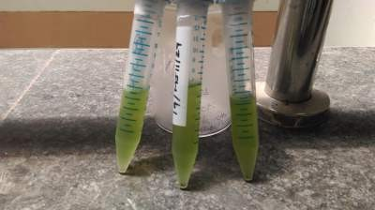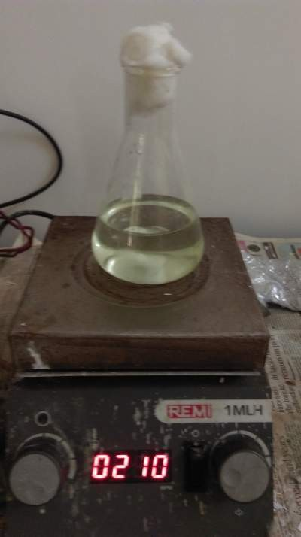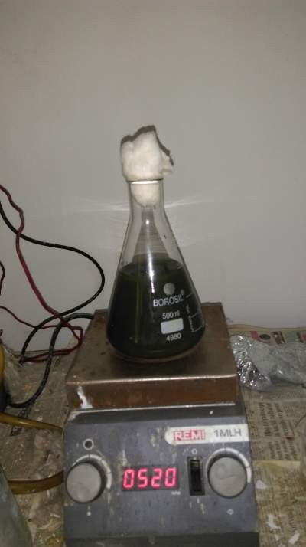

# Experimentation

Inverse Fluidisation Unit

* + 1. Designof IFBR:
       1. The unit consist of long perplexed glass tube–
* Height=1.240m
* Diameter= 10cm
* Wall thickness= 3mm

1.Centrifugal pump

* Power0.5HP
* Head= 14ft
  + - 1. Calibrated Rota meter

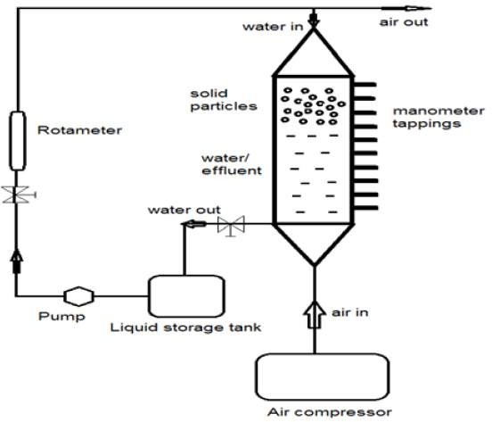

* For water= 0-100LPM
* For Gas=0-200m3/hr
  + - 1. Manometer
* Number = 4
* Length = 1m
  + - 1. Circular pith distributed plate
      2. Conical heads (at the top and bottom)
* Apex angle=60̊
* Inner diameter=10cm
* Height=30 cm

Figure– 5: Outline sketch of the IFBR unit

# Experimental Procedure for operation in IFBR:

* + - 1. The column was loaded with some amount of polypropylene balls.
      2. Fill the liquid storage tank with10 litre of water and mix waste water around 200ml to it. Then add 250 ml of algae sample to the tank and mix it very well.
      3. Pump the water from liquid storage tank to the vertical unit with the liquid flow rate of 10LPM and till certain height is reached in the bed measured from the scales tick to it on the outer surface.
      4. The pressure drop across the test section is measured with the help of manometer connected across the bed.

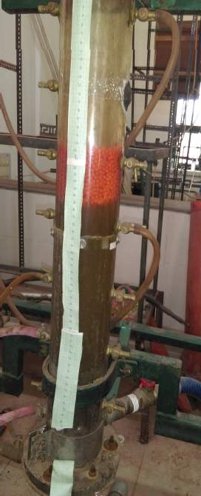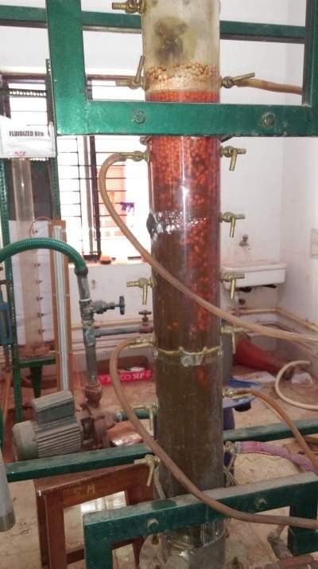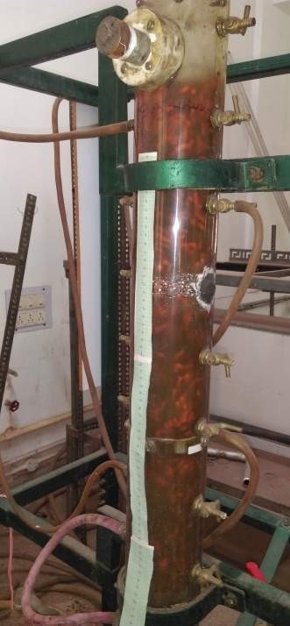

* + - 1. The flow rate of the gas is slowly increased to bring the bed into the state of mixing , as mixing provides better growth of microbes due to continuous interaction with each other .
      2. The bed continuously kept under light of intensity which is required for the growth of algae.
      3. The mixture of wastewater, algae and nutrients was kept in fluidization for hours and sample was taken for COD and BOD analysis after 6hr, 24hr, 32hr, 48hr, 96hr, 120hr.
      4. Two wastewater samples were taken untreated and sterilized wastewater for the treatment.

(a) Fixed bed (b) Onset of fluidization (c)Turbulent fluidization Figure -6: Experimental set up for hydrodynamic studies

* 1. **COD Analysis**

# Materials required**:**

* + - 1. Potassium dichromate
      2. Concentrated sulphuric acid
      3. Ferro in indicator
      4. Ferrous Ammonium Sulphate(FAS)
      5. Mercuric sulphate
      6. Distilled water
      7. Glassware’s( conical flask, beaker, heater, stirrer, measuring cylinder )

# Procedure:

* + - 1. Potassium Dichromate (K2Cr2O7) solution
         * 12.259 g of K2Cr2O7 was dissolved in 1000ml distilled water.
      2. FAS solution
         * 98 g of FAS is dissolved in distilled water and then 20ml of Conc.Sulphuric acid was added and the solution is diluted to 1000ml

Molarity of FAS can be calculated as

VolumeofK2Cr2O7inml∗0.25 Volume of FAS used in ml

Molarity FAS=

- (1)

* + - 1. Now 20ml of the sample was taken in a 500ml flask



* + - 1. Then10ml of K2Cr2O7 was added to it.
      2. 30 ml of conc.H2SO4 was added slowly and cautiously.
      3. 0.4gm of Mercuric sulphate was then added then the sample was heated at 120̊C for

Around 10min.

* + - 1. Then the sample was cooled to room temperature
      2. The solution was diluted to two times its volume with distilled water.
      3. Fill the burette with FAS solution and add 2–3 drops of Ferroin indicator to the diluted solution and titrate it against FAS solution.
      4. The end point of the titration is determined by sharp colour change from blue green to reddish brown which persisted for 1 min.
      5. Similarly the waste water sterilized and untreated were also titrated to check the COD before process.

# Sample Calculation



Molarity of FAS=0.1M

* For Waste water before sterilization

COD=(A-B)*M*8*1000/Volume of the sample used (2)

(Source-APHA standard method for examination of water and waste water,20thedition, Method 5220C)

Where;

A=Volume of FAS for blank = 13.4

B=Volume of FAS for sample=3.0 M = molarity of FAS solution = 0.1 M Volume of the sample used = 20ml COD = 416 mg/ml

* For waste water after sterilization COD measured = 380 mg/ml

### BOD Analysis

# Materials Required:

* + - 1. Potassium hydrogen phosphate (KH2PO4)
      2. Di-potassium hydrogen phosphate (K2HPO4)
      3. Di-sodium hydrogen phosphate (Na2HPO4.7H2O)
      4. Ammonium chloride (NH4Cl)
      5. Magnesium sulphate hepta-hydrate (MgSO4.7H2O)
      6. Calcium chloride (CaCl2)
      7. Ferric Chloride (FeCl3.6H2O)
      8. Sodium sulphite (Na2SO3)
      9. Distilled water
      10. Glassware’s(test tubes, beaker, conical flask)

# Procedure for preparation of solution:

* + - 1. Phosphate buffer solution

8.5g of KH2PO4 ,21.75g of K2HPO4, 33.4 g of Na2HPO4.7H2O and 1.7g of NH4Cl



Was dissolved in 500 ml distilled water and diluted it to 1000ml. Make sure that the pH is adjusted to 7.2.

* + - 1. Magnesium Sulphate solution

22.5g MgSO4.7H2O was dissolved in distilled water and dilute it to1litre.

* + - 1. Calcium Chloride solution

27.5g of CaCl2 was dissolved in 1000 ml distilled water.

* + - 1. Ferric Chloride solution

0.25g of Ferric chloride solution was dissolved in 1000ml of distilled water.

* + - 1. Sodium sulphite solution

1.575g of sodium sulphite is dissolved in 1000ml of distilled water.

NOTE:All the solutions must be prepared daily because they are not stable.

# Procedure:

* + - 1. The 20 ml sample was kept in a 1 litre flask
      2. Then 1 ml magnesium sulphite solution, 1 ml calcium chloride solution, and 1 ml ferric chloride solution were added to 1 litre of distilled water.
      3. If the solutions are acidic or alkaline, then they must be neutralised before use, and this can be done by adding sodium thio-sulphate solution to destroy residual chlorine.
      4. The sample must be diluted as follows:
* Strong water =0.1,0.5,or 1%
* Settled domestic sewage= 1,2.5,or5%
* Treated effluents =5, 12.5or25%
* River water= 25to100%
  + - 1. The sample was diluted with distilled water and mixed nicely.
      2. The diluted sample was the taken in two BOD bottles.
      3. The DO of diluted water and diluted waste water was taken immediately.
      4. The other two bottles were kept at 20degreeC for 3–5 days and the sample was incubated.
      5. After 3 days the DO of sample was taken.
      6. The procedure for DO analysis follows this.

# Procedure for Dissolved oxygen analysis:



* + - 1. The two BOD bottles were taken and 2ml ofalkali–iodize-azidewasaddedtoitbelow the liquid level.
      2. Thebottle must completelyairtight sothat no airshouldenter intoit.Thesamplewas mixed properly. The presence of oxygen is indicated by the appearance brownish – orange cloud of precipitate or floc. This floc can be disappeared byturning the bottle upside down and allowing it to settle.
      3. Then2mlofsulphuricacidwasaddedtoitviaapipetteholdingitjustabovethesurface ofthesample. Againthebottleisinvertedaftercarefullypluggingthestopperintoitto dissolve the floc. Then the sample is kept for 8 hr.
      4. Filled the burettewithsodiumthiosulfate solution.
      5. 2 mlstarchsolutionwasaddedsoa blue colourforms.
      6. The sample was titrated slowly till the end point .And end point is determined whenthe blue colour disappears.
      7. The concentrationofdissolved oxygencan be determined bythe number of millilitres titrantused.Aseachmlofsodiumthio-sulphateaddedequals1mg/ldissolvedoxygen.

# SampleCalculationforBOD

Initial DO of diluted sample, Do= 8.2 DO at the end of 3 day ,D3=6.08 Blank correction, BC = 0.2

Volume of sample diluted ,Vd=500ml Volume of sample taken , Vs =20ml

BOD =(Do–D3-BC)*Vd/Vs (3)

(Source:APHAstandard methodforexaminationofwaterandwastewater,20th edition, Method 5220C)

=(8.2–608-0.2) *500/20

= 48mg/ml



## CHAPTER- 4

## RESULTAND DISCUSSION

* 1. Fornon-sterilizedwastewateraftertreatment withChlorellaScenedesmusat Vb/Vr=0.5 Initial Value of COD before treatment is 416 mg/ml, pH = 6.7

AftertreatmentthepH is8.5 attheendof192 hr

Table–3:VariationofCODwithtimefornon-sterilizedwastewater

|  |  |  |
| --- | --- | --- |
| S.No: | NumberofHours of  operation | CODinmg/ml |
| 1 | 0 | 416 |
| 2 | 6 | 400 |
| 3 | 24 | 346 |
| 4 | 48 | 277 |
| 5 | 72 | 236 |
| 6 | 168 | 149.76 |
| 7 | 192 | 146.6 |

450



400

350

300

250

CODINMG/ML

200

150

100

50

0

0 50 100 150 200

TIMEINHOUR

Figure–7:VariationofCODwithtimefornon-sterilizedwastewater



Table-4:BODanalysisofnon-sterilized wastewater

|  |  |  |
| --- | --- | --- |
| S.  No.: | Numberofhours ofoperation | BODinmg/ml |
| 1 | 0 | 48 |
| 2 | 72 | 28 |
| 3 | 144 | 15 |

60



50

40

30

BODIN MG/ML

20

10

0

0 20 40 60 80 100 120 140 160

TIMEINHOURS

Figure-8:BODvstime fornon-sterilizedwastewater



* 1. Forwastewater(sterilized)aftertreatment withChlorellasp.atVb/Vr=0.5 Initial value of pH before treatment is 8.3 and after treatment

AftertreatmentpHwas8.9forthe totaltimedurationof192hours.

Table-5: VariationofCOD withtimeforsterilizedwastewater

|  |  |  |
| --- | --- | --- |
| S.NO | Numberofhoursof  operation | CODinmg/ml |
| 1 | 0 | 380 |
| 2 | 6 | 368 |
| 3 | 24 | 310 |
| 4 | 48 | 246.4 |
| 5 | 72 | 195.4 |
| 6 | 168 | 126 |
| 7 | 192 | 114 |

400



350

300

250

CODINMG/ML

200

150

100

50

0

0 50 100 150 200 250

TIMEINHOURS

Figure–9:CODvstime forsterilized wastewater



Table-6:BODvstimeforsterilized wastewater

|  |  |  |
| --- | --- | --- |
| S.NO. | Numberofhours ofoperation | BODinmg/ml |
| 1 | 0 | 44 |
| 2 | 72 | 23 |
| 3 | 144 | 13 |

50



45

40

35

30

BODIN MG/ML

25

20

15

10

5

0

0 20 40 60 80 100 120 140 160

TIMEINHOUR

Figure-10BODvstimeforsterilized wastewater

### Calculation ofpercentagereduction in CODand BODaftertreating itwithalgae

%ReductioninCODfornon-sterilized wastewater

=[(initialvalueofCOD-finalvalueofCOD)/ initial value of COD] * 100

|  |  |  |  |  |  |  |  |  |  |
| --- | --- | --- | --- | --- | --- | --- | --- | --- | --- |
| % | Reduction | in | COD | | for | sterilized | =  =  = | (416–146.67/416) *100  65%  [(initialvalueofCOD-finalvalue | of |
| wastewater | |  |  |  |  | | COD)/initial valueofCOD]* 100  =((380–114)/380)*100  =70% | |  |
| %Reduction wastewater | | in | BOD | for | non-sterilized | | =[(initialvalueofBOD-finalvalue BOD)/ initial value of BOD] * 100  =((48–15)/48)*100  =68.75% | | of |
| %Reduction wastewater | | in | BOD | for | non-sterilized | | =[(initialvalueofBOD-finalvalue BOD)/ initial value of BOD] * 100  =((44-13)/44)*100  =70.5% | | of |



Table–7:%ReductioninCODandBODofChlorellaScenedesmuswithother speciesof Algae

|  |  |  |  |
| --- | --- | --- | --- |
| S.No. | NameoftheAlgaespecies | %ReductionofBOD | %ReductionofCOD |
| 1 | NostocMuscorum  (Ref. :3) | --- | 20–57.1 |
| 2 | Chlorella.Pyrenoidosa  (Ref. :5) | 92 | 86 |
| 3 | Euglena  (Ref-12 ) | 96 | 80 |
| 4 | Chlorellasp  (Ref–4) | ------ | 50.8 |
| 5 | Chlorella Scenedesmus (Speciesusedforthisproject) | 68.75 | 70 |

### AlgaeIdentification

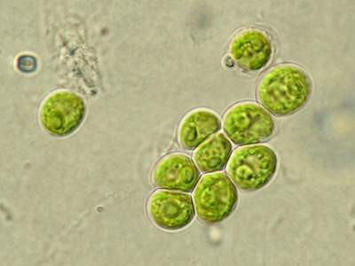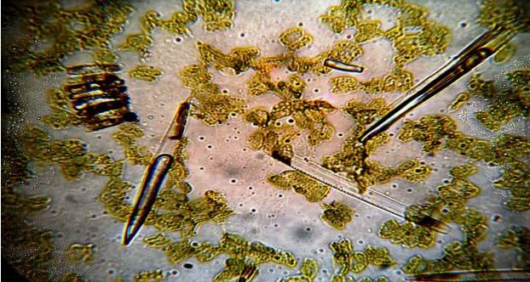

AlgaeName:ChlorellaScenedesmus

Figure-11:Chlorella(Microscopicviewofchlorellaviewedintherangeof10microm)

Figure–12:Scenedesmus(Microscopicviewofchlorellaintherangeof10microm)

## CHAPTER5



## CONCLUSION

COD and BOD analysis of wastewater is one of the basic step which is needed to set up any wastewatertreatment plant and to controllosses tothe sewer system. Manyways ofchemical treating wastewater has been proved to be very expensive and produces harmful end product which isverynecessaryto beavoided intoday’scentury. Thisstudywhich includestreatment ofsteelplant waste water withthe most abundantlyavailable resource i.e., algae showsa new pathwaytoachievetwomajorgoalsofanywastewatertreatmentplantfirstbeingtheeconomy and second being the efficiency in reduction of harmful components present in industrial , domesticormunicipalwastewater.Treatmentininversefluidisationunit isveryeconomicalas itverycheaptoprocure,easytohandleandrequirelowpowertooperateandinadditiontothis using Algae in it for degradationofhazardous components sortsout problems suchas cost of oxygen supply needed for conversion of organic compounds and moreover algae can further beusedasasourceofbiofuelanddiet supplementaryassomeofthespeciesare veryeffective for it. Continuous mixing with the help of solid particles in fluidization unit helps Algae to grow on its surface. Thus, this type of study is necessary before setting up any wastewater treatment plant.

FUTURE WORK:

* + 1. MeasurementoftheCODandBODcontentoftheoutletstreamfromtheinverse fluidization unit by varying parameter such as :
       - Gasflowrate
       - Concentrationofeffluentinwater
       - Differentstrains(Spirulinaandmix)
       - Rationofvolume ofbed andvolume ofthe reactor
    2. Comparingthismethodofusingalgaewithotherbiologicalmethods.
    3. Comparingitwithother conventionalmethodforwastewatertreatment.
    4. Analysingthebio-hydrogenevolutionfrombiomassunderanaerobic condition

## REFERENCES:



1. Chan,A.,HamidrezaSalsali,andEdMcBean,“HeavyMetalRemoval(CopperandZinc) in Secondary Effluent from Wastewater Treatment Plants by Microalgae”,ACS sustainable chemistry and engineering, dx.doi.org/10.1021/sc400289z | ACS Sustainable Chem. Eng. 2014, 2, 130−137.
2. Deviram,GNVS,Pradeep K.V and R GyanaPrasunaetal,“Purification of waste water using Algal species.”,Euro. J. Exp. Bio., 2011, 1(3):216-222.
3. EI-Sheekh,M.M, W.A .El-Shouny, M.E. Osman,“ Treatment of sewage and industrial wastewater effluents by the Cyanobacteria Nostocmuscorum and Anabaena sub- cylinderica*.”*, Journalof WaterChemistryand TechnologyJuly 2014, Volume 36, Issue 4, pp 190-197.
4. Kim,J.,BalaP.Lingaraju,RachaelRheaume,Joo-YoupLee,,KanizF.Siddiqui,“Removal of Ammonia from Wastewater Effluent by Chlorella Vulgaris” , Tsinghua Science And Technology Issnl,1007-0214ll04/16llpp391-396 ,Volume 15, Number 4, August 2010.
5. Kothari,R., Vinayak V. Pathak, Virendra Kumar, D.P. Singh “Experimental study for growth potential of unicellular algae Chlorella pyrenoidosa on dairy waste water: An integrated approach for treatment and biofuel production.” Bio-resource Technology 116 (2012) 466–470.
6. Kumar, R. and A. Sahoo, “Heavy metal biosorption using algae”, B.Tech thesis NIT Rourkela.
7. Lima,TandA.Sahoo,“AerobicBiologicalTreatmentofIndustrialEffluentsUsingInverse Fluidized Bioreactor : Statistical Analysis”, NIT Rourkela, e-thesis.
8. Norström, A. “ Treatments of wastewater using micro-biological process and hydroponic inSweden”,RoyalInstituteofTechnologyDepartmentofBiotechnologyStockholm2005.
9. Roy, G., H.M. Jena ,B.C. Meikap, “Hydrodynamics of three-phase fluidization of a homogeneous ternary mixture of irregular particles.” , Chemical Engineering Science 79 (2012) 210–218.



1. Sokol,W., AlemayehuAmbawb, BelayWoldeyes, “Biologicalwastewatertreatment inthe inverse fluidised bed reactor”, Chemical Engineering Journal150 (2009) 63–68..
2. Sriram,S and R.Sreenivasan.,“Microalgae Cultivation in Wastewater for Nutrient Removal”,J. Algal Biomass Utln. 2012, 3 (2): 9- 13.
3. Yadavalli,R.,C. S. Rao,Ramgopal S. Rao and RavichandraPotumarthi, “Dairy effluent treatment and lipids production by Chlorella pyrenoidosa and Euglena gracilis: Study on open and closed systems”, Asia-Pacific Journal Of Chemical Engineering Asia-Pac. J. Chem. Eng. 2014; 9: 368–373.
4. Afreen, S., Shamsi, T.N., Baig, M.A., Ahmad, N., Fatima, S., Qureshi, M.I., Hassan, M.I., Fatma, T., 2017. A novel multicopper oxidase (laccase) from cyanobacteria: Purification, characterization with potential in the decolorization of anthraquinonic dye. PLoS One 12, 1–20. [http://dx.doi.org/10.](http://dx.doi.org/10.1371/journal.pone.0175144)[1371/journal.pone.0175144](http://dx.doi.org/10.1371/journal.pone.0175144).
5. Ali, S.S., Kornaros, M., Manni, A., Sun, J., El-Shanshoury, A.E.R.R., Kenawy, E.R., Khalil, M.A., 2020. Enhanced anaerobic digestion performance by two artificially constructed microbial consortia capable of woody biomass degradation and chlorophenols detoxification. J. Hazard. Mater. 389, 122076. <http://dx.doi.org/10.1016/j.jhazmat.2020.122076>.
6. Amenorfenyo, D.K., Huang, X., Zhang, Y., Zeng, Q., Zhang, N., Ren, J., Huang, Q., 2019. Microalgae brewery wastewater treatment: Potentials, benefits and the challenges. Int. J. Environ. Res. Public Health 30, <http://dx.doi.org/10.3390/ijerph16111910>.
7. Angayarkanni, J., Palaniswamy, M., Swaminathan, K., 2003. Biotreatment of distillery effluent using Aspergillusniveus. Bull. Environ. Contam. Toxicol.
8. 70, 268–277. <http://dx.doi.org/10.1007/s00128-002-0187-2>.
9. Ashokkumar, V., Chen, W.H., Kamyab, H., Kumar, G., Al-Muhtaseb, A.H., Ngamcharussrivichai, C., 2019. Cultivation of microalgae Chlorella sp. in municipal sewage for biofuel production and utilization of biochar derived from residue for the conversion of hematite iron ore (Fe2O3) to iron (Fe) – Integrated algal biorefinery. Energy 189, 116128. <http://dx.doi.org/10.1016/j.energy.2019.116128>.
10. Azzam, A.M., Heikel, Y.A., 1989. Aerobic treatment of molasses distillery wastewater and biomass production. J. Environ. Sci. Health A 24, 967–978. <http://dx.doi.org/10.1080/10934528909375529>.
11. Bajhaiya, A.K., Ziehe, J., If, T.D., Pittman, J.K., 2017. Transcriptional engineering of microalgae: prospects for chemicals. Trends Biotechnol. 35, 95–99. <http://dx.doi.org/10.1016/j.tibtech.2016.06.001>.
12. Barrocal, V.M., García-Cubero, M.T., González-Benito, G., Coca, M., 2010. Production of biomass by Spirulina maxima using sugar beet vinasse in growth media. New Biotechnol. 27, 851–856. <http://dx.doi.org/10.1016/j.nbt.2010.07.001>.
13. [Bastos, R.G., Fonte, J.C., Pizarro, I.F., 2017. Influence of C/N ratio in growth of cyanobacteria Geitlerinema sp. from sugarcane vinasse. In: 2017 Spokane,](http://refhub.elsevier.com/S2352-1864(21)00487-9/sb9)[Washington July 16 e July 19, 2017.](http://refhub.elsevier.com/S2352-1864(21)00487-9/sb9)
14. Bezuneh, T.T., 2016. The role of microorganisms in distillery wastewater treatment: A review. Bioremed. Biodegrad. 7, [http://dx.doi.org/10.4172/2155-](http://dx.doi.org/10.4172/2155-6199.1000375)[6199.1000375](http://dx.doi.org/10.4172/2155-6199.1000375).
15. Buikema, A.L., McGinniss, M.J., Cairns, J., 1979. Phenolics in aquatic ecosystems: A selected review of recent literature. Mar. Environ. Res. 2, 87–181. <http://dx.doi.org/10.1016/0141-1136(79)90006-0>.
16. Chandra, R., Kumar, V., 2017. Detection of Bacillus and Stenotrophomonas species growing in an organic acid and endocrine-disrupting chemical-rich environment of distillery spent wash and its phytotoxicity. Environ. Monit. Assess. 189, <http://dx.doi.org/10.1007/s10661-016-5746-9>.
17. Chandra, R., Kumar, V., Tripathi, S., 2018. Evaluation of molasses-melanoidindecolourisation by potential bacterial consortium discharged in distillery effluent. 3 Biotech 8, 187.<http://dx.doi.org/10.1007/s13205-018-1205-3>.
18. [Chandra, R., Saxena, G., Kumar, V., 2015. Phytoremediation of environmental pollutants: An eco-sustainable green technology to environmental](http://refhub.elsevier.com/S2352-1864(21)00487-9/sb14)[management. In: Chandra, R. (Ed.), Advances in Biodegradation and Bioremediation of Industrial Waste. CRC Press, Boca Raton, pp. 1–29.](http://refhub.elsevier.com/S2352-1864(21)00487-9/sb14)
19. Chaudhari, P.K., Mishra, I.M., Chand, S., 2007. Decolourization and removal of chemical oxygen demand (COD) with energy recovery: Treatment of biodigester effluent of a molasses-based alcohol distillery using inorganic coagulants. Colloids Surf. A 296, 238–247. [http://dx.doi.org/10.1016/j.](http://dx.doi.org/10.1016/j.colsurfa.2006.10.005)[colsurfa.2006.10.005](http://dx.doi.org/10.1016/j.colsurfa.2006.10.005).
20. Chiaramonti, D., Maniatis, K., Tredici, M.R., Verdelho, V., Yan, J., 2015. Life cycle assessment of algae biofuels: Needs and challenges. Appl. Energy 154, 1049–1051. <http://dx.doi.org/10.1016/j.apenergy.2015.06.006>.
21. Clarens, A.F., Resurreccion, E.P., White, M.A., Colosi, L.M., 2010. Environmental life cycle comparison of algae to other bioenergy feedstocks. Environ.
22. Sci. Technol. 44, 1813–1819. <http://dx.doi.org/10.1021/es902838n>.
23. Coca, M., Barrocal, V.M., Lucas, S., González-Benito, G., García-Cubero, M.T., 2015. Protein production in Spirulinaplatensis biomass using beet vinasse-supplemented culture media. Food Bioprod. Process. 94, 306–312. <http://dx.doi.org/10.1016/j.fbp.2014.03.012>.
24. Cuellar-Bermudez, S.P., Garcia-Perez, J.S., Rittmann, B.E., Parra-Saldivar, R., 2015. Photosynthetic bioenergy utilizing CO2: An approach on flue gases utilization for third generation biofuels. J. Clean. Prod. 98, 53–65. <http://dx.doi.org/10.1016/j.jclepro.2014.03.034>.
25. David, C., Arivazhagan, M., Balamurali, M.N., Shanmugarajan, D., 2015. Decolorizationof distillery spent wash using biopolymer synthesized by
26. Pseudomonas aeruginosa isolated from tannery effluent. Biomed. Res. Int. <http://dx.doi.org/10.1155/2015/195879>.
27. David, C., Arivazhagan, M., Mishrra, A., 2019. Treatment of spent wash effluent using kaolin immobilisednanoZnOphotocatalyst and material characterization. Indian Chem. Eng. 1–12. <http://dx.doi.org/10.1080/00194506.2019.1647801>.

1. [Davis, R., Aden, A., Pienkos, P.T., 2011. Techno-economic analysis of autotrophic microalgae for fuel production. Appl. Energy J. 88, 3524–3531.](http://refhub.elsevier.com/S2352-1864(21)00487-9/sb22)
2. De-Bashan, L.E., Bashan, Y., 2010. Immobilized microalgae for removing pollutants: Review of practical aspects. Bioresour. Technol. 101, 1611–1627. <http://dx.doi.org/10.1016/j.biortech.2009.09.043>.
3. [Dhurve, D.K., Rashmi, P., Rashmi, S.D., 2015. Occurrence and diversity of diazotrophic cyanobacteria in distillery effluents. Int. J. Sci. Res. 4 (1),](http://refhub.elsevier.com/S2352-1864(21)00487-9/sb24)[2634–2637.](http://refhub.elsevier.com/S2352-1864(21)00487-9/sb24)
4. Doušková, I., Kaštánek, F., Maléterová, Y., Kaštánek, P., Doucha, J., Zachleder, V., 2010. Utilization of distillery stillage for energy generation and concurrent production of valuable microalgal biomass in the sequence: Biogas-cogeneration-microalgae-products. Energy Convers. Manage. 51, 606–611. <http://dx.doi.org/10.1016/j.enconman.2009.11.008>.
5. [Elshobary, M.E., Zabed, H.M., Yun, J., Zhang, G., Qi, X., 2021. Recent insights into microalgae-assisted microbial fuel cells for generating sustainable](http://refhub.elsevier.com/S2352-1864(21)00487-9/sb26)[bioelectricity. Int. J. Hydrog. Energy 46 (4), 3135–3159.](http://refhub.elsevier.com/S2352-1864(21)00487-9/sb26)
6. Falade, A.O., Nwodo, U.U., Iweriebor, B.C., Green, E., Mabinya, L.V., Okoh, A.I., 2017. Lignin peroxidase functionalities and prospective applications.