**ARTIFICIAL INTELLIGENCE IN DENTISTRY: CURRENT CLINICAL TOOL**

**SHWETA KUMARI1 , YESH SHARMA2**

# 1INTERN, PACIFIC DENTAL COLLEGE AND HOSPITAL, UDAIPUR, RAJASTHAN

**2READER, DEPARTMENT OF CONSERVATIVE DENTISTRY AND ENDODODNTICS ,PACIFIC**

**DENTAL COLLEGE AND HOSPITAL, UDAIPUR , RAJASTHAN**

**Abstract**

What once seemed like science fiction is now becoming reality in health care. Artificial intelligence (AI) is a fast-moving technology that enables machines to perform tasks previously exclusive to humans. The field of artificial intelligence has experienced spectacular development and growth over the past two decades. With recent progress in digitized data acquisition, machine learning and computing infrastructure, AI applications are expanding into areas that were previously thought to be reserved for human experts1. Artificial intelligence (AI) has been used in healthcare for decades and has the potential to revolutionize dentistry by solving multiple clinical problems and making the work of clinicians easier. In this article we shall discuss use of AI in various branches of Dentistry.

**Keyword**

Artificial intelligence, Dentistry Advancements, Clinical challenges.

**Introduction**

The fourth industrial revolution is opening a new era, one of the most important contributions of which is Artificial Intelligence (AI). With more and more electronic devices assisting people’s life comprehensively, it has become possible to use and analyze the data from these devices through AI2. AI is blossoming and expanding rapidly in all sectors. It can learn from human expertise and undertake works typically requiring human intelligence.

One of its definitions is “the theory and development of computer systems able to perform tasks normally requiring human intelligence, such as visual perception, speech recognition, decision making, and translation between languages”. Many studies on AI applications in dentistry are underway or even have been put into practise in the aspects such as diagnosis, decision-making, treatment planning, prediction of treatment outcome, and disease prognosis3.

Limitations of the current AI development in dentistry are also discussed. includes various subfields, including machine learning (ML), natural language processing (NLP), computer vision, robotics, and more. Each category has different applications and associated algorithms that provide different results. With proper training, AI can perform tasks with greater precision and accuracy than humans. AI has a long history in health care, with early efforts dating back to the 1950s4. The first AI systems in medicine were developed in the 1950s when researchers at Jack Whitehead’s Technicon Corporation built a computer program called the “MIT Programmed Autoanalyzer” to analyze blood and urine samples. Despite being a relatively new technology, AI is increasingly being used in various medical specialties to diagnose diseases, interpret results, and help healthcare providers achieve positive patient outcomes. AI search in health care can be divided into two types virtual and robotic (Fig. 1). The virtual type deals with mathematical algorithms and the robotic type supports the physical part of healthcare systems. Table 1 listed some examples of how AI is being used in virtual type of AI5.

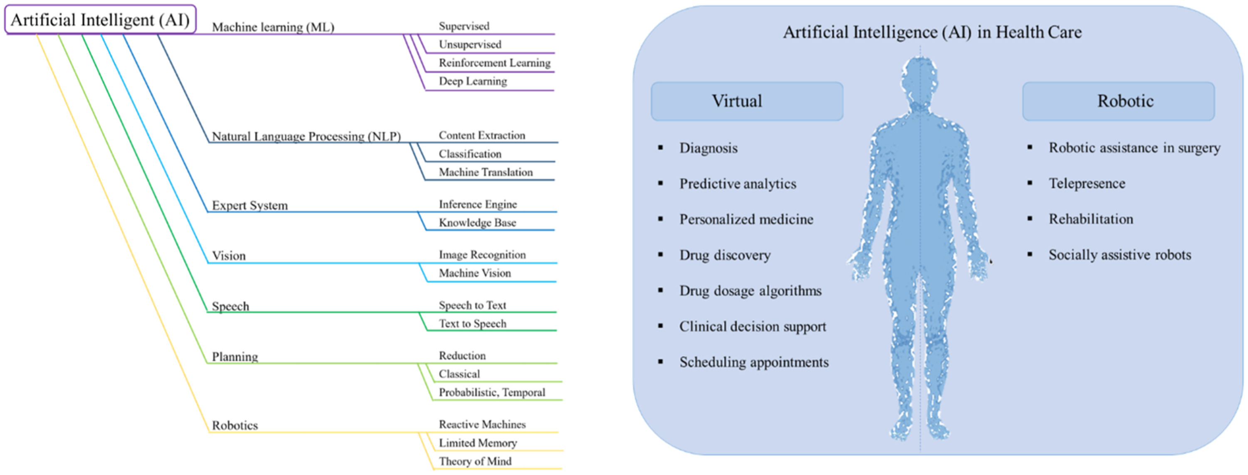

Fig. 1. Taxonomy of Artificial intelligence techniques and their applications in health care.

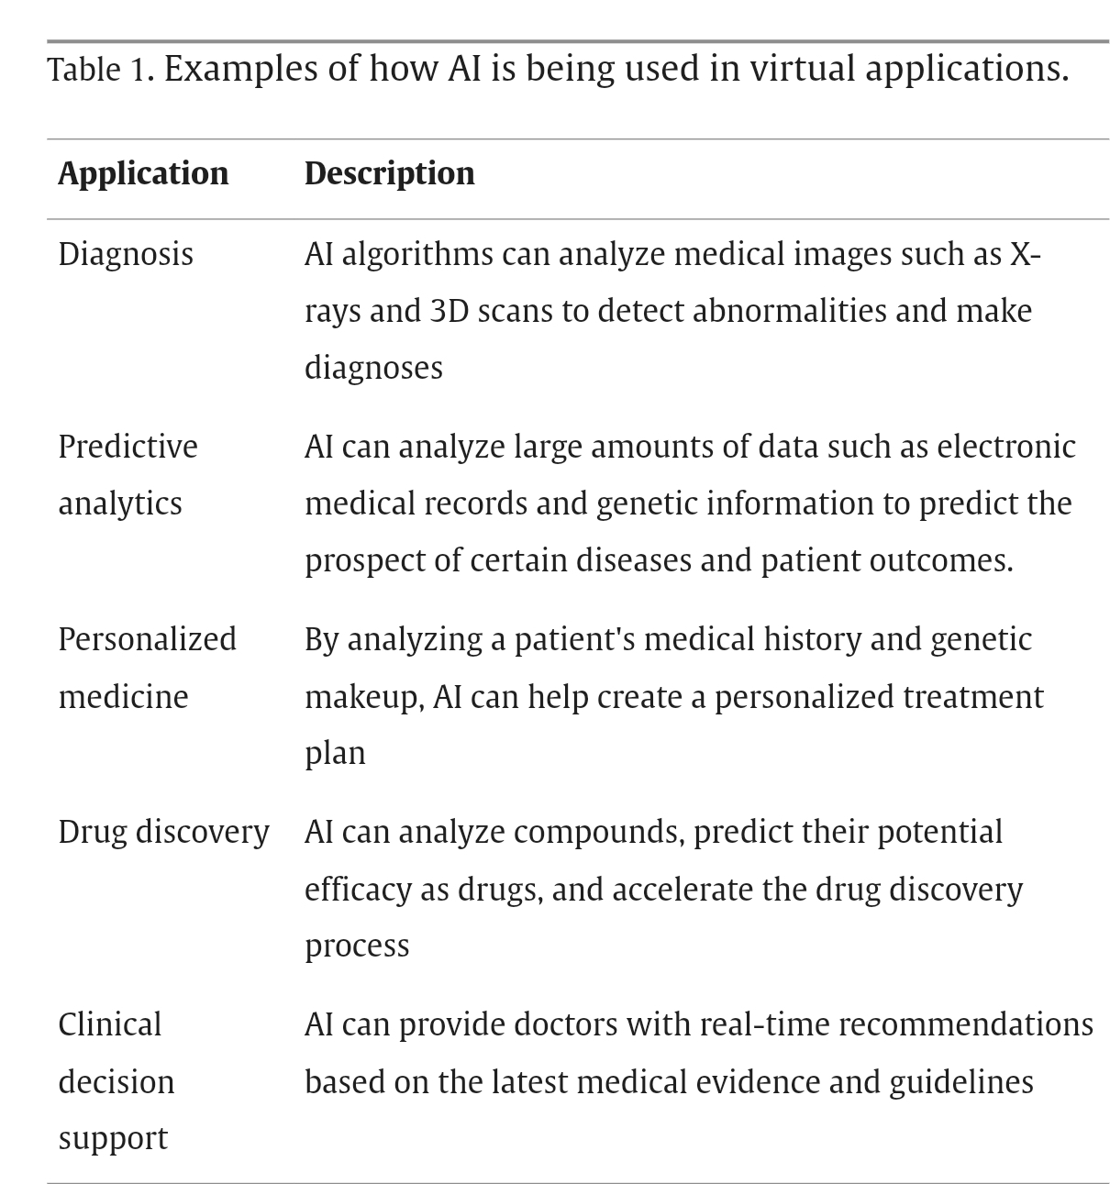

What Is Artificial Intelligence?

AI is a branch of computer science that aims to understand and build intelligent entities, often instantiated as software programs6. It can be defined as a sequence of operations designed to

perform a specific task. Historically, artificially intelligent systems applied hand-crafted rules to the specific tasks they were meant to solve. Each task required domain-specific knowledge, engineering and manual fine-tuning of the system by subject-matter experts.   
Machine learning (ML) is a branch of AI in which systems learn to perform intelligent tasks without a priori knowledge or hand-crafted rules.

Instead, the systems identify patterns in examples from a large dataset, without human assistance. This is accomplished by defining an objective and optimizing the system’s tunable functions to reach it. In this process, known as training, an ML algorithm gains experience through exposure to random examples and gradual adjustments of the “tunables” toward the correct answer.

Deep learning (DL) is a sub-branch of ML wherein systems attempt to learn, not only a pattern, but also a hierarchy of composable patterns that build on each other. The combination and stacking of patterns create a “deep” system far more powerful than a plain, “shallow” one. For instance, a child does not recognize a cat in a single, indivisible step of pattern-matching; rather, the child first sees the edges of the object, a particular grouping of which defines a textured outline with simple shapes, such as eyes and ears7.

A neural network is composed of an input layer, an output layer and hidden layers in between. It is possible to have 1 or a few hidden layers (shallow neural network) or multiple/many hidden layers (deep neural network, DNN) (Figure 2, i and ii). These layers are called hidden because their values are not pre-specified or visible to the outside. Their aim is to make it possible to build hierarchically on information retrieved from the visible input layer to compute the correct value of the visible output layer.

The pattern of connections between neurons defines the particular neural network’s architecture, and the fine-tunable strengths of those connections are called the weights of the neural network. In medicine and dentistry, one of the most commonly used subclasses of ANN is the convolutional neural network (CNN) (Figure 2.ii.c)8.

A CNN uses a special neuron connection architecture and the mathematical operation, convolution, to process digital signals such as sound, image and video. CNNs use a sliding window to scan a small neighbourhood of inputs at a time, from left to right and top to bottom, to analyze a wider image or signal. They are extremely well adapted to the task of image classification and are the most-used algorithm for image recognition.(Fig.3)

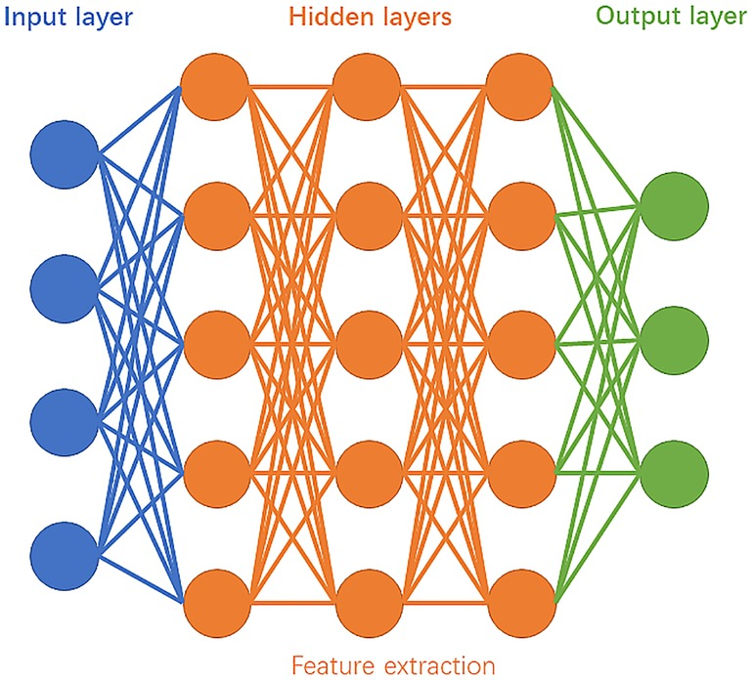

(i)

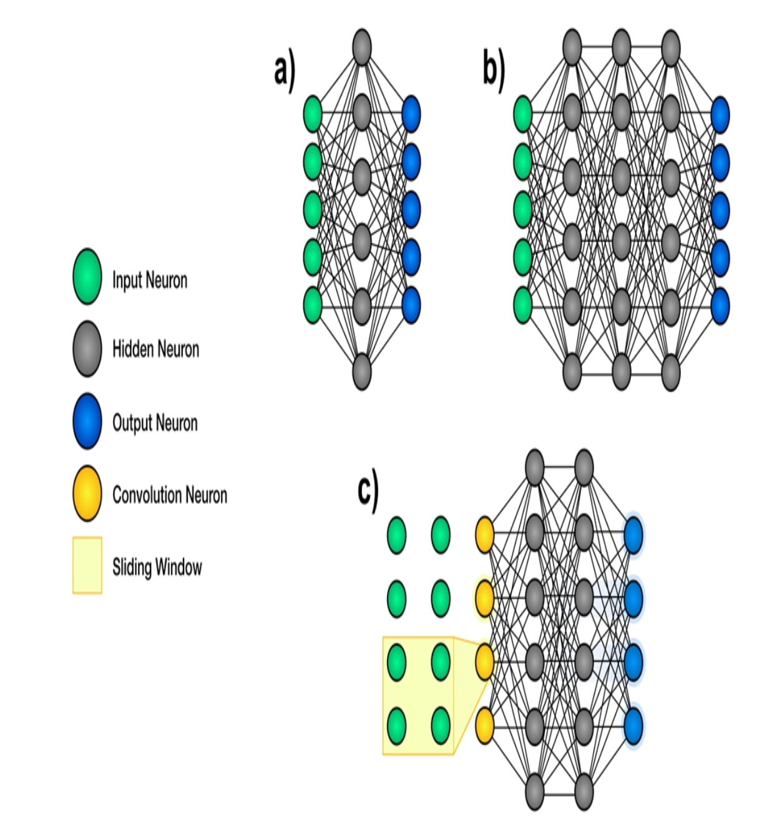

(ii)

Figure 2. (i)Schematic diagram of deep learning.

(ii) Schematic representation of the architecture of neural networks. Artificial neural networks are structures used in machine learning. They contain many small communicating units called neurons, which are organized in layers. a. Shallow neural networks are composed of an input layer, a few hidden layers and an output layer9.

b. Deep neural networks have an input layer, multiple hidden layers and an output layer. c. Convolutional neural networks use filters to scan a small neighbourhood of inputs.

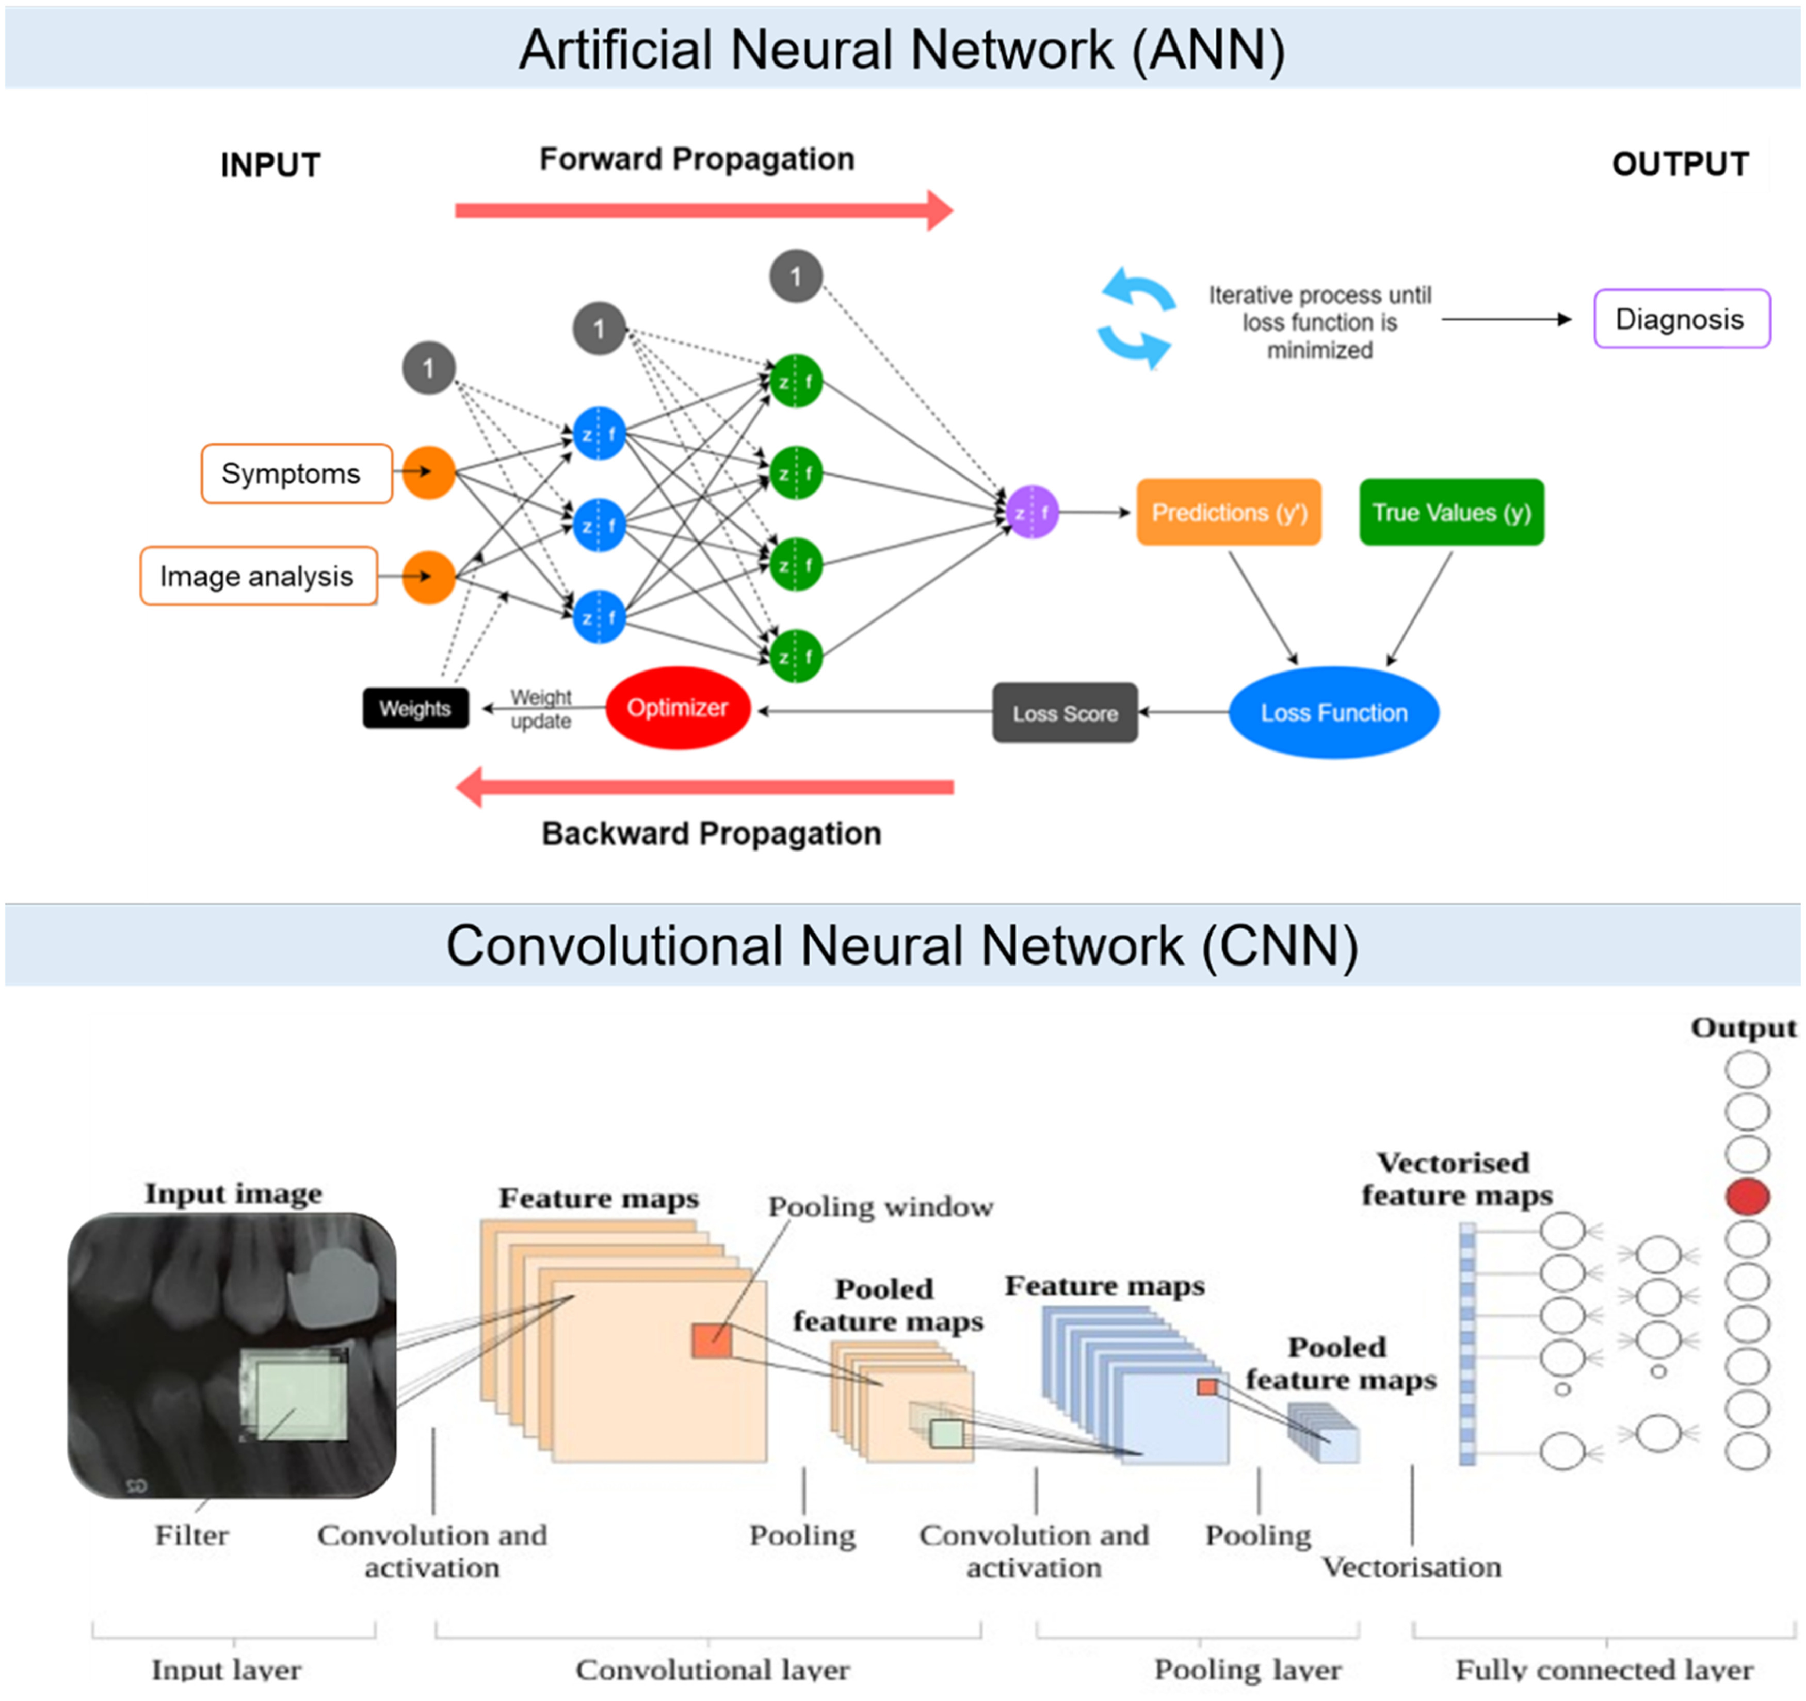

Figure 3. ANN and CNN

**Metrics evaluation**

Various metrics can be used to evaluate the performance of AI systems in healthcare. These metrics are not mutually exclusive, and the right metric to use depends on the specific application and goals of the AI system. Metrics and their brief descriptions used in the manuscript are listed in Table 2.

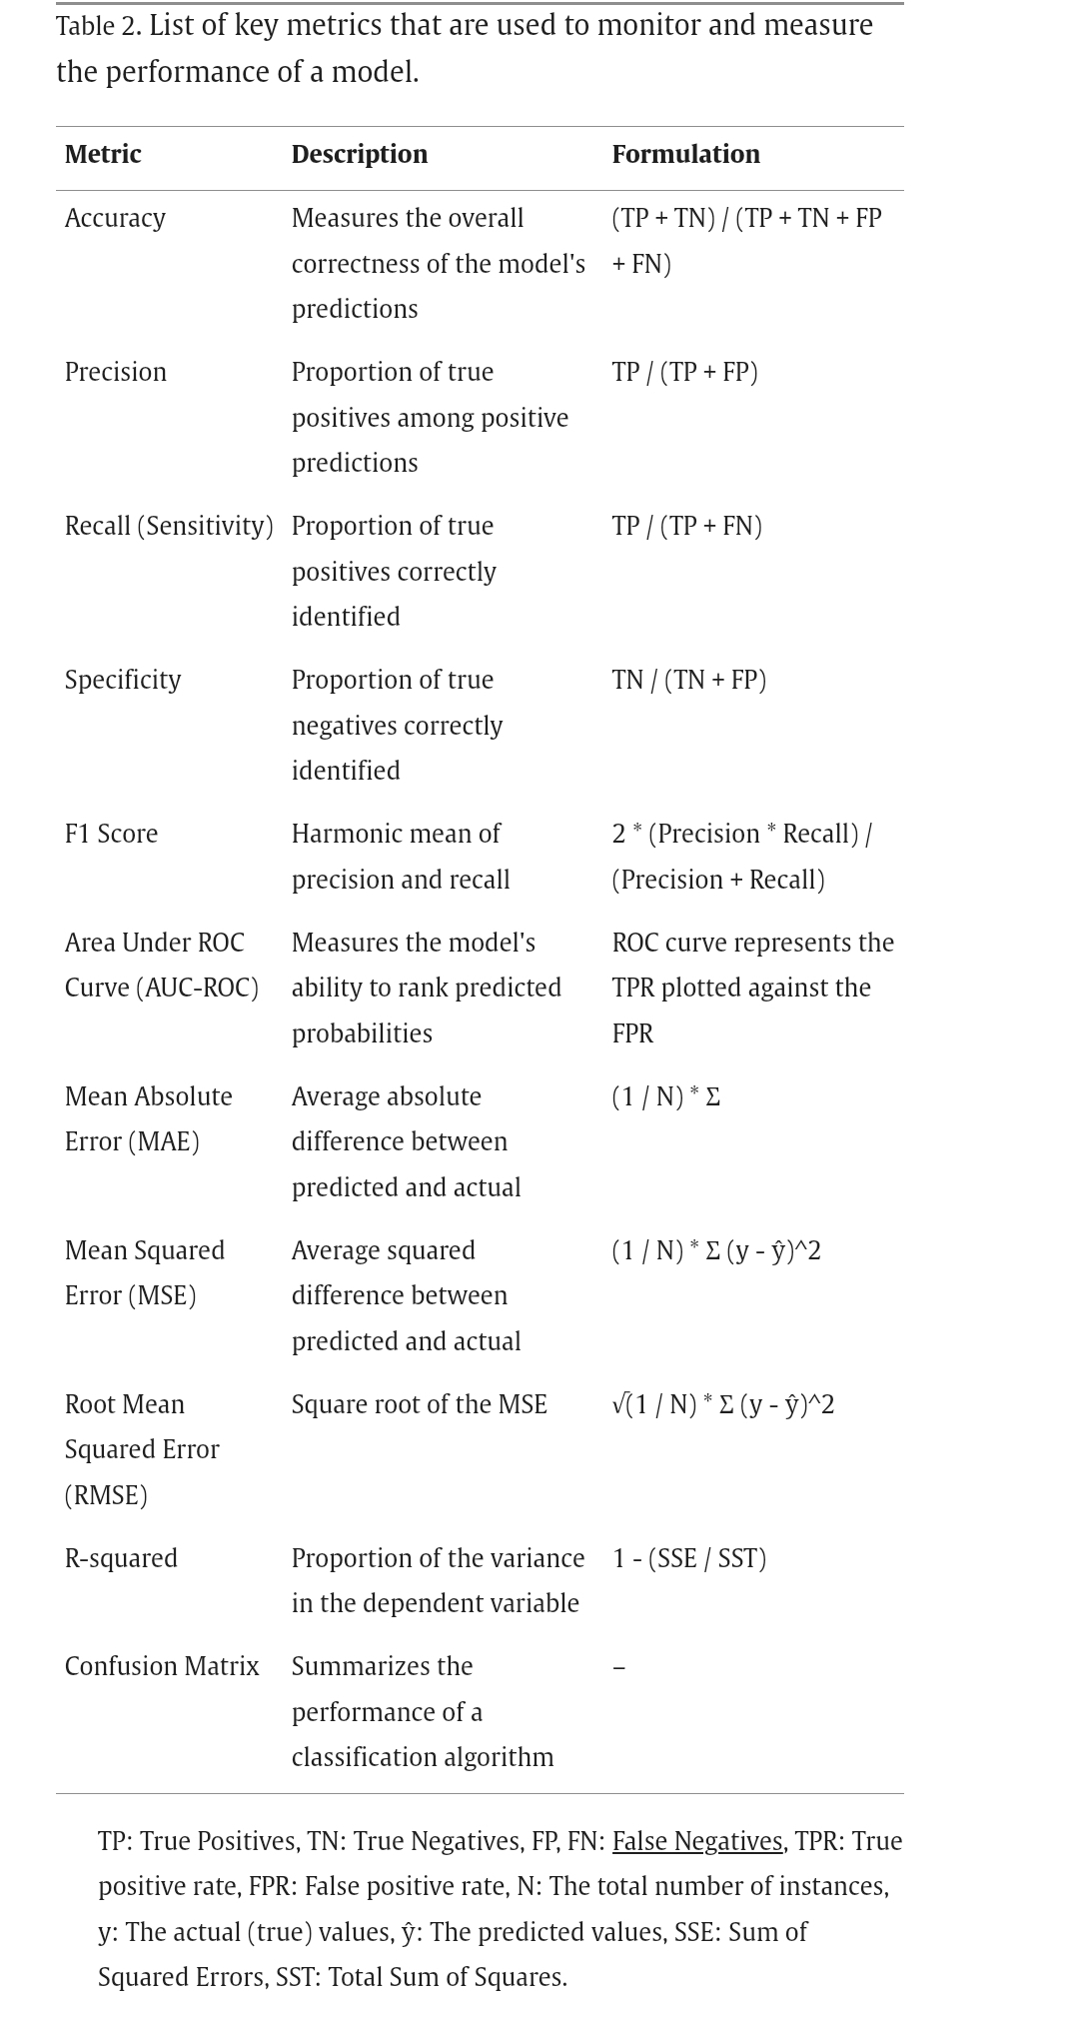

**Clinical Application of AI in Dentistry**  
**AI applications in oral mucosal disease**

Lichen planus is another chronic inflammatory disease that affects the skin and mucous membranes, including those in the mouth. It is characterized by the development of flat, purple lesions on the gums and other oral tissues. The diagnosis of oral lichen planus is usually based on a combination of clinical examination, laboratory testing and imaging studies.

**AI applications in cariology**

Cariology deals with the prevention, diagnosis, and treatment of dental caries. Dental caries is a multifactorial disease and one of the most common chronic diseases worldwide . Visual examination, dental radiography, dental cavities detection devices (such as the DIAGNOdent, Caries Detector, and the Spectra) and saliva tests are diagnostic tools that are commonly used in cariology to identify areas of caries lesion. Detection of carious lesions, particularly in the early stages can be subjective as they have different forms of clinical presentation during the disease process. As noted in the previous section, lack of consistency in dental radiographic interpretations have led to increased interest in using deep learning to process images10.

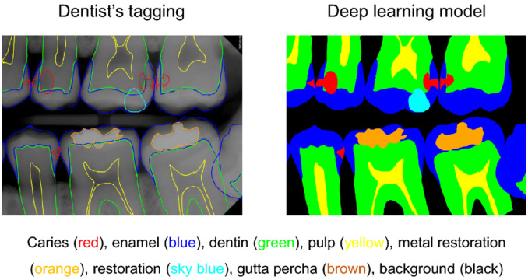

Fig.4 Analysis example of tooth structure and caries marking. On the bitewing radiographs, the observer drew lines for segmentation of tooth structure (enamel, dentin, pulp, metal restorations, tooth-colored restorations, gutta-percha) and caries.

Another aspect of cariology is to minimize the experience and impact of caries on an individual’s general health and quality of life. This model used data from the National Health and Nutrition Examination Survey. The model predicted the most relevant variables from demographic and lifestyle factors with an accuracy of 97.1 %, precision of 95.1 %, sensitivity of 99.6 %, and specificity of 94.3 % for identifying dental caries11.

A recent systematic review evaluated the success of machine learning algorithms in caries diagnosis and prognosis prediction. Most models were developed outside of a real clinical setting and were at unclear/high risk of bias, limiting the general applicability of the evidence. They concluded that the use of machine learning for caries diagnosis and prognosis is promising, but still in its early stages. Table 3 enlists some recent studies on deep learning methods in cariology disease detection12.

Table 3. Applications of AI in cariology.

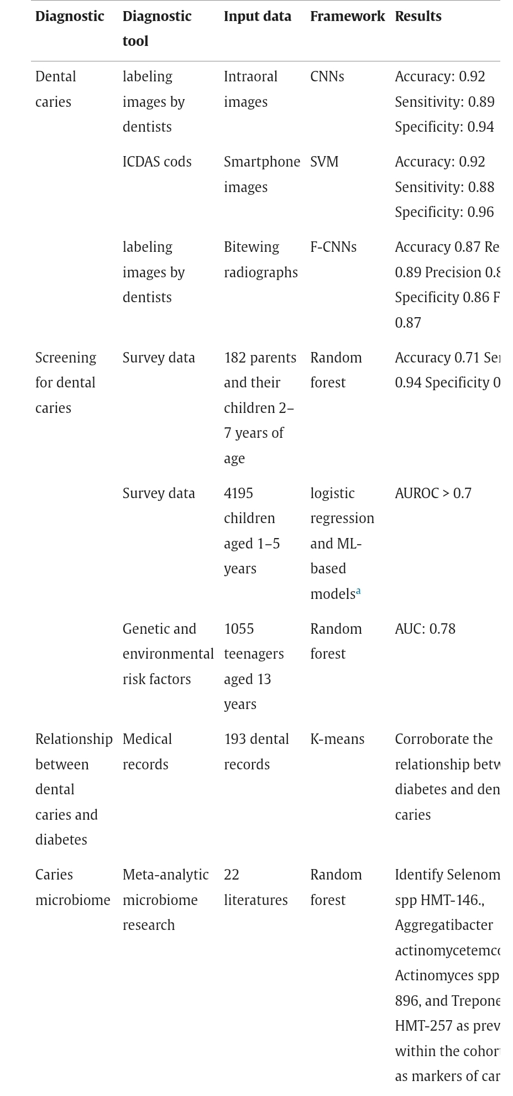

**AI in operative dentistry**

Traditionally, dentists diagnose caries by visual and tactile examination or by radiographic examination according to a detailed criterion. However, detecting early-stage lesions is challenging when deep fissures, tight interproximal contacts, and secondary lesions are present. Eventually, many lesions are detected only in the advanced stages of dental caries, leading to a more complicated treatment, i.e., dental crown, root canal therapy, or even implant13. Although dental radiography (whether panoramic, periapical, or bitewing views) and explorer (or dental probe) have been widely used and regarded as highly reliable diagnostic tools detecting dental caries, much of the screening and final diagnosis tends to rely on dentists’ experience. In operative dentistry, there has been research on the detection of dental caries, vertical root fractures, apical lesions, pulp space volumetric assessment, and evaluation of tooth wear (Table 4). In a two-dimensional (2D) radiograph, each pixel of the grayscale image has an intensity, i.e., brightness, which represents the density of the object. By learning from the above-mentioned characteristics, an AI algorithm can learn the pattern and give predictions to segment the tooth, detect caries, etc14.

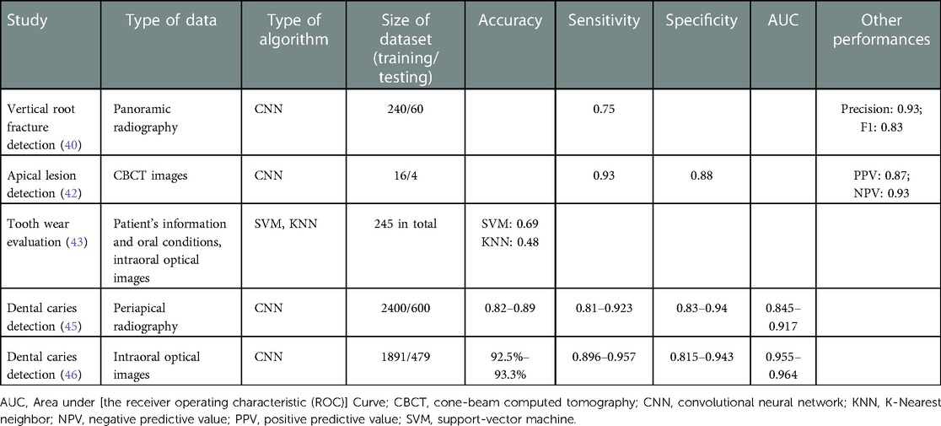

Table 4. Examples of AI applications in operative dentistry

**AI in periodontics**

Periodontitis is one of the most widespread diseases. It is a burden for billions of individuals and, if untreated, can lead to tooth mobility and even tooth loss. To prevent severe periodontitis, early detection and treatment are needed. In clinical practise, periodontal disease diagnosis is based on evaluating pocket probing depths and gingival recession. The Periodontal Screening Index (PSI) is frequently used to quantify clinical attachment loss. However, this clinical evaluation has low reliability: the screening for periodontal disease is still based on the experience of dentists, and they may miss localized periodontal tissue loss (50).In periodontics, AI has been utilised to diagnose periodontitis and classify plausible periodontal disease types .

**AI in Orthodontics**

ANNs have immense potential to aid in the clinical decision-making process. In orthodontic treatments, it is essential to plan treatments carefully to achieve predictable outcomes for patients(55). However, it is not uncommon to see teeth extractions included in the orthodontic treatment plan. Therefore, it is essential to ensure that the best clinical decision is made before initiating irreversible procedures. An ANN was used to help determine the need for tooth extraction before orthodontic therapy in patients with malocclusion. The four constructed ANNs, taking into consideration several clinical indices, showed an accuracy of 80–93% in determining whether extractions were needed to treat patients’ malocclusions16.

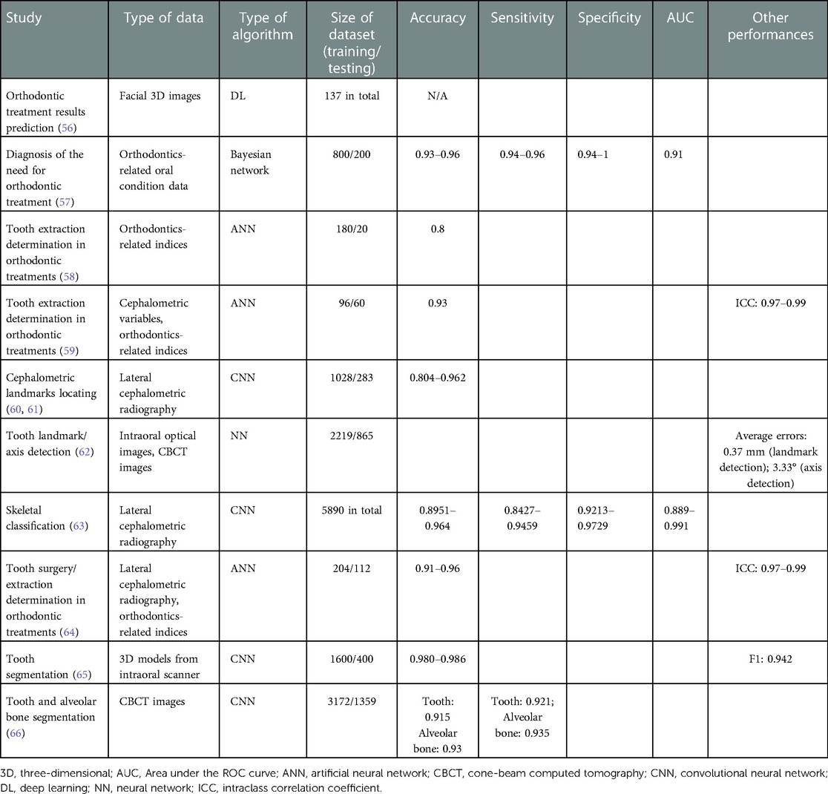

Table 5. Examples of AI applications in orthodontics

**AI in Oral Pathology**

Detection and diagnosis of oral lesions is of crucial importance in dental practices because early detection significantly improves prognosis. As some oral lesions can be precancerous or cancerous in nature, it is important to make an accurate diagnosis and prescribe appropriate treatment of the patient. CNN has been shown to be a promising aid throughout the process of diagnosis of head and neck cancer lesions. With specificity and accuracy at 78–81.8% and 80–83.3%, respectively (compared with those of specialists, which were 83.2% and 82.9% respectively), CNN shows great potential for detecting tumoural tissues in tissue samples or on radiographs. One study used a CNN algorithm to distinguish between 2 important maxillary tumours with similar radiologic appearance but different clinical properties: ameloblastomas and keratocystic odontogenic tumours. The specificity and the accuracy of diagnosis by the algorithm were 81.8% and 83.3%, respectively, comparable with those of clinical specialists at 81.1% and 83.2%. However, a more significant difference was observed in terms of diagnostic time: specialists took an average of 23.1 minutes to reach a diagnosis, while the CNN achieved similar results in 38 s.

**AI in Radiology**

CNNs have shown promising ability to detect and identify anatomical structures. For example, some have been trained to identify and label teeth from periapical radiographs. CNNs have demonstrated a precision rate of 95.8–99.45% in detecting and identifying teeth, almost rivalling the work of clinical experts, whose precision rate was 99.98%.CNNs have also been used for the detection and diagnosis of dental caries.

**AI in oral and maxillofacial pathology**

Oral and Maxillofacial Pathology (OMFP) is a specialty for examining pathological conditions and diagnosing diseases in the oral and maxillofacial region. The most severe type of OMFP is oral cancer.

In OMFP, as shown in Table 6, AI has been researched mostly for tumour and cancer detection based on radiographic, microscopic and ultrasonographic images. In addition, AI can be used to detect abnormal sites on radiographs, such as nerves in the oral cavity, interdigitated tongue muscles, and parotid and salivary glands. CNN algorithms were demonstrated to be a suitable tool for the automatically detecting cancers. It is worth mentioning that AI also plays a role in managing cleft lip and palate in risk prediction, diagnosis, pre-surgical orthopaedics, speech assessment, and surgery.

Early detection and diagnosis of various mucosal lesions are essential to classify them as benign or malignant. Surgery resection is required for malignant lesions. However, some of the lesions behave similarly in appearance, thus requiring the diagnosis by biopsy slides and radiographs.

Pathologists diagnose disease by observing the morphology of stained specimens on glass slides using a microscope . It is tedious work that requires much of effort for pathologists.. Thus, AI can be a suitable tool for aiding pathologists in this task Table 6 .

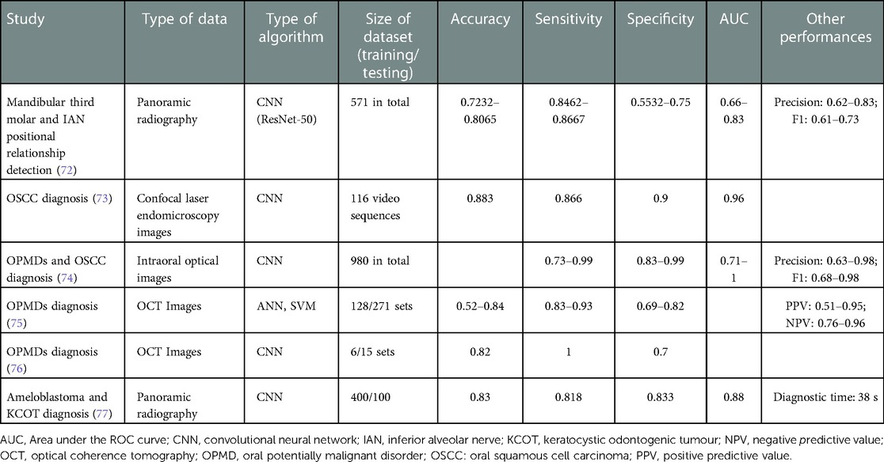

Table 6. Examples of AI applications in oral and maxillofacial surgery.

**AI in prosthodontics**

In prosthodontics, a typical treatment process to prepare a dental crown includes tooth preparation, impression taking, cast trimming, restoration design, fabrication, try-in, and cementation. The application of AI in prosthodontics mainly lies in the restoration design (Table 7). CAD/CAM has digitalised the design work in commercialized products, including CEREC, Sirona, 3Shape, etc. Although this has dramatically increased the efficiency of the design process by utilising a tooth library for crown design, it still cannot achieve a custom-made design for individual patients . Current ML algorithms are more focused on assisting the design process of removable dentures, e.g., classification of dental arches , and facial appearance prediction in edentulous patients17 .

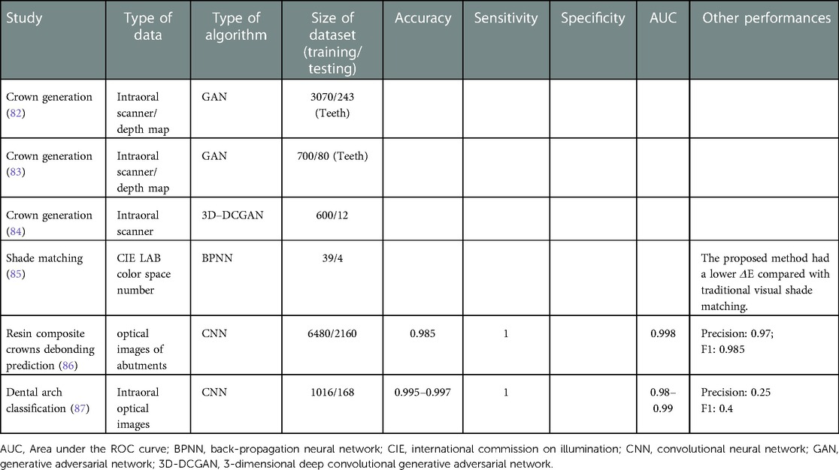

Table 7. Examples of AI applications in prosthodontics.

**AI in Implantology**

Implantology is a branch of dentistry that deals with the surgical placement and restoration of dental implants. Dental implants are a popular and effective treatment option for people who have lost one or more teeth due to injury, disease, or decay. They are made of biocompatible materials such as titanium, zirconia or ceramics, which allows the implant to fuse with the patient’s alveolar bone over time, creating a strong, stable base for the replacement teeth. The process of placing dental implants typically involves several stages, including preoperative evaluation, implant placement, abutment placement, prosthetic placement. With integration of technologies like CAD/CAM, CBCT and AI, implant placement has become high accurate, efficient and predictable outcomes. AI provided dentists with more detailed information about the patient’s mouth with 3D models of the jaw and teeth automated tooth segmentation, and guided implant placement , predict the outcomes of the implant placement , and design the final restoration, such as a crown, bridge or denture . AI also can be helpful in predicting the failure rate of implants and monitoring the status of the implant over time and to predict when it may need to be serviced or replaced18 .

**Challenges of AI**

The management and sharing of clinical data are major challenges in the implementation of AI systems in health care. Personal data from patients are necessary for initial training of AI algorithms, as well as ongoing training, validation and improvement. Furthermore, the development of AI will prompt data sharing among different institutions and, in some cases, across national boundaries. To integrate AI into clinical operations, systems must be adapted to protect patient confidentiality and privacy. Thus, before considering broader distribution, personal data will have to be anonymized. Even with the ability to take these precautions, there is skepticism in the health care community about secure data sharing.AI systems are also associated with safety issues. Mechanisms must be created to control the quality of the algorithms used in AI. To remedy this situation, the United States Food and Drug Administration has created a new drug category, “Software as Medical Device,” through which it regulates safe innovation and patient safety. Ambiguous accountability in the use of AI systems is another concern. Furthermore, health care professionals should possess a full understanding of the decisions and predictions made by an AI system, as well as the capability to defend them. Interpretability of AI technology is a known problem, and major advances are required before certain classes of algorithms, such as neural networks, can make clinical diagnoses or treatment recommendations with full transparency.

**Conclusion**

Although multiple studies have shown potential applications of AI in dentistry, these systems are far from being able to replace dental professionals. Rather, the use of AI should be viewed as a complementary asset, to assist dentists and specialists. It is crucial to ensure that AI is integrated in a safe and controlled manner to assure that humans retain the ability to direct treatment and make informed decisions in dentistry. The road to successful integration of AI into dentistry will necessitate training in dental and continuing education, a challenge that most institutions are not currently prepared for. In addition, AI plays a critical role in virtual reality (VR) and augmented reality (AR). A new term, mixed reality, incorporates aspects of generative AI, VR and AR into computer-superimposed information overlays to enhance learning and surgical planning.32 As various AI systems for diverse dental disciplines are being developed and have produced encouraging preliminary results, a future for AI in the health care system cannot be discounted. AI systems show promise as a great aid to oral health professionals.

**References**

1. Stevenson A. Oxford Dictionary of English. USA: Oxford University Press (2010).

2. Poplin R, Varadarajan AV, Blumer K, Liu Y, McConnell MV, Corrado GS, et al. Prediction of cardiovascular risk factors from retinal fundus photographs via deep learning. Nat Biomed Eng. (2018) 2(3):158–64. doi: 10.1038/s41551-018-0195-0

3. Khanagar SB, Al-ehaideb A, Maganur PC, Vishwanathaiah S, Patil S, Baeshen HA, et al. Developments, application, and performance of artificial intelligence in dentistry—a systematic review. J Dent Sci. (2021) 16(1):508–22. doi: 10.1016/j.jds.2020.06.019

4. Khanagar SB, Al-Ehaideb A, Vishwanathaiah S, Maganur PC, Patil S, Naik S, et al. Scope and performance of artificial intelligence technology in orthodontic diagnosis, treatment planning, and clinical decision-making—a systematic review. J Dent Sci. (2021) 16(1):482–92. doi: 10.1016/j.jds.2020.05.022

5. Mahmood H, Shaban M, Indave BI, Santos-Silva AR, Rajpoot N, Khurram SA. Use of artificial intelligence in diagnosis of head and neck precancerous and cancerous lesions: a systematic review. Oral Oncol. (2020) 110:104885. doi: 10.1016/j.oraloncology.2020.104885

6. Farook TH, Jamayet NB, Abdullah JY, Alam MK. Machine learning and intelligent diagnostics in dental and orofacial pain management: a systematic review. Pain Res Manag. (2021) 2021:6659133. doi: 10.1155/2021/6659133

7. AbuSalim S, Zakaria N, Islam MR, Kumar G, Mokhtar N, Abdulkadir SJ. Analysis of deep learning techniques for dental informatics: a systematic literature review. Healthcare. (2022) 10(10):1892. doi: 10.3390/healthcare10101892

8. Mohammad-Rahimi H, Motamedian SR, Pirayesh Z, Haiat A, Zahedrozegar S, Mahmoudinia E, et al. Deep learning in periodontology and oral implantology: a scoping review. J Periodont Res. (2022) 57(5):942–51. doi: 10.1111/jre.13037

9.Yu KH, Beam AL, Kohane IS. Artificial intelligence in healthcare. Nat Biomed Eng. 2018;2(10):719-31.

10.Topol EJ. Deep medicine: how artificial intelligence can make healthcare human again. 1st ed. New York: Basic Books; 2019.

11.Russell SJ, Norvig P. Artificial intelligence: a modern approach. 3rd ed. Hoboken, N.J.: Prentice Hall; 2010.

12.Muller J, Massaron L. Artificial intelligence for dummies. Hoboken, N.J.: John Wiley & Sons; 2018.

13.James G, Witten D, Hastie T, Tibshirani R. An introduction to statistical learning with applications in R. New York: Springer; 2013.

Goodfellow I, Bengio Y, Courville A. Deep learning. 1st ed. Cambridge, Mass.: MIT Press; 2016.

14.Nielsen MA. Neural networks and deep learning. Determination Press; 2015. Available: http://neuralnetworksanddeeplearning.com/ (accessed 2021 April 16).

15.Zhang K, Wu J, Chen H, Lyu P. An effective teeth recognition method using label tree with cascade network structure. Comput Med Imaging Graph. 2018;68:61-70.

16.Tuzoff DV, Tuzova LN, Bornstein MM, Krasnov AS, Kharchenko MA, Nikolenko SI, et al. Tooth detection and numbering in panoramic radiographs using convolutional neural networks. Dentomaxillofac Radiol. 2019;48(4):20180051.

17.Lee JH, Kim DH, Jeong SN, Choi SH. Detection and diagnosis of dental caries using a deep learning-based convolutional neural network

18.L.T. Skeggs, H. Hochstrasser Multiple automatic sequential analysis;Clin. Chem., 10 (1964), pp. 918-936, 10.1093/clinchem/10.10.918